

Page 1 of 26
INTEGRATED CIRCUITS, SILICON MONOLITHIC, HCMOS, DUAL 2-LINE TO 4-LINE DECODER/DEMULTIPLEXER WITH FULLY BUFFERED INVERTED OUTPUTS
BASED ON TYPE 54HC139

ESCC Detail Specification No. 9205/017

Issue 5 | October 2018



Document Custodian: European Space Agency – see https://escies.org

Legal Disclaimer and Copyright
European Space Agency, Copyright © 2018. All rights reserved.
The European Space Agency disclaims any liability or responsibility, to any person or entity, with respect to any loss or damage caused, or alleged to be caused, directly or indirectly by the use and application of this ESCC publication.
This publication, without the prior permission of the European Space Agency and provided that it is not used for a commercial purpose, may be:
- copied in whole, in any medium, without alteration or modification.
- copied in part, in any medium, provided that the ESCC document identification, comprising the ESCC symbol, document number and document issue, is removed.

DOCUMENTATION CHANGE NOTICE
(Refer to https://escies.org for ESCC DCR content)
DCR No. | CHANGE DESCRIPTION
TBA | Specification upissued to incorporate changes per DCR.

TABLE OF CONTENTS
1 General 6
1.1 SCOPE 6
1.2 APPLICABLE DOCUMENTS 6
1.3 TERMS, DEFINITIONS, ABBREVIATIONS, SYMBOLS AND UNITS 6
1.4 THE ESCC COMPONENT NUMBER AND COMPONENT TYPE VARIANTS 6
1.4.1 The ESCC Component Number 6
1.4.2 Component Type Variants 6
1.5 MAXIMUM RATINGS 7
1.6 HANDLING PRECAUTIONS 7
1.7 PHYSICAL DIMENSIONS AND TERMINAL IDENTIFICATION 8
1.7.1 Flat Package (FP) - 16 Pin 8
1.7.2 Dual-in-line Package (DIP) - 16 Pin 9
1.7.3 Chip Carrier Package (CCP) - 20 Terminal 10
1.7.4 Small Outline Ceramic Package (SO) - 16 Pin 12
1.7.5 Notes to Physical Dimensions and Terminal Identification 13
1.8 FUNCTIONAL DIAGRAM 13
1.9 PIN ASSIGNMENT 14
1.10 TRUTH TABLE 14
1.11 PROTECTION NETWORKS 15
2 REQUIREMENTS 15
2.1 GENERAL 15
2.1.1 Deviations from the Generic Specification 15
2.2 MARKING 15
2.3 ELECTRICAL MEASUREMENTS AT ROOM, HIGH AND LOW TEMPERATURES 15
2.3.1 Room Temperature Electrical Measurements 16
2.3.2 High and Low Temperatures Electrical Measurements 19
2.3.3 Notes to Electrical Measurement Tables 20
2.4 PARAMETER DRIFT VALUES 21
2.5 INTERMEDIATE AND END-POINT ELECTRICAL MEASUREMENTS 22
2.6 HIGH TEMPERATURE REVERSE BIAS BURN-IN CONDITIONS 23
2.6.1 N-Channel HTRB 23
2.6.2 P-Channel HTRB 23
2.7 POWER BURN-IN CONDITIONS 24
2.8 OPERATING LIFE CONDITIONS 24
2.9 TOTAL DOSE RADIATION TESTING 25
2.9.1 Bias Conditions and Total Dose Level for Total Dose Radiation Testing 25
2.9.2 Electrical Measurements for Total Dose Radiation Testing 25
APPENDIX ‘A’ 26

General

SCOPE
This specification details the ratings, physical and electrical characteristics and test and inspection data for the component type variants and/or the range of components specified below. It supplements the requirements of, and shall be read in conjunction with, the ESCC Generic Specification listed under Applicable Documents.

APPLICABLE DOCUMENTS
The following documents form part of this specification and shall be read in conjunction with it:
          - ESCC Generic Specification No. 9000
          - MIL-STD-883, Test Methods and Procedures for Microelectronics

TERMS, DEFINITIONS, ABBREVIATIONS, SYMBOLS AND UNITS
For the purpose of this specification, the terms, definitions, abbreviations, symbols and units specified in ESCC Basic Specification No. 21300 shall apply.

THE ESCC COMPONENT NUMBER AND COMPONENT TYPE VARIANTS

The ESCC Component Number
The ESCC Component Number shall be constituted as follows:
Example: 920501701F
- Detail Specification Reference: 9205017
- Component Type Variant Number: 01 (as required)
- Total Dose Radiation Level Letter: F (as required)

Component Type Variants
The component type variants applicable to this specification are as follows:
Variant Number | Based on Type | Case | Terminal Material and/or Finish | Weight  max g | Total Dose  Radiation Level  Letter
01 | 54HC139 | FP | G2 | 0.7 | F [50kRAD(Si)]
02 | 54HC139 | FP | G4 | 0.7 | F [50kRAD(Si)]
05 | 54HC139 | CCP | 2 | 0.6 | F [50kRAD(Si)]
10 | 54HC139 | DIP | G2 | 2.2 | F [50kRAD(Si)]
11 | 54HC139 | DIP | G4 | 2.2 | F [50kRAD(Si)]
12 | 54HC139 | SO | G2 | 0.7 | F [50kRAD(Si)]
13 | 54HC139 | SO | G4 | 0.7 | F [50kRAD(Si)]
The terminal material and/or finish shall be in accordance with the requirements of ESCC Basic Specification No. 23500.
The total dose radiation level letter shall be as defined in ESCC Basic Specification No. 22900. If an alternative radiation test level is specified in the Purchase Order the letter shall be changed accordingly.

MAXIMUM RATINGS
The maximum ratings shall not be exceeded at any time during use or storage.
Maximum ratings shall only be exceeded during testing to the extent specified in this specification and when stipulated in Test Methods and Procedures of the ESCC Generic Specification.
Characteristics | Symbols | Maximum Ratings | Units | Remarks
Supply Voltage | VDD | -0.5 to 7 | V | Note 1
Input Voltage | VIN | -0.5 to VDD+0.5 | V | Notes 1, 2
Output Voltage | VOUT | -0.5 to VDD+0.5 | V | Notes 1, 3
Device Power Dissipation  (Continuous) | PD | 300 | mW | Note 4
Supply Current | IDDop | 50 | mA
Operating Temperature Range | Top | -55 to +125 | °C | Tamb
Storage Temperature Range | Tstg | -65 to +150 | °C
Soldering Temperature  For FP, DIP and SO  For CCP | Tsol | +265  +245 | °C | Note 5  Note 6
NOTES:
            - Device is functional for 2V ≤ V_{DD} ≤ 6V.
            - Input current limited to I_{IC} = ±20mA.
            - Output current limited to I_{OUT} = ±25mA.
            - The maximum device dissipation is determined by I_{DDop} max (50mA) × 6V.
            - Duration 10 seconds maximum at a distance of not less than 1.5mm from the device body and the same terminal shall not be resoldered until 3 minutes have elapsed.
            - Duration 5 seconds maximum and the same terminal shall not be resoldered until 3 minutes have elapsed.

HANDLING PRECAUTIONS
These devices are susceptible to damage by electrostatic discharge. Therefore, suitable precautions shall be employed for protection during all phases of manufacture, testing, packaging, shipment and any handling.
These components are categorised as Class 2 per ESCC Basic Specification No. 23800 with a minimum Critical Path Failure Voltage of 2500 Volts.

PHYSICAL DIMENSIONS AND TERMINAL IDENTIFICATION
Consolidated Notes are given following the case drawings and dimensions (see Para. 1.7.5).

Flat Package (FP) - 16 Pin
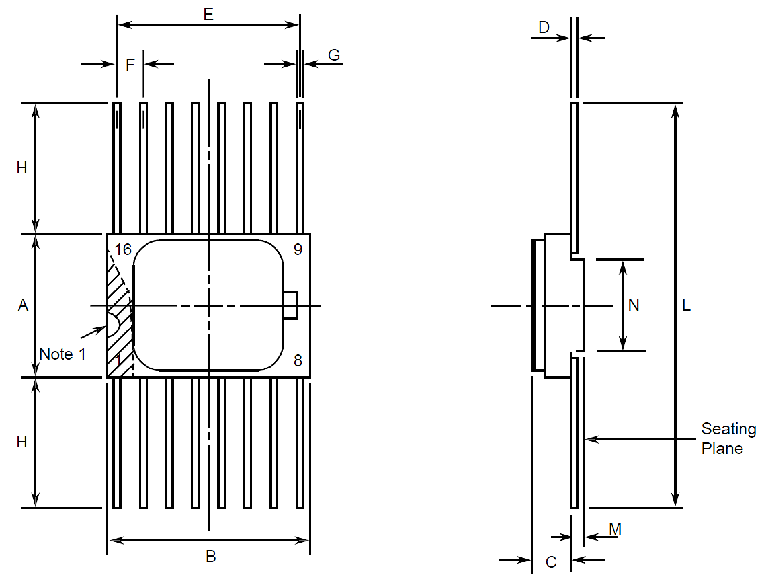
Symbols | Dimensions mm |  | Notes
Symbols | Min | Max | Notes
A | 6.75 | 7.06
B | 9.76 | 10.14
C | 1.49 | 1.95
D | 0.1 | 0.15 | 5
E | 8.76 | 9.01
F | 1.27 BSC |  | 3, 6
G | 0.38 | 0.48 | 5
H | 6 | - | 5
L | 18.75 | 22
M | 0.33 | 0.43
N | 4.32 TYPICAL

Dual-in-line Package (DIP) - 16 Pin
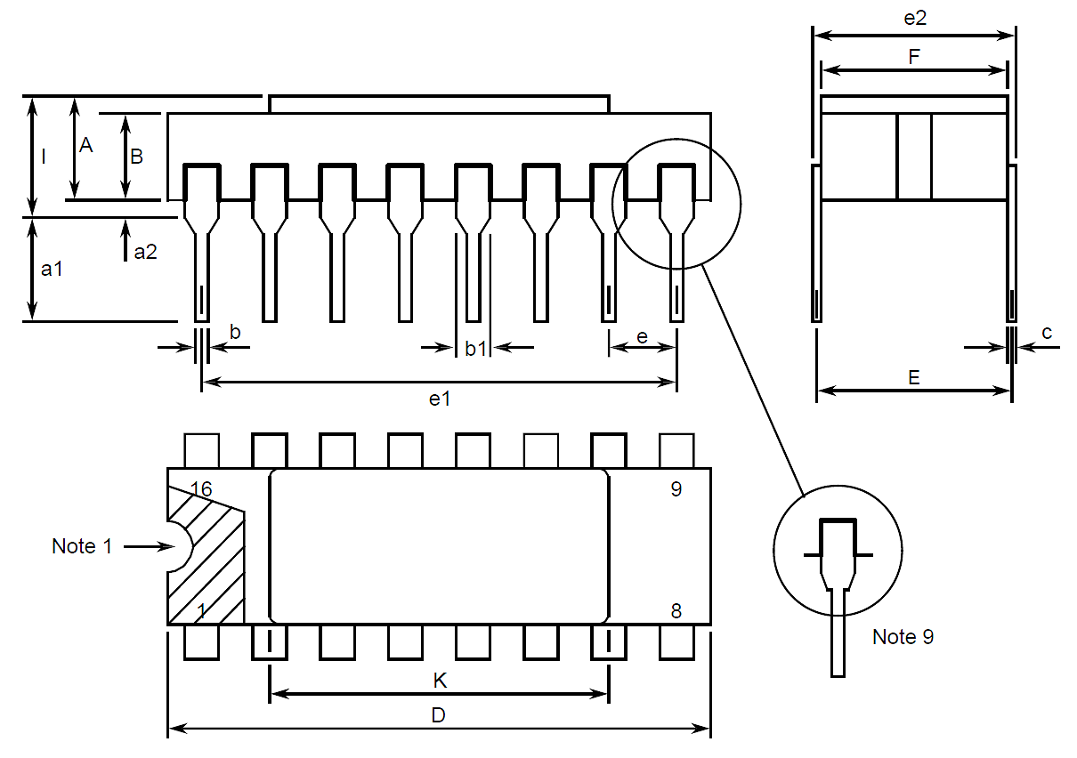
Symbols | Dimensions mm |  | Notes
Symbols | Min | Max | Notes
A | 2.1 | 2.71
a1 | 3 | 3.7
a2 | 0.63 | 1.14 | 2
B | 1.82 | 2.39
b | 0.4 | 0.5 | 5
b1 | 1.14 | 1.5 | 5
c | 0.2 | 0.3 | 5
D | 20.06 | 20.58
E | 7.36 | 7.87
e | 2.54 BSC |  | 4, 6
e1 | 17.65 | 17.9
e2 | 7.62 | 8.12
F | 7.29 | 7.7
I | - | 3.83
K | 10.9 | 12.1

Chip Carrier Package (CCP) - 20 Terminal
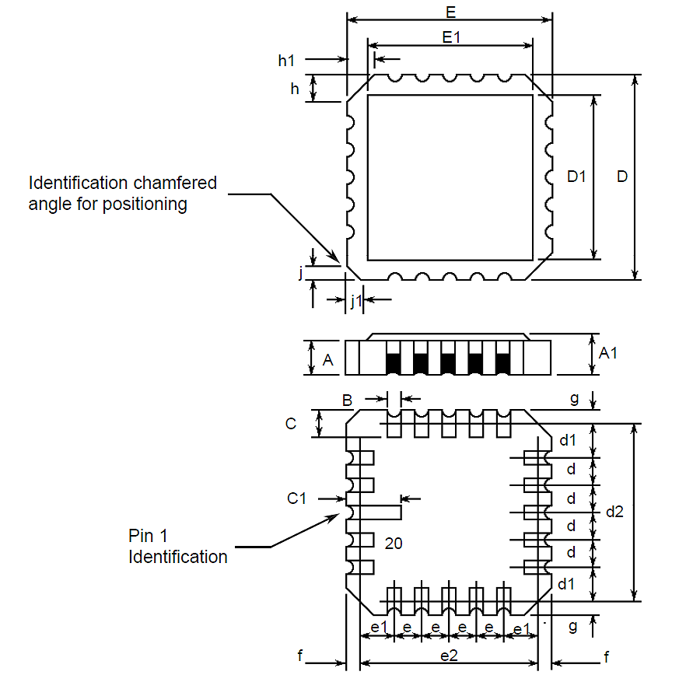
Symbols | Dimensions mm |  | Notes
Symbols | Min | Max | Notes
A | 1.14 | 1.95
A1 | 1.63 | 2.36
B | 0.55 | 0.72 | 5
C | 1.06 | 1.47 | 5
C1 | 1.91 | 2.41
D | 8.67 | 9.09
D1 | 7.21 | 7.52
d, d1 | 1.27 BSC |  | 3
d2 | 7.62 BSC
E | 8.67 | 9.09
E1 | 7.21 | 7.52
e, e1 | 1.27 BSC |  | 3
e2 | 7.62 BSC
f, g | - | 0.76
h, h1 | 1.01 TYPICAL |  | 8
j, j1 | 0.51 TYPICAL |  | 7

Small Outline Ceramic Package (SO) - 16 Pin
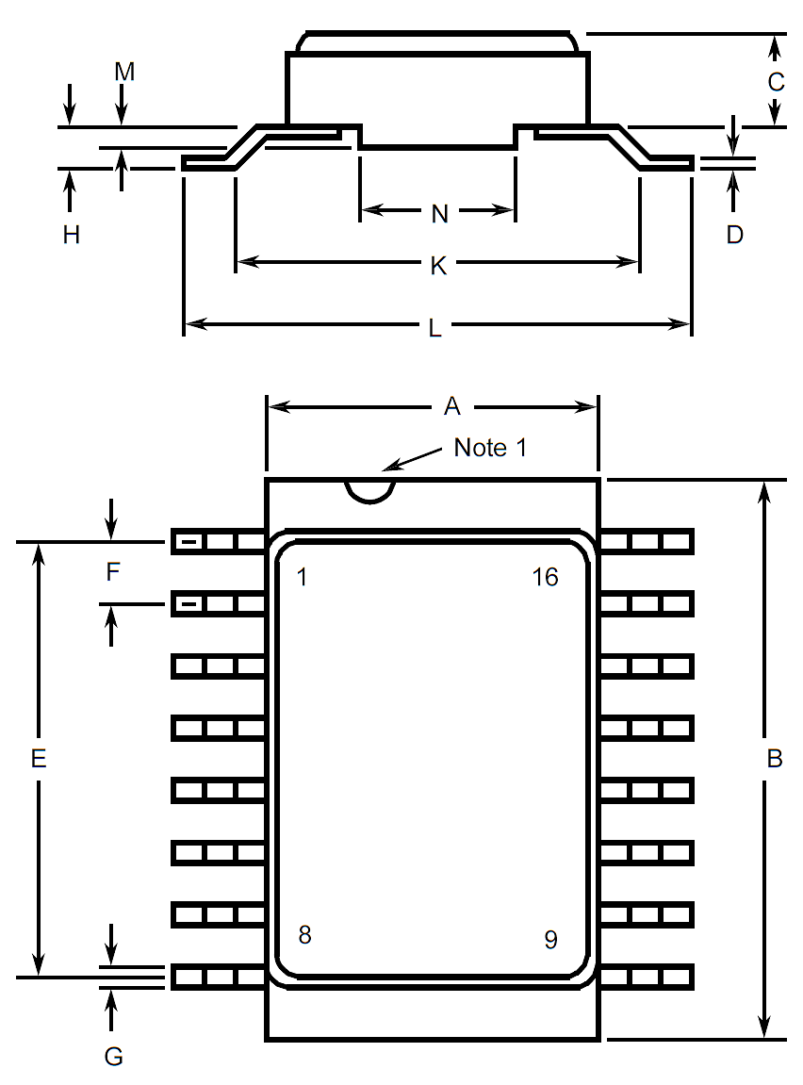
Symbols | Dimensions mm |  | Notes
Symbols | Min | Max | Notes
A | 6.75 | 7.06
B | 9.76 | 10.14
C | 1.49 | 1.95
D | 0.1 | 0.15 | 5
E | 8.76 | 9.01
F | 1.27 BSC |  | 3, 6
G | 0.38 | 0.48 | 5
H | 0.6 | 0.9 | 5
K | 9 TYPICAL
L | 10 | 10.65
M | 0.33 | 0.43
N | 4.31 TYPICAL

Notes to Physical Dimensions and Terminal Identification
            - Index area; a notch or a dot shall be located adjacent to Pin 1 and shall be within the shaded area shown. For chip carrier packages, the index shall be as shown.
            - The dimension shall be measured from the seating plane to the base plane.
            - The true position pin spacing is 1.27mm between centrelines. Each pin centreline shall be located within ±0.13mm of its true longitudinal position relative to Pin 1 and the highest pin number.
            - The true position pin spacing is 2.54mm between centrelines. Each pin centreline shall be located within ±0.25mm of its true longitudinal position relative to Pin 1 and the highest pin number.
            - All terminals.
            - 14 spaces.
            - Index corner only - 2 dimensions.
            - 3 non-index corners - 6 dimensions.
            - For all pins, either pin shape may be supplied.

FUNCTIONAL DIAGRAM
Pin numbers relate to FP, DIP and SO packages only.
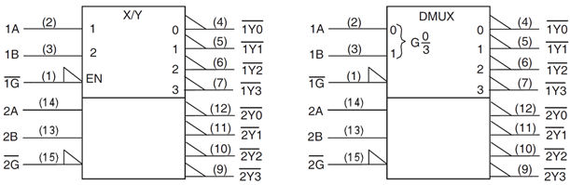

PIN ASSIGNMENT
Pin | Function |  | Pin | Function
Pin | FP, DIP and SO | CCP | Pin | FP, DIP and SO | CCP
1 | $\overline{\text{1G}}$ Input (Enable) | - | 11 | $\overline{\text{2Y1}}$ Output | -
2 | 1A Input (Select) | $\overline{\text{1G}}$ Input (Enable) | 12 | $\overline{\text{2Y0}}$ Output | $\overline{\text{2Y3}}$ Output
3 | 1B Input (Select) | 1A Input (Select) | 13 | 2B Input (Select) | $\overline{\text{2Y2}}$ Output
4 | $\overline{\text{1Y0}}$ Output | 1B Input (Select) | 14 | 2A Input (Select) | $\overline{\text{2Y1}}$ Output
5 | $\overline{\text{1Y1}}$ Output | $\overline{\text{1Y0}}$ Output | 15 | $\overline{\text{2G}}$ Input (Enable) | $\overline{\text{2Y0}}$ Output
6 | $\overline{\text{1Y2}}$ Output | - | 16 | VDD | -
7 | $\overline{\text{1Y3}}$ Output | $\overline{\text{1Y1}}$ Output | 17 | - | 2B Input (Select)
8 | VSS | $\overline{\text{1Y2}}$ Output | 18 | - | 2A Input (Select)
9 | $\overline{\text{2Y3}}$ Output | $\overline{\text{1Y3}}$ Output | 19 | - | $\overline{\text{2G}}$ Input (Enable)
10 | $\overline{\text{2Y2}}$ Output | VSS | 20 | - | VDD

TRUTH TABLE
            - Logic Level Definitions: L = Low Level, H = High Level, X = Irrelevant.
EACH DECODER
INPUTS |  |  | OUTPUTS
ENABLE | SELECT |  | $$\overline{\text{Y0}}$$ | $$\overline{\text{Y1}}$$ | $$\overline{\text{Y2}}$$ | $$\overline{\text{Y3}}$$
$$\overline{\text{G}}$$ | B | A
H | X | X | H | H | H | H
L | L | L | L | H | H | H
L | L | H | H | L | H | H
L | H | L | L | H | L | H
L | H | H | H | L | H | L

PROTECTION NETWORKS
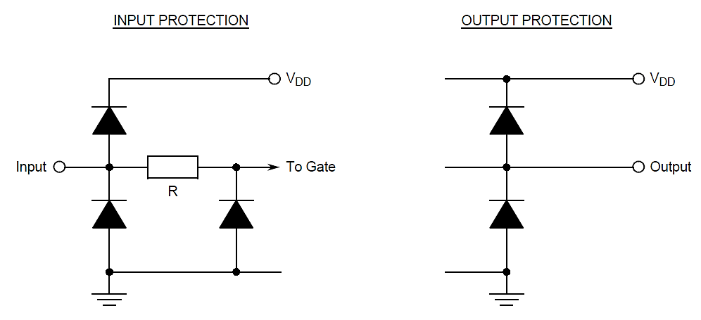

REQUIREMENTS

GENERAL
The complete requirements for procurement of the components specified herein are as stated in this specification and the ESCC Generic Specification. Permitted deviations from the Generic Specification, applicable to this specification only, are listed below.
Permitted deviations from the Generic Specification and this Detail Specification, formally agreed with specific Manufacturers on the basis that the alternative requirements are equivalent to the ESCC requirement and do not affect the component’s reliability, are listed in the appendices attached to this specification.

Deviations from the Generic Specification
None.

MARKING
The marking shall be in accordance with the requirements of ESCC Basic Specification No. 21700 and as follows.
The information to be marked on the component shall be:
          - Terminal identification (see Para. 1.7).
          - The ESCC qualified components symbol (for ESCC qualified components only).
          - The ESCC Component Number (see Para. 1.4.1).
          - Traceability information.

ELECTRICAL MEASUREMENTS AT ROOM, HIGH AND LOW TEMPERATURES
Electrical measurements shall be performed at room, high and low temperatures. Consolidated Notes are given after the tables (see Para. 2.3.3).

Room Temperature Electrical Measurements
The measurements shall be performed at T_{amb} = +22 ±3°C.
Characteristics | Symbols | MIL-STD-883  Test Method | Test Conditions  Note 1 | Limits |  | Units
 |  |  |  | Min | Max | Units
Functional Test 1 | - | 3014 | Verify Truth Table without Load  V_{IL} = 0.3V, V_{IH} = 1.5V  V_{DD} = 2V, V_{SS} = 0V  t_{r} < 1μs  Note 2 | - | - | -
Functional Test 2 | - | 3014 | Verify Truth Table without Load  V_{IL} = 0.9V, V_{IH} = 3.15V  V_{DD} = 4.5V, V_{SS} = 0V  t_{r} = t_{f} < 500ns  Note 2 | - | - | -
Functional Test 3 | - | 3014 | Verify Truth Table without Load  V_{IL} = 1.2V, V_{IH} = 4.2V  V_{DD} = 6V, V_{SS} = 0V  t_{r} = t_{f} < 400ns  Note 2 | - | - | -
Quiescent Current | I_{DD} | 3005 | V_{IL} = 0V, V_{IH} = 6V  V_{DD} = 6V, V_{SS} = 0V  All Outputs Open  Note 3 | - | 400 | nA
Low Level Input Current | I_{IL} | 3009 | V_{IN} (Under Test) = 0V  V_{IN} (Remaining Inputs) = 6V  V_{DD} = 6V, V_{SS} = 0V | - | -50 | nA
High Level Input Current | I_{IH} | 3010 | V_{IN} (Under Test) = 6V  V_{IN} (Remaining Inputs) = 0V  V_{DD} = 6V, V_{SS} = 0V | - | 50 | nA
Low Level Output Voltage 1 | V_{OL1} | 3007 | V_{IL}=0.3V, V_{IH}=1.5V, I_{OL}=20μA  V_{DD}=2V, V_{SS}=0V | - | 100 | mV
Low Level Output Voltage 2 | V_{OL2} | 3007 | V_{IL} = 0.9V, V_{IH} = 3.15V,  I_{OL} = 20μA  V_{DD} = 4.5V, V_{SS} = 0V | - | 100 | mV
Low Level Output Voltage 3 | V_{OL3} | 3007 | V_{IL} = 1.2V, V_{IH} = 4.2V, I_{OL} = 20μA  V_{DD} = 6V, V_{SS} = 0V | - | 100 | mV
Low Level Output Voltage 4 | V_{OL4} | 3007 | V_{IL} = 0.9V, V_{IH} = 3.15V, I_{OL} = 4mA  V_{DD} = 4.5V, V_{SS} = 0V | - | 260 | mV
Low Level Output Voltage 5 | V_{OL5} | 3007 | V_{IL} = 1.2V, V_{IH} = 4.2V, I_{OL} = 5.2mA  V_{DD} = 6V, V_{SS} = 0V | - | 260 | mV
High Level Output Voltage 1 | V_{OH1} | 3006 | V_{IL} = 0.3V, V_{IH} = 1.5V,  I_{OH} = -20μA  V_{DD} = 2V, V_{SS} = 0V | 1.9 | - | V
High Level Output Voltage 2 | V_{OH2} | 3006 | V_{IL} = 0.9V, V_{IH} = 3.15V,  I_{OH} = -20μA  V_{DD} = 4.5V, V_{SS} = 0V | 4.4 | - | V
High Level Output Voltage 3 | V_{OH3} | 3006 | V_{IL} = 1.2V, V_{IH} = 4.2V,  I_{OH} = -20μA  V_{DD} = 6V, V_{SS} = 0V | 5.9 | - | V
High Level Output Voltage 4 | V_{OH4} | 3006 | V_{IL} = 0.9V, V_{IH} = 3.15V,  I_{OH} = -4mA  V_{DD} = 4.5V, V_{SS} = 0V | 3.98 | - | V
High Level Output Voltage 5 | V_{OH5} | 3006 | V_{IL} = 1.2V, V_{IH} = 4.2V,  I_{OH} = -5.2mA  V_{DD} = 6V, V_{SS} = 0V | 5.48 | - | V
Threshold Voltage N-Channel | V_{THN} | - | $\overline{\text{1G}}$ Input at Ground  All Other Inputs:  V_{IN} = 5V  V_{DD} = 5V, I_{SS} = -10μA | -0.45 | -1.45 | V
Threshold Voltage P-Channel | V_{THP} | - | $\overline{\text{1G}}$ Input at Ground  All Other Inputs:  V_{IN} = -5V  V_{SS} = -5V, I_{DD} = 10μA | 0.45 | 1.35 | V
Input Clamp Voltage 1, to V_{SS} | V_{IC1} | - | I_{IN} (Under Test) =  -100μA  V_{DD} = Open, V_{SS} = 0V  All Other Pins Open | -400 | -900 | mV
Input Clamp Voltage 2, to V_{DD} | V_{IC2} | - | I_{IN} (Under Test) =  100μA  V_{DD} = 0V, V_{SS} = Open  All Other Pins Open | 400 | 900 | mV
Input Capacitance | C_{IN} | 3012 | V_{IN} (Not Under Test) = 0V  V_{DD} = V_{SS} = 0V  f = 100kHz to 1MHz  Note 4 | - | 10 | pF
Propagation Delay Low to High 1,  1A to $\overline{\text{1Y0}}$  2A to $\overline{\text{2Y0}}$ | t_{PLH1} | 3003 | V_{IN} (Under Test) = Pulse Generator  V_{IN} (Remaining Inputs) = Truth Table  V_{IL} = 0V, V_{IH} = 4.5V  V_{DD} = 4.5V, V_{SS} = 0V  Note 5 | - | 35 | ns
Propagation Delay High to Low 1,  1A to $\overline{\text{1Y0}}$  2A to $\overline{\text{2Y0}}$ | t_{PHL1} | 3003 | V_{IN} (Under Test) = Pulse Generator  V_{IN} (Remaining Inputs) = Truth Table  V_{IL} = 0V, V_{IH} = 4.5V  V_{DD} = 4.5V, V_{SS} = 0V  Note 5 | - | 35 | ns
Propagation Delay Low to High 2,  $\overline{\text{1G}}$ to $\overline{\text{1Y0}}$  $\overline{\text{2G}}$ to $\overline{\text{2Y0}}$ | t_{PLH2} | 3003 | V_{IN} (Under Test) = Pulse Generator  V_{IN} (Remaining Inputs) = Truth Table  V_{IL} = 0V, V_{IH} = 4.5V  V_{DD} = 4.5V, V_{SS} = 0V  Note 5 | - | 35 | ns
Propagation Delay High to Low 2,  $\overline{\text{1G}}$ to $\overline{\text{1Y0}}$  $\overline{\text{2G}}$ to $\overline{\text{2Y0}}$ | t_{PHL2} | 3003 | V_{IN} (Under Test) = Pulse Generator  V_{IN} (Remaining Inputs) = Truth Table  V_{IL} = 0V, V_{IH} = 4.5V  V_{DD} = 4.5V, V_{SS} = 0V  Note 5 | - | 35 | ns
Transition Time Low to High  $\overline{\text{1Y0}}$, $\overline{\text{2Y0}}$ | t_{TLH} | 3004 | V_{IN} (Under Test) = Pulse Generator  V_{IN} (Remaining Inputs) = Truth Table  V_{IL} = 0V, V_{IH} = 4.5V  V_{DD} = 4.5V, V_{SS} = 0V  Note 5 | - | 15 | ns
Transition Time High to Low  $\overline{\text{1Y0}}$, $\overline{\text{2Y0}}$ | t_{THL} | 3004 | V_{IN} (Under Test) = Pulse Generator  V_{IN} (Remaining Inputs) = Truth Table  V_{IL} = 0V, V_{IH} = 4.5V  V_{DD} = 4.5V, V_{SS} = 0V  Note 5 | - | 15 | ns

High and Low Temperatures Electrical Measurements
The measurements shall be performed at T_{amb} = +125 (+0 -5)°C and T_{amb} = -55 (+5 -0)°C.
Characteristics | Symbols | MIL-STD-883 Test Method | Test Conditions  Note 1 | Limits |  | Units
 |  |  |  | Min | Max | Units
Functional Test 1 | - | 3014 | Verify Truth Table without Load  V_{IL} =0.3V, V_{IH} = 1.5V  V_{DD} = 2V, V_{SS} = 0V  t_{r} < 1μs  Note 2 | - | - | -
Functional Test 2 | - | 3014 | Verify Truth Table without Load  V_{IL} = 0.9V, V_{IH} = 3.15V  V_{DD} = 4.5V, V_{SS} = 0V  t_{r} = t_{f} < 500ns  Note 2 | - | - | -
Functional Test 3 | - | 3014 | Verify Truth Table without Load  V_{IL} = 1.2V, V_{IH} = 4.2V  V_{DD} = 6V, V_{SS} = 0V  t_{r} = t_{f} < 400ns  Note 2 | - | - | -
Quiescent Current | I_{DD} | 3005 | V_{IL} = 0V, V_{IH} = 6V  V_{DD} = 6V, V_{SS} = 0V  All Outputs Open  Note 3 | - | 8 | μA
Low Level Input Current | I_{IL} | 3009 | V_{IN} (Under Test) = 0V  V_{IN} (Remaining Inputs) = 6V  V_{DD} = 6V, V_{SS} = 0V | - | -1 | μA
High Level Input Current | I_{IH} | 3010 | V_{IN} (Under Test) = 6V  V_{IN} (Remaining Inputs) = 0V  V_{DD} = 6V, V_{SS} = 0V | - | 1 | μA
Low Level Output Voltage 1 | V_{OL1} | 3007 | V_{IL} = 0.3V, V_{IH} = 1.5V,  I_{OL} = 20μA  V_{DD} = 2V, V_{SS} = 0V | - | 100 | mV
Low Level Output Voltage 2 | V_{OL2} | 3007 | V_{IL} = 0.9V, V_{IH} = 3.15V,  I_{OL} = 20μA  V_{DD} = 4.5V, V_{SS} = 0V | - | 100 | mV
Low Level Output Voltage 3 | V_{OL3} | 3007 | V_{IL} = 1.2V, V_{IH} = 4.2V,  I_{OL} = 20μA  V_{DD} = 6V, V_{SS} = 0V | - | 100 | mV
Low Level Output Voltage 4 | V_{OL4} | 3007 | V_{IL} = 0.9V, V_{IH} = 3.15V,  I_{OL} = 4mA  V_{DD} = 4.5V, V_{SS} = 0V | - | 400 | mV
Low Level Output Voltage 5 | V_{OL5} | 3007 | V_{IL} = 1.2V, V_{IH} = 4.2V,  I_{OL} = 5.2mA  V_{DD} = 6V, V_{SS} = 0V | - | 400 | mV
High Level Output Voltage 1 | V_{OH1} | 3006 | V_{IL} = 0.3V, V_{IH} = 1.5V,  I_{OH} = -20μA  V_{DD} = 2V, V_{SS} = 0V | 1.9 | - | V
High Level Output Voltage 2 | V_{OH2} | 3006 | V_{IL} = 0.9V, V_{IH} = 3.15V,  I_{OH} = -20μA  V_{DD} = 4.5V, V_{SS} = 0V | 4.4 | - | V
High Level Output Voltage 3 | V_{OH3} | 3006 | V_{IL} = 1.2V, V_{IH} = 4.2V,  I_{OH} = -20μA  V_{DD} = 6V, V_{SS} = 0V | 5.9 | - | V
High Level Output Voltage 4 | V_{OH4} | 3006 | V_{IL} = 0.9V, V_{IH} = 3.15V,  I_{OH} = -4mA  V_{DD} = 4.5V, V_{SS} = 0V | 3.7 | - | V
High Level Output Voltage 5 | V_{OH5} | 3006 | V_{IL} = 1.2V, V_{IH} = 4.2V,  I_{OH} = -5.2mA  V_{DD} =6V, V_{SS} = 0V | 5.2 | - | V
Input Clamp Voltage 1, to V_{SS} | V_{IC1} | - | I_{IN} (Under Test) =  -100μA  V_{DD} = Open, V_{SS} = 0V  All Other Pins Open | -0.1 | -1.2 | V
Input Clamp Voltage 2, to V_{DD} | V_{IC2} | - | I_{IN} (Under Test) =  100μA  V_{DD} = 0V, V_{SS} = Open  All Other Pins Open | 0.1 | 1.2 | V

Notes to Electrical Measurement Tables
            - Unless otherwise specified, all inputs and outputs shall be tested for each characteristic, inputs not under test shall be V_{IN} = V_{SS} or V_{DD} and outputs not under test shall be open.
            - Functional tests shall be performed with f = 10kHz (min). The maximum time to output comparator strobe = 30µs.
            - Quiescent Current shall be tested using the following input conditions:
- All inputs = V_{IH}
- All inputs = V_{IL}
            - Guaranteed but not tested.
            - Measurements shall be performed as a go-no-go test on a 100% basis. Read and record measurements shall be performed on a sample of 5 components.
The pulse generator shall have the following characteristics:
V_{GEN} = 0 to V_{DD}; f_{GEN} = 1MHz minimum; t_{r} and t_{f} ≤ 6ns (10% to 90%); duty cycle = 50%; Z_{out} = 50Ω.
Output load capacitance C_{L} = 50pF ±5% including scope probe, wiring and stray capacitance without component in the test fixture and output load resistance R_{L} = 1kΩ ±5%.
Propagation delay shall be measured referenced to the 50% input and output voltages.
Transition time shall be measured referenced to the 10% and 90% output voltage.

PARAMETER DRIFT VALUES
Unless otherwise specified, the measurements shall be performed at T_{amb} = +22 ±3°C.
The test methods and test conditions shall be as per the corresponding test defined in Para. 2.3.1 Room Temperature Electrical Measurements.
The drift values (Δ) shall not be exceeded for each characteristic specified. The corresponding absolute limit values for each characteristic shall not be exceeded.
Characteristics | Symbols | Limits |  |  | Units
Characteristics | Symbols | Drift  Value  Δ | Absolute |  | Units
Characteristics | Symbols | Drift  Value  Δ | Min | Max | Units
Quiescent Current | IDD | ±120 | - | 400 | nA
Low Level Input Current | IIL | ±20 | - | -50 | nA
High Level Input Current | IIH | ±20 | - | 50 | nA
Low Level Output Voltage 4 | VOL4 | ±26 | - | 260 | mV
High Level Output Voltage 4 | VOH4 | ±0.2 | 3.98 | - | V
Threshold Voltage N-Channel | VTHN | ±0.3 | -0.45 | -1.45 | V
Threshold Voltage P-Channel | VTHP | ±0.3 | 0.45 | 1.35 | V
NOTES:
            - Unless otherwise specified all inputs and outputs shall be tested for each characteristic.

INTERMEDIATE AND END-POINT ELECTRICAL MEASUREMENTS
Unless otherwise specified, the measurements shall be performed at T_{amb} = +22 ±3°C.
The test methods and test conditions shall be as per the corresponding test defined in Para. 2.3.1 Room Temperature Electrical Measurements.
The drift values (Δ) shall not be exceeded for each characteristic where specified. The corresponding absolute limit values for each characteristic shall not be exceeded.
Characteristics | Symbols | Limits |  |  | Units
Characteristics | Symbols | Drift  Value  Δ | Absolute |  | Units
Characteristics | Symbols | Drift  Value  Δ | Min | Max | Units
Functional Test 1 | - | - | - | - | -
Functional Test 2 | - | - | - | - | -
Functional Test 3 | - | - | - | - | -
Quiescent Current | IDD | ±120 | - | 400 | nA
Low Level Input Current | IIL | ±20 | - | -50 | nA
High Level Input Current | IIH | ±20 | - | 50 | nA
Low Level Output Voltage 4 | VOL4 | ±26 | - | 260 | mV
Low Level Output Voltage 5 | VOL5 | ±26 | - | 260 | mV
High Level Output Voltage 4 | VOH4 | ±0.2 | 3.98 | - | V
High Level Output Voltage 5 | VOH5 | ±0.2 | 5.48 | - | V
Threshold Voltage N-Channel | VTHN | ±0.3 | -0.45 | -1.45 | V
Threshold Voltage P-Channel | VTHP | ±0.3 | 0.45 | 1.35 | V
NOTES:
            - Unless otherwise specified all inputs and outputs shall be tested for each characteristic.
            - The drift values (Δ) are applicable to the Operating Life test only.

HIGH TEMPERATURE REVERSE BIAS BURN-IN CONDITIONS

N-Channel HTRB
Characteristics | Symbols | Test Conditions | Units
Ambient Temperature | Tamb | +125 (+0 -5) | °C
Outputs $\overline{\text{1Y0}}$, $\overline{\text{1Y1}}$, $\overline{\text{1Y2}}$, $\overline{\text{1Y3}}$, $\overline{\text{2Y0}}$, $\overline{\text{2Y1}}$, $\overline{\text{2Y2}}$, $\overline{\text{2Y3}}$ | VOUT | Open or VSS | V
Inputs $\overline{\text{1G}}$, 1A, 1B, 2B, 2A, $\overline{\text{2G}}$ | VIN | VSS | V
Positive Supply Voltage | VDD | 6 (+0 -0.5) | V
Negative Supply Voltage | VSS | 0 | V
Duration | t | 72 | Hours
NOTES:
            - Input Protection Resistor = 680Ω min to 47kΩ max.
            - Output Load = 1kΩ min to 10kΩ max.

P-Channel HTRB
Characteristics | Symbols | Test Conditions | Units
Ambient Temperature | Tamb | +125 (+0 -5) | °C
Outputs $\overline{\text{1Y0}}$, $\overline{\text{1Y1}}$, $\overline{\text{1Y2}}$, $\overline{\text{1Y3}}$, $\overline{\text{2Y0}}$, $\overline{\text{2Y1}}$, $\overline{\text{2Y2}}$, $\overline{\text{2Y3}}$ | VOUT | Open or VDD | V
Inputs $\overline{\text{1G}}$, 1A, 1B, 2B, 2A, $\overline{\text{2G}}$ | VIN | VDD | V
Positive Supply Voltage | VDD | 6 (+0 -0.5) | V
Negative Supply Voltage | VSS | 0 | V
Duration | t | 72 | Hours
NOTES:
            - Input Protection Resistor = 680Ω min to 47kΩ max.
            - Output Load = 1kΩ min to 10kΩ max.

POWER BURN-IN CONDITIONS
Characteristics | Symbols | Test Conditions | Units
Ambient Temperature | Tamb | +125 (+0 -5) | °C
Outputs $\overline{\text{1Y0}}$, $\overline{\text{1Y1}}$, $\overline{\text{1Y2}}$, $\overline{\text{1Y3}}$, $\overline{\text{2Y0}}$, $\overline{\text{2Y1}}$, $\overline{\text{2Y2}}$, $\overline{\text{2Y3}}$ | VOUT | VDD | V
Inputs $\overline{\text{1G}}$, $\overline{\text{2G}}$ | VIN | VSS | V
Inputs 1A, 2A | VIN | V_{GEN1} | V
Inputs 1B, 2B | VIN | VGEN2 | V
Pulse Voltage | VGEN | 0V to VDD | V
Pulse Frequency Square Wave | fGEN1  fGEN2 | 100k ±10%  50k ±10%  50 ±15% Duty Cycle  tr = tf ≤ 400ns | Hz
Positive Supply Voltage | VDD | 6 (+0 -0.5) | V
Negative Supply Voltage | VSS | 0 | V
NOTES:
            - Input Protection Resistor = 680Ω min to 47kΩ max.
            - Output Load = 1kΩ min to 10kΩ max.

OPERATING LIFE CONDITIONS
The conditions shall be as specified in Para. 2.7 for Power Burn-in.

TOTAL DOSE RADIATION TESTING

Bias Conditions and Total Dose Level for Total Dose Radiation Testing
Continuous bias shall be applied during irradiation testing as specified below.
The total dose level applied shall be as specified in Para. 1.4.2 the component type variant information herein or in the Purchase Order.
Characteristics | Symbols | Test Conditions | Units
Ambient Temperature | T_{amb} | + 22 ±3 | °C
Outputs $\overline{\text{1Y0}}$, $\overline{\text{1Y1}}$, $\overline{\text{1Y2}}$, $\overline{\text{1Y3}}$, $\overline{\text{2Y0}}$, $\overline{\text{2Y1}}$, $\overline{\text{2Y2}}$, $\overline{\text{2Y3}}$ | VOUT | Open | V
Inputs 1A, 1B, 2B, 2A | VIN | VDD | V
Inputs $\overline{\text{1G}}$, $\overline{\text{2G}}$ | VIN | VSS | V
Positive Supply Voltage | V_{DD} | 6 ±0.3 | V
Negative Supply Voltage | V_{SS} | 0 | V
NOTES:
            - Input Protection Resistor = 680Ω min to 47kΩ max.

Electrical Measurements for Total Dose Radiation Testing
Prior to irradiation testing the devices shall have successfully met Room Temperature Electrical Measurements specified in Para. 2.3.1 herein.
Unless otherwise stated the measurements shall be performed at T_{amb} = +22 ±3°C.
The test methods and test conditions shall be as per the corresponding test defined in Para. 2.3.1 Room Temperature Electrical Measurements.
The parameters to be measured during and on completion of irradiation testing are shown below.
Unless otherwise specified all inputs and outputs shall be tested for each characteristic.
Characteristics | Symbols | Limits |  |  | Units
Characteristics | Symbols | Drift  Values  Δ | Absolute |  | Units
Characteristics | Symbols | Drift  Values  Δ | Min | Max | Units
Quiescent Current | I_{DD} | - | - | 40 | µA
Threshold Voltage N-Channel | V_{THN} | ±0.6 | -0.4 | -1.5 | V
Threshold Voltage P-Channel | V_{THP} | ±0.6 | 0.4 | 1.4 | V

APPENDIX A
AGREED DEVIATIONS FOR STMICROELECTRONICS (F)
ITEMS AFFECTED | DESCRIPTION OF DEVIATIONS
Para. 2.1.1 Deviations from the Generic Specification:  Deviations from Screening Tests - Chart F3 | External Visual Inspection: The criteria applicable to chip-outs are those described in MIL-STD-883, Test Method 2009, Paras 3.3.6(b) and 3.3.7(a).  High Temperature Reverse Bias Burn-in: The temperature limits of MIL-STD-883, Para. 4.5.8(c) may be used.  Power Burn-in test is performed using STMicroelectronics Specification Ref: 0019255.  Solderability is not applicable unless specifically stipulated in the Purchase Order.
Para. 2.1.1 Deviations from the Generic Specification:  Deviations from Qualification and Periodic Tests - Chart F4 | External Visual Inspection: The criteria applicable to chip-outs are those described in MIL-STD-883, Test Method 2009, Paras 3.3.6(b) and 3.3.7(a).  Operating Life: The temperature limits of MIL-STD-883, Para. 4.5.8(c) may be used.
Para. 2.3.2 High and Low Temperatures Electrical Measurements | High and Low Temperatures Electrical Measurements may be considered guaranteed but not tested if successful pilot lot testing has been performed on the wafer lot which includes High and Low Temperatures Electrical Measurements per the Detail Specification.  A summary of the pilot lot testing shall be provided if required by the Purchase Order.
Para. 2.3.1 Room Temperature Electrical Measurements | All AC characteristics (Capacitance and Timings) may be considered guaranteed but not tested if successful pilot lot testing has been performed on the wafer lot which includes AC characteristic measurements per the Detail Specification.  A summary of the pilot lot testing shall be provided if required by the Purchase Order.

