

Page 1 of 17

CAPACITORS, VARIABLE, CONCENTRIC TRIMMER, SAPPHIRE DIELECTRIC, 0.6 TO 4.5pF, BODY DIAMETER 3mm
ESCC Detail Specification No. 3010/015
Issue 3 Draft A | August 2017



Document Custodian: European Space Agency – see https://escies.org

LEGAL DISCLAIMER AND COPYRIGHT
European Space Agency, Copyright © 2017. All rights reserved.
The European Space Agency disclaims any liability or responsibility, to any person or entity, with respect to any loss or damage caused, or alleged to be caused, directly or indirectly by the use and application of this ESCC publication.
This publication, without the prior permission of the European Space Agency and provided that it is not used for a commercial purpose, may be:
- copied in whole, in any medium, without alteration or modification.
- copied in part, in any medium, provided that the ESCC document identification, comprising the ESCC symbol, document number and document issue, is removed.

DOCUMENTATION CHANGE NOTICE
(Refer to https://escies.org for ESCC DCR content)
DCR No. | CHANGE DESCRIPTION
TBD | Specification updated to incorporate changes per DCR.

TABLE OF CONTENTS

1 GENERAL 5
1.1 SCOPE 5
1.2 APPLICABLE DOCUMENTS 5
1.3 TERMS, DEFINITIONS, ABBREVIATIONS, SYMBOLS AND UNITS 5
1.4 THE ESCC COMPONENT NUMBER AND Component Type Variants 5
1.4.1 The ESCC Component Number 5
1.4.2 Component Type Variants 5
1.5 MAXIMUM RATINGS 6
1.6 PHYSICAL DIMENSIONS 7
1.6.1 Component Type Variants 01 and 02 7
1.6.2 Component Type Variants 03 and 04 7
1.6.3 Component Type Variants 05 and 06 8
1.6.4 Component Type Variants 07 and 08 9
1.6.5 Component Type Variants 09 and 10 9
1.6.6 Component Type Variants 11 and 12 10
1.6.7 Component Type Variants 13 and 14 11
1.7 FUNCTIONAL DIAGRAM 11
1.8 MATERIALS AND FINISHES 11
1.8.1 Case 11
1.8.2 Terminals 11
2 REQUIREMENTS 12
2.1 GENERAL 12
2.1.1 Deviations from the Generic Specification 12
2.1.1.1 Deviations from Qualification and Periodic Tests – Chart F4 12
2.2 MARKING 12
2.3 Robustness of terminations 12
2.4 RESISTANCE TO SOLDERING HEAT 12
2.5 ELECTRICAL AND MECHANICAL MEASUREMENTS AT ROOM, HIGH AND LOW TEMPERATURES 13
2.5.1 Room Temperature Electrical and Mechanical Measurements 13
2.5.2 High and Low Temperatures Electrical Measurements 13
2.6 INTERMEDIATE AND END-POINT ELECTRICAL AND MECHANICAL MEASUREMENTS 14
2.7 BURN-IN CONDITIONS 16
2.8 OPERATING LIFE conditions 16
APPENDIX ‘A’ 17

GENERAL

SCOPE
This specification details the ratings, physical and electrical characteristics, and test and inspection data for the component type variants specified below. It supplements the requirements of, and shall be read in conjunction with, the ESCC Generic Specification listed under Applicable Documents.

APPLICABLE DOCUMENTS
The following documents form part of this specification and shall be read in conjunction with it:
          - ESCC Generic Specification No. 3010.

TERMS, DEFINITIONS, ABBREVIATIONS, SYMBOLS AND UNITS
For the purpose of this specification, the terms, definitions, abbreviations, symbols and units specified in ESCC Basic Specification No. 21300 shall apply.

THE ESCC COMPONENT NUMBER AND Component Type Variants

The ESCC Component Number
The ESCC Component Number shall be constituted as follows:
Example: 301001504
- Detail Specification Reference: 3010015
- Component Type Variant Number: 04 (as required)

Component Type Variants
The Component Type Variants applicable to this specification are as follows:
Type Variant | Minimum and Maximum Specified Capacitance  (pF) |  | Temperature Coefficient  (10⁻⁶/°C) | Weight  Max  (g)
Type Variant | Cm | CM | Temperature Coefficient  (10⁻⁶/°C) | Weight  Max  (g)
01 | 0.6 | 4.5 | -75 ±75 | 0.5
02 | 0.6 | 4.5 | 400 ±100 | 0.5
03 | 0.6 | 4.5 | -75 ±75 | 0.5
04 | 0.6 | 4.5 | 400 ±100 | 0.5
05 | 0.6 | 4.5 | -75 ±75 | 0.5
06 | 0.6 | 4.5 | 400 ±100 | 0.5
07 | 0.6 | 4.5 | -75 ±75 | 0.5
08 | 0.6 | 4.5 | 400 ±100 | 0.5
09 | 0.6 | 4.5 | -75 ±75 | 0.5
10 | 0.6 | 4.5 | 400 ±100 | 0.5
11 | 0.6 | 4.5 | -75 ±75 | 0.5
12 | 0.6 | 4.5 | 400 ±100 | 0.5
13 | 0.7 | 4.5 | -75 ±75 | 0.5
14 | 0.7 | 4.5 | 400 ±100 | 0.5

MAXIMUM RATINGS
The maximum ratings shall not be exceeded at any time during use or storage.
Maximum ratings shall only be exceeded during testing to the extent specified in this specification and when stipulated in Test Methods and Procedures of the ESCC Generic Specification.
Characteristics | Symbols | Maximum Ratings | Units | Remarks
Rated Voltage | U_{R} | 250 | V
Operating Temperature Range | T_{op} | -55 to +125 | °C | T_{amb}
Storage Temperature Range | T_{stg} | -55 to +125 | °C
Soldering Temperature | T_{sol} | +185 | °C | Note 1
Operating Torque | T_{qm} | 1.5 | N.cm | Note 2
NOTES:
            - Duration 5 seconds maximum.
            - Handling precautions are as follows:
- An appropriate turning tool must be used.
- The rotor shall not be disconnected from the stator.
- Solvents must not be used for cleaning.

PHYSICAL DIMENSIONS

Component Type Variants 01 and 02
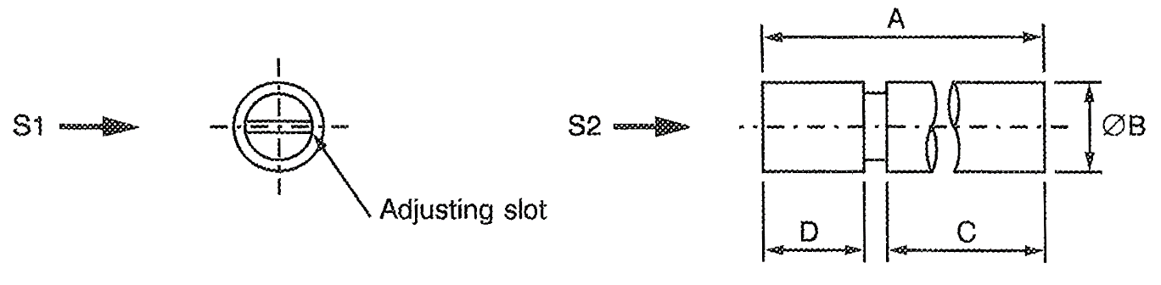
S1, S2 – Vibration and Shock axes
Symbols | Dimensions (mm)
Symbols | Min | Max
A | 7.7 | 8.3
ØB | - | 3
C | 5.1 | 5.3
D | 2.2 | 2.4

Component Type Variants 03 and 04
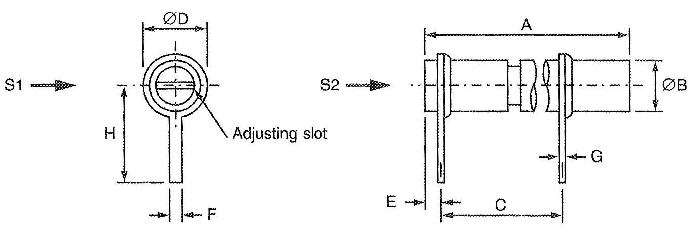
S1, S2 – Vibration and Shock axes
Symbols | Dimensions (mm)
Symbols | Min | Max
A | 7.7 | 8.3
ØB | - | 3
C | 3.1 | 3.3
ØD | - | 3.6
E | 0.9 | 1.1
F | 0.95 | 1.05
G | 0.15 | 0.25
H | 5.8 | 6

Component Type Variants 05 and 06
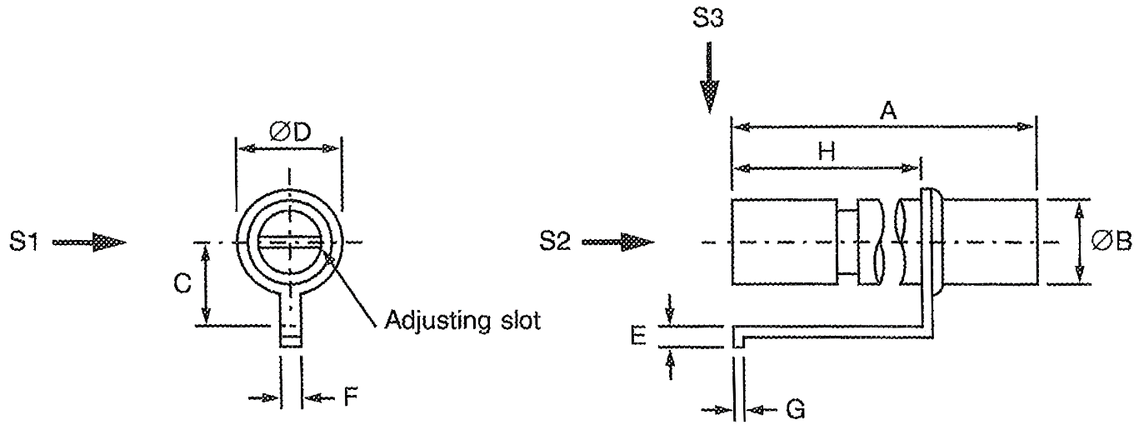
S1, S2, S3 – Vibration and Shock axes
Symbols | Dimensions (mm)
Symbols | Min | Max
A | 7.7 | 8.3
ØB | - | 3
C | 2.7 | 2.9
ØD | - | 3.6
E | 0.5 | 0.7
F | 0.95 | 1.05
G | 0.15 | 0.25
H | 3.8 | 4

Component Type Variants 07 and 08
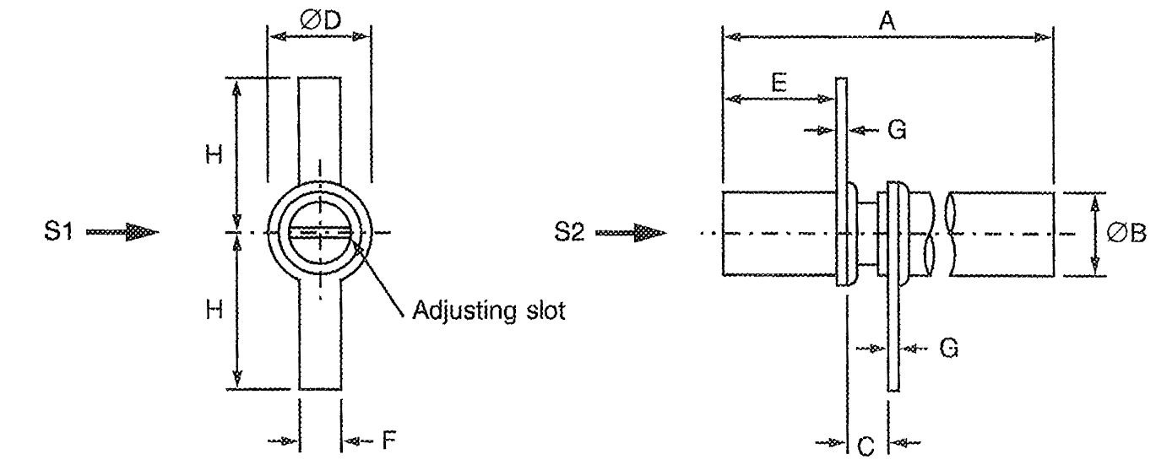
S1, S2 – Vibration and Shock axes
Symbols | Dimensions (mm)
Symbols | Min | Max
A | 7.7 | 8.3
ØB | - | 3
C | 1.5 | 1.7
ØD | - | 3.6
E | 1.5 | 1.7
F | 2.35 | 2.45
G | 0.15 | 0.25
H | 5.8 | 6

Component Type Variants 09 and 10
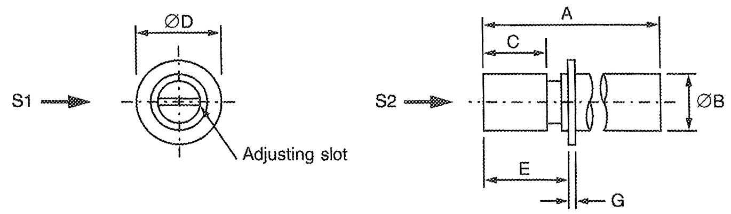
S1, S2 – Vibration and Shock axes
Symbols | Dimensions (mm)
Symbols | Min | Max
A | 7.7 | 8.3
ØB | - | 3
C | 2.2 | 2.4
ØD | - | 4.7
E | 3.9 | 4.1
G | 0.15 | 0.25

Component Type Variants 11 and 12
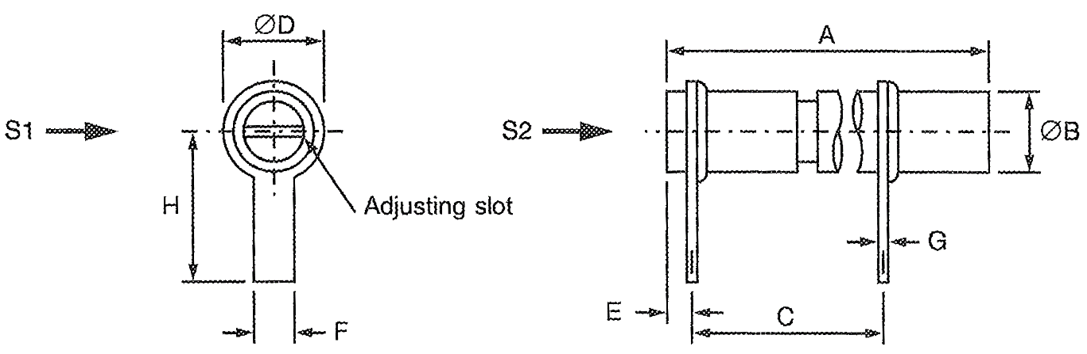
S1, S2 – Vibration and Shock axes
Symbols | Dimensions (mm)
Symbols | Min | Max
A | 7.7 | 8.3
ØB | - | 3
C | 3.1 | 3.3
ØD | - | 3.6
E | 0.9 | 1.1
F | 2.35 | 2.45
G | 0.15 | 0.25
H | 5.8 | 6

Component Type Variants 13 and 14
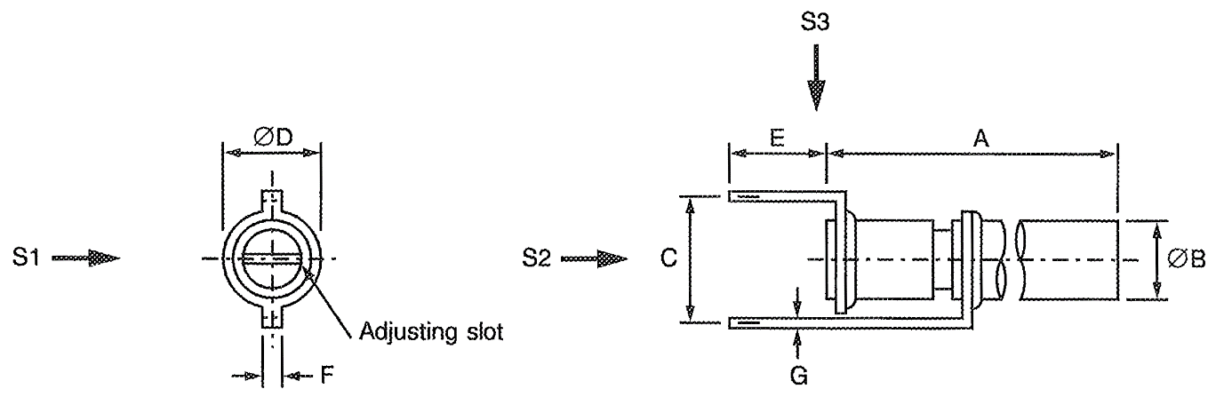
S1, S2, S3 – Vibration and Shock axes
Symbols | Dimensions (mm)
Symbols | Min | Max
A | 7.7 | 8.3
ØB | - | 3
C | 4 | 4.4
ØD | - | 3.6
E | 2.4 | 2.6
F | 0.95 | 1.05
G | 0.15 | 0.25

FUNCTIONAL DIAGRAM



MATERIALS AND FINISHES

Case
The body of the components shall be sapphire.

Terminals
Terminals shall be gold plated.

REQUIREMENTS

GENERAL
The complete requirements for procurement of the components specified herein are as stated in this specification and the ESCC Generic Specification. Permitted deviations from the Generic Specification, applicable to this specification only, are listed below.
Permitted deviations from the Generic Specification and this Detail Specification, formally agreed with specific Manufacturers on the basis that the alternative requirements are equivalent to the ESCC requirement and do not affect the component’s reliability, are listed in the appendices attached to this specification.

Deviations from the Generic Specification

Deviations from Qualification and Periodic Tests – Chart F4
          - Mechanical Endurance: The 50 cycles shall be divided into 10 groups of 5 cycles. Upon completion of each group of 5 cycles, 1 minute of standing by shall be observed.

MARKING
The marking shall be in accordance with the requirements of ESCC Basic Specification No. 21700 and as follows.
The information to be marked on the component or its primary package shall be:
          - The ESCC qualified components symbol (for ESCC qualified components only).
          - The ESCC Component Number.
          - Traceability information.

Robustness of terminations
Component Type Variants 01, 02, 09 and 10 shall be subjected to Robustness of Terminations as specified in the ESCC Generic Specification.
Not applicable to Component Type Variants 03, 04, 05, 06, 07, 08, 11, 12, 13, 14.

RESISTANCE TO SOLDERING HEAT
The test conditions for Resistance to Soldering Heat are as follows:
- Immersion depth: To within 1mm from the body.
- Immersion time: 3.5 ±0.5 seconds.

ELECTRICAL AND MECHANICAL MEASUREMENTS AT ROOM, HIGH AND LOW TEMPERATURES
Electrical and mechanical measurements shall be performed at room, high and low temperatures.

Room Temperature Electrical and Mechanical Measurements
The measurements shall be performed at T_{amb} = +22 ±3°C.
Characteristics | Symbols | Test Method and  Conditions | Limits |  | Units
Characteristics | Symbols | Test Method and  Conditions | Min | Max | Units
Minimum Capacitance | Cm | ESCC No. 3010  Frequency: 1 ±0.1MHz | - | Note 1 | pF
Maximum Capacitance | CM | ESCC No. 3010  Frequency: 1 ±0.1MHz | Note 1 | - | pF
Change in Capacitance | - | ESCC No. 3010  Frequency: 1 ±0.1MHz | Note 2 |  | -
Insulation Resistance | R_{i} | ESCC No. 3010  Test voltage = 500 ±25V | 10⁴ | - | MΩ
Voltage Proof | VP | ESCC No. 3010 | 1000 | - | V
Quality Factor | Q | ESCC No. 3010  Frequency: 100 ±5MHz  Note 3 | 3000 | - | -
Operating Torque | T_{qo} | ESCC No. 3010  C minimum to maximum | 0.1 | 1 | N.cm
NOTES:
            - See Para. 1.4.2.
            - The rate of change in capacitance as a function of the change in adjustment shall not change sign over the entire range of adjustment.
            - For Screening Tests, Quality Factor shall be performed on a randomly selected sample of 3 components with no failures allowed.

High and Low Temperatures Electrical Measurements
Characteristics | Symbols | Test Method and Conditions  (Note 1) | Limits |  | Units
Characteristics | Symbols | Test Method and Conditions  (Note 1) | Min | Max | Units
Insulation Resistance | R_{i} | ESCC No. 3010  Test voltage = 500 ±25V  T_{amb} = +125 (+0 -3)°C | 10³ | - | MΩ
Temperature Coefficient | TC | ESCC No. 3010  Note 2 |  |  | 10⁻⁶/°C
Temperature Coefficient | TC | Between -55°C and +22°C | Note 3
Temperature Coefficient | TC | Between +22°C and +125°C | Note 3
NOTES:
            - Measurements shall be performed on a sample of 5 components from each manufacturing lot with 0 failures allowed. In the event of any failure a 100% inspection may be performed.
            - Rotor set at approximately 75% of the maximum specified capacitance value and 2 components may be connected in parallel.
            - See Para. 1.4.2.

INTERMEDIATE AND END-POINT ELECTRICAL AND MECHANICAL MEASUREMENTS
Unless otherwise specified, the measurements shall be performed at T_{amb} = +22 ±3°C.
Unless otherwise specified the test methods and test conditions shall be as per the corresponding test defined in Para. 2.5.1, Room Temperature Electrical and Mechanical Measurements.
Test Reference per ESCC No. 3010 | Characteristics | Symbols | Limits |  | Units
Test Reference per ESCC No. 3010 | Characteristics | Symbols | Min | Max | Units
Rapid Change of Temperature
Initial Measurements | Capacitance | CM  & Cm | Note 1 |  | pF
Final Measurements | Capacitance | CM  & Cm | Note 1 |  | pF
 | Capacitance Drift | ΔCM  & ΔCm | -0.05 | +0.05 | pF
Vibration
Initial Measurements | Capacitance (Note 2) | C | Record Values |  | pF
Final Measurements | Capacitance (Note 2) | C | Record Values |  | pF
 | Capacitance Drift | ΔC | -0.05 | +0.05 | pF
Shock
Initial Measurements | Capacitance (Note 2) | C | Record Values |  | pF
Final Measurements | Capacitance (Note 2) | C | Record Values |  | pF
 | Capacitance Drift | ΔC | -0.05 | +0.05 | pF
Resistance to Soldering Heat
Initial Measurements | Capacitance (Note 2) | C | Record Values |  | pF
Final Measurements | Capacitance (Note 2) | C | Record Values |  | pF
 | Capacitance Drift | ΔC | -0.05 | +0.05 | pF
 | Voltage Proof | VP | Note 3 | - | V
 | Quality Factor | Q | Note 3 | - | -
Climatic Sequence
Initial Measurements | Capacitance (Note 2) | C | Record Values |  | pF
Final Measurements | Capacitance (Note 2) | C | Record Values |  | pF
 | Capacitance Drift | ΔC | -0.05 | +0.05 | pF
 | Quality Factor | Q | Note 3 | - | -
 | Insulation Resistance | R_{i} | 10³ | - | MΩ
 | Voltage Proof | VP | Note 3 | - | V
 | Operating Torque | T_{qo} | Note 3 |  | N.cm
Damp Heat, Steady State
(Note 4)
Initial Measurements | Capacitance | CM  & Cm | Note 1 |  | pF
Damp Heat, Steady State Final Measurements | Capacitance | CM  & Cm | Note 1 |  | pF
 | Capacitance Drift | ΔCM  & ΔCm | -0.05 | +0.05 | pF
 | Quality Factor | Q | Note 3 | - | -
 | Insulation Resistance | R_{i} CM  & R_{i} Cm | 10³ | - | MΩ
 | Voltage Proof | VP | Note 3 | - | V
 | Operating Torque | T_{qo} | Note 3 |  | N.cm
Operating Life
Initial Measurements | Capacitance | CM | Note 1 | - | pF
Intermediate Measurements  (500 hours) (Note 5)  (500 and 1000 hours) (Note 6) | Capacitance | CM | Note 1 | - | pF
 | Capacitance Drift | ΔCM | -0.05 | +0.05 | pF
 | Insulation Resistance | R_{i} CM | Note 3 | - | MΩ
 | Voltage Proof | VP | Note 3 | - | V
 | Quality Factor | Q | Note 3 | - | -
 | Operating Torque | T_{qo} | Note 3 |  | N.cm
Final Measurements  (1000 or 2000 hours) (Note 7) | Capacitance | CM | Note 1 | - | pF
Final Measurements  (1000 or 2000 hours) (Note 7) | Capacitance Drift | ΔCM | -0.05 | +0.05 | pF
 | Insulation Resistance | R_{i} CM | Note 3 | - | MΩ
 | Voltage Proof | VP | Note 3 | - | V
 | Quality Factor | Q | Note 3 | - | -
 | Operating Torque | T_{qo} | Note 3 |  | N.cm
Axial Thrust (Note 8)
Initial Measurements | Capacitance (Note 2) | C | Record Values |  | pF
Measurements during Test | Capacitance (Note 2) | C | Record Values |  | pF
 | Capacitance Drift | ΔC | -0.05 | +0.05 | pF
Mechanical Endurance
Measurements after Mechanical Endurance Cycling | Voltage Proof | VP | Note 3 | - | V
Measurements after Mechanical Endurance Cycling | Change in Capacitance versus Rotation | - | Deviation ±10% max. (Note 9) |  | -
Final Measurements | Operating Torque | T_{qo} | 0.05 | 1.35 | N.cm
 | Insulation Resistance (between rotor screw and mounting base) | R_{i} | Note 3 | - | MΩ
 | Quality Factor | Q | Note 3 | - | -
Electrical and Mechanical Measurements | Minimum Capacitance | Cm | - | Note 1 | pF
Electrical and Mechanical Measurements | Maximum Capacitance | CM | Note 1 | - | pF
 | Change in Capacitance | - | Note 3 |  | -
 | Insulation Resistance | R_{i} | Note 3 | - | MΩ
 | Voltage Proof | VP | Note 3 | - | V
 | Quality Factor | Q | Note 3 | - | -
 | Operating Torque | T_{qo} | Note 3 |  | N.cm
Temperature Coefficient  (Note 2) |  | TC |  |  | 10⁻⁶/°C
Temperature Coefficient  (Note 2) | Between -55°C and +22°C |  | Note 1
Temperature Coefficient  (Note 2) | Between +22°C and +125°C |  | Note 1
End-Stop Torque (Note 10)
Final Measurements | Minimum Capacitance | Cm | - | Note 1 | pF
Final Measurements | Maximum Capacitance | CM | Note 1 | - | pF
NOTES:
            - As specified in Para. 1.4.2.
            - Measurements shall be made with the rotor set at approximately 75% of the maximum specified capacitance value.
            - As specified in Para. 2.5.1.
            - Half the sample shall be measured with U_{R} applied and the remaining components shall be measured with no U_{R} applied.
            - 500 hours is applicable to Periodic Testing for extension of qualification.
            - 500 and 1000 hours is applicable to Qualification Testing, and to Periodic Testing for renewal of qualification after lapse.
            - 1000 hours is applicable to Periodic Testing for extension of qualification. 2000 hours is applicable to Qualification Testing, and to Periodic Testing for renewal of qualification after lapse.
            - Thrust: 2N
            - No reversals in direction.
            - Torque: 1.5N.cm

BURN-IN CONDITIONS
Characteristics | Symbols | Conditions | Units
Ambient Temperature | T_{amb} | +125 (+0 -3) | °C
Applied Voltage | V_{A} | 750 | V

OPERATING LIFE conditions
The conditions shall be as specified in Para. 2.7.

APPENDIX ‘A’
AGREED DEVIATIONS FOR EXXELIA TEMEX (F)
Item Affected | Description of Deviations
Para. 2.1.1, Deviations from the Generic Specification | The following Deviations from Screening Tests – Chart F3 shall apply:  - Quality Factor per Electrical and Mechanical Measurements in ESCC Generic Specification No. 3010 and Para. 2.5.1 herein:  Quality Factor measurements shall be performed at frequencies comprised between 100 and 400 MHz. The value of the Quality Factor shall be determined at 100MHz by using the following formula:  Qfo = Qm × (fm/fo)^{3/2}  Where Qm is the Quality Factor read at frequency fm (fm is that frequency where the quarter-wave line, including the capacitance being measured, is resonating) and fo = 100MHz.  The record sheet shall indicate the Quality Factor at 100MHz, as specified in Para. 2.5.1, as well as the frequency fm at which the Quality Factor was read.
Para. 2.1.1.1, Deviations from Qualification and Periodic Tests – Chart F4 | - Quality Factor per Electrical and Mechanical Measurements in ESCC Generic Specification No. 3010 and Para. 2.5.1 herein:  Quality Factor measurements shall be performed at frequencies comprised between 100 and 400 MHz. The value of the Quality Factor shall be determined at 100MHz by using the following formula:  Qfo = Qm × (fm/fo)^{3/2}  Where Qm is the Quality Factor read at frequency fm (fm is that frequency where the quarter-wave line, including the capacitance being measured, is resonating) and fo = 100MHz.  The record sheet shall indicate the Quality Factor at 100MHz, as specified in Para. 2.5.1, as well as the frequency fm at which the Quality Factor was read.  - Electrical Subgroup (Subgroup 3), Electrical and Mechanical Measurements: Quality Factor measurements shall be performed prior to Solderability.

