

Page 1 of 19

CAPACITORS, VARIABLE, CONCENTRIC TRIMMER, AIR DIELECTRIC, 1.4 TO 14pF, BODY DIAMETER 7.6mm
ESCC Detail Specification No. 3010/006
Issue 3 Draft A | July 2017



Document Custodian: European Space Agency – see https://escies.org

LEGAL DISCLAIMER AND COPYRIGHT
European Space Agency, Copyright © 2017. All rights reserved.
The European Space Agency disclaims any liability or responsibility, to any person or entity, with respect to any loss or damage caused, or alleged to be caused, directly or indirectly by the use and application of this ESCC publication.
This publication, without the prior permission of the European Space Agency and provided that it is not used for a commercial purpose, may be:
- copied in whole, in any medium, without alteration or modification.
- copied in part, in any medium, provided that the ESCC document identification, comprising the ESCC symbol, document number and document issue, is removed.

DOCUMENTATION CHANGE NOTICE
(Refer to https://escies.org for ESCC DCR content)
DCR No. | CHANGE DESCRIPTION
TBD | Specification updated to incorporate changes per DCR.

TABLE OF CONTENTS

1 GENERAL 5
1.1 SCOPE 5
1.2 APPLICABLE DOCUMENTS 5
1.3 TERMS, DEFINITIONS, ABBREVIATIONS, SYMBOLS AND UNITS 5
1.4 THE ESCC COMPONENT NUMBER AND Component Type Variants 5
1.4.1 The ESCC Component Number 5
1.4.2 Component Type Variants 5
1.5 MAXIMUM RATINGS 6
1.6 PHYSICAL DIMENSIONS 7
1.6.1 Component Type Variant 01 (Lug Panel Mount) 7
1.6.2 Component Type Variant 02 (Turret Panel Mount) 8
1.6.3 Component Type Variant 03 (PCB Mount) 9
1.6.4 Component Type Variant 04 (Vertical Mount) 10
1.6.5 Component Type Variant 05 (Special Vertical Mount) 11
1.6.6 Component Type Variant 06 (Stripline Mount) 12
1.7 FUNCTIONAL DIAGRAM 12
1.8 MATERIALS AND FINISHES 12
1.8.1 Case 12
1.8.2 Terminals 12
2 REQUIREMENTS 13
2.1 GENERAL 13
2.1.1 Deviations from the Generic Specification 13
2.1.1.1 Deviations from Screening Tests – Chart F3 13
2.2 MARKING 13
2.3 Robustness of terminations 13
2.4 RESISTANCE TO SOLDERING HEAT 13
2.5 ELECTRICAL AND MECHANICAL MEASUREMENTS AT ROOM, HIGH AND LOW TEMPERATURES 14
2.5.1 Room Temperature Electrical and Mechanical Measurements 14
2.5.2 High and Low Temperatures Electrical Measurements 14
2.6 INTERMEDIATE AND END-POINT ELECTRICAL AND MECHANICAL MEASUREMENTS 15
2.7 OPERATING LIFE conditions 18
APPENDIX ‘A’ 19

GENERAL

SCOPE
This specification details the ratings, physical and electrical characteristics, and test and inspection data for the component type variants specified below. It supplements the requirements of, and shall be read in conjunction with, the ESCC Generic Specification listed under Applicable Documents.

APPLICABLE DOCUMENTS
The following documents form part of this specification and shall be read in conjunction with it:
          - ESCC Generic Specification No. 3010.

TERMS, DEFINITIONS, ABBREVIATIONS, SYMBOLS AND UNITS
For the purpose of this specification, the terms, definitions, abbreviations, symbols and units specified in ESCC Basic Specification No. 21300 shall apply.

THE ESCC COMPONENT NUMBER AND Component Type Variants

The ESCC Component Number
The ESCC Component Number shall be constituted as follows:
Example: 301000601
- Detail Specification Reference: 3010006
- Component Type Variant Number: 01 (as required)

Component Type Variants
The Component Type Variants applicable to this specification are as follows:
Type Variant | Minimum and Maximum Specified Capacitance  (pF) |  | Case Description (Note 1) | Weight  Max  (g)
Type Variant | Cm | CM | Case Description (Note 1) | Weight  Max  (g)
01 | 1.4 | 14 | Lug Panel Mount | 2.5
02 | 1.4 | 14 | Turret Panel Mount | 2.5
03 | 1.4 | 14 | PCB Mount | 2.5
04 | 1.5 | 14 | Vertical Mount | 2.5
05 | 1.5 | 14 | Special Vertical Mount | 2.5
06 | 1.4 | 14 | Stripline Mount | 2.5
NOTES:
            - See Para. 1.6 for Physical Dimensions.

MAXIMUM RATINGS
The maximum ratings shall not be exceeded at any time during use or storage.
Maximum ratings shall only be exceeded during testing to the extent specified in this specification and when stipulated in Test Methods and Procedures of the ESCC Generic Specification.
Characteristics | Symbols | Maximum Ratings | Units | Remarks
Rated Voltage | U_{R} | 250 | V
Operating Temperature Range | T_{op} | -55 to +125 | °C | T_{amb}
Storage Temperature Range | T_{stg} | -55 to +125 | °C
Soldering Temperature | T_{sol} | +260 | °C | Note 1
Panel Mounting Nut Tightening Torque | - | 40 | N.cm | Notes 2, 3
Sealing Cap Tightening Torque | - | 10 | N.cm | Note 3
NOTES:
            - Duration 5 seconds maximum.
            - Only applicable to Variants 01 and 02.
            - Handling precautions are as follows:
- An appropriate turning tool must be used.
- The rotor shall not be disconnected from the stator.
- When cleaning with solvent, the sealing cap must be correctly fitted and tightened to the rated torque.
- The sealing cap, which is supplied with all units, must be removed from all flight units prior to flight.

PHYSICAL DIMENSIONS
Note: The sealing cap is intentionally omitted from the case drawings.

Component Type Variant 01 (Lug Panel Mount)
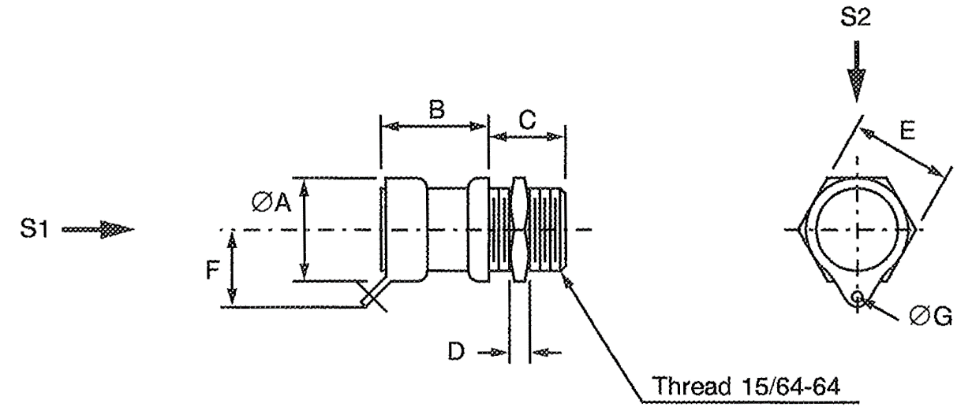
S1, S2 – Vibration and Shock axes
Symbols | Dimensions (mm)
Symbols | Min | Max
ØA | - | 7.6
B | - | 7.7
C | 4.5 | 4.7
D | 0.9 | 1.1
E | 6.9 | 7.1
F | - | 6
ØG | 1.1 | 1.3

Component Type Variant 02 (Turret Panel Mount)
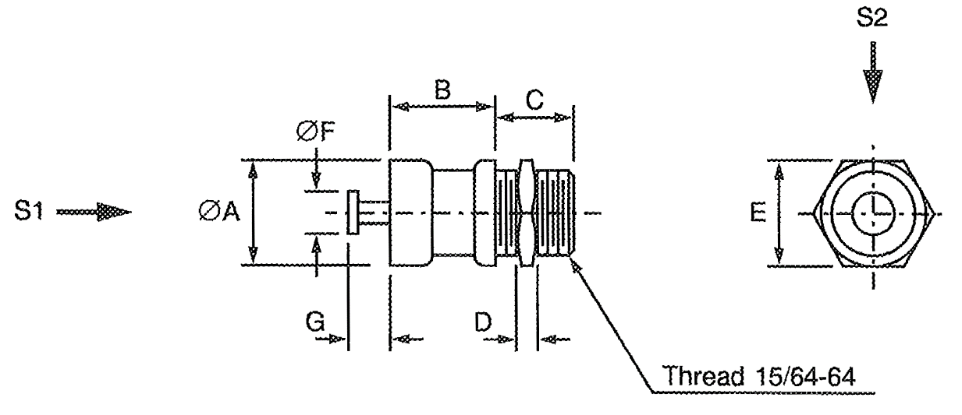
S1, S2 – Vibration and Shock axes
Symbols | Dimensions (mm)
Symbols | Min | Max
ØA | - | 7.6
B | 7 | 7.4
C | 4.5 | 4.7
D | 0.9 | 1.1
E | 6.9 | 7.1
ØF | 2.3 | 2.5
G | 2.7 | 2.9

Component Type Variant 03 (PCB Mount)
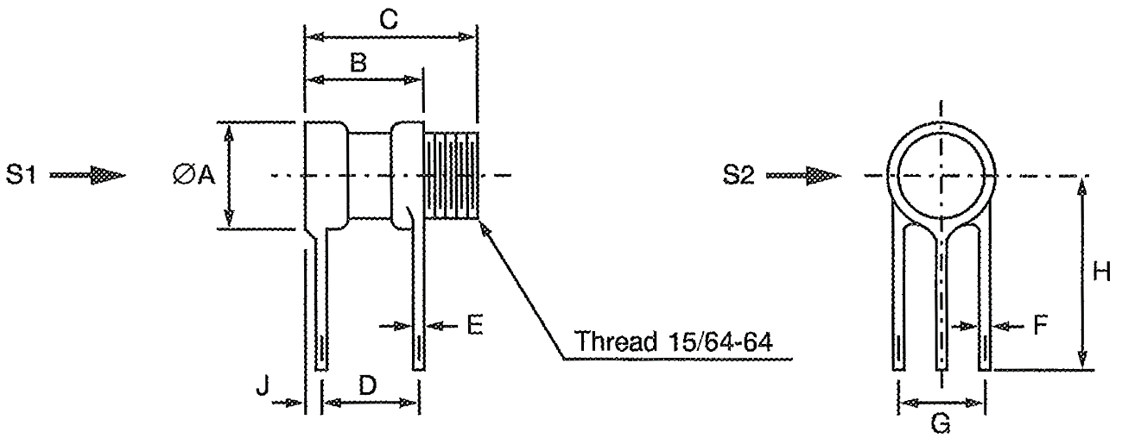
S1, S2 – Vibration and Shock axes
Symbols | Dimensions (mm)
Symbols | Min | Max
ØA | - | 7.6
B | 7.8 | 8.2
C | 11.8 | 12.2
D | 7 | 7.4
E | 0.35 | 0.45
F | 0.75 | 0.85
G | 5.5 | 5.7
H | 7.9 | -
J | - | 0.5

Component Type Variant 04 (Vertical Mount)
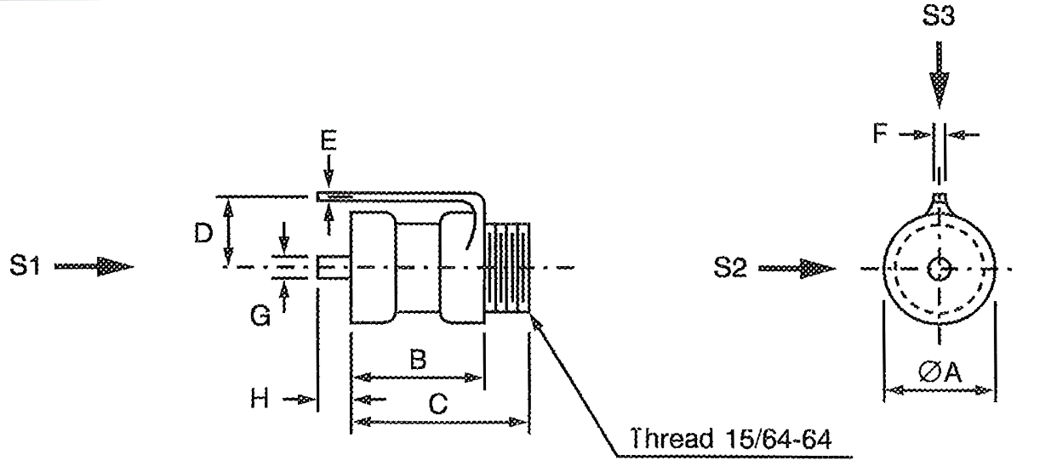
S1, S2, S3 – Vibration and Shock axes
Symbols | Dimensions (mm)
Symbols | Min | Max
ØA | - | 7.6
B | 7.3 | 7.7
C | 11.5 | 11.9
D | 5 | 5.4
E | 0.35 | 0.45
F | 0.95 | 1.05
G | 1.4 | 1.6
H | - | 2.8

Component Type Variant 05 (Special Vertical Mount)
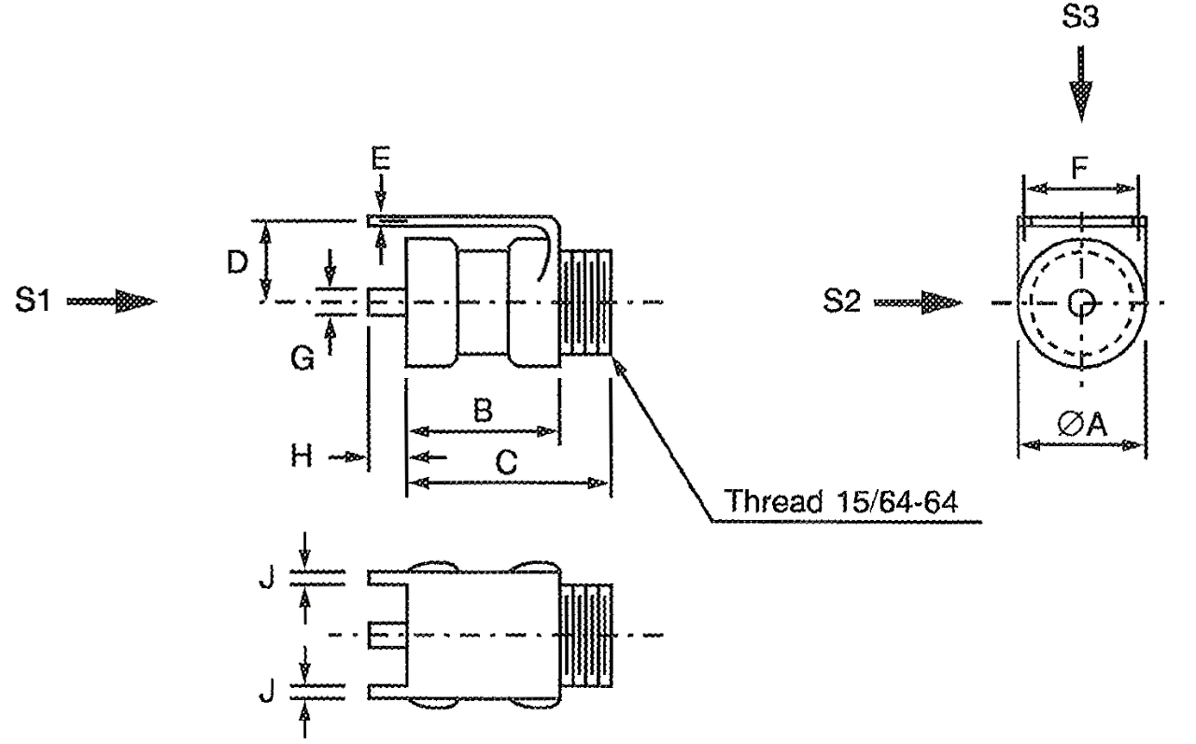
S1, S2, S3 – Vibration and Shock axes
Symbols | Dimensions (mm)
Symbols | Min | Max
ØA | - | 7.6
B | 7.3 | 7.7
C | 11.5 | 11.9
D | 7 | 7.4
E | 0.35 | 0.45
F | 5.45 | 5.65
G | 1.4 | 1.6
H | - | 2.8
J | 0.75 | 0.85

Component Type Variant 06 (Stripline Mount)
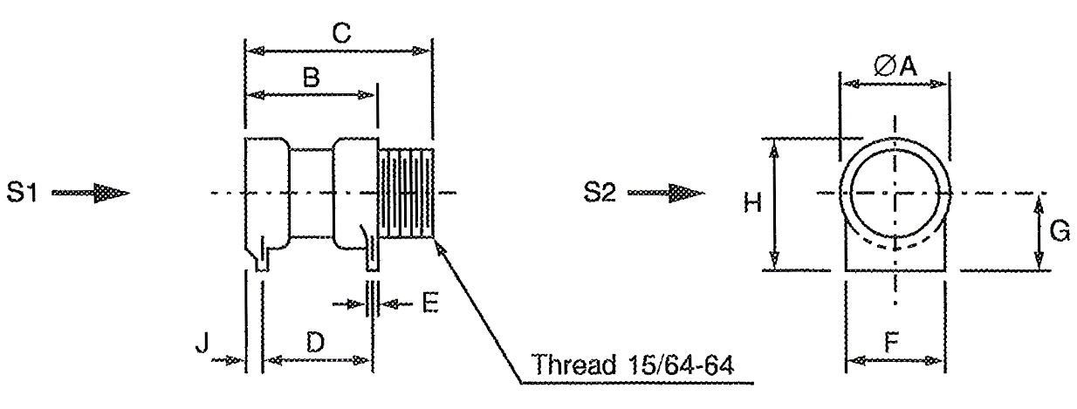
S1, S2 – Vibration and Shock axes
Symbols | Dimensions (mm)
Symbols | Min | Max
ØA | - | 7.6
B | 7.8 | 8.2
C | 11.8 | 12.2
D | 7 | 7.4
E | 0.35 | 0.45
F | - | 7.3
G | 3.85 | 3.95
H | - | 8
J | - | 0.5

FUNCTIONAL DIAGRAM

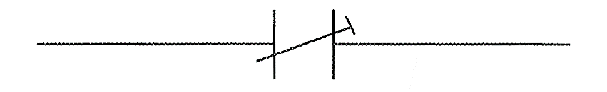

MATERIALS AND FINISHES

Case
The body of the components shall be ceramic.

Terminals
Terminals shall be either gold plated or tinned.

REQUIREMENTS

GENERAL
The complete requirements for procurement of the components specified herein are as stated in this specification and the ESCC Generic Specification. Permitted deviations from the Generic Specification, applicable to this specification only, are listed below.
Permitted deviations from the Generic Specification and this Detail Specification, formally agreed with specific Manufacturers on the basis that the alternative requirements are equivalent to the ESCC requirement and do not affect the component’s reliability, are listed in the appendices attached to this specification.

Deviations from the Generic Specification

Deviations from Screening Tests – Chart F3
          - Burn-in: Not applicable.

MARKING
The marking shall be in accordance with the requirements of ESCC Basic Specification No. 21700 and as follows.
The information to be marked on the component or its primary package shall be:
          - The ESCC qualified components symbol (for ESCC qualified components only).
          - The ESCC Component Number.
          - Traceability information.

Robustness of terminations
Component Type Variants 03 and 04 shall be subjected to Robustness of Terminations as specified in the ESCC Generic Specification.
Not applicable to Component Type Variants 01, 02, 05, 06.

RESISTANCE TO SOLDERING HEAT
The test conditions for Resistance to Soldering Heat are as follows:
- Immersion depth: To within 1mm from the body.
- Immersion time: 3.5 ±0.5 seconds.

ELECTRICAL AND MECHANICAL MEASUREMENTS AT ROOM, HIGH AND LOW TEMPERATURES
Electrical and mechanical measurements shall be performed at room, high and low temperatures.

Room Temperature Electrical and Mechanical Measurements
The measurements shall be performed at T_{amb} = +22 ±3°C.
Characteristics | Symbols | Test Method and  Conditions | Limits |  | Units
Characteristics | Symbols | Test Method and  Conditions | Min | Max | Units
Minimum Capacitance | Cm | ESCC No. 3010  Frequency: 1 ±0.1MHz | - | Note 1 | pF
Maximum Capacitance | CM | ESCC No. 3010  Frequency: 1 ±0.1MHz | Note 1 | - | pF
Change in Capacitance | - | ESCC No. 3010  Frequency: 1 ±0.1MHz | Note 2 |  | -
Insulation Resistance | R_{i} | ESCC No. 3010  Test voltage = 500 ±25V | 10⁶ | - | MΩ
Voltage Proof | VP | ESCC No. 3010 | 500 | - | V
Quality Factor | Q | ESCC No. 3010  Frequency: 100 ±5MHz  Note 3 | 3000 | - | -
Operating Torque | T_{qo} | ESCC No. 3010  C minimum to maximum | 0.7 | 3.5 | N.cm
NOTES:
            - See Para. 1.4.2.
            - The rate of change in capacitance as a function of the change in adjustment shall not change sign over the entire range of adjustment.
            - For Screening Tests, Quality Factor shall be performed on a randomly selected sample of 3 components with no failures allowed.

High and Low Temperatures Electrical Measurements
Characteristics | Symbols | Test Method and Conditions  (Note 1) | Limits |  | Units
Characteristics | Symbols | Test Method and Conditions  (Note 1) | Min | Max | Units
Insulation Resistance | R_{i} | ESCC No. 3010  Test voltage = 500 ±25V  T_{amb} = +125 (+0 -3)°C | 10⁵ | - | MΩ
Temperature Coefficient | TC | ESCC No. 3010  Note 2 |  |  | 10⁻⁶/°C
Temperature Coefficient | TC | Between -55°C and +22°C | -25 | +25
Temperature Coefficient | TC | Between +22°C and +125°C | -25 | +25
NOTES:
            - Measurements shall be performed on a sample of 5 components from each manufacturing lot with 0 failures allowed. In the event of any failure a 100% inspection may be performed.
            - Rotor set at approximately 75% of the maximum specified capacitance value.

INTERMEDIATE AND END-POINT ELECTRICAL AND MECHANICAL MEASUREMENTS
Unless otherwise specified, the measurements shall be performed at T_{amb} = +22 ±3°C.
Unless otherwise specified the test methods and test conditions shall be as per the corresponding test defined in Para. 2.5.1, Room Temperature Electrical and Mechanical Measurements.
Test Reference per ESCC No. 3010 | Characteristics | Symbols | Limits |  | Units
Test Reference per ESCC No. 3010 | Characteristics | Symbols | Min | Max | Units
Rapid Change of Temperature
Initial Measurements | Capacitance | CM  & Cm | Note 1 |  | pF
Final Measurements | Capacitance | CM  & Cm | Note 1 |  | pF
 | Capacitance Drift | ΔCM  & ΔCm | -0.05  -0.5 | +0.05  +0.5 | pF or  %  (Note 2)
Vibration
Initial Measurements | Capacitance (Note 3) | C | Record Values |  | pF
Final Measurements | Capacitance (Note 3) | C | Record Values |  | pF
 | Capacitance Drift | ΔC | -0.05  -1 | +0.05  +1 | pF or  %  (Note 2)
Shock
Initial Measurements | Capacitance (Note 3) | C | Record Values |  | pF
Final Measurements | Capacitance (Note 3) | C | Record Values |  | pF
 | Capacitance Drift | ΔC | -0.05  -1 | +0.05  +1 | pF or  %  (Note 2)
Resistance to Soldering Heat
Initial Measurements | Capacitance (Note 3) | C | Record Values |  | pF
Final Measurements | Capacitance (Note 3) | C | Record Values |  | pF
 | Capacitance Drift | ΔC | -0.05  -1 | +0.05  +1 | pF or  %  (Note 2)
 | Voltage Proof | VP | Note 4 | - | V
 | Quality Factor | Q | Note 4 | - | -
Climatic Sequence
Initial Measurements | Capacitance (Note 3) | C | Record Values |  | pF
Final Measurements | Capacitance (Note 3) | C | Record Values |  | pF
 | Capacitance Drift | ΔC | -0.05  -1 | +0.05  +1 | pF or  %  (Note 2)
 | Quality Factor | Q | Note 4 | - | -
 | Insulation Resistance | R_{i} | 10⁵ | - | MΩ
 | Voltage Proof | VP | Note 4 | - | V
 | Operating Torque | T_{qo} | Note 4 |  | N.cm
Damp Heat, Steady State
(Note 5)
Initial Measurements | Capacitance | CM  & Cm | Note 1 |  | pF
Final Measurements | Capacitance | CM  & Cm | Note 1 |  | pF
 | Capacitance Drift | ΔCM  & ΔCm | -0.05  -2 | +0.05  +2 | pF or  %  (Note 2)
 | Quality Factor | Q | Note 4 | - | -
 | Insulation Resistance | R_{i} CM  & R_{i} Cm | 10⁵ | - | MΩ
 | Voltage Proof | VP | Note 4 | - | V
 | Operating Torque | T_{qo} | Note 4 |  | N.cm
Operating Life
Initial Measurements | Capacitance | CM | Note 1 | - | pF
Intermediate Measurements  (500 hours) (Note 6)  (500 and 1000 hours) (Note 7) | Capacitance | CM | Note 1 | - | pF
 | Capacitance Drift | ΔCM | -0.05  -2 | +0.05  +2 | pF or  %  (Note 2)
 | Insulation Resistance | R_{i} CM | Note 4 | - | MΩ
 | Voltage Proof | VP | Note 4 | - | V
 | Quality Factor | Q | Note 4 | - | -
 | Operating Torque | T_{qo} | Note 4 |  | N.cm
Operating Life  Final Measurements  (1000 or 2000 hours) (Note 8) | Capacitance | CM | Note 1 | - | pF
 | Capacitance Drift | ΔCM | -0.05  -2 | +0.05  +2 | pF or  %  (Note 2)
 | Insulation Resistance | R_{i} CM | Note 4 | - | MΩ
 | Voltage Proof | VP | Note 4 | - | V
 | Quality Factor | Q | Note 4 | - | -
 | Operating Torque | T_{qo} | Note 4 |  | N.cm
Axial Thrust (Note 9)
Initial Measurements | Capacitance (Note 3) | C | Record Values |  | pF
Measurements during Test | Capacitance (Note 3) | C | Record Values |  | pF
 | Capacitance Drift | ΔC | -0.05  -1 | +0.05  +1 | pF or  %  (Note 2)
Mechanical Endurance
Measurements after Mechanical Endurance Cycling | Voltage Proof | VP | Note 4 | - | V
Measurements after Mechanical Endurance Cycling | Change in Capacitance versus Rotation | - | Deviation ±10% max. (Note 10) |  | -
Final Measurements | Operating Torque | T_{qo} | 0.35 | 4.75 | N.cm
 | Insulation Resistance (between rotor screw and mounting base) | R_{i} | Note 4 | - | MΩ
 | Quality Factor | Q | Note 4 | - | -
Electrical and Mechanical Measurements | Minimum Capacitance | Cm | - | Note 1 | pF
Electrical and Mechanical Measurements | Maximum Capacitance | CM | Note 1 | - | pF
Electrical and Mechanical Measurements | Change in Capacitance | - | Note 4 |  | -
Electrical and Mechanical Measurements | Insulation Resistance | R_{i} | Note 4 | - | MΩ
Electrical and Mechanical Measurements | Voltage Proof | VP | Note 4 | - | V
Electrical and Mechanical Measurements | Quality Factor | Q | Note 4 | - | -
Electrical and Mechanical Measurements | Operating Torque | T_{qo} | Note 4 |  | N.cm
Temperature Coefficient  (Note 3) |  | TC |  |  | 10⁻⁶/°C
Temperature Coefficient  (Note 3) | Between -55°C and +22°C |  | Note 11
Temperature Coefficient  (Note 3) | Between +22°C and +125°C |  | Note 11
End-Stop Torque (Note 12)
Final Measurements | Minimum Capacitance | Cm | - | Note 1 | pF
Final Measurements | Maximum Capacitance | CM | Note 1 | - | pF
NOTES:
            - As specified in Para. 1.4.2.
            - Whichever is greater.
            - Measurements shall be made with the rotor set at approximately 75% of the maximum specified capacitance value.
            - As specified in Para. 2.5.1.
            - Half the sample shall be measured with U_{R} applied and the remaining components shall be measured with no U_{R} applied.
            - 500 hours is applicable to Periodic Testing for extension of qualification.
            - 500 and 1000 hours is applicable to Qualification Testing, and to Periodic Testing for renewal of qualification after lapse.
            - 1000 hours is applicable to Periodic Testing for extension of qualification. 2000 hours is applicable to Qualification Testing, and to Periodic Testing for renewal of qualification after lapse.
            - Thrust: 10N
            - No reversals in direction.
            - As specified in Para. 2.5.2.
            - Torque: 5N.cm

OPERATING LIFE conditions
Characteristics | Symbols | Conditions | Units
Ambient Temperature | T_{amb} | +125 (+0 -3) | °C
Applied Voltage | V_{A} | 375 | V

APPENDIX ‘A’
AGREED DEVIATIONS FOR EXXELIA TEMEX (F)
Item Affected | Description of Deviations
Para. 2.1.1.1, Deviations from Screening Tests – Chart F3 | - Quality Factor per Electrical and Mechanical Measurements in ESCC Generic Specification No. 3010 and Para. 2.5.1 herein:  Quality Factor measurements shall be performed at frequencies comprised between 100 and 400 MHz. The value of the Quality Factor shall be determined at 100MHz by using the following formula:  Qfo = Qm × (fm/fo)^{3/2}  Where Qm is the Quality Factor read at frequency fm (fm is that frequency where the quarter-wave line, including the capacitance being measured, is resonating) and fo = 100MHz.  The record sheet shall indicate the Quality Factor at 100MHz, as specified in Para. 2.5.1, as well as the frequency fm at which the Quality Factor was read.
Para. 2.1.1, Deviations from the Generic Specification | The following Deviations from Qualification and Periodic Tests – Chart F4 shall apply:  - Quality Factor per Electrical and Mechanical Measurements in ESCC Generic Specification No. 3010 and Para. 2.5.1 herein:  Quality Factor measurements shall be performed at frequencies comprised between 100 and 400 MHz. The value of the Quality Factor shall be determined at 100MHz by using the following formula:  Qfo = Qm × (fm/fo)^{3/2}  Where Qm is the Quality Factor read at frequency fm (fm is that frequency where the quarter-wave line, including the capacitance being measured, is resonating) and fo = 100MHz.  The record sheet shall indicate the Quality Factor at 100MHz, as specified in Para. 2.5.1, as well as the frequency fm at which the Quality Factor was read.  - Electrical Subgroup (Subgroup 3), Electrical and Mechanical Measurements: Quality Factor measurements shall be performed prior to Solderability.

