

Page 1 of 19
LOAD, RF, COAXIAL, TYPE SMA 2.9, DC - 31.5GHz
ESCC Detail Specification No. 3403/009

Issue 6 Draft B | June 2018



Document Custodian: European Space Agency – see https://escies.org

Legal Disclaimer and Copyright
European Space Agency, Copyright © 2018. All rights reserved.
The European Space Agency disclaims any liability or responsibility, to any person or entity, with respect to any loss or damage caused, or alleged to be caused, directly or indirectly by the use and application of this ESCC publication.
This publication, without the prior permission of the European Space Agency and provided that it is not used for a commercial purpose, may be:
- copied in whole, in any medium, without alteration or modification.
- copied in part, in any medium, provided that the ESCC document identification, comprising the ESCC symbol, document number and document issue, is removed.

DOCUMENTATION CHANGE NOTICE
(Refer to https://escies.org for ESCC DCR content)
DCR No. | CHANGE DESCRIPTION
tbc | Specification upissued to incorporate changes per DCR.

TABLE OF CONTENTS
1 General 5
1.1 SCOPE 5
1.2 APPLICABLE DOCUMENTS 5
1.3 TERMS, DEFINITIONS, ABBREVIATIONS, SYMBOLS AND UNITS 5
1.4 THE ESCC COMPONENT NUMBER AND COMPONENT TYPE VARIANTS 5
1.4.1 The ESCC Component Number 5
1.4.2 Component Type Variants and Range of Components 5
1.5 MAXIMUM RATINGS 6
1.6 PHYSICAL DIMENSIONS 7
1.6.1 Interface Dimensions 9
1.6.2 Mating Gauge Dimensions 11
1.7 MATERIALS AND FINISHES 14
2 REQUIREMENTS 14
2.1 GENERAL 14
2.1.1 Deviations from the Generic Specification 14
2.1.1.1 Deviations from Qualification and Periodic Tests - Chart F4 14
2.2 MARKING 14
2.3 CONTACT ENGAGEMENT AND SEPARATION FORCES TEST 15
2.4 COUPLING PROOF TORQUE TEST 15
2.5 MATING AND UNMATING FORCES TEST 15
2.6 ELECTRICAL MEASUREMENTS AT ROOM, HIGH AND LOW TEMPERATURES 15
2.6.1 Room Temperature Electrical Measurements 16
2.6.2 High and Low Temperatures Electrical Measurements 16
2.7 PARAMETER DRIFT VALUES 16
2.8 INTERMEDIATE AND END-POINT ELECTRICAL MEASUREMENTS 17
2.9 BURN-IN CONDITIONS 19
2.10 OPERATING LIFE CONDITIONS 19

General

SCOPE
This specification details the ratings, physical and electrical characteristics and test and inspection data for the component type variants and/or the range of components specified below. It supplements the requirements of, and shall be read in conjunction with, the ESCC Generic Specification listed under Applicable Documents.

APPLICABLE DOCUMENTS
The following documents form part of this specification and shall be read in conjunction with it:
          - ESCC Generic Specification No. 3403.

TERMS, DEFINITIONS, ABBREVIATIONS, SYMBOLS AND UNITS
For the purpose of this specification, the terms, definitions, abbreviations, symbols and units specified in ESCC Basic Specification No. 21300 shall apply.

THE ESCC COMPONENT NUMBER AND COMPONENT TYPE VARIANTS

The ESCC Component Number
The ESCC Component Number shall be constituted as follows:
Example: 340300903
- Detail Specification Reference: 3403009
- Component Type Variant Number: 03 (as required)

Component Type Variants and Range of Components
The component type variants and range of components applicable to this specification are as follows:
Variant Number | Description | Voltage Standing Wave Ratio |  | Weight  Max  (g)
Variant Number | Description | DC to 20GHz | 20 to 31.5GHz | Weight  Max  (g)
03 | Male Load | ≤ 1.2 | ≤ 1.25 | 5
04 | Female Load | ≤ 1.2 | ≤ 1.25 | 5

MAXIMUM RATINGS
The maximum ratings shall not be exceeded at any time during use or storage.
Maximum ratings shall only be exceeded during testing to the extent specified in this specification and when stipulated in Test Methods and Procedures of the ESCC Generic Specification.
Characteristics | Symbols | Maximum Ratings | Units | Remarks
RF Power | P_{RF} | 1 | W | T_{amb} ≤ +70°C  Note 1
Peak Power | P_{P} | 50 | W | duration 1μs  1% duty cycle
DC Power | P_{DC} | 1 | W | T_{amb} ≤ +70°C
Impedance | Z | 47.5 to 52.5 | Ω | -
Frequency Range | f_{op} | DC to 40 | GHz | -
RF Leakage | E | -85 | dBi | -
Operating Temperature Range | T_{op} | -55 to +125 | °C | T_{amb}
Storage Temperature  Range | T_{stg} | -55 to +125 | °C | -
Coupling Nut Torque Range | Tq | 80 to 115 | N.cm | Note 2
NOTES:
            - RF Power shall be derated against operating temperature as follows: For T_{amb} > +70°C, derate linearly to 25% of RF Power at +125°C.
            - Coupling Proof Torque: 170N.cm. During engagement of the component with its mating counterpart the body of the component shall be restrained by means of the body flats whilst torque is applied to the coupling nuts (see Physical Dimensions).

PHYSICAL DIMENSIONS
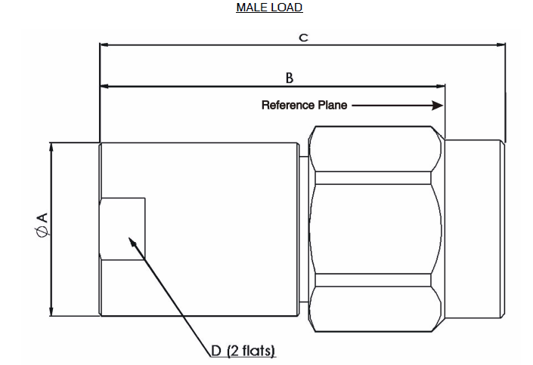
Symbols | Dimensions mm
Symbols | Min | Max
∅A | 7 | 8
B | 14.5 | 15.5
C | - | 18.5
D | 6.5 | 7.5
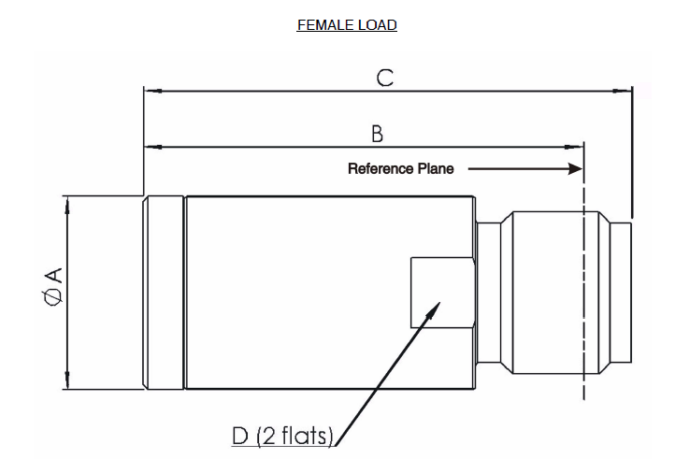
Symbols | Dimensions mm
Symbols | Min | Max
∅A | 7 | 8
B | 16.5 | 17.5
C | - | 19.5
D | 6.5 | 7.5

Interface Dimensions
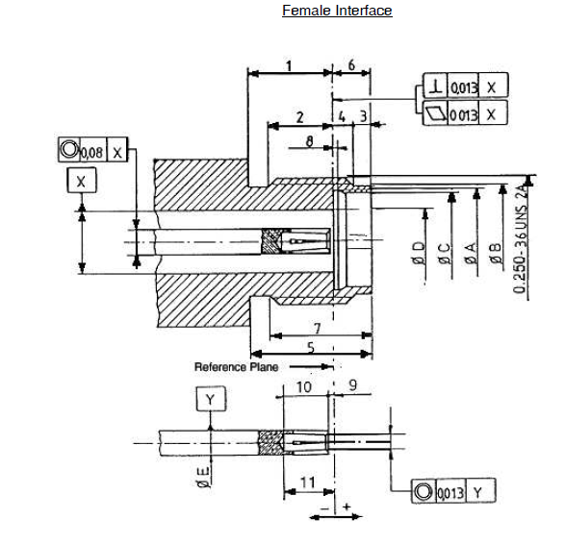
Symbols | Dimensions mm
Symbols | Min | Max
1 | 3.82 | 4.32
2 | 2.87 | 3.27
3 | 0.65 | 0.95
4 | 0.93 | 1.33
5 | 5.8 | 6.2
6 | 1.88 | 1.98
7 | 4.85 | 5.15
8 | 0.3 | 0.5
9 | 0 | 0.08
10 | 2.8 | 3.2
11 | 2.8 | 3.28
ØA | 4.8 | 5
ØB | 5.3 | 5.35
ØC | 4.6 | 4.63
ØD | 2.905 | 2.945
ØE | 1.26 | 1.28
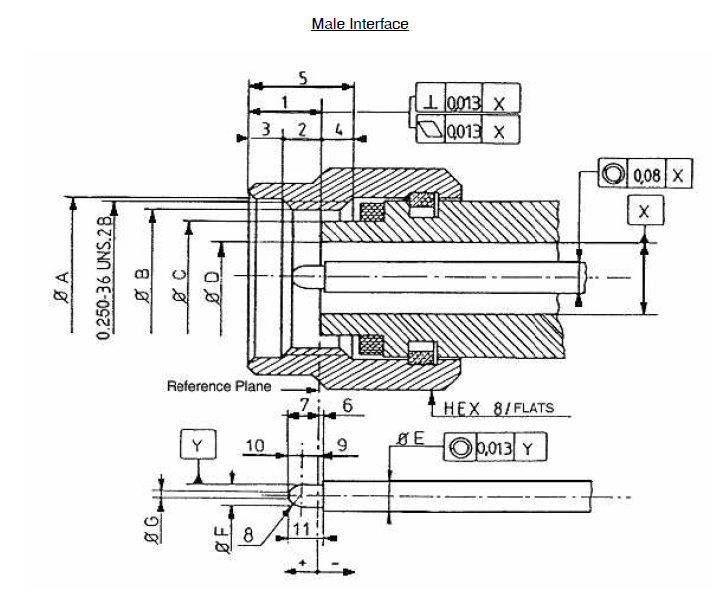
Symbols | Dimensions mm |  | Notes
Symbols | Min | Max | Notes
1 | 2.63 | 3.25
2 | 1.58 | 2.2
3 | 0.75 | 1.15
4 | 0.85 | 1.47
5 | 3.8 | 4.2
6 | 0 | 0.08
7 | 1.42 | 1.6
8 | 0.8 | 0.9 | Radius
9 | 0.693 | 0.984
10 | 0.616 | 0.727
11 | 1.5 | 1.6
ØA | 6.6 | 6.7
ØB | 5.59 | -
ØC | 4.55 | 4.58
ØD | 2.905 | 2.94
ØE | 1.26 | 1.28
ØF | 0.92 | 0.94
ØG | 0.2 | 0.34

Mating Gauge Dimensions
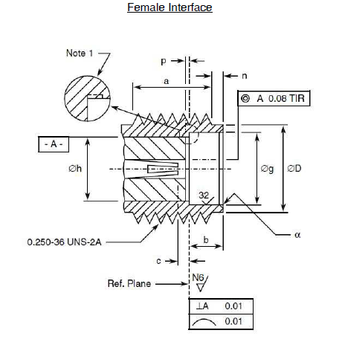
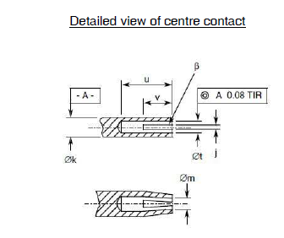

Symbols | Dimensions mm |  | Notes
Symbols | Min | Max | Notes
a | 3.81 | -
b | 1.88 | 1.98
c | 0 | 0.08 | Contact recess
ØD | 5.28 | 5.49
Øg | 4.6 | 4.67
Øh | 4.1 | 4.13
j | 0.13 | 0.23 | 2 or more slots
Øk | 1.27 | 1.29
Øm | 0.72 | 0.84 | After closing
n | 0.38 | 1.14
p | 0 | 0.05 | Insert recess
u | 2.54 | -
Øt | 0.94 | 0.99
v | 1.91 | 2.41
α | - | 0.25 | 45° Chamfer
β | 0.99 | 1.19 | 45° Chamfer
NOTES:
            - No fillet permitted. Radial undercut 0.2mm maximum deep x 0.89mm maximum long permitted.
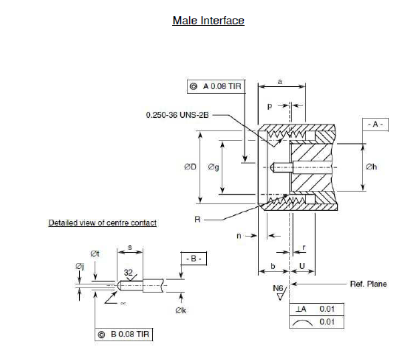
Symbols | Dimensions mm |  | Notes
Symbols | Min | Max | Notes
a | 3.71 | 4.32
b | 2.59 | 3.35
ØD | 6.48 | 6.73
Øg | 4.34 | 4.59
Øh | 4.1 | 4.13
Øj | - | 0.38 | Flat
Øk | 1.27 | 1.29
n | 0.64 | 1.14
p | 0 | 0.05 | Insert recess
r | 0 | 0.08 | Contact recessed
R | - | 0.08 | Radius
s | 2.03 | 2.29
Øt | 0.9 | 0.93
U | 2.03 | -
α | - | - | 45 ±3° Chamfer

MATERIALS AND FINISHES
Materials and finishes shall be as follows:
- Shell, Coupling Nut: Amagnetic Stainless Steel, electro-passivated
- Centre Contact: Beryllium Copper, with nickel underplate (2µm minimum) and Gold plating (1.3µm minimum). Measurements of plating thickness shall be performed inside the female centre contact at a maximum distance of 0.4mm from the end and on the male centre contact on pin diameter ∅F (see Interface Dimensions).
- Inserts: ULTEM 1000
- Gaskets: Silicone rubber.

REQUIREMENTS

GENERAL
The complete requirements for procurement of the components specified herein are as stated in this specification and the ESCC Generic Specification. Permitted deviations from the Generic Specification, applicable to this specification only, are listed below.
Permitted deviations from the Generic Specification and this Detail Specification, formally agreed with specific Manufacturers on the basis that the alternative requirements are equivalent to the ESCC requirement and do not affect the component’s reliability, are listed in the appendices attached to this specification.

Deviations from the Generic Specification

Deviations from Qualification and Periodic Tests - Chart F4
          - Residual Magnetism: is not applicable.

MARKING
The marking shall be in accordance with the requirements of ESCC Basic Specification No. 21700 and as follows.
The information to be marked on the component shall be:
          - The ESCC qualified components symbol (for ESCC qualified components only).
          - The ESCC Component Number.
          - Traceability information.

CONTACT ENGAGEMENT AND SEPARATION FORCES TEST
Ref. Contact Engagement and Separation Forces in the ESCC Generic Specification.
          - Oversize Test Pin
- Pin diameter : 0.95/0.955mm
- Insertion depth : 0.76/1.14mm
          - Maximum Diameter Test Pin
- Pin diameter: 0.94/0.946mm
- Engagement depth: 1.27/1.9mm
- Engagement force: 1380g maximum.
          - Minimum Diameter Test Pin
- Pin diameter: 0.89/0.902mm
- Separation depth: 1.27/1.9mm
- Separation force: 28g minimum.
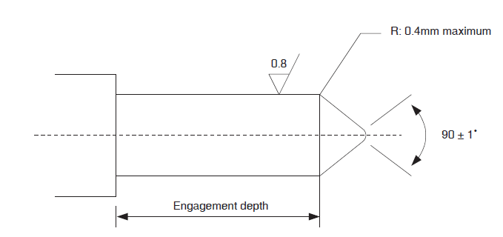

COUPLING PROOF TORQUE TEST
Ref. Coupling Proof Torque in the ESCC Generic Specification.
Coupling Proof Torque: 170N.cm.

MATING AND UNMATING FORCES TEST
Ref. Mating and Unmating Forces in the ESCC Generic Specification.
Maximum torque during mating or unmating: 24N.cm.

ELECTRICAL MEASUREMENTS AT ROOM, HIGH AND LOW TEMPERATURES
The measurements shall be performed at room, high and low temperatures.

Room Temperature Electrical Measurements
The measurements shall be performed at T_{amb} = +22 ±3°C.
Characteristics | Symbols | Test Method and  Conditions | Limits |  | Units
Characteristics | Symbols | Test Method and  Conditions | Min | Max | Units
Voltage Standing Wave Ratio | VSWR | ESCC No. 3403  f = 0 to 31.5GHz | - | Note 1 | -
Resistance | R | Test current < 50mA  DC to 2kHz max. | 47.5 | 52.5 | Ω
NOTES:
            - The limits for VSWR are specified in Component Type Variants and Range of Components.

High and Low Temperatures Electrical Measurements
The measurements shall be performed at T_{amb} = +125 (+0 -3)°C and T_{amb} = -55 (+3 -0)°C.
Characteristics | Symbols | Test Method and  Conditions (Note 1) | Limits |  | Units
Characteristics | Symbols | Test Method and  Conditions (Note 1) | Min | Max | Units
Temperature Coefficient of Resistance | TC_{R} | Test current < 50mA  DC to 2kHz max. | - | 3 x 10⁻⁴ | Ω/Ω/°C
NOTES:
            - Measurements shall be performed during Screening Tests on a sample of 2 components. In the event of any failure a 100% inspection shall be performed.

PARAMETER DRIFT VALUES
Unless otherwise specified, the measurements shall be performed at T_{amb} = +22 ±3°C.
The test methods and test conditions shall be as per the corresponding test defined in Room Temperature Electrical Measurements.
The drift values (Δ) shall not be exceeded for each characteristic where specified. The corresponding absolute limit values for each characteristic shall not be exceeded.
Characteristics | Symbols | Drift Value Δ | Units
Voltage Standing Wave Ratio | $$\frac{Δ\text{VSWR}}{\text{VSWR}}$$ | ±2 | %
Resistance | ΔR | ±250 | mΩ

INTERMEDIATE AND END-POINT ELECTRICAL MEASUREMENTS
Unless otherwise specified, the measurements shall be performed at T_{amb} = +22 ±3ºC.
Unless otherwise specified, test methods and test conditions shall be as per the corresponding test defined in Room Temperature Electrical Measurements.
The drift values (Δ) shall not be exceeded for each characteristic where specified. The corresponding absolute limit values for each characteristic shall not be exceeded.
Test Reference per ESCC No. 3403 | Characteristics | Symbols | Limits |  | Units
Test Reference per ESCC No. 3403 | Characteristics | Symbols | Min | Max | Units
Vibration  Initial Measurements | Resistance  Voltage Standing Wave Ratio | R  VSWR | 47.5  - | 52.5  Note 1 | Ω  -
Measurements during last cycle | Intermittent contact | - | No discontinuity > 0.5ms  No open or short circuit |  | -
Final Measurements | Resistance | R | 47.5 | 52.5 | Ω
 | Resistance Drift (from initial measurement) | ΔR | - | ±250 | mΩ
 | Voltage Standing Wave Ratio | VSWR | - | Note 1 | -
 | VSWR Drift (from initial measurement) | $$\frac{Δ\text{VSWR}}{\text{VSWR}}$$ | - | ±2 | %
Mechanical Shock  Initial Measurements | Resistance (Note 2)  Voltage Standing Wave Ratio (Note 2) | R  VSWR | 47.5  - | 52.5  Note 1 | Ω  -
Final Measurements | Resistance | R | 47.5 | 52.5 | Ω
 | Resistance Drift (from initial measurement) | ΔR | - | ±250 | mΩ
 | Voltage Standing Wave Ratio | VSWR | - | Note 1 | -
 | VSWR Drift (from initial measurement) | $$\frac{Δ\text{VSWR}}{\text{VSWR}}$$ | - | ±2 | %
Rapid Change of Temperature  Initial Measurements | Resistance  Voltage Standing Wave Ratio | R  VSWR | 47.5  - | 52.5  Note 1 | Ω  -
Final Measurements | Resistance | R | 47.5 | 52.5 | Ω
 | Resistance Drift (from initial measurement) | ΔR | - | ±250 | mΩ
 | Voltage Standing Wave Ratio | VSWR | - | Note 1 | -
 | VSWR Drift (from initial measurement) | $$\frac{Δ\text{VSWR}}{\text{VSWR}}$$ | - | ±2 | %
Climatic Sequence  Initial Measurements | Resistance (Note 2)  Voltage Standing Wave Ratio (Note 2) | R  VSWR | 47.5  - | 52.5  Note 1 | Ω  -
Measurements during Dry Heat | Temperature Coefficient of Resistance | TC_{R} | - | 3 x 10⁻⁴ | Ω/Ω/°C
Measurements during Cold | Temperature Coefficient of Resistance | TC_{R} | - | 3 x 10⁻⁴ | Ω/Ω/°C
Final Measurements | Resistance | R | 47.5 | 52.5 | Ω
 | Resistance Drift (from initial measurement) | ΔR | - | ±250 | mΩ
 | Voltage Standing Wave Ratio | VSWR | - | Note 1 | -
 | VSWR Drift (from initial measurement) | $$\frac{Δ\text{VSWR}}{\text{VSWR}}$$ | - | ±2 | %
Operating Life  Initial Measurements | Resistance (Note 2)  Voltage Standing Wave Ratio (Note 2) | R  VSWR | 47.5  - | 52.5  Note 1 | Ω  -
Final Measurements | Resistance | R | 47.5 | 52.5 | Ω
 | Resistance Drift (from initial measurement) | ΔR | - | ±250 | mΩ
 | Voltage Standing Wave Ratio | VSWR | - | Note 1 | -
 | VSWR Drift (from initial measurement) | $$\frac{Δ\text{VSWR}}{\text{VSWR}}$$ | - | ±2 | %
RF Leakage | RF leakage  f = 0 to 31.5GHz | E | -85 | - | dBi
Peak Power  Final Measurements | Resistance | R | 47.5 | 52.5 | Ω
NOTES:
            - The limits for VSWR are as specified in Component Type Variants and Range of Components.
            - This test need not be repeated. The most recent result from the previous test may be used instead.

BURN-IN CONDITIONS
Characteristics | Symbols | Test Conditions | Units
Ambient Temperature | T_{amb} | +125 | °C
Power | P_{in} | 0 | W

OPERATING LIFE CONDITIONS
Characteristics | Symbols | Test Conditions | Units
Ambient Temperature | T_{amb} | +25 | °C
Power | P_{in} | 1 | W
Frequency | f_{in} | Note 1 | -
NOTES:
            - Operating Life may be performed at DC, 10GHz, 18GHz or 22GHz.

