

Page 1 of 32
ACCESSORIES FOR RECTANGULAR CONNECTORS, MICROMINIATURE, 3401/081, 3401/082 AND CONNECTOR SAVERS 3401/088

ESCC Detail Specification No. 3401/084

Issue 4 Draft A | May 2018



Document Custodian: European Space Agency – see https://escies.org

Legal Disclaimer and Copyright
European Space Agency, Copyright © 2018. All rights reserved.
The European Space Agency disclaims any liability or responsibility, to any person or entity, with respect to any loss or damage caused, or alleged to be caused, directly or indirectly by the use and application of this ESCC publication.
This publication, without the prior permission of the European Space Agency and provided that it is not used for a commercial purpose, may be:
- copied in whole, in any medium, without alteration or modification.
- copied in part, in any medium, provided that the ESCC document identification, comprising the ESCC symbol, document number and document issue, is removed.

DOCUMENTATION CHANGE NOTICE
(Refer to https://escies.org for ESCC DCR content)
DCR No. | CHANGE DESCRIPTION
tbc | Specification upissued to incorporate editorial changes per DCR.

TABLE OF CONTENTS
1 General 5
1.1 SCOPE 5
1.2 TYPE VARIANTS 5
1.3 MAXIMUM RATINGS 5
1.4 PARAMETER DERATING INFORMATION 5
1.5 PHYSICAL DIMENSIONS 5
2 applicable documents 5
3 TERMS, DEFINITIONS, ABBREVIATIONS, SYMBOLS AND UNITS 5
4 REQUIREMENTS 31
4.1 GENERAL 31
4.2 DEVIATIONS FROM GENERIC SPECIFICATION 31
4.2.1 Deviations from Special In-Process Controls 31
4.2.2 Deviations from Final Production Tests (Chart II) 31
4.2.3 Deviations from Burn-in and Electrical Measurements (Chart III) 31
4.2.4 Deviations from Qualification, Environmental and Endurance Tests (Chart IV) 31
4.2.5 Deviations from Lot Acceptance Tests (Chart V) 31
4.3 MECHANICAL REQUIREMENTS 31
4.3.1 Dimension Check 31
4.3.2 Weight 31
4.3.3 Torque Value 31
4.4 MATERIALS AND FINISHES 31
4.4.1 Screw Lock Assemblies (Jackpost, Jackscrew) 32
4.4.2 Clips 32
4.4.3 Backshells 32
4.4.4 Dust Caps 32
4.5 MARKING 32
4.5.1 General 32
4.5.2 The ESCC Component Number 32
4.5.3 Traceability Information 32
4.6 ELECTRICAL MEASUREMENTS 32
4.7 SCREENING TESTS (TABLES 4 AND 5) 32
4.8 ENVIRONMENTAL AND ENDURANCE TESTS 32

General

SCOPE
This specification details the ratings, physical and electrical characteristics, test and inspection data of Accessories for Rectangular Connectors, Microminiature, 3401/081, 3401/082 and Connector Savers 3401/088.
The following ESCC Specifications, the requirements of which are supplemented herein, are associated with this specification:
- ESCC Generic Specification No. 3401, Connectors, Electrical, Non-Filtered, Circular and Rectangular.
- ESCC Detail Specification No. 3401/081, Connectors, Electrical, Rectangular, Microminiature, Non-removable Gauge 26 PCB Pin Contacts, Based on Type 8MCG.
- ESCC Detail Specification No. 3401/082, Connectors, Electrical, Rectangular, Microminiature, Removable Gauge 26 Crimp Contacts, Based on Type 8MCG.
- ESCC Detail Specification No. 3401/088, Connector Savers, Electrical, Rectangular, Microminiature, Non-removable Gauge 26 Contacts, Based on Type 8MCG.

TYPE VARIANTS
The type variants of accessories covered by this specification are given in Table 1(a).

MAXIMUM RATINGS
The maximum ratings, which shall not be exceeded at any time during use or storage, applicable to the accessories specified herein, are as scheduled in Table 1(b).

PARAMETER DERATING INFORMATION
Not applicable.

PHYSICAL DIMENSIONS
The physical dimensions of the accessories specified herein are shown in Figure 2.

applicable documents
The following documents form part of this specification and shall be read in conjunction with it:
- ESCC Generic Specification No. 3401, Connectors, Electrical Non-filtered, Circular and Rectangular.
- ESCC Detail Specification No. 3401/081, Connectors, Electrical, Rectangular, Microminiature, Non-removable Gauge 26 PCB Pin Contacts, Based on Type 8MCG.
- ESCC Detail Specification No. 3401/082, Connectors, Electrical, Rectangular, Microminiature, Removable Gauge 26 Crimp Contacts, Based on type 8MCG.
- ESCC Detail Specification No. 3401/088, Connector Savers, Electrical, Rectangular, Microminiature, Non-removable Gauge 26 Contacts, Based on Type 8MCG.

TERMS, DEFINITIONS, ABBREVIATIONS, SYMBOLS AND UNITS
For the purpose of this specification, the terms, definitions, abbreviations, symbols and units specified in ESCC Basic Specification No. 21300 shall apply.
TABLE 1(a) - TYPE VARIANTS
Type Variants | Descriptions | Applicable Shell Sizes | Weight Max  (g) | Torque Values (Nm) |  | Remarks
 |  |  |  | Min | Max | Remarks
01 | Jackscrew assembly (screw and retaining ring), allen head screw, low profile | A, B, C, D, E, F, G, H | 0.3 | 0.28 | 0.32
02 | Jackscrew assembly (screw and retaining ring), slot head screw, low profile | A, B, C, D, E, F, G, H | 0.3 | 0.28 | 0.32
03 | Jackpost assembly (screwlock, nut and lockwasher) | A, B, C, D, E, F, G, H | 0.62 | 0.44  0.28  0.44 | 0.48  0.32  0.48 | See Note 1  See Note 2  See Note 3
04 | Jackscrew assembly (screw and retaining ring), allen head screw, low profile | J | 0.35 | 0.4 | 0.44
05 | Jackscrew assembly (screw and retaining ring), slot head screw, low profile | J | 0.35 | 0.4 | 0.44
06 | Jackpost assembly (screwlock, nut and lockwasher) | J | 0.9 | 0.6  0.4  0.6 | 0.66  0.44  0.66 | See Note 1  See Note 2  See Note 3
07 | Jackscrew assembly (jackscrew and clip), allen head screw, low profile | A, B, C, D, E, F, G, H | 0.8 | 0.28 | 0.32
08 | Jackscrew assembly (jackscrew and clip), allen head screw, low profile | J | 1.1 | 0.4 | 0.44
09 | Straight backshell with male jackscrews and clips | A | 2.7 | - | - | See Note 4
10 | Straight backshell with male jackscrews and clips | B | 3 | - | - | See Note 4
11 | Straight backshell with male jackscrews and clips | C | 3.95 | - | - | See Note 4
12 | Straight backshell with male jackscrews and clips | D | 4.75 | - | - | See Note 4
13 | Straight backshell with male jackscrews and clips | E | 5.5 | - | - | See Note 4
14 | Straight backshell with male jackscrews and clips | F | 6.15 | - | - | See Note 4
15 | Straight backshell with male jackscrews and clips | G | 7.35 | - | - | See Note 4
16 | Straight backshell with female jackposts and nuts | A | 2.7 | - | - | See Note 5
17 | Straight backshell with female jackposts and nuts | B | 3 | - | - | See Note 5
18 | Straight backshell with female jackposts and nuts | C | 3.95 | - | - | See Note 5
19 | Straight backshell with female jackposts and nuts | D | 4.75 | - | - | See Note 5
20 | Straight backshell with female jackposts and nuts | E | 5.5 | - | - | See Note 5
21 | Straight backshell with female jackposts and nuts | F | 6.15 | - | - | See Note 5
22 | Straight backshell with female jackposts and nuts | G | 7.35 | - | - | See Note 5
23 | Angled backshell with male jackscrews and clips | A | 4.1 | - | - | See Note 4
24 | Angled backshell with male jackscrews and clips | B | 4.95 | - | - | See Note 4
25 | Angled backshell with male jackscrews and clips | C | 5.85 | - | - | See Note 4
26 | Angled backshell with male jackscrews and clips | D | 6.75 | - | - | See Note 4
27 | Angled backshell with male jackscrews and clips | E | 7.4 | - | - | See Note 4
28 | Angled backshell with male jackscrews and clips | F | 8.55 | - | - | See Note 4
29 | Angled backshell with male jackscrews and clips | G | 9.15 | - | - | See Note 4
30 | Angled backshell with male jackscrews and clips | A | 4.1 | - | - | See Note 5
31 | Angled backshell with female jackposts and nuts | B | 4.95 | - | - | See Note 5
32 | Angled backshell with female jackposts and nuts | C | 5.85 | - | - | See Note 5
33 | Angled backshell with female jackposts and nuts | D | 6.75 | - | - | See Note 5
34 | Angled backshell with female jackposts and nuts | E | 7.4 | - | - | See Note 5
35 | Angled backshell with female jackposts and nuts | F | 8.55 | - | - | See Note 5
36 | Angled backshell with female jackposts and nuts | G | 9.15 | - | - | See Note 5
37 | 90º backshell with male jackscrews and clips | A | 4.1 | - | - | See Note 4
38 | 90º backshell with male jackscrews and clips | B | 4.95 | - | - | See Note 4
39 | 90º backshell with male jackscrews and clips | C | 5.85 | - | - | See Note 4
40 | 90º backshell with male jackscrews and clips | D | 6.75 | - | - | See Note 4
41 | 90º backshell with male jackscrews and clips | E | 7.4 | - | - | See Note 4
42 | 90º backshell with male jackscrews and clips | F | 8.35 | - | - | See Note 4
43 | 90º backshell with male jackscrews and clips | G | 9.15 | - | - | See Note 4
44 | 90º backshell with female jackposts and nuts | A | 4.1 | - | - | See Note 5
45 | 90º backshell with female jackposts and nuts | B | 4.95 | - | - | See Note 5
46 | 90º backshell with female jackposts and nuts | C | 5.85 | - | - | See Note 5
47 | 90º backshell with female jackposts and nuts | D | 6.75 | - | - | See Note 5
48 | 90º backshell with female jackposts and nuts | E | 7.4 | - | - | See Note 5
49 | 90º backshell with female jackposts and nuts | F | 8.35 | - | - | See Note 5
50 | 90º backshell with female jackposts and nuts | G | 9.15 | - | - | See Note 5
51 | Straight backshell with male jackscrews and clips | H | 7.5 | - | - | See Note 4
52 | Straight backshell with male jackscrews and clips | J | 11.5 | - | - | See Note 6
53 | Straight backshell with female jackposts and nuts | H | 7.5 | - | - | See Note 5
54 | Straight backshell with female jackposts and nuts | J | 11.5 | - | - | See Note 7
55 | Angled backshell with male jackscrews and clips | H | 9.5 | - | - | See Note 4
56 | Angled backshell with male jackscrews and clips | J | 15.2 | - | - | See Note 6
57 | Angled backshell with female jackposts and nuts | H | 9.5 | - | - | See Note 5
58 | Angled backshell with female jackposts and nuts | J | 15.2 | - | - | See Note 7
59 | 90º backshell with male jackscrews and clips | H | 9.5 | - | - | See Note 4
60 | 90º backshell with male jackscrews and clips | J | 15.2 | - | - | See Note 6
61 | 90º backshell with female jackposts and nuts | H | 9.5 | - | - | See Note 5
62 | 90º backshell with female jackposts and nuts | J | 15.2 | - | - | See Note 7
63 | Dust Cap (Male) | A | N/A | - | -
64 | Dust Cap (Female) | A | N/A | - | -
65 | Dust Cap (Male) | B | N/A | - | -
66 | Dust Cap (Female) | B | N/A | - | -
67 | Dust Cap (Male) | C | N/A | - | -
68 | Dust Cap (Female) | C | N/A | - | -
69 | Dust Cap (Male) | D | N/A | - | -
70 | Dust Cap (Female) | D | N/A | - | -
71 | Dust Cap (Male) | E | N/A | - | -
72 | Dust Cap (Female) | E | N/A | - | -
73 | Dust Cap (Male) | F | N/A | - | -
74 | Dust Cap (Female) | F | N/A | - | - | -
75 | Dust Cap (Male) | G | N/A | - | -
76 | Dust Cap (Female) | G | N/A | - | -
77 | Dust Cap (Male) | H | N/A | - | -
78 | Dust Cap (Female) | H | N/A | - | -
79 | Dust Cap (Male) | J | N/A | - | -
80 | Dust Cap (Female) | J | N/A | - | -
81 | Jackpost assembly for rear mounting  on panel, Thickness Panel : 0.8 mm  (screwlock, nut and lockwasher) | A, B, C, D, E, F, G, H | 0.72 | 0.44  0.28  0.44 | 0.48  0.32  0.48 | See Note 1  See Note 2  See Note 3
82 | Jackpost assembly for rear mounting  on panel, Thickness Panel : 1.2 mm  (screwlock, nut and lockwasher) | A, B, C, D, E, F, G, H | 0.71 | 0.44  0.28  0.44 | 0.48  0.32  0.48 | See Note 1  See Note 2  See Note 3
83 | Jackpost assembly for rear mounting  on panel, Thickness Panel : 1.6 mm  (screwlock, nut and lockwasher) | A, B, C, D, E, F, G, H | 0.69 | 0.44  0.28  0.44 | 0.48  0.32  0.48 | See Note 1  See Note 2  See Note 3
84 | Jackpost assembly for rear mounting  on panel, Thickness Panel : 2.4 mm  (screwlock, nut and lockwasher) | A, B, C, D, E, F, G, H | 0.66 | 0.44  0.28  0.44 | 0.48  0.32  0.48 | See Note 1  See Note 2  See Note 3
85 | Jackpost assembly for rear mounting  on panel, Thickness Panel : 3.2mm  (screwlock, nut and lockwasher) | A, B, C, D, E, F, G, H | 0.62 | 0.44  0.28  0.44 | 0.48  0.32  0.48 | See Note 1  See Note 2  See Note 3
86 | Jackpost assembly for rear mounting  on panel, Thickness Panel : 0.8 mm  (screwlock, nut and lockwasher) | J | 1.08 | 0.6  0.4  0.4 | 0.66  0.44  0.66 | See Note 1  See Note 2  See Note 3
87 | Jackpost assembly for rear mounting  on panel, Thickness Panel : 1.2 mm  (screwlock, nut and lockwasher) | J | 1.05 | 0.6  0.4  0.4 | 0.66  0.44  0.66 | See Note 1  See Note 2  See Note 3
88 | Jackpost assembly for rear mounting  on panel, Thickness Panel : 1.6 mm  (screwlock, nut and lockwasher) | J | 1.03 | 0.6  0.4  0.4 | 0.66  0.44  0.66 | See Note 1  See Note 2  See Note 3
89 | Jackpost assembly for rear mounting  on panel, Thickness Panel : 2.4 mm  (screwlock, nut and lockwasher) | J | 0.99 | 0.6  0.4  0.4 | 0.66  0.44  0.66 | See Note 1  See Note 2  See Note 3
90 | Jackpost assembly for rear mounting  on panel, Thickness Panel : 3.2mm  (screwlock, nut and lockwasher) | J | 0.95 | 0.6  0.4  0.4 | 0.66  0.44  0.66 | See Note 1  See Note 2  See Note 3
91 | Jackpost assembly for PCB mounting  straight spills/PC tails, (screwlock,  nut, lockwasher and spacer) | A, B, C, D, E, F, G, H | 1.2 | 0.44  0.28  0.44 | 0.48  0.32  0.48 | See Note 1  See Note 2  See Note 3
92 | Jackpost assembly for PCB mounting  straight spills/PC tails, (screwlock,  nut, lockwasher and spacer) | J | 2.3 | 0.6  0.4  0.6 | 0.66  0.48  0.66 | See Note 1  See Note 2  See Note 3
93 | Jackpost assembly for Connector  with Rear Grommet Version,  (screwlock, nut and lockwasher) | A, B, C, D, E, F, G, H | 0.9 | 0.44  0.28  0.44 | 0.48  0.32  0.48 | See Note 1  See Note 2  See Note 3
94 | Jackpost assembly for Connector  with Rear Grommet Version,  (screwlock, nut and lockwasher) | J | 1.6 | 0.6  0.4  0.6 | 0.66  0.48  0.66 | See Note 1  See Note 2  See Note 3
95 | Jackpost assembly for Savers  Connector (screwlock, and retaining ring) | A, B, C, D, E, F, G, H | 0.9 | 0.44  0.28  0.44 | 0.48  0.32  0.48 | See Note 1  See Note 2  See Note 3
96 | Jackpost assembly for Savers  Connector (screwlock, and retaining ring) | J | 1.8 | 0.6  0.4  0.6 | 0.66  0.48  0.66 | See Note 1  See Note 2  See Note 3
97 | Bracket for mounting on PCB with 90° bent contacts | A, B, C, D, E, F | 0.85 | 0.44 | 0.48
98 | Bracket for mounting on PCB with 90° bent contacts | G, H | 1 | 0.44 | 0.48
99 | Bracket for mounting on PCB with 90° bent contacts | J | 2.45 | 0.6 | 0.66
NOTES:
            - These torque values apply to the male side of the jackpost.
            - These torque values apply to the female side of the jackpost.
            - These torque values apply to the nut.
            - Weight of backshell without male jackscrews and clips. The maximum weight of one clip and one screw is 1.12g.
            - Weight of backshell without female jackposts and nuts. The maximum weight of jackpost and one nut is 0.65g.
            - Weight of backshell without male jackscrews and clips. The maximum weight of one clip and one screw is 1.75g.
            - Weight of backshell without female jackposts and nuts. The maximum weight of one jackpost and one nut is 0.95g.
TABLE 1(b) - MAXIMUM RATINGS
No. | Characteristics | Symbol | Maximum Ratings | Unit
1 | Operating Temperature Range | T_{op} | -55 to +125 | °C
2 | Storage Temperature Range | T_{stg} | -65 to +125 | °C
FIGURE 1 – parameter derating information
Not applicable.
FIGURE 2 - PHYSICAL DIMENSIONS
FIGURE 2(a) - VARIANTS 01 AND 02
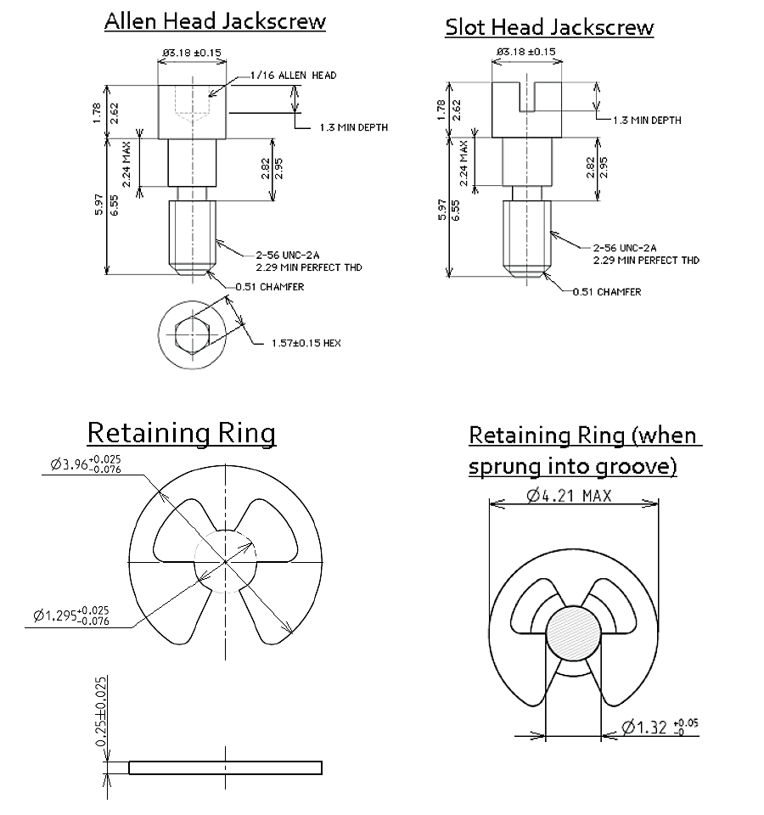
NOTES:
            - All dimensions are in millimetres.

FIGURE 2(b) - VARIANT 03
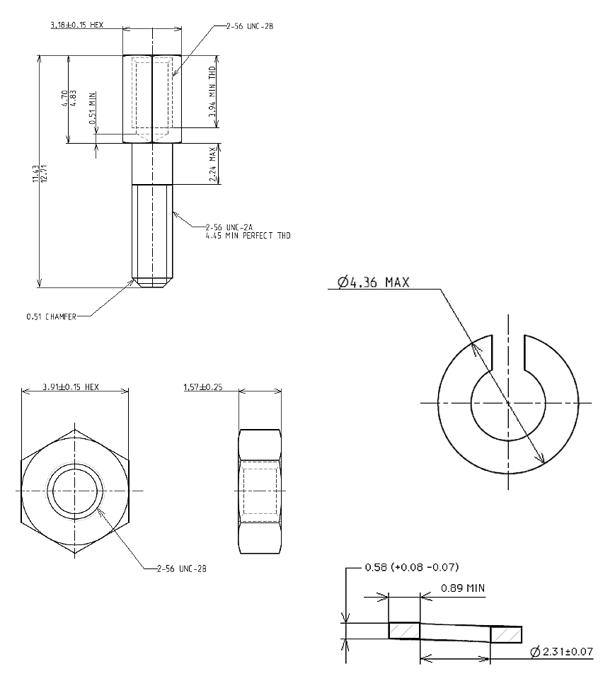
NOTES:
            - All dimensions are in millimetres.

FIGURE 2(c) - VARIANTS 04 AND 05
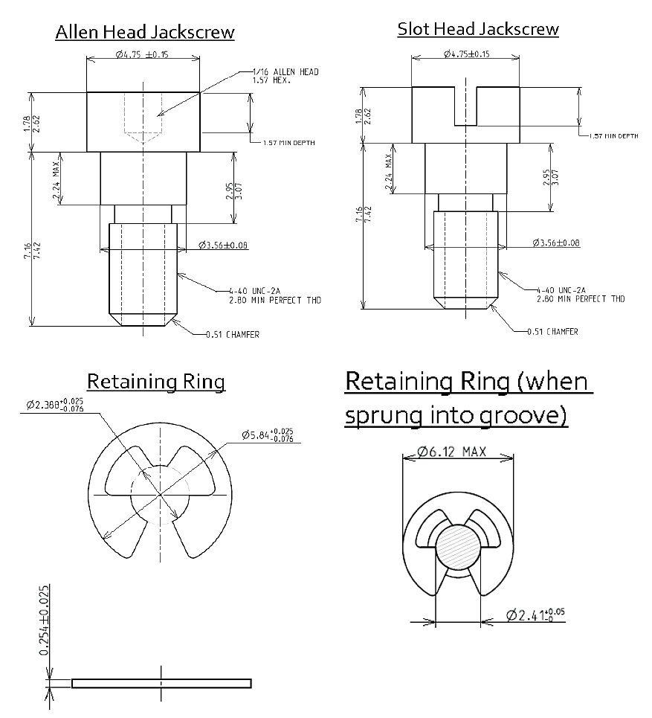
NOTES:
            - All dimensions are in millimetres.

FIGURE 2(d) - VARIANT 06
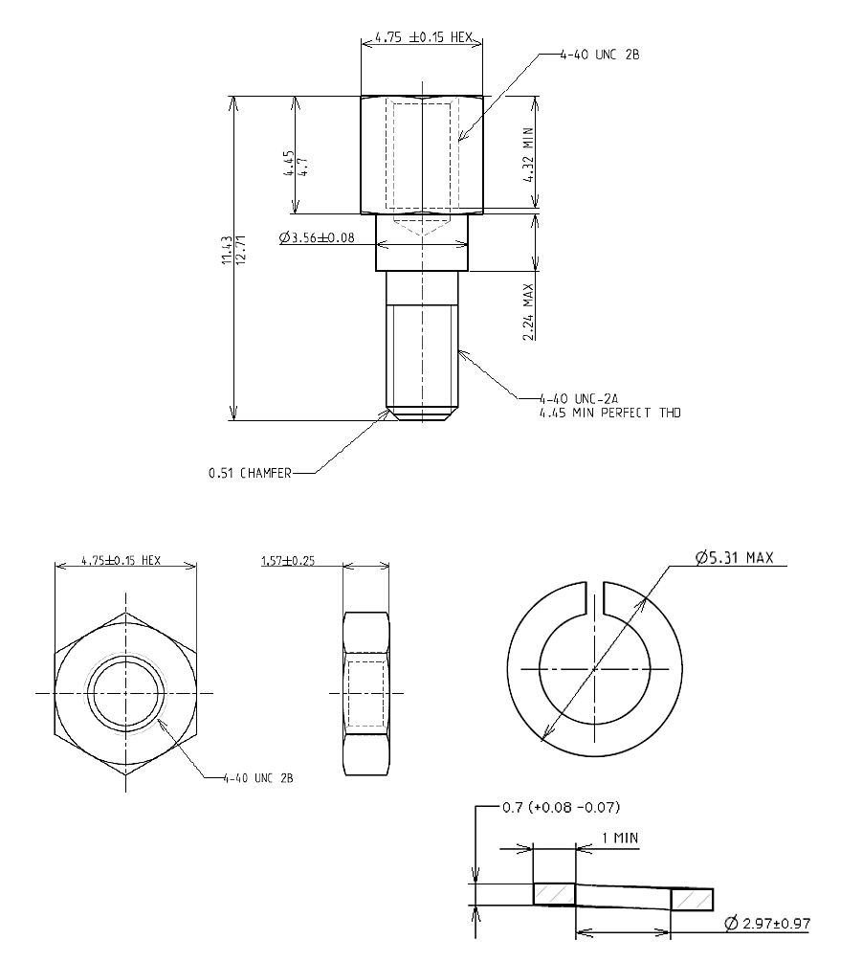
NOTES:
            - All dimensions are in millimetres.

FIGURE 2(e) - VARIANT 07
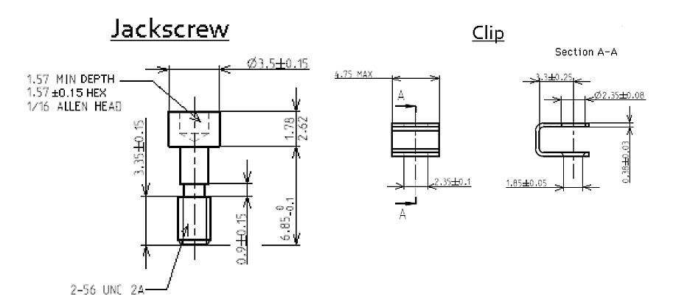
NOTES:
            - All dimensions are in millimetres.
FIGURE 2(f) - VARIANT 08
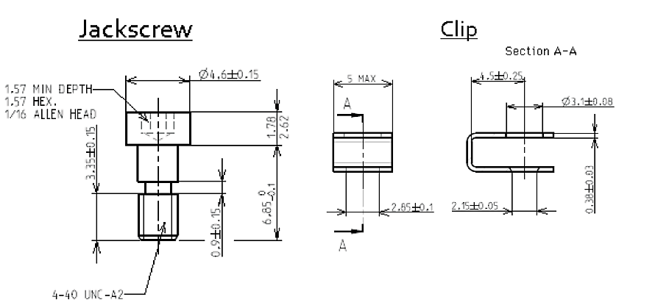
NOTES:
            - All dimensions are in millimetres.

FIGURE 2(g) - VARIANTS 09 TO 22
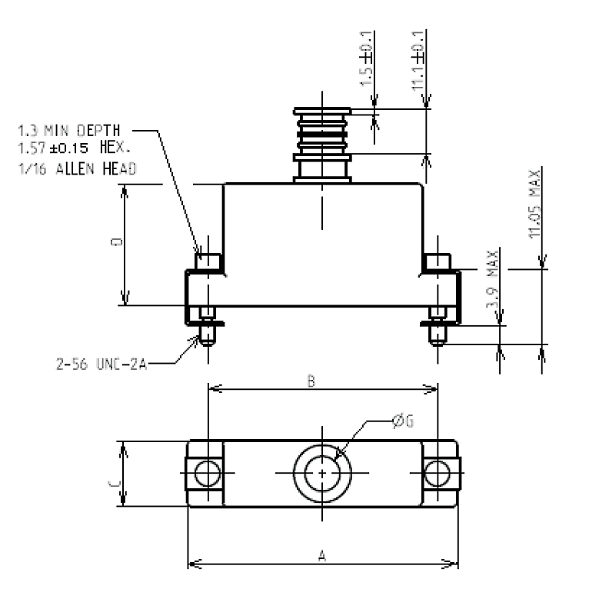
Variant Numbers |  | A |  | B |  | C |  | D Max | ØG
Male Jackscrew | Female Jackpost  (Note 2) | Min | Max | Min | Max | Min | Max | D Max | Min | Max
09 | 16 | 19.55 | 19.85 | 14.22 | 14.48 | 8.85 | 9.15 | 10 | 3.05 | 3.35
10 | 17 | 23.25 | 23.55 | 18.03 | 18.29 | 8.85 | 9.15 | 12 | 3.05 | 3.35
11 | 18 | 27.15 | 27.45 | 21.84 | 22.1 | 8.85 | 9.15 | 14 | 3.05 | 3.35
12 | 19 | 29.7 | 30 | 24.38 | 24.64 | 8.85 | 9.15 | 16 | 4.65 | 4.95
13 | 20 | 33.55 | 33.85 | 28.19 | 28.45 | 8.85 | 9.15 | 17 | 4.65 | 4.95
14 | 21 | 37.35 | 37.65 | 32 | 32.26 | 8.85 | 9.15 | 18 | 4.65 | 4.95
15 | 22 | 35.95 | 36.25 | 30.73 | 30.99 | 9.85 | 10.15 | 19 | 6.25 | 6.55
NOTES:
            - All dimensions are in millimetres.
            - See Figure 2(i) for female jackpost dimensions.
FIGURE 2(h) - VARIANTS 23 TO 36
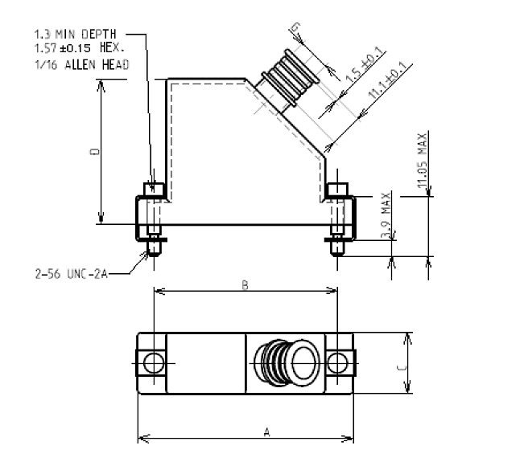
Variant Numbers |  | A |  | B |  | C |  | D Max | ØG
Male Jackscrew | Female Jackpost  (Note 2) | Min | Max | Min | Max | Min | Max | D Max | Min | Max
23 | 30 | 19.55 | 19.85 | 14.22 | 14.48 | 8.85 | 9.15 | 21 | 3.05 | 3.35
24 | 31 | 23.25 | 23.55 | 18.03 | 18.29 | 8.85 | 9.15 | 23 | 3.05 | 3.35
25 | 32 | 27.15 | 27.45 | 21.84 | 22.1 | 8.85 | 9.15 | 25 | 3.05 | 3.35
26 | 33 | 29.7 | 30 | 24.38 | 24.64 | 8.85 | 9.15 | 27 | 4.65 | 4.95
27 | 34 | 33.55 | 33.85 | 28.19 | 28.45 | 8.85 | 9.15 | 28 | 4.65 | 4.95
28 | 35 | 37.35 | 37.65 | 32 | 32.26 | 8.85 | 9.15 | 29 | 4.65 | 4.95
29 | 36 | 35.95 | 36.25 | 30.73 | 30.99 | 9.85 | 10.15 | 30 | 6.25 | 6.55
NOTES:
            - All dimensions are in millimetres.
            - See Figure 2(i) for female jackpost dimensions.
FIGURE 2(i) - VARIANTS 37 TO 50
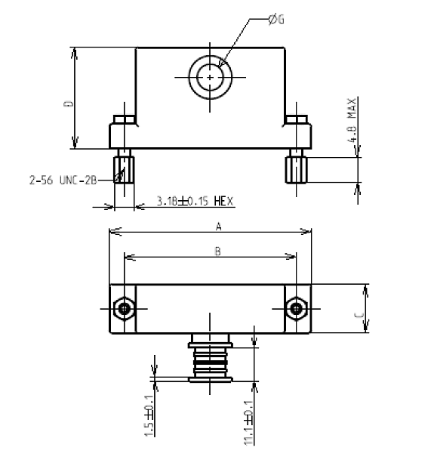
Variant Numbers |  | A |  | B |  | C |  | D Max | ØG
Male Jackscrew  (Note 2) | Female Jackpost | Min | Max | Min | Max | Min | Max | D Max | Min | Max
37 | 44 | 19.55 | 19.85 | 14.22 | 14.48 | 8.85 | 9.15 | 15 | 3.05 | 3.35
38 | 45 | 23.25 | 23.55 | 18.03 | 18.29 | 8.85 | 9.15 | 16.5 | 3.05 | 3.35
39 | 46 | 27.15 | 27.45 | 21.84 | 22.1 | 8.85 | 9.15 | 18 | 3.05 | 3.35
40 | 47 | 29.7 | 30 | 24.38 | 24.64 | 8.85 | 9.15 | 20 | 4.65 | 4.95
41 | 48 | 33.55 | 33.85 | 28.19 | 28.45 | 8.85 | 9.15 | 21 | 4.65 | 4.95
42 | 49 | 37.35 | 37.65 | 32 | 32.26 | 8.85 | 9.15 | 22 | 4.65 | 4.95
43 | 50 | 35.95 | 36.25 | 30.73 | 30.99 | 9.85 | 10.15 | 23 | 6.25 | 6.55
NOTES:
            - All dimensions are in millimetres.
            - See Figure 2(g) for male jackscrew dimensions.
FIGURE 2(j) - VARIANTS 51 TO 54
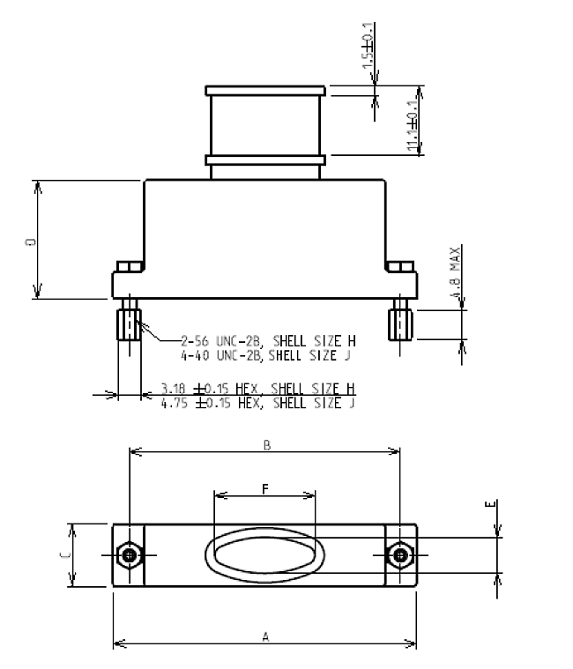
Variant Numbers |  | A |  | B |  | C |  | D Max | E |  | F
Male Jackscrew  (Note 2) | Female Jackpost | Min | Max | Min | Max | Min | Max | D Max | Min | Max | Min | Max
51 | 53 | 48.7 | 49 | 43.23 | 43.49 | 9.85 | 10.15 | 19 | 5.65 | 5.95 | 10.65 | 10.95
52 | 54 | 62.65 | 62.95 | 54.72 | 54.98 | 12.85 | 13.15 | 21 | 6.65 | 6.95 | 23.35 | 23.65
NOTES:
            - All dimensions are in millimetres.
            - See Figure 2(k) for male jackscrew dimensions.
FIGURE 2(k) - VARIANTS 55 TO 58
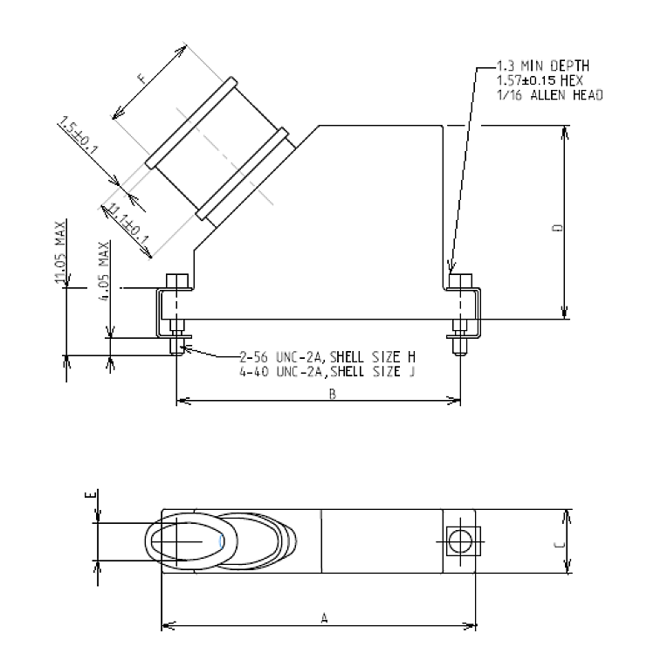
Variant Numbers |  | A |  | B |  | C |  | D Max | E |  | F
Male Jackscrew | Female Jackpost  (Note 2) | Min | Max | Min | Max | Min | Max | D Max | Min | Max | Min | Max
55 | 57 | 48.7 | 49 | 43.23 | 43.49 | 9.85 | 10.15 | 30 | 5.65 | 5.95 | 10.65 | 10.95
56 | 58 | 62.65 | 62.95 | 54.72 | 54.98 | 12.85 | 13.15 | 38 | 6.65 | 6.95 | 23.35 | 23.65
NOTES:
            - All dimensions are in millimetres.
            - See Figure 2(j) for female jackpost dimensions.
FIGURE 2(l) - VARIANTS 59 TO 62
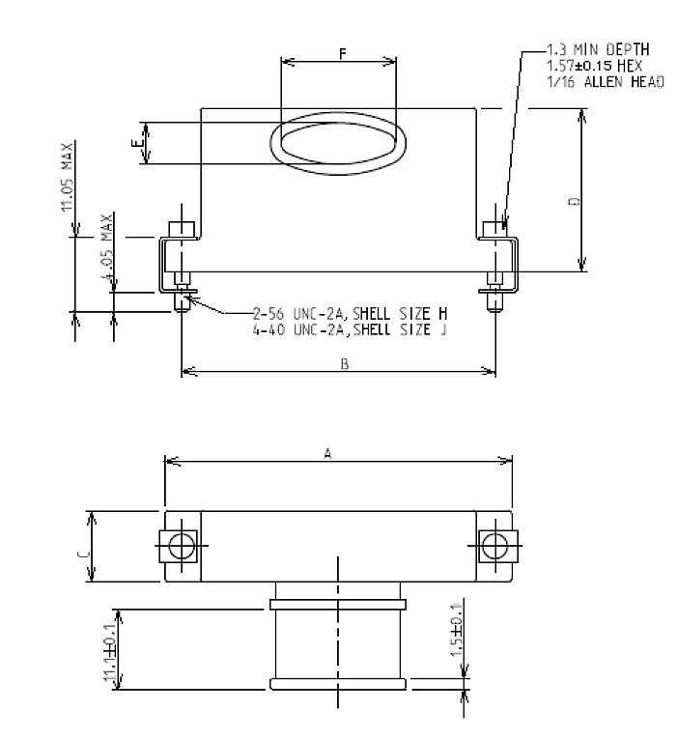
Variant Numbers |  | A |  | B |  | C |  | D Max | E |  | F
Male Jackscrew | Female Jackpost  (Note 2) | Min | Max | Min | Max | Min | Max | D Max | Min | Max | Min | Max
59 | 61 | 48.7 | 49 | 43.23 | 43.49 | 9.85 | 10.15 | 23 | 5.65 | 5.95 | 10.65 | 10.95
60 | 62 | 62.65 | 62.95 | 54.72 | 54.98 | 12.85 | 13.15 | 25 | 6.65 | 6.95 | 23.35 | 23.65
NOTES:
            - All dimensions are in millimetres.
            - See Figure 2(j) for female jackpost dimensions.

FIGURE 2(m) - VARIANTS 63 TO 80
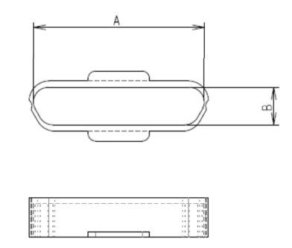
Variants | 63 | 64 | 65 | 66 | 67 | 68 | 69 | 70 | 71 | 72 | 73 | 74 | 75 | 76 | 77 | 78 | 79 | 80
A ±0.25 | 8 | 9.8 | 11.8 | 13.6 | 15.6 | 17.4 | 18.2 | 19.9 | 22 | 23.7 | 25.8 | 27.6 | 24.5 | 26.3 | 37.9 | 38.8 | 45.2 | 46.8
B ±0.25 | 4.7 | 6.4 | 4.7 | 6.4 | 4.7 | 6.4 | 4.7 | 6.4 | 4.7 | 6.4 | 4.7 | 6.4 | 5.8 | 7.4 | 5.8 | 7.4 | 9.35 | 11
NOTES:
            - All dimensions are in millimetres.

FIGURE 2(n) - VARIANTS 81 TO 85
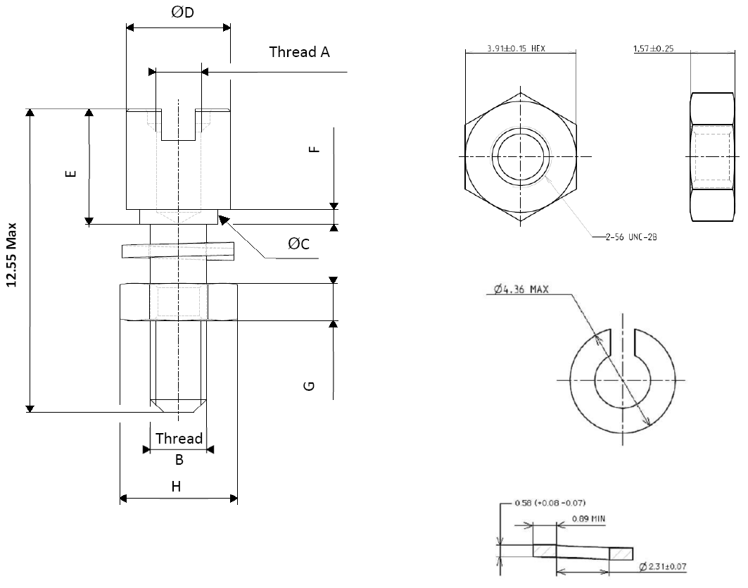
Variant | A | B | ØC Max | ØD Max | E | F Max | G Max | H Max
81 | 2-56 UNC-2B | 2-56 UNC-2A | 3 | 4.1 | 4.7/4.83 | 0.615 | 1.82 | 4.06
82 | 2-56 UNC-2B | 2-56 UNC-2A | 3 | 4.1 | 4.7/4.83 | 1.09 | 1.82 | 4.06
83 | 2-56 UNC-2B | 2-56 UNC-2A | 3 | 4.1 | 4.7/4.83 | 1.45 | 1.82 | 4.06
84 | 2-56 UNC-2B | 2-56 UNC-2A | 3 | 4.1 | 4.7/4.83 | 2.23 | 1.82 | 4.06
85 | 2-56 UNC-2B | 2-56 UNC-2A | 3 | 4.1 | 4.7/4.83 | 3.05 | 1.82 | 4.06
NOTES:
            - All dimensions are in millimetres.

FIGURE 2(o) - VARIANTS 86 TO 90
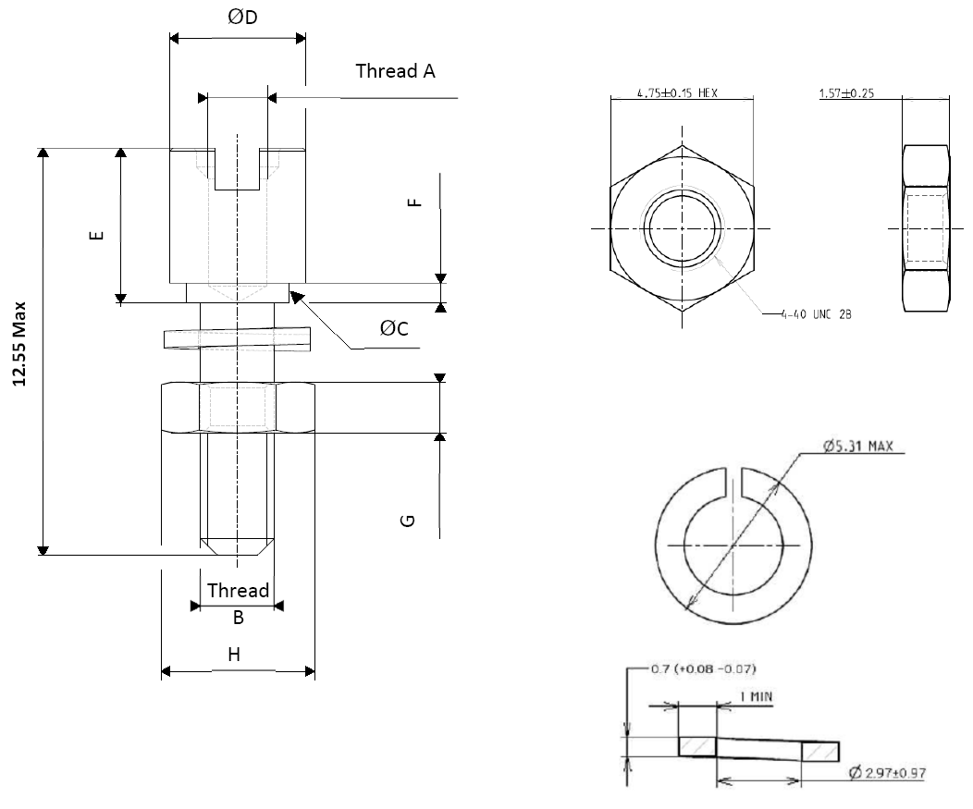
Variant | A | B | ØC Max | ØD Max | E | F Max | G Max | H Max
86 | 4-40 UNC-2B | 4-40 UNC-2A | 3.6 | 4.71 | 4.45/4.7 | 0.615 | 1.82 | 4.9
87 | 4-40 UNC-2B | 4-40 UNC-2A | 3.6 | 4.71 | 4.45/4.7 | 1.09 | 1.82 | 4.9
88 | 4-40 UNC-2B | 4-40 UNC-2A | 3.6 | 4.71 | 4.45/4.7 | 1.45 | 1.82 | 4.9
89 | 4-40 UNC-2B | 4-40 UNC-2A | 3.6 | 4.71 | 4.45/4.7 | 2.23 | 1.82 | 4.9
90 | 4-40 UNC-2B | 4-40 UNC-2A | 3.6 | 4.71 | 4.45/4.7 | 3.05 | 1.82 | 4.9
NOTES:
            - All dimensions are in millimetres.

FIGURE 2(p) - VARIANTS 91
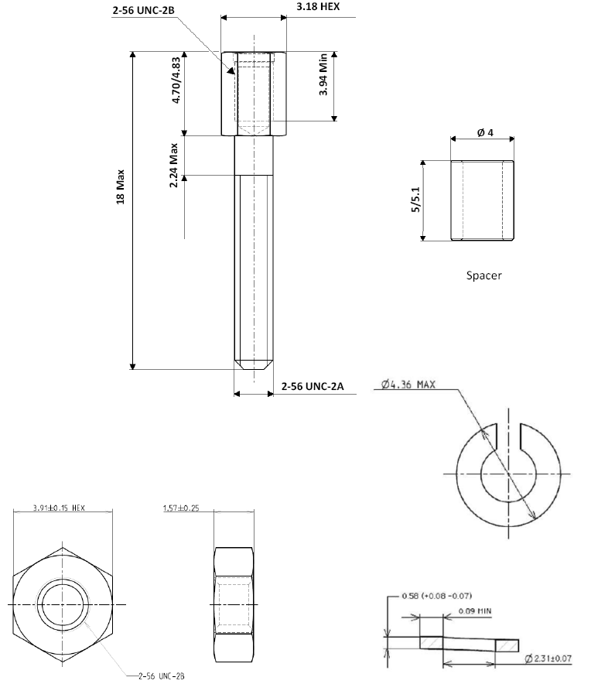
NOTES:
            - All dimensions are in millimetres
FIGURE 2(q) - VARIANT 92
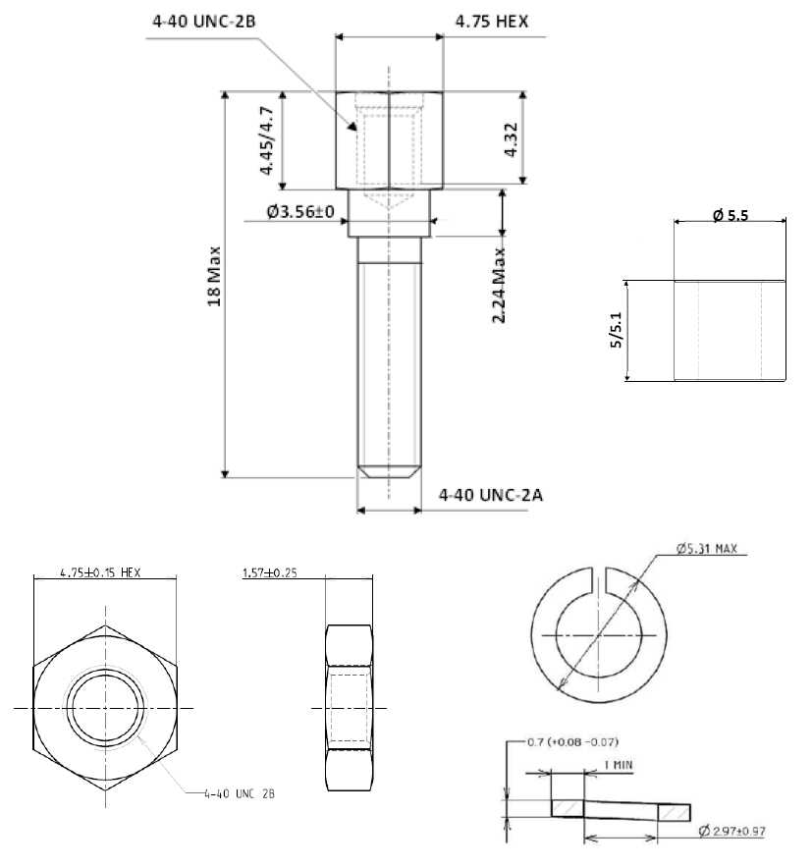
NOTES:
            - All dimensions are in millimetres
FIGURE 2(r) - VARIANTS 93 TO 94
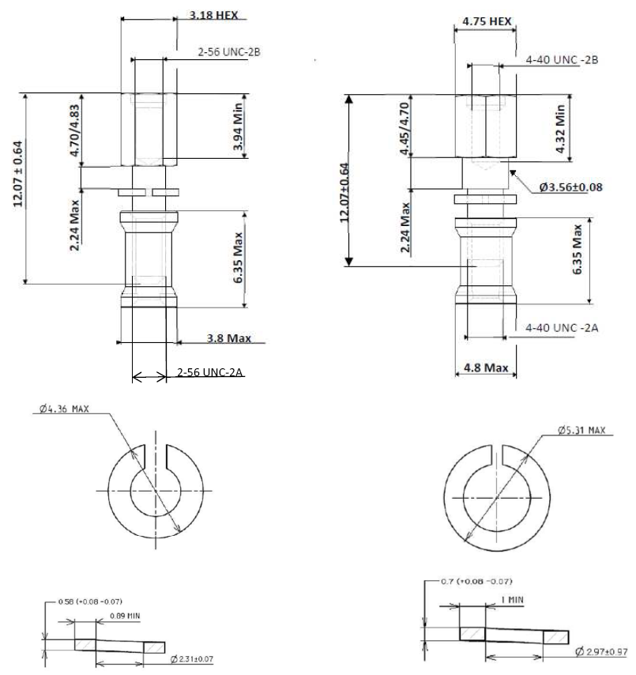
NOTES:
            - All dimensions are in millimetres
FIGURE 2(s) - VARIANTS 95 TO 96
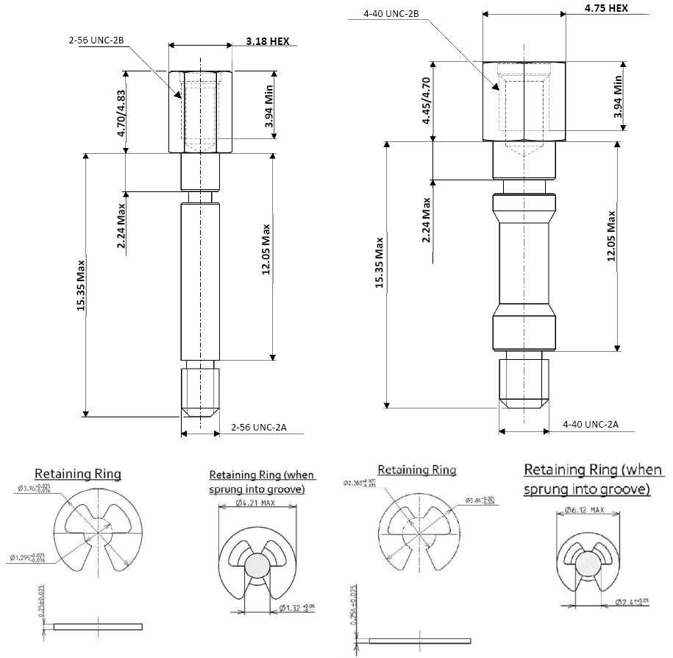
NOTES:
            - All dimensions are in millimetres
FIGURE 2(t) - VARIANTS 97 TO 99
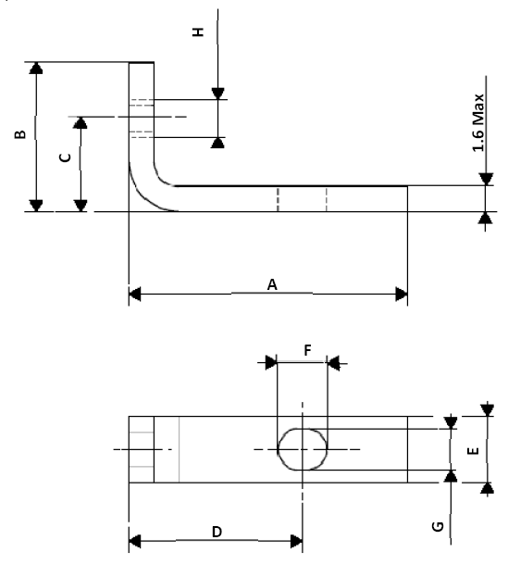
Variant | A Max | B Max | C ±0.10 | D ±0.10 | E ±0.10 | F Max | G | H
97 | 14.1 | 8.6 | 5 | 9.17 | 4 | 3.15 | 2.44 ±0.1 | 2-56 UNC-2B
98 | 16.9 | 9.1 | 5.6 | 10.44 | 4 | 3.15 | 2.44 ±0.1 | 2-56 UNC-2B
99 | 23.1 | 13.1 | 7.35 | 13.13 | 6.5 | 4.2 | 3.15 ±0.15 | 4-40 UNC-2B
NOTES:
            - All dimensions are in millimetres

REQUIREMENTS

GENERAL
The complete requirements for procurement of the accessories specified herein are stated in this specification and ESCC Generic Specification No. 3401. Deviations from the Generic Specification, applicable to this specification only, are listed in Para. 4.2.
Deviations from the applicable Generic Specification and this Detail Specification, formally agreed with specific Manufacturers on the basis that the alternative requirements are equivalent to the ESCC requirements and do not affect the components’ reliability, are listed in the appendices attached to this specification.

DEVIATIONS FROM GENERIC SPECIFICATION

Deviations from Special In-Process Controls
None.

Deviations from Final Production Tests (Chart II)
Only the following tests shall be performed:
          - Para. 9.6, Dimension Check.
          - Para. 9.7, External Visual Inspection. The magnification shall be X3.

Deviations from Burn-in and Electrical Measurements (Chart III)
Chart III is not applicable.

Deviations from Qualification, Environmental and Endurance Tests (Chart IV)
Chart IV is not applicable.

Deviations from Lot Acceptance Tests (Chart V)
Chart V is not applicable.

MECHANICAL REQUIREMENTS

Dimension Check
The dimensions of the accessories specified herein shall be verified in accordance with the requirements set out in Para. 9.6 of ESCC Generic Specification No. 3401 and Para. 4.2.2 of this specification; they shall conform to those shown in Figure 2.

Weight
The maximum weight of the accessories specified herein shall be as specified in Figure 2.

Torque Value
The torque value to be used for tightening the screws of the accessories specified herein shall be as specified in Table 1(a).

MATERIALS AND FINISHES
The materials and finishes shall be as specified herein. Where a definite material is not specified, a material which will enable the components specified herein to meet the performance requirements of this specification shall be used. Acceptance or approval of any constituent material does not guarantee acceptance of the finished product.

Screw Lock Assemblies (Jackpost, Jackscrew)
These shall be made of passivated stainless steel except for the female jackposts for backshell shell size J: The material shall be brass and the finish shall be electroless nickel with a minimum thickness of 10µm.

Clips
These shall be made of passivated stainless steel.

Backshells
The material shall be aluminium alloy and the finish shall be 0.7µm minimum of gold over a copper or electroless nickel base layer with a minimum thickness of 10µm.

Dust Caps
Material: Red, Black or White polypropylene or polyethylene.

MARKING

General
The marking of components delivered to this specification shall be in accordance with the requirements of ESCC Basic Specification No. 21700 and the following paragraphs. Each component shall be marked in respect of:
          - The ESCC Component Number.
          - Traceability Information.
These components being too small to accommodate the marking specified above, the ESCC marking information shall accompany the component in its primary package.

The ESCC Component Number
The ESCC Component Number shall be constituted and marked as follows:
Example: 340108401B
- Detail Specification Number: 3401084
- Type Variant (See Figure 1(a)): 01
- Testing Level: B

Traceability Information
Traceability information shall be marked in accordance with ESCC Basic Specification No. 21700.

ELECTRICAL MEASUREMENTS
Not applicable.

SCREENING TESTS (TABLES 4 AND 5)
Not applicable.

ENVIRONMENTAL AND ENDURANCE TESTS
Not applicable.

