

Page 1 of 21
CONNECTORS, ELECTRICAL, RECTANGULAR, MICROMINIATURE, REMOVABLE GAUGE 26 CRIMP CONTACTS
BASED ON TYPE 8MCG
ESCC Detail Specification No. 3401/082

Issue 7 Draft A | May 2018



Document Custodian: European Space Agency – see https://escies.org

Legal Disclaimer and Copyright
European Space Agency, Copyright © 2018. All rights reserved.
The European Space Agency disclaims any liability or responsibility, to any person or entity, with respect to any loss or damage caused, or alleged to be caused, directly or indirectly by the use and application of this ESCC publication.
This publication, without the prior permission of the European Space Agency and provided that it is not used for a commercial purpose, may be:
- copied in whole, in any medium, without alteration or modification.
- copied in part, in any medium, provided that the ESCC document identification, comprising the ESCC symbol, document number and document issue, is removed.

DOCUMENTATION CHANGE NOTICE
(Refer to https://escies.org for ESCC DCR content)
DCR No. | CHANGE DESCRIPTION
tbc | Specification upissued to incorporate editorial changes per DCR.

TABLE OF CONTENTS

1 General 6
1.1 SCOPE 6
1.2 COMPONENT TYPE VARIANTS AND RANGE OF COMPONENTS 6
1.3 MAXIMUM RATINGS 6
1.4 PARAMETER DERATING INFORMATION 6
1.5 PHYSICAL DIMENSIONS 6
2 APPLICABLE DOCUMENTS 6
3 TERMS, DEFINITIONS, ABBREVIATIONS, SYMBOLS AND UNITS 7
4 REQUIREMENTS 14
4.1 GENERAL 14
4.2 DEVIATIONS FROM GENERIC SPECIFICATION 14
4.2.1 Deviations from Special In-Process Controls 14
4.2.2 Deviations from Final Production Tests (Chart II) 14
4.2.3 Deviations from Burn-in and Electrical Measurements (Chart III) 14
4.2.4 Deviations from Qualification Tests (Chart IV) 14
4.2.5 Deviations from Lot Acceptance Tests (Chart V) 14
4.3 MECHANICAL REQUIREMENTS 14
4.3.1 Dimension Check 14
4.3.2 Weight 14
4.3.3 Contact Capability 14
4.3.4 Contact Retention (in Insert) 14
4.3.5 Mating and Unmating Forces 15
4.3.6 Insert Retention (in Shell) 15
4.3.7 Jackscrew Retention 15
4.3.8 Contact Insertion and Withdrawal Forces 15
4.3.9 Engagement and Separation Forces 15
4.3.10 Oversize Pin Exclusion 15
4.3.11 Probe Damage 15
4.3.12 Solderability 15
4.4 MATERIALS AND FINISHES 15
4.4.1 Shells 15
4.4.2 Inserts and Grommet 15
4.4.3 Contacts 15
4.4.4 Accessories 15
4.4.5 Magnetism Level 15
4.5 MARKING 16
4.5.1 General 16
4.5.2 Contact Position 16
4.5.3 The ESCC Component Number 16
4.5.4 Characteristics 16
4.5.4.1 Shell Size and Contact Arrangement 16
4.5.4.2 Alternate Designs 16
4.5.4.3 Type of Contact 17
4.5.4.4 Magnetism Level 17
4.5.4.5 Contact Information 17
4.5.5 Traceability Information 17
4.6 ELECTRICAL MEASUREMENTS 17
4.6.1 Electrical Measurements at Room Temperature 17
4.6.2 Electrical Measurements at High and Low Temperatures (Table 3) 17
4.6.3 Circuits for Electrical Measurements (Figure 4) 17
4.7 BURN-IN AND ELECTRICAL MEASUREMENTS (TABLES 4 AND 5) 17
4.8 ENVIRONMENTAL AND ENDURANCE TESTS (CHARTS IV AND V OF ESCC GENERIC SPECIFICATION No. 3401) 18
4.8.1 Measurements and Inspections on Completion of Environmental Tests 18
4.8.2 Measurements and Inspections at Intermediate Points during Endurance Tests 18
4.8.3 Measurements and Inspections on Completion of Endurance Tests 18
4.8.4 Conditions for Operating Life Test (Part of Endurance Testing) (Table 5) 18
4.8.5 Electrical Circuit for Operating Life Test (Figure 5) 18
4.8.6 Conditions for High Temperature Storage Test (Part of Endurance Testing) 18

General

SCOPE
This specification details the ratings, physical and electrical characteristics, test and inspection data for Connectors, Electrical, Rectangular, Microminiature, Removable Gauge 26 Crimp Contacts, based on Type 8MCG.
The following ESCC Specifications, the requirements of which are supplemented herein, are associated with this specification:
- ESCC Generic Specification No. 3401, Connectors, Electrical, Non-Filtered, Circular and Rectangular.
- ESCC Detail Specification No. 3401/081, Connectors, Electrical, Rectangular, Microminiature, Non-removable Gauge 26 PCB Pin Contacts, Based on Type 8MCG.
- ESCC Detail Specification No. 3401/083, Contacts, Electrical, Crimp, Gauge 26, for 3401/082 Connectors.
- ESCC Detail Specification No. 3401/084, Accessories for Rectangular Connectors, Microminiature, 3401/081, 3401/082 and Connector Savers 3401/088.
- ESCC Detail Specification No. 3401/088, Connector Savers, Electrical, Rectangular, Microminiature, Non-removable Gauge 26 Contacts, Based on Type 8MCG.

COMPONENT TYPE VARIANTS AND RANGE OF COMPONENTS
The different sizes of the connectors specified herein, together with their mechanical characteristics, are scheduled in Table 1(a).

MAXIMUM RATINGS
The maximum ratings, which shall not be exceeded at any time during use or storage, applicable to the connectors specified herein, are scheduled in Table 1(b).

PARAMETER DERATING INFORMATION
The derating information applicable to the connectors specified herein is shown in Figure 1.

PHYSICAL DIMENSIONS
The physical dimensions of the connectors specified herein, and the available contact arrangements, are shown in Figure 2.

APPLICABLE DOCUMENTS
The following documents form part of this specification and shall be read in conjunction with it:
          - ESCC Generic Specification No. 3401, Connectors, Electrical, Non-Filtered, Circular and Rectangular.
          - ESCC Detail Specification No. 3401/083, Contacts, Electrical, Crimp, Gauge 26, for 3401/082 Connectors.
          - ESCC Detail Specification No. 3401/084, Accessories for Rectangular Connectors, Microminiature, 3401/081, 3401/082 and Connector Savers 3401/088.
          - ESCC Detail Specification No. 3401/088, Connector Savers, Electrical, Rectangular, Microminiature, Non-removable Gauge 26 Contacts, Based on Type 8MCG.

TERMS, DEFINITIONS, ABBREVIATIONS, SYMBOLS AND UNITS
For the purpose of this specification, the terms, definitions, abbreviations, symbols and units specified in ESCC Basic Specification No. 21300 shall apply.
TABLE 1(a) - COMPONENT TYPE VARIANTS AND RANGE OF COMPONENTS
shell sizes
Variant  (Note 3) | Shell Size  (Note 1) | Weight Max  (g) (Note 2) |  | Weight Max with Grommet  (g) (Note 2) |  | Mating Force Max  (N) | Unmating Force (N)
 |  |  |  |  |  |  | Min | Max
Variant  (Note 3) | Shell Size  (Note 1) | Male | Female | Male | Female | Mating Force Max  (N) | Min | Max
01 | A | 1.05 | 1 | 1.77 | 1.72 | 11.9 | 0.95 | 11.9
01 | B | 1.35 | 1.25 | 2.14 | 2.04 | 18.7 | 1.5 | 18.7
01 | C | 1.6 | 1.45 | 2.87 | 2.72 | 22.1 | 1.8 | 22.1
01 | D | 1.8 | 1.65 | 3.31 | 3.16 | 28.9 | 2.35 | 28.9
01 | E | 2.1 | 1.88 | 3.9 | 3.68 | 35.7 | 2.9 | 35.7
01 | F | 2.35 | 2.1 | 4.31 | 4.06 | 42.5 | 3.5 | 42.5
01 | G | 2.5 | 2.2 | 4.5 | 4.2 | 56.1 | 4.6 | 56.1
01 | H | 3.44 | 2.95 | 5.88 | 5.39 | 86.7 | 7.1 | 86.7
01 | J | 6.1 | 4.75 | 9.47 | 8.12 | 178.8 | 14.5 | 178.8
02 | A | 1.35 | 1.45 | 2.07 | 2.17 | 11.9 | 0.95 | 11.9
02 | B | 1.75 | 1.8 | 2.54 | 2.59 | 18.7 | 1.5 | 18.7
02 | C | 2.15 | 2.2 | 3.42 | 3.47 | 22.1 | 1.8 | 22.1
02 | D | 2.35 | 2.4 | 3.86 | 3.91 | 28.9 | 2.35 | 28.9
02 | E | 2.7 | 2.69 | 4.5 | 4.49 | 35.7 | 2.9 | 35.7
02 | F | 2.95 | 2.9 | 4.91 | 4.86 | 42.5 | 3.5 | 42.5
02 | G | 3.15 | 3.05 | 5.15 | 5.05 | 56.1 | 4.6 | 56.1
02 | H | 4.2 | 4.1 | 6.64 | 6.54 | 86.7 | 7.1 | 86.7
02 | J | 7.3 | 6.45 | 10.67 | 9.82 | 178.8 | 14.5 | 178.8
NOTES:
            - See Figure 2(a).
            - Without contacts but see Para. 4.5.4.5. See ESCC Detail Specification No. 3401/083 for contact weights.
            - Refer to Para. 4.4.1 for definition of the Type Variants.
TABLE 1(b) - MAXIMUM RATINGS
No. | Characteristics | Symbols | Maximum Ratings |  | Units
No. | Characteristics | Symbols | Min | Max | Units
1 | Working Voltage Sea Level | U_{R} | - | 150 | Vrms
2 | Operating Temperature Range | T_{op} | -55 | +125 | °C
3 | Storage Temperature Range | T_{stg} | -65 | +125 | °C

FIGURE 1 - PARAMETER DERATING INFORMATION
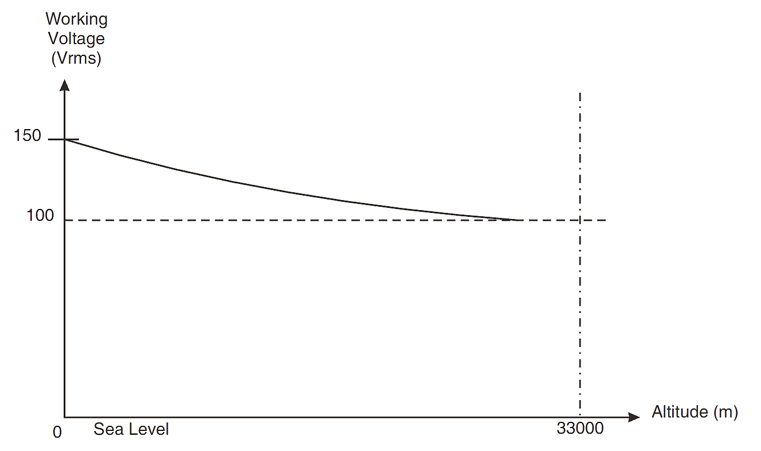
Working Voltage versus Altitude

FIGURE 2 - PHYSICAL DIMENSIONS
FIGURE 2(a) - CONNECTOR SHELLS
Plug Male Contacts
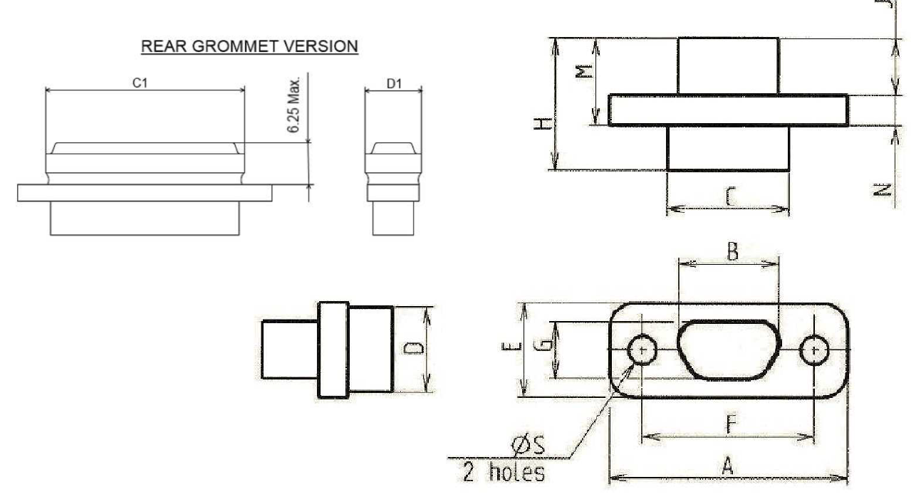

Shell Size | A  Max | B  Max | C  Max | D  Max | C1  Max | D1 Max | E  Max | F |  | G  Max | H  Max | J  Max | M  Max | N |  | ØS  (Note 2)
 |  |  |  |  |  |  |  | Min | Max |  |  |  |  | Min | Max | Min | Max
A | 19.94 | 8.48 | 10.16 | 6.86 | 11.7 | 8.45 | 7.82 | 14.22 | 14.48 | 4.69 | 10.82 | 4.72 | 7.21 | 2.23 | 2.49 | 2.23 | 2.39
B | 23.75 | 12.29 | 13.97 | 6.86 | 15.3 | 8.45 | 7.82 | 18.03 | 18.29 | 4.69 | 10.82 | 4.72 | 7.21 | 2.23 | 2.49 | 2.23 | 2.39
C | 27.56 | 16.1 | 17.78 | 6.86 | 19.1 | 8.45 | 7.82 | 21.84 | 22.1 | 4.69 | 10.82 | 4.72 | 7.21 | 2.23 | 2.49 | 2.23 | 2.39
D | 30.1 | 18.64 | 20.32 | 6.86 | 21.85 | 8.45 | 7.82 | 24.38 | 24.64 | 4.69 | 10.82 | 4.72 | 7.21 | 2.23 | 2.49 | 2.23 | 2.39
E | 33.91 | 22.45 | 24.13 | 6.86 | 25.7 | 8.45 | 7.82 | 28.19 | 28.45 | 4.69 | 10.82 | 4.72 | 7.21 | 2.23 | 2.49 | 2.23 | 2.39
F | 37.72 | 26.26 | 27.94 | 6.86 | 29.5 | 8.45 | 7.82 | 32 | 32.26 | 4.69 | 10.82 | 4.72 | 7.21 | 2.23 | 2.49 | 2.23 | 2.39
G | 36.45 | 24.99 | 26.67 | 7.87 | 28.25 | 9.45 | 8.92 | 30.73 | 30.99 | 5.78 | 10.82 | 4.72 | 7.21 | 2.23 | 2.49 | 2.23 | 2.39
H | 48.55 | 36.85 | 38.65 | 7.87 | 40.3 | 9.45 | 8.92 | 43.23 | 43.49 | 5.78 | 10.82 | 4.72 | 7.21 | 2.23 | 2.49 | 2.23 | 2.39
J | 62.75 | 45.1 | 47.65 | 11.25 | 49.25 | 12.85 | 12.5 | 54.72 | 54.98 | 9.25 | 10.82 | 4.72 | 7.21 | 2.23 | 2.49 | 3.68 | 3.83

RECEPTACLE FEMALE CONTACTS
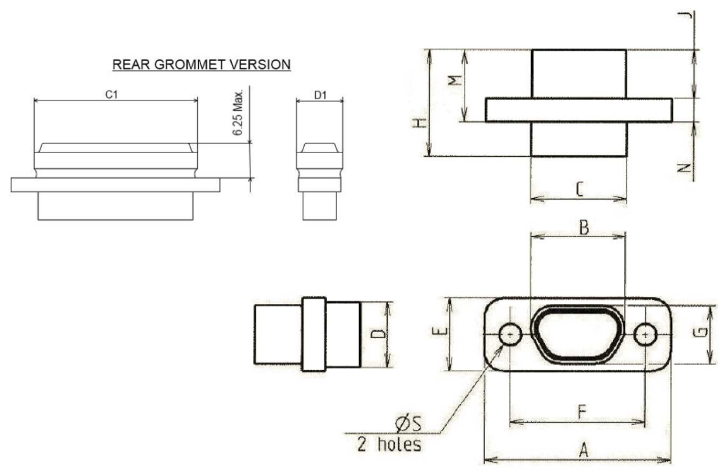
Shell Size | A  Max | B  Max | C  Max | D  Max | C1 Max | D1 Max | E  Max | F |  | G  Max | H  Max | J  Max | M  Max | N |  | ØS  (Note 2)
 |  |  |  |  |  |  |  | Min | Max |  |  |  |  | Min | Max | Min | Max
A | 19.94 | 10.16 | 10.16 | 6.86 | 11.7 | 8.45 | 7.82 | 14.22 | 14.48 | 6.38 | 11.11 | 5.05 | 7.54 | 2.23 | 2.49 | 2.23 | 2.39
B | 23.75 | 13.97 | 13.97 | 6.86 | 15.3 | 8.45 | 7.82 | 18.03 | 18.29 | 6.38 | 11.11 | 5.05 | 7.54 | 2.23 | 2.49 | 2.23 | 2.39
C | 27.56 | 17.78 | 17.78 | 6.86 | 19.1 | 8.45 | 7.82 | 21.84 | 22.1 | 6.38 | 11.11 | 5.05 | 7.54 | 2.23 | 2.49 | 2.23 | 2.39
D | 30.1 | 20.32 | 20.32 | 6.86 | 21.85 | 8.45 | 7.82 | 24.38 | 24.64 | 6.38 | 11.11 | 5.05 | 7.54 | 2.23 | 2.49 | 2.23 | 2.39
E | 33.91 | 24.13 | 24.13 | 6.86 | 25.7 | 8.45 | 7.82 | 28.19 | 28.45 | 6.38 | 11.11 | 5.05 | 7.54 | 2.23 | 2.49 | 2.23 | 2.39
F | 37.72 | 27.94 | 27.94 | 6.86 | 29.5 | 8.45 | 7.82 | 32 | 32.26 | 6.38 | 11.11 | 5.05 | 7.54 | 2.23 | 2.49 | 2.23 | 2.39
G | 36.45 | 26.67 | 26.67 | 7.87 | 28.25 | 9.45 | 8.92 | 30.73 | 30.99 | 7.47 | 11.11 | 5.05 | 7.54 | 2.23 | 2.49 | 2.23 | 2.39
H | 48.55 | 38.65 | 38.65 | 7.87 | 40.3 | 9.45 | 8.92 | 43.23 | 43.49 | 7.47 | 11.11 | 5.05 | 7.54 | 2.23 | 2.49 | 2.23 | 2.39
J | 62.75 | 46.8 | 47.65 | 11.25 | 49.25 | 12.85 | 12.5 | 54.72 | 54.98 | 10.94 | 11.11 | 5.05 | 7.54 | 2.23 | 2.49 | 3.68 | 3.83
NOTES:
            - All dimensions are in millimetres.
            - For shell size H only, the mounting holes may be as shown below. Such holes shall be centred as per the circular holes shown above.
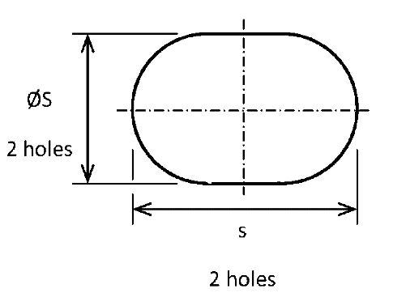
Dimension s shall be 2.76mm minimum and 2.99mm maximum.
            - Only the underlined dimensions shall be checked during procurement.
FIGURE 2(b) - CONTACT ARRANGEMENTS
front view male insert – use mirror view for female insert
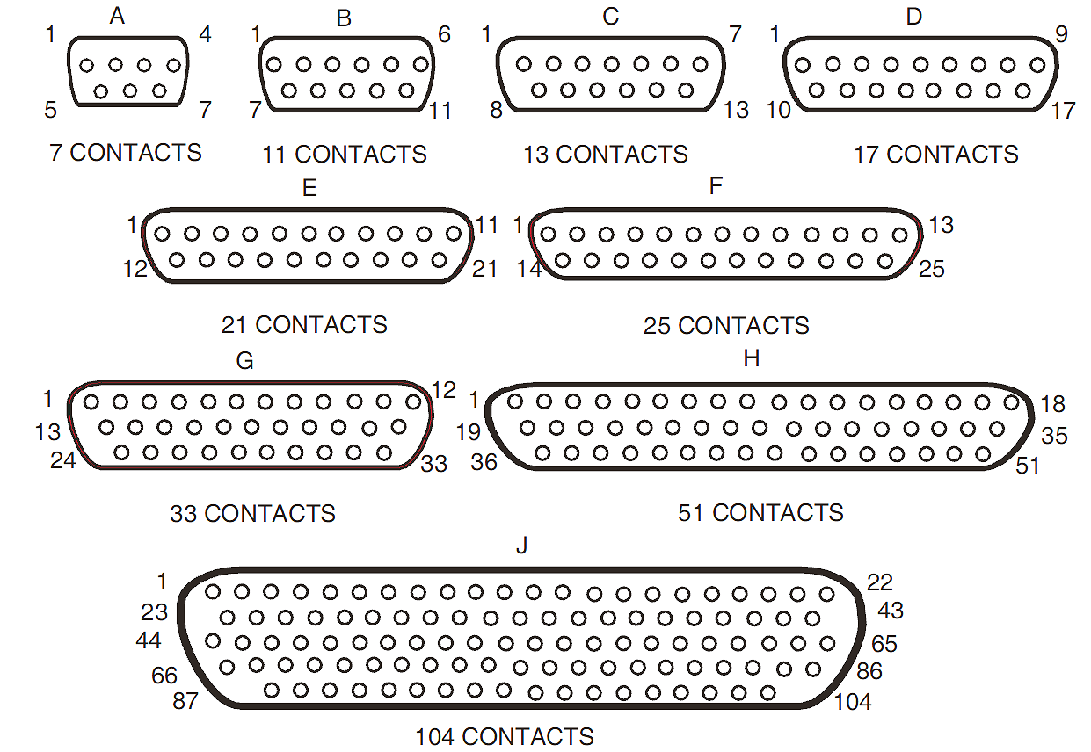
NOTES:
            - Only the outside contact cavities on each row are identified in the drawing, the remainder follow sequentially. Contact numbers are shown outside the insert for readability.
            - a = Distance between contact centres: 2mm typical.
b = Distance between rows: 1.732mm typical.
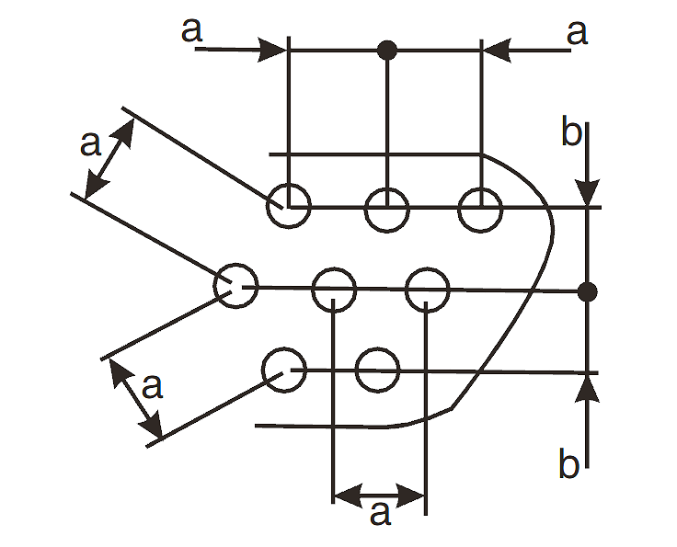
FIGURE 2(c) - MATING DIMENSIONS AND CONTACT POSITION
Mounting Condition
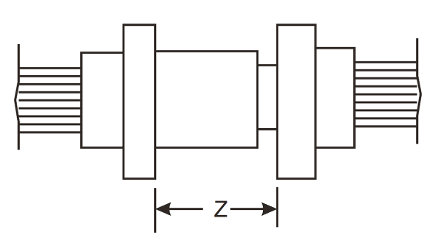
Plug Male Contact
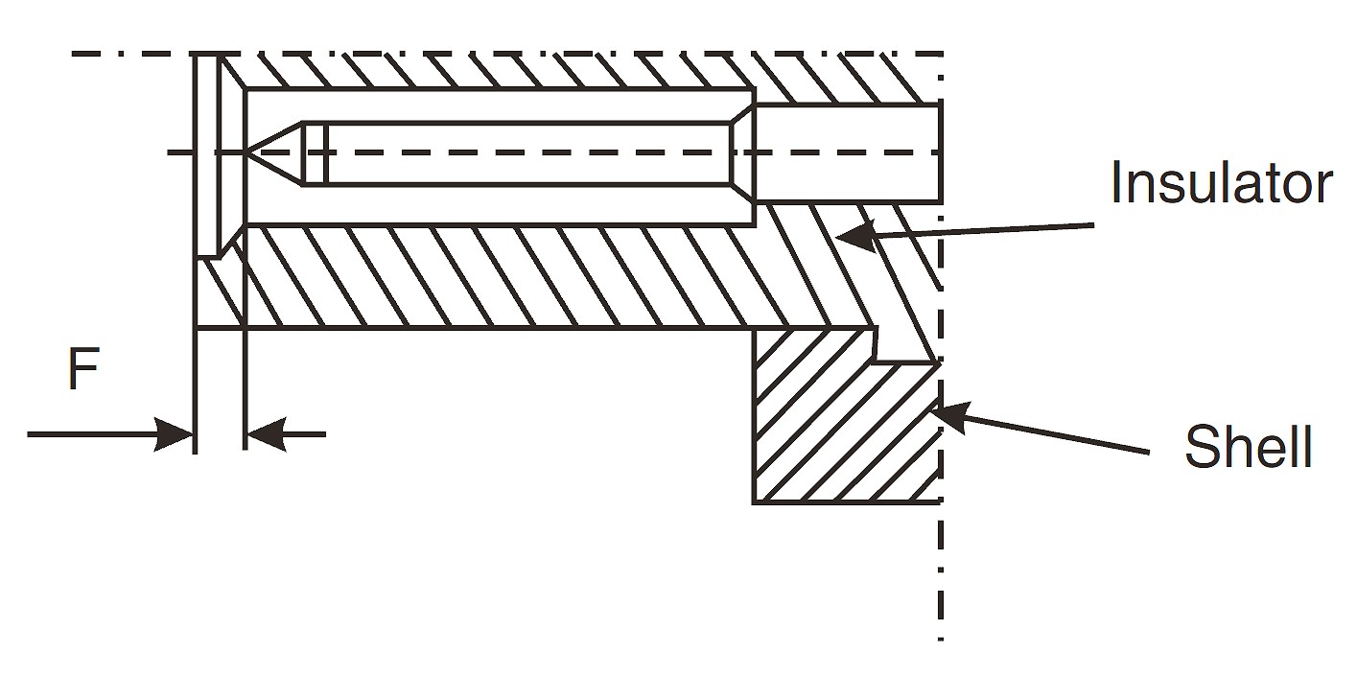
Receptacle Female Contact
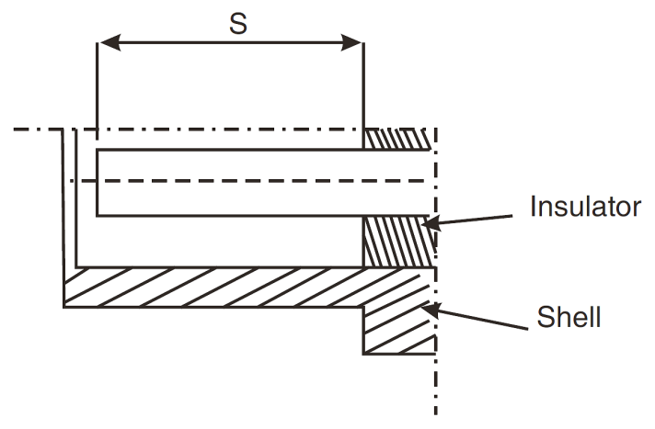
F |  | S |  | Z
Min | Max | Min | Max | Max
0.22 | 0.72 | 4.15 | 4.65 | 5.21
NOTES:
            - All dimensions are in millimetres.

REQUIREMENTS

GENERAL
The complete requirements for procurement of the components specified herein are stated in this specification and ESCC Generic Specification No. 3401. Deviations from the Generic Specification, applicable to this specification only, are detailed in Para. 4.2.
Deviations from the Generic Specification and this Detail Specification, formally agreed with specific Manufacturers on the basis that the alternative requirements are equivalent to the ESCC requirements and do not affect the components’ reliability, are listed in the appendices attached to this specification.

DEVIATIONS FROM GENERIC SPECIFICATION

Deviations from Special In-Process Controls
None.

Deviations from Final Production Tests (Chart II)
          - Para. 9.1.1.4, Mated Shell Conductivity: Not applicable.
          - Para. 9.9, Seal Test: Not applicable.

Deviations from Burn-in and Electrical Measurements (Chart III)
Chart III is not applicable.

Deviations from Qualification Tests (Chart IV)
          - Para. 9.1.1.4, Mated Shell Conductivity: Not applicable.
          - Para. 9.9, Seal Test: Not applicable.
          - Para. 9.24, Jackscrew Retention: Not applicable.
          - Para. 9.31, Solderability: Not applicable.

Deviations from Lot Acceptance Tests (Chart V)
          - Para. 9.1.1.4, Mated Shell Conductivity: Not applicable.
          - Para. 9.9, Seal Test: Not applicable.
          - Para. 9.24, Jackscrew Retention: Not applicable.
          - Para. 9.31, Solderability: Not applicable.

MECHANICAL REQUIREMENTS

Dimension Check
The dimensions of the connectors specified herein shall be verified in accordance with requirements set out in Para. 9.6 of ESCC Generic Specification No. 3401 and shall conform to those shown in Figure 2 of this specification.

Weight
The maximum weight of the connectors specified herein, without contacts, shall be as specified in Table 1(a).

Contact Capability
As specified in ESCC Detail Specification No. 3401/083.

Contact Retention (in Insert)
As specified in ESCC Detail Specification No. 3401/083.

Mating and Unmating Forces
The forces applied for the mating and unmating of the connectors shall conform to the values specified in Table 1(a).

Insert Retention (in Shell)
Connector inserts shall withstand a pressure of 34.4N/cm² without being dislodged from the shell.

Jackscrew Retention
Not applicable.

Contact Insertion and Withdrawal Forces
As specified in ESCC Detail Specification No. 3401/083.

Engagement and Separation Forces
As specified in ESCC Detail Specification No. 3401/083.

Oversize Pin Exclusion
As specified in ESCC Detail Specification No. 3401/083.

Probe Damage
As specified in ESCC Detail Specification No. 3401/083.

Solderability
Not applicable.

MATERIALS AND FINISHES
The materials and finishes shall be as specified herein. Where a definite material is not specified, a material which will enable the connectors specified herein to meet the performance requirements of this specification shall be used. Acceptance or approval of any constituent material does not guarantee acceptance of the finished product.

Shells
          - Variant 01:
Shells shall be made of glass-fibre reinforced thermoplastic. The plating shall be a minimum thickness of 1.27µm gold over 5µm minimum of electroless nickel or copper.
          - Variant 02
Shells shall be made of aluminium alloy. The plating shall be a minimum thickness of 1.27µm gold over 20µm minimum of electroless nickel.

Inserts and Grommet
Inserts shall be made of thermoplastic material.
The optional rear grommet shall be made of silicone elastomer.

Contacts
As specified in ESCC Detail Specification No. 3401/083.

Accessories
As specified in ESCC Detail Specification No. 3401/084.

Magnetism Level
The allowable value of magnetism shall not exceed that specified for the relevant level (see Para. 4.5.4.4). Only magnetism levels NMC and NMD are verified.

MARKING

General
The marking of all components delivered to this specification shall be in accordance with the requirements of ESCC Basic Specification No. 21700 and the following paragraphs. Each component shall be marked in respect of:
          - Contact Position.
          - The ESCC Component Number.
          - Characteristics.
          - Traceability Information.

Contact Position
The contact positions shall be marked on the insert in accordance with Figure 2(b).

The ESCC Component Number
Each component shall bear the ESCC Component Number which shall be constituted and marked as follows:
Example: 340108201B
- Detail Specification Number: 3401082
- Type Variant (see Table 1(a)): 01
- Testing Level: B

Characteristics
The characteristics to be marked in the following order of precedence are:
          - Alternative Design.
          - Shell Size.
          - Contact Arrangement.
          - Type of Contact.
          - Magnetism Level (only applicable to Variant 01).
          - Contact Information.
The information shall be constituted and marked as follows:
(example): GB11S-NMB-FO
- G: Rear Grommet Version
- Shell Size: B
- Contact Arrangement: 11
- Type of Contact: S
- Magnetism Level (200 gamma): NMB
- Contact Information: FO

Alternative Design
The letter G indicates a rear grommet dust proof version. The letter shall be omitted for the version without a rear grommet.

Shell Size and Contact Arrangement
Shell size shall be as designated in Table 1(a) and Figure 2(a). The shell size code also defines the contact arrangement. The layouts of the available contact arrangements are shown in Figure 2(b).

Type of Contact
Contact types shall be indicated by the following code letters.
Code Letter | Contact Type
P | Male
S | Female

Magnetism Level
The following codes shall be used for magnetism level. Magnetism level is not applicable to Variant 02 and therefore the magnetism level code shall be omitted.
Code | Definition
NMB | Magnetism Level: ≤ 200 gamma
NMC | Magnetism Level: ≤ 20 gamma
NMD | Magnetism Level: ≤ 2 gamma

Contact Information
-FO = Connector ordered without contacts. This information shall not be marked on the connector; it is only included on the packaging and all relevant data documentation.
Contacts must be from the same Manufacturer as the connector in which they are fitted and this shall be verified prior to assembly.

Traceability Information
Traceability information shall be marked in accordance with the requirements of ESCC Basic Specification No. 21700.

ELECTRICAL MEASUREMENTS

Electrical Measurements at Room Temperature
The parameters to be measured at room temperature are scheduled in Table 2. Unless otherwise specified, measurements shall be performed at T_{amb} = +22 ±3°C.

Electrical Measurements at High and Low Temperatures (Table 3)
Not applicable.

Circuits for Electrical Measurements (Figure 4)
Not applicable.

BURN-IN AND ELECTRICAL MEASUREMENTS (TABLES 4 AND 5)
Not applicable.
TABLE 2 - ELECTRICAL MEASUREMENTS AT ROOM TEMPERATURE
No. | Characteristic | Symbol | ESCC 3401  Test Method | Test Condition | Limits |  | Unit
 |  |  |  |  | Min | Max | Unit
1 | Insulation Resistance | R_{i} | Para. 9.1.1.1 | Para. 9.1.1.1 | 5000 | - | MΩ
2 | Voltage Proof Leakage Current | I_{L} | Para. 9.1.1.2 | 600Vrms | - | 2 | mA
tables 3, 4 and 5
Not applicable.

ENVIRONMENTAL AND ENDURANCE TESTS (CHARTS IV AND V OF ESCC GENERIC SPECIFICATION No. 3401)

Measurements and Inspections on Completion of Environmental Tests
The parameters to be measured and inspections to be performed on completion of environmental testing are scheduled in Table 6. Unless otherwise specified, the measurements shall be performed at T_{amb} = +22 ±3°C.

Measurements and Inspections at Intermediate Points during Endurance Tests
Not applicable.

Measurements and Inspections on Completion of Endurance Tests
The parameters to be measured and inspections to be performed on completion of endurance testing are scheduled in Table 6. Unless otherwise specified, the measurements shall be performed at T_{amb} = +22 ±3°C.

Conditions for Operating Life Test (Part of Endurance Testing) (Table 5)
Not applicable.

Electrical Circuit for Operating Life Test (Figure 5)
Not applicable.

Conditions for High Temperature Storage Test (Part of Endurance Testing)
The requirements for the high temperature storage test are specified in Section 9 of ESCC Generic Specification No. 3401. The conditions for high temperature storage testing shall be the maximum storage temperature specified in Table 1(b) of this specification.
Table 6 - MEASUREMENTS AND INSPECTIONS ON COMPLETION OF ENVIRONMENTAL AND ENDURANCE TESTING
No. | ESCC Generic Spec. No. 3401 |  | Measurements and Inspections |  | Symbol | Limits |  | Unit
No. | Environmental and Endurance Tests  (Note 1) | Test Method and  Conditions | Identification | Conditions | Symbol | Min | Max | Unit
01 | Wiring | Para. 9.10 | ESCC 3401/083 | - | - | - | -
02 | Vibration | Para. 9.11 | Initial Measurements  Coupling screw(s)  Unlocking Torque | - | Tq | Record Values |  | Nm
 |  |  | Final Measurements Full Engagement
 |  |  | Coupling screw(s)  Unlocking Torque Drift | - | ΔTq/Tq | -25 | +25 | %
 |  |  | Visual Examination | - | - | - | - | -
03 | Shock or Bump | Para. 9.12 | Full Engagement  Visual Examination | - | - | - | -
04 | Climatic Sequence | Para. 9.13 | Dry Heat  Insulation Resistance | Table 2, Item 1 | R_{i} | 10 | - | MΩ
 |  |  | Low Air Pressure  Voltage Proof Leakage Current | Figure 1 | I_{L} | Table 2, Item 2 |  | mA
 |  |  | Damp Heat  Insulation Resistance | Immediately after test  Table 2, Item 1 | R_{i} | 1 | - | MΩ
 |  |  | Final Measurements | After 1-24hrs recovery
 |  |  | External Visual Inspection | ESCC 3401  Para. 9.7 | - | ESCC 3401  Para. 9.7
 |  |  | Insulation Resistance | Table 2, Item 1 | R_{i} | Table 2, Item 1 |  | MΩ
 |  |  | Voltage Proof Leakage Current | Table 2, Item 2 | I_{L} | Table 2, Item 2 |  | mA
05 | Plating Thickness | Para. 9.14 | Thickness | - | - | Para. 4.4.1 of this spec.
06 | Rapid Change of Temperature | Para. 9.16 | Visual Examination | - | - | - | -
 | Rapid Change of Temperature |  | Insulation Resistance | Table 2, Item 1 | R_{i} | Table 2, Item 1 |  | MΩ
 |  |  | Voltage Proof Leakage Current | Table 2, Item 2 | I_{L} | Table 2, Item 2 |  | mA
07 | Contact Retention (in Insert) | Para. 9.17 & Para. 4.3.4 of this spec. | Contact Displacement | - | - | ESCC 3401  Para. 9.17
08 | Endurance | Para. 9.18. | Initial Measurements
 |  |  | Mating/Unmating Forces | - | F | Para. 4.3.5 of this spec. |  | N
 |  |  | Low Level Contact Resistance | ESCC 3401/083 | R_{cl} | ESCC 3401/083  Record Values |  | mΩ
 |  |  | Final Measurements  Visual Examination | - | - | - | -
 |  |  | Mating/Unmating Forces | - | F | Para. 4.3.5 of this spec. |  | N
 |  |  | Low Level Contact  Resistance Drift | ESCC 3401/083 | ΔR_{cl} | ESCC 3401/083 |  | mΩ
 |  |  | Insulation Resistance | Table 2, Item 1 | R_{i} | Table 2, Item 1 |  | MΩ
 |  |  | Voltage Proof Leakage Current | Table 2, Item 2 | I_{L} | Table 2, Item 2 |  | mA
09 | Permanence of Marking | Para. 9.19 | As applicable | - | - | - | -
10 | Mating/Unmating Forces | Para. 9.20 | Force | - | F | Para. 4.3.5 of this spec. |  | N
11 | High Temperature Storage | Para. 9.21 | Initial Measurements  Low Level Contact Resistance | ESCC 3401/083 | R_{cl} | ESCC 3401/083  Record Values |  | mΩ
 |  |  | Final Measurements  Visual Examination | - | - | - | -
 |  |  | Mating/Unmating Forces | - | F | Para. 4.3.5 of this spec. |  | N
 |  |  | Low Level Contact Resistance Drift | ESCC 3401/083 | ΔR_{cl} | ESCC 3401/083 |  | mΩ
 |  |  | Rated Current Contact Resistance | ESCC 3401/083 | R_{cr} | ESCC 3401/083 |  | mΩ
 |  |  | Insulation Resistance | Table 2, Item 1 | R_{i} | Table 2, Item 1 |  | MΩ
 |  |  | Voltage Proof Leakage Current | Table 2, Item 2 | I_{L} | Table 2, Item 2 |  | mA
 |  |  | Contact Retention (in Insert) | Para. 4.3.4 of this spec | - | ESCC 3401 Para. 9.17 |  | N
12 | Corrosion | Para. 9.22 | Visual Examination | - | - | - | -
13 | Insert Retention (in Shell) | Para. 9.23 & Para. 4.3.6 of this spec. | Visual Examination | - | - | Para. 4.3.6 of this spec.
14 | High Temperature Measurements | Para. 9.25 | Insulation Resistance | Table 2, Item 1  (Note 2) | R_{i} | 10 | - | MΩ
15 | Overload Test | Para. 9.26 | Internal Temperature | - | T | - | +100 | °C
 |  |  | Rated Current Contact Resistance | ESCC 3401/083 | R_{cr} | ESCC 3401/083 |  | mΩ
 |  |  | Insulation Resistance | Table 2, Item 1 | R_{i} | Table 2, Item 1 |  | MΩ
 |  |  | Voltage Proof Leakage Current | Table 2, Item 2 | I_{L} | Table 2, Item 2 |  | mA
16 | Maintenance Aging | Para. 9.27 | Visual Examination | - | - | - | -
 |  |  | Contact Retention | Para. 4.3.4 of this spec | - | ESCC 3401 Para. 9.17 |  | N
 |  |  | Contact Insertion & Withdrawal Forces | Para. 4.3.4 of this spec | - | Para. 4.3.8 of this spec |  | N
17 | Engage/Separation Forces | Para. 9.28 and Para. 4.3.9 of this spec. | Force | - | F | Para. 4.3.9 of this spec |  | N
18 | Oversize Pin Exclusion | Para. 9.29 and Para. 4.3.10 of this spec. | - | - | - | Para. 4.3.10 of this spec
19 | Probe Damage | Para. 9.30 and Para. 4.3.11 of this spec. | Contact Separation Force | - | F | Para. 4.3.11 of this spec |  | N
Notes:
            - The tests in this table refer to either Chart IV or V and shall be used as applicable.
            - T_{amb} = +125°C.

