

Page 1 of 27
CONNECTORS, ELECTRICAL, RECTANGULAR, MICROMINIATURE, NON-REMOVABLE GAUGE 26 PCB PIN CONTACTS
BASED ON TYPE 8MCG
ESCC Detail Specification No. 3401/081

Issue 6 Dft A | May 2018



Document Custodian: European Space Agency – see https://escies.org

Legal Disclaimer and Copyright
European Space Agency, Copyright © 2018. All rights reserved.
The European Space Agency disclaims any liability or responsibility, to any person or entity, with respect to any loss or damage caused, or alleged to be caused, directly or indirectly by the use and application of this ESCC publication.
This publication, without the prior permission of the European Space Agency and provided that it is not used for a commercial purpose, may be:
- copied in whole, in any medium, without alteration or modification.
- copied in part, in any medium, provided that the ESCC document identification, comprising the ESCC symbol, document number and document issue, is removed.

DOCUMENTATION CHANGE NOTICE
(Refer to https://escies.org for ESCC DCR content)
DCR No. | CHANGE DESCRIPTION
tbc | Specification upissued to incorporate editorial changes per DCR.

TABLE OF CONTENTS
1 General 6
1.1 SCOPE 6
1.2 COMPONENT TYPE VARIANTS AND RANGE OF COMPONENTS 6
1.3 MAXIMUM RATINGS 6
1.4 PARAMETER DERATING INFORMATION 6
1.5 PHYSICAL DIMENSIONS 6
2 APPLICABLE DOCUMENTS 6
3 TERMS, DEFINITIONS, ABBREVIATIONS, SYMBOLS AND UNITS 6
4 REQUIREMENTS 18
4.1 GENERAL 18
4.2 DEVIATIONS FROM GENERIC SPECIFICATION 18
4.2.1 Deviations from Special In-Process Controls 18
4.2.2 Deviations from Final Production Tests (Chart II) 19
4.2.3 Deviations from Burn-in and Electrical Measurements (Chart III) 19
4.2.4 Deviations from Qualification Tests (Chart IV) 19
4.2.5 Deviations from Lot Acceptance Tests (Chart V) 19
4.3 MECHANICAL REQUIREMENTS 19
4.3.1 Dimension Check 19
4.3.2 Weight 19
4.3.3 Contact Capability 19
4.3.4 Contact Retention (in Insert) 19
4.3.5 Mating and Unmating Forces 19
4.3.6 Insert Retention (in Shell) 19
4.3.7 Jackscrew Retention 20
4.3.8 Contact Insertion and Withdrawal Forces 20
4.3.9 Engagement and Separation Forces 20
4.3.10 Oversize Pin Exclusion 20
4.3.11 Probe Damage 20
4.3.12 Solderability 20
4.4 MATERIALS AND FINISHES 20
4.4.1 Shells 20
4.4.2 Inserts 20
4.4.3 Contacts 20
4.4.4 Brackets 20
4.4.5 Accessories 20
4.4.6 Magnetism Level 20
4.5 MARKING 21
4.5.1 General 21
4.5.2 Contact Position 21
4.5.3 The ESCC Component Number 21
4.5.4 Characteristics 21
4.5.4.1 Shell Size and Contact Arrangement 21
4.5.4.2 Type of Contact 21
4.5.4.3 Magnetism Level 22
4.5.4.4 Contact Termination Code 22
4.5.5 Traceability Information 22
4.6 ELECTRICAL MEASUREMENTS 22
4.6.1 Electrical Measurements at Room Temperature 22
4.6.2 Electrical Measurements at High and Low Temperatures (Table 3) 22
4.6.3 Circuits for Electrical Measurements (Figure 4) 22
4.7 BURN-IN AND ELECTRICAL MEASUREMENTS (TABLES 4 AND 5) 22
4.8 ENVIRONMENTAL AND ENDURANCE TESTS (CHARTS IV AND V OF ESCC GENERIC SPECIFICATION NO. 3401) 23
4.8.1 Measurements and Inspections on Completion of Environmental Tests 23
4.8.2 Measurements and Inspections at Intermediate Points During Endurance Tests 23
4.8.3 Measurements and Inspections on Completion of Endurance Tests 23
4.8.4 Conditions for Operating Life Test (Part of Endurance Testing) (Table 5) 23
4.8.5 Electrical Circuit for Operating Life Test (Figure 5) 23
4.8.6 Conditions for High Temperature Storage Test (Part of Endurance Testing) 23
appendix ‘a’ 27

General

SCOPE
This specification details the ratings, physical and electrical characteristics, test and inspection data for Connectors, Electrical, Rectangular, Microminiature, Non-removable Gauge 26 PCB Pin Contacts, based on Type 8MCG.
The following ESCC Specifications, the requirements of which are supplemented herein, are associated with this specification:
- ESCC Generic Specification No. 3401, Connectors, Electrical, Non-Filtered, Circular and Rectangular.
- ESCC Detail Specification No. 3401/082, Connectors, Electrical, Rectangular, Microminiature, Removable Gauge 26 Crimp Contacts, Based on Type 8MCG.
- ESCC Detail Specification No. 3401/084, Accessories for Rectangular Connectors, Microminiature, 3401/081, 3401/082 and Connector Savers 3401/088.
- ESCC Detail Specification No. 3401/088, Connector Savers, Electrical, Rectangular, Microminiature, Non-removable Gauge 26 Contacts, Based on Type 8MCG.

COMPONENT TYPE VARIANTS AND RANGE OF COMPONENTS
The different sizes of the connectors and contact types specified herein, which are also covered by this specification, together with their mechanical characteristics, are scheduled in Table 1(a).

MAXIMUM RATINGS
The maximum ratings, which shall not be exceeded at any time during use or storage, applicable to the connectors specified herein, are scheduled in Table 1(b).

PARAMETER DERATING INFORMATION
The derating information applicable to the connectors specified herein is shown in Figure 1.

PHYSICAL DIMENSIONS
The physical dimensions of the connectors specified herein, and the available contact arrangements, are shown in Figure 2.

APPLICABLE DOCUMENTS
The following documents form part of this specification and shall be read in conjunction with it:
          - ESCC Generic Specification No. 3401, Connectors, Electrical, Non-Filtered, Circular and Rectangular.
          - ESCC Detail Specification No. 3401/084, Accessories for Rectangular Connectors, Microminiature, 3401/081, 3401/082 and Connector Savers 3401/088.
          - ESCC Detail Specification No. 3401/088, Connector Savers, Electrical, Rectangular, Microminiature, Non-removable Gauge 26 Contacts, Based on Type 8MCG.

TERMS, DEFINITIONS, ABBREVIATIONS, SYMBOLS AND UNITS
For the purpose of this specification, the terms, definitions, abbreviations, symbols and units specified in ESCC Basic Specification No. 21300 shall apply.
TABLE 1(a) - COMPONENT TYPE VARIANTS AND RANGE OF COMPONENTS
SHELL SIZES
Shell Size  (Note 1) | Weight Max (g) (Notes 2, 3) |  | Mating Force  (N) Max | Unmating Force (N)
Shell Size  (Note 1) | Variant 01 (Note 4) | Variant 02 (Note 4) | Mating Force  (N) Max | Min | Max
A | 1.05 | 1.35 | 11.9 | 0.95 | 11.9
B | 1.35 | 1.75 | 18.7 | 1.5 | 18.7
C | 1.6 | 2.15 | 22.1 | 1.8 | 22.1
D | 1.8 | 2.35 | 28.9 | 2.35 | 28.9
E | 2.1 | 2.7 | 35.7 | 2.9 | 35.7
F | 2.35 | 2.95 | 42.5 | 3.5 | 42.5
G | 2.5 | 3.15 | 56.1 | 4.6 | 56.1
H | 3.44 | 4.2 | 86.7 | 7.1 | 86.7
J | 6.1 | 7.3 | 178.8 | 14.5 | 178.8
CONTACT TYPES
Contact Termination Code  (Note 5) | Contact Type Description | Weight of Contact  (g)  (Note 3)
OL3 | Gauge 26 straight PCB solder contact | 0.08
1AON | Gauge 26 90° PCB solder contact (2.54mm row spacing) | 0.09 (Note 6)  0.097 (Note 7)  0.11 (Note 8)
1BON | Gauge 26 90° PCB solder contact (2.84mm row spacing) | 0.093 (Note 6)  0.1 (Note 7)  0.12 (Note 8)
1A7N or 1B7N | Gauge 26 90° PCB solder contact (1A7N has 2.54mm row spacing; 1B7N has 2.84mm row spacing)  Connector equipped with 90° bracket and jackpost kits (Note 9)  Jackpost kit has either 2-56 nut or 4-40 nut (Note 10) | For 1A7N see  1AON above;  For 1B7N see 1BON above
NOTES:
            - See Figure 2(a).
            - Weights without contacts or accessories.
            - The total weight of the connector shall be calculated from the number of contacts (see Figure 2(b)) multiplied by the applicable Weight of Contact plus the connector weight and, where applicable, the weight of a 90° bracket and jackpost kit (see Note 9 below).
            - Refer to Para. 4.4.1 for definition of the Type Variants.
            - See Figure 2(c).
            - Average weight for Shell Sizes A, B, C, D, E, F.
            - Average weight for Shell Sizes G, H.
            - Average weight for Shell Size J.
            - Weight of a bracket and jackpost kit is 3.5g.
            - Jackpost kit with 4-40 nut applies to shell size J only.
TABLE 1(b) - MAXIMUM RATINGS
No. | Characteristics | Symbol | Maximum Ratings | Unit | Remarks
1 | Working Voltage Sea Level | U_{R} | 150 | Vrms | Note 1
2 | Rated Current | I_{R} | 2.5 | A
3 | Operating Temperature Range | T_{op} | -55 to +125 | °C | T_{amb}
4 | Storage Temperature Range | T_{stg} | -65 to +125 | °C
5 | Soldering Temperature | T_{sol} | +260 | °C | Note 2
NOTES:
            - Between contact and shell.
            - Duration 10 seconds maximum and the same contact shall not be resoldered until 3 minutes have elapsed.
FIGURE 1 - PARAMETER DERATING INFORMATION
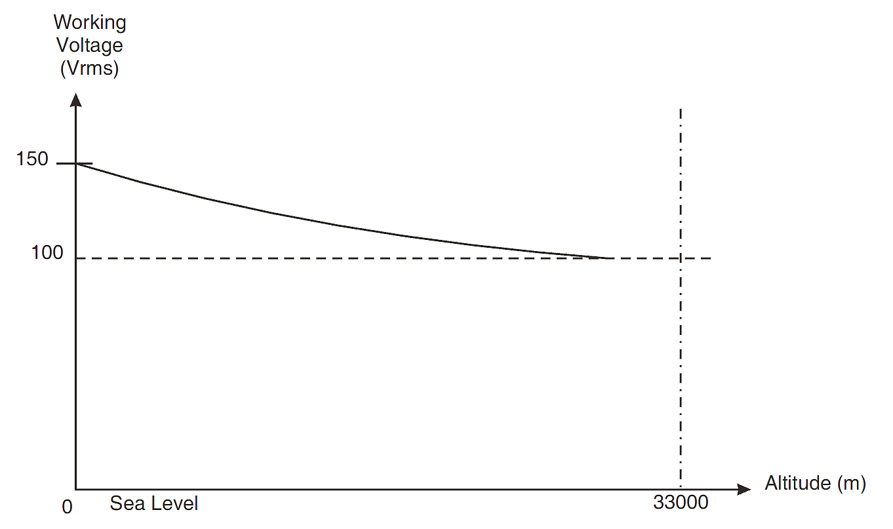

FIGURE 2 - PHYSICAL DIMENSIONS
FIGURE 2(a) - CONNECTOR SHELL
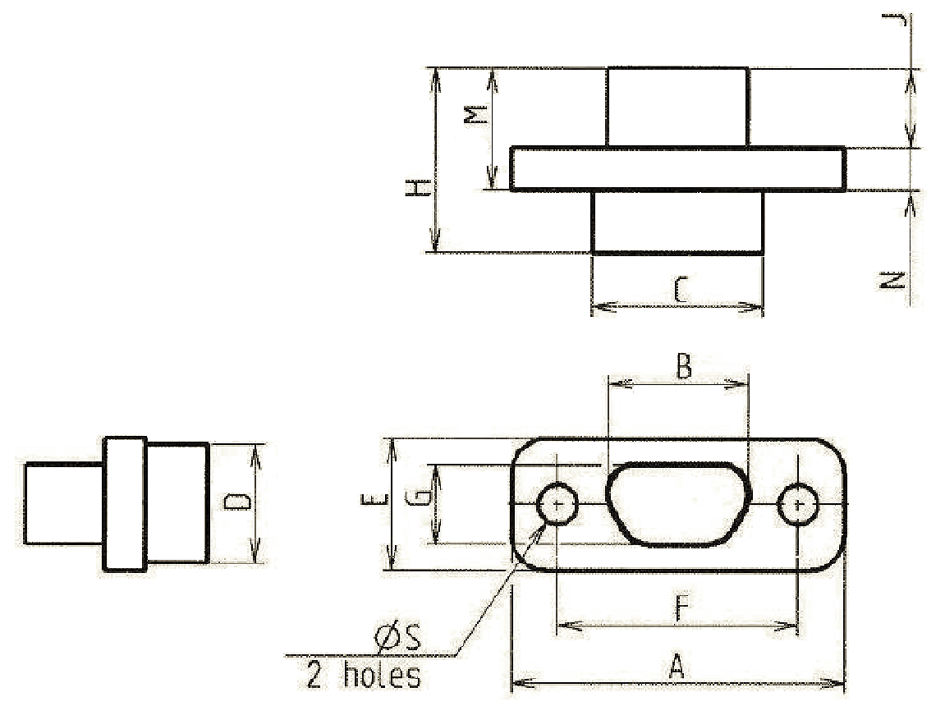
Shell Size | A  Max | B  Max | C  Max | D  Max | E  Max | F |  | G  Max | H  Max | J  Max | M  Max | N |  | ØS  (Note 2)
 |  |  |  |  |  | Min | Max |  |  |  |  | Min | Max | Min | Max
A | 19.94 | 8.48 | 10.16 | 6.86 | 7.82 | 14.22 | 14.48 | 4.69 | 10.82 | 4.72 | 7.21 | 2.23 | 2.49 | 2.26 | 2.39
B | 23.75 | 12.29 | 13.97 | 6.86 | 7.82 | 18.03 | 18.29 | 4.69 | 10.82 | 4.72 | 7.21 | 2.23 | 2.49 | 2.26 | 2.39
C | 27.56 | 16.1 | 17.78 | 6.86 | 7.82 | 21.84 | 22.1 | 4.69 | 10.82 | 4.72 | 7.21 | 2.23 | 2.49 | 2.26 | 2.39
D | 30.1 | 18.64 | 20.32 | 6.86 | 7.82 | 24.38 | 24.64 | 4.69 | 10.82 | 4.72 | 7.21 | 2.23 | 2.49 | 2.26 | 2.39
E | 33.91 | 22.45 | 24.13 | 6.86 | 7.82 | 28.19 | 28.45 | 4.69 | 10.82 | 4.72 | 7.21 | 2.23 | 2.49 | 2.26 | 2.39
F | 37.72 | 26.26 | 27.94 | 6.86 | 7.82 | 32 | 32.26 | 4.69 | 10.82 | 4.72 | 7.21 | 2.23 | 2.49 | 2.26 | 2.39
G | 36.45 | 24.99 | 26.67 | 7.87 | 8.92 | 30.73 | 30.99 | 5.78 | 10.82 | 4.72 | 7.21 | 2.23 | 2.49 | 2.26 | 2.39
H | 48.55 | 36.85 | 38.65 | 7.87 | 8.92 | 43.23 | 43.49 | 5.78 | 10.82 | 4.72 | 7.21 | 2.23 | 2.49 | 2.26 | 2.39
J | 62.75 | 46.8 | 47.65 | 11.25 | 12.5 | 54.72 | 54.98 | 9.25 | 10.82 | 4.72 | 7.21 | 2.23 | 2.49 | 3.7 | 3.83
NOTES:
            - All dimensions are in millimetres.
            - For shell size H only, the mounting holes may be as shown below. Such holes shall be centred as per the circular holes shown above.
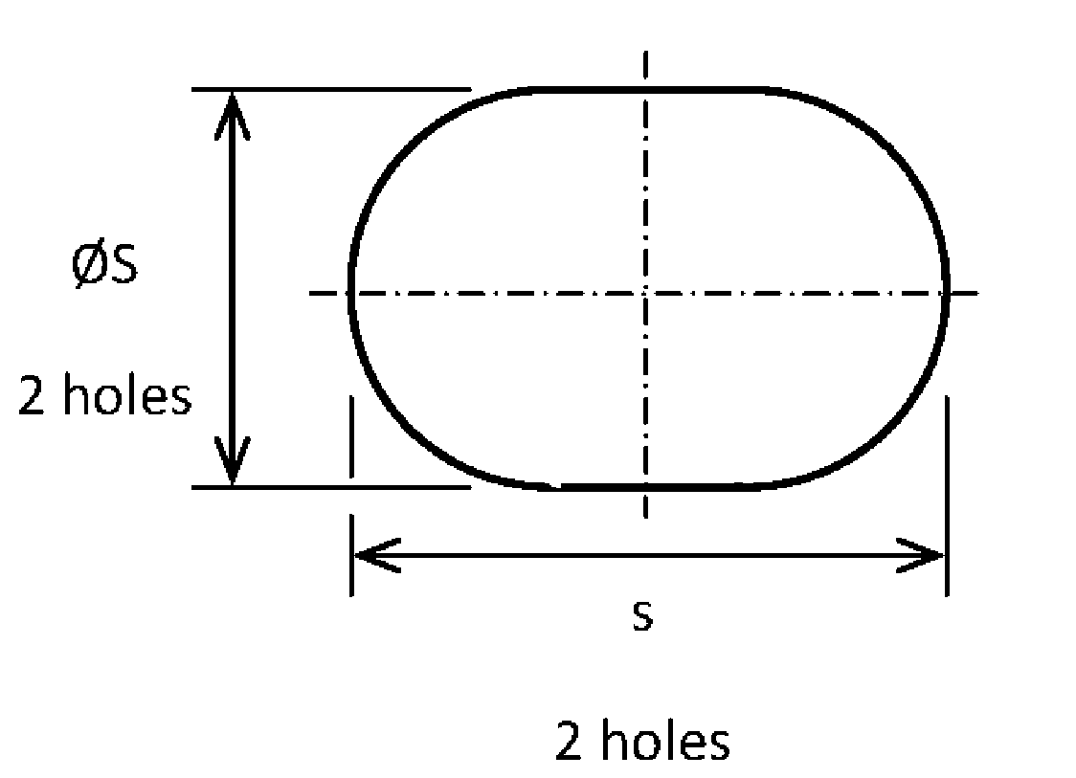
Dimension s shall be 2.76mm minimum and 2.99mm maximum.
            - Only the underlined dimensions shall be checked during procurement.
FIGURE 2(b) - CONTACT ARRANGEMENTS
FRONT VIEW MALE INSERT
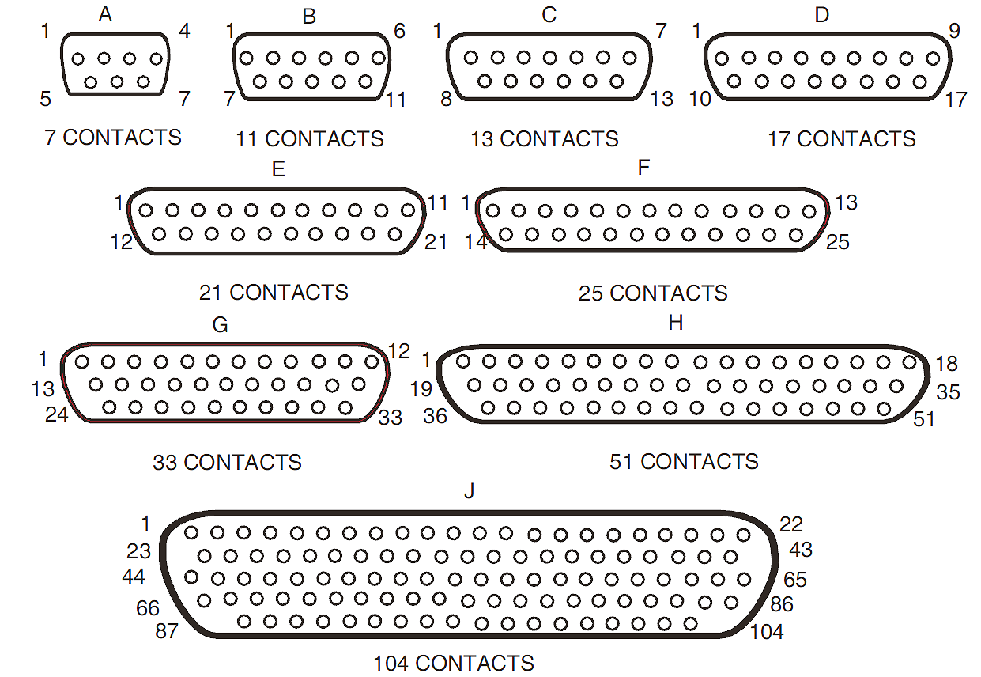
NOTES:
            - Only the outside contact cavities on each row are identified in the drawing, the remainder follow sequentially. Contact numbers are shown outside the insert for readability.
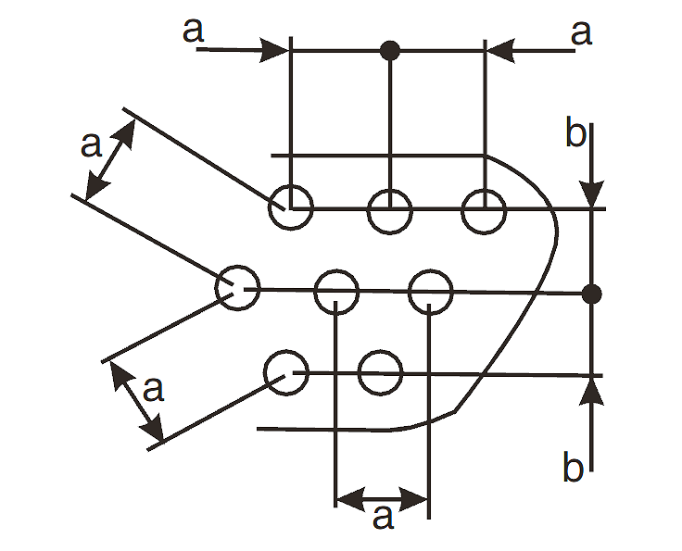
            - a = Distance between contact centres: 2mm typical.
b = Distance between rows: 1.732mm typical.
FIGURE 2(c) - REAR END
Gauge 26 Straight PCB Solder Contacts (Code OL3)
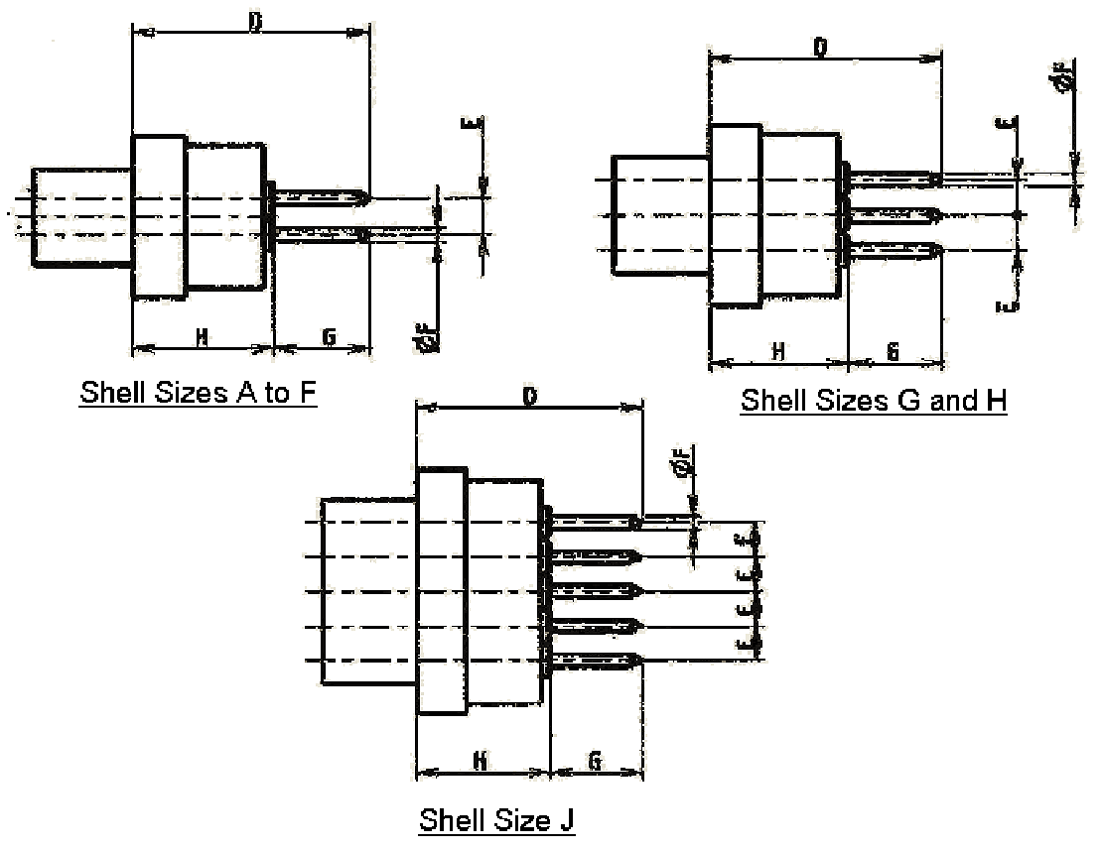
Pitch between contacts (all Shell Sizes): 2
Symbol  Dim. | D | E | ØF | G (Note 2) | H
Min | - | 1.662 | 0.48 | 4.4 | -
Max | 11.7 | 1.802 | 0.55 | 4.6 | 7
NOTES:
            - All dimensions are in millimetres.
            - This dimension is the length of the PCB tail extension of the contact.
            - Only the underlined dimensions shall be checked during procurement.
Gauge 26 90° PCB Solder Contacts (Shell Sizes A to F) (Codes 1AON, 1BON)
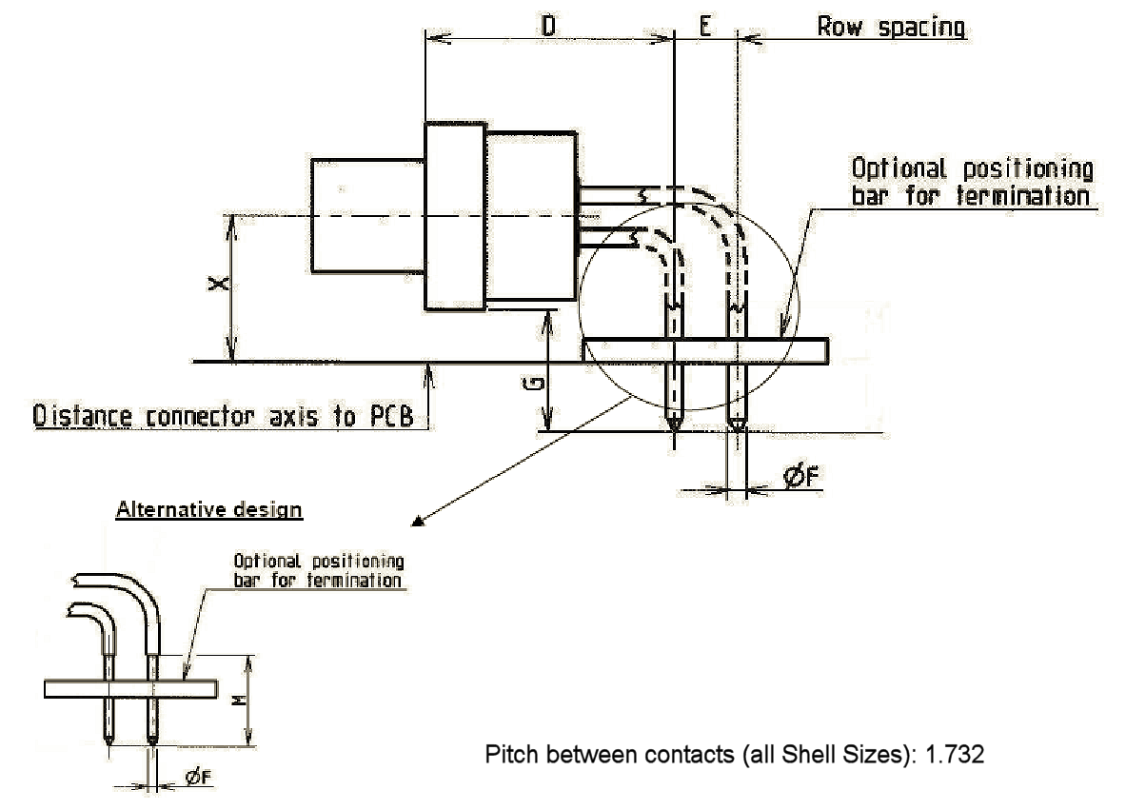
Symbol  Dim. | D | E |  | ØF | G | M | X
Symbol  Dim. | D | 1AON | 1BON
Min | 9.95 | 2.49 | 2.79 | 0.48 | 4.7 | 5.3 | 4.9
Max | 10.45 | 2.59 | 2.89 | 0.55 | 5.3 | - | 5.1
NOTES:
            - All dimensions are in millimetres.
            - Only the underlined dimensions shall be checked during procurement.

Gauge 26 90° PCB Solder Contacts (Shell Sizes G and H) (Codes 1AON, 1BON)
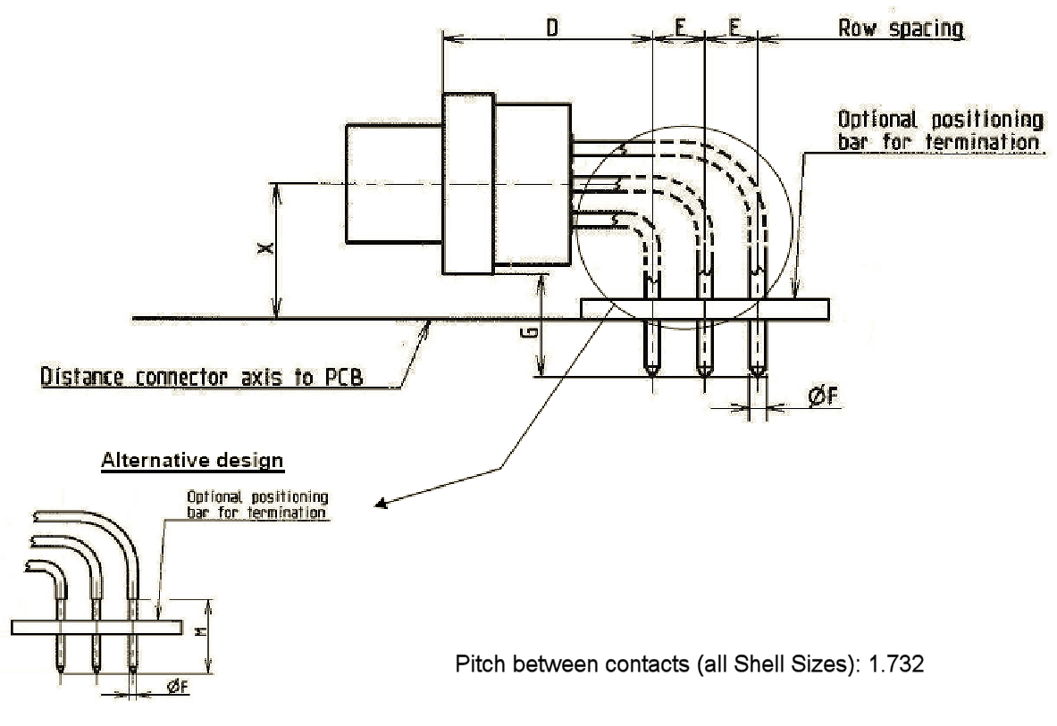
Symbol  Dim. | D | E |  | ØF | G | M | X
Symbol  Dim. | D | 1AON | 1BON
Min | 9.95 | 2.49 | 2.79 | 0.48 | 4.7 | 5.3 | 5.5
Max | 10.45 | 2.59 | 2.89 | 0.55 | 5.3 | - | 5.7
NOTES:
            - All dimensions are in millimetres.
            - Only the underlined dimensions shall be checked during procurement.

Gauge 26 90° PCB Solder Contacts (Shell Size J) (Codes 1AON, 1BON)
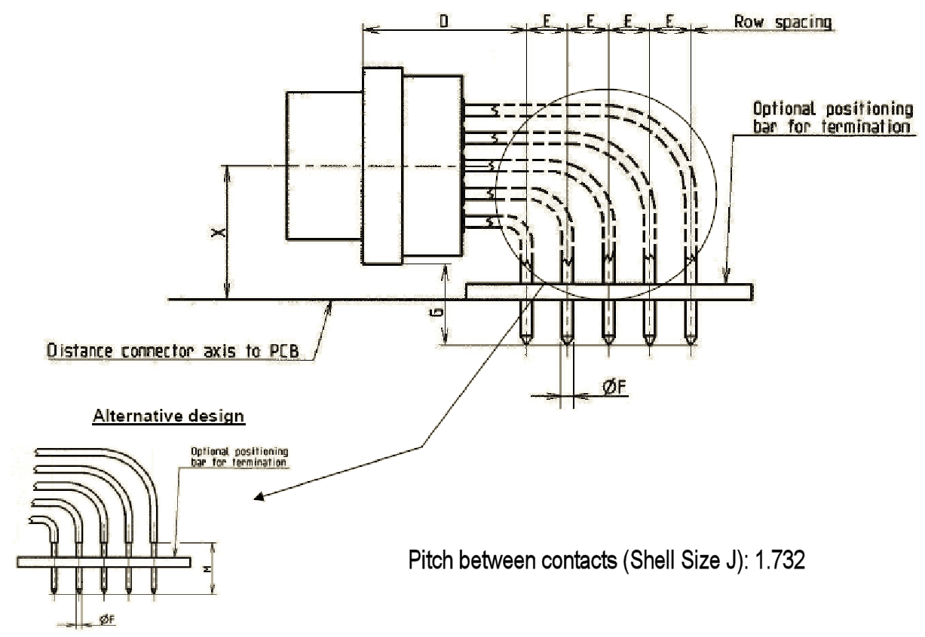
Symbol  Dim. | D | E |  | ØF | G | M | X
Symbol  Dim. | D | 1AON | 1BON
Min | 9.95 | 2.49 | 2.79 | 0.48 | 4.7 | 5.3 | 7.25
Max | 10.45 | 2.59 | 2.89 | 0.55 | 5.3 | - | 7.45
NOTES:
            - All dimensions are in millimetres.
            - Only the underlined dimensions shall be checked during procurement.

Gauge 26 90° PCB Solder Contacts with Brackets and Jackpost Kits (Shell Sizes A to F) (Codes 1A7N, 1B7N)
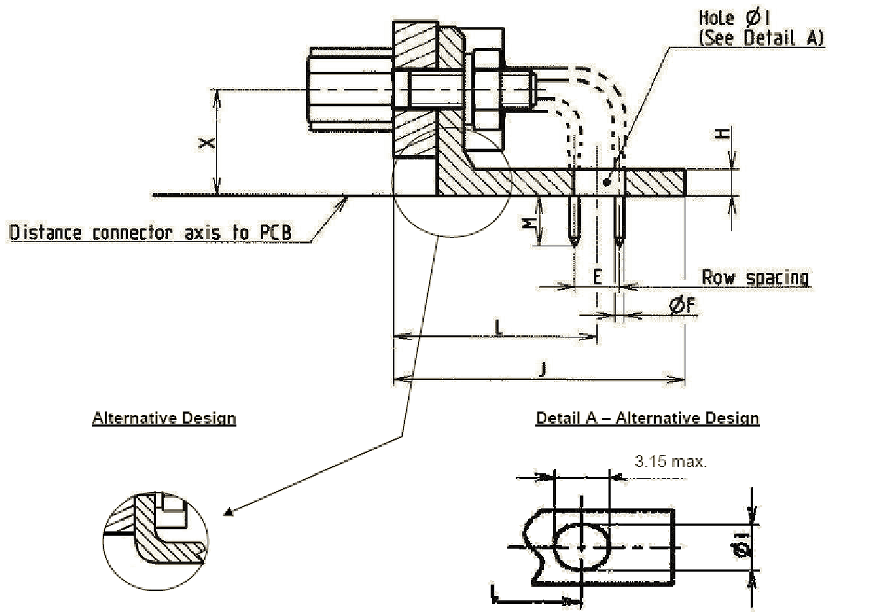
Symbol  Dim. | E |  | ØF | H | ØI | J | L | M | X
Symbol  Dim. | 1A7N | 1B7N
Min | 2.49 | 2.79 | 0.48 | 1.4 | 2.34 | - | 11.28 | 3.42 | 4.9
Max | 2.59 | 2.89 | 0.55 | 2.1 | 2.54 | 16.6 | 11.78 | 4.22 | 5.1
NOTES:
            - All dimensions are in millimetres.
            - See Table 1(a) for size of nut.
            - Only the underlined dimensions shall be checked during procurement.

Gauge 26 90° PCB Solder Contacts with Brackets and Jackpost Kits (Shell Sizes G and H) (Codes 1A7N, 1B7N)
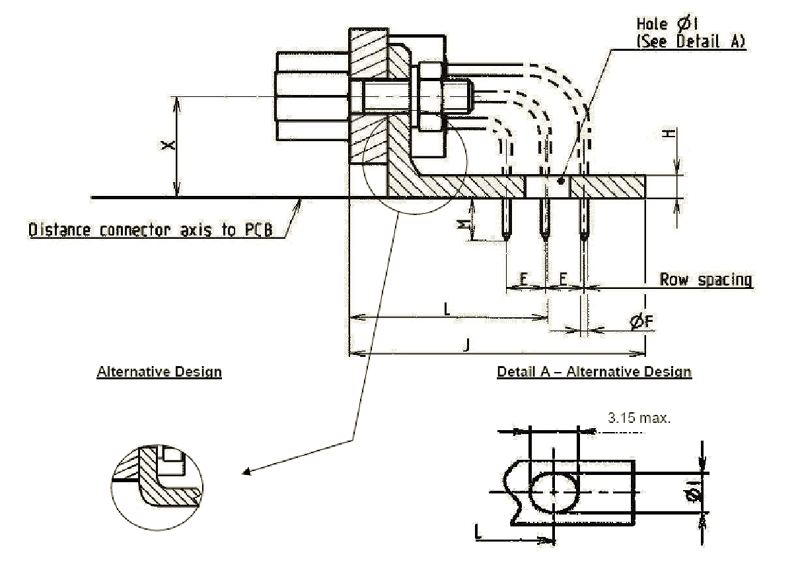
Symbol  Dim. | E |  | ØF | H | ØI | J | L | M | X
Symbol  Dim. | 1A7N | 1B7N
Min | 2.49 | 2.79 | 0.48 | 1.4 | 2.34 | - | 12.55 | 3.42 | 5.5
Max | 2.59 | 2.89 | 0.55 | 2.1 | 2.54 | 19.4 | 13.05 | 4.22 | 5.7
NOTES:
            - All dimensions are in millimetres.
            - See Table 1(a) for size of nut.
            - Only the underlined dimensions shall be checked during procurement.

Gauge 26 90° PCB Solder Contacts with Brackets and Jackpost Kits (Shell Size J) (Codes 1A7N, 1B7N)
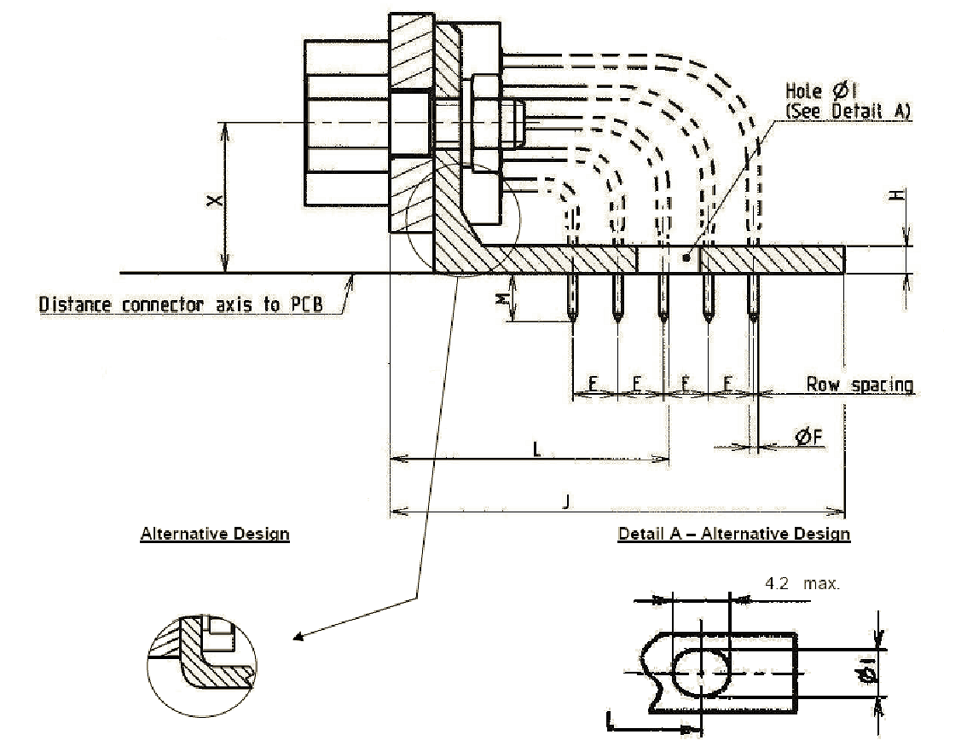
Symbol  Dim. | E |  | ØF | H | ØI | J | L | M | X
Symbol  Dim. | 1A7N | 1B7N
Min | 2.49 | 2.79 | 0.48 | 1.4 | 3 | - | 15.25 | 3.42 | 7.25
Max | 2.59 | 2.89 | 0.55 | 2.1 | 3.3 | 25.6 | 15.75 | 4.22 | 7.45
NOTES:
            - All dimensions are in millimetres.
            - See Table 1(a) for size of nut.
            - Only the underlined dimensions shall be checked during procurement.

FIGURE 2(d) - MATING DIMENSIONS AND CONTACT POSITION
Mounting Condition
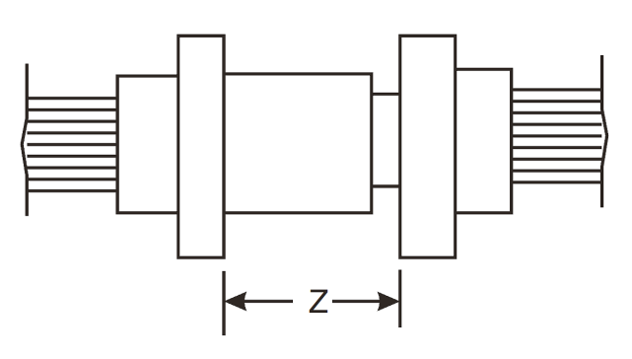
Plug Male Contact
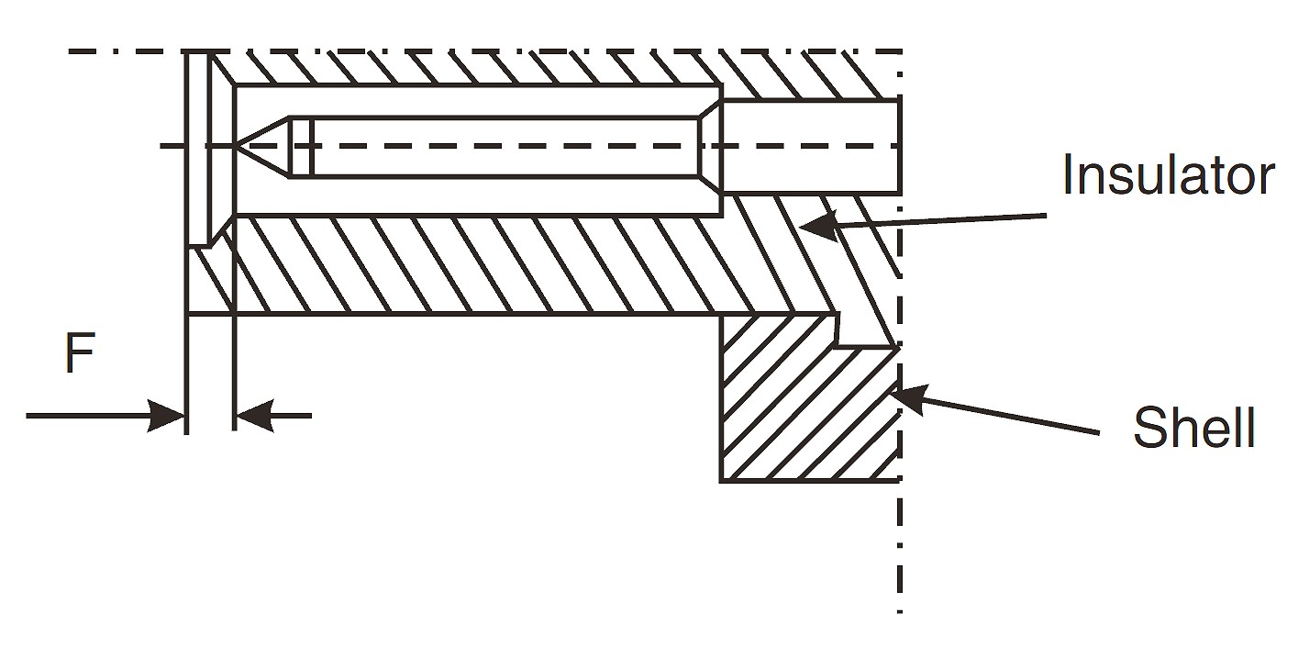
F |  | Z
Min | Max | Max
0.22 | 0.72 | 5.21
NOTES:
            - All dimensions are in millimetres.

REQUIREMENTS

GENERAL
The complete requirements for procurement of the components specified herein are stated in this specification and ESCC Generic Specification No. 3401. Deviations from the Generic Specification, applicable to this specification only, are detailed in Para. 4.2.
Deviations from the Generic Specification and this Detail Specification, formally agreed with specific Manufacturers on the basis that the alternative requirements are equivalent to the ESCC requirements and do not affect the components’ reliability, are listed in the appendices attached to this specification.

DEVIATIONS FROM GENERIC SPECIFICATION

Deviations from Special In-Process Controls
None.

Deviations from Final Production Tests (Chart II)
          - Para. 9.1.1.4, Mated Shell Conductivity: Not applicable.
          - Para. 9.9, Seal Test: Not applicable.

Deviations from Burn-in and Electrical Measurements (Chart III)
Chart III is not applicable.

Deviations from Qualification Tests (Chart IV)
          - Para. 9.1.1.4, Mated Shell Conductivity: Not applicable.
          - Para. 9.9, Seal Test: Not applicable.
          - Para. 9.15, Joint Strength: Not applicable.
          - Para. 9.24, Jackscrew Retention: Not applicable.
          - Para. 9.27, Maintenance Aging: Not applicable.
          - Para. 9.28, Engagement and Separation Forces: Not applicable.
          - Para. 9.29, Oversize Pin Exclusion: Not applicable.
          - Para. 9.30, Probe Damage: Not applicable.

Deviations from Lot Acceptance Tests (Chart V)
          - Para. 9.1.1.4, Mated Shell Conductivity: Not applicable.
          - Para. 9.9, Seal Test: Not applicable.
          - Para. 9.15, Joint Strength: Not applicable.
          - Para. 9.24, Jackscrew Retention: Not applicable.
          - Para. 9.27, Maintenance Aging: Not applicable.
          - Para. 9.28, Engagement and Separation Forces: Not applicable.
          - Para. 9.29, Oversize Pin Exclusion: Not applicable.
          - Para. 9.30, Probe Damage: Not applicable.

MECHANICAL REQUIREMENTS

Dimension Check
The dimensions of the connectors specified herein shall be verified in accordance with requirements set out in Para. 9.6 of ESCC Generic Specification No. 3401 and shall conform to those shown in Figure 2 of this specification.

Weight
The maximum weight of the connectors, contacts and accessories specified herein shall be as specified in Table 1(a).

Contact Capability
Not applicable.

Contact Retention (in Insert)
Contact retention within the insert shall be 15N.

Mating and Unmating Forces
The forces applied for the mating and unmating of the connectors shall conform to the values specified in Table 1(a).

Insert Retention (in Shell)
Connector inserts shall withstand a pressure of 34.4N/cm² applied from the mating side to the rear side.

Jackscrew Retention
Not applicable.

Contact Insertion and Withdrawal Forces
Not applicable.

Engagement and Separation Forces
Not applicable.

Oversize Pin Exclusion
Not applicable.

Probe Damage
Not applicable.

Solderability
Size A soldering iron shall be used.

MATERIALS AND FINISHES
The materials and finishes shall be as specified herein. Where a definite material is not specified, a material which will enable the connectors specified herein to meet the performance requirements of this specification shall be used. Acceptance or approval of any constituent material does not guarantee acceptance of the finished product.

Shells
Variant 01
Shells shall be made of glass-fibre reinforced thermoplastic. The plating shall be a minimum thickness of 1.27µm gold over 5µm minimum of electroless nickel or copper.
Variant 02
Shells shall be made of aluminium alloy. The plating shall be a minimum thickness of 1.27µm gold over 20µm minimum of electroless nickel.

Inserts
Inserts shall be made of thermoplastic material.

Contacts
Copper alloy with an underplate of 1µm minimum of nickel or copper, gold plated with 1.27µm minimum of gold.

Brackets
Stainless steel.

Accessories
As specified in ESCC Detail Specification No. 3401/084.

Magnetism Level
The allowable value of magnetism shall not exceed that specified for the relevant level (see Para. 4.5.4.3). Only magnetism levels NMC and NMD are verified.

MARKING

General
The marking of all components delivered to this specification shall be in accordance with the requirements of ESCC Basic Specification No. 21700 and the following paragraphs. Each component shall be marked in respect of:
          - Contact Position.
          - The ESCC Component Number.
          - Characteristics.
          - Traceability Information.

Contact Position
The contact positions shall be marked on the insert in accordance with Figure 2(b).

The ESCC Component Number
Each component shall bear the ESCC Component Number which shall be constituted and marked as follows:
Example: 340108101B
- Detail Specification Number: 3401081
- Type Variant (see Table 1(a)): 01
- Testing Level: B

Characteristics
The characteristics to be marked in the following order of precedence are:
          - Shell Size.
          - Contact Arrangement.
          - Type of Contact.
          - Magnetism Level (only applicable to Variant 01).
          - Contact Termination Code.
The information shall be constituted and marked as follows (example): C13PNMBOL3
- Shell Size: C
- Contact Arrangement: 13
- Type of Contact: P
- Magnetism Level (200 gamma): NMB
- Contact Termination Code: OL3

Shell Size and Contact Arrangement
Shell size shall be as designated in Table 1(a) and Figure 2(a). The shell size code also defines the contact arrangement. The layouts of the available contact arrangements are shown in Figure 2(b).

Type of Contact
Contact type code P indicates male (Pin) contact.

Magnetism Level
The following codes shall be used for magnetism level. Magnetism level is not applicable to Variant 02 and therefore the magnetism level code shall be omitted.
Code | Definition
NMB | Magnetism Level: ≤ 200 gamma
NMC | Magnetism Level: ≤ 20 gamma
NMD | Magnetism Level: ≤ 2 gamma

Contact Termination Code
Contact termination code shall be indicated as given in Table 1(a), Contact Types.
NOTES:
            - For connectors with contact arrangements that include coaxial or power contact cavities, the coaxial or power contacts shall be ordered separately in accordance with ESCC Detail Specification Nos. 3401/004 and 3401/040.
Coaxial and power contacts must be from the same manufacturer as the connector in which they are mounted and this shall be verified prior to assembly.

Traceability Information
Traceability information shall be marked in accordance with the requirements of ESCC Basic Specification No. 21700.

ELECTRICAL MEASUREMENTS

Electrical Measurements at Room Temperature
The parameters to be measured at room temperature are scheduled in Table 2. Unless otherwise specified, measurements shall be performed at T_{amb} = +22 ±3 °C.

Electrical Measurements at High and Low Temperatures (Table 3)
Not applicable.

Circuits for Electrical Measurements (Figure 4)
Not applicable.

BURN-IN AND ELECTRICAL MEASUREMENTS (TABLES 4 AND 5)
Not applicable.
TABLE 2 - ELECTRICAL MEASUREMENTS AT ROOM TEMPERATURE
No. | Characteristic | Symbol | ESCC 3401  Test Method | Test Condition | Limits |  | Unit
 |  |  |  |  | Min | Max | Unit
1 | Insulation Resistance | R_{i} | Para. 9.1.1.1 | Para. 9.1.1.1 | 5000 | - | MΩ
2 | Voltage Proof Leakage Current | I_{L} | Para. 9.1.1.2 | 600Vrms | - | 2 | mA
3 | Low Level Contact Resistance | R_{cl} | Para. 9.1.1.3 | Para. 9.1.1.3 | - | 6 | mΩ
4 | Rated Current  Contact Resistance | R_{cr} | Para. 9.1.1.3 | Table 1(b) | - | 5 | mΩ
Tables 3, 4 and 5
Not applicable.

ENVIRONMENTAL AND ENDURANCE TESTS (CHARTS IV AND V OF ESCC GENERIC SPECIFICATION NO. 3401)

Measurements and Inspections on Completion of Environmental Tests
The parameters to be measured and inspections to be performed on completion of environmental testing are scheduled in Table 6. Unless otherwise specified, the measurements shall be performed at T_{amb} = +22 ±3 ºC.

Measurements and Inspections at Intermediate Points During Endurance Tests
Not applicable.

Measurements and Inspections on Completion of Endurance Tests
The parameters to be measured and inspections to be performed on completion of endurance testing are scheduled in Table 6. Unless otherwise specified, the measurements shall be performed at T_{amb} = +22 ±3 ºC.

Conditions for Operating Life Test (Part of Endurance Testing) (Table 5)
Not applicable.

Electrical Circuit for Operating Life Test (Figure 5)
Not applicable.

Conditions for High Temperature Storage Test (Part of Endurance Testing)
The requirements for the high temperature storage test are specified in Section 9 of ESCC Generic Specification No. 3401. The conditions for high temperature storage testing shall be the maximum storage temperature specified in Table 1(b) of this specification.

Table 6 - MEASUREMENTS AND INSPECTIONS ON COMPLETION OF ENVIRONMENTAL AND ENDURANCE TESTING
No. | ESCC Generic Spec. No. 3401 |  | Measurements and Inspections |  | Symbol | Limits |  | Unit
No. | Environmental and Endurance Tests  (Note 1) | Test Method and  Conditions | Identification | Conditions | Symbol | Min | Max | Unit
01 | Vibration | Para. 9.11 | Initial Measurements  Coupling screw(s)  Unlocking Torque | - | Tq | Record Values |  | Nm
 |  |  | Final Measurements Full Engagement
 |  |  | Coupling screw(s)  Unlocking Torque Drift | - | ΔTq/Tq | -25 | +25 | %
 |  |  | Visual Examination | - | - | - | -
02 | Shock or Bump | Para. 9.12 | Full Engagement  Visual Examination | - | - | - | -
03 | Climatic Sequence | Para. 9.13 | Dry Heat  Insulation Resistance | At High Temperature  Table 2, Item 1  (Note 2) | R_{i} | 10 | - | MΩ
 |  |  | Low Air Pressure  Voltage Proof Leakage Current | Figure 1 | I_{L} | ESCC 3401  Para. 9.13.5 |  | mA
 |  |  | Damp Heat  Insulation Resistance | Immediately after test  Table 2 Item 1 | R_{i} | 1 | - | MΩ
 |  |  | Final Measurements | After 1-24hrs Recovery
 |  |  | External Visual Inspection | ESCC 3401 Para. 9.7 | - | ESCC 3401  Para. 9.7
 |  |  | Insulation Resistance | Table 2, Item 1 | R_{i} | Table 2, Item 1 |  | MΩ
 |  |  | Voltage Proof Leakage Current | Table 2, Item 2 | I_{L} | Table 2, Item 2 |  | mA
04 | Plating Thickness | Para. 9.14 | Thickness | - | - | Para. 4.4.3 of this spec.
05 | Rapid Change of Temperature | Para. 9.16 | Visual Examination | - | - | - | -
 | Rapid Change of Temperature |  | Insulation Resistance | Table 2, Item 1 | R_{i} | Table 2, Item 1 |  | MΩ
 |  |  | Voltage Proof Leakage Current | Table 2, Item 2 | I_{L} | Table 2, Item 2 |  | mA
06 | Contact Retention (in Insert) | Para. 9.17 & Para. 4.3.4 of this spec. | Contact Displacement | - | - | ESCC 3401  Para. 9.17
07 | Endurance | Para. 9.18 | Initial Measurements  Mating/Unmating Forces | - | F | Para. 4.3.5 of this spec. |  | N
 |  |  | Low Level Contact Resistance | Table 2, Item 3 | R_{cl} | Table 2, Item 3  Record Values |  | mΩ
 |  |  | Final Measurements  Visual Examination | - | - | - | -
 |  |  | Mating/Unmating Forces | - | F | Para. 4.3.5 of this spec. |  | N
 |  |  | Low Level Contact  Resistance Drift | Table 2, Item 3 | ΔR_{cl} | - | 3 | mΩ
 |  |  | Insulation Resistance | Table 2, Item 1 | R_{i} | Table 2, Item 1 |  | MΩ
 |  |  | Voltage Proof Leakage Current | Table 2, Item 2 | I_{L} | Table 2, Item 2 |  | mA
08 | Permanence of Marking | Para. 9.19 | As applicable | - | - | - | -
09 | Mating/Unmating Forces | Para. 9.20 | Force | - | F | Para. 4.3.5 of this spec. |  | N
10 | High Temperature Storage | Para. 9.21 | Initial Measurements  Low Level Contact Resistance | Table 2, Item 3 | R_{cl} | Table 2 Item 3  Record Values |  | mΩ
 |  |  | Final Measurements  Visual Examination | - | - | - | -
 |  |  | Mating/Unmating Forces | - | F | Para. 4.3.5 of this spec. |  | N
 |  |  | Low Level Contact Resistance Drift | Table 2, Item 3 | ΔR_{cl} | - | 3 | mΩ
 |  |  | Rated Current Contact Resistance | Table 2, Item 4 | R_{cr} | - | 6 | mΩ
 |  |  | Insulation Resistance | Table 2, Item 1 | R_{i} | Table 2, Item 1 |  | MΩ
 |  |  | Voltage Proof Leakage Current | Table 2, Item 2 | I_{L} | Table 2, Item 2 |  | mA
 |  |  | Contact Retention (in Insert) | Para. 4.3.4 of this spec. | - | ESCC 3401 Para. 9.17 |  | N
11 | Corrosion | Para. 9.22 | Visual Examination | - | - | - | -
12 | Insert Retention (in Shell) | Para. 9.23 & Para. 4.3.6 of this spec. | Visual Examination | - | - | Para. 4.3.6 of this spec.
13 | High Temperature Measurements | Para. 9.25 | Insulation Resistance | Table 2, Item 1  (Note 2) | R_{i} | 10 | - | MΩ
14 | Overload Test | Para. 9.26 | Internal Temperature | - | T | - | +100 | °C
 |  |  | Rated Current Contact Resistance | Table 2, Item 4 | R_{cr} | Table 2, Item 4 |  | mΩ
 |  |  | Insulation Resistance | Table 2, Item 1 | R_{i} | Table 2, Item 1 |  | MΩ
 |  |  | Voltage Proof Leakage Current | Table 2, Item 2 | I_{L} | Table 2, Item 2 |  | mA
15 | Solderability | Para. 9.31 and Para. 4.3.12 of this spec. | - | - | - | ESCC 3401 Para. 9.31
NOTES:
            - The tests in this table refer to either Chart IV or V and shall be used as applicable.
            - T_{amb} = +125 °C.

appendix ‘a’
agreed deviations for souriau (f)
Items Affected | Description of Deviations
Para. 4.2.2, Deviations from Final  Production Tests (Chart II(b)) | Para. 9.1.4, Electrical Measurements at Room Temperature:  For all contacts, Low Level Contact Resistance and Rated  Current Contact Resistance measurements, performed in  accordance with Table 2 of the Detail Specification, may be  omitted provided that Low Level Contact Resistance  measurements are performed on 10 contacts per contact batch,  in accordance with the Souriau PID requirements. The results  of the Low Level Contact Resistance measurements shall be  considered for PDA.

