

Page 1 of 25
INTEGRATED CIRCUITS, SILICON MONOLITHIC, CMOS DUAL D-TYPE FLIP-FLOP WITH FULLY BUFFERED OUTPUTS
BASED ON TYPE 4013B
ESCC Detail Specification No. 9203/023

Issue 5 Draft B | October 2017



Document Custodian: European Space Agency – see https://escies.org

Legal Disclaimer and Copyright
European Space Agency, Copyright ©2017. All rights reserved.
The European Space Agency disclaims any liability or responsibility, to any person or entity, with respect to any loss or damage caused, or alleged to be caused, directly or indirectly by the use and application of this ESCC publication.
This publication, without the prior permission of the European Space Agency and provided that it is not used for a commercial purpose, may be:
- copied in whole, in any medium, without alteration or modification.
- copied in part, in any medium, provided that the ESCC document identification, comprising the ESCC symbol, document number and document issue, is removed.

DOCUMENTATION CHANGE NOTICE
(Refer to https://escies.org for ESCC DCR content)
DCR No. | CHANGE DESCRIPTION
1105 | Specification upissued to incorporate changes per DCR.

TABLE OF CONTENTS
1 General 5
1.1 SCOPE 5
1.2 APPLICABLE DOCUMENTS 5
1.3 TERMS, DEFINITIONS, ABBREVIATIONS, SYMBOLS AND UNITS 5
1.4 THE ESCC COMPONENT NUMBER AND COMPONENT TYPE VARIANTS 5
1.4.1 The ESCC Component Number 5
1.4.2 Component Type Variants 5
1.5 MAXIMUM RATINGS 6
1.6 HANDLING PRECAUTIONS 6
1.7 PHYSICAL DIMENSIONS AND TERMINAL IDENTIFICATION 6
1.7.1 Flat Package (FP) - 14 Pin (Variants 01, 02) 7
1.7.2 Dual-in-line Package (DIP) - 14 Pin (Variants 03, 04) 8
1.7.3 Chip Carrier Package (CCP) - 20 Terminal (Variant 07) 9
1.7.4 Small Outline Ceramic Package (SO) - 14 Pin (Variants 08, 09) 11
1.7.5 Notes to Physical Dimensions and Terminal Identification for Packaged Components 12
1.7.6 Die (Variant 10) 13
1.8 FUNCTIONAL DIAGRAM 14
1.9 PIN/PAD ASSIGNMENT 14
1.10 TRUTH TABLE 15
1.11 INPUT PROTECTION NETWORK 15
2 REQUIREMENTS 16
2.1 GENERAL 16
2.1.1 Deviations from the Generic Specification 16
2.2 MARKING 16
2.3 ELECTRICAL MEASUREMENTS AT ROOM, HIGH AND LOW TEMPERATURES 16
2.3.1 Room Temperature Electrical Measurements 16
2.3.2 High and Low Temperatures Electrical Measurements 19
2.3.3 Notes to Electrical Measurement Tables 20
2.4 PARAMETER DRIFT VALUES 22
2.5 INTERMEDIATE AND END-POINT ELECTRICAL MEASUREMENTS 22
2.6 HIGH TEMPERATURE REVERSE BIAS BURN-IN CONDITIONS 23
2.6.1 N-Channel HTRB 23
2.6.2 P-Channel HTRB 24
2.7 POWER BURN-IN CONDITIONS 24
2.8 OPERATING LIFE CONDITIONS 24
APPENDIX ‘A’ 25

General

SCOPE
This specification details the ratings, physical and electrical characteristics and test and inspection data for the component type variants and/or the range of components specified below. It supplements the requirements of, and shall be read in conjunction with, the ESCC Generic Specification listed under Applicable Documents.

APPLICABLE DOCUMENTS
The following documents form part of this specification and shall be read in conjunction with it:
          - ESCC Generic Specification No. 9000
          - MIL-STD-883, Test Methods and Procedures for Microelectronics

TERMS, DEFINITIONS, ABBREVIATIONS, SYMBOLS AND UNITS
For the purpose of this specification, the terms, definitions, abbreviations, symbols and units specified in ESCC Basic Specification No. 21300 shall apply.

THE ESCC COMPONENT NUMBER AND COMPONENT TYPE VARIANTS

The ESCC Component Number
The ESCC Component Number shall be constituted as follows:
Example: 920302301
- Detail Specification Reference: 9203023
- Component Type Variant Number: 01 (as required)

Component Type Variants
The component type variants applicable to this specification are as follows:
Variant Number | Based on Type | Case | Terminal Material and/or Finish | Weight  max g
01 | 4013B | FP | G2 | 0.7
02 | 4013B | FP | G4 | 0.7
03 | 4013B | DIP | G2 | 2.2
04 | 4013B | DIP | G4 | 2.2
07 | 4013B | CCP | 2 | 0.6
08 | 4013B | SO | G2 | 0.7
09 | 4013B | SO | G4 | 0.7
10 | 4013B | Die | N/A | N/A
The terminal material and/or finish shall be in accordance with the requirements of ESCC Basic Specification No. 23500.

MAXIMUM RATINGS
The maximum ratings shall not be exceeded at any time during use or storage.
Maximum ratings shall only be exceeded during testing to the extent specified in this specification and when stipulated in Test Methods and Procedures of the ESCC Generic Specification.
Characteristics | Symbols | Maximum Ratings | Units | Remarks
Supply Voltage | V_{DD} | -0.5 to 18 | V | Note 1
Input Voltage | V_{IN} | -0.5 to V_{DD}+0.5 | V | Note 1  Power on
Input Current | I_{IN} | ±10 | mA | -
Device Power Dissipation  (Continuous) | P_{D} | 200 | mW | -
Power Dissipation per Output | P_{DSO} | 100 | mW | -
Operating Temperature Range | T_{op} | -55 to +125 | °C | T_{amb}
Storage Temperature Range | T_{stg} | -65 to +150 | °C | -
Soldering Temperature  For FP, DIP and SO  For CCP | T_{sol} | +265  +245 | °C | Note 2  Note 3
NOTES:
            - Device is functional for 3V ≤ V_{DD} ≤ 15V.
            - Duration 10 seconds maximum at a distance of not less than 1.5mm from the device body and the same terminal shall not be resoldered until 3 minutes have elapsed.
            - Duration 5 seconds maximum and the same terminal shall not be resoldered until 3 minutes have elapsed.

HANDLING PRECAUTIONS
These devices are susceptible to damage by electrostatic discharge. Therefore, suitable precautions shall be employed for protection during all phases of manufacture, testing, packaging, shipment and any handling.
These components are categorised as Class 1 per ESCC Basic Specification No. 23800 with a minimum Critical Path Failure Voltage of 400 Volts.

PHYSICAL DIMENSIONS AND TERMINAL IDENTIFICATION
Consolidated Notes for Packaged Components are given in Para. 1.7.5.

Flat Package (FP) - 14 Pin (Variants 01, 02)
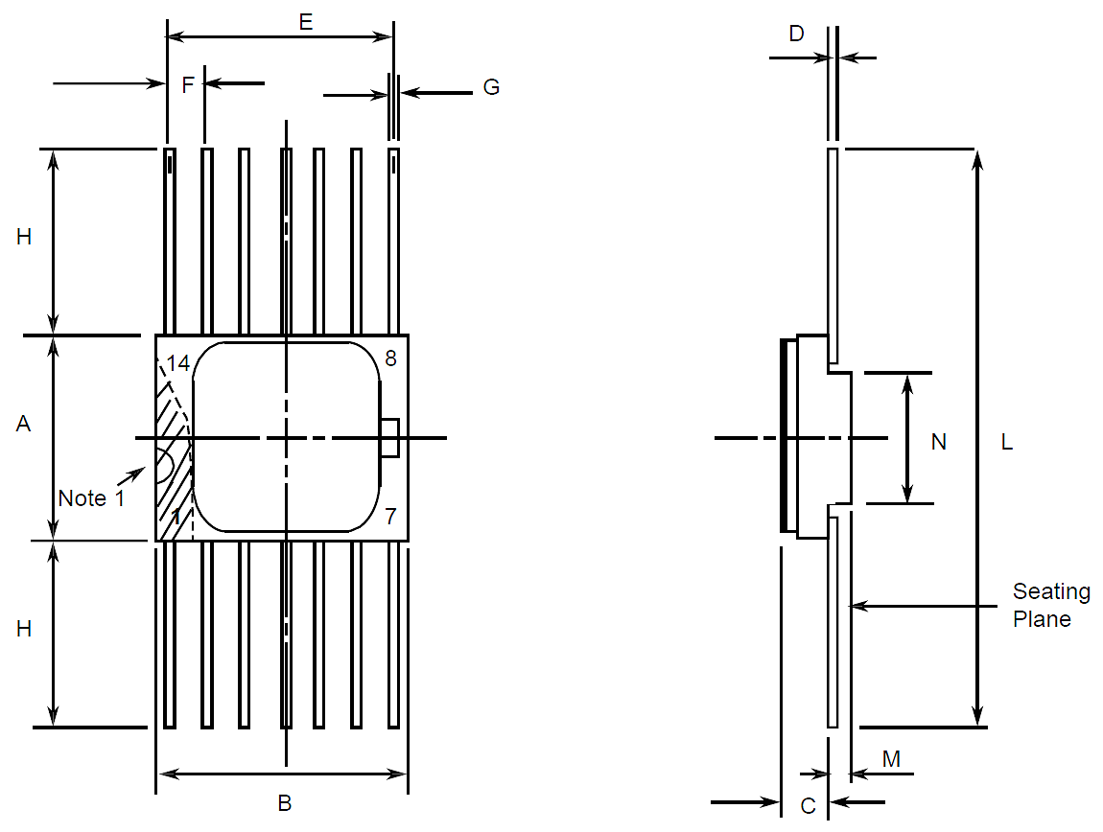
Symbols | Dimensions mm |  | Notes
Symbols | Min | Max | Notes
A | 6.75 | 7.06
B | 9.76 | 10.14
C | 1.49 | 1.95
D | 0.1 | 0.15 | 5
E | 7.5 | 7.75
F | 1.27 BSC |  | 3, 6
G | 0.38 | 0.48 | 5
H | 6 | - | 5
L | 18.75 | 22
M | 0.33 | 0.43
N | 4.32 TYPICAL

Dual-in-line Package (DIP) - 14 Pin (Variants 03, 04)
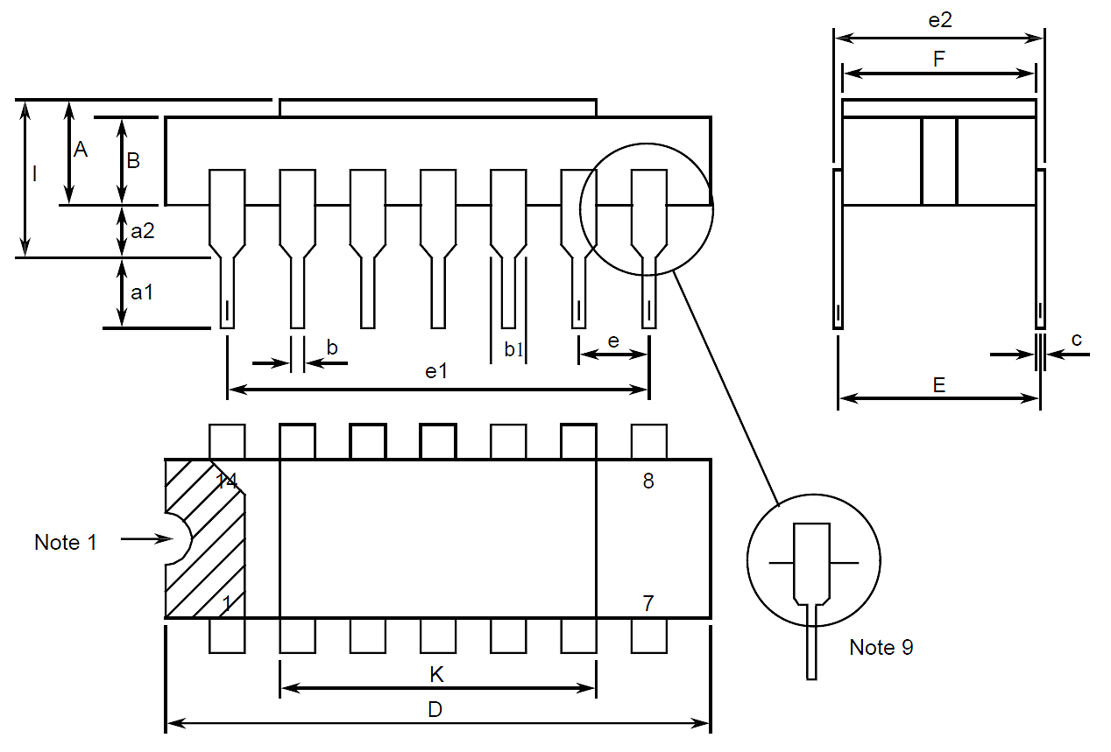
Symbols | Dimensions mm |  | Notes
Symbols | Min | Max | Notes
A | 2.1 | 2.54
a1 | 3 | 3.7
a2 | 0.63 | 1.14 | 2
B | 1.82 | 2.23
b | 0.4 | 0.5 | 5
b1 | 1.27 TYPICAL |  | 5
c | 0.2 | 0.3 | 5
D | 18.79 | 19.2
E | 7.36 | 7.87
e | 2.54 BSC |  | 4, 6
e1 | 15.11 | 15.37
e2 | 7.62 | 8.12
F | 7.11 | 7.75
I | - | 3.7
K | 10.9 | 12.1

Chip Carrier Package (CCP) - 20 Terminal (Variant 07)
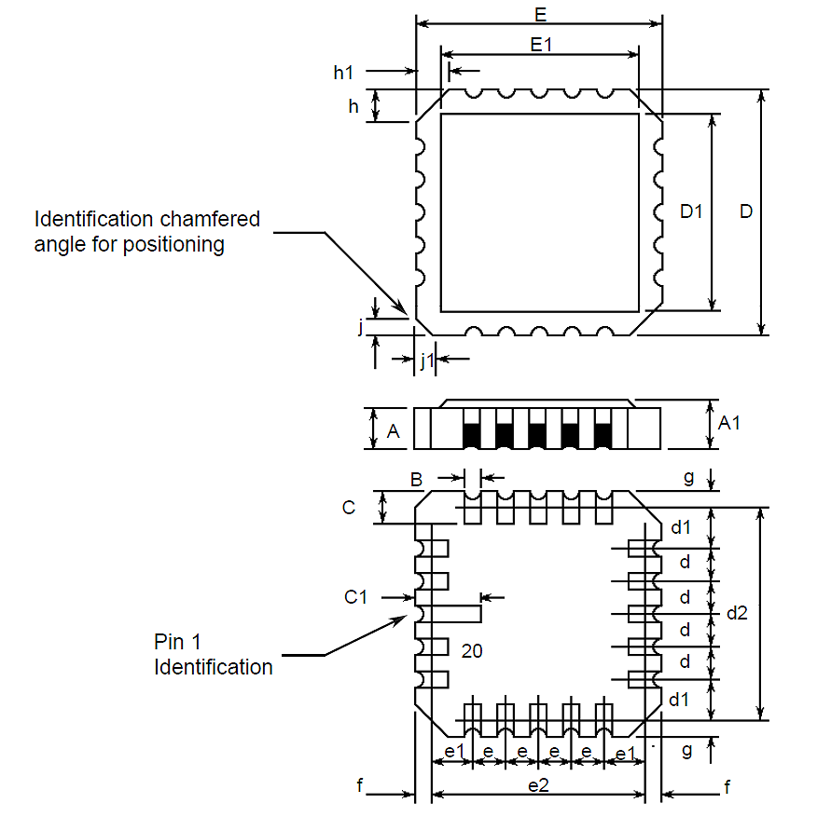
Symbols | Dimensions mm |  | Notes
Symbols | Min | Max | Notes
A | 1.14 | 1.95
A1 | 1.63 | 2.36
B | 0.55 | 0.72 | 5
C | 1.06 | 1.47 | 5
C1 | 1.91 | 2.41
D | 8.67 | 9.09
D1 | 7.21 | 7.52
d, d1 | 1.27 BSC |  | 3
d2 | 7.62 BSC
E | 8.67 | 9.09
E1 | 7.21 | 7.52
e, e1 | 1.27 BSC |  | 3
e2 | 7.62 BSC
f, g | - | 0.76
h, h1 | 1.01 TYPICAL |  | 8
j, j1 | 0.51 TYPICAL |  | 7

Small Outline Ceramic Package (SO) - 14 Pin (Variants 08, 09)
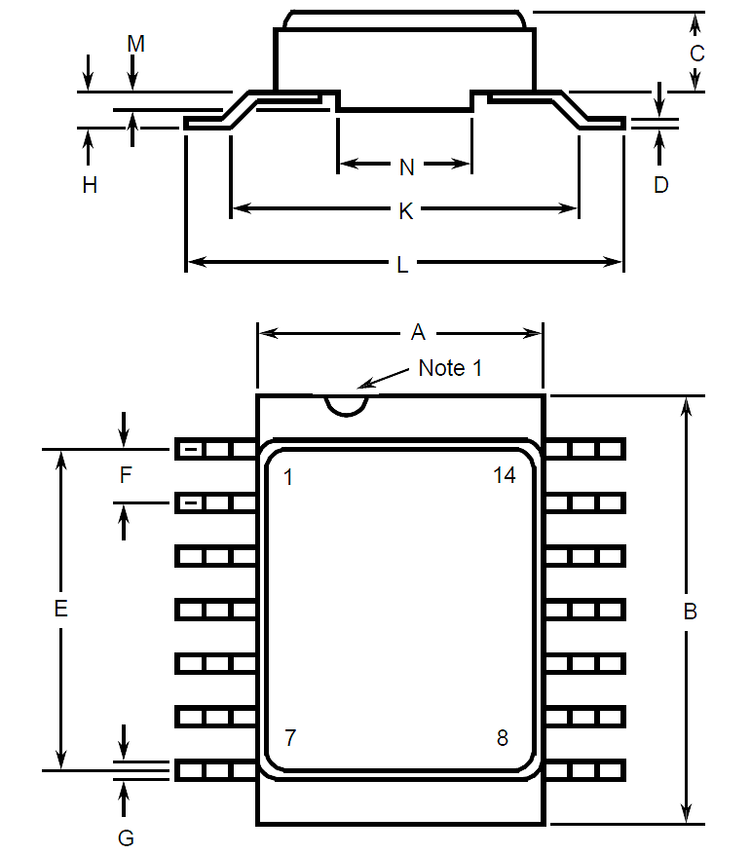
Symbols | Dimensions mm |  | Notes
Symbols | Min | Max | Notes
A | 6.75 | 7.06
B | 9.76 | 10.14
C | 1.49 | 1.95
D | 0.1 | 0.15 | 5
E | 7.5 | 7.75
F | 1.27 BSC |  | 3, 6
G | 0.38 | 0.48 | 5
H | 0.6 | 0.9 | 5
K | 9 TYPICAL
L | 10 | 10.65
M | 0.33 | 0.43
N | 4.31 TYPICAL

Notes to Physical Dimensions and Terminal Identification for Packaged Components
            - Index area; a notch or a dot shall be located adjacent to Pin 1 and shall be within the shaded area shown. For chip carrier packages, the index shall be as shown.
            - The dimension shall be measured from the seating plane to the base plane.
            - The true position pin spacing is 1.27mm between centrelines. Each pin centreline shall be located within ±0.13mm of its true longitudinal position relative to Pin 1 and the highest pin number.
            - The true position pin spacing is 2.54mm between centrelines. Each pin centreline shall be located within ±0.25mm of its true longitudinal position relative to Pin 1 and the highest pin number.
            - All terminals.
            - 12 spaces.
            - Index corner only - 2 dimensions.
            - 3 non-index corners - 6 dimensions.
            - For all pins, either pin shape may be supplied.

Die (Variant 10)
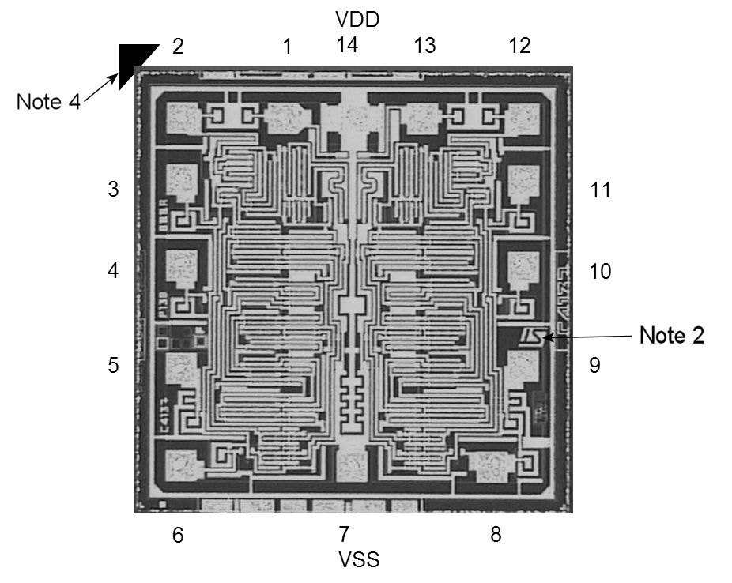
Notes:
            - Die materials and dimensions:
- Die substrate: Silicon
- Die length and width: 1.46mm (typ.)
- Die thickness: 525 ±25µm
- Glassivation: P-Vapox with thickness: 800nm ±160nm
- Top metalisation: Al/Si (1%) with thickness: 1.1 ± 0.1µm
- Backside metallisation: N/A (i.e. bare silicon)
- Bond pad dimensions: 90 x 90µm (typ.)
            - Terminal identification and die orientation: as indicated by the die mask, including the Manufacturer’s symbol marking (i.e. ST) and pad numbers as shown; see Para. 1.9
            - Bias details: backside contact = V_{DD}
            - Die packaging orientation: The die corner highlighted in black is positioned in the waffle pack as follows:
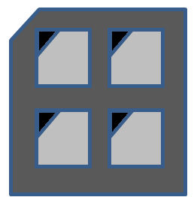

FUNCTIONAL DIAGRAM
Pin/Pad numbers only relate to FP, DIP, SO packages and Die.
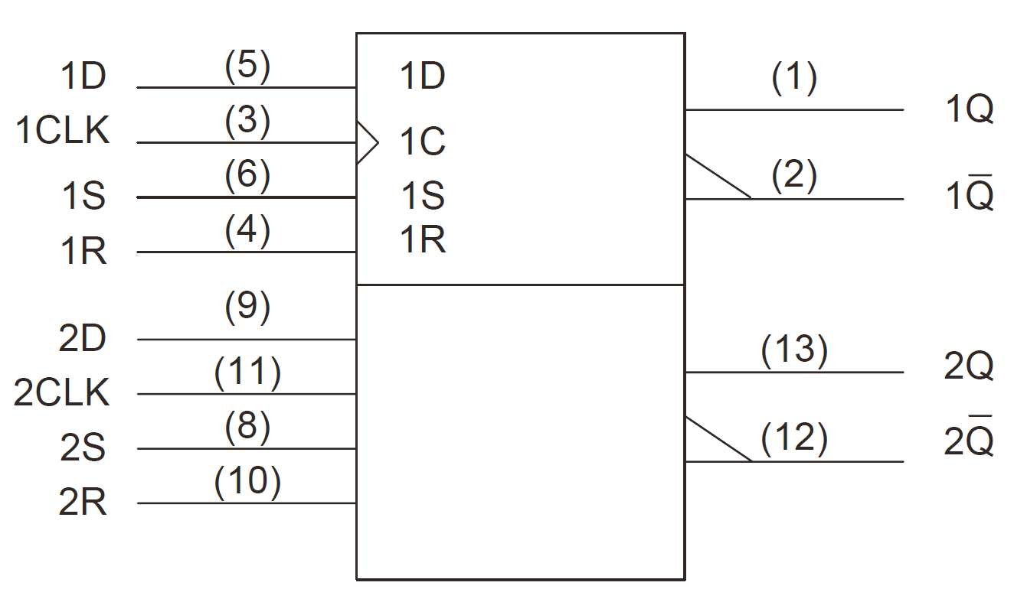

PIN/PAD ASSIGNMENT
Pin  /Pad | Function |  | Pin  /Pad | Function
Pin  /Pad | FP, DIP, SO, Die | CCP | Pin  /Pad | FP, DIP, SO, Die | CCP
1 | 1Q Output | - | 11 | 2CLK Input (Clock) | -
2 | 1$\overline{\text{Q}}$ Output | 1Q Output | 12 | 2$\overline{\text{Q}}$ Output | 2S Input (Set)
3 | 1CLK Input (Clock) | - | 13 | 2Q Output | -
4 | 1R Input (Reset) | 1$\overline{\text{Q}}$ Output | 14 | V_{DD} | 2D Input (Data)
5 | 1D Input (Data) | 1CLK Input (Clock) | 15 | - | 2R Input (Reset)
6 | 1S Input (Set) | 1R Input (Reset) | 16 | - | 2CLK Input (Clock)
7 | V_{SS} | 1D Input (Data) | 17 | - | 2$\overline{\text{Q}}$ Output
8 | 2S Input (Set) | - | 18 | - | -
9 | 2D Input (Data) | 1S Input (Set) | 19 | - | 2Q Output
10 | 2R Input (Reset) | V_{SS} | 20 | - | V_{DD}

TRUTH TABLE
            - Logic Level Definitions: L = Low Level, H = High Level, X = Irrelevant.
            - ↑ = Transition, Low to High; ↓ = Transition, High to Low.
            - Q₀ or $\overline{\text{Q}}$₀ = The level of Q or $\overline{\text{Q}}$ respectively before the indicated steady state input conditions are established.
each flip-flop
INPUTS |  |  |  | OUTPUTS
CLK | D | R | S | Q | $$\overline{\text{Q}}$$
↑ | L | L | L | L | H
↑ | H | L | L | H | L
↓ | X | L | L | Q₀ | $\overline{\text{Q}}$₀
X | X | H | L | L | H
X | X | L | H | H | L
X | X | H | H | H | H

INPUT PROTECTION NETWORK
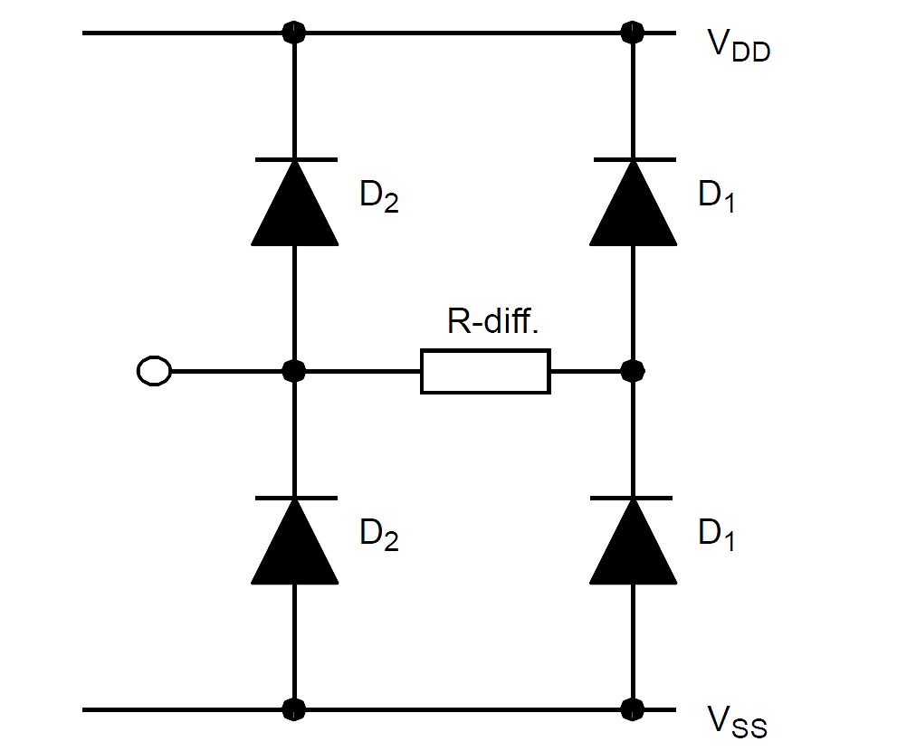

REQUIREMENTS

GENERAL
The complete requirements for procurement of the components specified herein are as stated in this specification and the ESCC Generic Specification. Permitted deviations from the Generic Specification, applicable to this specification only, are listed below.
Permitted deviations from the Generic Specification and this Detail Specification, formally agreed with specific Manufacturers on the basis that the alternative requirements are equivalent to the ESCC requirement and do not affect the component’s reliability, are listed in the appendices attached to this specification.

Deviations from the Generic Specification
None.

MARKING
The marking shall be in accordance with the requirements of ESCC Basic Specification No. 21700 and as follows.
The information to be marked on the component or its primary package shall be:
          - Terminal identification (see Para. 1.7).
          - The ESCC qualified components symbol (for ESCC qualified components only).
          - The ESCC Component Number.
          - Traceability information.

ELECTRICAL MEASUREMENTS AT ROOM, HIGH AND LOW TEMPERATURES
Electrical measurements shall be performed at room, high and low temperatures. Consolidated Notes are given in Para. 2.3.3.

Room Temperature Electrical Measurements
The measurements shall be performed at T_{amb} = +22 ±3°C .
Characteristics | Symbols | MIL-STD-883 Test Method | Test Conditions  Note 1 | Limits |  | Units
 |  |  |  | Min | Max | Units
Functional Test 1 | - | 3014 | Verify Truth Table without Load  V_{IL} = 0V, V_{IH} = 3V  V_{DD} = 3V, V_{SS} = 0V  Note 2 | - | - | -
Functional Test 2 | - | 3014 | Verify Truth Table without Load  V_{IL} = 0V, V_{IH} = 15V  V_{DD} = 15V, V_{SS} = 0V  Note 2 | - | - | -
Quiescent Current | I_{DD} | 3005 | V_{IL} = 0V, V_{IH} = 15V  V_{DD} = 15V, V_{SS} = 0V  Note 3 | - | 500 | nA
Low Level Input Current | I_{IL} | 3009 | V_{IN} (Under Test) = 0V  V_{DD} = 15V, V_{SS} = 0V | - | -50 | nA
High Level Input Current | I_{IH} | 3010 | V_{IN} (Under Test) = 15V  V_{DD} = 15V, V_{SS} = 0V | - | 50 | nA
Low Level Output Voltage 1 | V_{OL1} | 3007 | V_{IL} = 0V, V_{IH} = 15V,  I_{OL} = 0A  V_{DD} = 15V, V_{SS} = 0V | - | 50 | mV
Low Level Output Voltage 2 (Noise Immunity) | V_{OL2} | 3007 | V_{IL} = 1.5V, V_{IH} = 3.5V,  I_{OL} = 0A  V_{DD} = 5V, V_{SS} = 0V | - | 500 | mV
Low Level Output Voltage 3 (Noise Immunity) | V_{OL3} | 3007 | V_{IL} =4V, V_{IH} = 11V,  I_{OL} = 0A  V_{DD} = 15V, V_{SS} = 0V | - | 1.5 | V
High Level Output Voltage 1 | V_{OH1} | 3006 | V_{IL} = 0V, V_{IH} = 15V,  I_{OH} = 0A  V_{DD} = 15V, V_{SS} = 0V | 14.95 | - | V
High Level Output Voltage 2 (Noise Immunity) | V_{OH2} | 3006 | V_{IL} = 1.5V, V_{IH} = 3.5V,  I_{OH} = 0A  V_{DD} = 5V, V_{SS} = 0V | 4.5 | - | V
High Level Output Voltage 3 (Noise Immunity) | V_{OH3} | 3006 | V_{IL} = 4V, V_{IH} = 11V,  I_{OH} = 0A  V_{DD} = 15V, V_{SS} = 0V | 13.5 | - | V
Low Level Output Current 1 | I_{OL1} | - | V_{IL} = 0V, V_{IH} = 5V,  V_{OL} = 0.4V  V_{DD} = 5V, V_{SS} = 0V  Note 4 | 510 | - | μA
Low Level Output Current 2 | I_{OL2} | - | V_{IL} = 0V, V_{IH} = 15V,  V_{OL} = 1.5V  V_{DD} = 15V, V_{SS} = 0V  Note 4 | 3.4 | - | mA
High Level Output Current 1 | I_{OH1} | - | V_{IL} = 0V, V_{IH} = 5V,  V_{OH} = 4.6V  V_{DD} = 5V, V_{SS} = 0V  Note 4 | -510 | - | μA
High Level Output Current 2 | I_{OH2} | - | V_{IL} = 0V, V_{IH} = 15V,  V_{OH} = 13.5V  V_{DD} = 15V, V_{SS} = 0V  Note 4 | -3.4 | - | mA
Threshold Voltage N-Channel | V_{THN} | - | 1CLK Input at Ground  All Other Inputs:  V_{IN} = 5V  V_{DD} = 5V, I_{SS} = -10μA | -0.7 | -3 | V
Threshold Voltage P-Channel | V_{THP} | - | 1CLK Input at Ground  All Other Inputs:  V_{IN} = -5V  V_{SS} = -5V, I_{DD} = 10μA | 0.7 | 3 | V
Input Clamp Voltage 1,  to V_{SS} | V_{IC1} | - | I_{IN} (Under Test) = -100μA  V_{DD} = Open, V_{SS} = 0V  All Other Pins Open | - | -2 | V
Input Clamp Voltage 2,  to V_{DD} | V_{IC2} | - | V_{IN} (Under Test) = 6V  R = 30kΩ, V_{SS} = Open  All Other Pins Open  Note 5 | 3 | - | V
Input Capacitance | C_{IN} | 3012 | V_{IN} (Not Under Test) = 0V  V_{DD} = V_{SS} = 0V  f = 100 kHz to 1 MHz  Note 6 | - | 7.5 | pF
Propagation Delay Low to High, 1CLK to 1Q | t_{PLH} | 3003 | V_{IN} (Under Test) = Pulse Generator  V_{IN} (Remaining Inputs) = Truth Table  V_{IL} = 0V, V_{IH} = 5V,  V_{DD} = 5V, V_{SS} = 0V  Note 7 | - | 250 | ns
Propagation Delay High to Low, 1CLK to 1Q | t_{PHL} | 3003 | V_{IN} (Under Test) = Pulse Generator  V_{IN} (Remaining Inputs) = Truth Table  V_{IL} = 0V, V_{IH} = 5V,  V_{DD} = 5V, V_{SS} = 0V  Note 7 | - | 250 | ns
Transition Time Low to High, 1Q | t_{TLH} | 3004 | V_{IN} (Under Test) = Pulse Generator  V_{IN} (Remaining Inputs) = Truth Table  V_{IL} = 0V, V_{IH} = 5V,  V_{DD} = 5V, V_{SS} = 0V  Note 7 | - | 150 | ns
Transition Time High to Low, 1Q | t_{THL} | 3004 | V_{IN} (Under Test) = Pulse Generator  V_{IN} (Remaining Inputs) = Truth Table  V_{IL} = 0V, V_{IH} = 5V,  V_{DD} = 5V, V_{SS} = 0V  Note 7 | - | 150 | ns
Maximum Clock Frequency, 1CLK | f_{CLK} | - | V_{IN} (1CLK) = Pulse Generator  V_{IN} (Remaining Inputs) = Truth Table  V_{IL} = 0V, V_{IH} = 5V,  V_{DD} = 5V, V_{SS} = 0V  Notes 8, 9 | 3.5 | - | MHz

High and Low Temperatures Electrical Measurements
The measurements shall be performed at T_{amb} = +125 (+0 -5)°C and T_{amb} = -55 (+5 -0)°C.
Characteristics | Symbols | MIL-STD-883 Test Method | Test Conditions  Note 1 | Limits |  | Units
 |  |  |  | Min | Max | Units
Functional Test 1 | - | 3014 | Verify Truth Table without Load  V_{IL} = 0V, V_{IH} = 3V  V_{DD} = 3V, V_{SS} = 0V  Note 2 | - | - | -
Functional Test 2 | - | 3014 | Verify Truth Table without Load  V_{IL} = 0V, V_{IH} = 15V  V_{DD} = 15V, V_{SS} = 0V  Note 2 | - | - | -
Quiescent Current | I_{DD} | 3005 | V_{IL} = 0V, V_{IH} = 15V  V_{DD} = 15V, V_{SS} = 0V  Note 3  T_{amb} = +125°C  T_{amb} = -55°C | -  - | 15  0.5 | μA
Low Level Input Current | I_{IL} | 3009 | V_{IN} (Under Test) = 0V  V_{DD} = 15V, V_{SS} = 0V  T_{amb} = +125°C  T_{amb} = -55°C | -  - | -100  -50 | nA
High Level Input Current | I_{IH} | 3010 | V_{IN} (Under Test) = 15V  V_{DD} = 15V, V_{SS} = 0V  T_{amb} = +125°C  T_{amb} = -55°C | -  - | 100  50 | nA
Low Level Output Voltage 1 | V_{OL1} | 3007 | V_{IL} = 0V, V_{IH} = 15V,  I_{OL} = 0A  V_{DD} = 15V, V_{SS} = 0V | - | 50 | mV
Low Level Output Voltage 2 (Noise Immunity) | V_{OL2} | 3007 | V_{IL} = 1.5V, V_{IH} = 3.5V,  I_{OL} = 0A  V_{DD} = 5V, V_{SS} = 0V | - | 500 | mV
Low Level Output Voltage 3 (Noise Immunity) | V_{OL3} | 3007 | V_{IL} = 4V, V_{IH} = 11V,  I_{OL} = 0A  V_{DD} = 15V, V_{SS} = 0V | - | 1.5 | V
High Level Output Voltage 1 | V_{OH1} | 3006 | V_{IL} = 0V, V_{IH} = 15V,  I_{OH} = 0A  V_{DD} = 15V, V_{SS} = 0V | 14.95 | - | V
High Level Output Voltage 2 (Noise Immunity) | V_{OH2} | 3006 | V_{IL} = 1.5V, V_{IH} = 3.5V,  I_{OH} = 0A  V_{DD} = 5V, V_{SS} = 0V | 4.5 | - | V
High Level Output Voltage 3 (Noise Immunity) | V_{OH3} | 3006 | V_{IL} = 4V, V_{IH} = 11V,  I_{OH} = 0A  V_{DD} = 15V, V_{SS} = 0V | 13.5 | - | V
Low Level Output Current 1 | I_{OL1} | - | V_{IL} = 0V, V_{IH} = 5V,  V_{OL} = 0.4V  V_{DD} = 5V, V_{SS} = 0V  Note 4  T_{amb} = +125°C  T_{amb} = -55°C | 360  640 | -  - | μA
Low Level Output Current 2 | I_{OL2} | - | V_{IL} = 0V, V_{IH} = 15V,  V_{OL} = 1.5V  V_{DD} = 15V, V_{SS} = 0V  Note 4  T_{amb} = +125°C  T_{amb} = -55°C | 2.4  4.2 | -  - | mA
High Level Output Current 1 | I_{OH1} | - | V_{IL} = 0V, V_{IH} = 5V,  V_{OH} = 4.6V  V_{DD}=5V, V_{SS}=0V  Note 4  T_{amb} = +125°C  T_{amb} = -55°C | -360  -640 | -  - | μA
High Level Output Current 2 | I_{OH2} | - | V_{IL} = 0V, V_{IH} = 15V,  V_{OH} = 13.5V  V_{DD} = 15V, V_{SS} = 0V  Note 4  T_{amb} = +125°C  T_{amb} = -55°C | -2.4  -4.2 | -  - | mA
Threshold Voltage N-Channel | V_{THN} | - | 1CLK Input at Ground  All Other Inputs:  V_{IN} = 5V  V_{DD} = 5V, I_{SS} = -10μA  T_{amb} = +125°C  T_{amb} = -55°C | -0.3  -0.7 | -3.5  -3.5 | V
Threshold Voltage P-Channel | V_{THP} | - | 1CLK Input at Ground  All Other Inputs:  V_{IN} = -5V  V_{SS} = -5V, I_{DD} = 10μA  T_{amb} = +125°C  T_{amb} = -55°C | 0.3  0.7 | 3.5  3.5 | V

Notes to Electrical Measurement Tables
            - Unless otherwise specified all inputs and outputs shall be tested for each characteristic, inputs not under test shall be V_{IN} = V_{SS} or V_{DD} and outputs not under test shall be open.
            - Functional tests shall be performed to verify Truth Table with V_{OH} ≥ V_{DD}-0.5V, V_{OL} ≤ 0.5V. The maximum time to output comparator strobe = 300µs.
            - Quiescent Current shall be tested using the following input conditions:
          - Inputs 1CLK = 1R = 1D = 2CLK = 2R = 2D = V_{IH} ; Inputs 1S = 2S = V_{IL}
          - Inputs 1CLK = 1R = 1D = 2CLK = 2R = 2D = V_{IL} ; Inputs 1S = 2S = V_{IH}
          - All inputs = V_{IL}
          - All inputs = V_{IH}
            - Interchange of forcing and measuring parameters is permitted.
            - Input Clamp Voltage 2 to V_{DD}, V_{IC2}, shall be tested on each input as follows:
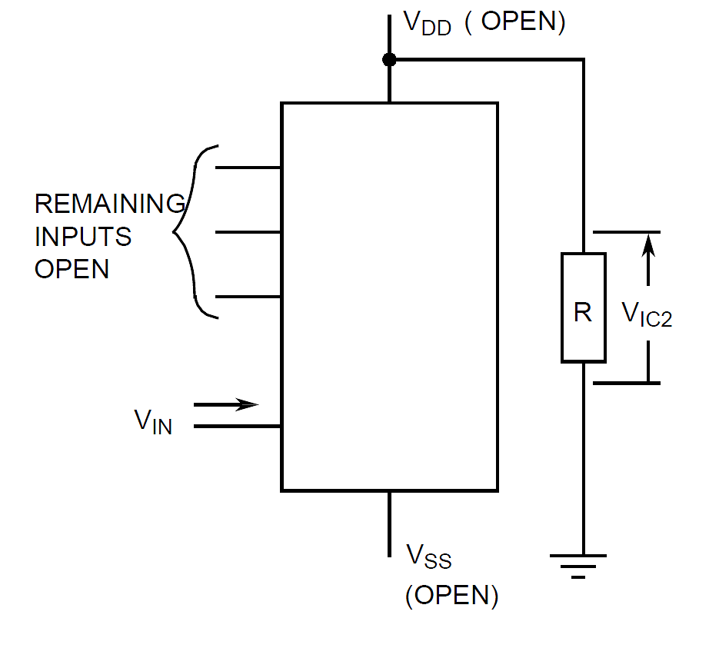
            - Guaranteed but not tested.
            - For Packaged Components (Variants 01 to 09), read and record measurements shall be performed on a sample of 32 components with 0 failures permitted. For Die Components (Variant 10), 32 components or 100% of the Packaged Test Sublot, whichever is less, shall be tested with 0 failures permitted.
The pulse generator shall have the following characteristics:
V_{GEN} = 0 to V_{DD}; f_{GEN} = 500kHz; t_{r} and t_{f} ≤ 15ns (10% to 90%); duty cycle = 50%; Z_{out} = 50Ω. Output load capacitance C_{L} = 50pF ±5% including scope probe, wiring and stray capacitance without component in the test fixture. Output load resistance R_{L} = 200kΩ ±5%.
Propagation delay shall be measured referenced to the 50% input and output voltages.
Transition time shall be measured referenced to the 10% and 90% output voltage.
            - For Packaged Components (Variants 01 to 09), read and record measurements shall be performed on a sample of 32 components with 0 failures permitted. For Die Components (Variant 10), 32 components or 100% of the Packaged Test Sublot, whichever is less, shall be tested with 0 failures permitted.
            - A pulse, having the following conditions, shall be applied to the 1CLK input: V_{P} = 0V to V_{DD}. Maximum clock frequency of f_{CLK} requirement is considered met if proper output state changes occur with the pulse repetition rate set to that given in the Limits column.

PARAMETER DRIFT VALUES
Unless otherwise specified, the measurements shall be performed at T_{amb} = +22 ±3°C.
The test methods and test conditions shall be as per the corresponding test defined in Para. 2.3.1 Room Temperature Electrical Measurements.
The drift values (Δ) shall not be exceeded for each characteristic specified. The corresponding absolute limit values for each characteristic shall not be exceeded.
Characteristics | Symbols | Limits |  |  | Units
Characteristics | Symbols | Drift  Value  Δ | Absolute |  | Units
Characteristics | Symbols | Drift  Value  Δ | Min | Max | Units
Quiescent Current | I_{DD} | ±75 | - | 500 | nA
Low Level Output Current 1 | I_{OL1} | ±15% (2) | 510 | - | μA
High Level Output Current 1 | I_{OH1} | ±15% (2) | -510 | - | μA
Threshold Voltage N-Channel | V_{THN} | ±0.3 | -0.7 | -3 | V
Threshold Voltage P-Channel | V_{THP} | ±0.3 | 0.7 | 3 | V
NOTES:
            - Unless otherwise specified all inputs and outputs shall be tested for each characteristic.
            - Percentage of limit value if voltage is the measuring parameter.

INTERMEDIATE AND END-POINT ELECTRICAL MEASUREMENTS
Unless otherwise specified, the measurements shall be performed at T_{amb} = +22 ±3°C.
The test methods and test conditions shall be as per the corresponding test defined in Para. 2.3.1 Room Temperature Electrical Measurements.
The drift values (Δ) shall not be exceeded for each characteristic where specified. The corresponding absolute limit values for each characteristic shall not be exceeded.
Characteristics | Symbols | Limits |  |  | Units
Characteristics | Symbols | Drift  Value  Δ | Absolute |  | Units
Characteristics | Symbols | Drift  Value  Δ | Min | Max | Units
Functional Test 1 | - | - | - | - | -
Quiescent Current | I_{DD} | ±75 | - | 500 | nA
Low Level Input Current | I_{IL} | - | - | -50 | nA
High Level Input Current | I_{IH} | - | - | 50 | nA
Low Level Output Voltage 1 | V_{OL1} | - | - | 50 | mV
Low Level Output Voltage 2  (Noise Immunity) | V_{OL2} | - | - | 500 | mV
High Level Output Voltage 1 | V_{OH1} | - | 14.95 | - | V
High Level Output Voltage 2  (Noise Immunity) | V_{OH2} | - | 4.5 | - | V
Low Level Output Current 1 | I_{OL1} | ±15% (3) | 510 | - | μA
Low Level Output Current 2 | I_{OL2} | ±15% (3) | 3.4 | - | mA
High Level Output Current 1 | I_{OH1} | ±15% (3) | -510 | - | μA
High Level Output Current 2 | I_{OH2} | ±15% (3) | -3.4 | - | mA
Threshold Voltage N-Channel | V_{THN} | ±0.3 | -0.7 | -3 | V
Threshold Voltage P-Channel | V_{THP} | ±0.3 | 0.7 | 3 | V
NOTES:
            - Unless otherwise specified, all inputs and outputs shall be tested for each characteristic.
            - The drift values (Δ) are applicable to the Operating Life test only.
            - Percentage of limit value if voltage is the measuring parameter.

HIGH TEMPERATURE REVERSE BIAS BURN-IN CONDITIONS

N-Channel HTRB
Characteristics | Symbols | Test Conditions | Units
Ambient Temperature | T_{amb} | +125 (+0 -5) | °C
Outputs 1Q, 1$\overline{\text{Q}}$, 2Q, 2$\overline{\text{Q}}$ | V_{OUT} | Open | V
Inputs 1S, 2D, 2R, 2CLK | V_{IN} | V_{SS} | V
Inputs 1CLK, 1R, 1D, 2S | V_{IN} | V_{DD} | V
Positive Supply Voltage | V_{DD} | 15 (+0 -0.5) | V
Negative Supply Voltage | V_{SS} | 0 | V
Duration | t | 72 | Hours
NOTES:
            - Input Protection Resistor = 2kΩ min to 47kΩ max.

P-Channel HTRB
Characteristics | Symbols | Test Conditions | Units
Ambient Temperature | T_{amb} | +125 (+0 -5) | °C
Outputs 1Q, 1$\overline{\text{Q}}$, 2Q, 2$\overline{\text{Q}}$ | V_{OUT} | Open | V
Inputs 1S, 2D, 2R, 2CLK | V_{IN} | V_{DD} | V
Inputs 1CLK, 1R, 1D, 2S | V_{IN} | V_{SS} | V
Positive Supply Voltage | V_{DD} | 15 (+0 -0.5) | V
Negative Supply Voltage | V_{SS} | 0 | V
Duration | t | 72 | Hours
NOTES:
            - Input Protection Resistor = 2kΩ min to 47kΩ max.

POWER BURN-IN CONDITIONS
Characteristics | Symbols | Test Conditions | Units
Ambient Temperature | T_{amb} | +125 (+0 -5) | °C
Outputs 1Q, 1$\overline{\text{Q}}$, 2Q, 2$\overline{\text{Q}}$ | V_{OUT} | V_{DD}/2 | V
Inputs 1R, 1S, 2R, 2S | V_{IN} | V_{SS} | V
Inputs 1CLK, 2CLK | V_{IN} | V_{GEN1} | V
Inputs 1D, 2D | V_{IN} | V_{GEN2} | V
Pulse Voltage | V_{GEN} | 0V to V_{DD} | V
Pulse Frequency Square Wave | f_{GEN1}  f_{GEN2} | ≥ 50k  ≥ 25k  50% Duty Cycle | Hz
Positive Supply Voltage | V_{DD} | 15 (+0 -0.5) | V
Negative Supply Voltage | V_{SS} | 0 | V
NOTES:
            - Input Protection Resistor = Output Load = 2kΩ min to 47kΩ max.

OPERATING LIFE CONDITIONS
The conditions shall be as specified for Power Burn-in.

APPENDIX ‘A’
AGREED DEVIATIONS FOR STMICROELECTRONICS (F)
ITEMS AFFECTED | DESCRIPTION OF DEVIATIONS
Para. 2.1.1 Deviations from the Generic Specification - Screening Tests – Chart F3 | External Visual Inspection: The criteria applicable to chip-outs are those described in MIL-STD-883, Test Method 2009, Paras 3.3.6(b) and 3.3.7(a).  High Temperature Reverse Bias Burn-in: The temperature limits of MIL-STD-883, Para. 4.5.8(c) may be used.  Power Burn-in test is performed using STMicroelectronics Specification Ref: 0019255.  Solderability is not applicable unless specifically stipulated in the Purchase Order.
Para. 2.1.1 Deviations from the Generic Specification - Qualification and Periodic Tests – Chart F4 | External Visual Inspection: The criteria applicable to chip-outs are those described in MIL-STD-883, Test Method 2009, Paras 3.3.6(b) and 3.3.7(a).  Operating Life: The temperature limits of MIL-STD-883, Para. 4.5.8(c) may be used.
Para. 2.3.2 Deviations from High and Low Temperatures Electrical Measurements | High and Low Temperatures Electrical Measurements may be considered guaranteed but not tested if successful pilot lot testing has been performed on the wafer lot which includes High and Low Temperatures Electrical Measurements per the Detail Specification.  A summary of the pilot lot testing shall be provided if required by the Purchase Order.
Para. 2.3.1 Deviations from Room Temperature Electrical Measurements | All AC characteristics (Capacitance and Timings) may be considered guaranteed but not tested if successful pilot lot testing has been performed on the wafer lot which includes AC characteristic measurements per the Detail Specification.  A summary of the pilot lot testing shall be provided if required by the Purchase Order.

