DCR 3401065

- Weight (page 7)
Modification of the weight of the plug and receptacle

Issue 4
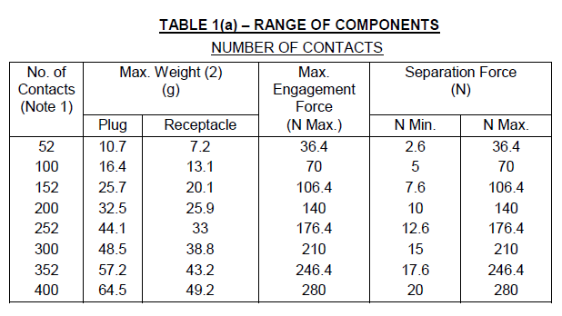
New Table for the max weight of plug
No. Of Contacts (Note 1) | Max. Weight (2) (g) |  | Max. Engagement Force (N Max.) | Separation Force (N)
No. Of Contacts (Note 1) | Plug | Receptacle | Max. Engagement Force (N Max.) | N Min | N Max.
52 | 14 | 8 | 36,4 | 2,6 | 36,4
100 | 20 | 15 | 70 | 5 | 70
152 | 32 | 22 | 106,4 | 7,6 | 106,4
200 | 38 | 28 | 140 | 10 | 140
252 | 50 | 36 | 176,4 | 12,6 | 176,4
300 | 56 | 42 | 210 | 15 | 210
352 | 65 | 47 | 246,4 | 17,6 | 246,4
400 | 75 | 55 | 280 | 20 | 280

- Codes 45 and 47 (page31)

Issue 4 | New picture
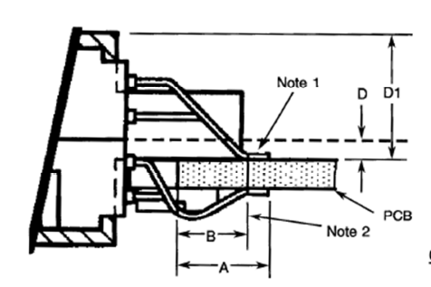 | Add Note 3 :  3 – Dimensions E1&E2 applicable to all terminals  Add E1 and E2 at the end of the table  New table :  Add a new picture  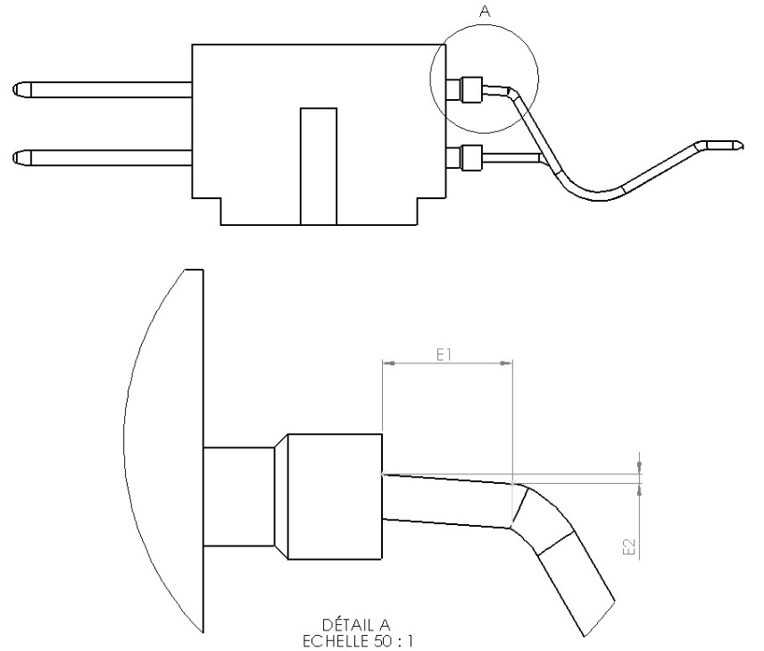
  Symbol | Millimetres
  Symbol | Min | Max
  a | 0,25 | 0,45
  b | 0,2 | 0,4
  B | 3 | 4,1
  D | 0,9 | 1,2
  D1 | - | 7
  E1 | 0,7 | -
  E2 | 0 | 0,18

- Page 17 plug 52: the writing of the line’s number was NOK.

Issue 4 | New pictures
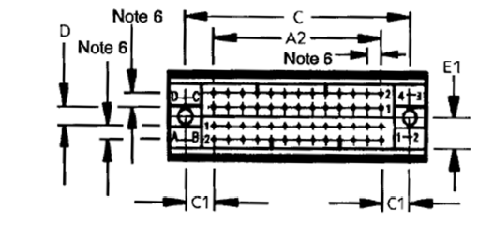  Plug 52 | 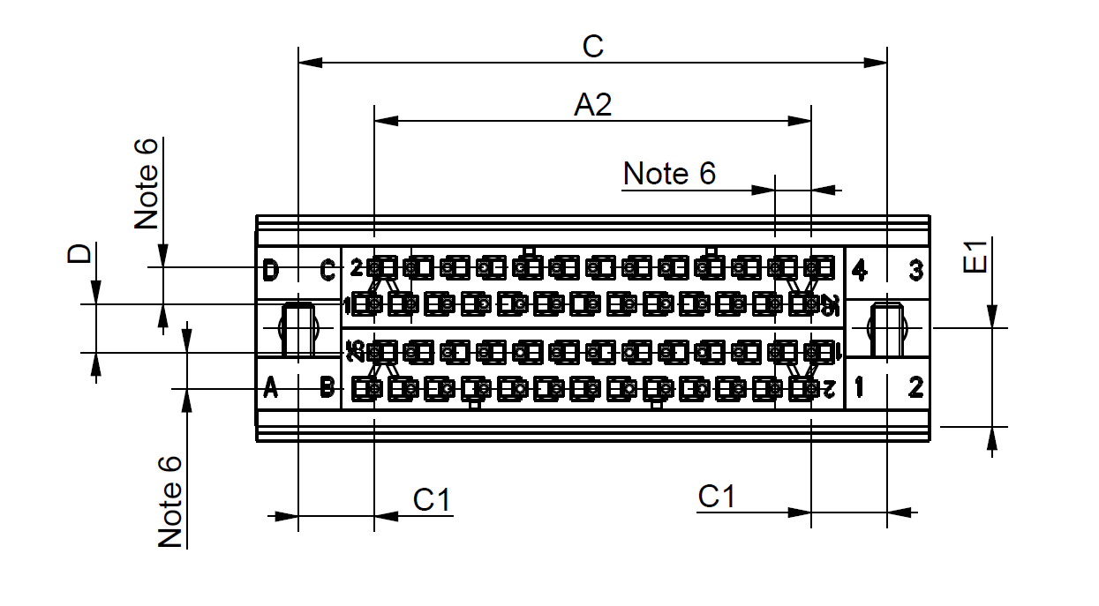
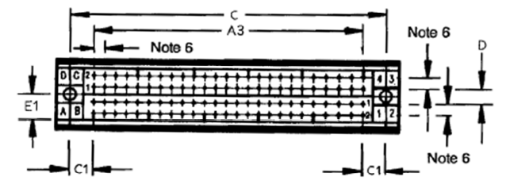  Exemple Plug 100 | 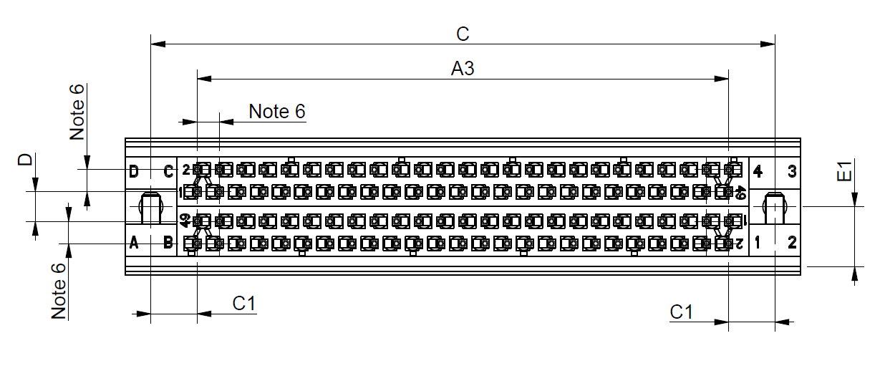

- Figure 2 – Receptacle 152 contacts (page 11)

Issue 4
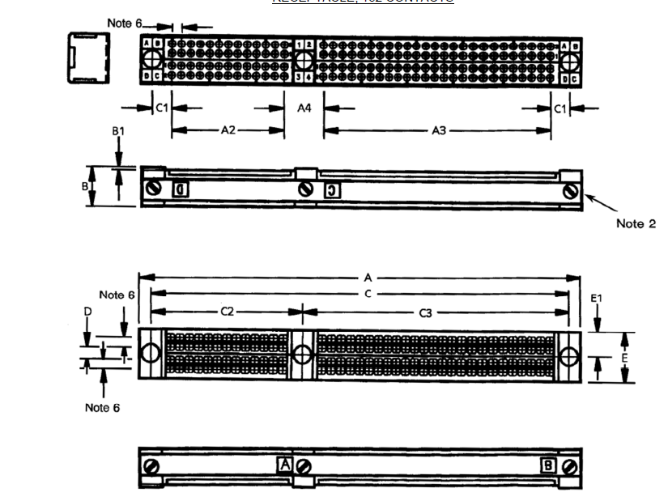
New picture


