DCR 3401039

- Figure 2(b) :
The locking devices code 201, 202 (page 29) and 204 (page30) are not well drawn.

Issue 4 | New picture
Code 201 | 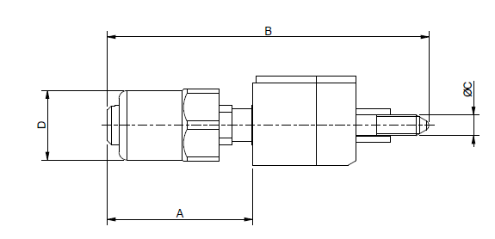
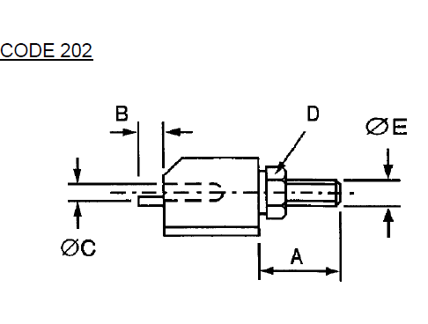 | 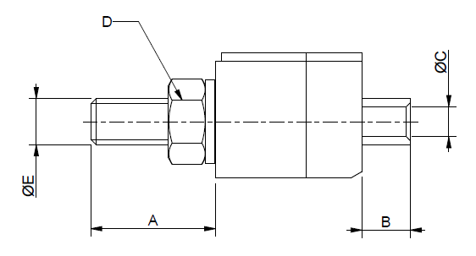
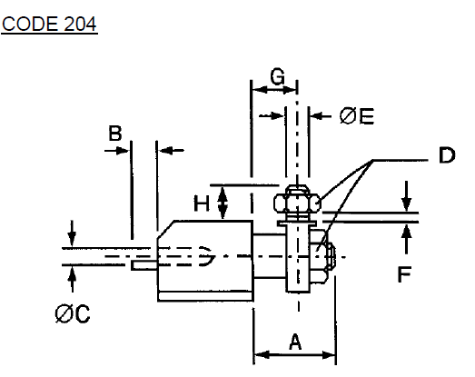 | 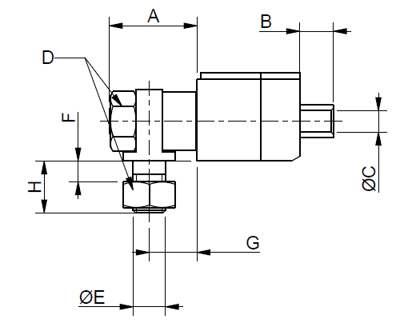

- figure 2(b) code 206 (page 30)
The arrow of the dimension A is not well placed.

Issue 4 | New picture
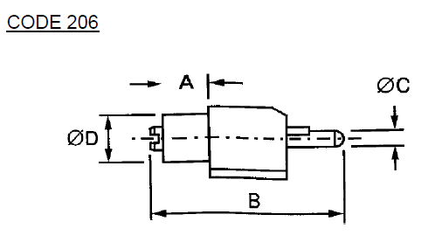 | 

