DCR 3401016

- Figure 2(2) - code 13, 14, 15, 16, 17, 19, 22 : the shape of the insulator has been modified

Issue 4 - code 13, 14, 15, 16, 17 (page 23 to 27) | New picture
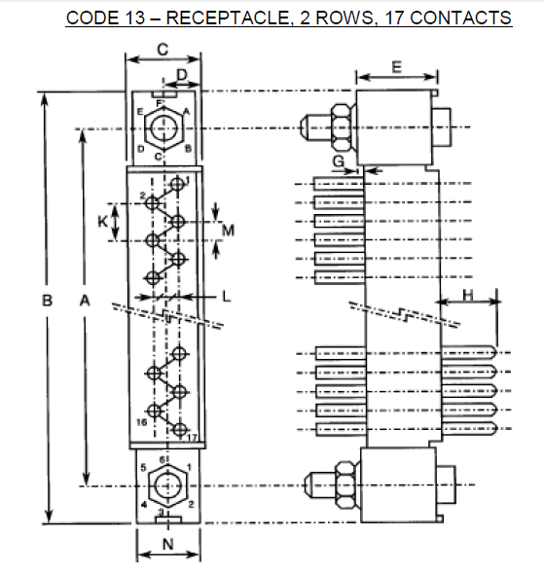 | 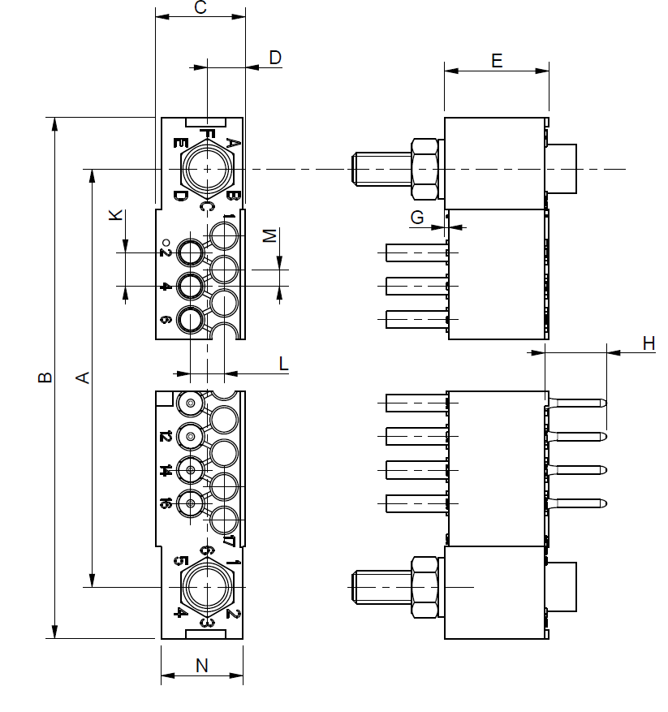
Issue 4 - code 19, 22 (page 29 & 31) | New picture
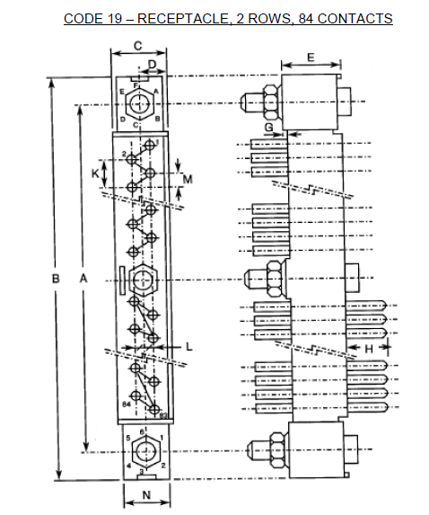 | 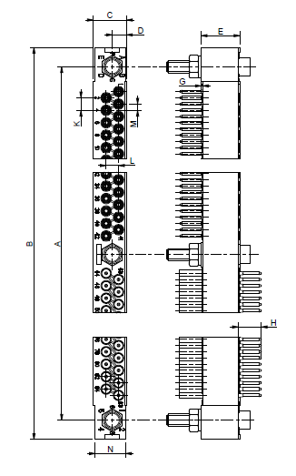

- Table 1(a) page 9

Guiding devices female Code 36 are compatible with plug 01, 02, 03, 04, 05, 58, 60 and 62.
Guiding devices female Code 36 are compatible only when used on end of insert with plug 07, 08, 10, 12 and 56.

Issue 4 | New picture
 | 

