

Page 1 of 19

CAPACITORS, FIXED, CERAMIC DIELECTRIC, TYPE I, HIGH VOLTAGE, 1kV TO 5kV
BASED ON TYPES VR, CV AND CH
ESCC Detail Specification No. 3001/033
Issue 4 Draft E | February 2017



Document Custodian: European Space Agency – see https://escies.org

LEGAL DISCLAIMER AND COPYRIGHT
European Space Agency, Copyright © 2017. All rights reserved.
The European Space Agency disclaims any liability or responsibility, to any person or entity, with respect to any loss or damage caused, or alleged to be caused, directly or indirectly by the use and application of this ESCC publication.
This publication, without prior the permission of the European Space Agency and provided that it is not used for a commercial purpose, may be:
- copied in whole, in any medium, without alteration or modification.
- copied in part, in any medium, provided that the ESCC document identification, comprising the ESCC symbol, document number and document issue, is removed.

DOCUMENTATION CHANGE NOTICE
(Refer to https://escies.org for ESCC DCR content)
DCR No. | CHANGE DESCRIPTION
764 | Specification updated to incorporate changes per DCR.  Specification produced in MSWORD. Changes in presentation are possible.

TABLE OF CONTENTS

1 GENERAL 5
1.1 SCOPE 5
1.2 APPLICABLE DOCUMENTS 5
1.3 TERMS, DEFINITIONS, ABBREVIATIONS, SYMBOLS AND UNITS 5
1.4 THE ESCC COMPONENT NUMBER AND COMPONENT TYPE VARIANTS 5
1.4.1 The ESCC Component Number 5
1.4.2 Component Type Variants and Range of Components 6
1.5 MAXIMUM RATINGS 8
1.6 PHYSICAL DIMENSIONS 9
1.6.1 Case Type VR with Radial Leads 9
1.6.2 Case Type CV with Radial Leads 10
1.6.3 Case Type CH with Straight DIL Leads 11
1.6.4 Case Type CH with L DIL Leads 12
1.7 FUNCTIONAL DIAGRAM 12
2 REQUIREMENTS 13
2.1 GENERAL 13
2.1.1 Deviations from the Generic Specification 13
2.2 MARKING 13
2.3 ROBUSTNESS OF TERMINATIONS 14
2.4 ELECTRICAL MEASUREMENTS AT ROOM, HIGH AND LOW TEMPERATURES 14
2.4.1 Room Temperature Electrical Measurements 14
2.4.2 High and Low Temperatures Electrical Measurements 15
2.5 INTERMEDIATE AND END-POINT ELECTRICAL MEASUREMENTS 16
2.6 BURN-IN 18
APPENDIX A 19

GENERAL

SCOPE
This specification details the ratings, physical and electrical characteristics, and test and inspection data for the component type variants and/or the range of components specified below. It supplements the requirements of, and shall be read in conjunction with, the ESCC Generic Specification listed under Applicable Documents.

APPLICABLE DOCUMENTS
The following documents form part of this specification and shall be read in conjunction with it:
          - ESCC Generic Specification No. 3001.

TERMS, DEFINITIONS, ABBREVIATIONS, SYMBOLS AND UNITS
For the purpose of this specification, the terms, definitions, abbreviations, symbols and units specified in ESCC Basic Specification No. 21300 shall apply.

THE ESCC COMPONENT NUMBER AND COMPONENT TYPE VARIANTS

The ESCC Component Number
The ESCC Component Number shall be constituted as follows:
Example: 300103301470K1R
- Detail Specification Reference: 3001033
- Component Type Variant Number: 01 (as required)
- Characteristic code: Capacitance Value (47pF): 470 (as required)
- Characteristic code: Capacitance Tolerance (±10%): K (as required)
- Characteristic code: Temperature Coefficient (±30 ×10⁻⁶/°C): 1
- Rating code: Rated Voltage (3kV): R (as required)

Characteristics and Ratings Codes
Characteristics and ratings to be codified as part of the ESCC Component Number shall be as follows:
          - Rated Capacitance Value C_{n} expressed by means of the following codes in accordance with ESCC Basic Specification No. 21700. The unit quantity shall be picofarad (pF).
Capacitance Value C_{n}  (pF) | Code
XX 10⁰ | XX0
XX 10¹ | XX1
XX 10² | XX2
XX 10³ | XX3
XX 10⁴ | XX4
          - Capacitance Tolerance expressed by the following codes in accordance with ESCC Basic Specification No. 21700:
Tolerance  (± %) | Code Letter
5 | J
10 | K
20 | M
          - Temperature Coefficient expressed by the following code:
Temperature Coefficient  (± 10⁻⁶/°C) | Code
30 | 1
          - Rated Voltage expressed by the following codes:
Rated Voltage U_{R}  (kV) | Code Letter
1 | M
2 | P
3 | R
4 | S
5 | Z

Component Type Variants and Range of Components
The component type variants and range of components applicable to this specification are as follows:
Variant  Number | Package Details  (Note 1) |  |  |  | Capacitance Range C_{n}  (pF) (Note 4) |  |  |  |  | Weight  Max (g)
Variant  Number | Case Type (Note 2) | Lead Type | No. of  Leads | Lead  Mat. & Fin.  (Note 3) | Rated  Voltage  U_{R} = 1kV | Rated  Voltage  U_{R} = 2kV | Rated  Voltage  U_{R} = 3kV | Rated  Voltage  U_{R} =4kV | Rated  Voltage  U_{R} = 5kV | Weight  Max (g)
01 | VR30S | Radial | 2 | A3 | 390 to 2200 | 56 to 470 | 33 to 330 | - | - | 1
02 | VR30 | Radial | 2 | A3 | 2700 to 5600 | 560 to 1800 | 390 to 680 | - | - | 1
03 | VR40 | Radial | 2 | A3 | 6800 to 15000 | 2200 to 4700 | 820 to 1500 | 390 to 820 | 330 to 560 | 2
04 | VR50 | Radial | 2 | A3 | 18000 to 33000 | 5600 to 10000 | 1800 to 2700 | 1000 to 1800 | 680 to 1200 | 3
05 | VR66 | Radial | 2 | A3 | 39000 to 68000 | 12000 to 18000 | 3300 to 5600 | 2200 to 3300 | 1500 to 2200 | 5
06 | VR84 | Radial | 2 | A3 | 82000 to 100000 | 22000 to 39000 | 6800 to 12000 | 3900 to 6800 | 2700 to 4700 | 8
07 | VR90 | Radial | 2 | A3 | 120000 to 330000 | 47000 to 100000 | 15000 to 33000 | 8200 to 18000 | 5600 to 12000 | 19
08 | CV41 | Radial | 2 | A3 | 6800 to 15000 | 2200 to 4700 | 820 to 1500 | 390 to 820 | 330 to 560 | 2
09 | CH41 | Straight DIL | 6 | N9 | 6800 to 15000 | 2200 to 4700 | 820 to 1500 | 390 to 820 | 330 to 560 | 2
10 | CH41 | L DIL | 6 | N9 | 6800 to 15000 | 2200 to 4700 | 820 to 1500 | 390 to 820 | 330 to 560 | 2
11 | CV51 | Radial | 2 | A3 | 18000 to 33000 | 5600 to 10000 | 1800 to 2700 | 1000 to 1800 | 680 to 1200 | 3
12 | CH51 | Straight DIL | 8 | N9 | 18000 to 33000 | 5600 to 10000 | 1800 to 2700 | 1000 to 1800 | 680 to 1200 | 3
13 | CH51 | L DIL | 8 | N9 | 18000 to 33000 | 5600 to 10000 | 1800 to 2700 | 1000 to 1800 | 680 to 1200 | 3
14 | CV61 | Radial | 2 | A3 | 39000 to 68000 | 12000 to 18000 | 3300 to 5600 | 2200 to 3300 | 1500 to 2200 | 5
15 | CH61 | Straight DIL | 10 | N9 | 39000 to 68000 | 12000 to 18000 | 3300 to 5600 | 2200 to 3300 | 1500 to 2200 | 5
16 | CH61 | L DIL | 10 | N9 | 39000 to 68000 | 12000 to 18000 | 3300 to 5600 | 2200 to 3300 | 1500 to 2200 | 5
17 | CV76 | Radial | 2 | A3 | 82000 to 100000 | 22000 to 39000 | 6800 to 12000 | 3900 to 6800 | 2700 to 4700 | 8
18 | CH76 | Straight DIL | 12 | N9 | 82000 to 100000 | 22000 to 39000 | 6800 to 12000 | 3900 to 6800 | 2700 to 4700 | 8
19 | CH76 | L DIL | 12 | N9 | 82000 to 100000 | 22000 to 39000 | 6800 to 12000 | 3900 to 6800 | 2700 to 4700 | 8
20 | CV91 | Radial | 2 | A3 | 120000 to 330000 | 47000 to 100000 | 15000 to 33000 | 8200 to 18000 | 5600 to 12000 | 19
21 | CH91 | Straight DIL | 28 | N9 | 120000 to 330000 | 47000 to 100000 | 15000 to 33000 | 8200 to 18000 | 5600 to 12000 | 19
22 | CH91 | L DIL | 28 | N9 | 120000 to 330000 | 47000 to 100000 | 15000 to 33000 | 8200 to 18000 | 5600 to 12000 | 19
NOTES:
            - See Physical Dimensions.
            - For Variants 01 to 07 (case type VR) the body shall be coated with epoxy resin. Variants 08 to 22 (case types CV & CH) are classified as non-insulated.
            - The lead materials and finishes shall be in accordance with the requirements of ESCC Basic Specification No. 23500.
            - Available capacitance values and tolerances are as follows:
- Tolerance: ±5%; value series: E12
- Tolerance: ±10%; value series: E12
- Tolerance: ±20%; value series: E12

MAXIMUM RATINGS
The maximum ratings shall not be exceeded at any time during use or storage.
Maximum ratings shall only be exceeded during testing to the extent specified in this specification and when stipulated in Test Methods and Procedures of the ESCC Generic Specification.
Characteristics | Symbols | Maximum Ratings | Units | Remarks
Rated Voltage | U_{R} | 1, 2, 3, 4, 5 | kV | Note 1
Operating Temperature Range | T_{op} | -55 to +125 | °C | Without derating. T_{amb}
Storage Temperature Range | T_{stg} | -55 to +125 | °C
Soldering Temperature | T_{sol} | +260 | °C | Note 2
NOTES:
            - As required; See Component Type Variants and Range of Components.
            - Duration 5 seconds maximum at a distance of not less than 1.5mm from the body and the same lead shall not be resoldered until 3 minutes have elapsed.

PHYSICAL DIMENSIONS

Case Type VR with Radial Leads
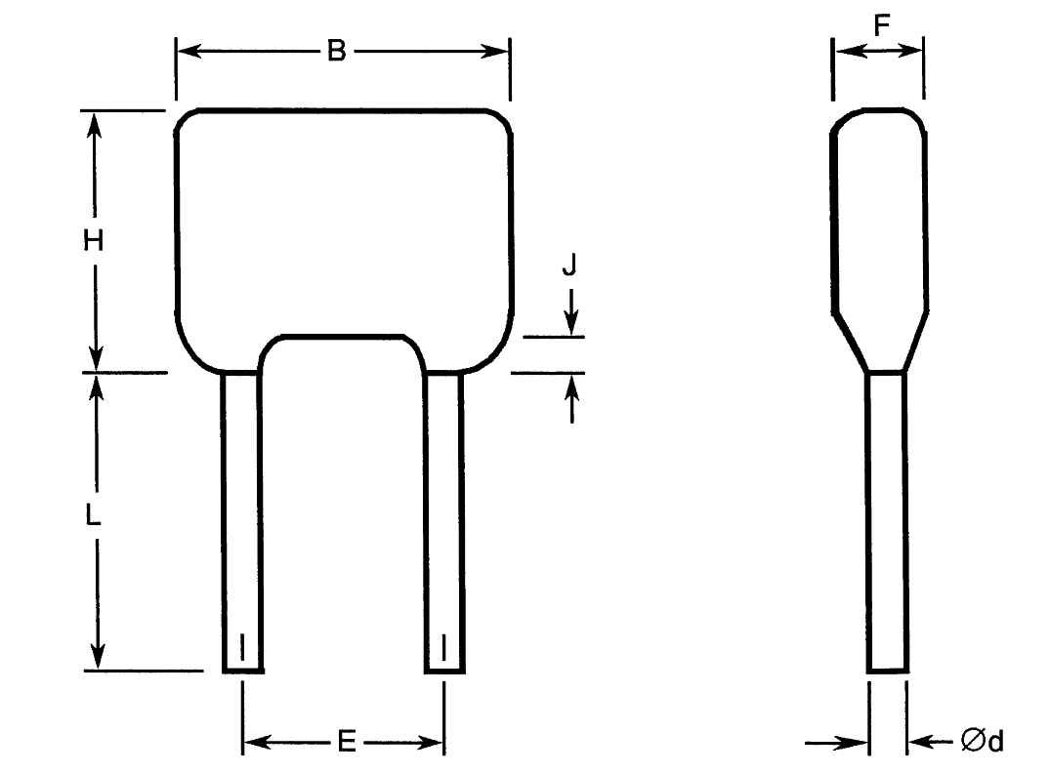
Variant  Number | Case Type | Dimensions (mm)
Variant  Number | Case Type | B  Max | Ød  (Note 1) |  | E |  | F  Max | H  Max | J  Max | L  Min (Note 1)
Variant  Number | Case Type | B  Max | Min | Max | Min | Max
01 | VR30S | 7.62 | 0.46 | 0.56 | 4.58 | 5.58 | 5 | 6.1 | 1.5 | 31.7
02 | VR30 | 7.62 | 0.46 | 0.56 | 4.58 | 5.58 | 5 | 9.62 | 1.5 | 31.7
03 | VR40 | 10.16 | 0.46 | 0.56 | 4.58 | 5.58 | 5 | 11.7 | 1.5 | 31.7
04 | VR50 | 12.7 | 0.59 | 0.69 | 9.66 | 10.66 | 5.1 | 14.2 | 1.5 | 31.7
05 | VR66 | 17.5 | 0.86 | 0.96 | 14.2 | 15.2 | 6.4 | 16.5 | 1.5 | 31.7
06 | VR84 | 23.62 | 0.86 | 0.96 | 20.4 | 22 | 6.4 | 19.78 | 1.5 | 31.7
07 | VR90 | 23.5 | 0.86 | 0.96 | 20.4 | 22 | 6.4 | 42 | 1.5 | 31.7
NOTES:
            - Both leads.

Case Type CV with Radial Leads
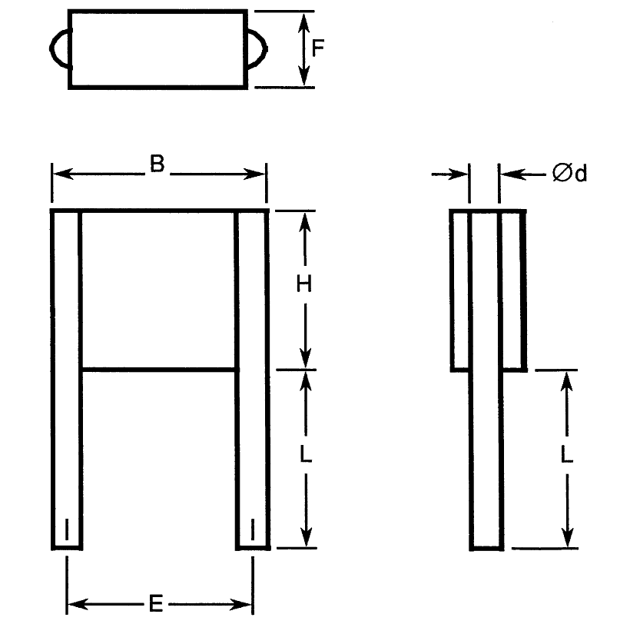
Variant  Number | Case Type | Dimensions (mm)
Variant  Number | Case Type | B  Max | Ød  (Note 1) |  | E |  | F  Max | H  Max | L  (Note 1)
Variant  Number | Case Type | B  Max | Min | Max | Min | Max | F  Max | H  Max | Min | Max
08 | CV41 | 10.6 | 0.65 | 0.75 | 7.7 | 8.7 | 3.8 | 8.7 | 22 | 28
11 | CV51 | 11.9 | 0.85 | 0.95 | 9.66 | 10.66 | 3.8 | 10.7 | 22 | 28
14 | CV61 | 16.5 | 0.85 | 0.95 | 14.74 | 15.74 | 3.8 | 13.6 | 22 | 28
17 | CV76 | 22.7 | 0.85 | 0.95 | 20.4 | 22 | 3.8 | 16.6 | 22 | 28
20 | CV91 | 22.7 | 1.15 | 1.25 | 20.4 | 22 | 3.8 | 40.6 | 22 | 28
NOTES:
            - Both leads.

Case Type CH with Straight DIL Leads
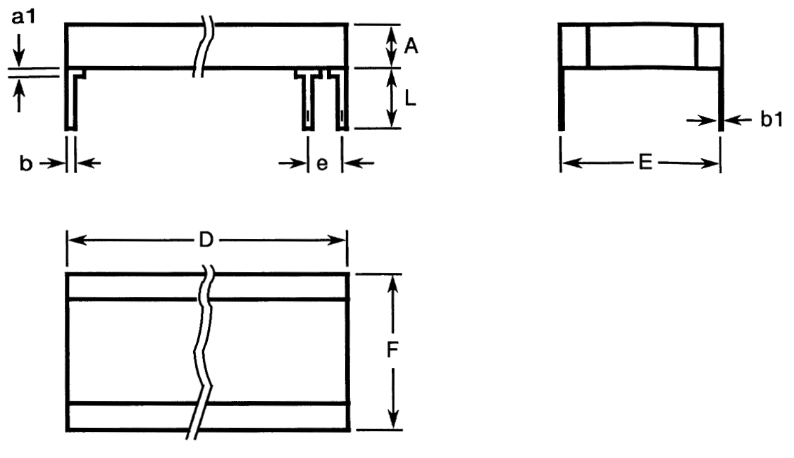
Variant  Number | Case Type | Dimensions (mm)
Variant  Number | Case Type | A  Max | a1  Max  (Note 1) | b  (Note 1) |  | b1  (Note 1) |  | D  Max | E  (Note 1) |  | e  (Note 1) |  | F  Max | L  (Note 1)
 |  |  |  | Min | Max | Min | Max | D  Max | Min | Max | Min | Max | F  Max | Min | Max
09 | CH41 | 3.8 | 2 | 0.45 | 0.55 | 0.204 | 0.304 | 8.7 | 7.7 | 8.7 | 2.49 | 2.59 | 9.2 | 12 | 14
12 | CH51 | 3.8 | 2 | 0.45 | 0.55 | 0.204 | 0.304 | 10.7 | 9.66 | 10.66 | 2.49 | 2.59 | 10.7 | 12 | 14
15 | CH61 | 3.8 | 2 | 0.45 | 0.55 | 0.204 | 0.304 | 13.6 | 13.5 | 14.5 | 2.49 | 2.59 | 14.9 | 12 | 14
18 | CH76 | 3.8 | 2 | 0.45 | 0.55 | 0.204 | 0.304 | 16.6 | 19.52 | 21.12 | 2.49 | 2.59 | 21.6 | 12 | 14
21 | CH91 | 3.8 | 2 | 0.45 | 0.55 | 0.204 | 0.304 | 40.6 | 19.52 | 21.12 | 2.49 | 2.59 | 24 | 12 | 14
NOTES:
            - All leads.

Case Type CH with L DIL Leads
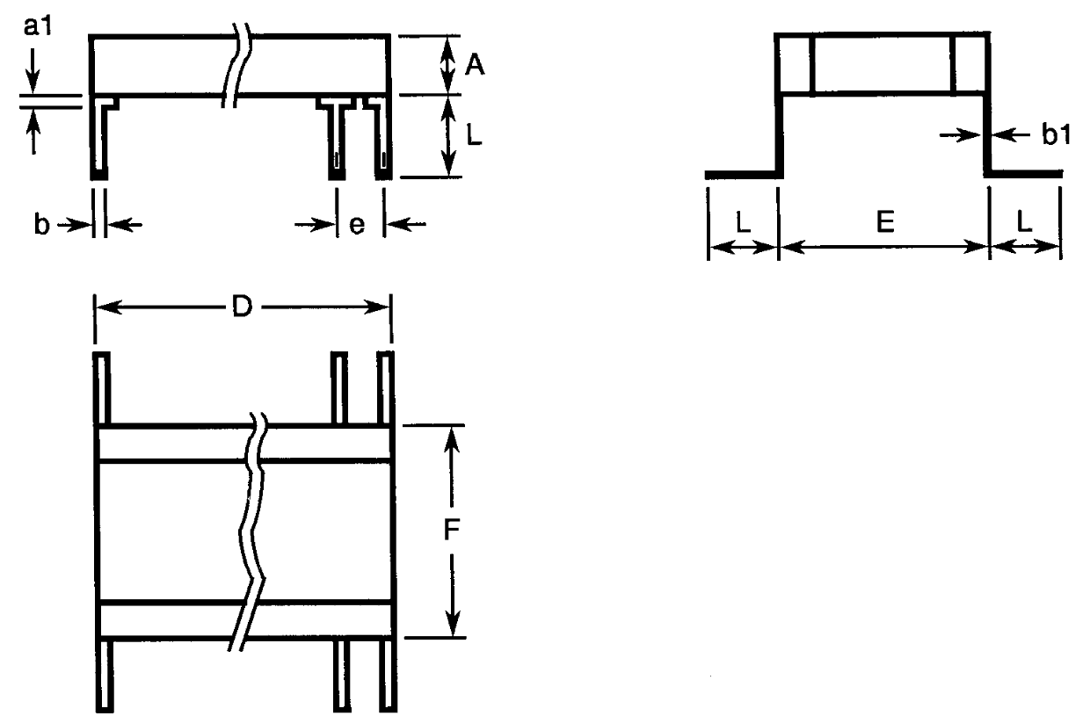
Variant  Number | Case Type | Dimensions (mm)
Variant  Number | Case Type | A  Max | a1  Max  (Note 1) | b  (Note 1) |  | b1  (Note 1) |  | D  Max | E  (Note 1) |  | e  (Note 1) |  | F  Max | L  (Note 1)
 |  |  |  | Min | Max | Min | Max | D  Max | Min | Max | Min | Max | F  Max | Min | Max
10 | CH41 | 3.8 | 2 | 0.45 | 0.55 | 0.204 | 0.304 | 8.7 | 7.7 | 8.7 | 2.49 | 2.59 | 9.2 | 2.04 | 3.04
13 | CH51 | 3.8 | 2 | 0.45 | 0.55 | 0.204 | 0.304 | 10.7 | 9.66 | 10.66 | 2.49 | 2.59 | 10.7 | 2.04 | 3.04
16 | CH61 | 3.8 | 2 | 0.45 | 0.55 | 0.204 | 0.304 | 13.6 | 13.5 | 14.5 | 2.49 | 2.59 | 14.9 | 2.04 | 3.04
19 | CH76 | 3.8 | 2 | 0.45 | 0.55 | 0.204 | 0.304 | 16.6 | 19.52 | 21.12 | 2.49 | 2.59 | 21.6 | 2.04 | 3.04
22 | CH91 | 3.8 | 2 | 0.45 | 0.55 | 0.204 | 0.304 | 40.6 | 19.52 | 21.12 | 2.49 | 2.59 | 24 | 2.04 | 3.04
NOTES:
            - All leads.

FUNCTIONAL DIAGRAM

NOTES:
            - For case type CH, all leads on each side of the component are connected to the same capacitor terminal.

REQUIREMENTS

GENERAL
The complete requirements for procurement of the components specified herein are as stated in this specification and the ESCC Generic Specification. Permitted deviations from the Generic Specification, applicable to this specification only, are listed below.
Permitted deviations from the Generic Specification and this Detail Specification, formally agreed with specific Manufacturers on the basis that the alternative requirements are equivalent to the ESCC requirement and do not affect the component’s reliability, are listed in the appendices attached to this specification.

Deviations from the Generic Specification

Deviations from Special In-Process Controls (Chart F2)
          - Robustness of Terminations: Shall be replaced with a lead peel test as specified in Robustness of Terminations herein.
      - Deviations from Qualification and Periodic Tests (Chart F4)
          - Steady State Humidity (85/85): Not applicable and shall be replaced in Chart F4 Group 1 of the Generic Specification by a Damp Heat Steady State test as follows:
Components shall be subjected to Test Cab of IEC Publication No. 60068-2-78. The following details shall apply:
- Test Conditions:
          - Temperature: 40 ±2°C
          - Relative humidity: 93 ±3%
          - Duration: 56 days
          - Bias during test: Half the samples shall have no voltage applied; the remaining half shall have 100V applied.
- Data Points
Prior to the test, Capacitance shall be measured as specified in Intermediate and End-Point Electrical Measurements.
On completion of testing the components shall be subjected to standard atmospheric conditions for recovery for 6 to 24 hours.
After recovery, the components shall be visually examined. There shall be no evidence of damage. Capacitance, Change in Capacitance, Tangent of Loss Angle, Insulation Resistance and Voltage Proof (Body Insulation) shall be measured as specified in Intermediate and End-Point Electrical Measurements. Change in Capacitance shall be related to the initial measurements.

MARKING
The marking shall be in accordance with the requirements of ESCC Basic Specification No. 21700 and as follows.
The information to be marked on the component shall be:
          - The ESCC qualified components symbol (for ESCC qualified components only).
          - The ESCC Component Number.
          - Traceability information.

ROBUSTNESS OF TERMINATIONS
The terminations of these devices are classified as rigid.
Robustness of Terminations shall be performed as a lead peel test on a sample of 5 components from each manufacturing lot with 0 failures allowed. The sample components shall be leaded but not encapsulated or coated. Where necessary, the leads of the component under test shall be bent through 90° in the plane of the joint such that a tensile force applied to the leads will result in a peeling force being applied to the leads’ joint.
A tensile force shall be applied evenly across the length, on the capacitor terminal, to all leads on that side of the component together, until the lead joint peels. All leads shall be tested.
The minimum peeling force shall be as follows:
          - For case types VR & CV: 8.9N
          - For case type CH: 22.25N

ELECTRICAL MEASUREMENTS AT ROOM, HIGH AND LOW TEMPERATURES
Electrical measurements shall be performed at room, high and low temperatures.

Room Temperature Electrical Measurements
The measurements shall be performed at T_{amb} = +22 ±3°C.
Characteristics | Symbols | Test Method and  Conditions | Tolerance  (± %) | Limits |  | Units
 |  |  |  | Min | Max | Units
Capacitance | C_{A} | ESCC No. 3001 |  |  |  | pF
Capacitance | C_{A} | ESCC No. 3001 | 5 | 0.95C_{n} | 1.05C_{n} | pF
Capacitance | C_{A} | ESCC No. 3001 | 10 | 0.9C_{n} | 1.1C_{n} | pF
Capacitance | C_{A} | ESCC No. 3001 | 20 | 0.8C_{n} | 1.2C_{n} | pF
Tangent of Loss Angle | tgδ | ESCC No. 3001 | All | - | 10 ×10⁻⁴ | -
Insulation Resistance  (Dielectric) | R_{ID} | ESCC No. 3001 | All
Insulation Resistance  (Dielectric) | R_{ID} | C_{n} ≤ 10000pF | All | 100 | - | GΩ
Insulation Resistance  (Dielectric) | R_{ID} | C_{n} > 10000pF | All | 1000 | - | GΩ.nF
Insulation Resistance  (Body Insulation) | R_{IB} | ESCC No. 3001  Case type VR only  Note 1 | All
Insulation Resistance  (Body Insulation) | R_{IB} | C_{n} ≤ 10000pF | All | 100 | - | GΩ
Insulation Resistance  (Body Insulation) | R_{IB} | C_{n} > 10000pF | All | 1000 | - | GΩ.nF
Voltage Proof  (Dielectric) | VP_{D} | ESCC No. 3001 | All |  |  | V
Voltage Proof  (Dielectric) | VP_{D} | For U_{R} = 1000V | All | 1.5U_{R} | - | V
Voltage Proof  (Dielectric) | VP_{D} | For U_{R} ≥ 2000V | All | 1.3U_{R} | - | V
Voltage Proof  (Body Insulation) | VP_{B} | ESCC No. 3001  Case type VR only  Note 1 | All |  |  | V
Voltage Proof  (Body Insulation) | VP_{B} | For U_{R} = 1000V | All | 1.5U_{R} | - | V
Voltage Proof  (Body Insulation) | VP_{B} | For U_{R} ≥ 2000V | All | 1.3U_{R} | - | V
NOTES:
            - The measurements shall be performed on a sample of 5 components from each manufacturing lot with 0 failures allowed. In the event of any failure a 100% inspection may be performed. In the case of a 100% inspection, a 1% total percent defective is allowed.

High and Low Temperatures Electrical Measurements
Characteristics | Symbols | Test Method and Conditions  (Note 1) | Limits |  | Units
Characteristics | Symbols | Test Method and Conditions  (Note 1) | Min | Max | Units
Temperature Coefficient | TC | ESCC No. 3001  T_{amb} = -55 ±2°C, +20 ±2°C, +125 ±2°C  Note 2 | -30 | +30 | 10⁻⁶/°C
NOTES:
            - The measurements shall be performed on a sample of 5 components from each manufacturing lot with 0 failures allowed. In the event of any failure a 100% inspection may be performed.
            - In the case of a 100% inspection, a 1% total percent defective is allowed.

INTERMEDIATE AND END-POINT ELECTRICAL MEASUREMENTS
Unless otherwise specified, the measurements shall be performed at T_{amb} = +22 ±3°C.
Unless otherwise specified the test methods and test conditions shall be as per the corresponding test defined in Room Temperature Electrical Measurements.
Test Reference per ESCC No. 3001 | Characteristics | Symbols | Limits |  | Units
Test Reference per ESCC No. 3001 | Characteristics | Symbols | Min | Max | Units
Rapid Change of
Temperature
Initial Measurements | Capacitance | C_{A} | Note 1
Final Measurements | Capacitance | C_{A} | Note 1
Final Measurements | Change in Capacitance | ΔC_{A}/C_{A} | -1 | +1 | %
Final Measurements | Tangent of Loss Angle | tgδ | - | 20 ×10⁻⁴ | -
Damp Heat Steady State
Initial Measurements | Capacitance | C_{A} | Note 1
Final Measurements | Capacitance | C_{A} | Note 1
Final Measurements | Change in Capacitance | ΔC_{A}/C_{A} | -2 | +2 | %
Final Measurements | Tangent of Loss Angle | tgδ | - | 20 ×10⁻⁴ | -
Final Measurements | Insulation Resistance (Dielectric): | R_{ID}
Final Measurements | C_{n} ≤ 10000pF |  | 10 | - | GΩ
Final Measurements | C_{n} > 10000pF |  | 100 | - | GΩ.nF
Final Measurements | Insulation Resistance (Body Insulation) (Note 2): | R_{IB}
Final Measurements | C_{n} ≤ 10000pF |  | 10 | - | GΩ
Final Measurements | C_{n} > 10000pF |  | 100 | - | GΩ.nF
Final Measurements | Voltage Proof (Body Insulation) (Note 2) | V_{PB} | Note 1
Operating Life
Initial Measurements | Capacitance | C_{A} | Note 1
Intermediate Measurements  (1000 hours) (Note 3) | Capacitance | C_{A} | Note 1
Intermediate Measurements  (1000 hours) (Note 3) | Change in Capacitance | ΔC_{A}/C_{A} | -3 | +3 | %
Intermediate Measurements  (1000 hours) (Note 3) | Insulation Resistance (Dielectric): | R_{ID}
Intermediate Measurements  (1000 hours) (Note 3) | C_{n} ≤ 10000pF |  | 10 | - | GΩ
Intermediate Measurements  (1000 hours) (Note 3) | C_{n} > 10000pF |  | 100 | - | GΩ.nF
Intermediate Measurements  (1000 hours) (Note 3) | Insulation Resistance (Body Insulation) (Note 2): | R_{IB}
Intermediate Measurements  (1000 hours) (Note 3) | C_{n} ≤ 10000pF |  | 10 | - | GΩ
Intermediate Measurements  (1000 hours) (Note 3) | C_{n} > 10000pF |  | 100 | - | GΩ.nF
Final Measurements  (1000 or 2000 hours) (Note 4) | Capacitance | C_{A} | Note 1
Final Measurements  (1000 or 2000 hours) (Note 4) | Change in Capacitance | ΔC_{A}/C_{A} | -3 | +3 | %
Final Measurements  (1000 or 2000 hours) (Note 4) | Tangent of Loss Angle | tgδ | - | 20 ×10⁻⁴ | -
Final Measurements  (1000 or 2000 hours) (Note 4) | Insulation Resistance (Dielectric): | R_{ID}
Final Measurements  (1000 or 2000 hours) (Note 4) | C_{n} ≤ 10000pF |  | 10 | - | GΩ
Final Measurements  (1000 or 2000 hours) (Note 4) | C_{n} > 10000pF |  | 100 | - | GΩ.nF
Final Measurements  (1000 or 2000 hours) (Note 4) | Insulation Resistance (Body Insulation) (Note 2): | R_{IB}
Final Measurements  (1000 or 2000 hours) (Note 4) | C_{n} ≤ 10000pF |  | 10 | - | GΩ
Final Measurements  (1000 or 2000 hours) (Note 4) | C_{n} > 10000pF |  | 100 | - | GΩ.nF
Final Measurements  (1000 or 2000 hours) (Note 4) | Voltage Proof (Dielectric) | V_{PD} | Note 1
Final Measurements  (1000 or 2000 hours) (Note 4) | Voltage Proof (Body Insulation) (Note 2) | V_{PB} | Note 1
Capacitance-Temperature Characteristics | Temperature Coefficient | TC | Note 5
Resistance to Soldering Heat
Initial Measurements | Capacitance | C_{A} | Note 1
Final Measurements | Capacitance | C_{A} | Note 1
Final Measurements | Change in Capacitance | ΔC_{A}/C_{A} | -1 | +1 | %
Final Measurements | Insulation Resistance (Dielectric) | R_{ID} | Note 1
Final Measurements | Insulation Resistance (Body Insulation) (Note 2) | R_{IB} | Note 1
NOTES:
            - As specified in Room Temperature Electrical Measurements.
            - Case type VR only.
            - Intermediate measurements are optional at the Manufacturer’s discretion.
            - 1000 hours is applicable to Periodic Testing for extension of qualification. 2000 hours is applicable to Qualification Testing, and to Periodic Testing for renewal of qualification after lapse.
            - As specified in High and Low Temperatures Electrical Measurements.

BURN-IN
The requirements for Burn-in are specified in the ESCC Generic Specification. The following conditions shall also apply:
- After Burn-in, the components shall be removed from the chamber and allowed to cool under normal atmospheric conditions for recovery for 24 hours minimum.

APPENDIX A
AGREED DEVIATIONS FOR AVX LTD (GB)
Items Affected | Description of Deviations
Deviations from Generic Specification:  Special In-Process Controls (Chart F2) | Microsection Inspection: may be performed using AVX inspection document as per PID.
 | Internal Visual Inspection: may be performed using AVX inspection document as per PID.
Deviations from Generic Specification:  Screening (Chart F3) | External Visual Inspection: may be performed using AVX inspection document as per PID.
Deviations from Generic Specification:  Qualification and Periodic Tests (Chart F4) | External Visual Inspection: may be performed using AVX inspection document as per PID.

