

Page 1 of 20

CAPACITORS, FIXED, MULTIPLE LAYER, CERAMIC DIELECTRIC, TYPE II
BASED ON TYPES CNC53, CNC54, CNC55, CNC56, CNC57, CNC58 AND CNC65
ESCC Detail Specification No. 3001/038
Issue 3 Draft A | February 2017



Document Custodian: European Space Agency – see https://escies.org

LEGAL DISCLAIMER AND COPYRIGHT
European Space Agency, Copyright © 2017. All rights reserved.
The European Space Agency disclaims any liability or responsibility, to any person or entity, with respect to any loss or damage caused, or alleged to be caused, directly or indirectly by the use and application of this ESCC publication.
This publication, without the prior permission of the European Space Agency and provided that it is not used for a commercial purpose, may be:
- copied in whole, in any medium, without alteration or modification.
- copied in part, in any medium, provided that the ESCC document identification, comprising the ESCC symbol, document number and document issue, is removed.

DOCUMENTATION CHANGE NOTICE
(Refer to https://escies.org for ESCC DCR content)
DCR No. | CHANGE DESCRIPTION
TBA | Specification updated to incorporate changes per DCR.

TABLE OF CONTENTS

1 GENERAL 5
1.1 SCOPE 5
1.2 APPLICABLE DOCUMENTS 5
1.3 TERMS, DEFINITIONS, ABBREVIATIONS, SYMBOLS AND UNITS 5
1.4 THE ESCC COMPONENT NUMBER AND COMPONENT TYPE VARIANTS 5
1.4.1 The ESCC Component Number 5
1.4.2 Component Type Variants and Range of Components 6
1.5 MAXIMUM RATINGS 10
1.6 PHYSICAL DIMENSIONS 11
1.6.1 Variants 01 to 07 (lead type N) 11
1.6.2 Variants 08 to 14 (lead type P) 12
1.6.3 Variants 15 to 21 (lead type PL) 13
1.6.4 Variants 22 to 28 (lead type L) 14
1.7 FUNCTIONAL DIAGRAM 14
2 REQUIREMENTS 15
2.1 GENERAL 15
2.1.1 Deviations from the Generic Specification 15
2.2 MARKING 15
2.3 ROBUSTNESS OF TERMINATIONS 15
2.4 ELECTRICAL MEASUREMENTS AT ROOM, HIGH AND LOW TEMPERATURES 16
2.4.1 Room Temperature Electrical Measurements 16
2.4.2 High and Low Temperatures Electrical Measurements 17
2.5 INTERMEDIATE AND END-POINT ELECTRICAL MEASUREMENTS 17
2.6 BURN-IN 19
APPENDIX A 20

GENERAL

SCOPE
This specification details the ratings, physical and electrical characteristics, and test and inspection data for the component type variants and/or the range of components specified below. It supplements the requirements of, and shall be read in conjunction with, the ESCC Generic Specification listed under Applicable Documents.

APPLICABLE DOCUMENTS
The following documents form part of this specification and shall be read in conjunction with it:
          - ESCC Generic Specification No. 3001.

TERMS, DEFINITIONS, ABBREVIATIONS, SYMBOLS AND UNITS
For the purpose of this specification, the terms, definitions, abbreviations, symbols and units specified in ESCC Basic Specification No. 21300 shall apply.

THE ESCC COMPONENT NUMBER AND COMPONENT TYPE VARIANTS

The ESCC Component Number
The ESCC Component Number shall be constituted as follows:
Example: 300103801126KC
- Detail Specification Reference: 3001038
- Component Type Variant Number: 01 (as required)
- Characteristic code: Capacitance Value (12μF): 126 (as required)
- Characteristic code: Capacitance Tolerance (±10%): K (as required)
- Rating code: Rated Voltage (50V): C (as required)

Characteristics and Ratings Codes
Characteristics and ratings to be codified as part of the ESCC Component Number shall be as follows:
          - Rated Capacitance Value C_{n} expressed by means of the following codes in accordance with ESCC Basic Specification No. 21700. The unit quantity shall be picofarad (pF).
Capacitance Value C_{n}  (pF) | Code
XX 10⁴ | XX4
XX 10⁵ | XX5
XX 10⁶ | XX6
XX 10⁷ | XX7
          - Capacitance Tolerance expressed by the following codes in accordance with ESCC Basic Specification No. 21700:
Tolerance  (± %) | Code Letter
10 | K
20 | M
          - Rated Voltage expressed by the following codes:
Rated Voltage U_{R}  (V) | Code Letter
50 | C
100 | E
200 | G
500 | L

Component Type Variants and Range of Components
The component type variants and range of components applicable to this specification are as follows:
Variant  Number | Package Details  (Note 1) |  |  |  |  | Capacitance Range C_{n}  (µF) (Note 4) |  |  |  | Weight  Max  (g)
Variant  Number | Type  (Note 2) | Lead  Type | Lead  Mat. & Fin.  (Note 3) | No. of  Leads | Dim. H  Max (mm) | Rated  Voltage  U_{R} = 50V | Rated  Voltage  U_{R} = 100V | Rated  Voltage  U_{R} = 200V | Rated  Voltage  U_{R} = 500V | Weight  Max  (g)
01 | CNC53NE | N | A10 | 6 | 4 | 1.8 to 3.3 | 1 to 2.7 | 0.27 to 0.68 | 0.1 to 0.22 | 2
 |  |  |  |  | 8 | 3.9 to 6.8 | 3.3 to 5.6 | 0.82 to 1.2 | 0.27 to 0.47 | 3.5
 |  |  |  |  | 12 | 8.2 to 10 | 6.8 to 8.2 | 1.5 to 1.8 | 0.56 to 0.68 | 5
 |  |  |  |  | 16 | 12 | 10 | 2.2 to 2.7 | 0.82 to 1 | 6.5
02 | CNC54NE | N | A10 | 8 | 4 | 3.3 to 5.6 | 1.8 to 3.9 | 0.47 to 1 | 0.22 to 0.39 | 3
 |  |  |  |  | 8 | 6.8 to 10 | 4.7 to 8.2 | 1.2 to 2.2 | 0.47 to 0.82 | 5.5
 |  |  |  |  | 12 | 12 to 15 | 10 to 12 | 2.7 to 3.3 | 1 to 1.2 | 8.5
 |  |  |  |  | 16 | 18 to 22 | 15 | 3.9 | 1.5 | 11
03 | CNC55NE | N | A10 | 10 | 4 | 6.8 to 10 | 2.7 to 8.2 | 1 to 2.2 | 0.33 to 0.82 | 4.5
 |  |  |  |  | 8 | 12 to 22 | 10 to 15 | 2.7 to 4.7 | 1 to 1.8 | 9
 |  |  |  |  | 12 | 27 to 33 | 18 to 22 | 5.6 to 6.8 | 2.2 to 2.7 | 13.5
 |  |  |  |  | 16 | 39 | 27 to 33 | 8.2 to 10 | 3.3 | 18
04 | CNC56NE | N | A10 | 14 | 4 | 10 to 18 | 4.7 to 15 | 1.8 to 3.9 | 0.47 to 1.5 | 6.5
 |  |  |  |  | 8 | 22 to 39 | 18 to 27 | 4.7 to 6.8 | 1.8 to 3.3 | 13
 |  |  |  |  | 12 | 47 to 56 | 33 to 39 | 8.2 to 10 | 3.9 to 4.7 | 19.5
 |  |  |  |  | 16 | 68 | 47 | 12 | 5.6 | 26
05 | CNC57NE | N | A10 | 28 | 4 | 15 to 22 | 12 to 18 | 2.2 to 3.9 | 0.82 to 1.5 | 7.5
 |  |  |  |  | 8 | 27 to 47 | 22 to 39 | 4.7 to 8.2 | 1.8 to 3.3 | 15
 |  |  |  |  | 12 | 56 to 68 | 47 to 56 | 10 to 12 | 3.9 to 4.7 | 22.5
 |  |  |  |  | 16 | 82 | 68 | 15 | 5.6 | 30
06 | CNC58NE | N | A10 | 28 | 4 | 39 to 47 | 33 to 39 | 8.2 to 10 | 2.7 to 4.7 | 15
 |  |  |  |  | 8 | 56 to 100 | 47 to 82 | 12 to 22 | 5.6 to 10 | 30
 |  |  |  |  | 12 | 120 to 150 | 100 to 120 | 27 to 33 | 12 to 15 | 45
 |  |  |  |  | 16 | 180 | 150 | 39 | 18 | 60
07 | CNC65NE | N | A10 | 12 | 4 | 10 to 18 | 4.7 to 15 | 1.8 to 3.9 | 0.47 to 1.5 | 6.5
 |  |  |  |  | 8 | 22 to 39 | 18 to 27 | 4.7 to 6.8 | 1.8 to 3.3 | 13
 |  |  |  |  | 12 | 47 to 56 | 33 to 39 | 8.2 to 10 | 3.9 to 4.7 | 19.5
 |  |  |  |  | 16 | 68 | 47 | 12 | 5.6 | 26
08 | CNC53PE | P | A10 | 6 | 4 | 1.8 to 3.3 | 1 to 2.7 | 0.27 to 0.68 | 0.1 to 0.22 | 2
 |  |  |  |  | 8 | 3.9 to 6.8 | 3.3 to 5.6 | 0.82 to 1.2 | 0.27 to 0.47 | 3.5
 |  |  |  |  | 12 | 8.2 to 10 | 6.8 to 8.2 | 1.5 to 1.8 | 0.56 to 0.68 | 5
 |  |  |  |  | 16 | 12 | 10 | 2.2 to 2.7 | 0.82 to 1 | 6.5
09 | CNC54PE | P | A10 | 8 | 4 | 3.3 to 5.6 | 1.8 to 3.9 | 0.47 to 1 | 0.22 to 0.39 | 3
 |  |  |  |  | 8 | 6.8 to 10 | 4.7 to 8.2 | 1.2 to 2.2 | 0.47 to 0.82 | 5.5
 |  |  |  |  | 12 | 12 to 15 | 10 to 12 | 2.7 to 3.3 | 1 to 1.2 | 8.5
 |  |  |  |  | 16 | 18 to 22 | 15 | 3.9 | 1.5 | 11
10 | CNC55PE | P | A10 | 10 | 4 | 6.8 to 10 | 2.7 to 8.2 | 1 to 2.2 | 0.33 to 0.82 | 4.5
 |  |  |  |  | 8 | 12 to 22 | 10 to 15 | 2.7 to 4.7 | 1 to 1.8 | 9
 |  |  |  |  | 12 | 27 to 33 | 18 to 22 | 5.6 to 6.8 | 2.2 to 2.7 | 13.5
 |  |  |  |  | 16 | 39 | 27 to 33 | 8.2 to 10 | 3.3 | 18
11 | CNC56PE | P | A10 | 14 | 4 | 10 to 18 | 4.7 to 15 | 1.8 to 3.9 | 0.47 to 1.5 | 6.5
 |  |  |  |  | 8 | 22 to 39 | 18 to 27 | 4.7 to 6.8 | 1.8 to 3.3 | 13
 |  |  |  |  | 12 | 47 to 56 | 33 to 39 | 8.2 to 10 | 3.9 to 4.7 | 19.5
 |  |  |  |  | 16 | 68 | 47 | 12 | 5.6 | 26
12 | CNC57PE | P | A10 | 28 | 4 | 15 to 22 | 12 to 18 | 2.2 to 3.9 | 0.82 to 1.5 | 7.5
 |  |  |  |  | 8 | 27 to 47 | 22 to 39 | 4.7 to 8.2 | 1.8 to 3.3 | 15
 |  |  |  |  | 12 | 56 to 68 | 47 to 56 | 10 to 12 | 3.9 to 4.7 | 22.5
 |  |  |  |  | 16 | 82 | 68 | 15 | 5.6 | 30
13 | CNC58PE | P | A10 | 28 | 4 | 39 to 47 | 33 to 39 | 8.2 to 10 | 2.7 to 4.7 | 15
 |  |  |  |  | 8 | 56 to 100 | 47 to 82 | 12 to 22 | 5.6 to 10 | 30
 |  |  |  |  | 12 | 120 to 150 | 100 to 120 | 27 to 33 | 12 to 15 | 45
 |  |  |  |  | 16 | 180 | 150 | 39 | 18 | 60
14 | CNC65PE | P | A10 | 12 | 4 | 10 to 18 | 4.7 to 15 | 1.8 to 3.9 | 0.47 to 1.5 | 6.5
 |  |  |  |  | 8 | 22 to 39 | 18 to 27 | 4.7 to 6.8 | 1.8 to 3.3 | 13
 |  |  |  |  | 12 | 47 to 56 | 33 to 39 | 8.2 to 10 | 3.9 to 4.7 | 19.5
 |  |  |  |  | 16 | 68 | 47 | 12 | 5.6 | 26
15 | CNC53PLE | PL | A10 | 6 | 4 | 1.8 to 3.3 | 1 to 2.7 | 0.27 to 0.68 | 0.1 to 0.22 | 2
 |  |  |  |  | 8 | 3.9 to 6.8 | 3.3 to 5.6 | 0.82 to 1.2 | 0.27 to 0.47 | 3.5
 |  |  |  |  | 12 | 8.2 to 10 | 6.8 to 8.2 | 1.5 to 1.8 | 0.56 to 0.68 | 5
 |  |  |  |  | 16 | 12 | 10 | 2.2 to 2.7 | 0.82 to 1 | 6.5
16 | CNC54PLE | PL | A10 | 8 | 4 | 3.3 to 5.6 | 1.8 to 3.9 | 0.47 to 1 | 0.22 to 0.39 | 3
 |  |  |  |  | 8 | 6.8 to 10 | 4.7 to 8.2 | 1.2 to 2.2 | 0.47 to 0.82 | 5.5
 |  |  |  |  | 12 | 12 to 15 | 10 to 12 | 2.7 to 3.3 | 1 to 1.2 | 8.5
 |  |  |  |  | 16 | 18 to 22 | 15 | 3.9 | 1.5 | 11
17 | CNC55PLE | PL | A10 | 10 | 4 | 6.8 to 10 | 2.7 to 8.2 | 1 to 2.2 | 0.33 to 0.82 | 4.5
 |  |  |  |  | 8 | 12 to 22 | 10 to 15 | 2.7 to 4.7 | 1 to 1.8 | 9
 |  |  |  |  | 12 | 27 to 33 | 18 to 22 | 5.6 to 6.8 | 2.2 to 2.7 | 13.5
 |  |  |  |  | 16 | 39 | 27 to 33 | 8.2 to 10 | 3.3 | 18
18 | CNC56PLE | PL | A10 | 14 | 4 | 10 to 18 | 4.7 to 15 | 1.8 to 3.9 | 0.47 to 1.5 | 6.5
 |  |  |  |  | 8 | 22 to 39 | 18 to 27 | 4.7 to 6.8 | 1.8 to 3.3 | 13
 |  |  |  |  | 12 | 47 to 56 | 33 to 39 | 8.2 to 10 | 3.9 to 4.7 | 19.5
 |  |  |  |  | 16 | 68 | 47 | 12 | 5.6 | 26
19 | CNC57PLE | PL | A10 | 28 | 4 | 15 to 22 | 12 to 18 | 2.2 to 3.9 | 0.82 to 1.5 | 7.5
 |  |  |  |  | 8 | 27 to 47 | 22 to 39 | 4.7 to 8.2 | 1.8 to 3.3 | 15
 |  |  |  |  | 12 | 56 to 68 | 47 to 56 | 10 to 12 | 3.9 to 4.7 | 22.5
 |  |  |  |  | 16 | 82 | 68 | 15 | 5.6 | 30
20 | CNC58PLE | PL | A10 | 28 | 4 | 39 to 47 | 33 to 39 | 8.2 to 10 | 2.7 to 4.7 | 15
 |  |  |  |  | 8 | 56 to 100 | 47 to 82 | 12 to 22 | 5.6 to 10 | 30
 |  |  |  |  | 12 | 120 to 150 | 100 to 120 | 27 to 33 | 12 to 15 | 45
 |  |  |  |  | 16 | 180 | 150 | 39 | 18 | 60
21 | CNC65PLE | PL | A10 | 12 | 4 | 10 to 18 | 4.7 to 15 | 1.8 to 3.9 | 0.47 to 1.5 | 6.5
 |  |  |  |  | 8 | 22 to 39 | 18 to 27 | 4.7 to 6.8 | 1.8 to 3.3 | 13
 |  |  |  |  | 12 | 47 to 56 | 33 to 39 | 8.2 to 10 | 3.9 to 4.7 | 19.5
 |  |  |  |  | 16 | 68 | 47 | 12 | 5.6 | 26
22 | CNC53LE | L | A10 | 6 | 4 | 1.8 to 3.3 | 1 to 2.7 | 0.27 to 0.68 | 0.1 to 0.22 | 2
 |  |  |  |  | 8 | 3.9 to 6.8 | 3.3 to 5.6 | 0.82 to 1.2 | 0.27 to 0.47 | 3.5
 |  |  |  |  | 12 | 8.2 to 10 | 6.8 to 8.2 | 1.5 to 1.8 | 0.56 to 0.68 | 5
 |  |  |  |  | 16 | 12 | 10 | 2.2 to 2.7 | 0.82 to 1 | 6.5
23 | CNC54LE | L | A10 | 8 | 4 | 3.3 to 5.6 | 1.8 to 3.9 | 0.47 to 1 | 0.22 to 0.39 | 3
 |  |  |  |  | 8 | 6.8 to 10 | 4.7 to 8.2 | 1.2 to 2.2 | 0.47 to 0.82 | 5.5
 |  |  |  |  | 12 | 12 to 15 | 10 to 12 | 2.7 to 3.3 | 1 to 1.2 | 8.5
 |  |  |  |  | 16 | 18 to 22 | 15 | 3.9 | 1.5 | 11
24 | CNC55LE | L | A10 | 10 | 4 | 6.8 to 10 | 2.7 to 8.2 | 1 to 2.2 | 0.33 to 0.82 | 4.5
 |  |  |  |  | 8 | 12 to 22 | 10 to 15 | 2.7 to 4.7 | 1 to 1.8 | 9
 |  |  |  |  | 12 | 27 to 33 | 18 to 22 | 5.6 to 6.8 | 2.2 to 2.7 | 13.5
 |  |  |  |  | 16 | 39 | 27 to 33 | 8.2 to 10 | 3.3 | 18
25 | CNC56LE | L | A10 | 14 | 4 | 10 to 18 | 4.7 to 15 | 1.8 to 3.9 | 0.47 to 1.5 | 6.5
 |  |  |  |  | 8 | 22 to 39 | 18 to 27 | 4.7 to 6.8 | 1.8 to 3.3 | 13
 |  |  |  |  | 12 | 47 to 56 | 33 to 39 | 8.2 to 10 | 3.9 to 4.7 | 19.5
 |  |  |  |  | 16 | 68 | 47 | 12 | 5.6 | 26
26 | CNC57LE | L | A10 | 28 | 4 | 15 to 22 | 12 to 18 | 2.2 to 3.9 | 0.82 to 1.5 | 7.5
 |  |  |  |  | 8 | 27 to 47 | 22 to 39 | 4.7 to 8.2 | 1.8 to 3.3 | 15
 |  |  |  |  | 12 | 56 to 68 | 47 to 56 | 10 to 12 | 3.9 to 4.7 | 22.5
 |  |  |  |  | 16 | 82 | 68 | 15 | 5.6 | 30
27 | CNC58LE | L | A10 | 28 | 4 | 39 to 47 | 33 to 39 | 8.2 to 10 | 2.7 to 4.7 | 15
 |  |  |  |  | 8 | 56 to 100 | 47 to 82 | 12 to 22 | 5.6 to 10 | 30
 |  |  |  |  | 12 | 120 to 150 | 100 to 120 | 27 to 33 | 12 to 15 | 45
 |  |  |  |  | 16 | 180 | 150 | 39 | 18 | 60
28 | CNC65LE | L | A10 | 12 | 4 | 10 to 18 | 4.7 to 15 | 1.8 to 3.9 | 0.47 to 1.5 | 6.5
 |  |  |  |  | 8 | 22 to 39 | 18 to 27 | 4.7 to 6.8 | 1.8 to 3.3 | 13
 |  |  |  |  | 12 | 47 to 56 | 33 to 39 | 8.2 to 10 | 3.9 to 4.7 | 19.5
 |  |  |  |  | 16 | 68 | 47 | 12 | 5.6 | 26
NOTES:
            - See Physical Dimensions and Functional Diagram.
            - For Variants 01 to 07 the body shall be coated with varnish. Variants 08 to 28 are classified as non-insulated.
            - The lead materials and finishes shall be in accordance with the requirements of ESCC Basic Specification No. 23500.
            - Available capacitance values and tolerances are as follows:
- Tolerance: ±10%; value series: E12
- Tolerance: ±20%; value series: E6

MAXIMUM RATINGS
The maximum ratings shall not be exceeded at any time during use or storage.
Maximum ratings shall only be exceeded during testing to the extent specified in this specification and when stipulated in Test Methods and Procedures of the ESCC Generic Specification.
Characteristics | Symbols | Maximum Ratings | Units | Remarks
Rated Voltage | U_{R} | 50, 100, 200, 500 | V | Note 1
Operating Temperature Range | T_{op} | -55 to +125 | °C | Without derating. T_{amb}
Storage Temperature Range | T_{stg} | -55 to +125 | °C
Soldering Temperature | T_{sol} | +260 | °C | Note 2
NOTES:
            - As required; See Component Type Variants and Range of Components.
            - Duration 10 seconds maximum and the same lead shall not be resoldered until 3 minutes have elapsed.

PHYSICAL DIMENSIONS

Variants 01 to 07 (lead type N)
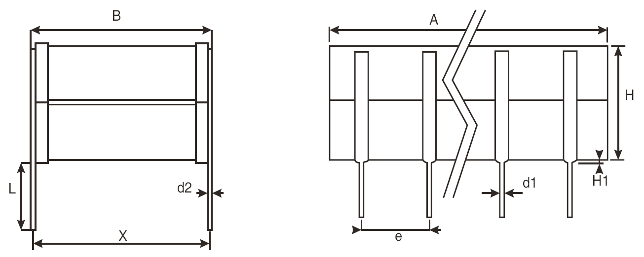
Variant  Number | No. of  Leads | Dimensions (mm)
Variant  Number | No. of  Leads | A  Max | B  Max | d1  (Note 1) |  | d2  (Note 1) |  | e  (Note 1) |  | H  Max | H1  Max  (Note 1) | L  Min  (Note 1) | X  (Note 1)
 |  |  |  | Min | Max | Min | Max | Min | Max | H  Max | H1  Max  (Note 1) | L  Min  (Note 1) | Min | Max
01 | 6 | 8.7 | 9.2 | 0.4 | 0.6 | 0.2 | 0.3 | 2.49 | 2.59 | Note 2 | 2.05 | 7.5 | 7.7 | 8.7
02 | 8 | 10.7 | 10.7 | 0.4 | 0.6 | 0.2 | 0.3 | 2.49 | 2.59 | Note 2 | 2.05 | 7.5 | 9.66 | 10.66
03 | 10 | 13.6 | 14.9 | 0.4 | 0.6 | 0.2 | 0.3 | 2.49 | 2.59 | Note 2 | 2.05 | 7.5 | 13.5 | 14.5
04 | 14 | 21.6 | 16.8 | 0.4 | 0.6 | 0.2 | 0.3 | 2.49 | 2.59 | Note 2 | 2.05 | 7.5 | 14.74 | 15.74
05 | 28 | 38.2 | 12 | 0.4 | 0.6 | 0.2 | 0.3 | 2.49 | 2.59 | Note 2 | 2.05 | 7.5 | 9.66 | 10.66
06 | 28 | 40.6 | 24 | 0.4 | 0.6 | 0.2 | 0.3 | 2.49 | 2.59 | Note 2 | 2.05 | 7.5 | 19.82 | 20.82
07 | 12 | 16.6 | 21.6 | 0.4 | 0.6 | 0.2 | 0.3 | 2.49 | 2.59 | Note 2 | 2.05 | 7.5 | 19.82 | 20.82
NOTES:
            - All leads.
            - See Component Type Variants and Range of Components for dimension H.

Variants 08 to 14 (lead type P)
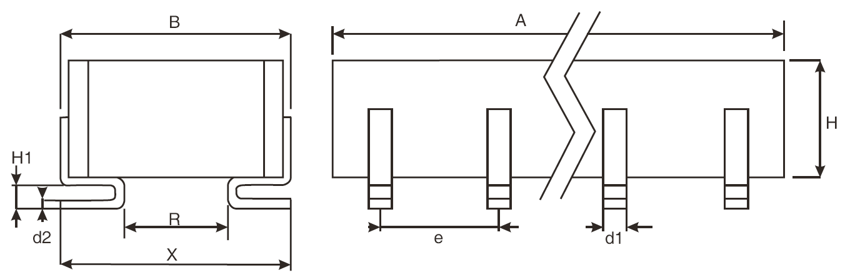
Variant  Number | No. of  Leads | Dimensions (mm)
Variant  Number | No. of  Leads | A  Max | B  Max | d1  (Note 1) |  | d2  (Note 1) |  | e  (Note 1) |  | H  Max | H1  (Note 1) |  | R  Min  (Note 1) | X  (Note 1)
 |  |  |  | Min | Max | Min | Max | Min | Max | H  Max | Min | Max | R  Min  (Note 1) | Min | Max
08 | 6 | 8.7 | 9.2 | 0.4 | 0.6 | 0.2 | 0.3 | 2.49 | 2.59 | Note 2 | 1.1 | 1.6 | 3.1 | 7.5 | 9
09 | 8 | 10.7 | 10.7 | 0.4 | 0.6 | 0.2 | 0.3 | 2.49 | 2.59 | Note 2 | 1.1 | 1.6 | 4 | 9.5 | 12
10 | 10 | 13.6 | 14.9 | 0.4 | 0.6 | 0.2 | 0.3 | 2.49 | 2.59 | Note 2 | 1.1 | 1.6 | 7.5 | 13.5 | 14.9
11 | 14 | 21.6 | 16.8 | 0.4 | 0.6 | 0.2 | 0.3 | 2.49 | 2.59 | Note 2 | 1.1 | 1.6 | 10 | 14.5 | 16.8
12 | 28 | 38.2 | 12 | 0.4 | 0.6 | 0.2 | 0.3 | 2.49 | 2.59 | Note 2 | 1.1 | 1.6 | 5.2 | 10 | 12
13 | 28 | 40.6 | 24 | 0.4 | 0.6 | 0.2 | 0.3 | 2.49 | 2.59 | Note 2 | 1.1 | 1.6 | 16.1 | 20 | 24
14 | 12 | 16.6 | 21.6 | 0.4 | 0.6 | 0.2 | 0.3 | 2.49 | 2.59 | Note 2 | 1.1 | 1.6 | 14.8 | 19 | 21.6
NOTES:
            - All leads.
            - See Component Type Variants and Range of Components for dimension H.

Variants 15 to 21 (lead type PL)
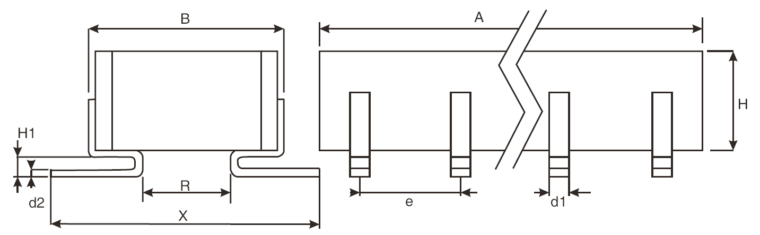
Variant  Number | No. of  Leads | Dimensions (mm)
Variant  Number | No. of  Leads | A  Max | B  Max | d1  (Note 1) |  | d2  (Note 1) |  | e  (Note 1) |  | H  Max | H1  (Note 1) |  | R  Min  (Note 1) | X  (Note 1)
 |  |  |  | Min | Max | Min | Max | Min | Max | H  Max | Min | Max | R  Min  (Note 1) | Min | Max
15 | 6 | 8.7 | 9.2 | 0.4 | 0.6 | 0.2 | 0.3 | 2.49 | 2.59 | Note 2 | 1.1 | 1.6 | 3.1 | 11.5 | 15
16 | 8 | 10.7 | 10.7 | 0.4 | 0.6 | 0.2 | 0.3 | 2.49 | 2.59 | Note 2 | 1.1 | 1.6 | 4 | 13.5 | 18
17 | 10 | 13.6 | 14.9 | 0.4 | 0.6 | 0.2 | 0.3 | 2.49 | 2.59 | Note 2 | 1.1 | 1.6 | 7.5 | 17.5 | 20.9
18 | 14 | 21.6 | 16.8 | 0.4 | 0.6 | 0.2 | 0.3 | 2.49 | 2.59 | Note 2 | 1.1 | 1.6 | 10 | 18.5 | 22.8
19 | 28 | 38.2 | 12 | 0.4 | 0.6 | 0.2 | 0.3 | 2.49 | 2.59 | Note 2 | 1.1 | 1.6 | 5.2 | 14 | 18
20 | 28 | 40.6 | 24 | 0.4 | 0.6 | 0.2 | 0.3 | 2.49 | 2.59 | Note 2 | 1.1 | 1.6 | 16.1 | 24 | 30
21 | 12 | 16.6 | 21.6 | 0.4 | 0.6 | 0.2 | 0.3 | 2.49 | 2.59 | Note 2 | 1.1 | 1.6 | 14.8 | 23 | 27.6
NOTES:
            - All leads.
            - See Component Type Variants and Range of Components for dimension H.

Variants 22 to 28 (lead type L)
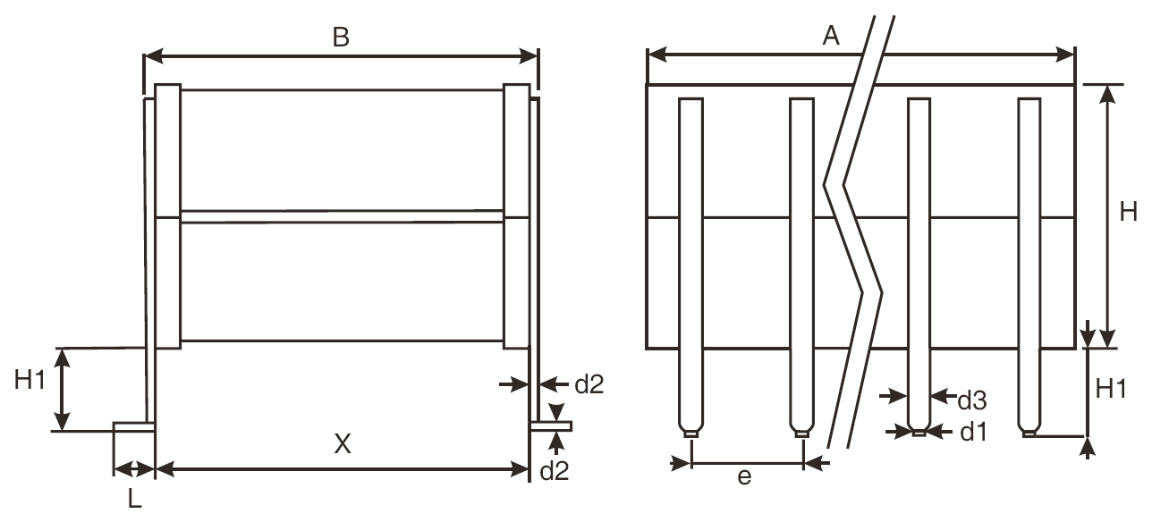
Variant  Number | No. of  Leads | Dimensions (mm)
Variant  Number | No. of  Leads | A  Max | B  Max | d1  (Note 1) |  | d2  (Note 1) |  | d3  (Note 1) |  | e  (Note 1) |  | H  Max | H1  (Note 1) |  | L  (Note 1) |  | X  (Note 1)
 |  |  |  | Min | Max | Min | Max | Min | Max | Min | Max | H  Max | Min | Max | Min | Max | Min | Max
22 | 6 | 8.7 | 9.2 | 0.4 | 0.6 | 0.2 | 0.3 | 0.9 | 1.1 | 2.49 | 2.59 | Note 2 | 2 | 3 | 2 | 3 | 6.7 | 8.7
23 | 8 | 10.7 | 10.7 | 0.4 | 0.6 | 0.2 | 0.3 | 0.9 | 1.1 | 2.49 | 2.59 | Note 2 | 2 | 3 | 2 | 3 | 8.2 | 10
24 | 10 | 13.6 | 14.9 | 0.4 | 0.6 | 0.2 | 0.3 | 0.9 | 1.1 | 2.49 | 2.59 | Note 2 | 2 | 3 | 2 | 3 | 12.4 | 14.4
25 | 14 | 21.6 | 16.8 | 0.4 | 0.6 | 0.2 | 0.3 | 0.9 | 1.1 | 2.49 | 2.59 | Note 2 | 2 | 3 | 2 | 3 | 14.3 | 16.3
26 | 28 | 38.2 | 12 | 0.4 | 0.6 | 0.2 | 0.3 | 0.9 | 1.1 | 2.49 | 2.59 | Note 2 | 2 | 3 | 2 | 3 | 9.5 | 11.5
27 | 28 | 40.6 | 24 | 0.4 | 0.6 | 0.2 | 0.3 | 0.9 | 1.1 | 2.49 | 2.59 | Note 2 | 2 | 3 | 2 | 3 | 21.5 | 23.5
28 | 12 | 16.6 | 21.6 | 0.4 | 0.6 | 0.2 | 0.3 | 0.9 | 1.1 | 2.49 | 2.59 | Note 2 | 2 | 3 | 2 | 3 | 19.5 | 21.1
NOTES:
            - All leads.
            - See Component Type Variants and Range of Components for dimension H.

FUNCTIONAL DIAGRAM

NOTES:
            - All leads on each side of the component are connected to the same capacitor terminal.

REQUIREMENTS

GENERAL
The complete requirements for procurement of the components specified herein are as stated in this specification and the ESCC Generic Specification. Permitted deviations from the Generic Specification, applicable to this specification only, are listed below.
Permitted deviations from the Generic Specification and this Detail Specification, formally agreed with specific Manufacturers on the basis that the alternative requirements are equivalent to the ESCC requirement and do not affect the component’s reliability, are listed in the appendices attached to this specification.

Deviations from the Generic Specification

Deviations from Qualification and Periodic Tests (Chart F4)
          - Resistance to Soldering Heat and Solderability:
- For Variants 01 to 07: Immersion depth shall be between 2mm and 2.5mm from the body.
- For Variants 08 to 28: Only the part of the leads designed to be soldered shall be tested.
          - Vibration: Prior to Vibration, the samples shall be mounted and glued on to a suitable substrate in order to avoid any stress. The samples shall be maintained on the substrate for all subsequent tests in the subgroup test sequence.

MARKING
The marking shall be in accordance with the requirements of ESCC Basic Specification No. 21700 and as follows.
The information to be marked on the component shall be:
          - The ESCC qualified components symbol (for ESCC qualified components only).
          - The ESCC Component Number.
          - Traceability information.

ROBUSTNESS OF TERMINATIONS
The terminations of these devices are classified as rigid. The test conditions for Robustness of Terminations shall be as specified in the ESCC Generic Specification and as follows:
For Variants 01 to 07:
- Applicable test: Ua1 (tensile) only.
- Terminations tested: a minimum of one randomly selected lead on each side of the component.
- Applied force: 5N
For Variants 08 to 28:
- Applicable test: Ue3 (shear) only.
- Pushing force: 10N for 10s

ELECTRICAL MEASUREMENTS AT ROOM, HIGH AND LOW TEMPERATURES
Electrical measurements shall be performed at room, high and low temperatures.

Room Temperature Electrical Measurements
The measurements shall be performed at T_{amb} = +22 ±3°C.
Characteristics | Symbols | Test Method and  Conditions | Tolerance  (± %) | Limits |  | Units
 |  |  |  | Min | Max | Units
Capacitance  (Note 1) | C_{A} | ESCC No. 3001 |  |  |  | µF
Capacitance  (Note 1) | C_{A} | ESCC No. 3001 | 10 | 0.9C_{n} | 1.1C_{n} | µF
Capacitance  (Note 1) | C_{A} | ESCC No. 3001 | 20 | 0.8C_{n} | 1.2C_{n} | µF
Tangent of Loss Angle | tgδ | ESCC No. 3001 | All | - | 250 ×10⁻⁴ | -
Insulation Resistance  (Dielectric) | R_{ID} | ESCC No. 3001 | All | 1000 | - | GΩ.nF
Insulation Resistance  (Body Insulation) | R_{IB} | ESCC No. 3001  Variants 01 to 07 only  Note 2 | All | 1000 | - | GΩ.nF
Voltage Proof  (Dielectric) | VP_{D} | ESCC No. 3001 | All |  |  | V
Voltage Proof  (Dielectric) | VP_{D} | U_{R} < 500V | All | 2.5U_{R} | - | V
Voltage Proof  (Dielectric) | VP_{D} | U_{R} = 500V | All | 2U_{R} | - | V
Voltage Proof  (Body Insulation) | VP_{B} | ESCC No. 3001  Variants 01 to 07 only  Note 2 | All |  |  | V
Voltage Proof  (Body Insulation) | VP_{B} | U_{R} < 500V | All | 2.5U_{R} | -
Voltage Proof  (Body Insulation) | VP_{B} | U_{R} = 500V | All | 2U_{R} | -
NOTES:
            - Capacitance limits may be adjusted to take into account capacitance ageing, as specified in the Generic Specification.
            - The measurements shall be performed on a sample of 5 components from each manufacturing lot with 0 failures allowed. In the event of any failure a 100% inspection may be performed. In the case of a 100% inspection, a 1% total percent defective is allowed.

High and Low Temperatures Electrical Measurements
Characteristics | Symbols | Test Method and Conditions  (Note 1) | Limits |  | Units
Characteristics | Symbols | Test Method and Conditions  (Note 1) | Min | Max | Units
Temperature Characteristic | TC | ESCC No. 3001  T_{amb} = -55 ±2°C, +20 ±2°C, +125 ±2°C  Note 2 |  |  | %
Temperature Characteristic | TC | For V_{T} = no voltage applied | -20 | +20
Temperature Characteristic | TC | For V_{T} = U_{R} (Note 3) | -50 | +30
NOTES:
            - The measurements shall be performed on a sample of 5 components from each manufacturing lot with 0 failures allowed. In the event of any failure a 100% inspection may be performed.
            - In the case of a 100% inspection, a 1% total percent defective is allowed.
            - V_{T} = 200V for all U_{R} = 500V components.

INTERMEDIATE AND END-POINT ELECTRICAL MEASUREMENTS
Unless otherwise specified, the measurements shall be performed at T_{amb} = +22 ±3°C.
Unless otherwise specified the test methods and test conditions shall be as per the corresponding test defined in Room Temperature Electrical Measurements.
Test Reference per ESCC No. 3001 | Characteristics | Symbols | Limits |  | Units
Test Reference per ESCC No. 3001 | Characteristics | Symbols | Min | Max | Units
Rapid Change of
Temperature
Initial Measurements | Capacitance | C_{A} | Note 1
Final Measurements | Capacitance | C_{A} | Note 1
Final Measurements | Change in Capacitance | ΔC_{A}/C_{A} | -15 | +15 | %
Final Measurements | Tangent of Loss Angle | tgδ | - | 250 ×10⁻⁴ | -
Steady State Humidity
Initial Measurements | Capacitance | C_{A} | Note 1
Final Measurements | Capacitance | C_{A} | Note 1
Final Measurements | Change in Capacitance | ΔC_{A}/C_{A} | -10 | +10 | %
Final Measurements | Tangent of Loss Angle | tgδ | - | 250 ×10⁻⁴ | -
Final Measurements | Insulation Resistance (Dielectric) (Note 2) | R_{ID} | 30 | - | GΩ.nF
Final Measurements | Insulation Resistance (Body Insulation) (Notes 2, 3) | R_{IB} | 30 | - | GΩ.nF
Operating Life
Initial Measurements | Capacitance | C_{A} | Note 1
Intermediate Measurements  (1000 hours) (Note 4) | Capacitance | C_{A} | Note 1
Intermediate Measurements  (1000 hours) (Note 4) | Change in Capacitance | ΔC_{A}/C_{A} | -15 | +15 | %
Intermediate Measurements  (1000 hours) (Note 4) | Insulation Resistance (Dielectric) (Note 2) | R_{ID} | 100 | - | GΩ.nF
Intermediate Measurements  (1000 hours) (Note 4) | Insulation Resistance (Body Insulation) (Notes 2, 3) | R_{IB} | 100 | - | GΩ.nF
Final Measurements  (1000 or 2000 hours)  (Note 5) | Capacitance | C_{A} | Note 1
Final Measurements  (1000 or 2000 hours)  (Note 5) | Change in Capacitance | ΔC_{A}/C_{A} | -20 | +20 | %
Final Measurements  (1000 or 2000 hours)  (Note 5) | Tangent of Loss Angle | tgδ | - | 250 ×10⁻⁴ | -
Final Measurements  (1000 or 2000 hours)  (Note 5) | Insulation Resistance (Dielectric) (Note 2) | R_{ID} | 100 | - | MΩ.µF
Final Measurements  (1000 or 2000 hours)  (Note 5) | Insulation Resistance (Body Insulation) (Notes 2, 3) | R_{IB} | 100 | - | MΩ.µF
Final Measurements  (1000 or 2000 hours)  (Note 5) | Voltage Proof (Dielectric) | VP_{D} | Note 1
Final Measurements  (1000 or 2000 hours)  (Note 5) | Voltage Proof (Body Insulation) (Note 3) | VP_{B} | Note 1
Capacitance-Temperature Characteristics | Temperature Characteristic | TC | Note 6
Resistance to Soldering Heat
Initial Measurements | Capacitance | C_{A} | Note 1
Final Measurements | Capacitance | C_{A} | Note 1
Final Measurements | Change in Capacitance | ΔC_{A}/C_{A} | -15 | +15 | %
Final Measurements | Insulation Resistance (Dielectric) (Note 2) | R_{ID} | 1000 | - | GΩ.nF
Final Measurements | Insulation Resistance (Body Insulation) (Notes 2, 3) | R_{IB} | 1000 | - | GΩ.nF
NOTES:
            - As specified in Room Temperature Electrical Measurements.
            - Test conditions for Insulation Resistance shall be as specified in Steady State Humidity in the ESCC Generic Specification.
            - Variants 01 to 07 only.
            - Intermediate measurements are optional at the Manufacturer’s discretion.
            - 1000 hours is applicable to Periodic Testing for extension of qualification. 2000 hours is applicable to Qualification Testing, and to Periodic Testing for renewal of qualification after lapse.
            - As specified in High and Low Temperatures Electrical Measurements.

BURN-IN
The requirements for Burn-in are specified in the ESCC Generic Specification. The following conditions shall also apply:
- After Burn-in, the components shall be removed from the chamber and allowed to cool under normal atmospheric conditions for recovery for 24 hours minimum.

APPENDIX A
AGREED DEVIATIONS FOR EXXELIa TECHNOLOGIES (F)
Items Affected | Description of Deviations
Deviations from Generic Specification:  Special In-Process Controls (Chart F2) | Robustness of Terminations shall not be performed.

