

Page 1 of 20

CAPACITORS, FIXED, CERAMIC DIELECTRIC, TYPE II, HIGH CAPACITANCE, 50V TO 500V
BASED ON TYPES BR, CV AND CH
ESCC Detail Specification No. 3001/030
Issue 8 Draft A | February 2017



Document Custodian: European Space Agency – see https://escies.org

LEGAL DISCLAIMER AND COPYRIGHT
European Space Agency, Copyright © 2017. All rights reserved.
The European Space Agency disclaims any liability or responsibility, to any person or entity, with respect to any loss or damage caused, or alleged to be caused, directly or indirectly by the use and application of this ESCC publication.
This publication, without the prior permission of the European Space Agency and provided that it is not used for a commercial purpose, may be:
- copied in whole, in any medium, without alteration or modification.
- copied in part, in any medium, provided that the ESCC document identification, comprising the ESCC symbol, document number and document issue, is removed.

DOCUMENTATION CHANGE NOTICE
(Refer to https://escies.org for ESCC DCR content)
DCR No. | CHANGE DESCRIPTION
TBA | Specification updated to incorporate changes per DCR.

TABLE OF CONTENTS

1 GENERAL 5
1.1 SCOPE 5
1.2 APPLICABLE DOCUMENTS 5
1.3 TERMS, DEFINITIONS, ABBREVIATIONS, SYMBOLS AND UNITS 5
1.4 THE ESCC COMPONENT NUMBER AND COMPONENT TYPE VARIANTS 5
1.4.1 The ESCC Component Number 5
1.4.2 Component Type Variants and Range of Components 6
1.5 MAXIMUM RATINGS 9
1.6 PHYSICAL DIMENSIONS 10
1.6.1 Case Type BR with Radial Leads 10
1.6.2 Case Type CV with Radial Leads 11
1.6.3 Case Type CH with Straight DIL Leads 12
1.6.4 Case Type CH with L DIL Leads 14
1.7 FUNCTIONAL DIAGRAM 15
2 REQUIREMENTS 16
2.1 GENERAL 16
2.1.1 Deviations from the Generic Specification 16
2.2 MARKING 16
2.3 ROBUSTNESS OF TERMINATIONS 16
2.4 ELECTRICAL MEASUREMENTS AT ROOM, HIGH AND LOW TEMPERATURES 17
2.4.1 Room Temperature Electrical Measurements 17
2.4.2 High and Low Temperatures Electrical Measurements 17
2.5 INTERMEDIATE AND END-POINT ELECTRICAL MEASUREMENTS 18
2.6 BURN-IN 19
APPENDIX A 20

GENERAL

SCOPE
This specification details the ratings, physical and electrical characteristics, and test and inspection data for the component type variants and/or the range of components specified below. It supplements the requirements of, and shall be read in conjunction with, the ESCC Generic Specification listed under Applicable Documents.

APPLICABLE DOCUMENTS
The following documents form part of this specification and shall be read in conjunction with it:
          - ESCC Generic Specification No. 3001.

TERMS, DEFINITIONS, ABBREVIATIONS, SYMBOLS AND UNITS
For the purpose of this specification, the terms, definitions, abbreviations, symbols and units specified in ESCC Basic Specification No. 21300 shall apply.

THE ESCC COMPONENT NUMBER AND COMPONENT TYPE VARIANTS

The ESCC Component Number
The ESCC Component Number shall be constituted as follows:
Example: 300103001476KE
- Detail Specification Reference: 3001030
- Component Type Variant Number: 01 (as required)
- Characteristic code: Capacitance Value (47μF): 476 (as required)
- Characteristic code: Capacitance Tolerance (±10%): K (as required)
- Rating code: Rated Voltage (100V): E (as required)

Characteristics and Ratings Codes
Characteristics and ratings to be codified as part of the ESCC Component Number shall be as follows:
          - Rated Capacitance Value C_{n} expressed by means of the following codes in accordance with ESCC Basic Specification No. 21700. The unit quantity shall be picofarad (pF).
Capacitance Value C_{n}  (pF) | Code
XX 10⁴ | XX4
XX 10⁵ | XX5
XX 10⁶ | XX6
XX 10⁷ | XX7
          - Capacitance Tolerance expressed by the following codes in accordance with ESCC Basic Specification No. 21700:
Tolerance  (± %) | Code Letter
10 | K
20 | M
          - Rated Voltage expressed by the following codes:
Rated Voltage U_{R}  (V) | Code Letter
50 | C
100 | E
200 | G
500 | L

Component Type Variants and Range of Components
The component type variants and range of components applicable to this specification are as follows:
Variant  Number | Package Details  (Note 1) |  |  |  | Capacitance Range C_{n}  (µF) (Note 4) |  |  |  | Weight  Max (g)
Variant  Number | Case Type (Note 2) | Lead Type | No. of  Leads | Lead  Mat. & Fin.  (Note 3) | Rated  Voltage  U_{R} = 50V | Rated  Voltage  U_{R} = 100V | Rated  Voltage  U_{R} = 200V | Rated  Voltage  U_{R} = 500V | Weight  Max (g)
01 | BR40 | Radial | 2 | A3 | 1.8 to 3.3 | 1.2 to 2.7 | 0.33 to 0.56 | 0.12 to 0.22 | 2
02 | BR50 | Radial | 2 | A3 | 3.9 to 5.6 | 2.2 to 3.9 | 0.68 to 1 | 0.27 to 0.39 | 3
03 | BR66 | Radial | 2 | A3 | 6.8 to 10 | 4.7 to 8.2 | 1 to 2.2 | 0.47 to 1 | 5
04 | BR72 | Radial | 2 | A3 | 12 to 18 | 8.2 to 15 | 2.2 to 3.3 | 0.82 to 1.5 | 8
05 | BR84 | Radial | 2 | A3 | 12 to 18 | 8.2 to 15 | 2.2 to 3.3 | 0.82 to 1.5 | 8
06 | CV41 | Radial | 2 | A3 | 1.8 to 3.3 | 1.2 to 2.7 | 0.33 to 0.56 | 0.12 to 0.22 | 2
07 | CH41 | Straight DIL | 6 | N9 | 1.8 to 3.3 | 1.2 to 2.7 | 0.33 to 0.56 | 0.12 to 0.22 | 2
08 | CH41 | L DIL | 6 | N9 | 1.8 to 3.3 | 1.2 to 2.7 | 0.33 to 0.56 | 0.12 to 0.22 | 2
09 | CH42 | Straight DIL | 6 | N9 | 3.9 to 6.8 | 3.3 to 5.6 | 0.68 to 1.2 | 0.27 to 0.47 | 4
10 | CH42 | L DIL | 6 | N9 | 3.9 to 6.8 | 3.3 to 5.6 | 0.68 to 1.2 | 0.27 to 0.47 | 4
11 | CH43 | Straight DIL | 6 | N9 | 8.2 to 10 | 6.8 to 8.2 | 1.5 to 1.8 | 0.56 to 0.68 | 6
12 | CH43 | L DIL | 6 | N9 | 8.2 to 10 | 6.8 to 8.2 | 1.5 to 1.8 | 0.56 to 0.68 | 6
13 | CH44 | Straight DIL | 6 | N9 | 12 | 10 | 2.2 | 0.82 to 1 | 8
14 | CH44 | L DIL | 6 | N9 | 12 | 10 | 2.2 | 0.82 to 1 | 8
15 | CV51 | Radial | 2 | A3 | 3.9 to 5.6 | 2.2 to 3.9 | 0.68 to 1 | 0.27 to 0.39 | 3
16 | CH51 | Straight DIL | 8 | N9 | 3.9 to 5.6 | 2.2 to 3.9 | 0.68 to 1 | 0.27 to 0.39 | 3
17 | CH51 | L DIL | 8 | N9 | 3.9 to 5.6 | 2.2 to 3.9 | 0.68 to 1 | 0.27 to 0.39 | 3
18 | CH52 | Straight DIL | 8 | N9 | 6.8 to 10 | 4.7 to 8.2 | 1 to 2.2 | 0.47 to 0.82 | 6
19 | CH52 | L DIL | 8 | N9 | 6.8 to 10 | 4.7 to 8.2 | 1 to 2.2 | 0.47 to 0.82 | 6
20 | CH53 | Straight DIL | 8 | N9 | 12 to 15 | 10 to 12 | 2.7 to 3.3 | 1 to 1.2 | 9
21 | CH53 | L DIL | 8 | N9 | 12 to 15 | 10 to 12 | 2.7 to 3.3 | 1 to 1.2 | 9
22 | CH54 | Straight DIL | 8 | N9 | 18 to 22 | 15 | 3.9 | 1.5 | 12
23 | CH54 | L DIL | 8 | N9 | 18 to 22 | 15 | 3.9 | 1.5 | 12
24 | CV61 | Radial | 2 | A3 | 6.8 to 10 | 4.7 to 8.2 | 1 to 2.2 | 0.47 to 1 | 5
25 | CH61 | Straight DIL | 10 | N9 | 6.8 to 10 | 4.7 to 8.2 | 1 to 2.2 | 0.47 to 1 | 5
26 | CH61 | L DIL | 10 | N9 | 6.8 to 10 | 4.7 to 8.2 | 1 to 2.2 | 0.47 to 1 | 5
27 | CH62 | Straight DIL | 10 | N9 | 12 to 22 | 10 to 15 | 2.7 to 4.7 | 1 to 1.8 | 10
28 | CH62 | L DIL | 10 | N9 | 12 to 22 | 10 to 15 | 2.7 to 4.7 | 1 to 1.8 | 10
29 | CH63 | Straight DIL | 10 | N9 | 27 to 33 | 18 to 22 | 5.6 to 6.8 | 2.2 to 2.7 | 15
30 | CH63 | L DIL | 10 | N9 | 27 to 33 | 18 to 22 | 5.6 to 6.8 | 2.2 to 2.7 | 15
31 | CH64 | Straight DIL | 10 | N9 | 39 | 27 to 33 | 8.2 to 10 | 3.3 | 20
32 | CH64 | L DIL | 10 | N9 | 39 | 27 to 33 | 8.2 to 10 | 3.3 | 20
33 | CV71 | Radial | 2 | A3 | 12 to 18 | 8.2 to 15 | 2.2 to 3.3 | 0.82 to 1.5 | 8
34 | CH71 | Straight DIL | 14 | N9 | 12 to 18 | 8.2 to 15 | 2.2 to 3.3 | 0.82 to 1.5 | 8
35 | CH71 | L DIL | 14 | N9 | 12 to 18 | 8.2 to 15 | 2.2 to 3.3 | 0.82 to 1.5 | 8
36 | CH72 | Straight DIL | 14 | N9 | 22 to 39 | 18 to 27 | 3.9 to 6.8 | 1.8 to 3.3 | 16
37 | CH72 | L DIL | 14 | N9 | 22 to 39 | 18 to 27 | 3.9 to 6.8 | 1.8 to 3.3 | 16
38 | CH73 | Straight DIL | 14 | N9 | 47 to 56 | 33 to 39 | 8.2 to 10 | 3.9 to 4.7 | 24
39 | CH73 | L DIL | 14 | N9 | 47 to 56 | 33 to 39 | 8.2 to 10 | 3.9 to 4.7 | 24
40 | CH74 | Straight DIL | 14 | N9 | 68 | 47 | 12 | 5.6 | 32
41 | CH74 | L DIL | 14 | N9 | 68 | 47 | 12 | 5.6 | 32
42 | CV76 | Radial | 2 | A3 | 12 to 18 | 8.2 to 15 | 2.2 to 3.3 | 0.82 to 1.5 | 8
43 | CH76 | Straight DIL | 12 | N9 | 12 to 18 | 8.2 to 15 | 2.2 to 3.3 | 0.82 to 1.5 | 8
44 | CH76 | L DIL | 12 | N9 | 12 to 18 | 8.2 to 15 | 2.2 to 3.3 | 0.82 to 1.5 | 8
45 | CH77 | Straight DIL | 12 | N9 | 22 to 39 | 18 to 27 | 3.9 to 6.8 | 1.8 to 3.3 | 16
46 | CH77 | L DIL | 12 | N9 | 22 to 39 | 18 to 27 | 3.9 to 6.8 | 1.8 to 3.3 | 16
47 | CH78 | Straight DIL | 12 | N9 | 47 to 56 | 33 to 39 | 8.2 to 10 | 3.9 to 4.7 | 24
48 | CH78 | L DIL | 12 | N9 | 47 to 56 | 33 to 39 | 8.2 to 10 | 3.9 to 4.7 | 24
49 | CH79 | Straight DIL | 12 | N9 | 68 | 47 | 12 | 5.6 | 32
50 | CH79 | L DIL | 12 | N9 | 68 | 47 | 12 | 5.6 | 32
51 | CH81 | Straight DIL | 28 | N9 | 15 to 22 | 12 to 18 | 2.2 to 3.9 | 0.82 to 1.5 | 10
52 | CH81 | L DIL | 28 | N9 | 15 to 22 | 12 to 18 | 2.2 to 3.9 | 0.82 to 1.5 | 10
53 | CH82 | Straight DIL | 28 | N9 | 27 to 47 | 22 to 39 | 4.7 to 8.2 | 1.8 to 3.3 | 20
54 | CH82 | L DIL | 28 | N9 | 27 to 47 | 22 to 39 | 4.7 to 8.2 | 1.8 to 3.3 | 20
55 | CH83 | Straight DIL | 28 | N9 | 56 to 68 | 47 to 56 | 10 to 12 | 3.9 to 4.7 | 30
56 | CH83 | L DIL | 28 | N9 | 56 to 68 | 47 to 56 | 10 to 12 | 3.9 to 4.7 | 30
57 | CH84 | Straight DIL | 28 | N9 | 82 | 68 | 15 | 5.6 | 40
58 | CH84 | L DIL | 28 | N9 | 82 | 68 | 15 | 5.6 | 40
59 | CH86 | Straight DIL | 28 | N9 | 22 to 33 | 15 to 27 | 3.9 to 6.8 | 1.5 to 2.2 | 14
60 | CH86 | L DIL | 28 | N9 | 22 to 33 | 15 to 27 | 3.9 to 6.8 | 1.5 to 2.2 | 14
61 | CH87 | Straight DIL | 28 | N9 | 39 to 68 | 33 to 56 | 8.2 to 15 | 2.7 to 4.7 | 28
62 | CH87 | L DIL | 28 | N9 | 39 to 68 | 33 to 56 | 8.2 to 15 | 2.7 to 4.7 | 28
63 | CH88 | Straight DIL | 28 | N9 | 82 to 100 | 68 to 82 | 18 to 22 | 5.6 to 6.8 | 42
64 | CH88 | L DIL | 28 | N9 | 82 to 100 | 68 to 82 | 18 to 22 | 5.6 to 6.8 | 42
65 | CH89 | Straight DIL | 28 | N9 | 120 | 100 | 27 | 8.2 | 56
66 | CH89 | L DIL | 28 | N9 | 120 | 100 | 27 | 8.2 | 56
67 | CH91 | Straight DIL | 28 | N9 | 39 to 47 | 33 to 39 | 8.2 to 10 | 2.7 to 4.7 | 19
68 | CH91 | L DIL | 28 | N9 | 39 to 47 | 33 to 39 | 8.2 to 10 | 2.7 to 4.7 | 19
69 | CH92 | Straight DIL | 28 | N9 | 56 to 100 | 47 to 82 | 12 to 22 | 5.6 to 10 | 38
70 | CH92 | L DIL | 28 | N9 | 56 to 100 | 47 to 82 | 12 to 22 | 5.6 to 10 | 38
71 | CH93 | Straight DIL | 28 | N9 | 120 to 150 | 100 to 120 | 27 to 33 | 12 to 15 | 57
72 | CH93 | L DIL | 28 | N9 | 120 to 150 | 100 to 120 | 27 to 33 | 12 to 15 | 57
73 | CH94 | Straight DIL | 28 | N9 | 180 | 150 | 39 | 18 | 76
74 | CH94 | L DIL | 28 | N9 | 180 | 150 | 39 | 18 | 76
NOTES:
            - See Physical Dimensions.
            - For Variants 01 to 05 (case type BR) the body shall be coated with epoxy resin. Variants 06 to 74 (case types CV & CH) are classified as non-insulated.
            - The lead material and finishes shall be in accordance with the requirements of ESCC Basic Specification No. 23500.
            - Available capacitance values and tolerances are as follows:
- Tolerance: ±10%; value series: E12
- Tolerance: ±20%; value series: E12

MAXIMUM RATINGS
The maximum ratings shall not be exceeded at any time during use or storage.
Maximum ratings shall only be exceeded during testing to the extent specified in this specification and when stipulated in Test Methods and Procedures of the ESCC Generic Specification.
Characteristics | Symbols | Maximum Ratings | Units | Remarks
Rated Voltage | U_{R} | 50, 100, 200, 500 | V | Note 1
Operating Temperature Range | T_{op} | -55 to +125 | °C | Without derating. T_{amb}
Storage Temperature Range | T_{stg} | -55 to +125 | °C
Soldering Temperature | T_{sol} | +260 | °C | Note 2
NOTES:
            - As required; See Component Type Variants and Range of Components.
            - Duration 5 seconds maximum at a distance of not less than 1.5mm from the body and the same lead shall not be resoldered until 3 minutes have elapsed.

PHYSICAL DIMENSIONS

Case Type BR with Radial Leads
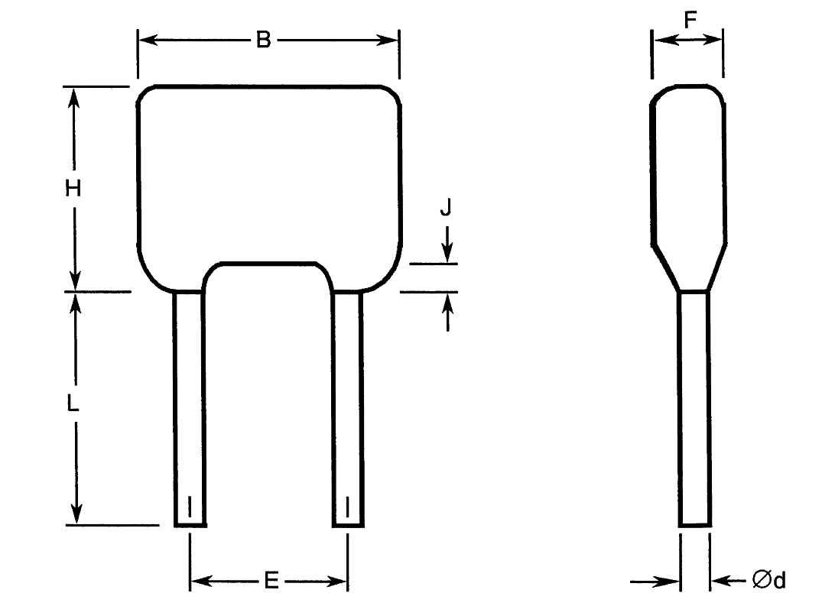
Variant  Number | Case Type | Dimensions (mm)
Variant  Number | Case Type | B  Max | Ød  (Note 1) |  | E |  | F  Max | H  Max | J  Max | L  Min  (Note 1)
Variant  Number | Case Type | B  Max | Min | Max | Min | Max
01 | BR40 | 10.16 | 0.46 | 0.56 | 4.58 | 5.58 | 5 | 11.7 | 1.5 | 31.7
02 | BR50 | 12.7 | 0.59 | 0.69 | 9.66 | 10.66 | 5.1 | 14.2 | 1.5 | 31.7
03 | BR66 | 17.5 | 0.86 | 0.96 | 14.2 | 15.2 | 6.4 | 16.5 | 1.5 | 31.7
04 | BR72 | 19.3 | 0.86 | 0.96 | 14.74 | 15.74 | 6.4 | 24 | 1.5 | 31.7
05 | BR84 | 23.62 | 0.71 | 0.81 | 18.93 | 20.83 | 6.4 | 19.78 | 1.5 | 31.7
NOTES:
            - Both leads.

Case Type CV with Radial Leads
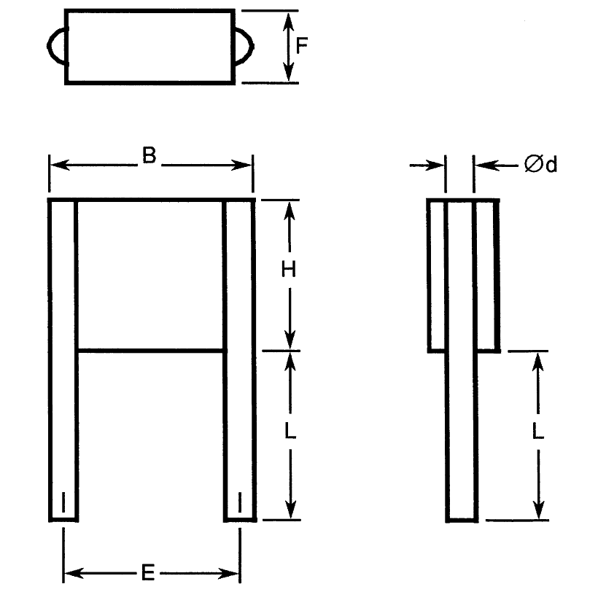
Variant  Number | Case Type | Dimensions (mm)
Variant  Number | Case Type | B  Max | Ød  (Note 1) |  | E |  | F  Max | H  Max | L  (Note 1)
Variant  Number | Case Type | B  Max | Min | Max | Min | Max | F  Max | H  Max | Min | Max
06 | CV41 | 10.6 | 0.65 | 0.75 | 7.7 | 8.7 | 3.8 | 8.7 | 22 | 28
15 | CV51 | 11.9 | 0.85 | 0.95 | 9.66 | 10.66 | 3.8 | 10.7 | 22 | 28
24 | CV61 | 16.5 | 0.85 | 0.95 | 14.74 | 15.74 | 3.8 | 13.6 | 22 | 28
33 | CV71 | 17.8 | 0.85 | 0.95 | 14.74 | 15.74 | 3.8 | 21.6 | 22 | 28
42 | CV76 | 22.7 | 0.85 | 0.95 | 20.4 | 22 | 3.8 | 16.6 | 22 | 28
NOTES:
            - Both leads.

Case Type CH with Straight DIL Leads
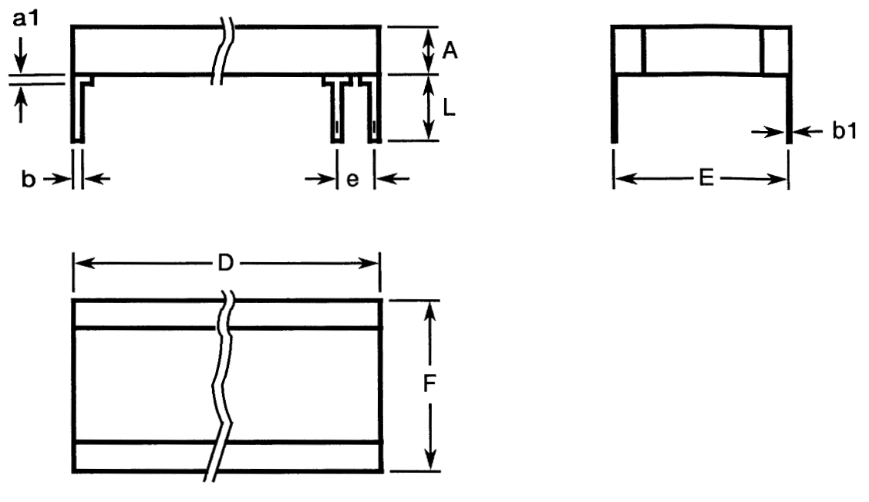
Variant  Number | Case Type | Dimensions (mm)
Variant  Number | Case Type | A  Max | a1  Max  (Note 1) | b  (Note 1) |  | b1  (Note 1) |  | D  Max | E  (Note 1) |  | e  (Note 1) |  | F  Max | L  (Note 1)
 |  |  |  | Min | Max | Min | Max | D  Max | Min | Max | Min | Max | F  Max | Min | Max
07 | CH41 | 3.8 | 2 | 0.45 | 0.55 | 0.204 | 0.304 | 8.7 | 7.7 | 8.7 | 2.49 | 2.59 | 9.2 | 12 | 14
09 | CH42 | 7.4 | 2 | 0.45 | 0.55 | 0.204 | 0.304 | 8.7 | 7.7 | 8.7 | 2.49 | 2.59 | 9.2 | 12 | 14
11 | CH43 | 11.1 | 2 | 0.45 | 0.55 | 0.204 | 0.304 | 8.7 | 7.7 | 8.7 | 2.49 | 2.59 | 9.2 | 12 | 14
13 | CH44 | 14.8 | 2 | 0.45 | 0.55 | 0.204 | 0.304 | 8.7 | 7.7 | 8.7 | 2.49 | 2.59 | 9.2 | 12 | 14
16 | CH51 | 3.8 | 2 | 0.45 | 0.55 | 0.204 | 0.304 | 10.7 | 9.66 | 10.66 | 2.49 | 2.59 | 10.7 | 12 | 14
18 | CH52 | 7.4 | 2 | 0.45 | 0.55 | 0.204 | 0.304 | 10.7 | 9.66 | 10.66 | 2.49 | 2.59 | 10.7 | 12 | 14
20 | CH53 | 11.1 | 2 | 0.45 | 0.55 | 0.204 | 0.304 | 10.7 | 9.66 | 10.66 | 2.49 | 2.59 | 10.7 | 12 | 14
22 | CH54 | 14.8 | 2 | 0.45 | 0.55 | 0.204 | 0.304 | 10.7 | 9.66 | 10.66 | 2.49 | 2.59 | 10.7 | 12 | 14
25 | CH61 | 3.8 | 2 | 0.45 | 0.55 | 0.204 | 0.304 | 13.6 | 13.5 | 14.5 | 2.49 | 2.59 | 14.9 | 12 | 14
27 | CH62 | 7.4 | 2 | 0.45 | 0.55 | 0.204 | 0.304 | 13.6 | 13.5 | 14.5 | 2.49 | 2.59 | 14.9 | 12 | 14
29 | CH63 | 11.1 | 2 | 0.45 | 0.55 | 0.204 | 0.304 | 13.6 | 13.5 | 14.5 | 2.49 | 2.59 | 14.9 | 12 | 14
31 | CH64 | 14.8 | 2 | 0.45 | 0.55 | 0.204 | 0.304 | 13.6 | 13.5 | 14.5 | 2.49 | 2.59 | 14.9 | 12 | 14
34 | CH71 | 3.8 | 2 | 0.45 | 0.55 | 0.204 | 0.304 | 21.6 | 14.74 | 15.74 | 2.49 | 2.59 | 16.8 | 12 | 14
36 | CH72 | 7.4 | 2 | 0.45 | 0.55 | 0.204 | 0.304 | 21.6 | 14.74 | 15.74 | 2.49 | 2.59 | 16.8 | 12 | 14
38 | CH73 | 11.1 | 2 | 0.45 | 0.55 | 0.204 | 0.304 | 21.6 | 14.74 | 15.74 | 2.49 | 2.59 | 16.8 | 12 | 14
40 | CH74 | 14.8 | 2 | 0.45 | 0.55 | 0.204 | 0.304 | 21.6 | 14.74 | 15.74 | 2.49 | 2.59 | 16.8 | 12 | 14
43 | CH76 | 3.8 | 2 | 0.45 | 0.55 | 0.204 | 0.304 | 16.6 | 19.52 | 21.12 | 2.49 | 2.59 | 21.6 | 12 | 14
45 | CH77 | 7.4 | 2 | 0.45 | 0.55 | 0.204 | 0.304 | 16.6 | 19.52 | 21.12 | 2.49 | 2.59 | 21.6 | 12 | 14
47 | CH78 | 11.1 | 2 | 0.45 | 0.55 | 0.204 | 0.304 | 16.6 | 19.52 | 21.12 | 2.49 | 2.59 | 21.6 | 12 | 14
49 | CH79 | 14.8 | 2 | 0.45 | 0.55 | 0.204 | 0.304 | 16.6 | 19.52 | 21.12 | 2.49 | 2.59 | 21.6 | 12 | 14
51 | CH81 | 3.8 | 2 | 0.45 | 0.55 | 0.204 | 0.304 | 38.2 | 9.66 | 10.66 | 2.49 | 2.59 | 12 | 12 | 14
53 | CH82 | 7.4 | 2 | 0.45 | 0.55 | 0.204 | 0.304 | 38.2 | 9.66 | 10.66 | 2.49 | 2.59 | 12 | 12 | 14
55 | CH83 | 11.1 | 2 | 0.45 | 0.55 | 0.204 | 0.304 | 38.2 | 9.66 | 10.66 | 2.49 | 2.59 | 12 | 12 | 14
57 | CH84 | 14.8 | 2 | 0.45 | 0.55 | 0.204 | 0.304 | 38.2 | 9.66 | 10.66 | 2.49 | 2.59 | 12 | 12 | 14
59 | CH86 | 3.8 | 2 | 0.45 | 0.55 | 0.204 | 0.304 | 38.2 | 14.74 | 15.74 | 2.49 | 2.59 | 18.9 | 12 | 14
61 | CH87 | 7.4 | 2 | 0.45 | 0.55 | 0.204 | 0.304 | 38.2 | 14.74 | 15.74 | 2.49 | 2.59 | 18.9 | 12 | 14
63 | CH88 | 11.1 | 2 | 0.45 | 0.55 | 0.204 | 0.304 | 38.2 | 14.74 | 15.74 | 2.49 | 2.59 | 18.9 | 12 | 14
65 | CH89 | 14.8 | 2 | 0.45 | 0.55 | 0.204 | 0.304 | 38.2 | 14.74 | 15.74 | 2.49 | 2.59 | 18.9 | 12 | 14
67 | CH91 | 3.8 | 2 | 0.45 | 0.55 | 0.204 | 0.304 | 40.6 | 19.52 | 21.12 | 2.49 | 2.59 | 24 | 12 | 14
69 | CH92 | 7.4 | 2 | 0.45 | 0.55 | 0.204 | 0.304 | 40.6 | 19.52 | 21.12 | 2.49 | 2.59 | 24 | 12 | 14
71 | CH93 | 11.1 | 2 | 0.45 | 0.55 | 0.204 | 0.304 | 40.6 | 19.52 | 21.12 | 2.49 | 2.59 | 24 | 12 | 14
73 | CH94 | 14.8 | 2 | 0.45 | 0.55 | 0.204 | 0.304 | 40.6 | 19.52 | 21.12 | 2.49 | 2.59 | 24 | 12 | 14
NOTES:
            - All leads.

Case Type CH with L DIL Leads
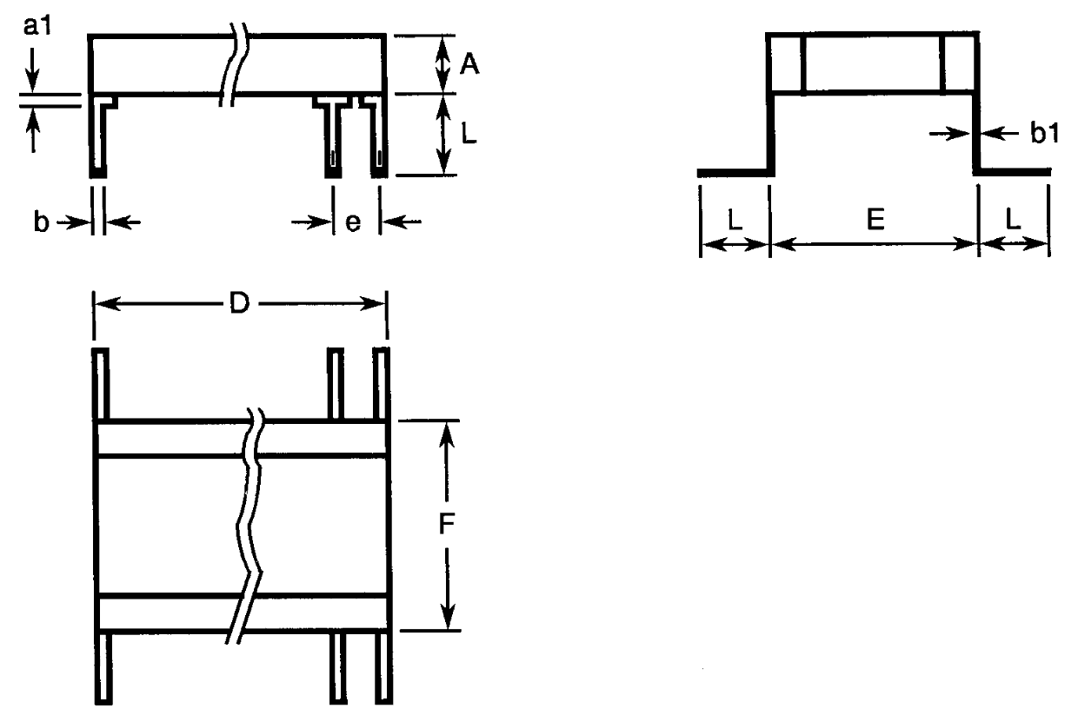
Variant  Number | Case Type | Dimensions (mm)
Variant  Number | Case Type | A  Max | a1  Max  (Note 1) | b  (Note 1) |  | b1  (Note 1) |  | D  Max | E  (Note 1) |  | e  (Note 1) |  | F  Max | L  (Note 1)
 |  |  |  | Min | Max | Min | Max | D  Max | Min | Max | Min | Max | F  Max | Min | Max
08 | CH41 | 3.8 | 2 | 0.45 | 0.55 | 0.204 | 0.304 | 8.7 | 7.7 | 8.7 | 2.49 | 2.59 | 9.2 | 2.04 | 3.04
10 | CH42 | 7.4 | 2 | 0.45 | 0.55 | 0.204 | 0.304 | 8.7 | 7.7 | 8.7 | 2.49 | 2.59 | 9.2 | 2.04 | 3.04
12 | CH43 | 11.1 | 2 | 0.45 | 0.55 | 0.204 | 0.304 | 8.7 | 7.7 | 8.7 | 2.49 | 2.59 | 9.2 | 2.04 | 3.04
14 | CH44 | 14.8 | 2 | 0.45 | 0.55 | 0.204 | 0.304 | 8.7 | 7.7 | 8.7 | 2.49 | 2.59 | 9.2 | 2.04 | 3.04
17 | CH51 | 3.8 | 2 | 0.45 | 0.55 | 0.204 | 0.304 | 10.7 | 9.66 | 10.66 | 2.49 | 2.59 | 10.7 | 2.04 | 3.04
19 | CH52 | 7.4 | 2 | 0.45 | 0.55 | 0.204 | 0.304 | 10.7 | 9.66 | 10.66 | 2.49 | 2.59 | 10.7 | 2.04 | 3.04
21 | CH53 | 11.1 | 2 | 0.45 | 0.55 | 0.204 | 0.304 | 10.7 | 9.66 | 10.66 | 2.49 | 2.59 | 10.7 | 2.04 | 3.04
23 | CH54 | 14.8 | 2 | 0.45 | 0.55 | 0.204 | 0.304 | 10.7 | 9.66 | 10.66 | 2.49 | 2.59 | 10.7 | 2.04 | 3.04
26 | CH61 | 3.8 | 2 | 0.45 | 0.55 | 0.204 | 0.304 | 13.6 | 13.5 | 14.5 | 2.49 | 2.59 | 14.9 | 2.04 | 3.04
28 | CH62 | 7.4 | 2 | 0.45 | 0.55 | 0.204 | 0.304 | 13.6 | 13.5 | 14.5 | 2.49 | 2.59 | 14.9 | 2.04 | 3.04
30 | CH63 | 11.1 | 2 | 0.45 | 0.55 | 0.204 | 0.304 | 13.6 | 13.5 | 14.5 | 2.49 | 2.59 | 14.9 | 2.04 | 3.04
32 | CH64 | 14.8 | 2 | 0.45 | 0.55 | 0.204 | 0.304 | 13.6 | 13.5 | 14.5 | 2.49 | 2.59 | 14.9 | 2.04 | 3.04
35 | CH71 | 3.8 | 2 | 0.45 | 0.55 | 0.204 | 0.304 | 21.6 | 14.74 | 15.74 | 2.49 | 2.59 | 16.8 | 2.04 | 3.04
37 | CH72 | 7.4 | 2 | 0.45 | 0.55 | 0.204 | 0.304 | 21.6 | 14.74 | 15.74 | 2.49 | 2.59 | 16.8 | 2.04 | 3.04
39 | CH73 | 11.1 | 2 | 0.45 | 0.55 | 0.204 | 0.304 | 21.6 | 14.74 | 15.74 | 2.49 | 2.59 | 16.8 | 2.04 | 3.04
41 | CH74 | 14.8 | 2 | 0.45 | 0.55 | 0.204 | 0.304 | 21.6 | 14.74 | 15.74 | 2.49 | 2.59 | 16.8 | 2.04 | 3.04
44 | CH76 | 3.8 | 2 | 0.45 | 0.55 | 0.204 | 0.304 | 16.6 | 19.52 | 21.12 | 2.49 | 2.59 | 21.6 | 2.04 | 3.04
46 | CH77 | 7.4 | 2 | 0.45 | 0.55 | 0.204 | 0.304 | 16.6 | 19.52 | 21.12 | 2.49 | 2.59 | 21.6 | 2.04 | 3.04
48 | CH78 | 11.1 | 2 | 0.45 | 0.55 | 0.204 | 0.304 | 16.6 | 19.52 | 21.12 | 2.49 | 2.59 | 21.6 | 2.04 | 3.04
50 | CH79 | 14.8 | 2 | 0.45 | 0.55 | 0.204 | 0.304 | 16.6 | 19.52 | 21.12 | 2.49 | 2.59 | 21.6 | 2.04 | 3.04
52 | CH81 | 3.8 | 2 | 0.45 | 0.55 | 0.204 | 0.304 | 38.2 | 9.66 | 10.66 | 2.49 | 2.59 | 12 | 2.04 | 3.04
54 | CH82 | 7.4 | 2 | 0.45 | 0.55 | 0.204 | 0.304 | 38.2 | 9.66 | 10.66 | 2.49 | 2.59 | 12 | 2.04 | 3.04
56 | CH83 | 11.1 | 2 | 0.45 | 0.55 | 0.204 | 0.304 | 38.2 | 9.66 | 10.66 | 2.49 | 2.59 | 12 | 2.04 | 3.04
58 | CH84 | 14.8 | 2 | 0.45 | 0.55 | 0.204 | 0.304 | 38.2 | 9.66 | 10.66 | 2.49 | 2.59 | 12 | 2.04 | 3.04
60 | CH86 | 3.8 | 2 | 0.45 | 0.55 | 0.204 | 0.304 | 38.2 | 14.74 | 15.74 | 2.49 | 2.59 | 18.9 | 2.04 | 3.04
62 | CH87 | 7.4 | 2 | 0.45 | 0.55 | 0.204 | 0.304 | 38.2 | 14.74 | 15.74 | 2.49 | 2.59 | 18.9 | 2.04 | 3.04
64 | CH88 | 11.1 | 2 | 0.45 | 0.55 | 0.204 | 0.304 | 38.2 | 14.74 | 15.74 | 2.49 | 2.59 | 18.9 | 2.04 | 3.04
66 | CH89 | 14.8 | 2 | 0.45 | 0.55 | 0.204 | 0.304 | 38.2 | 14.74 | 15.74 | 2.49 | 2.59 | 18.9 | 2.04 | 3.04
68 | CH91 | 3.8 | 2 | 0.45 | 0.55 | 0.204 | 0.304 | 40.6 | 19.52 | 21.12 | 2.49 | 2.59 | 24 | 2.04 | 3.04
70 | CH92 | 7.4 | 2 | 0.45 | 0.55 | 0.204 | 0.304 | 40.6 | 19.52 | 21.12 | 2.49 | 2.59 | 24 | 2.04 | 3.04
72 | CH93 | 11.1 | 2 | 0.45 | 0.55 | 0.204 | 0.304 | 40.6 | 19.52 | 21.12 | 2.49 | 2.59 | 24 | 2.04 | 3.04
74 | CH94 | 14.8 | 2 | 0.45 | 0.55 | 0.204 | 0.304 | 40.6 | 19.52 | 21.12 | 2.49 | 2.59 | 24 | 2.04 | 3.04
NOTES:
            - All leads.

FUNCTIONAL DIAGRAM

NOTES:
            - For case type CH, all leads on each side of the component are connected to the same capacitor terminal.

REQUIREMENTS

GENERAL
The complete requirements for procurement of the components specified herein are as stated in this specification and the ESCC Generic Specification. Permitted deviations from the Generic Specification, applicable to this specification only, are listed below.
Permitted deviations from the Generic Specification and this Detail Specification, formally agreed with specific Manufacturers on the basis that the alternative requirements are equivalent to the ESCC requirement and do not affect the component’s reliability, are listed in the appendices attached to this specification.

Deviations from the Generic Specification

Deviations from Special In-Process Controls (Chart F2)
          - Robustness of Terminations: Shall be replaced with a lead peel test as specified in Robustness of Terminations herein.

MARKING
The marking shall be in accordance with the requirements of ESCC Basic Specification No. 21700 and as follows.
The information to be marked on the component shall be:
          - The ESCC qualified components symbol (for ESCC qualified components only).
          - The ESCC Component Number.
          - Traceability information.

ROBUSTNESS OF TERMINATIONS
The terminations of these devices are classified as rigid.
Robustness of Terminations shall be performed as a lead peel test on a sample of 5 components from each manufacturing lot with 0 failures allowed. The sample components shall be leaded but not encapsulated or coated. Where necessary, the leads of the component under test shall be bent through 90° in the plane of the joint such that a tensile force applied to the leads will result in a peeling force being applied to the leads’ joint.
A tensile force shall be applied evenly across the length, on the capacitor terminal, to all leads on that side of the component together, until the lead joint peels. All leads shall be tested.
The minimum peeling force shall be as follows:
- For case types BR & CV: 8.9N
- For case type CH: 22.25N

ELECTRICAL MEASUREMENTS AT ROOM, HIGH AND LOW TEMPERATURES
Electrical measurements shall be performed at room, high and low temperatures.

Room Temperature Electrical Measurements
The measurements shall be performed at T_{amb} = +22 ±3°C.
Characteristics | Symbols | Test Method and  Conditions | Tolerance  (± %) | Limits |  | Units
 |  |  |  | Min | Max | Units
Capacitance  (Note 1) | C_{A} | ESCC No. 3001 |  |  |  | µF
Capacitance  (Note 1) | C_{A} | ESCC No. 3001 | 10 | 0.9C_{n} | 1.1C_{n} | µF
Capacitance  (Note 1) | C_{A} | ESCC No. 3001 | 20 | 0.8C_{n} | 1.2C_{n} | µF
Tangent of Loss Angle | tgδ | ESCC No. 3001 | All | - | 250 ×10⁻⁴ | -
Insulation Resistance  (Dielectric) | R_{ID} | ESCC No. 3001 | All | 1000 | - | GΩ.nF
Insulation Resistance  (Body Insulation) | R_{IB} | ESCC No. 3001  Case type BR only  Note 2 | All | 1000 | - | GΩ.nF
Voltage Proof  (Dielectric) | VP_{D} | ESCC No. 3001 | All |  |  | V
Voltage Proof  (Dielectric) | VP_{D} | For U_{R} < 500V | All | 2.5U_{R} | - | V
Voltage Proof  (Dielectric) | VP_{D} | For U_{R} = 500V | All | 2U_{R} | - | V
Voltage Proof  (Body Insulation) | VP_{B} | ESCC No. 3001  Case type BR only  Note 2 | All |  |  | V
Voltage Proof  (Body Insulation) | VP_{B} | For U_{R} < 500V | All | 2.5U_{R} | - | V
Voltage Proof  (Body Insulation) | VP_{B} | For U_{R} = 500V | All | 2U_{R} | - | V
NOTES:
            - Capacitance limits may be adjusted to take into account capacitance ageing, as specified in the Generic Specification.
            - The measurements shall be performed on a sample of 5 components from each manufacturing lot with 0 failures allowed. In the event of any failure a 100% inspection may be performed. In the case of a 100% inspection, a 1% total percent defective is allowed.

High and Low Temperatures Electrical Measurements
Characteristics | Symbols | Test Method and Conditions  (Note 1) | Limits |  | Units
Characteristics | Symbols | Test Method and Conditions  (Note 1) | Min | Max | Units
Temperature Characteristic | TC | ESCC No. 3001  T_{amb} = -55 ±2°C, +20 ±2°C, +125 ±2°C  Note 2 |  |  | %
Temperature Characteristic | TC | For V_{T} = no voltage applied | -20 | +20 | %
Temperature Characteristic | TC | For V_{T} = U_{R} | -50 | +30 | %
NOTES:
            - The measurements shall be performed on a sample of 5 components from each manufacturing lot with 0 failures allowed. In the event of any failure a 100% inspection may be performed.
            - In the case of a 100% inspection, a 1% total percent defective is allowed.

INTERMEDIATE AND END-POINT ELECTRICAL MEASUREMENTS
Unless otherwise specified, the measurements shall be performed at T_{amb} = +22 ±3°C.
Unless otherwise specified the test methods and test conditions shall be as per the corresponding test defined in Room Temperature Electrical Measurements.
Test Reference per ESCC No. 3001 | Characteristics | Symbols | Limits |  |  | Units
Test Reference per ESCC No. 3001 | Characteristics | Symbols | Min | Max |  | Units
Rapid Change of
Temperature
Initial Measurements | Capacitance | C_{A} | Note 1
Final Measurements | Capacitance | C_{A} | Note 1
Final Measurements | Change in Capacitance | ΔC_{A}/C_{A} | -10 |  | +10 | %
Final Measurements | Tangent of Loss Angle | tgδ | - |  | 500 ×10⁻⁴ | -
Steady State Humidity
Initial Measurements | Capacitance | C_{A} | Note 1
Final Measurements | Capacitance | C_{A} | Note 1
Final Measurements | Change in Capacitance | ΔC_{A}/C_{A} | -10 |  | +10 | %
Final Measurements | Tangent of Loss Angle | tgδ | - |  | 500 ×10⁻⁴ | -
Final Measurements | Insulation Resistance (Dielectric) Note 2 | R_{ID} | 30 |  | - | GΩ.nF
Final Measurements | Insulation Resistance (Body Insulation) Notes 2, 3 | R_{IB} | 30 |  | - | GΩ.nF
Operating Life
Initial Measurements | Capacitance | C_{A} | Note 1
Intermediate Measurements  (1000 hours) (Note 4) | Capacitance | C_{A} | Note 1
Intermediate Measurements  (1000 hours) (Note 4) | Change in Capacitance | ΔC_{A}/C_{A} | -15 |  | +15 | %
Intermediate Measurements  (1000 hours) (Note 4) | Insulation Resistance (Dielectric) Note 2 | R_{ID} | 100 |  | - | GΩ.nF
Intermediate Measurements  (1000 hours) (Note 4) | Insulation Resistance (Body Insulation) Notes 2, 3 | R_{IB} | 100 |  | - | GΩ.nF
Final Measurements  (1000 or 2000 hours) (Note 5) | Capacitance | C_{A} | Note 1
Final Measurements  (1000 or 2000 hours) (Note 5) | Change in Capacitance | ΔC_{A}/C_{A} | -15 |  | +15 | %
Final Measurements  (1000 or 2000 hours) (Note 5) | Tangent of Loss Angle | tgδ | - |  | 500 ×10⁻⁴ | -
Final Measurements  (1000 or 2000 hours) (Note 5) | Insulation Resistance (Dielectric) Note 2 | R_{ID} | 100 |  | - | GΩ.nF
Final Measurements  (1000 or 2000 hours) (Note 5) | Insulation Resistance (Body Insulation) Notes 2, 3 | R_{IB} | 100 |  | - | GΩ.nF
Final Measurements  (1000 or 2000 hours) (Note 5) | Voltage Proof (Dielectric) | V_{PD} | Note 1
Final Measurements  (1000 or 2000 hours) (Note 5) | Voltage Proof (Body Insulation) Note 3 | V_{PB} | Note 1
Capacitance-Temperature Characteristics | Temperature Characteristic | TC | Note 6
Resistance to Soldering Heat
Initial Measurements | Capacitance | C_{A} | Note 1
Final Measurements | Capacitance | C_{A} | Note 1
Final Measurements | Change in Capacitance | ΔC_{A}/C_{A} | -15 |  | +15 | %
Final Measurements | Insulation Resistance (Dielectric) Note 2 | R_{ID} | 1000 |  | - | GΩ.nF
Final Measurements | Insulation Resistance (Body Insulation) Notes 2, 3 | R_{IB} | 1000 |  | - | GΩ.nF
NOTES:
            - As specified in Room Temperature Electrical Measurements.
            - Test conditions for Insulation Resistance shall be as specified in Steady State Humidity in the ESCC Generic Specification.
            - Case type BR only.
            - Intermediate measurements are optional at the Manufacturer’s discretion.
            - 1000 hours is applicable to Periodic Testing for extension of qualification. 2000 hours is applicable to Qualification Testing, and to Periodic Testing for renewal of qualification after lapse.
            - As specified in High and Low Temperatures Electrical Measurements.

BURN-IN
The requirements for Burn-in are specified in the ESCC Generic Specification. The following conditions shall also apply:
- After Burn-in, the components shall be removed from the chamber and allowed to cool under normal atmospheric conditions for recovery for 24 hours minimum.

APPENDIX A
AGREED DEVIATIONS FOR AVX LTD (GB)
Items Affected | Description of Deviations
Deviations from Generic Specification:  Special In-Process Controls (Chart F2) | Microsection Inspection: may be performed using AVX inspection document as per PID.
 | Internal Visual Inspection: may be performed using AVX inspection document as per PID.
Deviations from Generic Specification:  Screening (Chart F3) | External Visual Inspection: may be performed using AVX inspection document as per PID.
Deviations from Generic Specification:  Qualification and Periodic Tests (Chart F4) | External Visual Inspection: may be performed using AVX inspection document as per PID.
Room Temperature Electrical Measurements  and  Intermediate And End-Point Electrical Measurements | For U_{R} = 200V, Insulation Resistance (Dielectric) and Insulation Resistance (Body Insulation) tested during Room Temperature Electrical Measurements, and Intermediate And End-Point Electrical Measurements for Operating Life and Resistance to Soldering Heat shall be measured with V_{T} = U_{R}.

