

Page 1 of 19

EVALUATION TEST PROGRAMME FOR
SURFACE ACOUSTIC WAVE (SAW) DEVICES

ESCC Basic Specification No. 2263502

Issue 3 Draft A | November 2016



Document Custodian: European Space Agency – see https://escies.org

Legal Disclaimer and Copyright
European Space Agency, Copyright © 2016. All rights reserved.
The European Space Agency disclaims any liability or responsibility, to any person or entity, with respect to any loss or damage caused, or alleged to be caused, directly or indirectly by the use and application of this ESCC publication.
This publication, without the prior permission of the European Space Agency and provided that it is not used for a commercial purpose, may be:
- copied in whole, in any medium, without alteration or modification.
- copied in part, in any medium, provided that the ESCC document identification, comprising the ESCC symbol, document number and document issue, is removed.

DOCUMENTATION CHANGE NOTICE
(Refer to https://escies.org for ESCC DCR content)
DCR No. | CHANGE DESCRIPTION
tba | Specification upissued to incorporate editorial changes per DCR.

TABLE OF CONTENTS
1 PURPOSE 6
2 APPLICABLE DOCUMENTS 6
2.1 ESCC SPECIFICATIONS 6
2.2 OTHER (REFERENCE) DOCUMENTS 6
3 PROCEDURE 6
4 TEST PROGRAMME SEQUENCE AND SAMPLE DISTRIBUTION 7
4.1 GENERAL 7
4.2 DETAIL SPECIFICATION(S) 7
4.3 INSPECTION RIGHTS 7
4.4 CONTROL DURING FABRICATION 7
5 INSPECTION 7
5.1 GENERAL 7
5.2 DIMENSIONS (100%) 7
5.3 ELECTRICAL MEASUREMENTS (100%) 8
5.4 EXTERNAL VISUAL INSPECTION (100%) 8
5.5 RADIOGRAPHIC INSPECTION (100%) 8
5.6 HERMETICITY (100%) 8
5.7 MARKING AND SERIALISATION (100%) 8
5.8 MATERIALS AND FINISHES 8
5.9 COMPLETION OF INSPECTION 8
6 INITIAL ELECTRICAL MEASUREMENTS (100% READ AND RECORD) 8
7 EVALUATION TEST PROGRAMME 9
7.1 GENERAL 9
7.2 GROUP 1 - CONTROL GROUP 9
7.3 GROUP 2 - DESTRUCTIVE TESTS 9
7.3.1 General 9
7.3.2 Subgroup 2A - Step-Stress Tests, Selection of Accelerated Life Conditions 9
7.3.2.1 General 9
7.3.2.2 Subgroup 2A(i) - Power Step-Stress Test 9
7.3.2.3 Subgroup 2A(ii) - Temperature Step-Stress Test 9
7.3.2.4 Analysis of Subgroup 2A 9
7.3.2.5 Failure Analysis (see Charts II, III and IV) 10
7.3.3 Subgroup 2B - Vibration Test 10
7.3.4 Subgroup 2C - Irradiation Testing 10
7.3.5 Subgroup 2D - Construction Analysis 11
7.3.6 Subgroup 2E - ESD Testing 11
7.4 GROUP 3 - LIFE TESTS 12
7.4.1 Subgroup 3A - Steady-State Accelerated Life Test 12
7.4.2 Subgroup 3B - Low Temperature Life Test 12
8 DATA DOCUMENTATION 12
8.1 GENERAL REQUIREMENTS 12
8.2 COVER SHEET(S) 13
8.3 LIST OF EQUIPMENT USED 13
8.4 LIST OF TEST REFERENCES 13
8.5 SAMPLE IDENTIFICATION (PARA. 4.1) 13
8.6 PRODUCTION DATA (PARA. 4.4) 13
8.7 INSPECTION DATA (PARA. 5) 13
8.8 INITIAL ELECTRICAL MEASUREMENTS (PARA. 6) 13
8.9 GROUP 1 - CONTROL GROUP DATA (PARA. 7.2) 13
8.10 SUBGROUP 2A - STEP-STRESS TESTS DATA 14
8.10.1 Subgroup 2A(i) - Power Step-Stress Test Data (Para. 7.3.2.2) 14
8.10.2 Subgroup 2A(ii) – Temperature Step-Stress Test Data (Para. 7.3.2.3) 14
8.11 SUBGROUP 2B - VIBRATION TEST DATA (PARA. 7.3.3) 14
8.12 SUBGROUP 2C - IRRADIATION TEST DATA (PARA. 7.3.4) 14
8.13 SUBGROUP 2D - CONSTRUCTION ANALYSIS DATA (PARA. 7.3.5) 14
8.14 SUBGROUP 2E - ESD TEST DATA (PARA. 7.3.6) 14
8.15 GROUP 3 - LIFE TESTS DATA 15
8.15.1 Subgroup 3B - Steady-State Accelerated Life Test Data (Para. 7.4.1) 15
8.15.2 Subgroup 3C - Low Temperature Life Test (Para. 7.4.2) 15
8.16 SUMMARY OF RESULTS AND CONCLUSIONS 15

PURPOSE
The purpose of this specification is to establish the procedure to be followed in the evaluation of component capabilities as required for space applications and thereby to anticipate, as far as possible, component behaviour during qualification testing. Therefore, the aim of such testing shall be to overstress specific characteristics of the component concerned with a view to the detection of possible failure modes. The evaluation shall also include a check of the susceptibility of the component to ESD damage. Additionally, a detailed destructive physical analysis shall be performed to detect any design and construction defects which may affect the reliability of the component and to facilitate failure analysis activities.

APPLICABLE DOCUMENTS
The following documents form part of, and shall be read in conjunction with, this specification.

ESCC SPECIFICATIONS
No. 3502, Generic Specification for Surface Acoustic Wave (SAW) Devices (Filters).
No. 20400, Internal Visual Inspection.
No. 20500, External Visual Inspection.
No. 20900, Radiographic Inspection.
No. 22600, Requirements for the Evaluation of Standard Electronic Components for Space Application.
No. 22900, Total Dose Steady-State Irradiation Test Method.
No. 23800, Electrostatic Discharge Sensitivity Test Method.
Unless otherwise stated herein, reference within the text of this specification to "the Detail Specification" shall mean the relevant ESCC Detail Specification.

OTHER (REFERENCE) DOCUMENTS
- IEC Publication No. 60068, Basic Environmental Testing Procedures.

PROCEDURE
Standard components shall be selected from a homogeneous lot at the Manufacturer to be evaluated. These components shall not have been submitted to any screening or burn-in, but must have been manufactured in conformity with high reliability practice and an established Process Identification Document (PID) or an identifiable process which shall form the basis for the PID.
The tests specified in the programme shall be performed in the sequence shown in Chart I. All results shall be recorded and failed components submitted to a failure analysis. Probable failure modes and mechanisms shall be determined.
The evaluation test programme shall be performed, under the supervision of the ESCC Executive, by the Manufacturer or at a test laboratory approved by the ESCC Executive.

TEST PROGRAMME SEQUENCE AND SAMPLE DISTRIBUTION

GENERAL
The number of components chosen for evaluation testing shall depend upon whether a single component type or a family of parts is evaluated and the number of component types chosen to represent the family.
Not less than 20 specimens shall be used for each test programme.
The component types chosen to represent a family shall cover the range of components to be evaluated and be representative of the different package and pin configurations under consideration. They shall also be the most suitable for highlighting those characteristics and parameters that are pertinent to an investigation into failure modes and weaknesses.
The above mentioned quantity shall be submitted to the full evaluation procedure whenever a new technology has been applied to the components concerned, where there is insufficient experience in their production.

DETAIL SPECIFICATION(S)
Should a Detail Specification(s) for the device(s) to be evaluated not exist, the Manufacturer shall prepare such a document(s) in accordance with the established ESCC format and submit it to the ESCC Executive for provisional approval. This shall then serve as a basis for the ordering and testing of the relevant components.

INSPECTION RIGHTS
The ESCC Executive reserves the right to inspect at any time the components processed for evaluation purposes. The Manufacturer shall notify the ESCC Executive at least three working days in advance of the date of internal visual inspection (see Para. 4.4).

CONTROL DURING FABRICATION
The components shall be produced as defined in Para. 3. Internal visual inspections shall be performed on the lot to be tested to the extent that this forms part of the Manufacturer's standard procedures. Progress of the components shall be observed closely and recorded together with an analysis of any rejects. A chart showing the numbers in/out and failure cause for each fabrication stage shall be submitted to the ESCC Executive.

INSPECTION

GENERAL
The components shall be checked to verify their suitability for the Evaluation Test Programme. Defects or deviations from the established ESCC requirements may invalidate the evaluation.

DIMENSIONS (100%)
All devices shall be inspected in accordance with Figure 2 of the Detail Specification and the results recorded together with any non-conformities. Rejected components shall be replaced.

ELECTRICAL MEASUREMENTS (100%)
These measurements shall be performed in accordance with Table 2 of the Detail Specification at an ambient temperature of +22 ±3°C (go-no-go). Rejected components shall be replaced.

EXTERNAL VISUAL INSPECTION (100%)
All devices shall be inspected in accordance with ESCC Basic Specification No. 20500. Rejected components shall be replaced.

RADIOGRAPHIC INSPECTION (100%)
Unless otherwise specified in the Detail Specification, all devices shall be inspected in accordance with ESCC Basic Specification No. 20900. Additional axes to those specified in the relevant ancillary Basic Specifications of ESCC Basic Specification No. 20900 may be radiographed if, by so doing, it is possible to observe any faults. Rejected components shall be replaced.

HERMETICITY (100%)
Fine and gross leak tests shall be performed on all components in accordance with the requirements of ESCC Generic Specification No. 3502, Para. 9.4. Rejected components shall be replaced.

MARKING AND SERIALISATION (100%)
All components shall be marked and serialised in accordance with the standard procedures of the Manufacturer concerned.

MATERIALS AND FINISHES
All non-metallic external materials and finishes, that are not within a hermetically sealed enclosure, of the components specified herein shall comply with the restrictions on materials specified in ESCC Basic Specification No. 22600.

COMPLETION OF INSPECTION
At the completion of inspection, a formal review shall be conducted of the quantity and type of reject encountered and an assessment made of the probability of a satisfactory Evaluation if pursued to the conclusion of the Test Programme. If sufficient confidence cannot be established at this time, work on the Evaluation Lot should be terminated.

INITIAL ELECTRICAL MEASUREMENTS (100% READ AND RECORD)
These measurements shall be made according to Tables 2 and 3 of the Detail Specification. All characteristics shall be recorded against serial numbers.

EVALUATION TEST PROGRAMME

GENERAL
The evaluation tests shall be performed as specified in Chart I. The components shall be randomly divided into three groups and their associated subgroups in the proportions indicated in Chart I. When a family of components is under investigation, the variations within that family must be represented in each group/subgroup. The Group 2 tests shall be completed and the results analysed before the Group 3 tests are commenced.

GROUP 1 - CONTROL GROUP
This group shall be retained for comparison purposes. Whenever electrical measurements are made on any devices under test, these devices shall also be measured.

GROUP 2 - DESTRUCTIVE TESTS

General
This group shall be randomly divided into four subgroups in the proportions indicated in Chart I.

Subgroup 2A - Step-Stress Tests, Selection of Accelerated Life Conditions

General
This subgroup shall be randomly divided into two further subgroups in the proportions indicated in Chart I. The step-stress sequence shall be terminated when 50% (rounded up) of the specimens have been destroyed, unless practical reasons prevent this.

Subgroup 2A(i) - Power Step-Stress Test
The tests in this subgroup shall be performed as specified in Chart II at maximum operating temperature (as defined in the Detail Specification). Electrical measurements shall be made in accordance with Table 2 of the Detail Specification. The starting power (which will be no higher than the maximum input power as defined in the Detail Specification) and the power steps to be employed will be decided by the ESCC Executive. The input power frequency shall be the design centre frequency (as defined in the Detail Specification).

Subgroup 2A(ii) - Temperature Step-Stress Test
The tests in this subgroup shall be performed as specified in Chart III. Electrical measurements shall be made in accordance with Table 2 of the Detail Specification. The starting temperature (which will be no higher than the maximum operating temperature as defined in the Detail Specification) and the temperature steps to be employed will be decided by the ESCC Executive.

Analysis of Subgroup 2A
The analysis of Subgroup 2A shall be presented to the ESCC Executive in a graphical form, supported by the actual results, as follows:
- The number of functional failures shall be plotted against each power level or temperature applied. The cumulative failure rate shall also be plotted.
- The parameters (as defined in Paras. 7.3.2.2 and 7.3.2.3) shall be monitored, recorded and plotted against time for each power level or temperature applied, as appropriate.
- The average drift of the parameters at each power level or temperature applied shall be plotted against power or temperature as appropriate.
The analysis of the results of Subgroup 2A(ii) shall be used to determine the most effective temperature for the steady-state accelerated life test (Subgroup 3A).

Failure Analysis (see Charts II, III and IV)
All failed components shall be analysed. The depth of analysis shall depend upon the circumstances in which failure occurred and upon whether useful information may be gained. As a minimum, the failure mode shall be determined in each case. Components not failing catastrophically, i.e. those displaying out-of-tolerance electrical parameters, shall not be removed from the test sequence but monitored to observe degradation trends.

Subgroup 2B - Vibration Test
The purpose of this test is to examine the susceptibility of the internal connecting wires, substrate attachment, etc., to high levels of vibration.
          - Decapping
The components shall be decapped or opened using a technique which does not contaminate the internal structure or in any way impair the ability to observe defects in the parts. Components from the same production lot, selected at random immediately prior to Lid Seal, may be used instead for this test.
          - Internal Visual Inspection
Each device shall be examined in accordance with ESCC Basic Specification No. 20400. A photographic record shall be made of the internal condition of the device.
          - Mounting
The components shall be fixed to the vibration machine, either directly or by means of a fixture as specified below. Mounting fixtures shall enable the specimens to be subjected to vibrations along the three mutually perpendicular axes in turn. When the component is provided with specified mounting means, these shall be used as specified in the Detail Specification and any additional restraining straps should be avoided. Unless otherwise specified in the Detail Specification, components not provided with specific mounting means shall be clamped by the body.
          - Procedure
The following procedure, based on IEC Publication No. 60068-2-6, shall be followed:
            - A resonance search shall be carried out in range 1 to 2000Hz paying particular attention to the longest lead wires in the device. All three axes shall be explored.
            - The frequency at which the lowest order of resonance for a particular element is found (if at all) shall be recorded.
            - The device shall be subjected to a vibration amplitude of 1.5mm (for frequencies less than or equal to 62Hz) or 200m/s² for frequencies greater than 62Hz) for a period of 10 hours or until 10⁷ reversals have been experienced, whichever is the sooner, at each frequency defined in 2) above.
            - If no resonances are detected, the device shall be subjected to vibration, over the frequency spectrum defined in 1) above and at the severities defined in 3) above, with a sweep rate, ascending and descending, of approximately one octave per minute. The duration, in each principal axis, shall be for 4 hours or until 3 x10⁶ reversals have been experienced, whichever is the sooner.
          - Failure Criteria
Each device shall be examined in accordance with ESCC Basic Specification No. 20400 paying particular attention to the integrity of the leads and bonds. Any degradation shall be recorded photographically.

Subgroup 2C - Irradiation Testing
In accordance with ESCC Basic Specification No. 22900.

Subgroup 2D - Construction Analysis
The purpose of this analysis, consisting of a series of examinations and evaluations, is to examine the construction of a device and to assess potential reliability hazards. The tests shall be performed on the devices previously submitted to the Subgroup 2C tests. Each step shall be recorded separately and a summary of the entire process and the results shall be made.
          - Decapping
The components shall be decapped or opened using a technique which does not damage or contaminate the internal structure or in any way impair the ability to observe defects in the parts.
          - Internal Visual Inspection
Each device shall be examined in accordance with ESCC Basic Specification No. 20400. Any visual anomalies shall be recorded and a photographic record made.
          - Scanning Electron Microscope (SEM) Inspection
Unless practical reasons prevent it, analysis by SEM shall be made to inspect bonds and metallisation, and a photographic record made.
          - Description of Components
Each component type shall be described fully and photographed to highlight the functional elements. The description shall include, but not be limited to, the substrate size, type of bonds, size and material of internal pins as well as typical clearances from the can. Also recorded shall be the diameter and material of the internal connecting wire, type of metallisation and substrate attachment material.
          - Bond Strength
Half the bonds on one component shall be subjected to a test in accordance with the requirements of ESCC Generic Specification No. 3502, Para. 9.2. The results of this test shall be recorded and tabulated.
          - Microsectioning
Unless the substrate is sufficiently transparent to permit inspection without microsectioning, one component shall be microsectioned for the following purposes:
- To detect any voids under the substrate.
- To examine the shape of bonds (not tested in (e)) on metallisation and pins.
- To examine plating thicknesses and the plating material on pins.
The microsectioning of the bonds and plating may be performed on small representative substrates if practical reasons prevent the use of a complete device.
A photographic record shall be made.

Subgroup 2E - ESD Testing
ESD testing shall be performed in accordance with ESCC Basic Specification No. 23800 on devices having the smallest separation between conductors. If the component under examination is not categorised into one of the three Classes listed, then the component shall be termed "unclassified". Representative test structures may be employed for this test that is constructed in a fashion enabling an internal microscopic visual inspection and record to be made of damage to the sensitive elements. The voltage level at which the damage becomes evident shall be regarded as the failure point for the device. The internal environment of the test structure, during the ESD testing, shall be the same as that normally prevailing within the component it represents. Results obtained with the test structures shall be verified by the use of true components.

GROUP 3 - LIFE TESTS

Subgroup 3A - Steady-State Accelerated Life Test
This test shall not be performed until the Group 2 tests have been completed and analysed, and the test conditions selected. The test shall be performed as specified in Chart IV.
The temperature shall be chosen such that within approximately 1000 hours, the parameter(s) can be expected to have drifted to an extreme of the permitted range.
Intermediate electrical measurements shall be performed in accordance with Table 2 of the Detail Specification and shall be performed at 200 ±24 hours, 400 ±24 hours, 700 ±24 hours and 1000 +24/-0 hours.
Failed components shall be removed for analysis as specified in Para. 7.3.2.5.

Subgroup 3B - Low Temperature Life Test
          - Procedure
The components shall be stored at the minimum storage temperature defined in the Detail Specification for 1000 hours.
          - Decapping
After a recovery period of 1 to 24 hours at room temperature conditions, the components shall be decapped or opened using a technique which does not contaminate the internal structure or in any way impair the ability to observe defects in the parts.
          - Internal Visual Inspection
Each device shall then be examined in accordance with ESCC Basic Specification No. 20400, paying particular attention to the condition of any non-metallic elements of the device, e.g. acoustic absorbers, etc. Any degradation shall be recorded photographically.

DATA DOCUMENTATION

GENERAL REQUIREMENTS
An evaluation test report shall be established. This shall comprise the following:
          - Cover sheet (or sheets).
          - List of equipment (testing and measuring).
          - List of test references.
          - Sample identification.
          - Production data.
          - Inspection data.
          - Initial electrical measurements.
          - Group 1 - Control Group data.
          - Subgroup 2A(i) - Power Step-Stress test data.
          - Subgroup 2A(ii) - Temperature Step-Stress test data.
          - Subgroup 2B - Vibration Test data.
          - Subgroup 2C - Irradiation Test data.
          - Subgroup 2D - Construction Analysis data.
          - Subgroup 2E - ESD test data.
          - Subgroup 3A - Steady-State Accelerated Life test data.
          - Subgroup 3B - Low Temperature Life test data.
          - Summary of results and conclusions.
Items (a) to (q) inclusive shall be grouped, preferably as subpackages, and for identification purposes, each page shall include the following information:
- Manufacturer's/test house's name.
- Lot identification.
- Date of establishment of the document.
- Page number.

COVER SHEET(S)
The cover sheet (or sheets) of the evaluation test report shall include as a minimum:
          - Reference to this document, including issue and date.
          - Component type and number.
          - Lot identification.
          - Manufacturer's/test house's name and address.
          - Location of the manufacturing plant/test house.
          - Signature on behalf of the Manufacturer/test house.
          - Total number of pages of the evaluation test report.

LIST OF EQUIPMENT USED
A list of equipment used for tests and measurements shall be included in the evaluation test report. Where applicable, this list shall contain the inventory number, Manufacturer type number, serial number etc. This list shall indicate for which tests such equipment was used.

LIST OF TEST REFERENCES
This list shall include all references or codes which are necessary to correlate the test data provided with the applicable tests.

SAMPLE IDENTIFICATION (PARA. 4.1)
This shall identify the criteria used for the selection of the particular components used for the tests, when evaluating a range of components by means of representative samples.

PRODUCTION DATA (PARA. 4.4)
The progress of the components through the normal manufacturing processes shall be documented. The components failing a particular process shall be detailed, together with the reason for their removal.

INSPECTION DATA (PARA. 5)
The number of components subjected to each test shall be identified together with the number and reason for any rejects. Radiographs (if applicable) of any failed components shall be presented.

INITIAL ELECTRICAL MEASUREMENTS (PARA. 6)
All data shall be recorded against serial numbers. A histogram of device parameters shall be produced.

GROUP 1 - CONTROL GROUP DATA (PARA. 7.2)
All data shall be recorded against serial numbers.

SUBGROUP 2A - STEP-STRESS TESTS DATA

Subgroup 2A(i) - Power Step-Stress Test Data (Para. 7.3.2.2)
All data shall be recorded against serial numbers. This shall include:
          - Frequency used.
          - Starting power.
          - Electrical measurements tabulated for each step.
          - Graphical output as defined in Para. 7.3.2.4.
          - Analysis of any failed components as defined in Para. 7.3.2.5.

Subgroup 2A(ii) – Temperature Step-Stress Test Data (Para. 7.3.2.3)
All data shall be recorded against serial numbers. This shall include:
          - Starting temperature.
          - Temperature steps.
          - Electrical measurements tabulated for each step.
          - Graphical output as defined in Para. 7.3.2.4.
          - Analysis of any failed components as defined in Para. 7.3.2.5.

SUBGROUP 2B - VIBRATION TEST DATA (PARA. 7.3.3)
All data shall be recorded against serial numbers. This shall include:
          - Photographic record of each device.
          - Resonances found, and the element in which they occur.
          - Resonances chosen for endurance.
          - Endurance results.
          - Photographs of any degradation.

SUBGROUP 2C - IRRADIATION TEST DATA (PARA. 7.3.4)
All data shall be recorded against serial numbers.

SUBGROUP 2D - CONSTRUCTION ANALYSIS DATA (PARA. 7.3.5)
All data shall be recorded against serial numbers. This shall include:
          - Photographs.
          - SEM photographs (if applicable).
          - Description of components.
          - Results of bond strength tests.
          - Microsectioning photographs (if applicable).

SUBGROUP 2E - ESD TEST DATA (PARA. 7.3.6)
All data shall be recorded against serial numbers.

GROUP 3 - LIFE TESTS DATA

Subgroup 3B - Steady-State Accelerated Life Test Data (Para. 7.4.1)
All data shall be recorded against serial numbers. This shall include:
          - Temperature.
          - Electrical measurements tabulated and plotted for each intermediate time as defined in Para. 7.4.1.
          - Drift values referred to the initial electrical measurements (Para. 6).
          - Analysis of any failed components as defined in Para. 7.3.2.5.

Subgroup 3C - Low Temperature Life Test (Para. 7.4.2)
All data shall be recorded against serial numbers. This shall include:
          - Temperature.
          - Photographs of any degradation.

SUMMARY OF RESULTS AND CONCLUSIONS
The above shall be briefly reviewed, indicating the success or otherwise of the evaluation test programme. Any production screens that need to be introduced into the PID shall be outlined.

cHART I - EVALUATION TEST PROGRAMME
Para. 5.2 Dimensions 100%
Para. 5.3 Electrical Parameters go-no-go 100%
Para 5.4 External Visual Inspection 100%
Para. 5.5 Radiographic Inspection 100%
Para. 5.6 Hermeticity 100%
Para. 5.7 Marking and Serialisation 100%
INSPECTION Para. 5
100% Read and Record Para. 6
Table 2 and 3 of ESCC Detail Specification
INITIAL ELECTRICAL MEASUREMENTS
n = 20
Group 1
Group 2
Control Group
Para. 7.2
Group 3
Destructive Tests
Para. 7.3
Life Tests
Para. 7.4
n = 2
n = 6
n = 12
Subgroup 2A
Subgroup 2C
n = 4
n = 2
n = 3
Subgroup 2B
Vibration Test
Para. 7.3.3
Step-Stress, Selection of Accelerated Life Conditions
Para. 7.3.2
Irradiation Testing
Para. 7.3.4
Power Step-Stress Test
Para. 7.3.2.2
Temperature Step-Stress Test
Para. 7.3.2.3
Subgroup 2E
Steady-State Accelerated Life Test
Para. 7.4.1
n = 3
ESD
Test
Para. 7.3.6
n = 3
Low Temperature Life Test
Para. 7.4.2
n = 3
n = 3
Construction Analysis
Para. 7.3.5
Subgroup 2A(i)
Subgroup 2A(ii)
Subgroup 3A
Subgroup 3B
Subgroup 2D

CHART II - POWER STEP-STRESS SEQUENCE
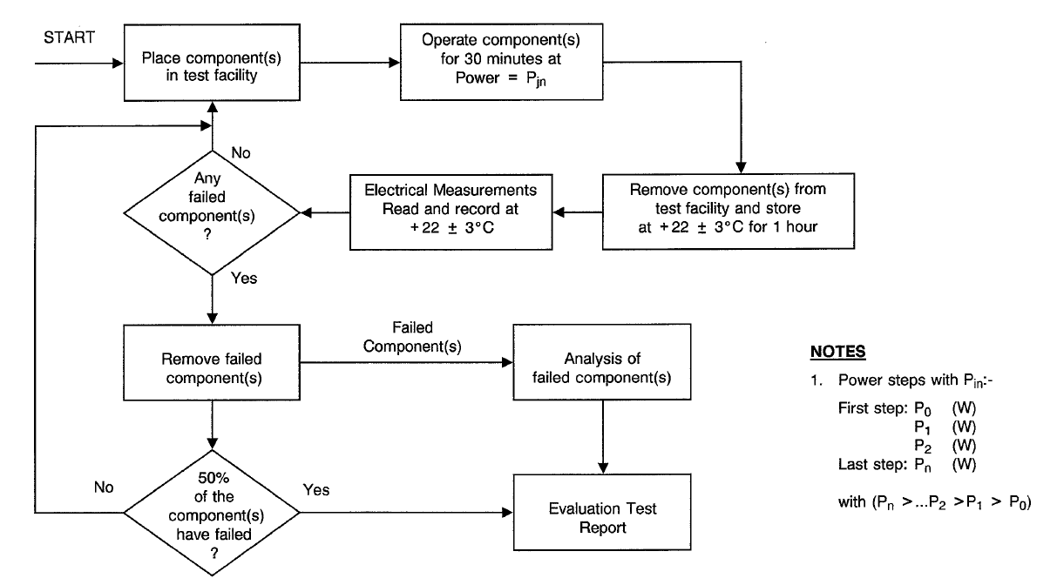
CHART III - TEMPERATURE STEP-STRESS SEQUENCE
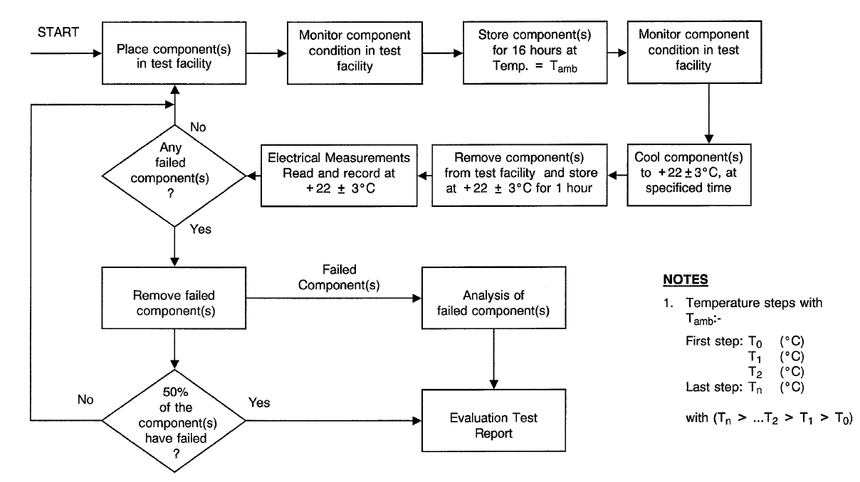
CHART IV - STEADY-STATE ACCELERATED LIFE TEST


