

Page 1 of 18
Power INDUCTORS, MOULDED, SMD
BASED ON SERIES SESI
ESCC Detail Specification No. 3201/009

Issue 13 Draft C | September 2016



Document Custodian: European Space Agency – see https://escies.org

Legal Disclaimer and Copyright
European Space Agency, Copyright © 2016. All rights reserved.
The European Space Agency disclaims any liability or responsibility, to any person or entity, with respect to any loss or damage caused, or alleged to be caused, directly or indirectly by the use and application of this ESCC publication.
This publication, without the prior permission of the European Space Agency and provided that it is not used for a commercial purpose, may be:
- copied in whole, in any medium, without alteration or modification.
- copied in part, in any medium, provided that the ESCC document identification, comprising the ESCC symbol, document number and document issue, is removed.

DOCUMENTATION CHANGE NOTICE
(Refer to https://escies.org for ESCC DCR content)
DCR No. | CHANGE DESCRIPTION
TBA | Specification upissued to incorporate changes per DCR.
13/07/2016 S.Thacker (TW) | First draft revision similar to ESCC 3201/008 Draft 7B to go with ESCC 3201 Draft 6C. Content based on 3201/009 issue 12.
27/07/2016 S.Thacker (TW) | New revision per Exxelia review of Draft 7B per emails dated 27/07/16 & 28/07/16.  Changes in this revision are highlighted in yellow.  All agreed comments have been removed.
06/09/2016 S.Thacker (TW) | New revision per Exxelia email dated 31/08/16 with 2 new values added (to variants 04 & 05).  Changes in this revision are highlighted in green.

TABLE OF CONTENTS
1 General 5
1.1 SCOPE 5
1.2 APPLICABLE DOCUMENTS 5
1.3 TERMS, DEFINITIONS, ABBREVIATIONS, SYMBOLS AND UNITS 5
1.4 THE ESCC COMPONENT NUMBER AND COMPONENT TYPE VARIANTS 5
1.4.1 The ESCC Component Number 5
1.4.1.1 Characteristics Codes 5
1.4.2 Component Type Variants and Range of Components 6
1.5 MAXIMUM RATINGS 12
1.6 PHYSICAL DIMENSIONS and terminal identification 13
1.7 FUNCTIONAL DIAGRAM 14
1.8 MATERIALS AND FINISHES 15
1.8.1 Case 15
1.8.2 Terminals 15
2 REQUIREMENTS 15
2.1 GENERAL 15
2.1.1 Deviations from the Generic Specification 15
2.1.1.1 Deviations from Qualification and Periodic Tests (Chart F4) 15
2.2 MARKING 15
2.3 ELECTRICAL MEASUREMENTS AT ROOM, HIGH AND LOW TEMPERATURES 16
2.3.1 Room Temperature Electrical Measurements 16
2.3.2 High and Low Temperatures Electrical Measurements 16
2.4 INTERMEDIATE AND END-POINT ELECTRICAL MEASUREMENTS 17
2.5 BURN-IN CONDITIONS 18
2.6 OPERATING LIFE CONDITIONS 18

General

SCOPE
This specification details the ratings, physical and electrical characteristics and test and inspection data for the component type variants and/or the range of components specified below. It supplements the requirements of, and shall be read in conjunction with, the ESCC Generic Specification listed under Applicable Documents.

APPLICABLE DOCUMENTS
The following documents form part of this specification and shall be read in conjunction with it:
          - ESCC Generic Specification No. 3201.

TERMS, DEFINITIONS, ABBREVIATIONS, SYMBOLS AND UNITS
For the purpose of this specification, the terms, definitions, abbreviations, symbols and units specified in ESCC Basic Specification No. 21300 shall apply.

THE ESCC COMPONENT NUMBER AND COMPONENT TYPE VARIANTS

The ESCC Component Number
The ESCC Component Number shall be constituted as follows:
Example: 3201009014L7M
- Detail Specification Reference: 3201009
- Component Type Variant Number: 01 (as required)
- Characteristic code: Inductance Value (4.7µH): 4L7 (as required)
- Characteristic code: Inductance Tolerance (±20%): M (as required)

Characteristics Codes
Characteristics to be codified as part of the ESCC Component Number shall be as follows:
          - Inductance Value expressed by means of the following codes in accordance with ESCC Basic Specification No. 21700. The unit quantity shall be microhenries (µH):
Inductance Value L  (µH) | Code
X.X | XLX
XX | XX0
XX 10¹ | XX1
XX 10² | XX2
          - Inductance Tolerance expressed by the following codes in accordance with ESCC Basic Specification No. 21700:
Tolerance (± %) | Code Letter
10 | K
20 | M
30 | N

Component Type Variants and Range of Components
The component type variants and range of components applicable to this specification are as follows:
Variant Number | Type | Case Description (1) | Terminal Finish (2) | Weight Max (g)
01 | SESI 14SR | Size 14 with 2 SMD terminals | Sn60Pb40 | 4
02 | SESI 15SR | Size 15 with 2 SMD terminals | Sn60Pb40 | 5.5
03 | SESI 15WR | Size 15 with 8 Gullwing terminals | Sn60Pb40 | 6
04 | SESI 18WR | Size 18 with 8 Gullwing terminals | Sn60Pb40 | 11
05 | SESI 9.1WR | Size 9.1 with 4 Gullwing terminals | Sn60Pb40 | 2
06 | SESI 22WR | Size 22 with 8 Gullwing terminals | Sn60Pb40 | 28
07 | SESI 32WR | Size 32 with 16 Gullwing terminals | Sn60Pb40 | 58
08 | SESI 32PR | Size 32 with 16 Pin terminals | Sn60Pb40 | 58

RANGE OF COMPONENTS – VARIANT 01 (SESI 14SR)
Inductance (3)  L (μH) | Tolerance  ± % | Rated DC Current  I_{R} (A) | Loaded Inductance at I_{R} (3, 4)  L_{R} (μH) | Peak Current (5)  I_{P} (A) | Max. DC Resistance  R_{DC} (mΩ)
3.3 | 20 | 5.8 | 2.3 | 8 | 15
4.7 | 20 | 5.4 | 3.3 | 6.9 | 17.5
6 | 20 | 4.3 | 4.2 | 5.7 | 26.5
8.2 | 20 | 3.7 | 5.7 | 5.2 | 42
10 | 20 | 3.3 | 7 | 4.6 | 47
15 | 20 | 2.7 | 10.5 | 3.8 | 90
22 | 20 | 2.2 | 15.4 | 3 | 110
33 | 20 | 1.8 | 23.1 | 2.5 | 170
47 | 10 | 1.6 | 32.9 | 2.1 | 200
56 | 10 | 1.5 | 39.2 | 1.9 | 240
68 | 10 | 1.3 | 47.6 | 1.7 | 290
82 | 10 | 1.2 | 57.4 | 1.5 | 315
100 | 10 | 1.1 | 70 | 1.4 | 440
120 | 10 | 1 | 84 | 1.3 | 500
150 | 10 | 0.9 | 105 | 1.1 | 645
180 | 10 | 0.83 | 126 | 1 | 740
220 | 10 | 0.72 | 154 | 1 | 980
330 | 10 | 0.57 | 231 | 0.8 | 1575
RANGE OF COMPONENTS – VARIANTS 02 and 03 (SESI 15SR, SESI 15WR)
Inductance (3)  L (μH) | Tolerance  ± % | Rated DC Current  I_{R} (A) | Loaded Inductance at I_{R} (3, 4)  L_{R} (μH) | Peak Current (5)  I_{P} (A) | Max. DC Resistance  R_{DC} (mΩ)
1.5 | 30 | 14 | 0.9 | 19 | 5
1.8 | 30 | 10 | 1.05 | 14 | 5
2.7 | 20 | 8.2 | 1.9 | 11.5 | 6.5
4.9 | 20 | 6 | 3.4 | 8.5 | 11
6.4 | 20 | 5.3 | 4.5 | 7.5 | 12
8 | 20 | 4.8 | 5.6 | 6.5 | 16
12 | 20 | 4 | 8.4 | 5.5 | 23
16 | 20 | 3.4 | 11.2 | 4.5 | 27
18 | 20 | 3.1 | 12.6 | 4.2 | 29
21 | 20 | 2.9 | 14.7 | 4 | 36
27 | 20 | 2.6 | 18.9 | 3.5 | 44
33 | 20 | 2.3 | 23 | 3.2 | 59
48 | 10 | 1.9 | 33 | 2.7 | 72
56 | 10 | 1.8 | 39 | 2.5 | 82
68 | 10 | 1.6 | 47 | 2.2 | 110
82 | 10 | 1.5 | 57 | 2.1 | 120
100 | 10 | 1.35 | 70 | 1.9 | 155
120 | 10 | 1.2 | 84 | 1.7 | 180
150 | 10 | 1.1 | 105 | 1.5 | 230
220 | 10 | 0.9 | 154 | 1.3 | 355
330 | 10 | 0.74 | 231 | 1 | 630
1000 | 10 | 0.38 | 800 | 0.5 | 2130
2300 | 10 | 0.28 | 1900 | 0.36 | 4400
RANGE OF COMPONENTS – Variant 04 (SESI 18WR)
Inductance (3)  L (μH) | Tolerance  ± % | Rated DC Current  I_{R} (A) | Loaded Inductance at I_{R} (3, 4)  L_{R} (μH) | Peak Current (5)  I_{P} (A) | Max. DC Resistance  R_{DC} (mΩ)
6.8 | 20 | 9.8 | 4.2 | 13.6 | 7.5
8.2 | 20 | 8.3 | 5.7 | 11.5 | 9
11 | 20 | 7.2 | 7.7 | 10 | 12
15 | 20 | 6.35 | 10.5 | 8.9 | 15
18 | 20 | 5.7 | 12.6 | 7.9 | 17
22 | 20 | 5.1 | 15.4 | 7.2 | 20
27 | 20 | 4.7 | 18.9 | 6.5 | 25
37 | 10 | 4 | 25.9 | 5.6 | 29
49 | 10 | 3.5 | 34.3 | 4.8 | 45
56 | 10 | 3.3 | 39 | 4.6 | 48
70 | 10 | 2.9 | 49 | 4.1 | 65
86 | 10 | 2.6 | 60 | 3.7 | 72
100 | 10 | 2.4 | 70 | 3.3 | 75
120 | 10 | 2.2 | 84 | 3.1 | 115
150 | 10 | 1.95 | 105 | 2.7 | 125
180 | 10 | 1.8 | 126 | 2.6 | 175
220 | 10 | 1.6 | 154 | 2.3 | 210
330 | 10 | 1.34 | 231 | 1.9 | 250
470 | 10 | 0.9 | 376 | 1.35 | 600
1000 | 10 | 0.38 | 800 | 0.5 | 2130
2300 | 10 | 0.28 | 1900 | 0.36 | 4400
RANGE OF COMPONENTS – VARIANT 05 (SESI 9.1WR)
Inductance (3)  L (μH) | Tolerance  ± % | Rated DC Current  I_{R} (A) | Loaded Inductance at I_{R} (3, 4)  L_{R} (μH) | Peak Current (5)  I_{P} (A) | Max. DC Resistance  R_{DC} (mΩ)
1 | 30 | 6 | 0.6 | 11 | 8.5
1.5 | 30 | 5.4 | 0.9 | 9.5 | 11.5
2 | 30 | 4.3 | 1.4 | 8.2 | 17
2.6 | 20 | 3.6 | 1.8 | 7 | 23
3.4 | 20 | 3 | 2.4 | 6.2 | 35
4.3 | 20 | 2.8 | 3 | 5.5 | 40
6.2 | 20 | 2.3 | 4.3 | 4.3 | 59
8.5 | 20 | 1.9 | 6 | 3.7 | 87
10 | 20 | 1.85 | 7 | 3.4 | 93
15 | 20 | 1.5 | 10.5 | 2.8 | 140
18 | 20 | 1.27 | 12.6 | 2.5 | 192
22 | 20 | 1.21 | 15.4 | 2.3 | 215
26 | 20 | 1.03 | 18.2 | 2.14 | 290
33 | 10 | 0.92 | 23.1 | 1.9 | 350
47 | 10 | 0.8 | 32.9 | 1.6 | 470
66 | 10 | 0.73 | 46.2 | 1.3 | 565
81 | 10 | 0.63 | 56.7 | 1.21 | 745
100 | 10 | 0.6 | 70 | 1.1 | 795
150 | 10 | 0.53 | 105 | 0.8 | 750
220 | 10 | 0.43 | 154 | 0.7 | 1165
330 | 10 | 0.36 | 231 | 0.6 | 1475
470 | 10 | 0.3 | 329 | 0.5 | 2220
680 | 10 | 0.25 | 477 | 0.4 | 3255
1000 | 10 | 0.2 | 700 | 0.34 | 5865
6800 | 10 | 0.045 | 5440 | 0.067 | 28000
RANGE OF COMPONENTS – Variant 06 (SESI 22WR)
Inductance (3)  L (μH) | Tolerance  ± % | Rated DC Current  I_{R} (A) | Loaded Inductance at I_{R} (3, 4)  L_{R} (μH) | Peak Current (5)  I_{P} (A) | Max. DC Resistance  R_{DC} (mΩ)
7 | 20 | 18.9 | 3.8 | 24 | 5
7.7 | 20 | 16 | 5.4 | 20 | 4.5
10 | 20 | 13.8 | 7 | 17.7 | 5.5
13 | 20 | 12 | 9.1 | 15.6 | 7
19 | 20 | 10.9 | 11.5 | 14 | 11
24 | 20 | 8.4 | 16.8 | 11.5 | 13
33 | 20 | 7.7 | 23 | 9.8 | 20
47 | 10 | 5.7 | 37.6 | 8 | 16
64 | 10 | 5 | 51.2 | 7 | 21
82 | 10 | 4.3 | 65.6 | 6.1 | 24
100 | 10 | 3.9 | 80 | 5.5 | 30
150 | 10 | 3.2 | 120 | 4.7 | 44
210 | 10 | 2.7 | 168 | 3.8 | 70
340 | 10 | 2.1 | 272 | 3 | 120
470 | 10 | 1.8 | 376 | 2.5 | 180
680 | 10 | 1.5 | 544 | 2.1 | 220
820 | 10 | 1.4 | 656 | 2 | 300
1000 | 10 | 1.2 | 800 | 1.8 | 330
1500 | 10 | 1.1 | 1200 | 1.4 | 500
2200 | 10 | 0.8 | 1760 | 1.2 | 760
RANGE OF COMPONENTS – Variant 07 and 08 (SESI 32WR, SESI 32PR)
Inductance (3)  L (μH) | Tolerance  ± % | Rated DC Current  I_{R} (A) | Loaded Inductance at I_{R} (3, 4)  L_{R} (μH) | Peak Current (5)  I_{P} (A) | Max. DC Resistance  R_{DC} (mΩ)
4.9 | 30 | 24 | 3 | 27.6 | 1.9
12 | 30 | 15.5 | 7.3 | 17.8 | 4.4
22 | 30 | 11.5 | 13.5 | 13.2 | 7.8
36 | 20 | 9.2 | 21.75 | 10.6 | 13
53 | 20 | 7.6 | 34.2 | 8.7 | 18
73 | 10 | 6.5 | 47.2 | 7.5 | 25
84 | 10 | 6 | 68 | 6.9 | 29
110 | 10 | 5.3 | 88 | 6.1 | 38.5
150 | 10 | 4.5 | 123 | 5.2 | 54.5
200 | 10 | 3.9 | 163 | 4.5 | 70
260 | 10 | 3.4 | 210 | 3.9 | 89.5
350 | 10 | 3 | 281 | 3.4 | 117.5
470 | 10 | 2.5 | 385 | 2.9 | 160
620 | 10 | 2.2 | 505 | 2.5 | 221
820 | 10 | 1.9 | 670 | 2.2 | 254
1000 | 10 | 1.7 | 826 | 2 | 353
2000 | 10 | 1.2 | 1650 | 1.4 | 665
4700 | 10 | 0.8 | 3760 | 0.92 | 1300
NOTES:
            - See Physical Dimensions and Terminal Identification.
            - See Materials and Finishes for details.
            - See Room Temperature Electrical Measurements and High and Low Temperature Electrical Measurements (as applicable) for test conditions.
            - Minimum value when the inductance is measured with Rated DC Current, I_{R}, applied.
            - Peak current is the maximum current for a square pulse of duration < 10s.

MAXIMUM RATINGS
The maximum ratings shall not be exceeded at any time during use or storage.
Maximum ratings shall only be exceeded during testing to the extent specified in this specification and when stipulated in Test Methods and Procedures of the ESCC Generic Specification.
Characteristics | Symbols | Maximum Ratings | Units | Remarks
Rated DC Current | I_{R} | Note 1 | A
Dielectric Withstanding Voltage | DWV | 500 | Vrms
Peak Current | I_{P} | Note 1 |  | Square pulse < 10s
Operating Temperature Range | T_{op} | -55 to +125 | °C | T_{amb}
Storage Temperature Range | T_{stg} | -55 to +140 | °C
Soldering Temperature | T_{sol} | +260 | °C | Note 2
NOTES:
            - See Component Type Variants and Range of Components for values.
            - Duration 5 seconds maximum, the same terminal shall not be resoldered until 3 minutes have elapsed.

PHYSICAL DIMENSIONS and terminal identification
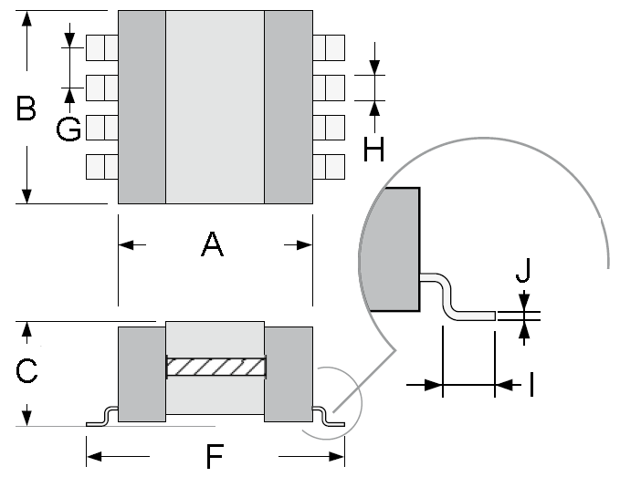
Variants 01, 02 Variants 03, 04, 06 (Note 1)
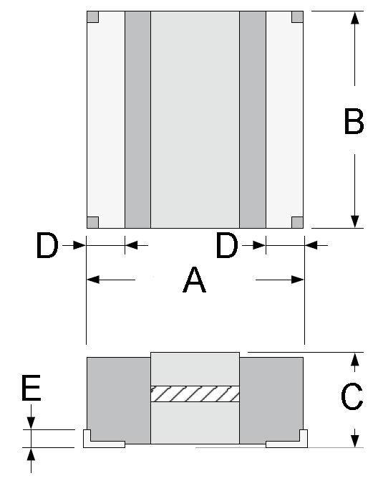

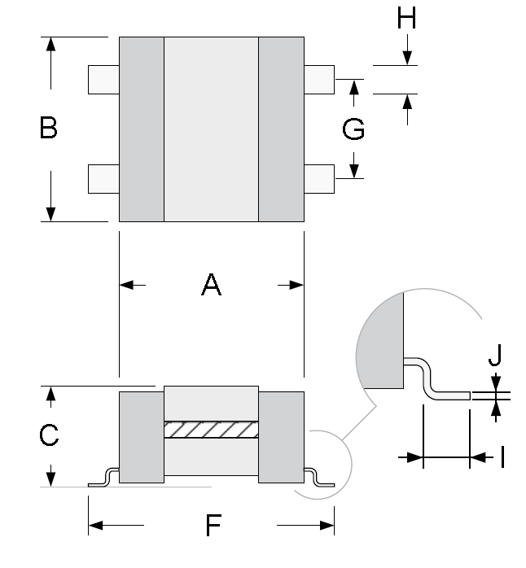
Variant 05 (Note 1) Variant 07 (Note 1)
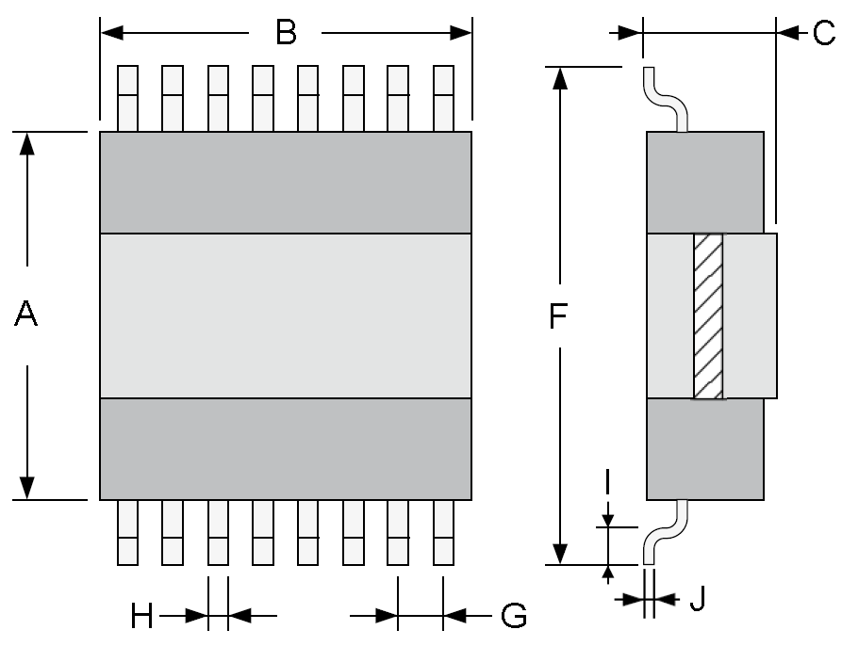
variant 08 (Note 1)
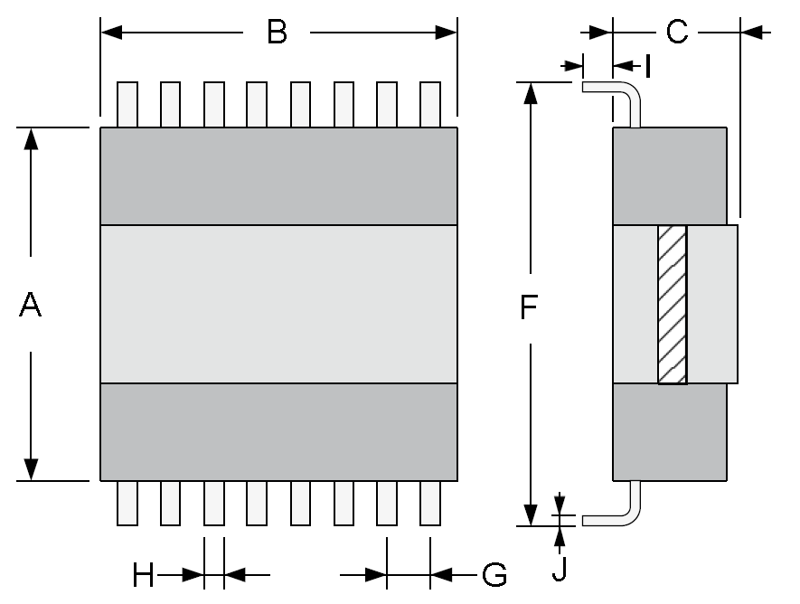

Symbols | Dimensions (mm)
Symbols | Variant 01 |  | Variant 02 |  | Variant 03 |  | Variant 04 |  | Variant 05 |  | Variant 06 |  | Variant 07 |  | Variant 08
Symbols | Min | Max | Min | Max | Min | Max | Min | Max | Min | Max | Min | Max | Min | Max | Min | Max
A | 15.7 | 16.3 | 15.7 | 16.3 | 16 | 16.5 | 21.7 | 22.3 | 10 | 10.6 | 30.4 | 31.2 | 42.1 | 42.9 | 42.1 | 42.9
B | - | 16 | - | 16 | - | 16 | - | 19.8 | - | 10.7 | - | 23.5 | - | 33.5 | - | 33.5
C | - | 5.4 | - | 7.4 | - | 7.9 | - | 8.9 | - | 5.8 | - | 12.2 | - | 13.7 | - | 13.7
D | 2.3 | - | 2.3 | - | - | - | - | - | - | - | - | - | - | - | - | -
E | 1 | 1.5 | 1 | 1.5 | - | - | - | - | - | - | - | - | - | - | - | -
F | - | - | - | - | 21.1 | 22 | 25.1 | 26 | 12.8 | 13.4 | 34.4 | 35.3 | 52 | 53.5 | 48.1 | 48.5
G | - | - | - | - | 3.7 | 3.9 | 3.7 | 3.9 | 5.6 | 5.8 | 3.7 | 3.9 | 3.7 | 3.9 | 3.7 | 3.9
H | - | - | - | - | 1 | 1.2 | 1.9 | 2.1 | 1.3 | 1.5 | 1.9 | 2.1 | 0.8 | 1 | 0.8 | 1
I | - | - | - | - | 1.3 | 1.6 | 1.3 | 1.6 | 0.9 | 1.3 | 1.3 | 1.6 | 2.15 | 2.35 | 4 | -
J | - | - | - | - | 0.2 | - | 0.2 | - | 0.2 | - | 0.2 | - | 0.4 | 0.7 | 0.4 | 0.7
NOTES:
            - Terminal identification: All terminals on each side of the body are connected together.

FUNCTIONAL DIAGRAM
Variants 01, 02 Variants 03, 04, 06

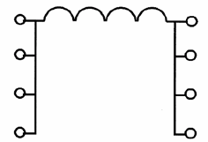

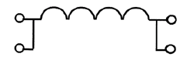
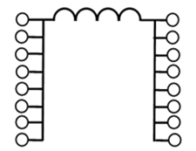
Variant 05 Variants 07, 08

MATERIALS AND FINISHES

Case
As a minimum, a resin moulding shall ensure the inductor’s protection.

Terminals
The terminal material shall be brass, plated with 2 to 4µm of nickel or copper. The finish shall be Sn60Pb40.

REQUIREMENTS

GENERAL
The complete requirements for procurement of the components specified herein are as stated in this specification and the ESCC Generic Specification. Permitted deviations from the Generic Specification, applicable to this specification only, are listed below.
Permitted deviations from the Generic Specification and this Detail Specification, formally agreed with specific Manufacturers on the basis that the alternative requirements are equivalent to the ESCC requirement and do not affect the component’s reliability, are listed in the appendices attached to this specification.

Deviations from the Generic Specification

Deviations from Qualification and Periodic Tests (Chart F4)
          - Temperature Rise: Ambient test temperature shall be +90 ±5°C.
          - Immersion: shall not be performed.
          - Moisture Resistance, Polarisation: there shall be no polarising voltage applied during test.

MARKING
The marking of all components delivered to this specification shall be in accordance with the requirements of ESCC Basic Specification No. 21700. When the component is too small to accommodate all of the marking specified, as much as space permits shall be marked and the marking information, in full, shall accompany each component in its primary package.
The information to be marked and the order of precedence, shall be as follows:
          - The ESCC qualified components symbol (for ESCC qualified components only).
          - The ESCC Component Number.
          - Traceability information.

ELECTRICAL MEASUREMENTS AT ROOM, HIGH AND LOW TEMPERATURES

Room Temperature Electrical Measurements
The measurements shall be performed at T_{amb} = +22 ±3 ºC.
Characteristics | Symbols | Test Method and Conditions | Tolerance  (± %) | Limits |  | Units
 |  |  |  | Min | Max | Units
Inductance | L | ESCC No. 3201  f = 100kHz  I = 0Adc  V = 250mV | 10 | 0.9L (Note 1) | 1.1L (Note 1) | µH
Inductance | L | ESCC No. 3201  f = 100kHz  I = 0Adc  V = 250mV | 20 | 0.8L (Note 1) | 1.2L (Note 1) | µH
Inductance | L | ESCC No. 3201  f = 100kHz  I = 0Adc  V = 250mV | 30 | 0.7L (Note 1) | 1.3L (Note 1) | µH
Loaded Inductance | L_{R} | ESCC No. 3201  f = 100kHz  I = I_{R} (Note 1)  V = 250mV | All | Note 1 | - | µH
DC Resistance | R_{DC} | ESCC No. 3201 | All | - | Note 1 | mΩ
Insulation  Resistance | R_{I} | ESCC No. 3201  V = 500Vdc | All | 1000 | - | MΩ
NOTES:
            - See Component Type Variants and Range of Components for values.

High and Low Temperatures Electrical Measurements
Characteristics | Symbols | Test Method and Conditions  (Note 1) | Limits |  | Unit
Characteristics | Symbols | Test Method and Conditions  (Note 1) | Min | Max | Unit
Loaded Inductance | L_{R} | ESCC No. 3201  T_{amb} = +110(+0 -5)°C and -55 (+5 -0)°C  f = 100kHz  I = I_{R} (Note 2)  V = 250mV | Note 2 | - | µH
NOTES:
            - The measurements shall be performed on a sample of 5 components from each lot with 0 failures allowed. In the event of any failure a 100% inspection may be performed.
            - See Component Type Variants and Range of Components for values.

INTERMEDIATE AND END-POINT ELECTRICAL MEASUREMENTS
Unless otherwise specified, the measurements shall be performed at T_{amb} = +22 ±3ºC.
Unless otherwise specified the test methods and test conditions shall be as per the corresponding test defined in Room Temperature Electrical Measurements.
Test Reference per ESCC No. 3201 | Characteristics | Symbols | Limits |  | Units
Test Reference per ESCC No. 3201 | Characteristics | Symbols | Min | Max | Units
Thermal Shock | DC Resistance | R_{DC} | Note 1 |  | mΩ
Barometric Pressure
Whilst at low pressure: | Dielectric Withstanding Voltage (2) | DWV | 500 | - | Vrms
Whilst at low pressure: | DWV Leakage Current (3) | I_{L} | - | 100 | µA
Temperature Rise | Test temperature: T_{amb} = +90 ±5°C
Initial Measurements | DC Resistance (at 0.1I_{r}) | R_{DC} | Record Value |  | mΩ
Final Measurements (within 30s of the removal of power) | DC Resistance (at I_{R}) | R_{DC} | Record Value |  | mΩ
Final Measurements (within 30s of the removal of power) | Temperature Rise | ΔT | - | 25 | °C
Overload | DC Resistance | R_{DC} | Note 1 |  | mΩ
 | Insulation Resistance | R_{I} | 1000 | - | MΩ
 | Dielectric Withstanding Voltage (2) | DWV | 500 | - | Vrms
 | DWV Leakage Current (3) | I_{L} | - | 100 | µA
Resistance to Soldering Heat | Inductance | L | Note 1 |  | µH
Resistance to Soldering Heat | DC Resistance | R_{DC} | Note 1 |  | mΩ
Resistance to Soldering Heat | Dielectric Withstanding Voltage (2) | DWV | 500 | - | Vrms
Resistance to Soldering Heat | DWV Leakage Current (3) | I_{L} | - | 100 | µA
Moisture Resistance
Within 30 min of removal from conditioning: | Dielectric Withstanding Voltage (2) | DWV | 500 | - | Vrms
Within 30 min of removal from conditioning: | DWV Leakage Current (3) | I_{L} | - | 100 | µA
Within 30 min of removal from conditioning: | Insulation Resistance | R_{I} | 1000 | - | MΩ
Within 1 hour of previous measurements: | Inductance | L | Note 1 |  | µH
Within 1 hour of previous measurements: | DC Resistance | R_{DC} | Note 1 |  | mΩ
Operating Life
Initial Measurements (0 hour) | Inductance | L | Note 1 |  | µH
Intermediate Measurements (1000 hours)(after 30 min recovery) | Dielectric Withstanding Voltage (2) | DWV | 500 | - | Vrms
 | DWV Leakage Current (3) | I_{L} | - | 100 | µA
 | Inductance Change | ΔL/L | -10 | +10 | %
Final Measurements (2000 hours)(after 30 min recovery) | Dielectric Withstanding Voltage (2) | DWV | 500 | - | Vrms
Final Measurements (2000 hours)(after 30 min recovery) | DWV Leakage Current (3) | I_{L} | - | 100 | µA
Final Measurements (2000 hours)(after 30 min recovery) | Inductance Change | ΔL/L | -10 | +10 | %
Final Measurements (2000 hours)(after 30 min recovery) | DC Resistance | R_{DC} | Note 1 |  | mΩ
Final Measurements (2000 hours)(after 30 min recovery) | Insulation Resistance | R_{I} | 1000 | - | MΩ
NOTES:
            - See Component Type Variants and Range of Components for values.
            - Test method and conditions per ESCC No. 3201.
            - Measured during Dielectric Withstanding Voltage.

BURN-IN CONDITIONS
Characteristics | Symbols | Test Conditions | Units
Ambient Temperature | T_{amb} | +125 (+0 -3) | ºC
NOTES:
            - After Burn-in, the components shall be removed from the chamber and allowed to cool under normal atmospheric conditions for recovery for 24 hours minimum.

OPERATING LIFE CONDITIONS
Characteristics | Symbols | Test Conditions | Units
Ambient Temperature | T_{amb} | +125 (+0 -3) | ºC
DC Current | I | I_{R} (Note 1) | mA
NOTES:
            - See Component Type Variants and Range of Components for values.

