

Page 1 of 24
DIODES, MICROWAVE, SILICON, PIN, FAST SWITCHING
BASED ON TYPES dh50201 To dh50209 and EH50201 to EH50209
ESCC Detail Specification No. 5513/033

Issue 5 Draft D | September 2016



Document Custodian: European Space Agency – see https://escies.org

Legal Disclaimer and Copyright
European Space Agency, Copyright © 2016. All rights reserved.
The European Space Agency disclaims any liability or responsibility, to any person or entity, with respect to any loss or damage caused, or alleged to be caused, directly or indirectly by the use and application of this ESCC publication.
This publication, without the prior permission of the European Space Agency and provided that it is not used for a commercial purpose, may be:
- copied in whole, in any medium, without alteration or modification.
- copied in part, in any medium, provided that the ESCC document identification, comprising the ESCC symbol, document number and document issue, is removed.

DOCUMENTATION CHANGE NOTICE
(Refer to https://escies.org for ESCC DCR content)
DCR No. | CHANGE DESCRIPTION
tba | Specification upissued to incorporate changes per DCR.

TABLE OF CONTENTS
1 General 6
1.1 SCOPE 6
1.2 APPLICABLE DOCUMENTS 6
1.3 TERMS, DEFINITIONS, ABBREVIATIONS, SYMBOLS AND UNITS 6
1.4 THE ESCC COMPONENT NUMBER AND COMPONENT TYPE VARIANTS 6
1.4.1 The ESCC Component Number 6
1.4.2 Component Type Variants 6
1.5 MAXIMUM RATINGS 9
1.6 Handling precautions 10
1.7 PHYSICAL DIMENSIONS AND TERMINAL IDENTIFICATION 10
1.7.1 Ceramic Pill A (2 Leads) - Variants 01, 08, 15, 22, 29, 36, 43 10
1.7.2 Ceramic Pill B - Variants 02, 09, 16, 23, 30, 37, 44 11
1.7.3 Ceramic Pill C (Cathode Lead) - Variants 03, 10, 17, 24, 31, 38, 45 12
1.7.4 Ceramic Pill D (Anode Lead) - Variants 04, 11, 18, 25, 32, 39, 46 13
1.7.5 Ceramic Pill E (2 Leads) - Variants 05, 12, 19, 26, 33, 40, 47 14
1.7.6 Ceramic Pill F (Anode Lead) - Variants 06, 13, 20, 27, 34, 41, 48 15
1.7.7 Ceramic Pill G - Variants 07, 14, 21, 28, 35, 42, 49, 56, 63 16
1.7.8 Ceramic Stripline - Variants 64 to 70 17
1.7.9 Naked Die – Variants 71 to 79 18
1.8 FUNCTIONAL DIAGRAM 18
1.9 MATERIALS AND FINISHES 19
1.9.1 Materials and Finishes of Packaged Components 19
1.9.2 Materials and Finishes of Naked Die Components 19
2 REQUIREMENTS 19
2.1 GENERAL 19
2.1.1 Deviations from the Generic Specification 19
2.1.1.1 Deviations from Qualification and Periodic Tests (Chart F4) 19
2.2 MARKING 19
2.3 Die Shear 20
2.4 TERMINAL STRENGTH 20
2.5 ELECTRICAL MEASUREMENTS AT ROOM, HIGH AND LOW TEMPERATURES 20
2.5.1 Room Temperature Electrical Measurements 20
2.5.2 High and Low Temperatures Electrical Measurements 21
2.6 PARAMETER DRIFT VALUES 22
2.7 INTERMEDIATE AND END-POINT ELECTRICAL MEASUREMENTS 22
2.8 BURN-IN 1 CONDITIONS 23
2.9 BURN-IN 2 CONDITIONS 23
2.10 OPERATING LIFE CONDITIONS 23
appendix ‘a’ 24

General

SCOPE
This specification details the ratings, physical and electrical characteristics and test and inspection data for the component type variants and/or the range of components specified below. It supplements the requirements of, and shall be read in conjunction with, the ESCC Generic Specification listed under Applicable Documents.

APPLICABLE DOCUMENTS
The following documents form part of this specification and shall be read in conjunction with it:
          - ESCC Generic Specification No. 5010
          - MIL-STD-750, Test Methods and Procedures for Semiconductor Devices

TERMS, DEFINITIONS, ABBREVIATIONS, SYMBOLS AND UNITS
For the purpose of this specification, the terms, definitions, abbreviations, symbols and units specified in ESCC Basic Specification No. 21300 shall apply.

THE ESCC COMPONENT NUMBER AND COMPONENT TYPE VARIANTS

The ESCC Component Number
The ESCC Component Number shall be constituted as follows:
Example: 551303301
- Detail Specification Reference: 5513033
- Component Type Variant Number: 01 (as required)

Component Type Variants
The component type variants applicable to this specification are as follows:
Packaged Components
Variant Number | Based On  Type | Package Type / Description | Total Capacitance  C_{T} (pF)  Max | Lead/Terminal Material and Finish (Note 1) |  | Weight  Max  (g)
 |  |  |  | Anode | Cathode | Weight  Max  (g)
01 | DH50201 | Ceramic Pill A (2 Leads) | 0.19 | E2 | E2 | 0.02
02 | DH50201 | Ceramic Pill B | 0.19 | D7 | D7 | 0.02
03 | DH50201 | Ceramic Pill C (Cathode Lead) | 0.19 | D7 | E2 | 0.02
04 | DH50201 | Ceramic Pill D (Anode Lead) | 0.19 | E2 | D7 | 0.02
05 | DH50201 | Ceramic Pill E (2 Leads) | 0.19 | E2 | E2 | 0.02
06 | DH50201 | Ceramic Pill F (Anode Lead) | 0.19 | E2 | D7 | 0.02
07 | DH50201 | Ceramic Pill G | 0.26 | D7 | A7 | 0.15
08 | DH50202 | Ceramic Pill A (2 Leads) | 0.21 | E2 | E2 | 0.02
09 | DH50202 | Ceramic Pill B | 0.21 | D7 | D7 | 0.02
10 | DH50202 | Ceramic Pill C (Cathode Lead) | 0.21 | D7 | E2 | 0.02
11 | DH50202 | Ceramic Pill D (Anode Lead) | 0.21 | E2 | D7 | 0.02
12 | DH50202 | Ceramic Pill E (2 Leads) | 0.21 | E2 | E2 | 0.02
13 | DH50202 | Ceramic Pill F (Anode Lead) | 0.21 | E2 | D7 | 0.02
14 | DH50202 | Ceramic Pill G | 0.28 | D7 | A7 | 0.15
15 | DH50203 | Ceramic Pill A (2 Leads) | 0.25 | E2 | E2 | 0.02
16 | DH50203 | Ceramic Pill B | 0.25 | D7 | D7 | 0.02
17 | DH50203 | Ceramic Pill C (Cathode Lead) | 0.25 | D7 | E2 | 0.02
18 | DH50203 | Ceramic Pill D (Anode Lead) | 0.25 | E2 | D7 | 0.02
19 | DH50203 | Ceramic Pill E (2 Leads) | 0.25 | E2 | E2 | 0.02
20 | DH50203 | Ceramic Pill F (Anode Lead) | 0.25 | E2 | D7 | 0.02
21 | DH50203 | Ceramic Pill G | 0.32 | D7 | A7 | 0.15
22 | DH50204 | Ceramic Pill A (2 Leads) | 0.3 | E2 | E2 | 0.02
23 | DH50204 | Ceramic Pill B | 0.3 | D7 | D7 | 0.02
24 | DH50204 | Ceramic Pill C (Cathode Lead) | 0.3 | D7 | E2 | 0.02
25 | DH50204 | Ceramic Pill D (Anode Lead) | 0.3 | E2 | D7 | 0.02
26 | DH50204 | Ceramic Pill E (2 Leads) | 0.3 | E2 | E2 | 0.02
27 | DH50204 | Ceramic Pill F (Anode Lead) | 0.3 | E2 | D7 | 0.02
28 | DH50204 | Ceramic Pill G | 0.37 | D7 | A7 | 0.15
29 | DH50205 | Ceramic Pill A (2 Leads) | 0.36 | E2 | E2 | 0.02
30 | DH50205 | Ceramic Pill B | 0.36 | D7 | D7 | 0.02
31 | DH50205 | Ceramic Pill C (Cathode Lead) | 0.36 | D7 | E2 | 0.02
32 | DH50205 | Ceramic Pill D (Anode Lead) | 0.36 | E2 | D7 | 0.02
33 | DH50205 | Ceramic Pill E (2 Leads) | 0.36 | E2 | E2 | 0.02
34 | DH50205 | Ceramic Pill F (Anode Lead) | 0.36 | E2 | D7 | 0.02
35 | DH50205 | Ceramic Pill G | 0.43 | D7 | A7 | 0.15
36 | DH50206 | Ceramic Pill A (2 Leads) | 0.53 | E2 | E2 | 0.02
37 | DH50206 | Ceramic Pill B | 0.53 | D7 | D7 | 0.02
38 | DH50206 | Ceramic Pill C (Cathode Lead) | 0.53 | D7 | E2 | 0.02
39 | DH50206 | Ceramic Pill D (Anode Lead) | 0.53 | E2 | D7 | 0.02
40 | DH50206 | Ceramic Pill E (2 Leads) | 0.53 | E2 | E2 | 0.02
41 | DH50206 | Ceramic Pill F (Anode Lead) | 0.53 | E2 | D7 | 0.02
42 | DH50206 | Ceramic Pill G | 0.6 | D7 | A7 | 0.15
43 | DH50207 | Ceramic Pill A (2 Leads) | 0.73 | E2 | E2 | 0.02
44 | DH50207 | Ceramic Pill B | 0.73 | D7 | D7 | 0.02
45 | DH50207 | Ceramic Pill C (Cathode Lead) | 0.73 | D7 | E2 | 0.02
46 | DH50207 | Ceramic Pill D (Anode Lead) | 0.73 | E2 | D7 | 0.02
47 | DH50207 | Ceramic Pill E (2 Leads) | 0.73 | E2 | E2 | 0.02
48 | DH50207 | Ceramic Pill F (Anode Lead) | 0.73 | E2 | D7 | 0.02
49 | DH50207 | Ceramic Pill G | 0.8 | D7 | A7 | 0.15
56 | DH50208 | Ceramic Pill G | 1 | D7 | A7 | 0.15
63 | DH50209 | Ceramic Pill G | 1.4 | D7 | A7 | 0.15
64 | DH50201 | Ceramic Stripline | 0.2 | D7 | D7 | 0.02
65 | DH50202 | Ceramic Stripline | 0.22 | D7 | D7 | 0.02
66 | DH50203 | Ceramic Stripline | 0.26 | D7 | D7 | 0.02
67 | DH50204 | Ceramic Stripline | 0.31 | D7 | D7 | 0.02
68 | DH50205 | Ceramic Stripline | 0.37 | D7 | D7 | 0.02
69 | DH50206 | Ceramic Stripline | 0.54 | D7 | D7 | 0.02
70 | DH50207 | Ceramic Stripline | 0.74 | D7 | D7 | 0.02
Naked Die Components (Note 2)
Variant Number | Based On Type | Junction Capacitance  C_{J} (pF)  Max | Total Capacitance  C_{T} (pF)  Max  (Note 3)
71 | EH50201 | 0.06 | 0.26
72 | EH50202 | 0.08 | 0.28
73 | EH50203 | 0.12 | 0.32
74 | EH50204 | 0.17 | 0.37
75 | EH50205 | 0.23 | 0.43
76 | EH50206 | 0.4 | 0.6
77 | EH50207 | 0.6 | 0.8
78 | EH50208 | 0.8 | 1
79 | EH50209 | 1.2 | 1.4
notes:
            - The lead/terminal material and finish shall be in accordance with the requirements of ESCC Basic Specification No. 23500.
            - For Naked Die Components, Variants 71 to 79, the default package selected for assembly of the Packaged Test Sublot shall be Ceramic Pill G. At the Manufacturer’s option, any of the other packages specified herein with a Variant for the same die may be selected. The die applicable to each Variant is indicated by the based on type number.
            - In cases where the default package is not selected for the Packaged Test Sublot, the Total Capacitance limit of the selected package shall apply.

MAXIMUM RATINGS
The maximum ratings shall not be exceeded at any time during use or storage.
Maximum ratings shall only be exceeded during testing to the extent specified in this specification and when stipulated in Test Methods and Procedures of the ESCC Generic Specification.
Characteristics | Symbols | Maximum Ratings | Unit | Remarks
DC Reverse Voltage | V_{Rmax} | -200 | V | I_{R} = 10µA
DC Forward Current (Continuous)  Variants 01 to 06, 08 to 13, 15 to 20:  Variants 07, 14, 21:  Variants 22 to 27, 29 to 34, 36 to 41, 43 to 48:  Variants 28, 35, 42, 49, 56:  Variant 63:  Variants 64 to 70: | I_{Fmax} | 150  240  180  300  600  90 | mA | Note 1
RF Power Dissipation  Variants 01 to 06, 08 to 13, 15 to 20:  Variants 07, 14, 21:  Variants 22 to 27, 29 to 34, 36 to 41, 43 to 48:  Variants 28, 35, 42, 49, 56:  Variant 63:  Variants 64 to 70: | P_{tot} | 0.5  0.83  0.62  1.25  1.87  0.3 | W | Note 2
Operating Temperature Range | T_{op} | -55 to +150 | °C | T_{case}
Storage Temperature Range | T_{stg} | -65 to +175 | °C
Junction Temperature | T_{j} | +150 | °C
Thermal Resistance, Junction-to-Case  Variants 01 to 06, 08 to 13, 15 to 20:  Variants 07, 14, 21, 71 to 73:  Variants 22 to 27, 29 to 34, 36 to 41, 43 to 48:  Variants 28, 35, 42, 49, 56, 74 to 78:  Variants 63, 79:  Variants 64 to 70: | R_{th(j-c)} | 150  90  120  60  40  250 | °C/W | Note 3
Soldering Temperature | T_{sol} | +230 | °C | Note 4
NOTES:
            - At T_{case} ≤ +75°C. For T_{case} > +75°C, derate linearly to 0A at T_{case} = +150°C.
            - At T_{case} ≤ +75°C. For T_{case} > +75°C, derate linearly to 0W at T_{case} = +150°C.
            - Thermal Resistance ratings for Naked Die Components, Variants 71 to 79, refer to the Packaged Test Sublot assembled in the default Ceramic Pill G package. In cases where the default package is not used, the Thermal Resistance rating associated with the package used and the same die shall apply.
            - Duration 5 seconds maximum and the same terminal shall not be resoldered until 3 minutes have elapsed. Only applicable to Variants 01 to 49, 56, 63 to 70 (Packaged Components).

Handling precautions
These devices are susceptible to damage by electrostatic discharge. Therefore, suitable precautions shall be employed for protection during all phases of manufacture, testing, packaging, shipment and any handling.
These components are categorised as Class 2 per ESCC Basic Specification No. 23800 with a Minimum Critical Path Failure Voltage of 1400V.

PHYSICAL DIMENSIONS AND TERMINAL IDENTIFICATION

Ceramic Pill A (2 Leads) - Variants 01, 08, 15, 22, 29, 36, 43
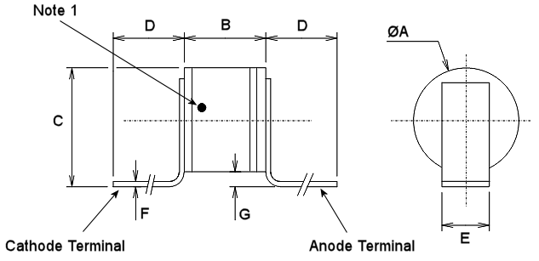
Symbols | Dimensions mm |  | Remarks
Symbols | Min | Max | Remarks
ØA | 1.07 | 1.47
B | 0.95 | 1.35
C | 1.3 | 1.9 | Both terminals
D | 2.5 | -
E | 0.55 | 0.65 | Both terminals
F | 0.06 | 0.1 | Both terminals
G | 0.1 | 0.5 | Both terminals
NOTES:
            - Terminal identification: The body shall be marked at a suitable location near the cathode terminal with a black dot.

Ceramic Pill B - Variants 02, 09, 16, 23, 30, 37, 44
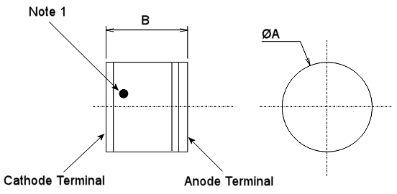
Symbols | Dimensions mm
Symbols | Min | Max
ØA | 1.07 | 1.47
B | 0.95 | 1.35
NOTES:
            - Terminal identification: The body shall be marked at a suitable location near the cathode terminal with a black dot.

Ceramic Pill C (Cathode Lead) - Variants 03, 10, 17, 24, 31, 38, 45
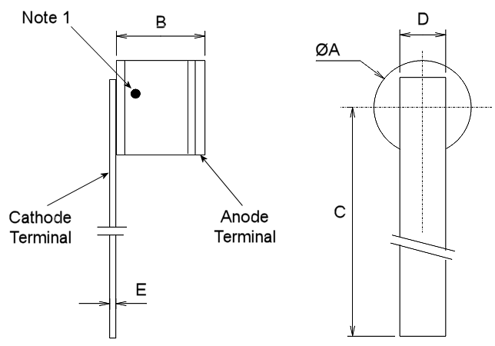
 | Symbols | Dimensions mm
 | Symbols | Min | Max
 | ØA | 1.07 | 1.47
 | B | 0.95 | 1.35
 | C | 5 | -
 | D | 0.55 | 0.65
 | E | 0.06 | 0.1
notes:
            - Terminal identification: The body shall be marked at a suitable location near the cathode terminal with a black dot.

Ceramic Pill D (Anode Lead) - Variants 04, 11, 18, 25, 32, 39, 46
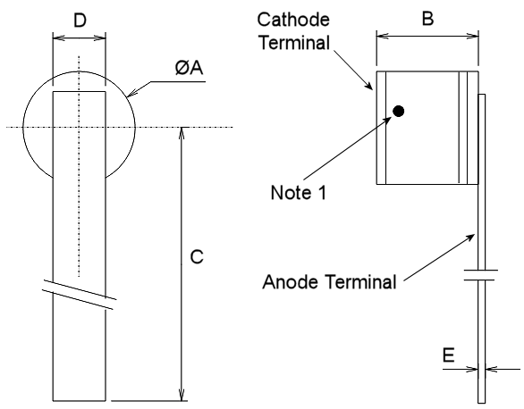
 | Symbols | Dimensions mm
 | Symbols | Min | Max
 | ØA | 1.07 | 1.47
 | B | 0.95 | 1.35
 | C | 5 | -
 | D | 0.55 | 0.65
 | E | 0.06 | 0.1
notes:
            - Terminal identification: The body shall be marked at a suitable location near the cathode terminal with a black dot.

Ceramic Pill E (2 Leads) - Variants 05, 12, 19, 26, 33, 40, 47
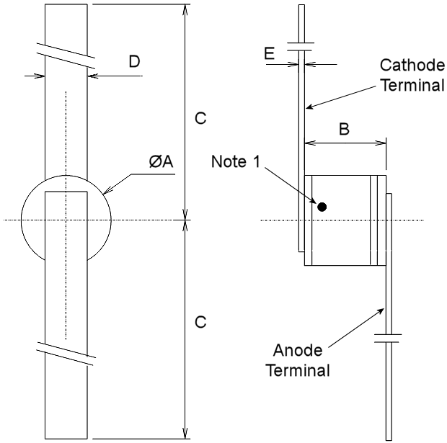
Symbols | Dimensions mm |  | Remarks
Symbols | Min | Max | Remarks
ØA | 1.07 | 1.47
B | 0.95 | 1.35
C | 5 | -
D | 0.55 | 0.65 | Both terminals
E | 0.06 | 0.1 | Both terminals
notes:
            - Terminal identification: The body shall be marked at a suitable location near the cathode terminal with a black dot.

Ceramic Pill F (Anode Lead) - Variants 06, 13, 20, 27, 34, 41, 48
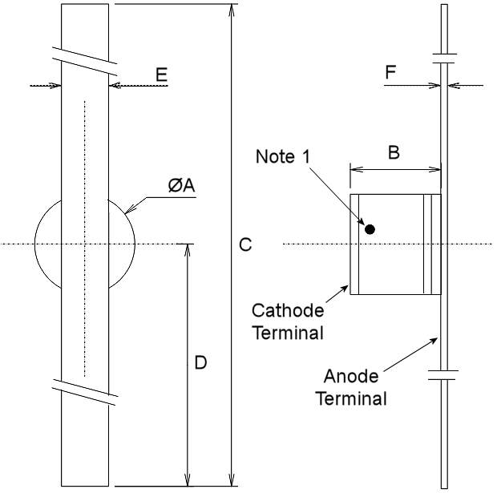
 | Symbols | Dimensions mm
 | Symbols | Min | Max
 | ØA | 1.07 | 1.47
 | B | 0.95 | 1.35
 | C | 10 | 10.4
 | D | 5 | -
 | E | 0.55 | 0.65
 | F | 0.06 | 0.1
notes:
            - Terminal identification: The body shall be marked at a suitable location near the cathode terminal with a black dot.

Ceramic Pill G - Variants 07, 14, 21, 28, 35, 42, 49, 56, 63
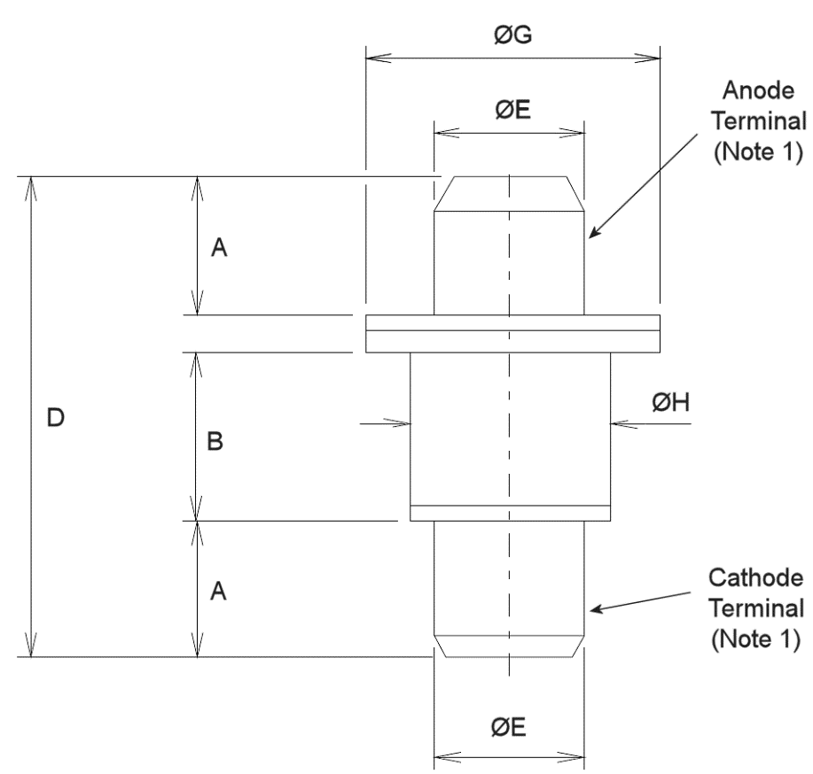
 | Symbols | Dimensions mm
 | Symbols | Min | Max
 | A | 1.52 | 1.63
 | B | 1.75 | 1.85
 | D | 5.2 | 5.72
 | ØE | 1.52 | 1.63
 | ØG | 3 | 3.23
 | ØH | 1.95 | 2.11
notes:
            - Terminal identification shall be by means of the physical configuration of the package.

Ceramic Stripline - Variants 64 to 70
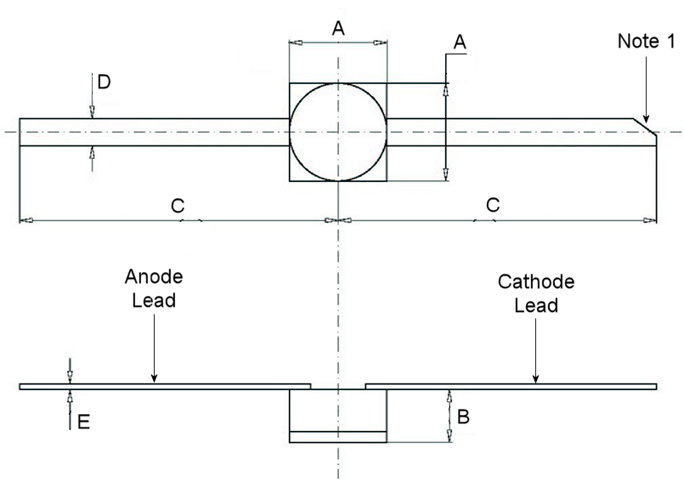
Symbols | Dimensions mm |  | Remarks
Symbols | Min | Max | Remarks
A | 1.68 | 1.88
B | 0.91 | 1.01
C | 6.15 | 6.55
D | 0.45 | 0.55 | Both leads
E | 0.08 | 0.12 | Both leads
notes:
            - Terminal identification: The end of the cathode lead shall have a 45° chamfer.

Naked Die – Variants 71 to 79
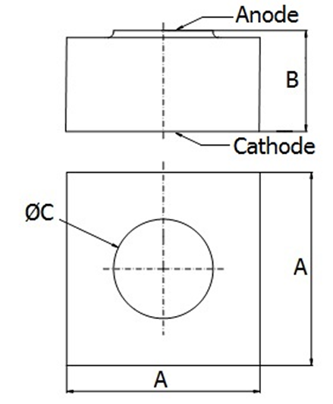
Symbols | Dimensions mm |  | Remarks
Symbols | Min | Max
A | 0.34  0.53 | 0.4  0.6 | Variants 71 to 77  Variants 78, 79
B | 0.16 | 0.26
ØC | 0.07  0.08  0.1  0.12  0.14  0.2  0.24  0.29  0.35 | 0.11  0.13  0.16  0.18  0.2  0.26  0.31  0.36  0.44 | Variant 71  Variant 72  Variant 73  Variant 74  Variant 75  Variant 76  Variant 77  Variant 78  Variant 79
notes:
            - Terminal identification shall be by means of the physical configuration.

FUNCTIONAL DIAGRAM
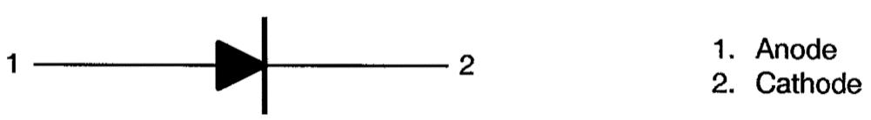
notes:
            - For Variants 64 to 70, the lid is isolated from the terminals.

MATERIALS AND FINISHES

Materials and Finishes of Packaged Components
For Variants 01 to 49, 56, 63 to 70, the materials and finishes shall be as follows:
          - Case
The case shall be hermetically sealed and have a ceramic body with a metal base and lid.
          - Terminals
As specified in Component Type Variants.

Materials and Finishes of Naked Die Components
For Variants 71 to 79, the materials and finishes shall be as follows:
          - Bond pad
The bond pad metallisation shall be TiPtAu with a layer of vacuum-deposited gold of thickness 0.7µm minimum.
          - Die backface
The die backface metallisation shall be TiPtAu with a layer of gold of thickness 0.7µm minimum.

REQUIREMENTS

GENERAL
The complete requirements for procurement of the components specified herein are as stated in this specification and the ESCC Generic Specification. Permitted deviations from the Generic Specification, applicable to this specification only, are listed below.
Permitted deviations from the Generic Specification and this Detail Specification, formally agreed with specific Manufacturers on the basis that the alternative requirements are equivalent to the ESCC requirement and do not affect the component’s reliability, are listed in the appendices attached to this specification.

Deviations from the Generic Specification

Deviations from Qualification and Periodic Tests (Chart F4)
          - Mechanical Shock: Shall not be performed.
          - Vibration: Shall not be performed.
          - Constant Acceleration: Shall not be performed.

MARKING
The marking shall be in accordance with the requirements of ESCC Basic Specification No. 21700 and as follows.
The information to be marked on the component shall be:
          - Terminal identification, as specified in Physical Dimensions and Terminal Identification.
          - The ESCC qualified components symbol (for ESCC qualified components only).
          - The ESCC Component Number.
          - Traceability information.

Die Shear
In those cases where package clearances are such that a die shear test is not practicable, the die shall be pushed away with a suitable tool. The force required to remove the die need not be recorded. The die attachment area shall be inspected and the component shall be considered acceptable if more than 50% of the semiconductor material remains.

TERMINAL STRENGTH
The test conditions for terminal strength, tested as specified in the ESCC Generic Specification, shall be as follows:
- For Variants 01, 03 to 06, 08, 10 to 13, 15, 17 to 20, 22, 24 to 27, 29, 31 to 34, 36, 38 to 41, 43, 45 to 48, 64 to 70: Test Condition A, tension, with a force of 1.25N for duration 10s.
- For Variants 02, 07, 09, 14, 16, 21, 23, 28, 30, 35, 37, 42, 44, 49, 56, 63, 71 to 79: shall not be performed.

ELECTRICAL MEASUREMENTS AT ROOM, HIGH AND LOW TEMPERATURES

Room Temperature Electrical Measurements
The measurements shall be performed at T_{amb} = +22 ±3°C.
Characteristics | Symbols | MIL-STD-750  Test Method | Test Conditions | Limits |  | Units
 |  |  |  | Min | Max | Units
Reverse Current 1 (Note 1) | I_{R1} | 4016 | V_{R} = -200V | - | 10 | µA
Reverse Current 2 (Note 1) | I_{R2} | 4016 | V_{R} = -100V | - | 500 | nA
Forward Voltage (Note 1) | V_{F} | 4011 | I_{F} = 10mA | - | 1.1 | V
Thermal Resistance, Junction-to-Case (Note 2) | R_{th(j-c)} | 3101 | Note 3 | - | Note 4 | °C/W
Variants 01 to 06, 08 to 13, 15 to 20, 64 to 70: | R_{th(j-c)} | 3101 | P = 0.25W | - | Note 4 | °C/W
Variants 07, 14, 21 to 27, 29 to 34, 36 to 41, 43 to 48, 71 to 73: | R_{th(j-c)} | 3101 | P = 0.5W | - | Note 4 | °C/W
Variants 28, 35, 42, 49, 56, 63, 74 to 79: | R_{th(j-c)} | 3101 | P = 1W | - | Note 4 | °C/W
Total Capacitance (Note 2) | C_{T} | 4001 | V_{R} = -50V  f = 1MHz | - | Note 5 | pF
Junction Capacitance (Note 6) | C_{J} | 4001 | V_{R} = -50V  f = 1MHz | - | Note 5 | pF
Forward Series Resistance  (Note 1) | R_{SF} | 4056 | I_{F} = 10mA  f = 120MHz |  |  | Ω
Variants 01 to 07, 64, 71:  Variants 08 to 14, 65, 72:  Variants 15 to 21, 66, 73:  Variants 22 to 28, 67, 74:  Variants 29 to 35, 68, 75:  Variants 36 to 42, 69, 76:  Variants 43 to 49, 70, 77:  Variants 56, 78:  Variants 63, 79: | R_{SF} | 4056 | I_{F} = 10mA  f = 120MHz | -  -  -  -  -  -  -  -  - | 2.3  2.1  1.5  1.3  1  0.8  0.7  0.6  0.5 | Ω
Minority Carrier Lifetime (Note 7) | τ_{L} | 4031 | I_{F} = 10mA  I_{R} = 6mA |  |  | ns
Variants 01 to 07, 64, 71:  Variants 08 to 14, 65, 72:  Variants 15 to 21, 66, 73:  Variants 22 to 28, 67, 74:  Variants 29 to 35, 68, 75:  Variants 36 to 42, 69, 76:  Variants 43 to 49, 70, 77:  Variants 56, 78:  Variants 63, 79: | τ_{L} | 4031 | I_{F} = 10mA  I_{R} = 6mA | 240  320  400  520  640  710  840  1000  1200 | -  -  -  -  -  -  -  -  - | ns
NOTES:
            - This characteristic applies to all Variants tested during Charts F2 and F3 of the Generic Specification.
            - 5. This characteristic applies to Variants 01 to 49, 56, 63 to 70 (Packaged Components) and Variants 71 to 79 (Packaged Test Sublot samples for Naked Die Components), tested only during Chart F3 of the Generic Specification.
            - Pulsed measurement, pulse width = 10ms.
            - See Maximum Ratings for the applicable limits.
            - See Component Type Variants for the applicable limits.
            - This characteristic only applies to Variants 71 to 79 (Naked Die Components), tested only during Chart F2 of the Generic Specification.
            - See Component Type Variants for the applicable limits.
            - Only performed during Chart F2 of the Generic Specification, on a sample of 27 dice per wafer. In the event of any failure, a 100% inspection shall be performed and all failures shall be clearly identified.

High and Low Temperatures Electrical Measurements
The measurements shall be performed only at T_{amb} = +150 (+0 -3)°C.
Characteristics | Symbols | MIL-STD-750  Test Method | Test Conditions  Note 1 | Limits |  | Units
 |  |  |  | Min | Max | Units
Reverse Current 2 (Note 2) | I_{R2} | 4016 | V_{R} = -100V | - | 50 | µA
NOTES:
            - Measurements shall be performed on a sample basis as specified in the Generic Specification.
            - This characteristic applies to all Variants tested during Charts F2 and F3 of the Generic Specification.

PARAMETER DRIFT VALUES
Unless otherwise specified, the measurements shall be performed at T_{amb} = +22 ±3°C.
The test methods and test conditions shall be as per the corresponding test defined in Room Temperature Electrical Measurements.
The drift values (Δ) shall not be exceeded for each characteristic specified. The corresponding absolute limit values for each characteristic shall not be exceeded.
Characteristics | Symbols | Limits |  |  | Units
Characteristics | Symbols | Drift  Value (1)  Δ | Absolute |  | Units
Characteristics | Symbols | Drift  Value (1)  Δ | Min | Max | Units
Reverse Current 2 | I_{R2} | ±50  or (2)  ±100% | - | 500 | nA
Forward Voltage | V_{F} | ±5% | - | 1.1 | V
Total Capacitance (Note 3) | C_{T} | ±5% (4)  or  ±10% (5) | - | Note 6 | pF
NOTES:
            - Δ1 = Δ2.
            - Whichever is the greater referred to the initial value.
            - This characteristic applies to Variants 01 to 49, 56, 63 to 70 (Packaged Components) and Variants 71 to 79 (Packaged Test Sublot samples for Naked Die Components).
            - Applicable drift value for C_{T} > 0.5pF and rounded upwards to the nearest 0.01pF.
            - Applicable drift value for C_{T} ≤ 0.5pF and rounded upwards to the nearest 0.01pF.
            - See Component Type Variants for the applicable limits.

INTERMEDIATE AND END-POINT ELECTRICAL MEASUREMENTS
Unless otherwise specified, the measurements shall be performed at T_{amb} = +22 ±3°C.
The test methods and test conditions shall be as per the corresponding test defined in Room Temperature Electrical Measurements.
The limit values for each characteristic shall not be exceeded.
Characteristics | Symbols | Limits |  | Units
Characteristics | Symbols | Min | Max | Units
Reverse Current 1 | I_{R1} | - | 10 | µA
Reverse Current 2 | I_{R2} | - | 500 | nA
Forward Voltage | V_{F} | - | 1.1 | V
Total Capacitance (Note 1) | C_{T} | - | Note 2 | pF
NOTES:
            - This characteristic applies to Variants 01 to 49, 56, 63 to 70 (Packaged Components) and Variants 71 to 79 (Packaged Test Sublot samples for Naked Die Components).
            - See Component Type Variants for the applicable limits.

BURN-IN 1 CONDITIONS
Characteristics | Symbols | Test Conditions | Units
Ambient Temperature | T_{amb} | +150 (+0 -3) | °C
Reverse Voltage (Note 1) | V_{R} | -150 | V
notes:
            - Upon completion of Burn-in 1, the test voltage shall be maintained until T_{amb} < +35°C.

BURN-IN 2 CONDITIONS
Characteristics | Symbols | Test Conditions | Units
Case Temperature | T_{case} | +125 (+0 -3) | °C
Forward Current | I_{F} |  | mA
Variants 01 to 06, 08 to 13, 15 to 20: | I_{F} | 50 | mA
Variants 07, 14, 21, 71 to 73: | I_{F} | 80 | mA
Variants 22 to 27, 29 to 34, 36 to 41, 43 to 48: | I_{F} | 60 | mA
Variants 28, 35, 42, 49, 56, 74 to 78: | I_{F} | 100 | mA
Variants 63, 79 | I_{F} | 200 | mA
Variants 64 to 70: | I_{F} | 30 | mA

OPERATING LIFE CONDITIONS
The conditions shall be as specified for Burn-in 2.

appendix ‘a’
agreed deviations for cobham microwave (f)
Items Affected | Description of Deviations
Deviations from Generic  Specification: Special In-Process Controls (Chart F2) | SEM Inspection: From each wafer selected for SEM Inspection, the sample of three dice shall be selected after die separation.
Bond Strength: The following pre-seal bond strength shall apply:
- 0.03N minimum
Deviations from Generic  Specification: Screening Tests (Chart F3) | Radiographic Inspection:  - Shall not be performed on Packaged Test Sublot samples for Naked Die Components.  - May be performed without serialisation and at any point during Chart F3. Any components found to fail Radiographic Inspection shall be removed from the lot.  May be performed in the X and Z axes only.
Deviations from Generic  Specification: Qualification and Periodic Tests for Packaged Components and Naked Die Components (Charts F4A and F4B) | For the De-encapsulation Subgroup, the Internal Visual Inspection, Bond Strength and Die Shear tests may be replaced by measurements verifying the die solder integrity and wire integrity, as follows:  - Thermal Impedance test in accordance with MIL-STD-750, Test Method 3101.  - For Variants 01 to 06, 08 to 13, 15 to 20, 64 to 70: P_{D} = 0.25W.  - For Variants 07, 14, 21 to 27, 29 to 34, 36 to 41, 43 to 48, 71 to 73: P_{D} = 0.5W.  - For Variants 28, 35, 42, 49, 56, 63, 74 to 79: P_{D} = 1W.  The Thermal Impedance shall be measured and shall not exceed the applicable value of Thermal Resistance, Junction-to-Case specified in Maximum Ratings.  - Forward Voltage test in accordance with MIL-STD-750, Test Method 4011.  - For Variants 01 to 49, 56, 63, 71 to 79: I_{F} = 100mA.  - For Variants 64 to 70: I_{F} = 90mA.  The Forward Voltage shall be measured and shall not exceed 1.2V.

