

Page 1 of 15
TRANSISTORS, MICROWAVE, SILICON, BIPOLAR, SMALL SIGNAL
BASED ON TYPEs BFY640B and BFY650B
ESCC Detail Specification No. 5611/010

Issue 3 Draft C | August 2016



Document Custodian: European Space Agency – see https://escies.org

Legal Disclaimer and Copyright
European Space Agency, Copyright © 2016. All rights reserved.
The European Space Agency disclaims any liability or responsibility, to any person or entity, with respect to any loss or damage caused, or alleged to be caused, directly or indirectly by the use and application of this ESCC publication.
This publication, without the prior permission of the European Space Agency and provided that it is not used for a commercial purpose, may be:
- copied in whole, in any medium, without alteration or modification.
- copied in part, in any medium, provided that the ESCC document identification, comprising the ESCC symbol, document number and document issue, is removed.

DOCUMENTATION CHANGE NOTICE
(Refer to https://escies.org for ESCC DCR content)
DCR No. | CHANGE DESCRIPTION
tba | Specification upissued to incorporate changes per DCR.

TABLE OF CONTENTS
1 General 5
1.1 SCOPE 5
1.2 APPLICABLE DOCUMENTS 5
1.3 TERMS, DEFINITIONS, ABBREVIATIONS, SYMBOLS AND UNITS 5
1.4 THE ESCC COMPONENT NUMBER AND COMPONENT TYPE VARIANTS 5
1.4.1 The ESCC Component Number 5
1.4.2 Component Type Variants 5
1.5 MAXIMUM RATINGS 6
1.6 handling precautions 6
1.7 PHYSICAL DIMENSIONS AND TERMINAL IDENTIFICATION 7
1.8 FUNCTIONAL DIAGRAM 8
1.9 MATERIALS AND FINISHES 8
2 REQUIREMENTS 8
2.1 GENERAL 8
2.1.1 Deviations from the Generic Specification 8
2.1.1.1 Deviations from Qualification and Periodic Tests for Packaged Components (Chart F4A) 8
2.2 MARKING 9
2.3 Die Shear 9
2.4 TERMINAL STRENGTH 9
2.5 ELECTRICAL MEASUREMENTS AT ROOM, HIGH AND LOW TEMPERATURES 9
2.5.1 Room Temperature Electrical Measurements 9
2.5.2 High and Low Temperatures Electrical Measurements 11
2.6 PARAMETER DRIFT VALUES 12
2.7 INTERMEDIATE AND END-POINT ELECTRICAL MEASUREMENTS 13
2.8 BURN-IN 1 CONDITIONS 13
2.9 BURN-IN 2 CONDITIONS 14
2.10 OPERATING LIFE CONDITIONS 14
APPENDIX A 15

General

SCOPE
This specification details the ratings, physical and electrical characteristics and test and inspection data for the component type variants and/or the range of components specified below. It supplements the requirements of, and shall be read in conjunction with, the ESCC Generic Specification listed under Applicable Documents.

APPLICABLE DOCUMENTS
The following documents form part of this specification and shall be read in conjunction with it:
          - ESCC Generic Specification No. 5010
          - MIL-STD-750, Test Methods and Procedures for Semiconductor Devices

TERMS, DEFINITIONS, ABBREVIATIONS, SYMBOLS AND UNITS
For the purpose of this specification, the terms, definitions, abbreviations, symbols and units specified in ESCC Basic Specification No. 21300 shall apply.

THE ESCC COMPONENT NUMBER AND COMPONENT TYPE VARIANTS

The ESCC Component Number
The ESCC Component Number shall be constituted as follows:
Example: 561101001
- Detail Specification Reference: 5611010
- Component Type Variant Number: 01 (as required)

Component Type Variants
The component type variants applicable to this specification are as follows:
Variant Number | Based on Type | Case | Lead Material and Finish | Weight  max g
01 | BFY640B-01 | Micro-X | G2 | 0.03
02 | BFY640B-03 | Micro-X | G2 | 0.03
03 | BFY640B-04 | Micro-X | G2 | 0.03
04 | BFY650B-11 | Micro-X | G2 | 0.03
The lead material and finish shall be in accordance with the requirements of ESCC Basic Specification No. 23500.

MAXIMUM RATINGS
The maximum ratings shall not be exceeded at any time during use or storage.
Maximum ratings shall only be exceeded during testing to the extent specified in this specification and when stipulated in Test Methods and Procedures of the ESCC Generic Specification.
Characteristics | Symbols | Maximum Ratings | Units | Remarks
Collector-Emitter Voltage | V_{CEO} | 4  3.5 | V | T_{amb} > 0°C  T_{amb} ≤ 0°C
Collector-Emitter Voltage | V_{CES} | 13 | V
Collector-Base Voltage | V_{CBO} | 13 | V
Emitter-Base Voltage | V_{EBO} | 1.2 | V
Collector Current  Variants 01, 02, 03  Variant 04 | I_{C} | 50  150 | mA
Base Current  Variants 01, 02, 03  Variant 04 | I_{B} | 3  10 | mA | Note 1
Power Dissipation  Variants 01, 02, 03  Variant 04 | P_{tot} | 200  600 | mW | T_{S} ≤ +110°C  T_{S} ≤ +76°C  Note 2
Operating Temperature Range | T_{op} | -65 to +175 | °C | T_{S}
Storage Temperature Range | T_{stg} | -65 to +175 | °C
Junction Temperature | T_{j} | +175 | °C
Thermal Resistance,  Junction-to-Soldering Point  Variants 01, 02, 03  Variant 04 | R_{th(j-s)} | 325  165 | °C/W
Soldering Temperature | T_{sol} | +250 | °C | Note 3
NOTES:
            - Maximum ratings must not be exceeded under any combination of DC ratings and RF voltage/current swings except as specified in Room Temperature Electrical Measurements herein.
            - T_{S} is measured on the collector lead at the soldering point to the PCB. For T_{S} greater than specified, P_{tot} derates linearly to 0W at T_{S} = +175°C.
            - Duration 5 seconds maximum at a distance of not less than 0.5mm from the device body and the same lead shall not be resoldered until 3 minutes have elapsed.

handling precautions
These devices are susceptible to damage by electrostatic discharge. Therefore suitable precautions shall be employed for protection during all phases of manufacture test, packaging, shipping and handling.
These components are categorised as Class 1 per ESCC Basic Specification No. 23800 with a Minimum Critical Path Failure Voltage of 100V.

PHYSICAL DIMENSIONS AND TERMINAL IDENTIFICATION
Micro-x Package
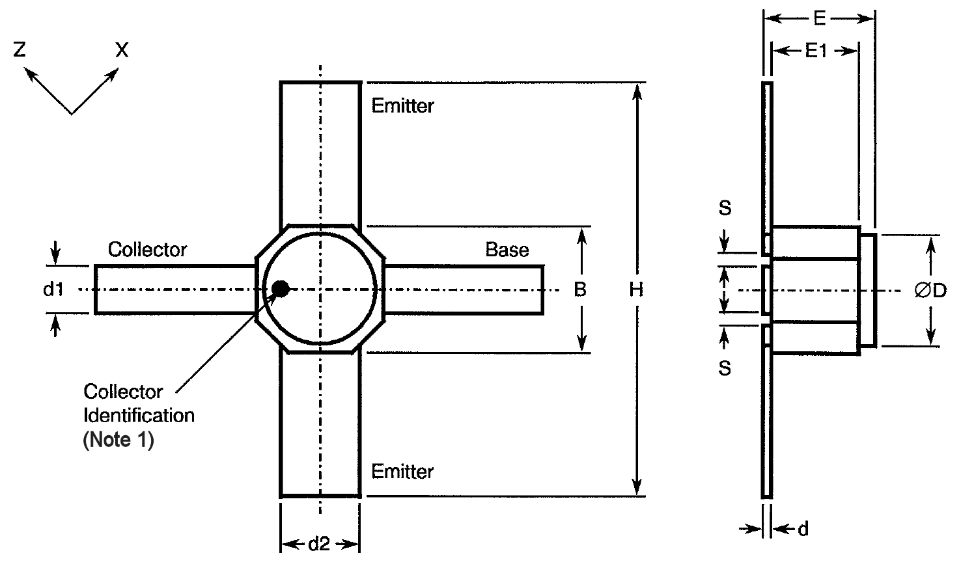
Symbols | Dimensions mm |  | Notes
Symbols | Min | Max | Notes
B | 1.68 | 1.88 | 2
d | 0.07 | 0.15 | 3
d1 | 0.4 | 0.6 | 2
d2 | 0.92 | 1.12 | 2
ØD | 1.55 | 1.85
E | 0.85 | 1.25 | 3
E1 | 0.66 | 0.86 | 3
H | 4 | 4.4 | 2
S | 0.08 | 0.3 | 4
NOTES:
            - The Collector terminal is identified by means of a black dot marked on the lid, with the three other terminals identifiable by the component’s geometry.
            - Applies in two places.
            - Applies to all leads.
            - Applies in four places.

FUNCTIONAL DIAGRAM
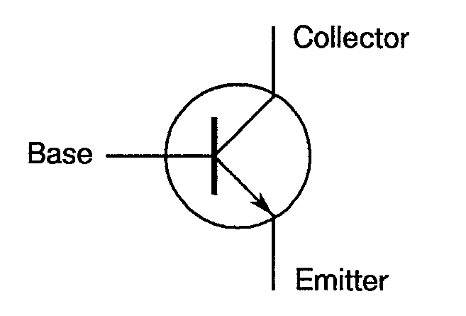
NOTES:
            - The lid is connected to the Emitter terminal.

MATERIALS AND FINISHES
Materials and finishes shall be as follows:
          - Case
The case shall be hermetically sealed and have a ceramic body with a metal lid.
          - Leads
As specified in Component Type Variants.

REQUIREMENTS

GENERAL
The complete requirements for procurement of the components specified herein are as stated in this specification and the ESCC Generic Specification. Permitted deviations from the Generic Specification, applicable to this specification only, are listed below.
Permitted deviations from the Generic Specification and this Detail Specification, formally agreed with specific Manufacturers on the basis that the alternative requirements are equivalent to the ESCC requirement and do not affect the component’s reliability, are listed in the appendices attached to this specification.

Deviations from the Generic Specification

Deviations from Qualification and Periodic Tests for Packaged Components (Chart F4A)
          - Mechanical Shock: Not applicable.
          - Vibration: Not applicable.
          - Constant Acceleration: Not applicable.

MARKING
The marking shall be in accordance with the requirements of ESCC Basic Specification No. 21700. The information to be marked and the order of precedence shall be as follows:
          - Terminal identification.
          - The ESCC qualified components symbol (for ESCC qualified components only).
          - The ESCC Component Number.
          - Traceability information.

Die Shear
In those cases where package clearances are such that a die shear test is not practicable, the die shall be pushed away with a suitable tool. The force required to remove the die need not be recorded. The die attachment area shall be inspected and the component shall be considered acceptable if more than 50% of the semiconductor material remains.

TERMINAL STRENGTH
The test conditions for terminal strength, tested as specified in the ESCC Generic Specification, shall be as follows:
- Test Condition A, tension, with a force of 2.23N and a duration of 5s.

ELECTRICAL MEASUREMENTS AT ROOM, HIGH AND LOW TEMPERATURES

Room Temperature Electrical Measurements
The measurements shall be performed at T_{amb} = +25 ±3°C.
Characteristics | Symbols | MIL-STD-750  Test Method | Test Conditions | Limits |  | Units
 |  |  |  | Min | Max | Units
Collector-Emitter Cut-off Current 1 | I_{CES1} | 3041 | Bias Condition C  V_{CE} = 13V | - | 10 | µA
Collector-Emitter Cut-off Current 2 | I_{CES2} | 3041 | Bias Condition C  V_{CE} = 10.5V | - | 5 | µA
Collector-Emitter Cut-off Current 3 | I_{CES3} | 3041 | Bias Condition C  V_{CE} = 5V | - | 2 | µA
Collector-Emitter Cut-off Current 4 | I_{CEX} | 3041 | V_{CE} = 4V, I_{B} = 100nA | 20 | 100 | µA
Emitter-Base Cut-off Current 1 | I_{EBO1} | 3061 | Bias Condition D  V_{EB} = 1.2V  Variants 01, 02, 03  Variant 04 | -  - | 5  15 | µA
Emitter-Base Cut-off Current 2 | I_{EBO2} | 3061 | Bias Condition D  V_{EB} = 500mV | - | 100 | nA
Forward-Current Transfer Ratio 1 | h_{FE1} | 3076 | V_{CE} = 3V  Variants 01, 02, 03: I_{C} = 30mA  Variant 04: I_{C} = 80mA | 135  100 | 250  250 | -
Forward-Current Transfer Ratio 2 | h_{FE2} | 3076 | V_{CE} = 3V, I_{C} = 20µA  Variants 01, 02, 03  Variant 04 | 190  190 | 600  530 | -
Base-Emitter Forward Voltage | V_{FBE} | 4011 | I_{B} = 12mA, I_{C} = 0A  Note 1 | - | 960 | mV
Collector-Emitter Capacitance | C_{CE} | 3236 | V_{CE} = 2V, I_{B} = 0A, f = 1MHz  Common Base Configuration  Variants 01, 02, 03  Variant 04 | -  - | 0.6  0.8 | pF
Collector-Base Capacitance | C_{CB} | 3236 | V_{CB} = 2V, I_{E} = 0A, f = 1MHz  Common Emitter Configuration  Variants 01, 02, 03  Variant 04 | -  - | 0.12  0.36 | pF
Emitter-Base Capacitance | C_{EB} | 3236 | V_{EB} = 500mV, I_{C} = 0A, f = 1MHz  Common Collector Configuration  Variants 01, 02, 03  Variant 04 | -  - | 0.8  1.8 | pF
Insertion Power Gain at 1.8GHz | |S₂₁|²_{1.8} | - | f = 1.8GHz, V_{CE} = 3V  Variants 01, 02, 03: I_{C} = 30mA  Variant 04: I_{C} = 80mA  Notes 2, 3 | 20.5  14.5 | -  - | dB
Insertion Power Gain at 6GHz | |S₂₁|²₆ | - | f = 6GHz, V_{CE} = 3V  Variants 01, 02, 03: I_{C} = 30mA  Variant 04: I_{C} = 80mA  Notes 2, 3 | 10.5  5.5 | -  - | dB
Maximum Available / Stable Gain at 1.8GHz | MAG / MSG_{1.8} | - | f = 1.8GHz, V_{CE} = 3V  Variants 01, 02, 03: I_{C} = 30mA  Variant 04: I_{C} = 80mA  Notes 2, 3, 4 | 23  18 | -  - | dB
Maximum Available / Stable Gain at 6GHz | MAG / MSG₆ | - | f = 6GHz, V_{CE} = 3V  Variants 01, 02, 03: I_{C} = 30mA  Variant 04: I_{C} = 80mA  Notes 2, 3, 4 | 12  8 | -  - | dB
Noise Figure at 1.8GHz | NF_{1.8} | - | f = 1.8GHz, V_{CE} = 3V, I_{C} = 5mA  Variant 01  Variant 02  Variant 03  Variant 04  Notes 3, 5, 6 | -  -  -  N/A | 1  1  0.8  N/A | dB
Noise Figure at 6GHz | NF₆ | - | f = 6GHz, V_{CE} = 3V, I_{C} = 5mA  Variants 01, 04  Variant 02  Variant 03  Notes 3, 5, 6 | N/A  -  - | N/A  1.6  1.4 | dB
Output Power | P_{out} | - | f = 1.8GHz, V_{CE} = 3V, I_{C} = 80mA  P_{in} = 0dBm  Variants 01, 02, 03  Variant 04  Notes 2, 7 | N/A  16 | N/A  - | dBm
NOTES:
            - Pulsed measurement, pulse duration < 1s, single pulse. I_{B} may exceed that specified in Maximum Ratings.
            - Measured in a 50Ω system using a suitable network analyser.
            - Small signal measurement.
            - MAG if K ≥ 1; MSG if K < 1.
            - Input tuned for NF_{min}.
            - Measurements shall be performed on a sample of 15 components with the maximum allowed limit reduced by 0.07dB. In the event of any failure a 100% inspection shall be performed and the specified limit shall apply.
            - Measurements shall be performed on a sample of 15 components with the minimum allowed limit increased by 0.5dBm. In the event of any failure a 100% inspection shall be performed and the specified limit shall apply.

High and Low Temperatures Electrical Measurements
Characteristics | Symbols | MIL-STD-750  Test Method | Test Conditions | Limits |  | Units
 |  |  |  | Min | Max | Units
Collector-Emitter Cut-off Current 2 | I_{CES2} | 3041 | T_{amb} = +150 (+0 -5)°C  Bias Condition C  V_{CE} = 10.5V, Note 1 | - | 5 | µA
Collector-Emitter Cut-off Current 3 | I_{CES3} | 3041 | T_{amb} = +150 (+0 -5)°C  Bias Condition C  V_{CE} = 5V, Note 1 | - | 1 | µA
Emitter-Base Cut-off Current 1 | I_{EBO1} | 3061 | T_{amb} = +150 (+0 -5)°C  Bias Condition D  V_{EB} = 1.2V, Note 1  Variants 01, 02, 03  Variant 04 | -  - | 50  150 | µA
Emitter-Base Cut-off Current 1 | I_{EBO1} | 3061 | T_{amb} = -55 (+5 -0)°C  Bias Condition D  V_{EB} = 1.2V, Note 2  Variants 01, 02, 03  Variant 04 | -  - | 5  15 | µA
Emitter-Base Cut-off Current 2 | I_{EBO2} | 3061 | T_{amb} = +150 (+0 -5)°C  Bias Condition D  V_{EB} = 500mV, Note 1 | - | 1 | µA
Forward-Current Transfer Ratio 1 | h_{FE1} | 3076 | T_{amb} = +150 (+0 -5)°C  V_{CE} = 3V, Note 1  Variants 01, 02, 03: I_{C} = 30mA  Variant 04: I_{C} = 80mA | 85  75 | 200  200 | -
Forward-Current Transfer Ratio 1 | h_{FE1} | 3076 | T_{amb} = -55 (+5 -0)°C  V_{CE} = 3V, I_{C} = 30mA, Note 2  Variants 01, 02, 03: I_{C} = 30mA  Variant 04: I_{C} = 80mA | 150  80 | 500  400 | -
NOTES:
            - Measurements shall be performed on a sample of 5 components. In the event of any failure a 100% inspection shall be performed.
            - Measurements shall be performed on a sample of 5 assembled components per wafer. In the event of any failure a 100% inspection shall be performed.

PARAMETER DRIFT VALUES
Unless otherwise specified, the measurements shall be performed at T_{amb} = +25 ±3°C.
The test methods and test conditions shall be as per the corresponding test defined in Room Temperature Electrical Measurements.
The drift values (Δ) shall not be exceeded for each characteristic specified. The corresponding absolute limit values for each characteristic shall not be exceeded.
Characteristics | Symbols | Limits |  |  | Units
Characteristics | Symbols | Drift  Value (1)  Δ | Absolute |  | Units
Characteristics | Symbols | Drift  Value (1)  Δ | Min | Max | Units
Collector-Emitter Cut-off Current 2 | I_{CES2} | ±20  or (2) +100/-50% | - | 5000 | nA
Collector-Emitter Cut-off Current 3 | I_{CES3} | ±5  or (2) +100/-50% | - | 2000 | nA
Emitter-Base Cut-off Current 1  Variants 01, 02, 03  Variant 04 | I_{EBO1} | ±0.5  or (2)  +100/-50% | -  - | 5  15 | µA
Emitter-Base Cut-off Current 2 | I_{EBO2} | ±20  or (2) +100/-50% | - | 100 | nA
Forward-Current Transfer Ratio 1  Variants 01, 02, 03  Variant 04 | h_{FE1} | ±10% | 135  100 | 250  250 | -
Base-Emitter Forward Voltage | V_{FBE} | ±20 (3) | - | 960 | mV
NOTES:
            - Δ1 = Δ2 except for V_{FBE}.
            - Whichever is greater.
            - The total change over both Burn-in 1 and Burn-in 2 referred to the initial value made prior to Burn-in 1.

INTERMEDIATE AND END-POINT ELECTRICAL MEASUREMENTS
Unless otherwise specified, the measurements shall be performed at T_{amb} = +25 ±3°C.
The test methods and test conditions shall be as per the corresponding test defined in Room Temperature Electrical Measurements.
The limit values for each characteristic shall not be exceeded.
Characteristics | Symbols | Limits |  |  | Units
Characteristics | Symbols | Drift  Value  Δ | Absolute |  | Units
Characteristics | Symbols | Drift  Value  Δ | Min | Max | Units
Collector-Emitter Cut-off Current 2 | I_{CES2} | ±20  or (1) +100/-50% | - | 5000 | nA
Collector-Emitter Cut-off Current 3 | I_{CES3} | ±5  or (1) +100/-50% | - | 2000 | nA
Emitter-Base Cut-off Current 1  Variants 01, 02, 03  Variant 04 | I_{EBO1} | ±0.5  or (1)  +100/-50% | -  - | 5  15 | µA
Emitter-Base Cut-off Current 2 | I_{EBO2} | ±20  or (1) +100/-50% | - | 100 | nA
Forward-Current Transfer Ratio 1  Variants 01, 02, 03  Variant 04 | h_{FE1} | ±10% | 135  100 | 250  250 | -
Base-Emitter Forward Voltage | V_{FBE} | ±20 | - | 960 | mV
notes:
            - Whichever is greater.

BURN-IN 1 CONDITIONS
Characteristics | Symbols | Test Conditions (Note 1) | Units
Soldering Point Temperature | T_{S} | +150 (+0 -5) | °C
Collector-Emitter Voltage | V_{CES} | 10.5 | V
Base-Emitter Voltage | V_{BE} | 0 | V
notes:
            - Maximum ratings shall not be exceeded during power up and power down sequences.

BURN-IN 2 CONDITIONS
Characteristics | Symbols | Test Conditions  (Notes 1, 2) | Units
Soldering Point Temperature  Variants 01, 02, 03  Variant 04 | T_{S} | ≥ +110  ≥ +76 | °C
Junction Temperature | T_{j} | +175 (+0 -5) | °C
Power Dissipation | P_{tot} | ≤ P_{tot} given in Maximum Ratings | mW
Collector-Emitter Voltage | V_{CE} | 3.5 | V
notes:
            - Maximum ratings shall not be exceeded during power up and power down sequences.
            - T_{S} and/or P_{tot} shall be adjusted to attain to attain the specified T_{j}.

OPERATING LIFE CONDITIONS
The conditions shall be as specified for Burn-in 2.

APPENDIX A
AGREED DEVIATIONS FOR INFINEON Technologies AG (D)
Items Affected | Description of Deviations
Deviations from Generic  Specification: Special In-Process Controls (Chart F2) | Internal Visual Inspection: Shall include verification of the length, height and shape of the wire bonding.
Bond Strength: The following pre-seal bond strength shall apply:
- 0.015N minimum
Die Shear: If Para. 2.3 does not apply the following shear strength may be applied:
- 0.4N minimum
 | Dimension Check: May be performed during Chart F3 testing.
Deviations from Generic  Specification: Screening Tests (Chart F3) | Temperature Cycling: Shall be replaced by a Thermal Shock test in accordance with  MIL-STD-202, Test Method 107, Test Condition B, 20 cycles.
 | Radiographic Inspection: Shall not be performed.
Deviations from Generic  Specification: Qualification and Periodic Tests (Chart F4) | Temperature Cycling: Shall be replaced by a Thermal Shock test in accordance with  MIL-STD-202, Test Method 107, Test Condition B, 100 cycles.
Assembly Capability Subgroup tests: In addition to the permitted use of empty packages or electrical rejects as test samples, components rejected during the following Screening Tests:
- Radiographic Inspection
- Seal
- External Visual Inspection
may be used on the condition that the cause for rejection has no possible impact on the tests, and they have been subjected to the same screening as the packages of the assembly lot with which they are associated.
Bond Strength: The following post–seal bond strength shall apply:
- 0.012N minimum
Die Shear: If Para. 2.3 does not apply the following shear strength may be applied:
- 0.4N minimum
Deviations from Generic Specification: Final Customer Source Inspection | Final Customer Source Inspection shall be limited to witnessing of the DC and 1MHz parameters specified in Room Temperature Electrical Measurements.
Deviations from Generic  Specification: Data Documentation | Additional Documentation and Wafer Lot Acceptance Data:  If Wafer Lot Acceptance Data is stipulated in the Purchase Order, such data will not be delivered but will be available for review at lnfineon Technologies AG.

