

Page 1 of 12
CHOKES, COMMON MODE, FIXED, MOULDED, SMD
BASED ON SERIES CMC 15, 18 AND 22
ESCC Detail Specification No. 3201/010

Issue 5 Draft B | July 2016



Document Custodian: European Space Agency – see https://escies.org

Legal Disclaimer and Copyright
European Space Agency, Copyright © 2016. All rights reserved.
The European Space Agency disclaims any liability or responsibility, to any person or entity, with respect to any loss or damage caused, or alleged to be caused, directly or indirectly by the use and application of this ESCC publication.
This publication, without the prior permission of the European Space Agency and provided that it is not used for a commercial purpose, may be:
- copied in whole, in any medium, without alteration or modification.
- copied in part, in any medium, provided that the ESCC document identification, comprising the ESCC symbol, document number and document issue, is removed.

DOCUMENTATION CHANGE NOTICE
(Refer to https://escies.org for ESCC DCR content)
DCR No. | CHANGE DESCRIPTION
TBA | Specification upissued to incorporate changes per DCR.
13/07/2016 S.Thacker (TW) | First draft revision similar to ESCC 3201/008 Draft 7B to go with ESCC 3201 Draft 6C. Content based on 3201/010 issue 4.
27/07/2016 S.Thacker (TW) | New revision per Exxelia review of Draft 5A per email dated 27/07/16.  Changes in this revision are highlighted in yellow.  All agreed comments have been removed.

TABLE OF CONTENTS
1 General 5
1.1 SCOPE 5
1.2 APPLICABLE DOCUMENTS 5
1.3 TERMS, DEFINITIONS, ABBREVIATIONS, SYMBOLS AND UNITS 5
1.4 THE ESCC COMPONENT NUMBER AND COMPONENT TYPE VARIANTS 5
1.4.1 The ESCC Component Number 5
1.4.1.1 Characteristics Codes 5
1.4.2 Component Type Variants and Range of Components 6
1.5 MAXIMUM RATINGS 7
1.6 PHYSICAL DIMENSIONS and terminal identification 8
1.7 FUNCTIONAL DIAGRAM 8
1.8 MATERIALS AND FINISHES 9
1.8.1 Case 9
1.8.2 Terminals 9
2 REQUIREMENTS 9
2.1 GENERAL 9
2.1.1 Deviations from the Generic Specification 9
2.1.1.1 Deviations from Qualification and Periodic Tests (Chart F4) 9
2.2 MARKING 9
2.3 ELECTRICAL MEASUREMENTS AT ROOM, HIGH AND LOW TEMPERATURES 10
2.3.1 Room Temperature Electrical Measurements 10
2.3.2 High and Low Temperatures Electrical Measurements 10
2.4 INTERMEDIATE AND END-POINT ELECTRICAL MEASUREMENTS 11
2.5 BURN-IN CONDITIONS 12
2.6 OPERATING LIFE CONDITIONS 12

General

SCOPE
This specification details the ratings, physical and electrical characteristics and test and inspection data for the component type variants and/or the range of components specified below. It supplements the requirements of, and shall be read in conjunction with, the ESCC Generic Specification listed under Applicable Documents.

APPLICABLE DOCUMENTS
The following documents form part of this specification and shall be read in conjunction with it:
          - ESCC Generic Specification No. 3201.

TERMS, DEFINITIONS, ABBREVIATIONS, SYMBOLS AND UNITS
For the purpose of this specification, the terms, definitions, abbreviations, symbols and units specified in ESCC Basic Specification No. 21300 shall apply.

THE ESCC COMPONENT NUMBER AND COMPONENT TYPE VARIANTS

The ESCC Component Number
The ESCC Component Number shall be constituted as follows:
Example: 320101001520
- Detail Specification Reference: 3201010
- Component Type Variant Number: 01 (as required)
- Characteristic code: Inductance Value (52µH): 520 (as required)

Characteristics Codes
Characteristics to be codified as part of the ESCC Component Number shall be as follows:
          - Inductance Value (nominal) expressed by means of the following codes in accordance with ESCC Basic Specification No. 21700. The unit quantity shall be microhenries (µH):
Inductance Value L_{n}  (µH) | Code
XX | XX0
XX 10¹ | XX1
XX 10² | XX2

Component Type Variants and Range of Components
The component type variants and range of components applicable to this specification are as follows:
Variant Number | Type | Case Description (1) | Terminal Finish (2) | Weight Max (g)
01 | CMC 15WR | Size 15 with 8 Gullwing terminals | Sn60Pb40 | 6
03 | CMC 18WR | Size 18 with 8 Gullwing terminals | Sn60Pb40 | 11
05 | CMC 22WR | Size 22 with 8 Gullwing terminals | Sn60Pb40 | 28
Range of Components
Variant Number | Nominal Inductance Each Winding (3)  L_{n} (µH) | Inductance Measurement Voltage Test Condition  V_{T} (mV) | Minimum Inductance Each Winding (3)  L_{min} (µH) | Max. DC Resistance Each Winding  R_{DC} (mΩ) | Rated RMS Current  Each Winding  I_{R} (Arms)
01 | 52 | 10 | 31 | 15 | 5.2
01 | 110 | 10 | 66 | 35 | 3.4
01 | 220 | 10 | 134 | 65 | 2.5
01 | 470 | 10 | 279 | 150 | 1.7
01 | 1000 | 20 | 597 | 350 | 1.1
01 | 2000 | 25 | 1210 | 770 | 0.7
01 | 4000 | 35 | 2430 | 1750 | 0.5
03 | 60 | 10 | 36 | 7 | 7.7
03 | 130 | 10 | 75 | 15 | 5.3
03 | 270 | 20 | 160 | 35 | 3.5
03 | 540 | 25 | 324 | 75 | 2.3
03 | 1100 | 35 | 675 | 175 | 1.5
03 | 2400 | 50 | 1440 | 415 | 1
03 | 4900 | 70 | 2910 | 920 | 0.7
05 | 60 | 10 | 35 | 5 | 11
05 | 140 | 20 | 86 | 10 | 7.3
05 | 340 | 30 | 205 | 20 | 4.5
05 | 740 | 45 | 443 | 40 | 3.3
05 | 1600 | 65 | 970 | 95 | 2.1
05 | 3300 | 90 | 1990 | 205 | 1.4

NOTES:
            - See Physical Dimensions and Terminal Identification.
            - See Materials and Finishes for details.
            - See Room Temperature Electrical Measurements for test conditions.

MAXIMUM RATINGS
The maximum ratings shall not be exceeded at any time during use or storage.
Maximum ratings shall only be exceeded during testing to the extent specified in this specification and when stipulated in Test Methods and Procedures of the ESCC Generic Specification.
Characteristics | Symbols | Maximum Ratings | Units | Remarks
Rated RMS Current | I_{R} | Note 1 | Arms | Over T_{op}
Dielectric Withstanding Voltage | DWV | 500 | Vrms | Over T_{op}. Note 2
Operating Temperature Range | T_{op} | -55 to +125 | °C | T_{amb}
Storage Temperature Range | T_{stg} | -55 to +175 | °C
Soldering Temperature | T_{sol} | +260 | °C | Note 3
NOTES:
            - See Component Type Variants and Range of Components for values.
            - Between the windings, and between the windings and the case.
            - Duration 5 seconds maximum, the same terminal shall not be resoldered until 3 minutes have elapsed.

PHYSICAL DIMENSIONS and terminal identification
(Top View)
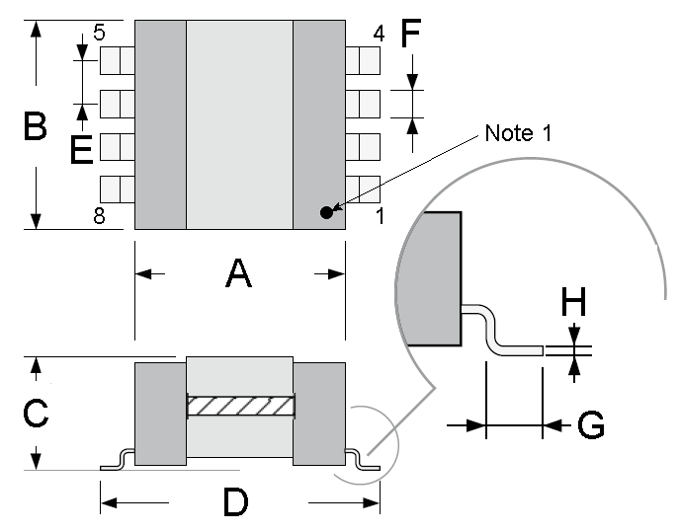
Symbols | Dimensions (mm)
Symbols | Variant 01 |  | Variant 03 |  | Variant 05
Symbols | Min | Max | Min | Max | Min | Max
A | 16 | 16.5 | 21.7 | 22.3 | 30.4 | 31.2
B | - | 16 | - | 19.8 | - | 23.5
C | - | 7.9 | - | 8.9 | - | 12.2
D | 21.1 | 22 | 25.1 | 26 | 34.4 | 35.3
E | 3.7 | 3.9 | 3.7 | 3.9 | 3.7 | 3.9
F | 1 | 1.2 | 1.9 | 2.1 | 1.9 | 2.1
G | 1.3 | 1.6 | 1.3 | 1.6 | 1.3 | 1.6
H | 0.2 | - | 0.2 | - | 0.2 | -
NOTES:
            - Terminal identification: Terminal 1 shall be identified with a contrasting coloured identification mark or indent on top of the body in the area shown.

FUNCTIONAL DIAGRAM
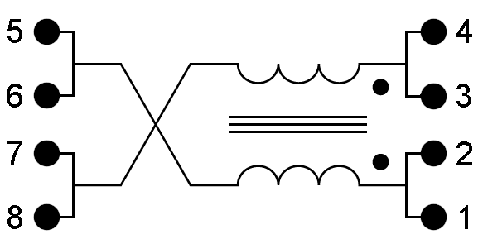
(Top View)

MATERIALS AND FINISHES

Case
As a minimum, a resin moulding shall ensure the inductor’s protection.

Terminals
The terminal material shall be brass, plated with 2 to 4µm of nickel or copper. The finish shall be Sn60Pb40.

REQUIREMENTS

GENERAL
The complete requirements for procurement of the components specified herein are as stated in this specification and the ESCC Generic Specification. Permitted deviations from the Generic Specification, applicable to this specification only, are listed below.
Permitted deviations from the Generic Specification and this Detail Specification, formally agreed with specific Manufacturers on the basis that the alternative requirements are equivalent to the ESCC requirement and do not affect the component’s reliability, are listed in the appendices attached to this specification.

Deviations from the Generic Specification

Deviations from Qualification and Periodic Tests (Chart F4)
          - Temperature Rise: Ambient test temperature shall be +90 ±5°C.
          - Immersion: shall not be performed.
          - Moisture Resistance, Polarisation: there shall be no polarising voltage applied during test.

MARKING
The marking of all components delivered to this specification shall be in accordance with the requirements of ESCC Basic Specification No. 21700. When the component is too small to accommodate all of the marking specified, as much as space permits shall be marked and the marking information, in full, shall accompany each component in its primary package.
The information to be marked and the order of precedence, shall be as follows:
          - The ESCC qualified components symbol (for ESCC qualified components only).
          - The ESCC Component Number.
          - Traceability information.

ELECTRICAL MEASUREMENTS AT ROOM, HIGH AND LOW TEMPERATURES

Room Temperature Electrical Measurements
The measurements shall be performed at T_{amb} = +22 ±3 ºC.
Characteristics | Symbols | Test Method and Conditions | Limits |  | Units
Characteristics | Symbols | Test Method and Conditions | Min | Max | Units
Inductance | L_{min} | ESCC No. 3201  f = 10kHz  I = 0Adc  V = V_{T} (Note 1)  Note 2 | Note 1 | - | µH
DC Resistance | R_{DC} | ESCC No. 3201 | - | Note 1 | mΩ
Dielectric Withstanding Voltage | DWV | ESCC No. 3201  Note 3 | 500 | - | Vrms
Dielectric Withstanding Voltage Leakage Current | I_{L} | Note 4 | - | 100 | µA
NOTES:
            - See Component Type Variants and Range of Components for values for each winding.
            - Any magnetic field present during testing of Inductance shall be < 10mT.
            - Tested both between the windings and between the windings and the case.
            - Measured during Dielectric Withstanding Voltage.

High and Low Temperatures Electrical Measurements
Characteristics | Symbols | Test Method and Conditions  (Note 1) | Limits |  | Unit
Characteristics | Symbols | Test Method and Conditions  (Note 1) | Min | Max | Unit
Inductance Change between -55 (+3 -0)ºC and +22 ± 3 ºC | ΔL/L | As per Room Temperature Electrical Measurements  Note 2 | -75 | +100 | %
Inductance Change between +125 (+0 -3)ºC and +22 ±3ºC | ΔL/L | As per Room Temperature Electrical Measurements  Note 2 | -75 | +100 | %
NOTES:
            - Performed only for qualification or qualification maintenance. The measurements shall be performed on a sample of 5 components from the lot with 0 failures allowed. In the event of any failure a 100% inspection may be performed.
            - For each winding.

INTERMEDIATE AND END-POINT ELECTRICAL MEASUREMENTS
Unless otherwise specified, the measurements shall be performed at T_{amb} = +22 ±3ºC.
Unless otherwise specified the test methods and test conditions shall be as per the corresponding test defined in Room Temperature Electrical Measurements.
Test Reference per ESCC No. 3201 | Characteristics | Symbols | Limits |  | Units
Test Reference per ESCC No. 3201 | Characteristics | Symbols | Min | Max | Units
Thermal Shock | DC Resistance | R_{DC} | Note 1 |  | mΩ
Barometric Pressure
Whilst at low pressure: | Dielectric Withstanding Voltage | DWV | 500 | - | Vrms
Whilst at low pressure: | DWV Leakage Current | I_{L} | - | 100 | µA
Temperature Rise | Test temperature: T_{amb} = +90 ±5°C
Initial Measurements | DC Resistance (at 0.1I_{r}) | R_{DC} | Record Value |  | mΩ
Final Measurements (within 30s of the removal of power) | DC Resistance (at I_{R}) | R_{DC} | Record Value |  | mΩ
Final Measurements (within 30s of the removal of power) | Temperature Rise | ΔT | - | 25 | °C
Overload | DC Resistance | R_{DC} | - | Note 1 | mΩ
 | Insulation Resistance (2) | R_{I} | 1000 | - | MΩ
 | Dielectric Withstanding Voltage | DWV | 500 | - | Vrms
 | DWV Leakage Current | I_{L} | - | 100 | µA
Resistance to Soldering Heat | Inductance | L_{min} | Note 1 | - | µH
Resistance to Soldering Heat | DC Resistance | R_{DC} | - | Note 1 | mΩ
Resistance to Soldering Heat | Dielectric Withstanding Voltage | DWV | 500 | - | Vrms
Resistance to Soldering Heat | DWV Leakage Current | I_{L} | - | 100 | µA
Moisture Resistance
Within 30 min of removal from conditioning: | Dielectric Withstanding Voltage | DWV | 500 | - | Vrms
Within 30 min of removal from conditioning: | DWV Leakage Current | I_{L} | - | 100 | µA
Within 30 min of removal from conditioning: | Insulation Resistance (2) | R_{I} | 1000 | - | MΩ
Within 1 hour of previous measurements: | Inductance | L_{min} | Note 1 | - | µH
Within 1 hour of previous measurements: | DC Resistance | R_{DC} | - | Note 1 | mΩ
Operating Life
Initial Measurements (0 hour) | Inductance | L_{min} | Note 1 | - | µH
Intermediate Measurements (1000 hours)(after 30 min recovery) | Dielectric Withstanding Voltage | DWV | 500 | - | Vrms
 | DWV Leakage Current | I_{L} | - | 100 | µA
 | Inductance Change | ΔL/L | -10 | +10 | %
Final Measurements (2000 hours)(after 30 min recovery) | Dielectric Withstanding Voltage | DWV | 500 | - | Vrms
Final Measurements (2000 hours)(after 30 min recovery) | DWV Leakage Current | I_{L} | - | 100 | µA
Final Measurements (2000 hours)(after 30 min recovery) | Inductance Change | ΔL/L | -10 | +10 | %
Final Measurements (2000 hours)(after 30 min recovery) | DC Resistance | R_{DC} | - | Note 1 | mΩ
Final Measurements (2000 hours)(after 30 min recovery) | Insulation Resistance (2) | R_{I} | 1000 | - | MΩ
NOTES:
            - See Component Type Variants and Range of Components for values.
            - Test method and conditions per ESCC No. 3201.

BURN-IN CONDITIONS
Characteristics | Symbols | Test Conditions | Units
Ambient Temperature | T_{amb} | +125 (+0 -3) | ºC
NOTES:
            - After Burn-in, the components shall be removed from the chamber and allowed to cool under normal atmospheric conditions for recovery for 24 hours minimum.

OPERATING LIFE CONDITIONS
Characteristics | Symbols | Test Conditions | Units
Ambient Temperature | T_{amb} | +125 (+0 -3) | ºC
Rated RMS Current | I | I_{R} (Notes 1, 2) | mA
NOTES:
            - See Component Type Variants and Range of Components for values for each winding.
            - Current shall be applied to both windings connected in series.

