

Page 1 of 21
CAPACITORS, LEADLESS SURFACE MOUNTED, TANTALUM, SOLID ELECTROLYTE, LOW EQUIVALENT SERIES RESISTANCE
BASED ON TYPE TES
ESCC Detail Specification No. 3012/004

Issue 3 | April 2014



Document Custodian: European Space Agency – see https://escies.org

Legal Disclaimer and Copyright
European Space Agency, Copyright © 2014. All rights reserved.
The European Space Agency disclaims any liability or responsibility, to any person or entity, with respect to any loss or damage caused, or alleged to be caused, directly or indirectly by the use and application of this ESCC publication.
This publication, without the prior permission of the European Space Agency and provided that it is not used for a commercial purpose, may be:
- copied in whole, in any medium, without alteration or modification.
- copied in part, in any medium, provided that the ESCC document identification, comprising the ESCC symbol, document number and document issue, is removed.

DOCUMENTATION CHANGE NOTICE
(Refer to https://escies.org for ESCC DCR content)
DCR No. | CHANGE DESCRIPTION
835 | Specification upissued to incorporate technical changes per DCR.

TABLE OF CONTENTS
1 General 6
1.1 Scope 6
1.2 component type variants and Range of Components 6
1.3 Maximum Ratings 6
1.4 Parameter Derating Information 6
1.5 Physical Dimensions 6
1.6 Functional Diagram 6
2 Applicable Documents 6
3 Terms, Definitions, Abbreviations, Symbols and Units 6
4 REQUIREMENTS 12
4.1 GENERAL 12
4.2 DEVIATIONS FROM GENERIC SPECIFICATION 12
4.2.1 Deviations from Special In-Process Controls 12
4.2.2 Deviations from Final Production Tests (Chart II) 12
4.2.3 Deviations from Burn-in and Electrical Measurements (Chart III) 12
4.2.4 Deviations from Qualification Tests (Chart IV) 12
4.2.5 Deviations from Lot Acceptance Tests (Chart V) 12
4.3 MECHANICAL REQUIREMENTS 12
4.3.1 Dimension Check 12
4.3.2 Weight 12
4.4 MATERIALS AND FINISHES 12
4.4.1 Terminal Material and Finish 12
4.5 MARKING 13
4.5.1 General 13
4.5.2 The ESCC Component Number 13
4.5.3 Electrical Characteristics and Ratings 13
4.5.3.1 Polarity 13
4.5.3.2 Capacitance Value 14
4.5.3.3 Tolerance 14
4.5.3.4 Rated Voltage 14
4.5.3.5 Equivalent Series Resistance 14
4.5.4 Traceability Information 14
4.6 Electrical Measurements 15
4.6.1 Electrical Measurements at Room Temperature 15
4.6.2 Electrical Measurements at High and Low Temperatures 15
4.6.3 Circuits for Electrical Measurements (Figure 4) 15
4.7 Burn-in Tests 15
4.7.1 Parameter Drift Values 15
4.7.2 Conditions for Burn-in 15
4.7.3 Electrical Circuit for Burn-in (Figure 5) 15
4.8 Environmental and Endurance Tests (Charts IV and V of ESCC Generic Specification No. 3012) 17
4.8.1 Measurements and Inspections on Completion of Environmental Tests 17
4.8.2 Measurements and Inspections at Intermediate Points During Endurance Tests 17
4.8.3 Measurements and Inspections on Completion of Endurance Tests 17
4.8.4 Conditions for Operating Life (Part of Endurance Testing) 17
4.8.5 Electrical Circuit for Operating Life Tests (Figure 5) 17
APPENDIX ‘A’ 21

General

Scope
This specification details the ratings, physical and electrical characteristics, test and inspection data for Capacitors, Leadless Surface Mounted, Tantalum, Solid Electrolyte, Low Equivalent Series Resistance, based on Type TES. It shall be read in conjunction with ESCC Generic Specification No. 3012, the requirements of which are supplemented herein.

component type variants and Range of Components
The variants and the range of components covered by this specification are given in Table 1(a).

Maximum Ratings
The maximum ratings, which shall not be exceeded at any time during use or storage, applicable to the components specified herein, are as scheduled in Table 1(b).

Parameter Derating Information
The parameter derating information applicable to the capacitors specified herein is shown in Figure 1.

Physical Dimensions
The physical dimensions of the capacitors specified herein are shown in Figure 2.

Functional Diagram
The functional diagram for the capacitors specified herein is shown in Figure 3.

Applicable Documents
The following documents form part of this specification and shall be read in conjunction with it:
          - ESCC Generic Specification No. 3012 for Capacitors, Leadless Surface Mounted, Tantalum, Solid Electrolyte, Enclosed Anode Connection

Terms, Definitions, Abbreviations, Symbols and Units
For the purpose of this specification, the terms, definitions, abbreviations, symbols and units specified in ESCC Basic specification No. 21300 shall apply.
Table 1(a) - TYPE VARIANTS AND RANGE OF COMPONENTS
Variant  Number | Case Code (Style) (Note 1) | Capacitance Range  C_{n} (µF)  (Notes 2, 3) | Rated Voltage  U_{R} (V)  (Note 2) | Maximum Equivalent Series Resistance  ESR (mΩ)  (Note 2) | Terminal Material and Finish | Weight Max  (g)
01 | A  (1206) | 1 to 22 | 6.3 to 25 | 900 to 3000 | G16 | 0.1
02 | B  (1210) | 1 to 47 | 6.3 to 50 | 500 to 2000 | G16 | 0.2
03 | C  (2312) | 3.3 to 150 | 6.3 to 50 | 300 to 1000 | P17 | 0.3
04 | D  (2917) | 4.7 to 330 | 6.3 to 50 | 35 to 200 | P17 | 0.5
05 | E  (2917) | 33 to 470 | 6.3 to 35 | 30 to 65 | P17 | 0.7
NOTES:
            - See Figure 2.
            - The following rated Capacitance (C_{n}), maximum Rated Voltage (U_{R}) and maximum Equivalent Series Resistance values (ESR) are available related to the Case Code (letters indicate Case Code; numbers indicate maximum ESR in mΩ):
Capacitance C_{n}  (μF) | Rated Voltage U_{R}
Capacitance C_{n}  (μF) | 6.3V | 10V | 12V | 16V | 20V | 25V | 35V | 50V
1 |  |  |  |  |  | A 3000 |  | B 2000
3.3 |  |  |  |  | A 2500 |  | B 1000 | C 1000
4.7 |  |  |  | A 2000 |  | B 1000 | C 600 | D 200
10 |  | A 1800 |  |  | B 1000 | C 600 | D 120
22 | A 900 |  |  | B 600 | C 400 |  | D 100
33 |  | B 650 |  |  | C 300 | D 65 | E 65
47 | B 500 |  |  | C 350 | D 55 | E 65
100 |  | C 200 |  | D 55 | E 45
150 | C 300 | D 45 |  | E 40
220 |  | D 35 | E 35
330 | D 35 | E 35
470 | E 30
            - The following Capacitance Tolerances are available:
±10% (K)
±20% (M)
Table 1(b) - MAXIMUM RATINGS
No. | Characteristics | Symbols | Maximum Ratings |  | Units | Remarks
1 | Rated Voltage | U_{R} | See Table 1(a) |  | V | Note 1
2 | Surge Voltage | U_{S} | - | 1.3 x U_{R} | V | T_{amb} ≤ +85°C
3 | Category Voltage | U_{C} | - | 0.66 x U_{R} | V
4 | Ripple Current | I_{ripple} | - | See Note 2 | mA | f = 100kHz, Note 3
5 | Operating Temperature Range | T_{op} | -55 to +125 |  | °C | T_{amb}
6 | Rated Temperature | T_{R} | - | +85 | °C
7 | Upper Category Temperature | T_{C} | - | +125 | °C
8 | Storage Temperature Range | T_{stg} | -55 to +125 |  | °C
9 | Soldering Temperature | T_{sol} | - | +260 | °C | Note 2
Notes:
            - At T_{amb} ≤ +85°C. For derating at T_{amb} > +85°C, see Figure 1(a).
            - Maximum I_{ripple}, which depends on C_{n} and U_{R}, shall be a follows:
Capacitance  C_{n} (µF) | Rated Voltage  U_{R} (V) | Maximum Ripple Current  I_{ripple} (mA)
22 | 6.3 | 290
47 | 6.3 | 410
150 | 6.3 | 610
330 | 6.3 | 2700
470 | 6.3 | 3000
10 | 10 | 200
33 | 10 | 360
100 | 10 | 740
150 | 10 | 2400
220 | 10 | 2700
330 | 50 | 2800
220 | 12 | 2800
4.7 | 16 | 190
22 | 16 | 380
47 | 16 | 560
100 | 16 | 2200
150 | 16 | 2600
3.3 | 20 | 170
10 | 20 | 290
22 | 20 | 520
33 | 20 | 610
47 | 20 | 2200
100 | 20 | 2500
1 | 25 | 160
4.7 | 25 | 290
10 | 25 | 430
33 | 25 | 2000
47 | 25 | 2000
3.3 | 35 | 290
4.7 | 35 | 430
10 | 35 | 1500
22 | 35 | 1600
33 | 35 | 2000
1 | 50 | 200
3.3 | 50 | 330
4.7 | 50 | 1100
            - At T_{amb} ≤ +25°C. For derating at T_{amb} > +25°C, see Figure 1(b).
            - Duration 5 seconds maximum for wave soldering and 10 seconds maximum for reflow soldering.
FIGURE 1 - PARAMETER DERATING INFORMATION
Figure 1(a) - Rated Voltage Versus Ambient Temperature
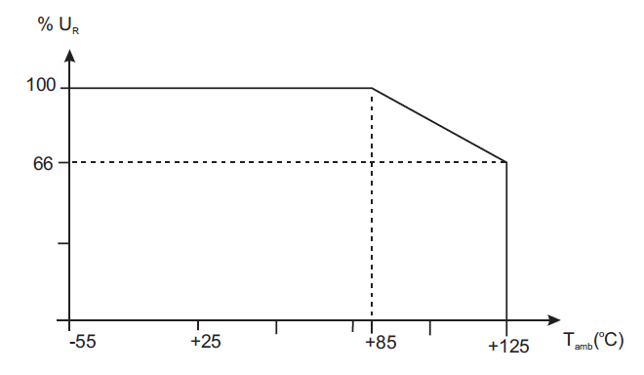
Figure 1(b) - Maximum Ripple Current versus Ambient Temperature
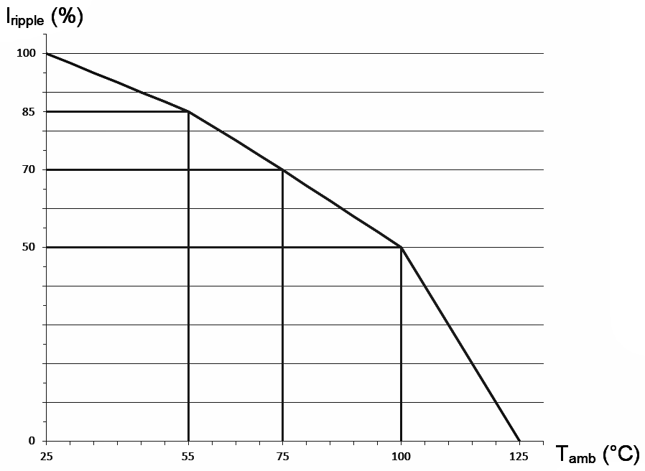
FIGURE 2 - PHYSICAL DIMENSIONS
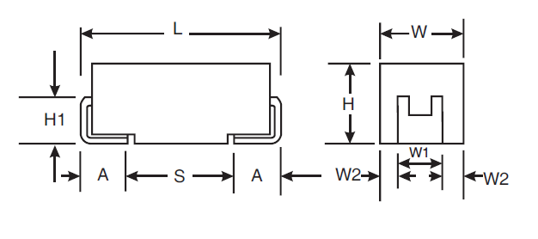
Variant  Number | Case  Code | Dimensions (mm)
Variant  Number | Case  Code | L |  | W |  | H | W1 |  | A |  | S | H1 | W2
Variant  Number | Case  Code | Min | Max | Min | Max | Max | Min | Max | Min | Max | Min | Min | Min | Max
01 | A | 3 | 3.4 | 1.5 | 1.8 | 1.8 | 1 | 1.4 | 0.6 | 1.1 | 1.1 | 0.7 | 0.05 | 0.4
02 | B | 3.3 | 3.7 | 2.7 | 3 | 2.1 | 2 | 2.4 | 0.6 | 1.1 | 1.4 | 0.7 | 0.15 | 0.5
03 | C | 5.8 | 6.2 | 3.1 | 3.4 | 2.8 | 2 | 2.4 | 1.1 | 1.6 | 2.9 | 0.7 | 0.35 | 0.7
04 | D | 7.1 | 7.5 | 4.2 | 4.5 | 3.1 | 2.2 | 2.6 | 1.1 | 1.6 | 4.4 | 0.7 | 0.8 | 1.15
05 | E | 7.1 | 7.5 | 4.2 | 4.5 | 4.3 | 2.2 | 2.6 | 1.1 | 1.6 | 4.4 | 0.7 | 0.8 | 1.15
Figure 3 - functional diagram
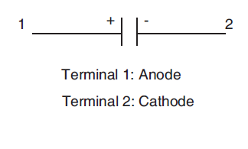

REQUIREMENTS

GENERAL
The complete requirements for procurement of the components specified herein are stated in this specification and ESCC Generic Specification No. 3012. Deviations from the Generic Specification, applicable to this specification only, are detailed in Para. 4.2.
Deviations from the Generic Specification and this Detail Specification, formally agreed with specific Manufacturers on the basis that the alternative requirements are equivalent to the ESCC requirements and do not affect the components’ reliability, are listed in the appendices attached to this specification.

DEVIATIONS FROM GENERIC SPECIFICATION

Deviations from Special In-Process Controls
None.

Deviations from Final Production Tests (Chart II)
None.

Deviations from Burn-in and Electrical Measurements (Chart III)
None

Deviations from Qualification Tests (Chart IV)
          - Para. 9.19, Solderability: The solderable area is the termination pad and up to 1/3 the height of the tab.

Deviations from Lot Acceptance Tests (Chart V)
          - Para. 9.19, Solderability: The solderable area is the termination pad and up to 1/3 the height of the tab.

MECHANICAL REQUIREMENTS

Dimension Check
The dimensions of the components specified herein shall be verified in accordance with the requirements set out in Para. 9.6 of ESCC Generic Specification No. 3012 and they shall conform to those shown in Figure 2 of this specification.

Weight
The maximum weight of the components specified herein shall be as given in Table 1(a).

MATERIALS AND FINISHES
The materials and finishes shall be as specified herein. Where a definite material is not specified, a material which will enable the capacitors specified herein to meet the performance requirements of this specification shall be used. Acceptance or approval of any constituent material does not guarantee acceptance of the finished product.

Terminal Material and Finish
The terminal material and finish shall be as specified in Table 1(a) in accordance with the requirements of ESCC Basic Specification No. 23500.

MARKING

General
The marking of all components delivered to this specification shall be in accordance with the requirements of ESCC Basic Specification No. 21700 and the following paragraphs. When the component is too small to accommodate all of the marking specified, as much as space permits shall be marked and the marking information, in full, shall accompany each component in its primary package.
The information to be marked and the order of precedence, shall be as follows:
          - The ESCC Component Number.
          - Electrical Characteristics and Ratings.
          - Traceability Information.

The ESCC Component Number
The ESCC Component Number shall be constituted and marked as follows:
301200401B
- Detail Specification Number: 3012004
- Type Variant (see Table 1(a)): 01
- Testing Level (B or C, as applicable): B

Electrical Characteristics and Ratings
The electrical characteristics and ratings to be marked in the following order of precedence are:
          - Polarity.
          - Capacitance Value.
          - Tolerance.
          - Rated Voltage.
          - Equivalent Series Resistance.
The information shall be constituted and marked as follows:
Example: 106KE0600
- Capacitance Value (10μF): 106
- Tolerance (±10%): K
- Rated Voltage (25V): E
- Equivalent Series Resistance (600mΩ): 0600

Polarity
The anode terminal shall be indicated by a polarity stripe marked on the top surface of the component.

Capacitance Value
The capacitance value shall be indicated by the following codes. The unit quantity for marking shall be picofarad.
Capacitance C_{n} (pF) | Code
XX10⁵ | XX5
XX10⁶ | XX6
XX10⁷ | XX7

Tolerance
The tolerance on capacitance value shall be indicated by the following code letters.
Tolerance (%) | Code Letter
±10 | K
±20 | M

Rated Voltage
The rated voltage shall be indicated by the following code letters.
Rated Voltage U_{R} (V) | Code Letter
6.3 | J
10 | A
12 | B
16 | C
20 | D
25 | E
35 | V
50 | T

Equivalent Series Resistance
The Equivalent Series Resistance maximum value shall be indicated by the following codes. The unit quantity for marking shall be milliohm.
Equivalent Series Resistance  ESR (mΩ) | Code
XX | 00XX
XXX | 0XXX
XXXX | XXXX

Traceability Information
Traceability information shall be marked in accordance with the requirements of ESCC Basic Specification No. 21700.

Electrical Measurements

Electrical Measurements at Room Temperature
The parameters to be measured at room temperature are scheduled in Table 2. Unless otherwise specified the measurements shall be performed at T_{amb} = +22 ±3°C.

Electrical Measurements at High and Low Temperatures
The parameters to be measured at high and low temperatures are scheduled in Table 3.

Circuits for Electrical Measurements (Figure 4)
Not applicable.

Burn-in Tests

Parameter Drift Values
The parameter drift values applicable to Burn-in are as specified in Table 4 of this specification. Unless otherwise stated, measurements shall be performed at T_{amb} = +22 ±3°C.
The parameter drift values (Δ) applicable to the parameters scheduled shall not be exceeded. In addition to these drift value requirements for a given parameter, the appropriate limit values specified in Table 2 shall not be exceeded.

Conditions for Burn-in
The requirements for Burn-in are specified in Section 7 of ESCC Generic Specification No. 3012. The conditions for Burn-in shall be as specified in Table 5 of this specification.

Electrical Circuit for Burn-in (Figure 5)
Not applicable
Table 2 – ELECTRICAL MEASUREMENTS AT ROOM TEMPERATURE
No. | Characteristics | Symbols | ESCC 3012 Test Method | Rated Voltage | Tolerance | Limits |  | Unit
 |  |  |  |  |  | Min | Max | Unit
1 | Capacitance | C | Para. 9.4.1.1 | All | ±10%  ±20% | 0.9C_{n}  0.8C_{n} | 1.1C_{n}  1.2C_{n} | µF
2 | DC Leakage Current | I_{L} | Para. 9.4.1.2 | All | All | - | 0.01C_{n} x U_{R} or (Note 1)  1 | µA
3 | Dissipation Factor | DF | Para. 9.4.1.3 | U_{R} < 10V  U_{R} ≥ 10V | All | - | 10  6 | %
4 | Equivalent Series  Resistance | ESR | Para. 9.4.1.4 | All | All | - | Note 2 | mΩ
NOTES:
            - Whichever is greater.
            - See Table 1(a) Note 2.
Table 3 - ELECTRICAL MEASUREMENTS AT HIGH AND LOW TEMPERATURES
No. | Characteristics | Symbols | ESCC 3012 Test Method | Test Conditions  (Note 1) | Limits |  | Unit
 |  |  |  |  | Min | Max | Unit
1 | Capacitance Change | ΔC/C | Para. 9.4.1.1 | T_{amb} = -55 (+3 -0) °C | -10 | 0 | %  (Note 2)
 | Capacitance Change |  |  | T_{amb} = +85 ±3°C | 0 | +10 | %  (Note 2)
 | Capacitance Change |  |  | T_{amb} = +125 (+0 -3) °C | 0 | +12 | %  (Note 2)
2 | DC Leakage Current | I_{L} | Para. 9.4.1.2 | T_{amb} = +85 ±3°C  V = U_{R} ±2% | - | 0.1C_{n} x U_{R}  or (Note 3)  1 | µA
 |  |  |  | T_{amb} = +125 (+0 -3) °C  V = U_{C} ±2% | - | 0.125C_{n} x U_{R} or (Note 3)  1 | µA
3 | Dissipation Factor | DF | Para. 9.4.1.3 | T_{amb} = -55 (+3 -0) °C | - | +50 | %  (Note 2)
 | Dissipation Factor |  |  | T_{amb} = +85 ±3°C | - | +50 | %  (Note 2)
 | Dissipation Factor |  |  | T_{amb} = +125 (+0 -3) °C | - | +100 | %  (Note 2)
4 | Equivalent Series  Resistance | ESR | Para. 9.4.1.4 | T_{amb} = -55 (+3 -0) °C | - | +150 | %  (Note 2)
 | Equivalent Series  Resistance |  |  | T_{amb} = +85 ±3°C | - | +50 | %  (Note 2)
 | Equivalent Series  Resistance |  |  | T_{amb} = +125 (+0 -3) °C | - | +50 | %  (Note 2)
NOTES:
            - Inspection level II single sampling, AQL 2.5% for each capacitance value. Each capacitance value shall be considered as constituting a complete lot.
            - Related to the value measured in Table 2.
            - Whichever is greater.
FIGURE 4 - CIRCUITS FOR ELECTRICAL MEASUREMENTS
Not applicable.
Table 4 - PARAMETER DRIFT VALUES
No. | Characteristics | Symbol | Spec. and/or Test Method | Test Conditions | Change Limits (Δ) | Unit
1 | Capacitance Change | ΔC/C | As per Table 2 | As per Table 2 | ±5 | %
2 | DC Leakage Current Change | ΔI_{L} | As per Table 2 | As per Table 2 | 2 x Initial Value (Note 1)  or (Note 2)  0.25 x Table 2 Item 2 + 0.05 | µA
NOTES:
            - Leakage currents < 0.1μA shall be considered as a 0.1μA value.
            - Whichever is smaller.
Table 5(a) – CONDITIONS FOR BURN-IN
No. | Characteristics | Symbol | Condition | Unit
1 | Ambient Temperature | T_{amb} | +85 (+0 -3) | °C
2 | Test Voltage | V_{T} | U_{R} | V
Table 5(b) – Conditions for Operating Life
No. | Characteristics | Symbol | Condition | Unit
1 | Ambient Temperature 1 | T_{amb1} | +85 (+0 -3) | °C
2 | Test Voltage 1 | V_{T1} | U_{R} | V
3 | Ambient Temperature 2 | T_{amb2} | +125 (+0 -3) | °C
4 | Test Voltage 2 | V_{T2} | U_{C} | V

Environmental and Endurance Tests (Charts IV and V of ESCC Generic Specification No. 3012)

Measurements and Inspections on Completion of Environmental Tests
The parameters to be measured and inspections to be performed on completion of environmental tests are scheduled in Table 6. Unless otherwise stated, the measurements shall be performed at T_{amb} = +22 ±3°C.

Measurements and Inspections at Intermediate Points During Endurance Tests
The parameters to be measured and inspections to be performed at intermediate points during endurance tests are scheduled in Table 6. Unless otherwise stated, the measurements shall be performed at T_{amb} = +22 ±3°C.

Measurements and Inspections on Completion of Endurance Tests
The parameters to be measured and inspections to be performed on completion of endurance tests are scheduled in Table 6. Unless otherwise stated, the measurements shall be performed at T_{amb} = +22 ±3°C.

Conditions for Operating Life (Part of Endurance Testing)
The requirements for Operating Life testing are specified in Section 9 of ESCC Generic Specification No. 3012. The conditions for Operating Life testing shall be as specified in Table 5(b) of this specification.

Electrical Circuit for Operating Life Tests (Figure 5)
Not applicable.

Table 6 - MEASUREMENTS AND INSPECTIONS ON COMPLETION OF ENVIRONMENTAL TESTS AND AT INTERMEDIATE POINTS AND ON COMPLETION OF ENDURANCE TESTING
No. | ESCC Generic Spec. No. 3012 |  | Measurements and Inspections |  | Symbols | Limits |  | Units
No. | Environmental and Endurance Tests (Note 1) | Test Methods and Conditions | Identification | Conditions | Symbols | Min | Max | Units
01 | Mounting | Para. 9.9 | Final Examination
 |  |  | Terminals | Good tinning | - | - | -
 |  |  | Final Measurements
 |  |  | Capacitance | Table 2 Item 1 | C | Table 2 |  | µF
 |  |  | Capacitance Change | Table 2 Item 1 | ΔC/C | -5 | +5 | %
 |  |  | DC Leakage Current | Table 2 Item 2 | I_{L} | - | Table 2 | µA
 |  |  | Dissipation Factor | Table 2 Item 3 | DF | - | Table 2 | %
 |  |  | Equivalent Series Resistance | Table 2 Item 4 | ESR | - | 1.25 x Table 2 | mΩ
02 | Rapid Change of  Temperature | Para. 9.3.2 | Initial Measurements
 | Rapid Change of  Temperature |  | Capacitance | Value recorded after Mounting | C | Table 2 |  | µF
 | Rapid Change of  Temperature |  | Final Measurements | Recovery period of 4 hours min.
 | Rapid Change of  Temperature |  | Visual Examination | No corrosion, no damage or obliteration of marking | - | - | -
 | Rapid Change of  Temperature |  | Capacitance Change | Table 2 Item 1 | ΔC/C | -5 | +5 | %
 | Rapid Change of  Temperature |  | DC Leakage Current | Table 2 Item 2 | I_{L} | - | Table 2 | µA
 | Rapid Change of  Temperature |  | Dissipation Factor | Table 2 Item 3 | DF | - | Table 2 | %
 | Rapid Change of  Temperature |  | Equivalent Series Resistance | Table 2 Item 4 | ESR | - | 1.25 x Table 2 | mΩ
03 | External Visual Inspection | Para. 9.5 | Final Inspection
 | External Visual Inspection |  | External Visual Inspection | ESCC No. 20500 | - | - | -
04 | Adhesion | Para. 9.10 | Initial Measurements
 |  |  | Capacitance | Value recorded after Mounting | C | Table 2 |  | µF
 |  |  | Final Measurements
 |  |  | Visual Examination | No damage or loosing from the substrate | - | - | -
 |  |  | Capacitance Change | Table 2 Item 1 | ΔC/C | -5 | +5 | %
05 | Vibration | Para. 9.11 | Measurements during test | During Last Cycle
 |  |  |  | No intermittent Contact >0.5ms, arcing or open or shorts | - | - | -
 |  |  | Final Examination
 |  |  | Visual Examination | No damage | - | - | -
06 | Shock or Bump | Para. 9.12 | Final Examination
 |  |  | Visual Examination | No damage | - | - | -
07 | Climatic Sequence | Para. 9.13 | Initial Measurements
 | Climatic Sequence |  | Capacitance | Value recorded after Mounting | C | Table 2 |  | µF
 | Climatic Sequence |  | Intermediate Measurements | After Dry Heat
 | Climatic Sequence |  | DC Leakage Current | Table 3 Item 2 (Note 2) | I_{L} | - | Table 3 | µA
 | Climatic Sequence |  | Final Measurements | After recovery of 1 to 24 tours
 | Climatic Sequence |  | External Visual Inspection | ESCC No. 20500 | - | - | -
 | Climatic Sequence |  | Capacitance Change | Table 2 Item 1 | ΔC/C | -5 | +5 | %
 | Climatic Sequence |  | DC Leakage Current | Table 2 Item 2 | I_{L} | - | Table 2 | µA
 | Climatic Sequence |  | Dissipation Factor | Table 2 Item 3 | DF | - | 1.25 x Table 2 | %
 | Climatic Sequence |  | Equivalent Series Resistance | Table 2 Item 4 | ESR | - | 1.25 x Table 2 | mΩ
08 | High and Low Temperature Stability | Para. 9.14 | Measurements during test
 | High and Low Temperature Stability |  | Electrical Measurements | Tables 2 & 3 |  | Tables 2 & 3
09 | Surge Voltage | Para. 9.15 | Final Measurements
 |  |  | Capacitance Change | Table 2 Item 1 | C | Table 2 |  | µF
 |  |  | DC Leakage Current | Table 2 Item 2 | I_{L} | - | Table 2 | µA
 |  |  | Dissipation Factor | Table 2 Item 3 | DF | - | Table 2 | %
 |  |  | Equivalent Series Resistance | Table 2 Item 4 | ESR | - | Table 2 | mΩ
10 | Damp Heat Steady State | Para. 9.16 | Initial Measurements
 | Damp Heat Steady State |  | Capacitance | Value recorded after Mounting | C | Table 2 |  | µF
 | Damp Heat Steady State |  | Final Measurements | After recovery of 1 to 2 hours
 | Damp Heat Steady State |  | Visual Examination | No damage | - | - | -
 | Damp Heat Steady State |  | Capacitance Change | Table 2 Item 1 | ΔC/C | -10 | +10 | %
 | Damp Heat Steady State |  | DC Leakage Current | Table 2 Item 2 | I_{L} | - | 1.5 x Table 2 | µA
 | Damp Heat Steady State |  | Dissipation Factor | Table 2 Item 3 | DF | - | 1.2 x Table 2 | %
 | Damp Heat Steady State |  | Equivalent Series Resistance | Table 2 Item 4 | ESR | - | 1.25 x Table 2 | mΩ
11 | Operating Life | Para. 9.17 | Initial Measurements
 |  |  | Capacitance | Value recorded after Mounting | C | Table 2 |  | µF
 |  |  | Intermediate Measurements | At 250 and 1000 hrs
 |  |  | DC Leakage Current | Table 3 Item 2 (Note 2) | I_{L} | - | 1.25 x Table 3 | µA
 |  |  | Final Measurements | At 1000 and 2000 hrs and after recovery or 1 to 2 hours
 |  |  | Capacitance Change | Table 2 Item 1 | ΔC/C | -10 | +10 | %
 |  |  | DC Leakage Current | Table 2 Item 2 | I_{L} | - | 1.25 x Table 2 | µA
 |  |  | Dissipation Factor | Table 2 Item 3 | DF | - | Table 2 | %
 |  |  | Equivalent Series Resistance | Table 2 Item 4 | ESR | - | 1.25 x Table 2 | mΩ
 |  |  | Visual Examination | No damage | - | - | -
12 | Permanence of Marking | Para. 9.18 | Final Examination
 | Permanence of Marking |  | Visual Examination | ESCC No. 24800 | - | - | -
13 | Solderability | Para. 9.19, 4.2.4 and 4.2.5 of this spec | Final Examination
 |  | Para. 9.19, 4.2.4 and 4.2.5 of this spec | Visual Examination | ESCC No. 3012 Para. 9.13.3 and no damage | - | - | -
NOTES:
            - The tests in this Table refer to either Chart IV or V and shall be used as applicable.
            - While still at the high temperature.

APPENDIX ‘A’
Agreed Deviations for AVX Czech Republic s.r.o (CZ)
Items Affected | Description of Deviations
Deviations from Final Production Tests  (Chart II) | Para. 9.1, Internal Visual Inspection: Shall not be performed.  Para. 9.5, External Visual Inspection: Visible base material is permitted on the edges of terminations (there is no plating on edges).
Deviations from Burn-in and Electrical Measurements  (Chart III) | Para. 9.5, External Visual Inspection: Visible base material is permitted on the edges of terminations (there is no plating on edges).
Deviations from Qualification Tests  (Chart IV) | Para. 9.5, External Visual Inspection: Visible base material is permitted on the edges of terminations (there is no plating on edges).
Deviations from Lot Acceptance Tests (Chart V) | Para. 9.5, External Visual Inspection: Visible base material is permitted on the edges of terminations (there is no plating on edges).

