
Page 1 of 19

CAPACITORS, LEADLESS SURFACE MOUNTED,
TANTALUM, SOLID ELECTROLYTE, ENCLOSED
ANODE CONNECTION,
BASED ON TYPE TAJ
ESCC Detail Specification No. 3012/001

Issue 5 | March 2015



Document Custodian: European Space Agency – see https://escies.org

Legal Disclaimer and Copyright
European Space Agency, Copyright © 2015. All rights reserved.
The European Space Agency disclaims any liability or responsibility, to any person or entity, with respect to any loss or damage caused, or alleged to be caused, directly or indirectly by the use and application of this ESCC publication.
This publication, without the prior permission of the European Space Agency and provided that it is not used for a commercial purpose, may be:
- copied in whole, in any medium, without alteration or modification.
- copied in part, in any medium, provided that the ESCC document identification, comprising the ESCC symbol, document number and document issue, is removed.

DOCUMENTATION CHANGE NOTICE
(Refer to https://escies.org for ESCC DCR content)
DCR No. | CHANGE DESCRIPTION
914 | Specification upissued to incorporate editorial changes per DCR.

TABLE OF CONTENTS
1 GENERAL 6
1.1 SCOPE 6
1.2 TYPE VARIANTS AND RANGE OF COMPONENTS 6
1.3 MAXIMUM RATINGS 6
1.4 PARAMETER DERATING INFORMATION 6
1.5 PHYSICAL DIMENSIONS 6
1.6 FUNCTIONAL DIAGRAM 6
2 APPLICABLE DOCUMENTS 10
3 TERMS, DEFINITIONS, ABBREVIATIONS, SYMBOLS AND UNITS 10
4 REQUIREMENTS 10
4.1 GENERAL 10
4.2 DEVIATIONS FROM GENERIC SPECIFICATION 10
4.2.1 Deviations from Special In-process Controls 10
4.2.2 Deviations from Final Production Tests (Chart II) 10
4.2.3 Deviations from Burn-in and Electrical Measurements (Chart III) 10
4.2.4 Deviations from Qualification Tests (Chart IV) 10
4.2.5 Deviations from Lot Acceptance Tests (Chart V) 10
4.3 MECHANICAL REQUIREMENTS 10
4.3.1 Dimension Check 10
4.3.2 Weight 11
4.4 MATERIALS AND FINISHES 11
4.4.1 Terminations 11
4.5 MARKING 11
4.5.1 General 11
4.5.2 The ESCC Component Number 11
4.5.3 Electrical Characteristics and Ratings 11
4.5.4 Traceability Information 12
4.6 ELECTRICAL MEASUREMENTS 12
4.6.1 Electrical Measurements at Room Temperature 12
4.6.2 Electrical Measurements at High and Low Temperatures 12
4.6.3 Circuits for Electrical Measurements 12
4.7 BURN-IN TESTS 13
4.7.1 Parameter Drift Values 13
4.7.2 Conditions for Burn-in 13
4.7.3 Electrical Circuits for Burn-in 13
4.8 ENVIRONMENTAL AND ENDURANCE TESTS (CHARTS IV AND V OF ESCC GENERIC SPECIFICATION No. 3012) 15
4.8.1 Measurements and Inspections on Completion of Environmental Tests 15
4.8.2 Measurements and Inspections at Intermediate Points during Endurance Tests 15
4.8.3 Measurements and Inspections on Completion of Endurance Tests 15
4.8.4 Conditions for Operating Life Tests (Part of Endurance Testing) 15
4.8.5 Electrical Circuit for Operating Life Tests (Figure 5) 15
Appendix ‘A’ 19

GENERAL

SCOPE
This specification details the ratings, physical and electrical characteristics, test and inspection data for Capacitors, Leadless Surface Mounted, Tantalum, Solid Electrolyte, Enclosed Anode Connection, based on Type TAJ.
It shall be read in conjunction with ESCC Generic Specification No. 3012, the requirements of which are supplemented herein.

TYPE VARIANTS AND RANGE OF COMPONENTS
Variants of the basic type capacitors and the range of components covered by this specification are scheduled in Figure 2 and Table 1(a) respectively.

MAXIMUM RATINGS
The maximum ratings, which shall not be exceeded at any time during use or storage, applicable to the capacitors specified herein, are as scheduled in Table 1(b).

PARAMETER DERATING INFORMATION
The parameter derating information applicable to the capacitors specified herein is shown in Figure 1.

PHYSICAL DIMENSIONS
The physical dimensions of the capacitors specified herein are shown in Figure 2.

FUNCTIONAL DIAGRAM
The functional diagram of the capacitors specified herein is shown in Figure 3.

TABLE 1(a) - RANGE OF COMPONENTS
CAP VALUE (μF) (2) | RATED VOLTAGE (V) (1)
CAP VALUE (μF) (2) | 4 | 6.3 | 10 | 16 | 20 | 25 | 35 | 50
0.1 |  |  |  |  |  |  | A | A
0.15 |  |  |  |  |  |  | A | B
0.22 |  |  |  |  |  |  | A | B
0.33 |  |  |  |  |  |  | A | B
0.47 |  |  |  |  |  | A | A, B | C
0.68 |  |  |  |  | A | A | A, B | C
1 |  |  |  | A | A | A | B | C
1.5 |  |  | A | A | A | B | B, C | D
2.2 |  | A | A | A, B | B | B | B, C | D
3.3 | A | A | A | A, B | B | B, C | C | D
4.7 | A | A | A, B | B | B, C | C | C, D | D
6.8 | A | A, B | B | B, C | C | C, D | D | D
10 | A, B | B | B, C | C | C | C, D | D | E
15 | B | B, C | C | C | C, D | D | D
22 | B, C | C | C | C, D | D | D | E
33 | C | C | C, D | D | D | E
47 | C, D | C, D | C, D | D | E
68 | C, D | D | D | D | E
100 | D | D | D | E
150 | D | D | E
220 | E | E | E
NOTES
            - Letters indicate case sizes (See Figure 2).
            - Tolerances of ±10% and ±20% are available.

TABLE 1(b) - MAXIMUM RATINGS
No. | Characteristics | Symbol | Maximum Ratings |  | Units | Remarks
No. | Characteristics | Symbol | Min | Max | Units | Remarks
1 | Rated Voltage | U_{R} | See Table 1(a) |  | Vdc
2 | Surge Voltage | U_{S} | - | 1.3 x U_{R} | Vdc | ≤ +85°C
3 | Category Voltage | U_{C} | - | 0.66 x U_{R} | Vdc
4 | Operating Temperature Range | T_{op} | -55 | +125 | °C
5 | Rated Temperature | T_{r} | - | +85 | °C
6 | Category Temperature | T_{c} | - | +125 | °C
7 | Storage Temperature Range | T_{stg} | -55 | +125 | °C
8 | Soldering Temperature | T_{sol} | - | +260 | °C | Note 1
NOTES
            - Soldering time 5 seconds maximum for wave soldering and 10 seconds maximum for reflow soldering.
Figure 1 - Parameter derating information
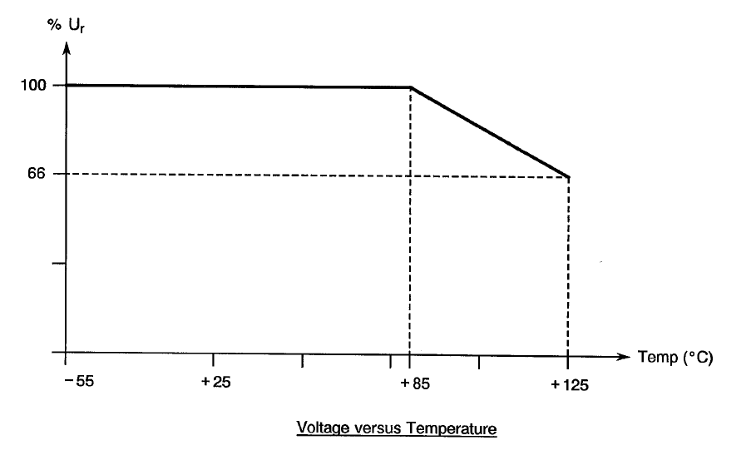
FIGURE 2 - PHYSICAL DIMENSIONS
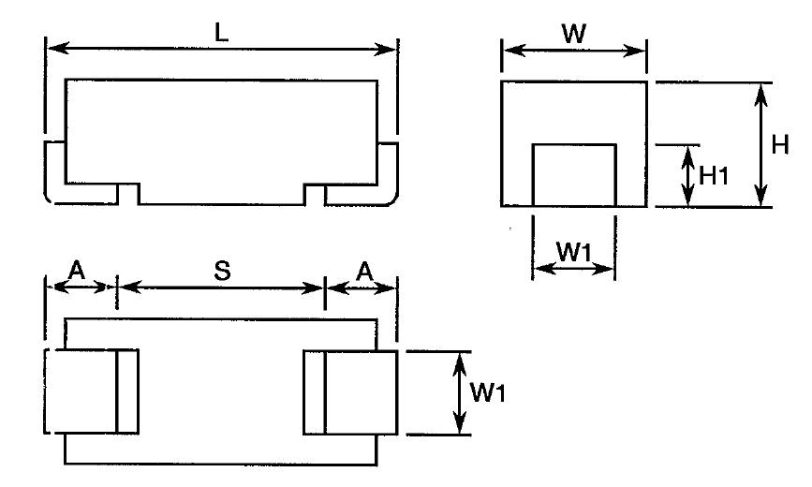
Variant (1) | Case Size | Dimensions (mm)
Variant (1) | Case Size | L |  | W |  | H | W1 |  | A |  | S | H1
Variant (1) | Case Size | Min | Max | Min | Max | Max | Min | Max | Min | Max | Min | Min
01  02  13  14  17 | A  B  C  D  E | 3  3.3  5.8  7.1  7.1 | 3.4  3.7  6.2  7.5  7.5 | 1.5  2.7  3.1  4.2  4.2 | 1.8  3  3.4  4.5  4.5 | 1.8  2.1  2.8  3.1  4.3 | 1.1  2.1  2.1  2.3  2.3 | 1.3  2.3  2.3  2.5  2.5 | 0.6  0.6  1.1  1.1  1.1 | 1.1  1.1  1.6  1.6  1.6 | 1.1  1.4  2.9  4.4  4.4 | 0.7  0.7  0.7  0.7  0.7
NOTE:
            - Variants 01 & 02 differ from Variants 13, 14 & 17 by their terminations (see Para. 4.4.1).
FIGURE 3 - FUNCTIONAL DIAGRAM
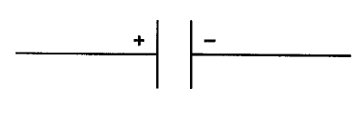

APPLICABLE DOCUMENTS
The following documents form part of this specification and shall be read in conjunction with it:
          - ESCC Generic Specification No. 3012 for Capacitors, Leadless Surface Mounted, Tantalum, Solid Electrolyte, Enclosed Anode Connection.

TERMS, DEFINITIONS, ABBREVIATIONS, SYMBOLS AND UNITS
For the purpose of this specification, the terms, definitions, abbreviations, symbols and units specified in ESCC Basic Specification No. 21300 shall apply.

REQUIREMENTS

GENERAL
The complete requirements for procurement of the components specified herein shall be as stated in this specification and ESCC Generic Specification No. 3012. Deviations from the Generic Specification, applicable to this Detail Specification only, are listed in Para. 4.2.
Deviations from the applicable Generic Specification and this Detail Specification, formally agreed with specific Manufacturers on the basis that the alternative requirements are equivalent to the ESCC requirements and do not affect the components' reliability, are listed in the appendices attached to this specification.

DEVIATIONS FROM GENERIC SPECIFICATION

Deviations from Special In-process Controls
None.

Deviations from Final Production Tests (Chart II)
None.

Deviations from Burn-in and Electrical Measurements (Chart III)
None.

Deviations from Qualification Tests (Chart IV)
          - Para. 9.19, Solderability: the solderable area is the termination 'pad' and up to 1/3 the height of the tab.

Deviations from Lot Acceptance Tests (Chart V)
          - Para. 9.19, Solderability: the solderable area is the termination 'pad' and up to 1/3 the height of the tab.

MECHANICAL REQUIREMENTS

Dimension Check
The dimensions of the components specified herein shall be verified in accordance with the requirements set out in Para. 9.6 of ESCC Generic Specification No. 3012. They shall conform to those shown in Figure 2 of this specification.

Weight
The maximum weight of the capacitors specified herein shall be as follows:
Case Size 'A' | - 0.1 grammes
Case Size 'B' | - 0.2 grammes
Case Size 'C' | - 0.3 grammes
Case Size 'D' | - 0.5 grammes
Case Size 'E' | - 0.7 grammes

MATERIALS AND FINISHES
The materials and finishes shall be as specified herein. Where a definite material is not specified, a material which will enable the components specified herein to meet the performance requirements of this specification shall be used. Acceptance or approval of any constituent material does not guarantee acceptance of the finished product.

Terminations
For Variants 01 & 02: the termination shall be Type 'G' with Type '16' finish in accordance with the requirements of ESCC Basic Specification No. 23500.
For Variants 13, 14 & 17: the termination shall be Type 'P' with Type '17' finish in accordance with the requirements of ESCC Basic Specification No. 23500.

MARKING

General
The marking of all components delivered to this specification shall be in accordance with the requirements of ESCC Basic Specification No. 21700 and the following paragraphs. For those components too small to accommodate the marking as specified hereafter, the marking information in full shall accompany each component in its primary package. Such marking shall comprise:
          - The ESCC Component Number.
          - Characteristics and Ratings.
          - Traceability Information.

The ESCC Component Number
Each component shall bear the ESCC Component Number which shall be constituted and marked as follows:
Example: 301200101B
- Detail Specification Number : 3012001
- Type Variant (as applicable, see Figure 2): 01
- Testing Level (B or C, as applicable): B

Electrical Characteristics and Ratings
The electrical characteristics and ratings to be marked, in the following order of precedence, are:
          - Polarity.
          - Numerical value.
          - Rated voltage.
          - Tolerance.

Polarity
The anode connection shall be indicated by a BAR on the coded surface.
NOTES:
            - For qualified devices, the ESCC qualified components symbol may be used to indicate the anode connection.

Capacitance
This shall be indicated by the value marked on the component.

Rated Voltage
This shall be indicated by the value marked on the component or, where the body size is too small, by the code letters specified hereafter:
Rated Voltage (V) | Code Letter
4  6.3  10  16  20  25  35  50 | G  J  A  C  D  E  V  T

Tolerance
The tolerance on numerical values shall be indicated by the code letters specified hereafter:
Tolerance | Code Letter
±10% | K
±20% | M

Traceability Information
Traceability information shall be marked in accordance with the requirements of ESCC Basic Specification No. 21700. The information to be marked shall be as follows:
          - Manufacturing date code.
          - Serial number.
          - Manufacturer's name.

ELECTRICAL MEASUREMENTS

Electrical Measurements at Room Temperature
The parameters to be measured in respect of electrical characteristics are scheduled in Table 2. The measurements shall be performed at T_{amb} = +22 ±3°C.

Electrical Measurements at High and Low Temperatures
The parameters to be measured at high and low temperatures are scheduled in Table 3.

Circuits for Electrical Measurements
Not applicable.

BURN-IN TESTS

Parameter Drift Values
The parameter drift values applicable to burn-in are specified in Table 4 of this specification. Unless otherwise stated, measurements shall be performed at T_{amb} = +22 ±3°C. The parameter drift values (Δ) applicable to the scheduled parameters shall not be exceeded. In addition to these drift value requirements for a given parameter, the appropriate limit value specified in Table 2 shall not be exceeded.

Conditions for Burn-in
The requirements for burn-in are specified in Section 7 of ESCC Generic Specification No. 3012. The conditions for burn-in shall be as specified in Table 5(a) of this specification.

Electrical Circuits for Burn-in
Not applicable.
TABLE 2 - ELECTRICAL MEASUREMENTS AT ROOM TEMPERATURE
No. | Characteristics | Symbol | Spec. and/or  Test Method | Test Conditions | Limits |  | Unit
 |  |  |  |  | Min | Max | Unit
1 | Capacitance | C | ESCC 3012  Para. 9.4.1.1 |  | -10  -20 | +10  +20 | %
2 | DC Leakage Current | I_{L} | ESCC 3012  Para. 9.4.1.2 |  | - | 0.01 x C x U_{R}  or (1)  1 | µA
3 | Dissipation Factor | DF | ESCC 3012  Para. 9.4.1.3 | U_{R} < 10V  U_{R} ≥ 10V, C ≤ 1µF  U_{R} ≥ 10V, C > 1µF | -  -  - | 6  4  6 | %
NOTES
            - Whichever is greater.
TABLE 3 - ELECTRICAL MEASUREMENTS AT HIGH and Low Temperature
No. | Characteristics | Symbol | Spec. and/or  Test Method | Test Conditions (Note 2) | Limits |  | Unit
 |  |  |  |  | Min | Max | Unit
1 | Capacitance Change | ΔC/C | ESCC 3012  Para. 9.4.1.1 | -55 (+3 -0)°C  +85 ±3°C  +125 (+0 -3)°C | -8  0  0 | 0  +8  +12 | %
2 | DC Leakage Current | I_{L} | ESCC 3012  Para. 9.4.1.2 | +85 ±3°C  +125 (+0 -3)°C | -  - | 0.1 x C x U_{R}  or (1)  1  0.125 x C x U_{R}  or (1)  1 (3) | µA
3 | Dissipation Factor | DF | ESCC 3012  Para. 9.4.1.3 | -55 (+3 -0)°C  +85 ±3°C  +125 (+0 -3)°C | -  -  - | 9  7.2  9 | %
NOTES
            - Whichever is greater.
            - Inspection level II single sampling, AQL 2.5% for each capacitance value. Each capacitance value shall be considered as constituting a complete lot.
            - Measured with category voltage.
Figure 4 – circuits for electrical measurements
Not applicable
TABLE 4 - PARAMETER DRIFT VALUES
No. | Characteristics | Symbol | Spec. and/or Test Method | Test Conditions | Limits | Unit
1 | Capacitance Change | ΔC/C | As per Table 2 | As per Table 2 | ±5 | %
2 | DC Leakage Current Change | ΔI_{L} | As per Table 2 | As per Table 2 | 2 x Initial Value (1)  or (2)  (0.25 x Table 2 Item 2) +0.05µA | µA
NOTES
            - Leakage currents ≤ 0.1µA are considered as a 0.1µA value.
            - Whichever is smaller.
TABLE 5(a) - CONDITIONS FOR BURN-IN
No. | Characteristics | Symbol | Conditions | Unit
1 | Ambient Temperature | T_{amb} | +85 (+0 -3) | °C
2 | Test Voltage | V_{T} | U_{R} | V
TABLE 5(b) - CONDITIONS FOR OPERATING LIFE TESTS
No. | Characteristics | Symbol | Conditions | Unit
1 | Ambient Temperature 1 | T_{amb1} | +85 (+0 -3) | °C
2 | Test Voltage 1 | V_{T1} | U_{R} | V
3 | Ambient Temperature 2 | T_{amb2} | +125 (+0 -3) | °C
4 | Test Voltage 2 | V_{T2} | U_{C} | V
FIGURE 5 - ELECTRICAL CIRCUIT FOR BURN-IN and operating life test
Not applicable.

ENVIRONMENTAL AND ENDURANCE TESTS (CHARTS IV AND V OF ESCC GENERIC SPECIFICATION No. 3012)

Measurements and Inspections on Completion of Environmental Tests
The parameters to be measured and inspections to be performed on completion of environmental tests are scheduled in Table 6. Unless otherwise stated, the measurements shall be performed at T_{amb} = +22 ±3°C.

Measurements and Inspections at Intermediate Points during Endurance Tests
The parameters to be measured and inspections to be performed at intermediate points during endurance tests are scheduled in Table 6. The measurements shall be performed at
the temperatures specified for the test.

Measurements and Inspections on Completion of Endurance Tests
The parameters to be measured and inspections to be performed on completion of endurance tests are scheduled in Table 6. Unless otherwise stated, the measurements shall be performed at
T_{amb} = +22 ±3°C.

Conditions for Operating Life Tests (Part of Endurance Testing)
The requirements for operating life testing are specified in Section 9 of ESCC Generic Specification No. 3012. The conditions for operating life testing shall be as specified in Table 5(b) of this specification.

Electrical Circuit for Operating Life Tests (Figure 5)
Not applicable.
TABLE 6 - MEASUREMENTS AND INSPECTIONS ON COMPLETION OF ENVIRONMENTAL TESTS AND AT INTERMEDIATE POINTS AND ON COMPLETION OF ENDURANCE TESTING
No. | ESCC Generic Spec. No. 3012 |  | Measurements and Inspections |  | Symbols | Limits |  |  | Units
No. | Environmental and Endurance Tests (Note 1) | Test Methods and Conditions | Identification | Conditions | Symbols | Min |  | Max | Units
01 | Mounting | Para. 9.9 | Final Examination
 |  |  | Terminals | Good tinning | - | - |  | -
 |  |  | Final Measurements
 |  |  | Capacitance | Table 2 Item 1 | C | Table 2 |  |  | µF
 |  |  | Capacitance Change | Table 2 Item 1 | ΔC/C | -5 | +5 |  | %
 |  |  | DC Leakage Current | Table 2 Item 2 | I_{L} | - |  | Table 2 | µA
 |  |  | Dissipation Factor | Table 2 Item 3 | DF | - |  | Table 2 | %
02 | Rapid Change of  Temperature | Para. 9.3.2 | Initial Measurements
 | Rapid Change of  Temperature |  | Capacitance | Value recorded after Mounting | C | Table 2 |  |  | µF
 | Rapid Change of  Temperature |  | Final Measurements | Recovery period of 4 hours min.
 | Rapid Change of  Temperature |  | Visual Examination | - | - | - |  | -
 | Rapid Change of  Temperature |  | Capacitance Change | Table 2 Item 1 | ΔC/C | -5 |  | +5 | %
 | Rapid Change of  Temperature |  | DC Leakage Current | Table 2 Item 2 | I_{L} | - |  | Table 2 | µA
 | Rapid Change of  Temperature |  | Dissipation Factor | Table 2 Item 3 | DF | - |  | Table 2 | %
03 | External Visual Inspection | Para. 9.5 | Final Inspection
 | External Visual Inspection |  | Visual Inspection | ESCC No. 20500 | - | - |  | -
04 | Adhesion | Para. 9.10 | Initial Measurements
 |  |  | Capacitance | Value recorded after Mounting | C | Table |  |  | µF
 |  |  | Final Measurements
 |  |  | Visual Examination | No damage or loosening from the substrate | - | - |  | -
 |  |  | Capacitance Change | Table 2 Item 1 | ΔC/C | -5 |  | +5 | %
05 | Vibration | Para. 9.11 | Measurements during test | During Last Cycle
 |  |  |  | No intermittent Contact >0.5ms, arcing or open or shorts | - | - |  | -
 |  |  | Final Examination
 |  |  | Visual Examination | No damage | - | - |  | -
06 | Shock or Bump | Para. 9.12 | Final Examination
 |  |  | Visual Examination | No damage | - | - |  | -
07 | Climatic Sequence | Para. 9.13 | Initial Measurements
 |  |  | Capacitance | Value recorded after Mounting | C | Table 2 |  |  | µF
 |  |  | Intermediate Measurements | After Dry Heat (2)
 |  |  | DC Leakage Current | Table 3 Item 2 | I_{L} | - |  | Table 3 | µA
 |  |  | Final Measurements | After recovery of 1 to 24 hours
 |  |  | Visual Inspection | ESCC No. 20500 | - | - |  | -
 |  |  | Capacitance Change | Table 2 Item 1 | ΔC/C | -5 |  | +5 | %
 |  |  | DC Leakage Current | Table 2 Item 2 | I_{L} | - |  | Table 2 | µA
 |  |  | Dissipation Factor | Table 2 Item 3 | DF | - |  | (3) | %
08 | High and Low Temperature Stability | Para. 9.14 | Measurements during test
 | High and Low Temperature Stability |  | Electrical Measurements | Tables 2 & 3 | - | Tables 2 & 3
09 | Surge Voltage | Para. 9.15 | Final Measurements
 |  |  | Capacitance | Table 2 Item 1 | C | Table 2 |  |  | µF
 |  |  | DC Leakage Current | Table 2 Item 2 | I_{L} | - |  | Table 2 | µA
 |  |  | Dissipation Factor | Table 2 Item 3 | DF | - |  | Table 2 | %
10 | Damp Heat Steady State | Para. 9.16 | Initial Measurements
 | Damp Heat Steady State |  | Capacitance | Value recorded after Mounting | C | Table 2 |  |  | µF
 | Damp Heat Steady State |  | Final Measurements | After recovery of 1 to 2 hours
 | Damp Heat Steady State |  | Visual Examination | - | - | - |  | -
 | Damp Heat Steady State |  | Capacitance Change | Table 2 Item 1 | ΔC/C | -5 |  | +5 | %
 | Damp Heat Steady State |  | DC Leakage Current | Table 2 Item 2 | I_{L} | - |  | Table 2 | µA
 | Damp Heat Steady State |  | Dissipation Factor | Table 2 Item 3 | DF | - |  | (3) | %
11 | Operating Life | Para. 9.17 | Initial Measurements
 |  |  | Capacitance | Value recorded after Mounting | C | Table 2 |  |  | µF
 |  |  | Intermediate Measurements | At 250 and 1000 hrs
 |  |  | DC Leakage Current (2) | Table 3 Item 2 | I_{L} | - |  | (4) | µA
 |  |  | Final Measurements | At 1000 and 2000 hrs and after recovery or 1 to 2 hours
 |  |  | Capacitance Change | Table 2 Item 1 | ΔC/C | -5 |  | +5 | %
 |  |  | DC Leakage Current | Table 2 Item 2 | I_{L} | - |  | (5) | µA
 |  |  | Dissipation Factor | Table 2 Item 3 | DF | - |  | Table 2 | %
 |  |  | Visual Examination | No damage | - | - |  | -
12 | Permanence of Marking | Para. 9.18 | Final Examination
 | Permanence of Marking |  | Visual Examination | No corrosion or obliteration of marking | - | - |  | -
13 | Solderability | Para. 9.19 and Paras. 4.2.4 and 4.2.5 of this spec | Final Examination
 |  | Para. 9.19 and Paras. 4.2.4 and 4.2.5 of this spec | Visual Examination | No damage | - | - |  | -
NOTES
            - The tests in this Table refer to either Chart IV or V and shall be used as applicable.
            - While still at the high temperature.
            - 1.2x the value specified in Table 2 of this specification.
            - 1.25x the value specified in Table 3 of this specification.
            - 1.25x the value specified in Table 2 of this specification.

Appendix ‘A’
AGREED DEVIATIONS FOR AVX CZECH RePUBLIC S.R.O. (CZ)
ITEMS AFFECTED | DESCRIPTION OF DEVIATIONS
Deviations from Final Production Tests (Chart II) | Para. 9.1, Internal Visual Inspection: Shall not be performed.
Deviations from Final Production Tests (Chart II) | Para. 9.5, External Visual Inspection: Visible base material is permitted on the edges of terminations (there is no plating on edges).
Deviations from Burn-in and Electrical Measurements  (Chart III) | Para. 9.5, External Visual Inspection: Visible base material is permitted on the edges of terminations (there is no plating on edges).
Deviations from Qualification Tests (Chart IV) | Para. 9.5, External Visual Inspection: Visible base material is permitted on the edges of terminations (there is no plating on edges).
Deviations from Lot Acceptance Tests (Chart V) | Para. 9.5, External Visual Inspection: Visible base material is permitted on the edges of terminations (there is no plating on edges).

