

Page 1 of 16
CAPACITORS, FIXED, TUBULAR, POROUS TANTALUM CATHODE AND ANODE, GELLED ELECTROLYTE, HERMETICALLY SEALED
BASED ON TYPE sT79
ESCC Detail Specification No. 3003/006

Issue 3 Draft B | April 2016



Document Custodian: European Space Agency – see https://escies.org

Legal Disclaimer and Copyright
European Space Agency, Copyright © 2016. All rights reserved.
The European Space Agency disclaims any liability or responsibility, to any person or entity, with respect to any loss or damage caused, or alleged to be caused, directly or indirectly by the use and application of this ESCC publication.
This publication, without the prior permission of the European Space Agency and provided that it is not used for a commercial purpose, may be:
- copied in whole, in any medium, without alteration or modification.
- copied in part, in any medium, provided that the ESCC document identification, comprising the ESCC symbol, document number and document issue, is removed.

DOCUMENTATION CHANGE NOTICE
(Refer to https://escies.org for ESCC DCR content)
DCR No. | CHANGE DESCRIPTION
984 | Specification upissued to incorporate changes per DCR.

TABLE OF CONTENTS
1 GENERAL 6
1.1 SCOPE 6
1.2 RANGE OF COMPONENTS 6
1.3 MAXIMUM RATINGS 6
1.4 PARAMETER DERATING INFORMATION 6
1.5 PHYSICAL DIMENSIONS 6
1.6 FUNCTIONAL DIAGRAM 6
2 APPLICABLE DOCUMENTS 9
3 TERMS, DEFINITIONS, ABBREVIATIONS, SYMBOLS AND UNITS 9
4 REQUIREMENTS 9
4.1 GENERAL 9
4.2 DEVIATIONS FROM GENERIC SPECIFICATION 9
4.2.1 Deviations from Special In-process Controls 9
4.2.2 Deviations from Final Production Tests (Chart II) 9
4.2.3 Deviations from Burn-in and Electrical Measurements (Chart III) 9
4.2.4 Deviations from Qualification Tests (Chart IV) 9
4.2.5 Deviations from Lot Acceptance Tests (Chart V) 9
4.3 MECHANICAL REQUIREMENTS 10
4.3.1 Dimension Check 10
4.3.2 Weight 10
4.3.3 Robustness of Terminations 10
4.4 MATERIALS AND FINISHES 10
4.4.1 Case 10
4.4.2 Lead Material and Finish 10
4.4.3 Insulation Sleeving 10
4.5 MARKING 10
4.5.1 General 10
4.5.2 Polarity 10
4.5.3 The ESCC Component Number 11
4.5.4 Characteristics and Ratings 11
4.5.5 Traceability Information 11
4.6 ELECTRICAL MEASUREMENTS 12
4.6.1 Electrical Measurements at Room Temperature 12
4.6.2 Electrical Measurements at High and Low Temperatures 12
4.7 Burn-In Tests 12
4.7.1 Parameter Drift Values 12
4.7.2 Conditions for Burn-in 12
4.8 ENVIRONMENTAL AND ENDURANCE TESTS (CHARTS IV AND V OF ESCC GENERIC SPECIFICATION No. 3003) 14
4.8.1 Measurements and Inspections on Completion of Environmental Tests 14
4.8.2 Measurements at Intermediate Points during Endurance Tests 14
4.8.3 Measurements and Inspections on Completion of Endurance Tests 14
4.8.4 Conditions for Operating Life 14

GENERAL

SCOPE
This specification details the ratings, physical and electrical characteristics, test and inspection data for Capacitors, Fixed, Tubular, Porous Tantalum Cathode and Anode, Gelled Electrolyte, Hermetically Sealed, Based on Type ST79. It shall be read in conjunction with ESCC Generic Specification No. 3003, the requirements of which are supplemented herein.

RANGE OF COMPONENTS
The range of components covered by this specification is given in Table 1(a).

MAXIMUM RATINGS
The maximum ratings, which shall not be exceeded at any time during use or storage, applicable to the components specified herein are scheduled in Table 1(b).

PARAMETER DERATING INFORMATION
The parameter derating information applicable to the components specified herein is shown in Figure 1.

PHYSICAL DIMENSIONS
The physical dimensions of the components specified herein are shown in Figure 2.

FUNCTIONAL DIAGRAM
The functional diagram for the components specified herein is shown in Figure 3.
TABLE 1(a) - RANGE OF COMPONENTS
U_{R}  (V)  (Note 3) | C_{n}  (µF) (Note 2) | I_{L} max  (µA) |  | DF max  (%)  at 100Hz | ΔC/C max  (%) |  |  | Z max (Ω)  at 100Hz | Case  Size  (Note 1) | Weight max  (g)
U_{R}  (V)  (Note 3) | +22°C | +22°C | +85°C, +125°C | +22°C, +85°C, +125°C | +85°C | +125°C | -55°C | -55°C | Case  Size  (Note 1) | Weight max  (g)
25 | 120 | 1 | 5 | 14 | +8 | +12 | -42 | 30 | A | 2.6
25 | 560 | 2 | 10 | 42 | +10 | +15 | -65 | 12 | B | 6.2
25 | 1200 | 5 | 20 | 70 | +12 | +18 | -70 | 7 | C | 11.6
25 | 1800 | 4 | 25 | 81 | +12 | +20 | -75 | 6 | D | 17.7
30 | 100 | 1 | 5 | 11 | +8 | +12 | -38 | 35 | A | 2.6
30 | 470 | 2 | 10 | 36 | +10 | +18 | -65 | 15 | B | 6.2
30 | 1000 | 7 | 25 | 63 | +10 | +18 | -70 | 7 | C | 11.6
30 | 1500 | 5 | 30 | 81 | +10 | +20 | -72 | 7 | D | 17.7
40 | 1000 | 8 | 65 | 40 | +10 | +20 | -60 | 8 | D | 17.7
50 | 68 | 1 | 5 | 9 | +8 | +15 | -25 | 40 | A | 2.6
50 | 220 | 2 | 10 | 18 | +8 | +15 | -50 | 20 | B | 6.2
50 | 470 | 3 | 25 | 31 | +8 | +15 | -50 | 10 | C | 11.6
50 | 680 | 5 | 40 | 43 | +10 | +20 | -60 | 8 | D | 17.7
50 | 750 | 6 | 55 | 40 | +10 | +20 | -60 | 8 | D | 17.7
60 | 47 | 1 | 5 | 9 | +8 | +12 | -25 | 60 | A | 2.6
60 | 150 | 2 | 10 | 15 | +8 | +15 | -40 | 25 | B | 6.2
60 | 390 | 3 | 25 | 31 | +8 | +15 | -50 | 13 | C | 11.6
60 | 560 | 5 | 40 | 40 | +8 | +15 | -60 | 8 | D | 17.7
60 | 700 | 7 | 60 | 42 | +10 | +20 | -60 | 8 | D | 17.7
63 | 500 | 5 | 40 | 40 | +8 | +15 | -60 | 8 | D | 17.7
75 | 33 | 1 | 5 | 8 | +5 | +9 | -25 | 85 | A | 2.6
75 | 330 | 3 | 30 | 29 | +10 | +20 | -50 | 12 | C | 11.6
75 | 470 | 5 | 50 | 38 | +10 | +20 | -60 | 10 | D | 17.7
100 | 15 | 1 | 5 | 5 | +3 | +10 | -18 | 165 | A | 2.6
100 | 68 | 2 | 10 | 12 | +4 | +12 | -30 | 45 | B | 6.2
100 | 150 | 3 | 25 | 21 | +6 | +12 | -38 | 22 | C | 11.6
100 | 220 | 5 | 50 | 23 | +6 | +12 | -50 | 18 | D | 17.7
125 | 10 | 1 | 5 | 5 | +3 | +10 | -15 | 240 | A | 2.6
125 | 47 | 2 | 10 | 10 | +5 | +12 | -25 | 60 | B | 6.2
125 | 100 | 3 | 25 | 16 | +5 | +10 | -25 | 35 | C | 11.6
125 | 150 | 5 | 50 | 21 | +6 | +12 | -35 | 22 | D | 17.7
Notes:
            - Refer to Figure 2 for Type Variant Number assigned to case size.
            - All capacitors are available with a tolerance of ±10% (K) and ±20% (M).
            - For T_{amb} ≤ +85°C (See Figure 1).
TABLE 1(b) - MAXIMUM RATINGS
No. | Characteristics | Symbols | Maximum Ratings | Units | Remarks
1 | Rated Voltage | U_{R} | See Table 1(a) | V | For derating, see Figure 1
2 | Surge Voltage | U_{S} | 1.15U_{R} | V
3 | Operating Temperature Range | T_{op} | -55 to +125 | °C | T_{amb}  For derating, see Figure 1
4 | Storage Temperature Range | T_{stg} | -55 to +125 | °C | T_{amb}
5 | Maximum Soldering Temperature | T_{L} | +260 | °C | Soldering time: t_{L} ≤ 5s (Note 1)
NOTES:
            - ≥ 3mm from body on cathode side and ≥ 3mm from weld on anode side.
FIGURE 1 - PARAMETER DERATING INFORMATION
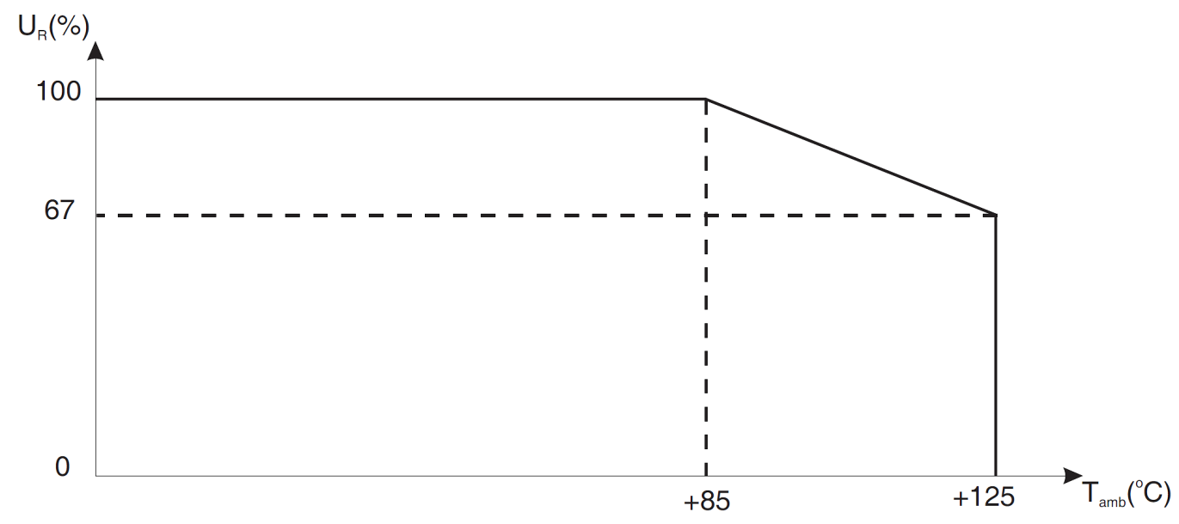
rated voltage versus ambient temperature (see table 1(b))
FIGURE 2 - PHYSICAL DIMENSIONS
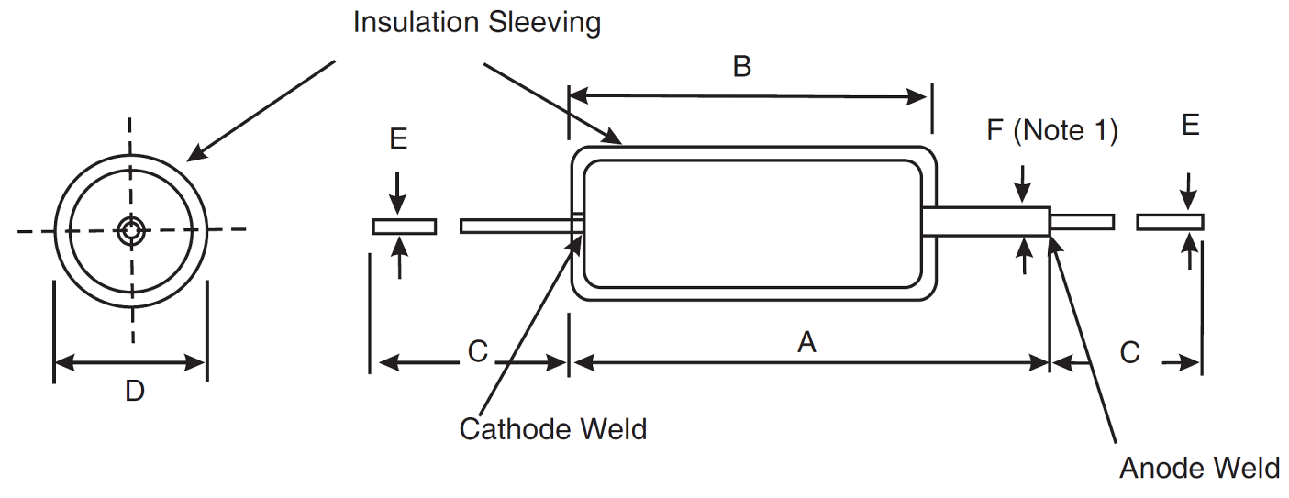
Variant | Case Size | Dimensions (mm)
Variant | Case Size | A  Max | B  Max | C  Min | D  Max | E |  | F  Max
 |  |  |  |  |  | Min | Max | F  Max
02 | A | 18 | 12.43 | 30 | 5.6 | 0.59 | 0.7 | 1.6
03 | B | 23 | 17.2 | 30 | 7.6 | 0.59 | 0.7 | 1.6
04 | C | 26 | 20.4 | 30 | 10 | 0.59 | 0.7 | 1.6
05 | D | 34 | 27.9 | 30 | 10 | 0.59 | 0.7 | 1.6
NOTES:
            - The anode lead-out stub must not be bent.
FIGURE 3 - FUNCTIONAL DIAGRAM
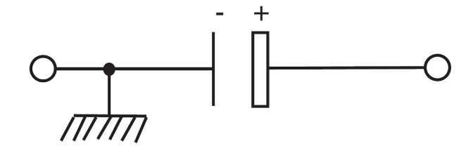

APPLICABLE DOCUMENTS
The following documents form part of this specification and shall be read in conjunction with it:
          - ESCC Generic Specification No. 3003 for Capacitors, Fixed, Tantalum, Non-solid Electrolyte.

TERMS, DEFINITIONS, ABBREVIATIONS, SYMBOLS AND UNITS
For the purpose of this specification, the terms, definitions, abbreviations, symbols and units specified in ESCC Basic Specification No. 21300 shall apply.

REQUIREMENTS

GENERAL
The complete requirements for procurement of the components specified herein are stated in this specification and ESCC Generic Specification No. 3003. Deviations from the Generic Specification, applicable to this specification only, are listed in Para. 4.2.
Deviations from the Generic Specification and this Detail Specification, formally agreed with specific Manufacturers on the basis that the alternative requirements are equivalent to the ESCC requirements and do not affect the components' reliability, are listed in the appendices attached to this specification.

DEVIATIONS FROM GENERIC SPECIFICATION

Deviations from Special In-process Controls
Not applicable.

Deviations from Final Production Tests (Chart II)
None.

Deviations from Burn-in and Electrical Measurements (Chart III)
None.

Deviations from Qualification Tests (Chart IV)
None.

Deviations from Lot Acceptance Tests (Chart V)
None.

MECHANICAL REQUIREMENTS

Dimension Check
The dimensions of the components specified herein shall be verified in accordance with the requirements set out in Para. 9.4 of ESCC Generic Specification No. 3003 and shall conform to those shown in Figure 2 of this specification.

Weight
The maximum weight of the components specified herein shall be as specified in Table 1(a).

Robustness of Terminations
The requirements and test conditions for robustness of terminations are specified in Para. 9.9 of ESCC Generic Specification No. 3003.

MATERIALS AND FINISHES
The materials and finishes shall be as specified herein. Where a definite material is not specified, a material which will enable the capacitors specified herein to meet the performance requirements of this specification shall be used. Acceptance or approval of any constituent material does not guarantee acceptance of the finished product.

Case
Tantalum, hermetically sealed.

Lead Material and Finish
Leads shall be Type E with Type 3 finish in accordance with the requirements of ESCC Basic Specification No. 23500. Leads shall be electrically welded to the case and shall be free from nonconductive and foreign materials.

Insulation Sleeving
Insulation Sleeving shall be of a non-fungus-nutrient material (cardboard shall not be used). The material shall not soften, creep or shrink to the extent that it causes any part of the cylindrical case to become uncovered at any test temperature specified herein. At any cross-section, the maximum thickness of the sleeving shall not exceed twice its minimum thickness.

MARKING

General
The marking of all components delivered to this specification shall be in accordance with the requirements of ESCC Basic Specification No. 21700 and the following paragraphs. When the component is too small to accommodate all the marking specified, as much as space permits shall be marked and the marking information, in full, shall accompany each component in its primary package.
The information to be marked and the order of precedence shall be as follows:
          - Polarity
          - The ESCC qualified components symbol (for ESCC qualified components only).
          - The ESCC Component Number (including Characteristics and Ratings).
          - Traceability Information.

Polarity
The polarity shall be indicated by a + symbol on the anode end of the case.

The ESCC Component Number
The ESCC Component Number shall be constituted and marked as follows:
Example: 300300605B567KM
- Detail Specification Number: 3003006
- Type Variant (see Figure 2): 05 (as required)
- Testing Level: B (B or C, as applicable)
- Characteristic code: Capacitance Value (560µF): 567 (as required)
- Characteristic code: Capacitance Tolerance (±10%): K (as required)
- Rating code: Rated Voltage (60V): M (as required)

Characteristics and Ratings
The characteristics and ratings to be codified as part of the ESCC Component Number shall be as follows:
          - Rated Capacitance Value C_{n} expressed by means of the following codes in accordance with ESCC Basic Specification No. 21700. The unit quantity for marking shall be picofarads (pF).
Capacitance Value C_{n} (pF) | Code
XX10⁶ | XX6
XX10⁷ | XX7
XX10⁸ | XX8
          - Capacitance Tolerance expressed by the following codes in accordance with ESCC Basic Specification No. 21700:
Tolerance (± %) | Code Letter
10 | K
20 | M
          - Rated Voltage expressed by the following codes:
Rated Voltage U_{R}  (V) | Code Letter
25 | F
30 | H
40 | J
50 | K
60 | M
63 | L
75 | P
100 | Q
125 | R

Traceability Information
Traceability information shall be marked in accordance with the requirements of ESCC Basic Specification No. 21700.

ELECTRICAL MEASUREMENTS

Electrical Measurements at Room Temperature
The parameters to be measured at room temperature are scheduled in Table 2. The measurements shall be performed at T_{amb} = +22 ±3°C.

Electrical Measurements at High and Low Temperatures
The parameters to be measured at high and low temperatures are scheduled in Table 3.

Burn-In Tests

Parameter Drift Values
The parameter drift values applicable to burn-in are specified in Table 4 of this specification. Unless otherwise stated, measurements shall be performed at T_{amb} = +22 ±3°C. The parameter drift values (Δ) applicable to the parameters scheduled shall not be exceeded. In addition to these drift value requirements for a given parameter, the appropriate limit value specified in Table 2 shall not be exceeded.

Conditions for Burn-in
The requirements for burn-in are specified in Section 7 of ESCC Generic Specification No. 3003. The conditions for burn-in shall be as specified in Table 5 of this specification. On completion of burn-in, a recovery period of 24 ±2 hours is necessary before the end-measurements.

TABLE 2 - ELECTRICAL MEASUREMENTS AT ROOM TEMPERATURE (NOTE 1)
No. | Characteristics | Symbols | ESCC 3003  Test Conditions | Limits |  | Units
 |  |  |  | Min | Max | Units
1 | DC Leakage | I_{L} | Para. 9.2.1.1 | See Table 1(a) |  | µA
2 | Capacitance Value | C | Para. 9.2.1.2 | See Table 1(a) |  | µF
3 | Dissipation Factor | DF | Para. 9.2.1.3 | See Table 1(a) |  | %
NOTES:
            - Measurements shall be made in the order shown. On completion of electrical measurements of Chart III and LAT3, each capacitor shall be discharged through a 470Ω resistor for 5s followed by short circuit for 2 minutes.
TABLE 3 - ELECTRICAL MEASUREMENTS AT HIGH AND LOW TEMPERATURES
(NOTEs 1, 2)
No. | Characteristics | Symbols | ESCC 3003 Test Conditions | Test Temperature  (T_{amb}) | Limits |  | Units
 |  |  |  |  | Min | Max | Units
1  2  3 | DC Leakage  Capacitance  Dissipation Factor  (Note 3) | I_{L}  C  DF | Para. 9.2.1.1  Para. 9.2.1.2  Para. 9.2.1.3 | +22 ±3°C | See Table 1(a) |  | µA  µF  %
4  5 | Impedance  Capacitance | Z  C | -  Para. 9.2.1.2 | -55 (+0 -3)°C | See Table 1(a) |  | Ω  µF
6  7  8 | DC Leakage  Capacitance  Dissipation Factor  (Note 3) | I_{L}  C  DF | Para. 9.2.1.1  Para. 9.2.1.2  Para. 9.2.1.3 | +22 ±3°C | See Table 1(a) |  | µA  µF  %
9  10  11 | DC Leakage  Capacitance  Dissipation Factor | I_{L}  C  DF | Para. 9.2.1.1  Para. 9.2.1.2  Para. 9.2.1.3 | +85 (+3 -0)°C | See Table 1(a) |  | µA  µF  %
12  13  14 | DC Leakage (Note 4) Capacitance  Dissipation Factor | I_{L}  C  DF | Para. 9.2.1.1  Para. 9.2.1.2  Para. 9.2.1.3 | +125 (+3 -0)°C | See Table 1(a) |  | µA  µF  %
15  16  17 | DC Leakage  Capacitance  Dissipation Factor | I_{L}  C  DF | Para. 9.2.1.1  Para. 9.2.1.2  Para. 9.2.1.3 | +22 ±3°C | See Table 1(a) |  | µA  µF  %
NOTES:
            - Measurements shall be made in the order shown. Capacitors shall be brought to thermal stability before the measurements are made. Thermal stability will have been reached when no further change in capacitance is observed between 2 successive measurements made at 15 minute intervals.
            - Inspection Level II, single sampling, AQL = 2.5%, for each capacitance value. Each capacitance value shall be considered as constituting a complete lot.
            - These measurements shall not be performed during Chart III.
            - Derated voltage, 0.67U_{R}, shall be applied for this measurement.
TABLE 4 - PARAMETER DRIFT VALUES
No. | Characteristics | Symbols | ESCC 3003  Test Conditions | Change Limits (Δ) | Units
1 | DC Leakage Change | ΔI_{L}/I_{L} | Para. 9.2.1.1 | (+200, -100) % of measured value or  +(25% +0.05µA) of limit value (Notes 1, 2) | -
2 | Capacitance Change | ΔC/C | Para. 9.2.1.2 | ±5 | %
NOTES:
            - Whichever is smaller.
            - Leakage currents need not be recorded when less than, or equal to:
- 0.5µA for case sizes A and B.
- 0.8µA for case size C.
- 1.4µA for case size D.
TABLE 5 - CONDITIONS FOR BURN-IN AND OPERATING LIFE
No. | Characteristics | Symbols | Conditions | Units
1 | Ambient Temperature | T_{amb} | +85 (+0 -3) | °C
2 | Test Voltage | U_{R} | U_{R} (Note 1) | V
NOTES:
            - See Table 1(a).

ENVIRONMENTAL AND ENDURANCE TESTS (CHARTS IV AND V OF ESCC GENERIC SPECIFICATION No. 3003)

Measurements and Inspections on Completion of Environmental Tests
The parameters to be measured and inspections to be performed on completion of environmental tests are scheduled in Table 6. Unless otherwise stated, the measurements shall be performed at T_{amb} = + 22 ±3°C.

Measurements at Intermediate Points during Endurance Tests
The parameters to be measured at intermediate points during endurance tests are scheduled in Table 6. Unless otherwise stated, the measurements shall be performed at T_{amb} = + 22 ±3°C.

Measurements and Inspections on Completion of Endurance Tests
The parameters to be measured and inspections to be performed on completion of endurance tests are scheduled in Table 6. Unless otherwise stated, the measurements shall be performed at T_{amb} = + 22 ±3°C.

Conditions for Operating Life
The requirements for operating life test are specified in Section 9 of ESCC Generic Specification No. 3003. The conditions for operating life testing shall be as specified in Table 5 of this specification.
TABLE 6 - MEASUREMENTS AND INSPECTIONS ON COMPLETION OF ENVIRONMENTAL TESTS AND AT INTERMEDIATE POINTS AND ON COMPLETION OF ENDURANCE TESTING
No. | ESCC Generic Spec. No. 3003 |  | Measurements and Inspections |  | Symbols | Limits |  | Units
No. | Environmental and Endurance Tests (1) | Test Methods and Conditions | Identification | Conditions | Symbols | Min | Max | Units
01 | Rapid Change of  Temperature | Para. 9.5 | DC Leakage | Table 2, Item 1 | I_{L} | 2.5 x Limit Table 1(a) |  | µA
 | Rapid Change of  Temperature |  | Capacitance Change | Table 2, Item 2 | ΔC/C | -15 | +15 | %
 | Rapid Change of  Temperature |  | Dissipation Factor | Table 2, Item 3 | DF | 1.5 x Limit Table 1(a) |  | %
 | Rapid Change of  Temperature |  | Visual Examination | No leakage of electrolyte | - | - |  | -
02 | Vibration | Para. 9.6 | Visual Examination | No damage or leakage of electrolyte | - | - | - | -
03 | Shock | Para. 9.7 | Visual Examination | No breakdown, arcing, damage or leakage of electrolyte | - | - | - | -
04 | Climatic Sequence | Para. 9.17 | DC Leakage | Table 2, Item 1 | I_{L} | 2.5 x Limit Table 1(a) |  | µA
 |  |  | Capacitance Change | Table 2, Item 2 | ΔC/C | -15 | +15 | %
 |  |  | Dissipation Factor | Table 2, Item 3 | DF | 1.5 x Limit Table 1(a) |  | %
 |  |  | Visual Examination | No damage or leakage of electrolyte
05 | Seal Test | Para. 9.1.2 | - | - | - | - | - | -
06 | External Visual Inspection | Para. 9.3 | - | - | - | - | - | -
07 | Solderability | Para. 9.8 | - | - | - | - | - | -
08 | Robustness of  Terminations | Para. 9.9 | Visual Examination | No damage or leakage of electrolyte | - | - | - | -
09 | Resistance to Soldering  Heat | Para. 9.10 | Visual Examination | No damage or leakage of electrolyte | - | - | - | -
10 | Damp Heat, Steady State | Para. 9.11 | DC Leakage | Table 2, Item 1 | I_{L} | 2 x Limit Table 1(a) |  | µA
 | Damp Heat, Steady State |  | Capacitance Change | Table 2, Item 2 | ΔC/C | -10 | +10 | %
 | Damp Heat, Steady State |  | Dissipation Factor | Table 2, Item 3 | DF | 1.5 x Limit Table 1(a) |  | %
 | Damp Heat, Steady State |  | Insulation Resistance | Gen. 3003, Para. 9.2.1.4 | R_{I} | 100 | - | MΩ
 | Damp Heat, Steady State |  | Visual Examination | No breakdown, arcing, corrosion, damage or leakage of electrolyte and marking legible | - | - | - | -
11 | Cold Test | Para. 9.12 | DC Leakage | Table 2, Item 1 | I_{L} | 2 x Limit Table 1(a) |  | µA
 |  |  | Capacitance Change | Table 2, Item 2 | ΔC/C | -5 | +5 | %
 |  |  | Dissipation Factor | Table 2, Item 3 | DF | 1.5 x Limit Table 1(a) |  | %
 |  |  | Visual Examination | No leakage of electrolyte | - | - | - | -
12 | Low Air Pressure | Para. 9.13 | Visual Examination | No breakdown, arcing, damage or leakage of electrolyte | - | - | - | -
13 | Surge Voltage | Para. 9.14 | Visual Examination | No damage or leakage of electrolyte | - | - | - | -
14 | Reverse Voltage | Para. 9.15 | DC Leakage | Table 2, Item 1 | I_{L} | 2 x Limit Table 1(a) |  | µA
 |  |  | Capacitance Change | Table 2, Item 2 | ΔC/C | -10 | +10 | %
 |  |  | Dissipation Factor | Table 2, Item 3 | DF | 1.5 x Limit Table 1(a) |  | %
15 | Life Test | Para. 9.16 |  | At 500, 1000 & 2000 hours and after 24 hours recovery
 |  |  | DC Leakage | Table 2, Item 1 | I_{L} | 2 x Limit Table 1(a) |  | µA
 |  |  | Capacitance Change | Table 2, Item 2 | ΔC/C | -10 | +10 | %
 |  |  | Dissipation Factor | Table 2, Item 3 | DF | 1.5 x Limit Table 1(a) |  | %
 |  |  | Insulation Resistance | Gen. 3003, Para. 9.2.1.4 | R_{I} | 100 | - | MΩ
16 | High and Low Temperature Measurements | Para. 9.2.3 | DC Leakage  Capacitance  Dissipation Factor (2)  Impedance | Table 3, Items 1 to 17 | I_{L}  C  DF  Z | See Table 3 |  | µA  µF  %  Ω
17 | Electrical Measurements | Para. 9.2.4 | DC Leakage  Capacitance  Dissipation Factor | Table 2, Item 1  Table 2, Item 2  Table 2, Item 3 | I_{L}  C  DF | See Table 2  See Table 2  See Table 2 |  | µA  µF  %
18 | Permanence of Marking | Para. 9.18 | - | - | - | - |  | -
NOTES:
            - The tests in this Table refer to either Chart IV or V and shall be used as applicable.
            - Not performed at low temperature.

