

Page 1 of 19
TRANSISTORS, LOW POWER, NPN
BASED ON TYPE 2N2222A
ESCC Detail Specification No. 5201/002

Issue 8 Draft A | February 2016



Document Custodian: European Space Agency – see https://escies.org

Legal Disclaimer and Copyright
European Space Agency, Copyright © 2016. All rights reserved.
The European Space Agency disclaims any liability or responsibility, to any person or entity, with respect to any loss or damage caused, or alleged to be caused, directly or indirectly by the use and application of this ESCC publication.
This publication, without the prior permission of the European Space Agency and provided that it is not used for a commercial purpose, may be:
- copied in whole, in any medium, without alteration or modification.
- copied in part, in any medium, provided that the ESCC document identification, comprising the ESCC symbol, document number and document issue, is removed.

DOCUMENTATION CHANGE NOTICE
(Refer to https://escies.org for ESCC DCR content)
DCR No. | CHANGE DESCRIPTION
tba | Specification upissued to incorporate editorial changes per DCR.

TABLE OF CONTENTS
1 General 5
1.1 SCOPE 5
1.2 APPLICABLE DOCUMENTS 5
1.3 TERMS, DEFINITIONS, ABBREVIATIONS, SYMBOLS AND UNITS 5
1.4 THE ESCC COMPONENT NUMBER AND COMPONENT TYPE VARIANTS 5
1.4.1 The ESCC Component Number 5
1.4.2 Component Type Variants 5
1.5 MAXIMUM RATINGS 6
1.6 PHYSICAL DIMENSIONS AND TERMINAL IDENTIFICATION 7
1.6.1 Metal Can Package (TO-18) - 3 lead 7
1.6.2 Chip Carrier Package (CCP) - 3 terminal 8
1.6.3 Chip Carrier Package (CCP) - 4 terminal 9
1.7 FUNCTIONAL DIAGRAM 10
1.8 MATERIALS AND FINISHES 10
2 REQUIREMENTS 10
2.1 GENERAL 10
2.1.1 Deviations from the Generic Specification 10
2.2 MARKING 11
2.3 TERMINAL STRENGTH 11
2.4 ELECTRICAL MEASUREMENTS AT ROOM, HIGH AND LOW TEMPERATURES 11
2.4.1 Room Temperature Electrical Measurements 11
2.4.2 High and Low Temperatures Electrical Measurements 15
2.5 PARAMETER DRIFT VALUES 15
2.6 INTERMEDIATE AND END-POINT ELECTRICAL MEASUREMENTS 15
2.7 POWER BURN-IN CONDITIONS 16
2.8 OPERATING LIFE CONDITIONS 16
2.9 TOTAL DOSE RADIATION TESTING 16
2.9.1 Bias Conditions and Total Dose Level for Total Dose Radiation Testing 16
2.9.2 Electrical Measurements for Radiation Testing 17
APPENDIX ‘A’ 19

General

SCOPE
This specification details the ratings, physical and electrical characteristics and test and inspection data for the component type variants and/or the range of components specified below. It supplements the requirements of, and shall be read in conjunction with, the ESCC Generic Specification listed under Applicable Documents.

APPLICABLE DOCUMENTS
The following documents form part of this specification and shall be read in conjunction with it:
          - ESCC Generic Specification No. 5000
          - MIL-STD-750, Test Methods and Procedures for Semiconductor Devices

TERMS, DEFINITIONS, ABBREVIATIONS, SYMBOLS AND UNITS
For the purpose of this specification, the terms, definitions, abbreviations, symbols and units specified in ESCC Basic Specification No. 21300 shall apply.

THE ESCC COMPONENT NUMBER AND COMPONENT TYPE VARIANTS

The ESCC Component Number
The ESCC Component Number shall be constituted as follows:
Example: 520100201R
- Detail Specification Reference: 5201002
- Component Type Variant Number: 01 (as required)
- Total Dose Radiation Level Letter: R (as required)

Component Type Variants
The component type variants applicable to this specification are as follows:
Variant Number | Based on Type | Case | Lead/Terminal Material and/or Finish | Weight  max g | Total Dose Radiation Level Letter
01 | 2N2222A | TO-18 | D2 | 0.4 | R [100kRAD(Si)]
02 | 2N2222A | TO-18 | D3 or D4 | 0.4 | R [100kRAD(Si)]
04 | 2N2222A | CCP  (3 Terminal) | 2 | 0.06 | R [100kRAD(Si)]
05 | 2N2222A | CCP  (3 Terminal) | 4 | 0.06 | R [100kRAD(Si)]
11 | 2N2222A | CCP  (4 Terminal) | 2 | 0.06 | R [100kRAD(Si)]
12 | 2N2222A | CCP  (4 Terminal) | 4 | 0.06 | R [100kRAD(Si)]
The lead/terminal material and/or finish shall be in accordance with the requirements of ESCC Basic Specification No. 23500.
Total dose radiation level letters are defined in ESCC Basic Specification No. 22900. If an alternative radiation test level is specified in the Purchase Order, the letter shall be changed accordingly.

MAXIMUM RATINGS
The maximum ratings shall not be exceeded at any time during use or storage.
Maximum ratings shall only be exceeded during testing to the extent specified in this specification and when stipulated in Test Methods and Procedures of the ESCC Generic Specification.
Characteristics | Symbols | Maximum Ratings | Unit | Remarks
Collector-Base Voltage | V_{CBO} | 75 | V | Over entire operating temperature range
Collector-Emitter Voltage | V_{CEO} | 50 | V | Over entire operating temperature range
Emitter-Base Voltage | V_{EBO} | 6 | V | Over entire operating temperature range
Collector Current | I_{C} | 800 | mA | Continuous
Power Dissipation  For TO-18 and CCP | P_{tot1} | 0.5 | W | At T_{amb} ≤ +25°C
For TO-18 | P_{tot2} | 1.8 | W | At T_{case} ≤ +25°C
Thermal Resistance,  Junction-to-Ambient | R_{th(j-a)} | 350 | °C/W
Thermal Resistance,  Junction-to-Case | R_{th(j-c)} | 97.2 | °C/W | Note 1
Operating Temperature Range | T_{op} | -65 to +200 | °C | Note 2
Storage Temperature Range | T_{stg} | -65 to +200 | °C | Note 2
Soldering Temperature  For TO-18  For CCP | T_{sol} | +260  +245 | °C | Note 3  Note 4
NOTES:
            - Thermal Resistance, Junction-to-Case only applies to TO-18 packaged Variants.
            - For Variants with tin-lead plating or hot solder dip lead finish all testing, and any handling, performed at T_{amb} > +125°C shall be carried out in a 100% inert atmosphere.
            - Duration 10 seconds maximum at a distance of not less than 1.5mm from the device body and the same lead shall not be resoldered until 3 minutes have elapsed.
            - Duration 5 seconds maximum and the same terminal shall not be resoldered until 3 minutes have elapsed.

PHYSICAL DIMENSIONS AND TERMINAL IDENTIFICATION

Metal Can Package (TO-18) - 3 lead
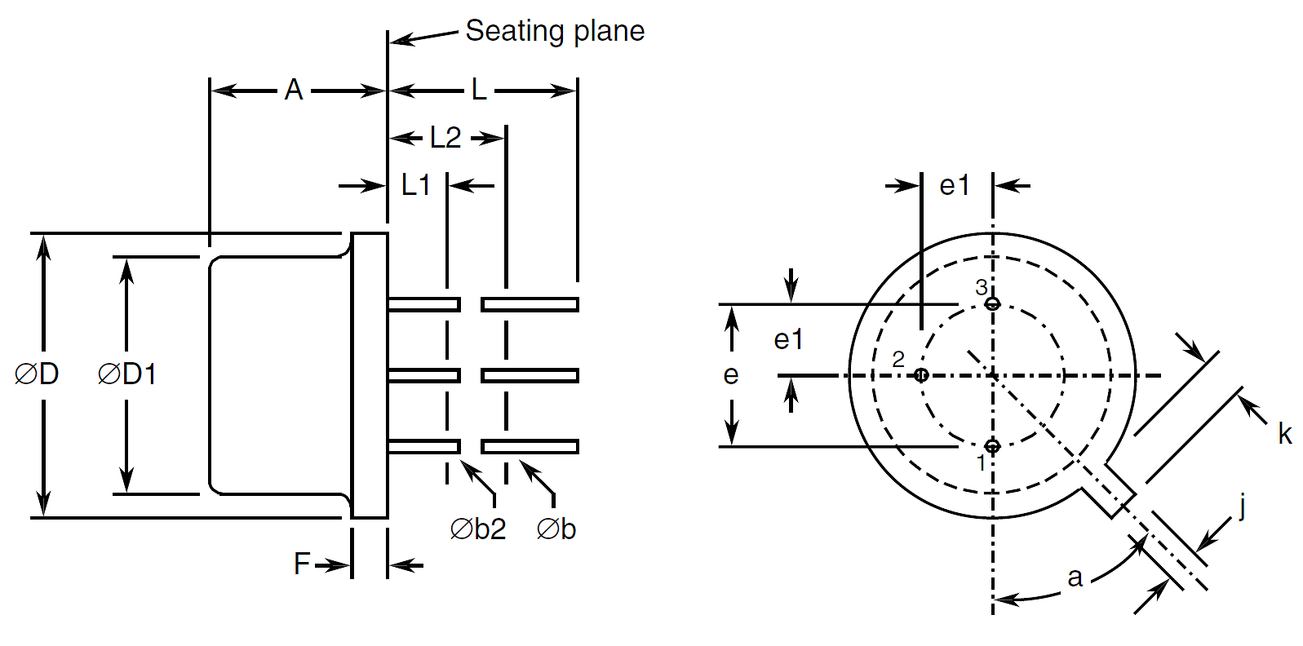
Symbols | Dimensions mm |  | Notes
Symbols | Min | Max | Notes
A | 4.32 | 5.33
Øb | 0.406 | 0.533 | 2, 3
Øb2 | 0.406 | 0.483 | 2, 3
ØD | 5.31 | 5.84
ØD1 | 4.52 | 4.95
e | 2.54 BSC |  | 4
e1 | 1.27 BSC |  | 4
F | - | 0.762
j | 0.914 | 1.17
k | 0.711 | 1.22 | 5
L | 12.7 | - | 2
L1 | - | 1.27 | 3
L2 | 6.35 | - | 3
a | 45° BSC |  | 1, 4, 6
NOTES:
            - Terminal identification is specified by reference to the tab position where lead 1 = emitter, lead 2 = base, lead 3 = collector.
            - Applies to all leads.
            - Øb2 applies between L1 and L2. Øb applies between L2 and 12.7mm from the seating plane. Diameter is uncontrolled within L1 and beyond 12.7mm from the seating plane.
            - Leads having maximum diameter 0.483mm measured in the gauging plane 1.37 (+0.025, -0) mm below the seating plane of the device shall be within 0.178mm of their true position relative to a maximum-width-tab.
            - Measured from the maximum diameter of the actual device.
            - Tab centreline.

Chip Carrier Package (CCP) - 3 terminal
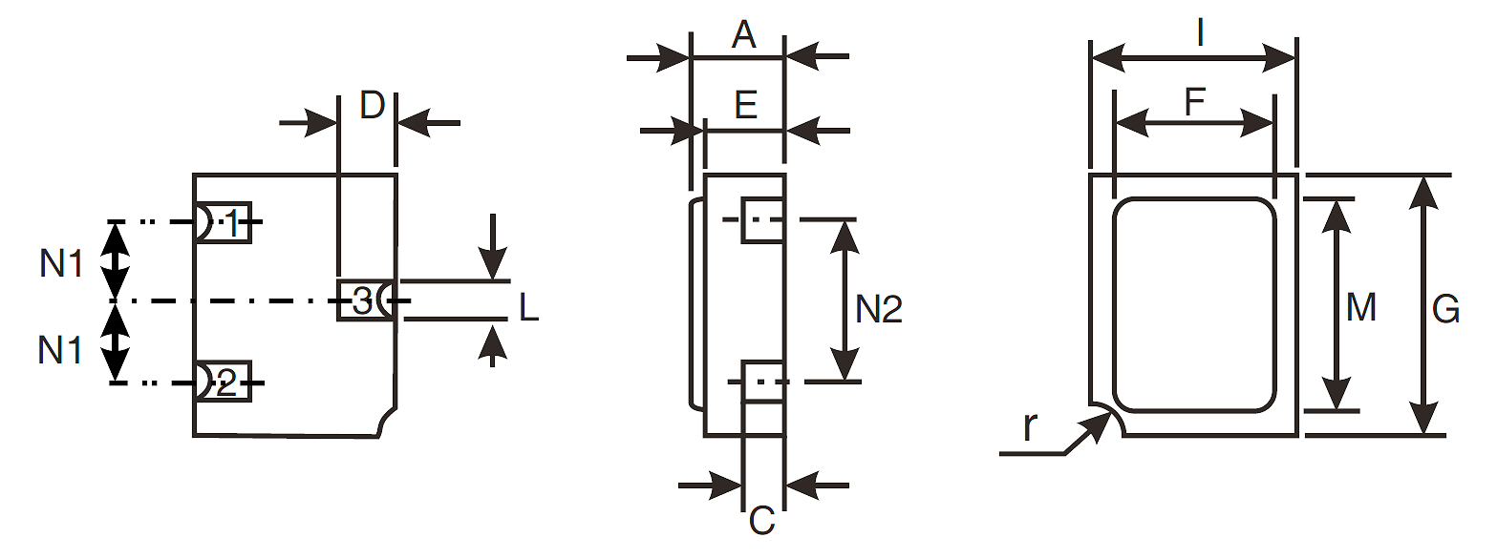
Symbols | Dimensions mm |  | Notes
Symbols | Min | Max | Notes
A | 1.15 | 1.5
C | 0.45 | 0.56 | 2
D | 0.6 | 0.91 | 2
E | 0.91 | 1.12
F | 1.9 | 2.15
G | 2.9 | 3.25
I | 2.4 | 2.85
L | 0.4 | 0.6 | 2
M | 2.4 | 2.65
N1 | 0.855 | 1.055
N2 | 1.8 | 2
r | 0.3 TYPICAL |  | 1
NOTES:
            - Terminal identification is specified by reference to the corner notch position where terminal 1 = emitter, terminal 2 = base, terminal 3 = collector.
            - Applies to all terminals.

Chip Carrier Package (CCP) - 4 terminal
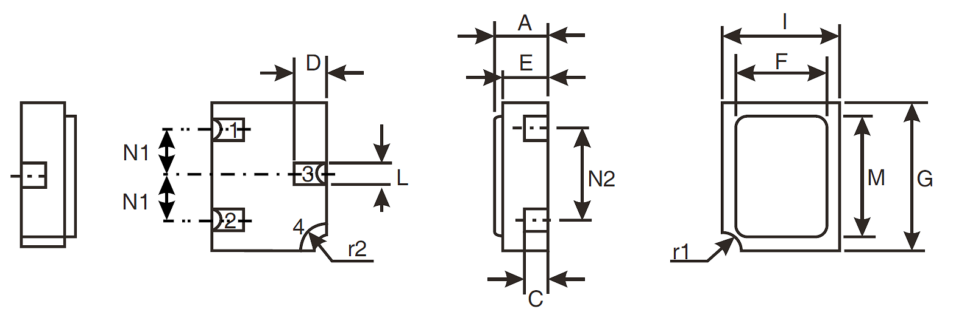
Symbols | Dimensions mm |  | Notes
Symbols | Min | Max | Notes
A | 1.15 | 1.5
C | 0.45 | 0.56 | 2
D | 0.6 | 0.91 | 2
E | 0.91 | 1.12
F | 1.9 | 2.15
G | 2.9 | 3.25
I | 2.4 | 2.85
L | 0.4 | 0.6 | 2
M | 2.4 | 2.65
N1 | 0.855 | 1.055
N2 | 1.8 | 2
r1 | 0.3 TYPICAL |  | 1
r2 | 0.56 TYPICAL |  | 1
NOTES:
            - Terminal identification is specified by reference to the corner notch position where terminal 1 = emitter, terminal 2 = base, terminal 3 = collector, terminal 4 = shielding connected to the lid.
            - Applies to terminals 1, 2, 3.

FUNCTIONAL DIAGRAM
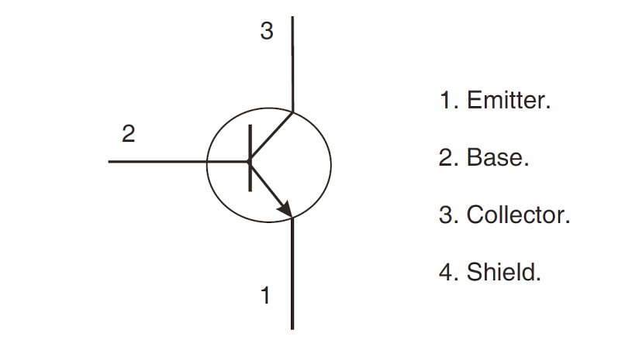
NOTES:
            - For TO-18, the collector is internally connected to the case.
            - For 3 terminal CCP (Variants 04, 05) the lid is not connected to any terminal.
            - For 4 terminal CCP (Variants 11, 12) the shielding terminal is connected to the lid.

MATERIALS AND FINISHES
Materials and finishes shall be as follows:
          - Case
For the metal can package the case shall be hermetically sealed and have a metal body with hard glass seals.
For the chip carrier package the case shall be hermetically sealed and have a ceramic body with a Kovar lid.
          - Leads/Terminals
As specified in Component Type Variants.

REQUIREMENTS

GENERAL
The complete requirements for procurement of the components specified herein are as stated in this specification and the ESCC Generic Specification. Permitted deviations from the Generic Specification, applicable to this specification only, are listed below.
Permitted deviations from the Generic Specification and this Detail Specification, formally agreed with specific Manufacturers on the basis that the alternative requirements are equivalent to the ESCC requirement and do not affect the component’s reliability, are listed in the appendices attached to this specification.

Deviations from the Generic Specification
          - Deviation from Screening Tests - Chart F3
High Temperature Reverse Bias Burn-in and the subsequent Final Measurements for HTRB shall be omitted.

MARKING
The marking shall be in accordance with the requirements of ESCC Basic Specification No. 21700 and as follows.
The information to be marked on the component shall be:
          - The ESCC qualified components symbol (for ESCC qualified components only).
          - The ESCC Component Number.
          - Traceability information.

TERMINAL STRENGTH
The test conditions for terminal strength, tested as specified in the ESCC Generic Specification, shall be as follows:
For TO-18, Test Condition: E, lead fatigue.

ELECTRICAL MEASUREMENTS AT ROOM, HIGH AND LOW TEMPERATURES
Electrical measurements shall be performed at room, high and low temperatures.

Room Temperature Electrical Measurements
The measurements shall be performed at T_{amb} = +22 ±3°C.
Characteristics | Symbols | MIL-STD-750  Test Method | Test Conditions | Limits |  | Units
 |  |  |  | Min | Max | Units
Collector-Base Breakdown Voltage | V_{(BR)CBO} | 3001 | I_{C} = 100µA  Bias Condition D | 75 | - | V
Collector-Emitter Breakdown Voltage | V_{(BR)CEO} | 3011 | Bias Condition D  Note 1  I_{C} = 10mA | 50 | - | V
Emitter-Base Breakdown Voltage | V_{(BR)EBO} | 3026 | I_{E} = 100µA  Bias Condition D | 6 | - | V
Collector-Base Cut-off Current | I_{CBO} | 3036 | V_{CB} = 60V  Bias Condition D | - | 10 | nA
Emitter-Base Cut-off Current | I_{EBO} | 3061 | V_{EB} = 3V  Bias Condition D | - | 10 | nA
Collector-Emitter Saturation Voltage | V_{CE(sat)} | 3071 | I_{C} = 150mA, I_{B} = 15mA  Note 1 | - | 300 | mV
Base-Emitter Saturation Voltage | V_{BE(sat)} | 3066 | I_{C} = 150mA, I_{B} = 15mA  Note 1 | - | 1.2 | V
Forward-Current Transfer Ratio | h_{FE1} | 3076 | V_{CE} = 10V, I_{C} = 100µA | 35 | - | -
Forward-Current Transfer Ratio | h_{FE2} | 3076 | V_{CE} = 10V, I_{C} = 10mA | 75 | - | -
Forward-Current Transfer Ratio | h_{FE3} | 3076 | V_{CE} = 10V, I_{C} = 150mA  Note 1 | 100 | 300 | -
Forward-Current Transfer Ratio | h_{FE4} | 3076 | V_{CE} = 10V, I_{C} = 500mA  Note 1 | 40 | - | -
Small-Signal Forward-Current Transfer Ratio | |h_{fe}| | 3306 | V_{CE} = 20V, I_{C} = 20mA  f = 100MHz  Note 2 | 2.5 |  | -
Output Capacitance | C_{obo} | 3236 | V_{CB} = 10V, I_{E} = 0A  100kHz ≤ f ≤ 1MHz  Note 2 | - | 8 | pF
Turn-on Time | t_{on} | - | I_{C} = 150mA  I_{B} = 15mA  Notes 2, 3 | - | 35 | ns
Turn-off Time | t_{off} | - | I_{C} = 150mA  I_{B} = 15mA  Notes 2, 4 | - | 285 | ns
NOTES:
            - Pulse measurement: Pulse Width ≤ 25ms, Duty Cycle ≤ 1%.
            - For AC characteristics read and record measurements shall be performed on a sample of 32 components with 0 failures allowed. Alternatively a 100% inspection may be performed.
            - t_{on} shall be measured using the following test circuit. The input waveform shall be supplied by a pulse generator with the following characteristics: Z_{OUT} = 50Ω, t_{r} ≤ 2ns, Pulse Width = 200 ±10ns, Duty Cycle ≤ 2%. The input and output waveforms shall be monitored on an oscilloscope with the following: Z_{IN} ≥ 100kΩ, input capacitance ≤ 12pF, t_{r} ≤ 5ns.
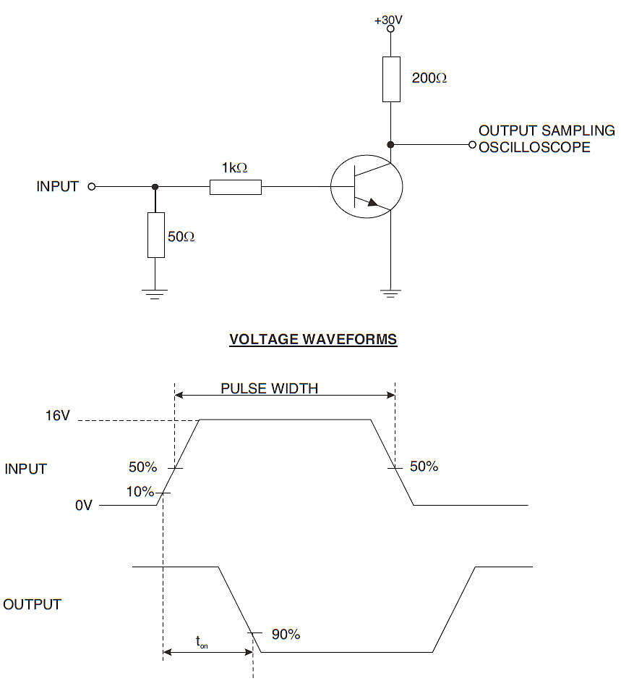
            - t_{off} shall be measured using the following test circuit. The input waveform shall be supplied by a pulse generator with the following characteristics: Z_{OUT} = 50Ω, t_{r} ≤ 2ns, Pulse Width = 10 to 100µs, Duty Cycle ≤ 2%. The input and output waveforms shall be monitored on an oscilloscope with the following characteristics: Z_{IN} ≥ 100kΩ, input capacitance ≤ 12pF, t_{r} ≤ 5ns.
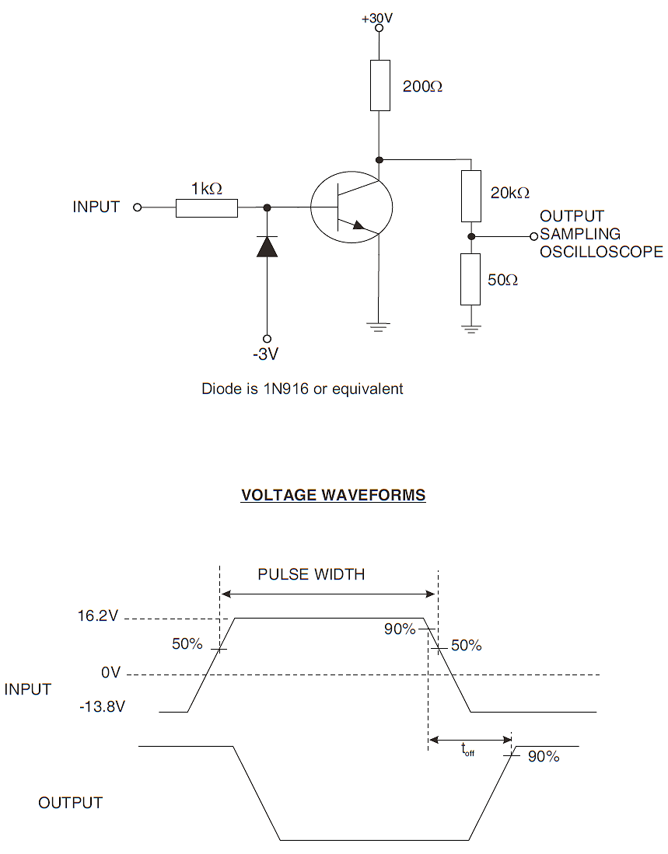

High and Low Temperatures Electrical Measurements
Characteristics | Symbols | MIL-STD-750  Test Method | Test Conditions  Note 1 | Limits |  | Units
 |  |  |  | Min | Max | Units
Collector-Base Cut-off Current | I_{CBO} | 3036 | T_{amb} = +150 (+0 -5)°C  V_{CB} = 60V, Bias Condition D | - | 10 | µA
Forward-Current Transfer Ratio 2 | h_{FE2} | 3076 | T_{amb} = -55 (+5 -0)°C  V_{CE} = 10V  I_{C} = 10mA | 35 | - | -
NOTES:
            - Read and record measurements shall be performed on a sample of 5 components with 0 failures allowed. Alternatively a 100% inspection may be performed.

PARAMETER DRIFT VALUES
Unless otherwise specified, the measurements shall be performed at T_{amb} = +22 ±3°C.
The test methods and test conditions shall be as per the corresponding test defined in Room Temperature Electrical Measurements.
The drift values (Δ) shall not be exceeded for each characteristic specified. The corresponding absolute limit values for each characteristic shall not be exceeded.
Characteristics | Symbols | Limits |  |  | Units
Characteristics | Symbols | Drift  Value  Δ | Absolute |  | Units
Characteristics | Symbols | Drift  Value  Δ | Min | Max | Units
Collector-Base Cut-off Current | I_{CBO} | ±5  or (1) ±100% | - | 10 | nA
Collector-Emitter Saturation Voltage | V_{CE(sat)} | ±30  or (1) ±15% | - | 300 | mV
Forward-Current Transfer Ratio 3 | h_{FE3} | ±15% | 100 | 300 | -
NOTES:
            - Whichever is the greater referred to the initial value.

INTERMEDIATE AND END-POINT ELECTRICAL MEASUREMENTS
Unless otherwise specified, the measurements shall be performed at T_{amb} = +22 ±3°C.
The test methods and test conditions shall be as per the corresponding test defined in Room Temperature Electrical Measurements.
The limit values for each characteristic shall not be exceeded.
Characteristics | Symbols | Limits |  | Units
Characteristics | Symbols | Min | Max | Units
Collector-Base Cut-off Current | I_{CBO} | - | 10 | nA
Collector-Emitter Saturation Voltage | V_{CE(sat)} | - | 300 | mV
Forward-Current Transfer Ratio 3 | h_{FE3} | 100 | 300 | -

POWER BURN-IN CONDITIONS
Characteristics | Symbols | Test Conditions | Units
Ambient Temperature | T_{amb} | +20 to +50 | °C
Power Dissipation | P_{tot} | As per Maximum Ratings.  Derate P_{tot1} at the chosen Tamb using the specified R_{th(j-a)}. | W
Collector-Base Voltage | V_{CB} | 10 to 40 | V

OPERATING LIFE CONDITIONS
The conditions shall be as specified for Power Burn-in.

TOTAL DOSE RADIATION TESTING
All lots shall be irradiated in accordance with ESCC Basic Specification No. 22900, low dose rate (window 2: 36 to 360 RAD/h).

Bias Conditions and Total Dose Level for Total Dose Radiation Testing
The following bias conditions shall be used for Total Dose Radiation Testing:
Characteristics | Symbols | Test Conditions | Units
Ambient Temperature | T_{amb} | +20 ±5 | °C
Bias Condition 1:  Collector-Emitter Voltage | V_{CES} | ≥ 80% V_{(BR)CEO} | V
Bias Condition 2:  Collector-Emitter Voltage | V_{CES} | 0 | V
The total dose level applied shall be as specified in the component type variant information herein or in the Purchase Order.

Electrical Measurements for Radiation Testing
Prior to irradiation testing the devices shall have successfully met Room Temperature Electrical Measurements specified herein.
Unless otherwise stated the measurements shall be performed at T_{amb} = +22 ±3°C.
Unless otherwise specified the test methods and test conditions shall be as per the corresponding test defined in Room Temperature Electrical Measurements.
The parameters to be measured during and on completion of irradiation testing are shown below.
Characteristics | Symbols | MIL-STD-750  Test Method | Test Conditions | Limits |  | Units
 |  |  |  | Min | Max | Units
Collector-Base Breakdown Voltage | V_{(BR)CBO} | See Room Temperature Electrical Measurements | See Room Temperature Electrical Measurements | 75 | - | V
Collector-Emitter Breakdown Voltage | V_{(BR)CEO} | See Room Temperature Electrical Measurements | See Room Temperature Electrical Measurements | 50 | - | V
Emitter-Base Breakdown Voltage | V_{(BR)EBO} | See Room Temperature Electrical Measurements | See Room Temperature Electrical Measurements | 6 | - | V
Collector-Base Cut-off Current | I_{CBO} | See Room Temperature Electrical Measurements | See Room Temperature Electrical Measurements | - | 10 | nA
Emitter-Base Cut-off Current | I_{EBO} | See Room Temperature Electrical Measurements | See Room Temperature Electrical Measurements | - | 10 | nA
Collector-Emitter  Saturation Voltage | V_{CE(sat)} | See Room Temperature Electrical Measurements | See Room Temperature Electrical Measurements | - | 300 | mV
Base-Emitter Saturation Voltage | V_{BE(sat)} | See Room Temperature Electrical Measurements | See Room Temperature Electrical Measurements | - | 1.2 | V
Forward-Current Transfer Ratio (post irradiation gain calculation) (Note 1) | [h_{FE1}] | 3076 | V_{CE} = 10V, I_{C} = 100µA | [17.5] | - | -
 | [h_{FE2}] | 3076 | V_{CE} = 10V, I_{C} = 10mA | [37.5] | - | -
 | [h_{FE3}] | 3076 | V_{CE} = 10V, I_{C} = 150mA | [50] | 300 | -
 | [h_{FE4}] | 3076 | V_{CE} = 10V, I_{C} = 500mA | [20] | - | -
NOTES:
            - The post-irradiation gain calculation of [h_{FE}], made using h_{FE} measurements from prior to and on completion of irradiation testing and after each annealing step if any, shall be as specified in MIL-STD-750 Method 1019.

APPENDIX ‘A’
AGREED DEVIATIONS FOR STMICROELECTRONICS (F)
ITEMS AFFECTED | DESCRIPTION OF DEVIATIONS
Deviations from Production Control -  Chart F2 | Special In-Process Controls - Internal Visual Inspection.  For CCP packages the criteria specified for voids in the fillet and minimum die mounting material around the visible die perimeter for die mounting defects may be omitted providing that a radiographic inspection to verify the die-attach process is performed on a sample basis in accordance with STMicroelectronics procedure 0076637.
Deviations from Room Temperature Electrical Measurements | All AC characteristics (Room Temperature Electrical Measurement Note 2) may be considered guaranteed but not tested if successful pilot lot testing has been performed on the wafer lot which includes AC characteristic measurements per the Detail Specification.  A summary of the pilot lot testing shall be provided if required by the Purchase Order.
Deviations from High and Low Temperatures Electrical Measurements | All characteristics specified may be considered guaranteed but not tested if successful pilot lot testing has been performed on the wafer lot which includes characteristic measurements at high and low temperatures per the Detail Specification. A summary of the pilot lot testing shall be provided if required by the Purchase Order.
Deviations from Screening Tests - Chart F3 | Solderability is not applicable unless specifically stipulated in the Purchase Order.

