

Page 1 of 10
ISOLATORS AND CIRCULATORS, LOW POWER, Ka-BAND (22GHz – 32GHz), WITH NON-INTEGRAL SMA 2.9 COAXIAL CONNECTORS
BASED ON TYPEs BK1xxx and BK3xxx
ESCC Detail Specification No. 3202/026

Issue 2 Draft A | January 2016



Document Custodian: European Space Agency – see https://escies.org

Legal Disclaimer and Copyright
European Space Agency, Copyright © 2016. All rights reserved.
The European Space Agency disclaims any liability or responsibility, to any person or entity, with respect to any loss or damage caused, or alleged to be caused, directly or indirectly by the use and application of this ESCC publication.
This publication, without the prior permission of the European Space Agency and provided that it is not used for a commercial purpose, may be:
- copied in whole, in any medium, without alteration or modification.
- copied in part, in any medium, provided that the ESCC document identification, comprising the ESCC symbol, document number and document issue, is removed.

DOCUMENTATION CHANGE NOTICE
(Refer to https://escies.org for ESCC DCR content)
DCR No. | CHANGE DESCRIPTION

TABLE OF CONTENTS
1 General 5
1.1 SCOPE 5
1.2 APPLICABLE DOCUMENTS 5
1.3 TERMS, DEFINITIONS, ABBREVIATIONS, SYMBOLS AND UNITS 5
1.4 THE ESCC COMPONENT NUMBER and COMPONENT TYPE VARIANTS 5
1.4.1 The ESCC Component Number 5
1.4.2 Component Type Variants 5
1.4.3 Manufacturer Specific Component Identification 6
1.5 MAXIMUM RATINGS 6
1.6 Handling Precautions 6
1.7 PHYSICAL DIMENSIONS 7
1.8 functional diagram 8
1.8.1 Variant 01 – Isolators 8
1.8.2 Variant 02 – Circulators 8
1.9 MATERIALS AND FINISHES 8
2 REQUIREMENTS 9
2.1 GENERAL 9
2.1.1 Deviations from the Generic Specification 9
2.2 MARKING 9
2.3 ELECTRICAL MEASUREMENTS AT ROOM, HIGH AND LOW TEMPERATURES 9
2.3.1 Room Temperature Electrical Measurements 9
2.3.2 High and Low Temperatures Electrical Measurements 10
2.4 INTERMEDIATE AND END-POINT ELECTRICAL MEASUREMENTS 10

General

SCOPE
This specification details the ratings, physical and electrical characteristics and test and inspection data for the component type variants and/or the range of components specified below. It supplements the requirements of, and shall be read in conjunction with, the ESCC Generic Specification listed under Applicable Documents.

APPLICABLE DOCUMENTS
The following documents form part of this specification and shall be read in conjunction with it:
          - ESCC Generic Specification No. 3202.
          - ESCC Detail Specification No. 3402/021, RF Coaxial Connectors Type SMA 2.9 (Male Contact).
          - ESCC Detail Specification No. 3402/022, RF Coaxial Connectors Type SMA 2.9 (Female Contact).

TERMS, DEFINITIONS, ABBREVIATIONS, SYMBOLS AND UNITS
For the purpose of this specification, the terms, definitions, abbreviations, symbols and units specified in ESCC Basic Specification No. 21300 shall apply.

THE ESCC COMPONENT NUMBER and COMPONENT TYPE VARIANTS

The ESCC Component Number
The ESCC Component Number shall be constituted as follows:
Example: 320202601A1234
- Detail Specification Reference: 3202026
- Component Type Variant Number: 01 (as required)
- Manufacturer Specific Component Identification: A1234 (as applicable), where:
- A: the first letter of the applicable Manufacturer’s name.
- 1234: a unique 4-digit number, sequentially allocated by the applicable Manufacturer, for each individual Component Design Drawing.

Component Type Variants
The component type variants applicable to this specification are as follows:
Variant Number | Based on Type | Description | Maximum Weight  (g)
01 | BK1xxx | Isolator with Non-integral Male or Female Coaxial Connectors in accordance with ESCC No. 3402/021 or ESCC No. 3402/022 | 21
02 | BK3xxx | Circulator with Non-integral Male or Female Coaxial Connectors in accordance with ESCC No. 3402/021 or ESCC No. 3402/022 | 23

Manufacturer Specific Component Identification
A Component Design Drawing shall be produced by the Manufacturer after negotiation with the Orderer and shall be held under configuration control by the Manufacturer who will allocate a unique Manufacturer Specific Component Identification sequentially when a request for an isolator or circulator is received.
Each Component Design Drawing shall include the following information:
- The ESCC Component Number including the Manufacturer Specific Component Identification.
- Physical and mechanical details as follows:
- Component Type (isolator or circulator)
- The non-integral coaxial connectors (and contacts) including the applicable ESCC Component Number(s) and ESCC Detail Specification(s)
- Component physical configuration, i.e. the locations of the connectors (and load for isolators)
- Port identification number marking which gives the specified signal direction.
- The required centre frequency and operating frequency range (f_{min} – f_{max}) (see Maximum Ratings).

MAXIMUM RATINGS
The maximum ratings shall not be exceeded at any time during use or storage.
Maximum ratings shall only be exceeded during testing to the extent specified in this specification and when stipulated in Test Methods and Procedures of the ESCC Generic Specification.
Characteristics | Symbols | Maximum Ratings | Units | Remarks
Centre Frequency Range | f_{C} | 22 – 32 | GHz | Note 1
Rated RF Power (Forward) | P_{F} | 1 | W
Rated RF Power (Reverse) | P_{R} | 0.5 | W
Functional Temperature Range | T_{func} | -30 to +115 | °C | T_{amb}  Note 2
Operating Temperature Range | T_{op} | -30 to +85 | °C | T_{amb}
Storage Temperature Range | T_{stg} | -40 to +115 | °C
NOTES:
            - The centre frequency of the component shall be defined in the Component Design Drawing and shall be within the centre frequency range. The best available centre frequency resolution is 0.1GHz. The maximum bandwidth (f_{min} – f_{max}, i.e. the Operating Frequency Range) over which device performance per Room Temperature Electrical Measurements and High and Low Temperatures Electrical Measurements specified herein is guaranteed is ±7% of the centre frequency.
            - The electrical performance of the components at T_{amb} > +85°C is neither guaranteed nor measured.

Handling Precautions
These devices are susceptible to damage by strong magnetic fields. Therefore suitable precautions shall be employed for protection during all phases of manufacture, testing, packaging, shipment and any handling.

PHYSICAL DIMENSIONS
All dimensions shown below are critical dimensions.
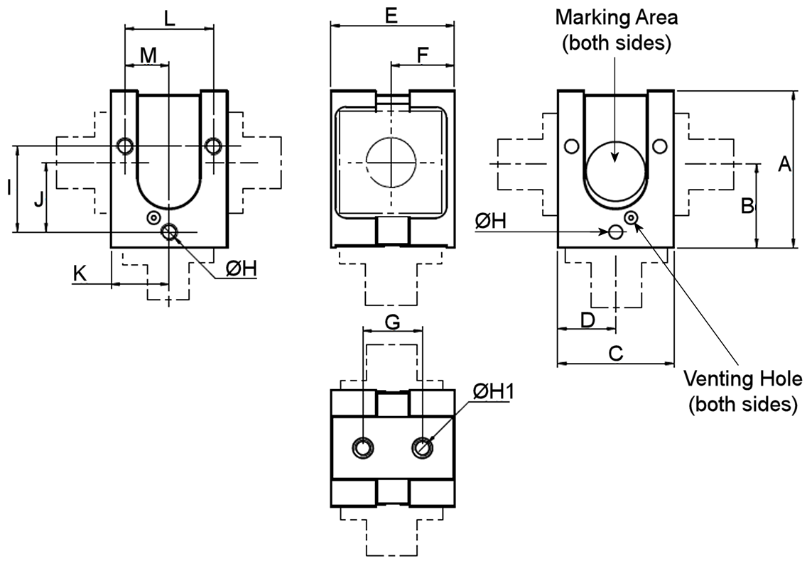
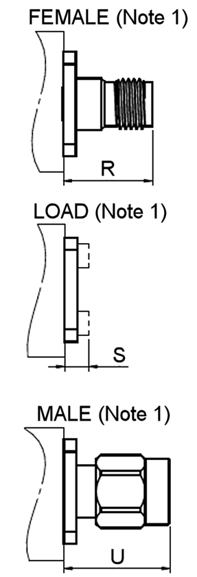 | SYMBOL | MILLIMETRES |  | NOTES
 | SYMBOL | MIN. | MAX. | NOTES
 | A | 18.35 | 18.55
 | B | 9.52 | 10.52
 | C | 13.6 | 13.8
 | D | 6.35 | 7.35
 | E | 14.1 | 15.1
 | F | 7.2 | 7.8
 | G | 6.7 | 7.3
 | ØH | M2 |  | 2
 | ØH1 | M2 |  | 3
 | I | 10 | 10.2
 | J | 7.9 | 8.5
 | K | 6.75 | 6.95
 | L | 10.2 | 10.6
 | M | 5.1 | 5.3
 | R | 10.57 | 10.74 | 4
 | S | - | 2.8
 | U | 12.83 | 12.89 | 5
NOTES:
            - For each component, the physical characteristics of the 3 ports shall be defined in the Component Design Drawing. For Variant 01 (isolators) one port shall be a load and the two remaining ports may be any combination of Male and Female SMA 2.9 coaxial connectors per ESCC Nos. 3402/021 and 3402/022. For Variant 02 (circulators) each port may be either a Male or Female SMA 2.9 coaxial connector per ESCC No. 3402/021 or ESCC No. 3402/022.
            - 6 places. Hole depth ≥ 3mm.
            - 2 places. Hole depth ≥ 5mm.
            - Full dimensions of the Female SMA 2.9 interface are specified in ESCC No. 3402/022.
            - Full dimensions of the Male SMA 2.9 interface are specified in ESCC No. 3402/021.

functional diagram

Variant 01 – Isolators
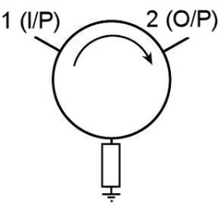
The 3 ports may be configured as either the Input, Output or Load. The signal direction is given by the port identification numbers. The port identification number marking shall be as specified in the Component Design Drawing.

Variant 02 – Circulators
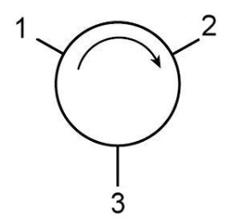
Port number 1 may be assigned to any of the 3 ports and shall be as specified in the Component Design Drawing. The signal direction (e.g. 1→2, 2→3, 3→1) is given by the port identification numbers.

MATERIALS AND FINISHES
          - Main Body: Aluminium, silver plated, plating thickness 13µm minimum.
          - Yoke: Steel, nickel plated, plating thickness 5µm minimum.
          - Coaxial Connectors: In accordance with ESCC No. 3402/021 or ESCC No. 3402/022, as applicable.
          - Load (applicable to Variant 01 (isolators) only): The load shall be made of a suitable absorptive material.

REQUIREMENTS

GENERAL
The complete requirements for procurement of the components specified herein are as stated in this specification and the ESCC Generic Specification. Permitted deviations from the Generic Specification, applicable to this specification only, are listed below.
Permitted deviations from the Generic Specification and this Detail Specification, formally agreed with specific Manufacturers on the basis that the alternative requirements are equivalent to the ESCC requirement and do not affect the component’s reliability, are listed in the appendices attached to this specification.

Deviations from the Generic Specification
None.

MARKING
The marking shall be in accordance with the requirements of ESCC Basic Specification No. 21700 and as follows.
The information to be marked on the component shall be:
          - Port identification numbers.
          - The ESCC qualified components symbol (for ESCC qualified components only).
          - The ESCC Component Number.
          - Traceability information.

ELECTRICAL MEASUREMENTS AT ROOM, HIGH AND LOW TEMPERATURES
The measurements shall be performed at room, high and low temperatures.

Room Temperature Electrical Measurements
The measurements shall be performed at T_{amb} = +22 ±3ºC.
Characteristics | Symbols | Test Method and Conditions  (Note 1) | Limits |  | Units
Characteristics | Symbols | Test Method and Conditions  (Note 1) | Min | Max | Units
Voltage Standing Wave Ratio | VSWR | ESCC No. 3202 | - | 1.15 | -
Isolation | ISO | ESCC No. 3202 | 23 | - | dB
Insertion Loss | I_{L} | ESCC No. 3202 | - | 0.6 | dB
Insertion Loss Variation | I_{LR} | Note 2 | - | 0.1 | dBp-p
NOTES:
            - Tested over the full operating frequency range specified in the applicable Component Design Drawing.
            - Calculated from the minimum and maximum values of Insertion Loss measured over the full operating frequency range.

High and Low Temperatures Electrical Measurements
The measurements shall be performed at T_{amb} = +85 (+0 -3)°C and T_{amb} = -30 (+3 -0)°C.
Characteristics | Symbols | Test Method and Conditions  (Note 1) | Limits |  | Units
Characteristics | Symbols | Test Method and Conditions  (Note 1) | Min | Max | Units
Voltage Standing Wave Ratio | VSWR | ESCC No. 3202 | - | 1.22 | -
Isolation | ISO | ESCC No. 3202 | 20 | - | dB
Insertion Loss | I_{L} | ESCC No. 3202 | - | 0.6 | dB
NOTES:
            - Tested over the full operating frequency range specified in the applicable Component Design Drawing.

INTERMEDIATE AND END-POINT ELECTRICAL MEASUREMENTS
Unless otherwise specified, the measurements shall be performed at T_{amb} = +22 ±3°C.
Unless otherwise specified, test methods and test conditions shall be as per the corresponding test defined in Room Temperature Electrical Measurements.
The drift values (Δ) shall not be exceeded for each characteristic where specified. The corresponding absolute limit values for each characteristic shall not be exceeded.
Test Reference per  ESCC No. 3202 | Characteristics | Symbols | Limits |  | Units
Test Reference per  ESCC No. 3202 | Characteristics | Symbols | Min | Max | Units
Random Vibration  Final Measurements | Voltage Standing Wave Ratio  Isolation  Insertion Loss | VSWR  ISO  I_{L} | -  23  - | 1.15  -  0.6 | -  dB  dB
Shock  Final Measurements | Voltage Standing Wave Ratio  Isolation  Insertion Loss | VSWR  ISO  I_{L} | -  23  - | 1.15  -  0.6 | -  dB  dB
Thermal Shock  Final Measurements | Voltage Standing Wave Ratio  Isolation  Insertion Loss | VSWR  ISO  I_{L} | -  23  - | 1.15  -  0.6 | -  dB  dB
Thermal Stability of Insertion Loss | Continuous monitoring of Insertion Loss | IL | As per ESCC No. 3202 |  | -
Radiated Emission Sniff Test | Shielding Effectiveness | SE | 70 | - | dBi

