ESCC Detail Specification PAGE 15
No. 3401/031 ISSUE 6

FIGURE 2.2 – UNISULATED SOLID WIRES
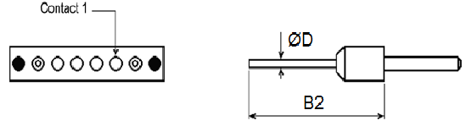
FR116 – Plug (pin contacts) FR116 – Receptacle (socket contact)
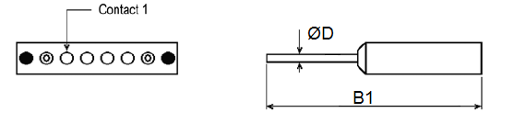
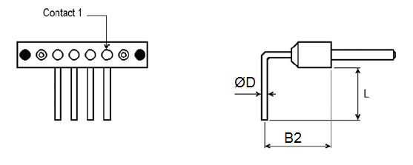
FR116 C – Plug (pin contacts) FR116 C – Receptacle (socket contact)
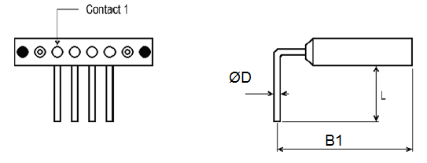
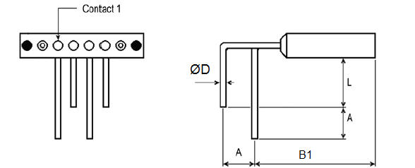
FR116 D1 – Plug (pin contacts) FR116 D1 – Receptacle (socket contact)
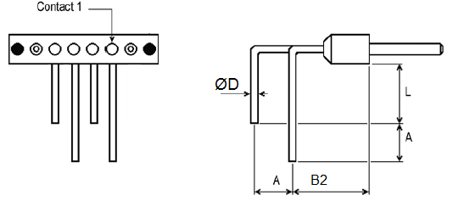

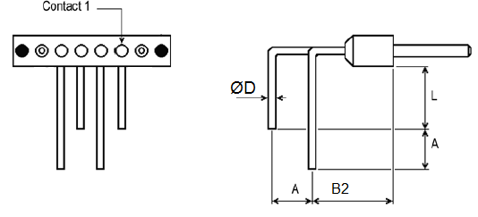
FR116 D2 – Plug (pin contacts) FR116 D2 – Receptacle (socket contact)
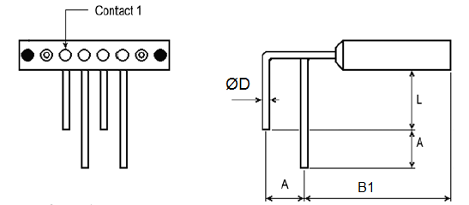
Terminations code | FR116 | FR116 C | FR116 D1 | FR116 D2
Wire Size AWG | 25 | 25 | 25 | 25
Max Diameter ‘D’ (mm) | 0.51 | 0.51 | 0.51 | 0.51
Min Diameter ‘D’ (mm) | 0.40 | 0.40 | 0.40 | 0.40
Max Weight (g/m) | 1.6 | 1.6 | 1.6 | 1.6
L min (mm) | - | (4) 6 | 4) 6 | 4) 6
A (mm) | - | 2.54 Typ | 2.54 Typ. | 2.54 Typ.
B1 (mm) | 32.6 min | 9.73 Typ. | 9.73 Typ. | 9.73 Typ.
B2 (mm) | 28 min | 5.08 Typ. | 5.08 Typ. | 5.08 Typ.

FIGURE 2.3 INSULATED WIRES
Plug (pin contact) Receptacle (socket contact)
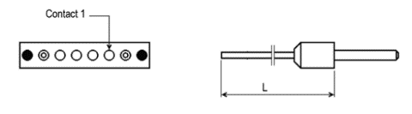
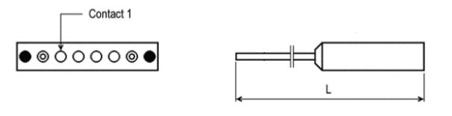

Miminum length : See Para 4.5.4.3

