ESCC Detail Specification PAGE 13
No. 3401/031 ISSUE 6

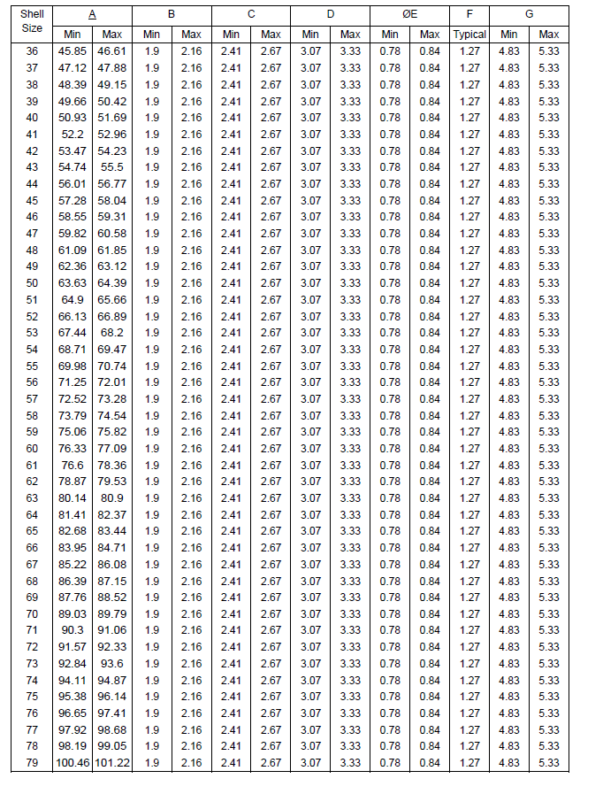
Shell Size from 51 to 81 to be removed
Shell Size to be replaced by Insert Size

