ESCC Detail Specification PAGE 10
No. 3401/031 ISSUE 6
Shell Size to be replaced by Insert Size

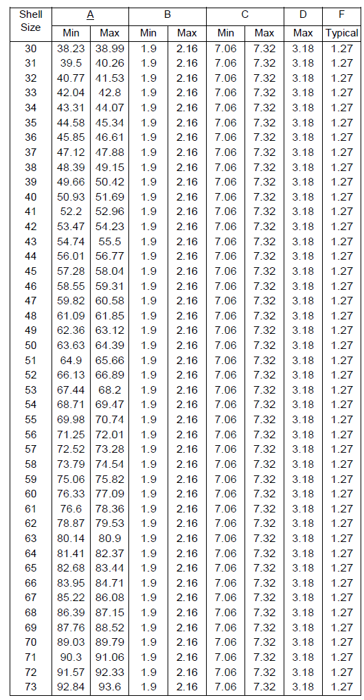
Size from 51 to 81 to be removed

