
Pages 1 to 23
SAW FILTERS, HERMETICALLY SEALED, SURFACE MOUNT
FREQUENCY RANGE 10MHZ - 4GHZ
ESCC Detail Specification No. 3502/002
Issue 3 | Not issued yet

Document Custodian: European Space Agency - see https://escies.org

LEGAL DISCLAIMER AND COPYRIGHT
European Space Agency, Copyright © 2011. All rights reserved.
The European Space Agency disclaims any liability or responsibility, to any person or entity, with respect to any loss or damage caused, or alleged to be caused, directly or indirectly by the use and application of this ESCC publication.
This publication, without the prior permission of the European Space Agency and provided that it is not used for a commercial purpose, may be:
- copied in whole, in any medium, without alteration or modification.
- copied in part, in any medium, provided that the ESCC document identification, comprising the ESCC symbol, document number and document issue, is removed.

DOCUMENTATION CHANGE NOTICE
(Refer to https://escies.org for ESCC DCR content)
DCR No. | CHANGE DESCRIPTION
1.4.2 and 1.7: New package types (14 and 15) added
1.7: Clarification added: GND on package base required
All figures in 1.7 updated with uniform design. Minor dimension corrections.
Appendix A: New deviations described.

TABLE OF CONTENTS
1. GENERAL 5
1.1 SCOPE 5
1.2 APPLICABLE DOCUMENTS 5
1.3 TERMS, DEFINITIONS, ABBREVIATIONS, SYMBOLS AND UNITS 5
1.4 THE ESCC COMPONENT NUMBER AND COMPONENT TYPE VARIANTS 5
1.4.1 The ESCC Component Number 5
1.4.2 Component Type Variants 5
1.4.3 Manufacturer Specific SAW Filter Identification 6
1.5 MAXIMUM RATINGS 6
1.6 HANDLING PRECAUTIONS 7
1.7 PHYSICAL DIMENSIONS AND TERMINAL IDENTIFICATION 8
1.7.1 Type A - 4 Gullwing Stripline Terminals 8
1.7.2 Type B - 6 Gullwing Stripline Terminals 9
1.7.3 Type C-1 - 4 Gullwing Stripline Terminals 10
1.7.4 Type C-2 - 4 Gullwing Stripline Terminals 11
1.7.5 Type D - 10 Terminals 12
1.7.6 Type E - 12 Gullwing Stripline Terminals 13
1.7.7 Type F-1 - 8 Gullwing Stripline Terminals 14
1.7.8 Type F-2 - 8 Gullwing Stripline Terminals 15
1.7.9 Type G-1 - 16 Pre-formed Stripline Terminals 16
1.7.10 Type G-2 - 16 Formed Stripline Terminals 17
1.7.11 Type H - 26 Formed Stripline Terminals 18
1.7.12 Type I - 6 Stripline Terminals 19
1.7.13 Type J-1 - 6 Formed Stripline Terminals 20
1.7.14 Type J-2 - 6 Stripline Terminals 21
1.7.15 Type J-3 – 4 Stripline Terminals 22
1.8 FUNCTIONAL DIAGRAM 23
1.9 PIN ASSIGNMENT 23
2. REQUIREMENTS 23
2.1 GENERAL 23
2.1.1 Deviations from the Generic Specification 23
2.2 MARKING 23
2.3 ELECTRICAL MEASUREMENTS AT ROOM, HIGH AND LOW TEMPERATURES 23
2.3.1 Room Temperature Electrical Measurements 23
2.3.2 High and Low Temperatures Electrical Measurements 24
2.4 PARAMETER DRIFT VALUES 24
2.5 INTERMEDIATE AND END-POINT ELECTRICAL MEASUREMENTS 24
2.6 BURN-IN CONDITIONS 25
2.7 OPERATING LIFE CONDITIONS 25
APPENDIX ‘A’ 26

GENERAL

SCOPE
This specification details the ratings, physical and electrical characteristics and test and inspection data for the component type variants and/or the range of components specified below. It supplements the requirements of, and shall be read in conjunction with, the ESCC Generic Specification listed under Applicable Documents.

APPLICABLE DOCUMENTS
The following documents form part of this specification and shall be read in conjunction with it:
- ESCC Generic Specification No. 3502.
- MIL-STD-883, Test Methods and Procedures for Microelectronics.
- ESCC-Q-ST-70-38, High-reliability soldering for surface mount and mixed technology.

TERMS, DEFINITIONS, ABBREVIATIONS, SYMBOLS AND UNITS
For the purpose of this specification, the terms, definitions, abbreviations, symbols and units specified in ESCC Basic Specification No. 21300 shall apply.

THE ESCC COMPONENT NUMBER AND COMPONENT TYPE VARIANTS

The ESCC Component Number
The ESCC Component Number shall be constituted as follows:
Example: 350200201S#####
- Detail Specification Reference: 3502002
- Component Type Variant Number: 01
- Manufacturer Specific SAW Filter Identification: S##### (as applicable), where S##### is a unique code allocated by the Manufacturer to a specific SAW Filter design.

Component Type Variants
The component type variants applicable to this specification are as follows:
Variant Number | Case Type Code Letter | Terminal Material and / or Finish | Weight  max g
01 | A | D2 | (Note 1)
02 | B | D2 | (Note 1)
03 | C - 1 | D2 | (Note 1)
04 | C - 2 | D2 | (Note 1)
05 | D | 2 | (Note 1)
06 | E | D2 | (Note 1)
07 | F - 1 | D2 | (Note 1)
08 | F - 2 | D2 | (Note 1)
09 | G - 1 | D2 | (Note 1)
10 | G - 2 | D2 | (Note 1)
11 | H | D2 | (Note 1)
12 | I | D2 | (Note 1)
13 | J - 1 | D2 | (Note 1)
14 | J – 2 | D2 | (Note 1)
15 | J - 3 | D2 | (Note 1)

NOTES:
1. The maximum weights of the individual SAW Filters are given in the applicable SAW Filter Data Sheets.
The terminal material and/or finish shall be in accordance with the requirements of ESCC Basic
Specification No. 23500.

Manufacturer Specific SAW Filter Identification
A SAW Filter Data Sheet shall be produced by the Manufacturer, following negotiation with the Orderer that, as a minimum, specifies all the requirements unique to the specific SAW Filter design that are identified herein as being specified in a SAW Filter Data Sheet. The SAW Filter Data Sheet shall be held under configuration control by the Manufacturer.
For identification and traceability purposes the Manufacturer shall allocate a unique Manufacturer Specific SAW Filter Identification to the SAW Filter Data Sheet and the specific SAW Filter design as specified in The ESCC Component Number herein.

MAXIMUM RATINGS
The maximum ratings shall not be exceeded at any time during use or storage.
Maximum ratings shall only be exceeded during testing to the extent specified in this specification and when stipulated in Test Methods and Procedures of the ESCC Generic Specification.
Characteristics | Symbols | Maximum Ratings | Units | Remarks
Device RF Input Power  (Continuous) | PRF | See SAW Filter Data Sheet | dBm | Note 1
Operating Temperature Range | Top | See SAW Filter Data Sheet | oC | Tcase
Storage Temperature Range | Tstg | See SAW Filter Data Sheet | oC | Tcase
Soldering Temperature | Tsol | +330 | oC | Note 2

NOTES:
- Guaranteed maximum input level for an operating time ≤24 hours. Degradation of performance may
ISSUE 1
occur if the specified Maximum Continuous RF Input Power is applied for periods longer than 24 hours. A derating of 6dBm from the specified Maximum Continuous RF Input Power must be applied under normal operating conditions.
- Duration 10 seconds maximum at a distance of not less than 1.6mm from the device body and the same terminal shall not be resoldered until 3 minutes have elapsed.

HANDLING PRECAUTIONS
These devices are susceptible to damage by electrostatic discharge. Therefore, suitable precautions shall be employed for protection during all phases of manufacture, testing, packaging, shipment and any handling.
These devices must not be subjected to any DC Voltage.
These components are categorised as Class 1 per ESCC Basic Specification No. 23800.

PHYSICAL DIMENSIONS AND TERMINAL IDENTIFICATION
For all package types GND is required on base of package to obtain electrical performance according to datasheets.

Type A - 4 Gullwing Stripline Terminals
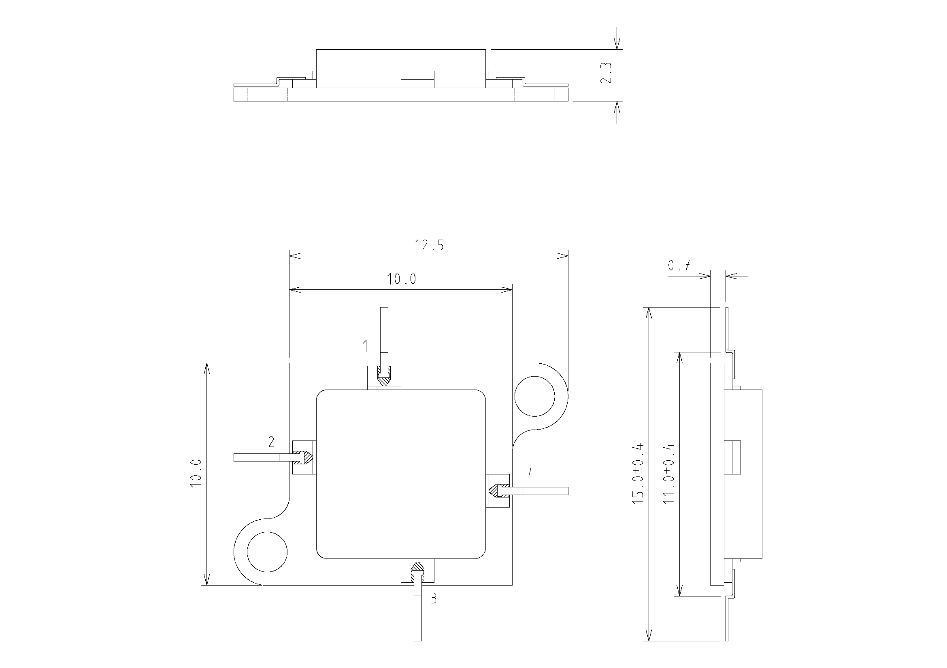

NOTES:
- All dimensions are in millimetres.
- Unless otherwise specified dimensions have a tolerance of ±0.15mm.
- Terminal identification: 1 - Input, 2 - Input Return, 3 - Output Return, 4 - Output.

Type B - 6 Gullwing Stripline Terminals
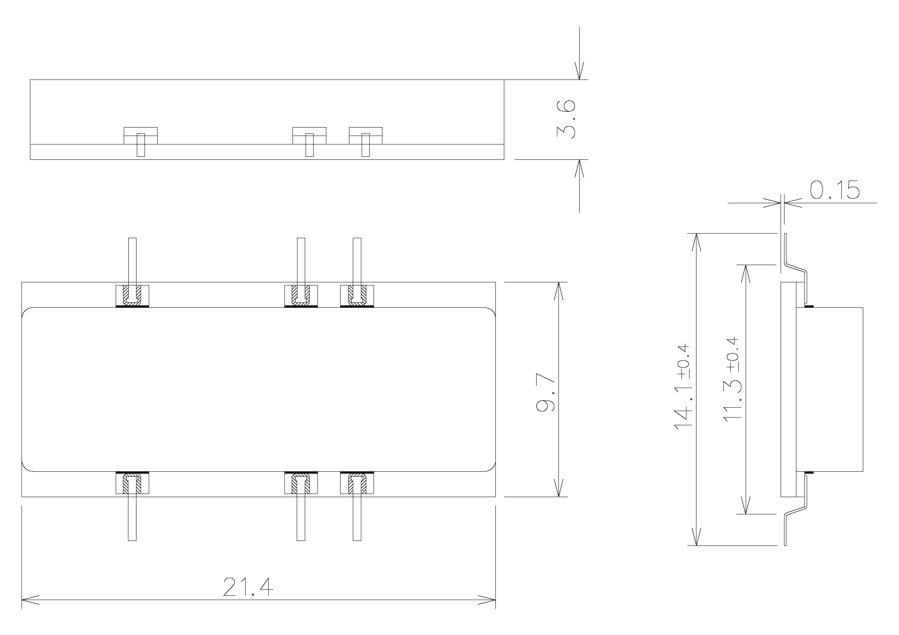

NOTES:
- All dimensions are in millimetres.
- Unless otherwise specified dimensions have a tolerance of ±0.15mm.
- Terminal identification is not applicable (the numbering and assignment of the terminals is
dependent on the specific SAW Filter design.)

Type C-1 - 4 Gullwing Stripline Terminals
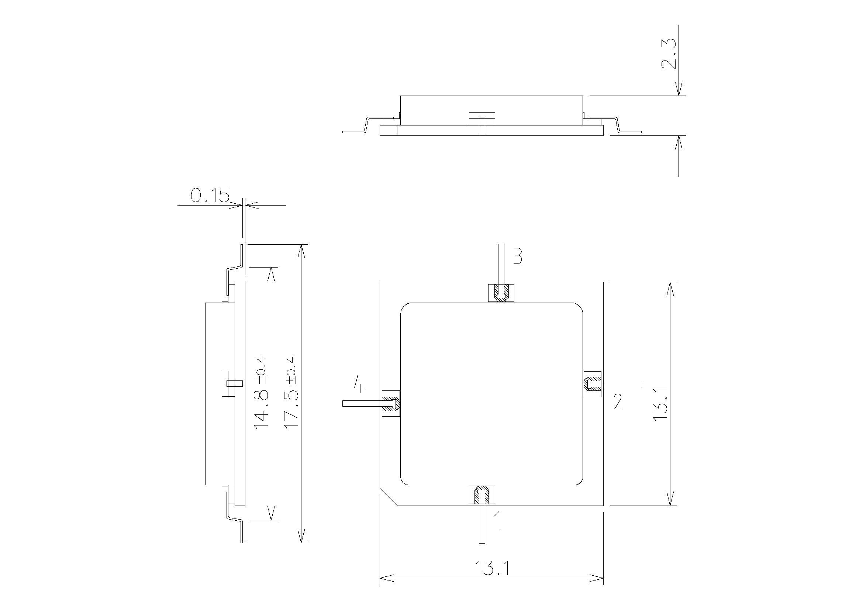

NOTES:
- All dimensions are in millimetres.
- Unless otherwise specified dimensions have a tolerance of ±0.15mm.
- Terminal identification: 1 - Input, 2 - Input Return, 3 - Output Return, 4 - Output.

Type C-2 - 4 Gullwing Stripline Terminals
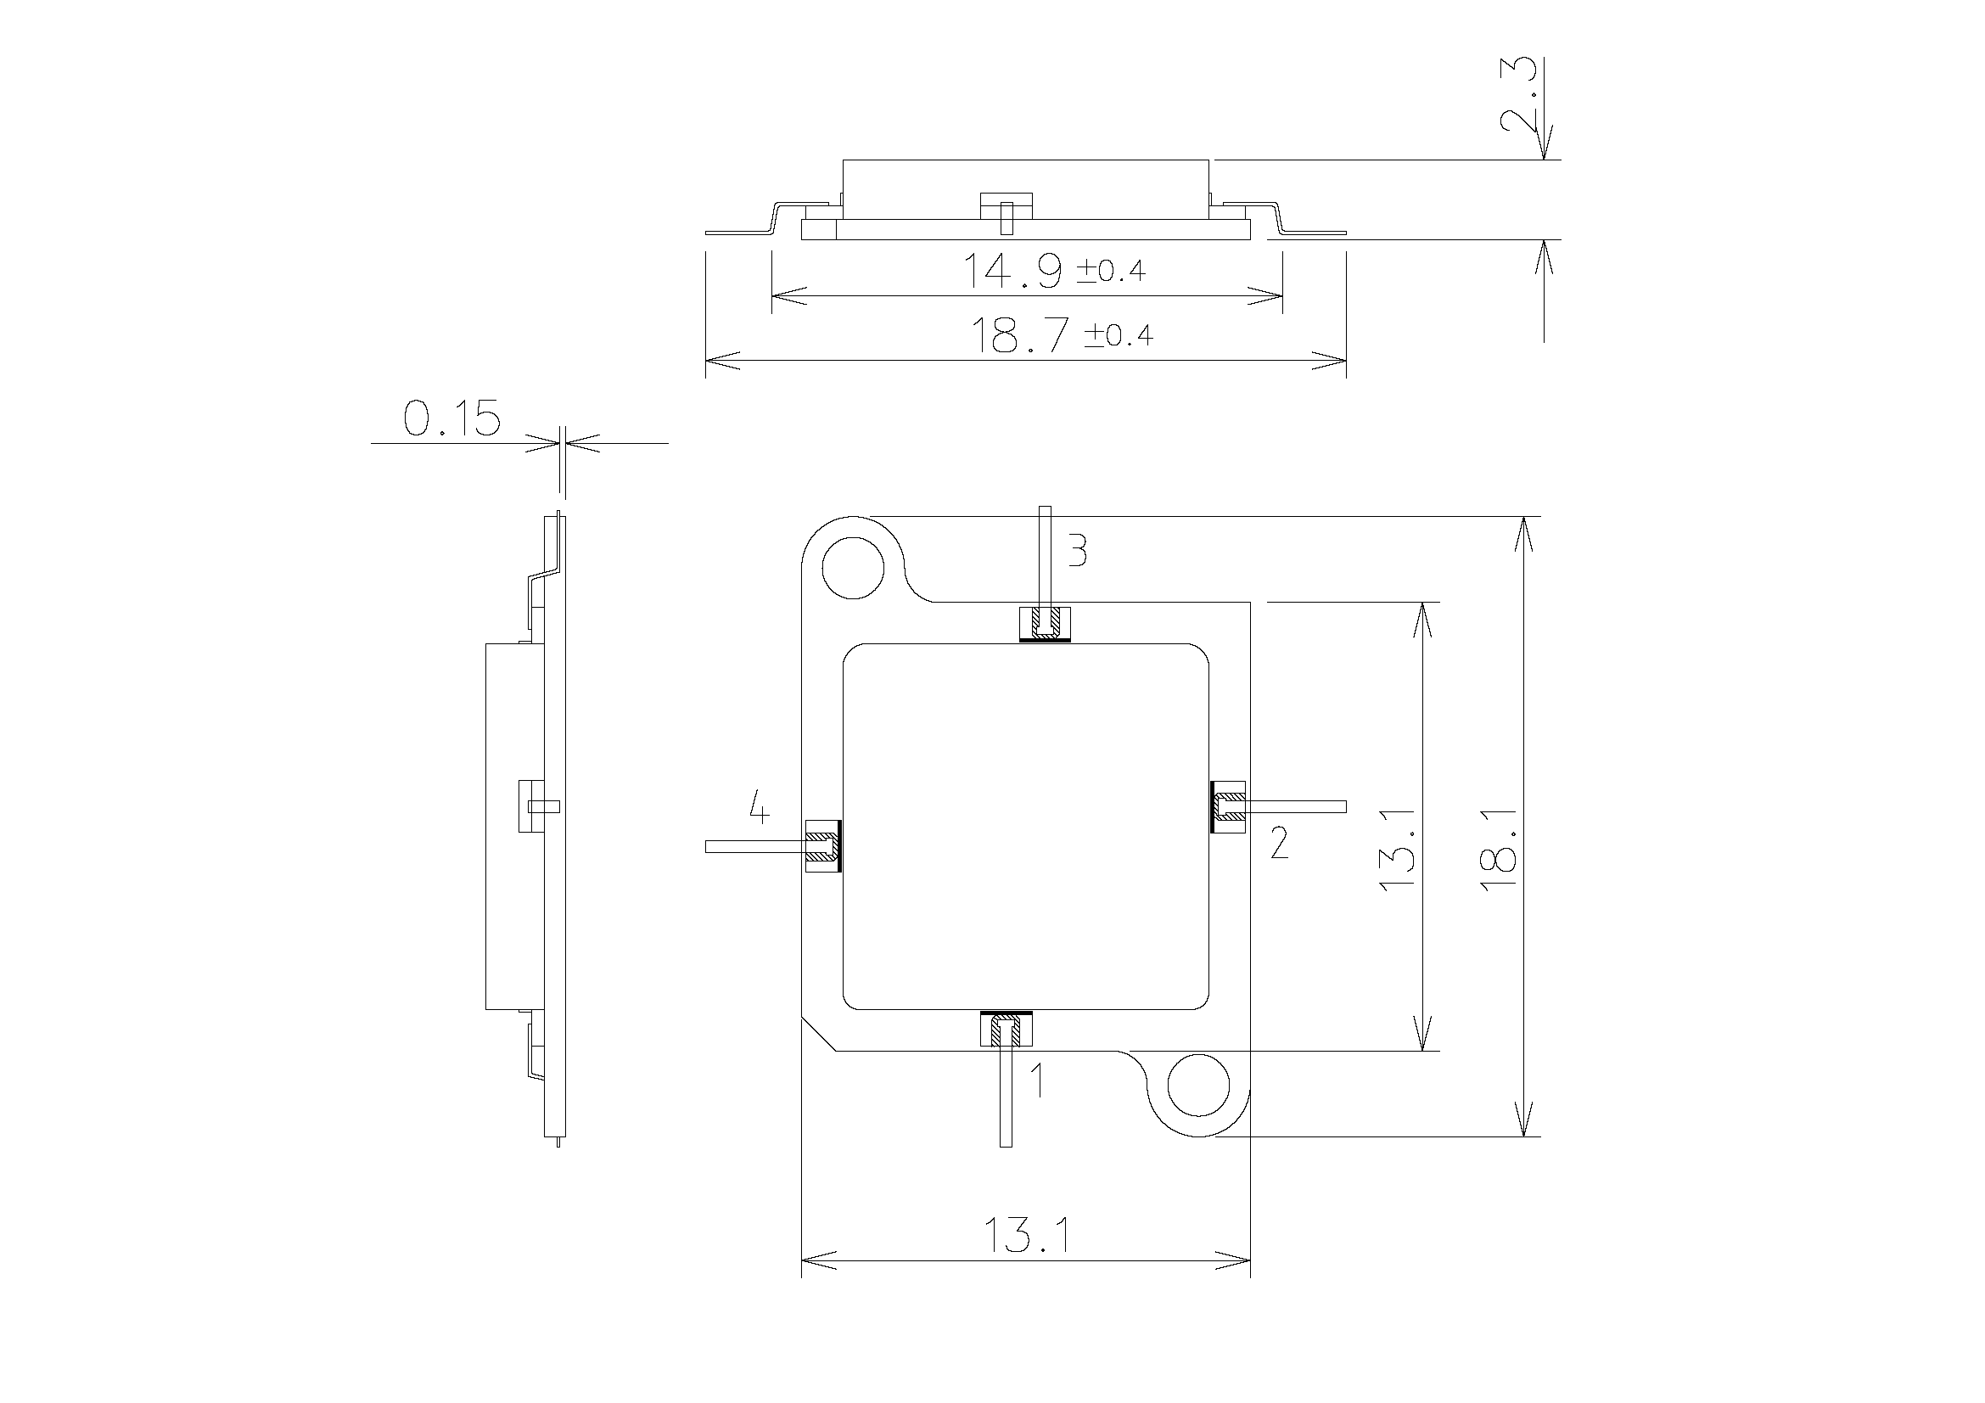

NOTES:
- All dimensions are in millimetres.
- Unless otherwise specified dimensions have a tolerance of ±0.15mm.
- Terminal identification: 1 - Input, 2 - Input Return, 3 - Output Return, 4 - Output.

Type D - 10 Terminals
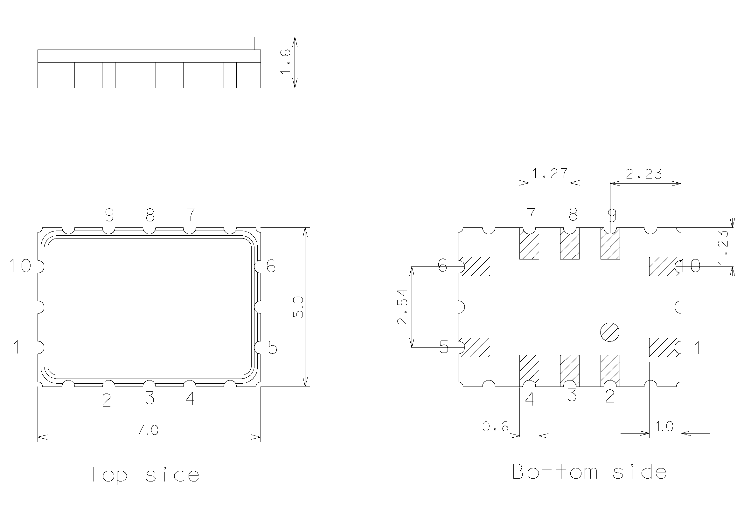

NOTES:
- All dimensions are in millimetres.
- The tolerance on all dimensions is ±0.15mm.
- Terminal identification is dependent on the configuration of the SAW Filter.
  - Differential input and output:
1 - Input Return
2, 3, 4, 7, 8, 9 - GND
    - - Output
    - - Output Return10 - Input
  - Differential input, single ended output:
1 - Input Return
2, 3, 4, 6, 7, 8, 9 - GND
    - - Output10 - Input
  - Single-ended input, differential output:
1, 2, 3, 4, 7, 8, 9 - GND
    - - Output
    - - Output Return
10 - Input
For all configurations, terminals 2, 3, 4 and 7, 8, 9 are internally connected.

Type E - 12 Gullwing Stripline Terminals
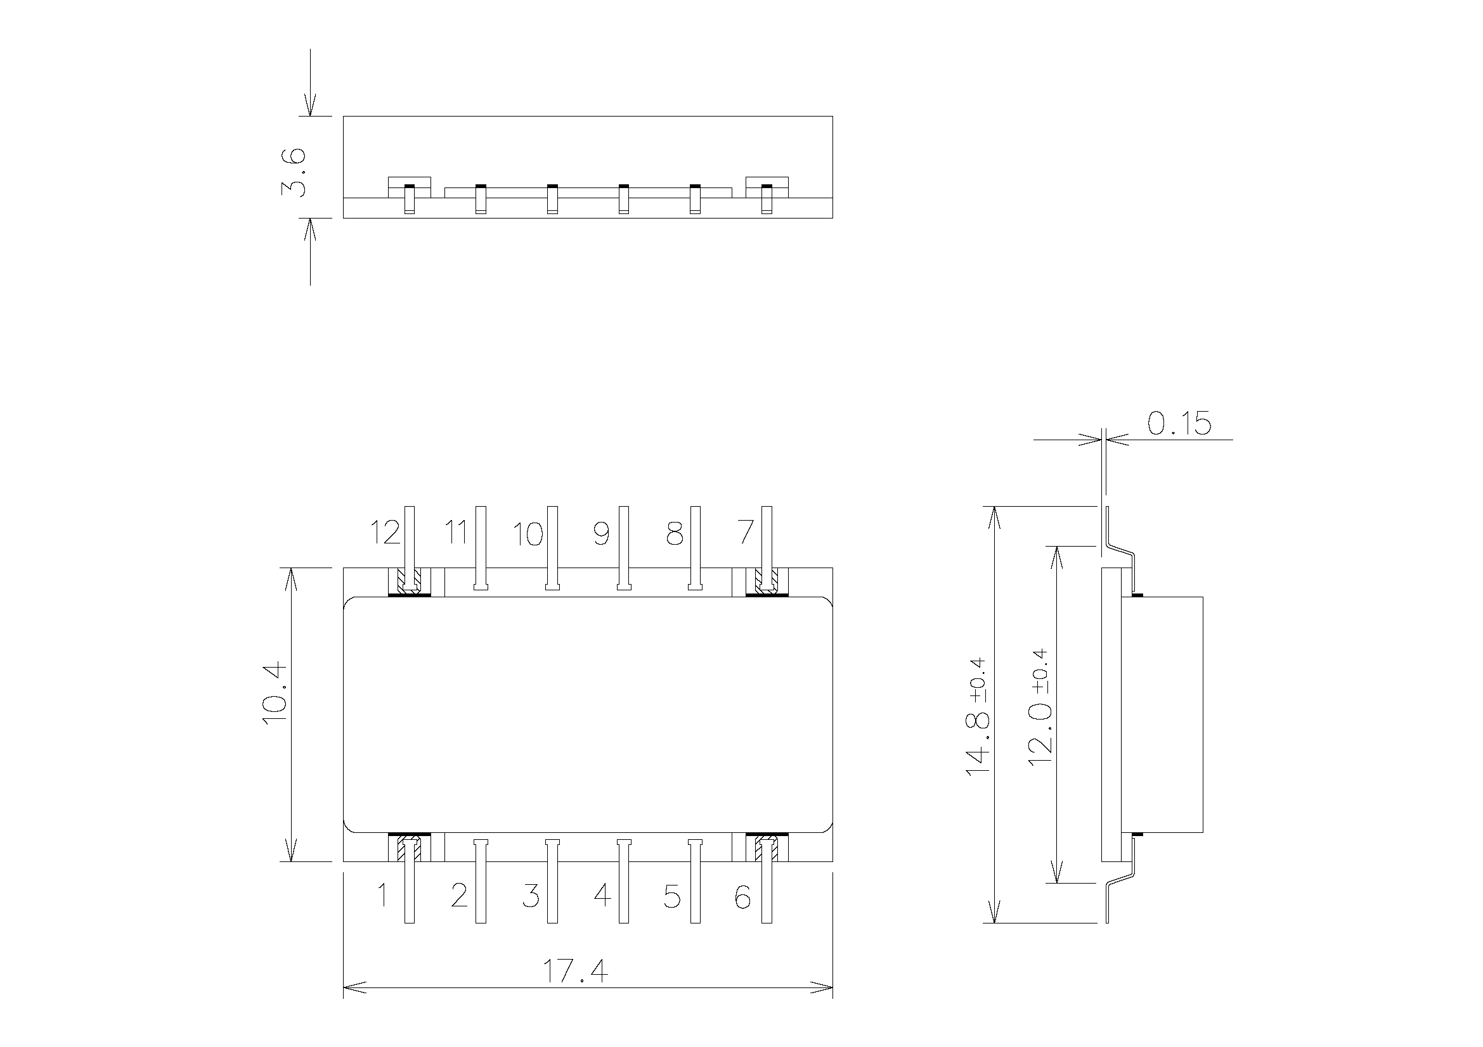

NOTES:
- All dimensions are in millimetres.
- Unless otherwise specified dimensions have a tolerance of ±0.15mm.
- Terminal identification:
1, 12 - Input
2, 3, 4, 5, 8, 9, 10, 11 - GND
6, 7 - Output

Type F-1 - 8 Gullwing Stripline Terminals
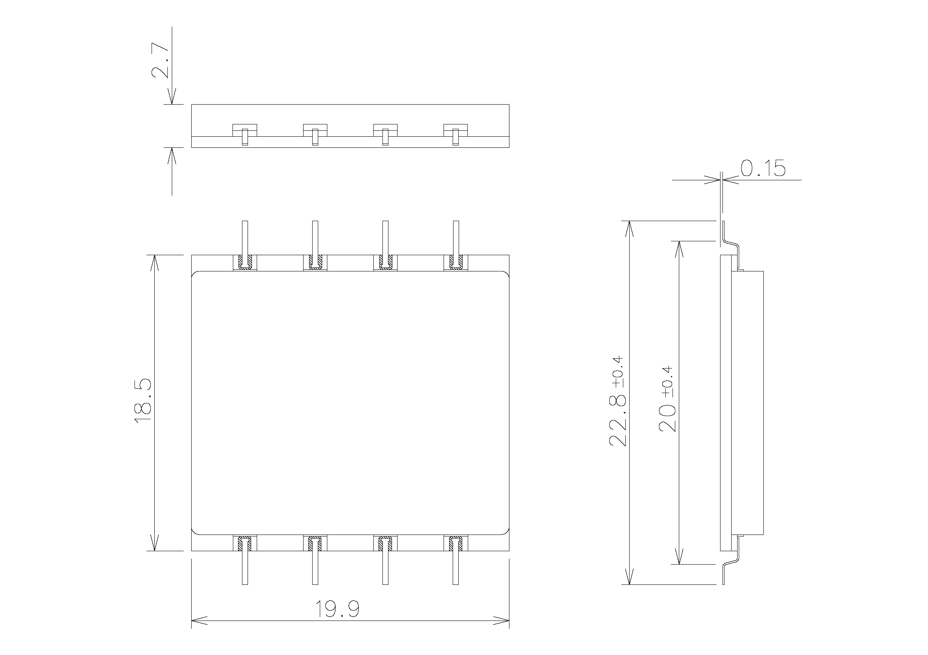

NOTES:
- All dimensions are in millimetres.
- Unless otherwise specified dimensions have a tolerance of ±0.15mm.
- Terminal identification is not applicable (the numbering and assignment of the terminals is
dependent on the specific SAW Filter design.)

Type F-2 - 8 Gullwing Stripline Terminals
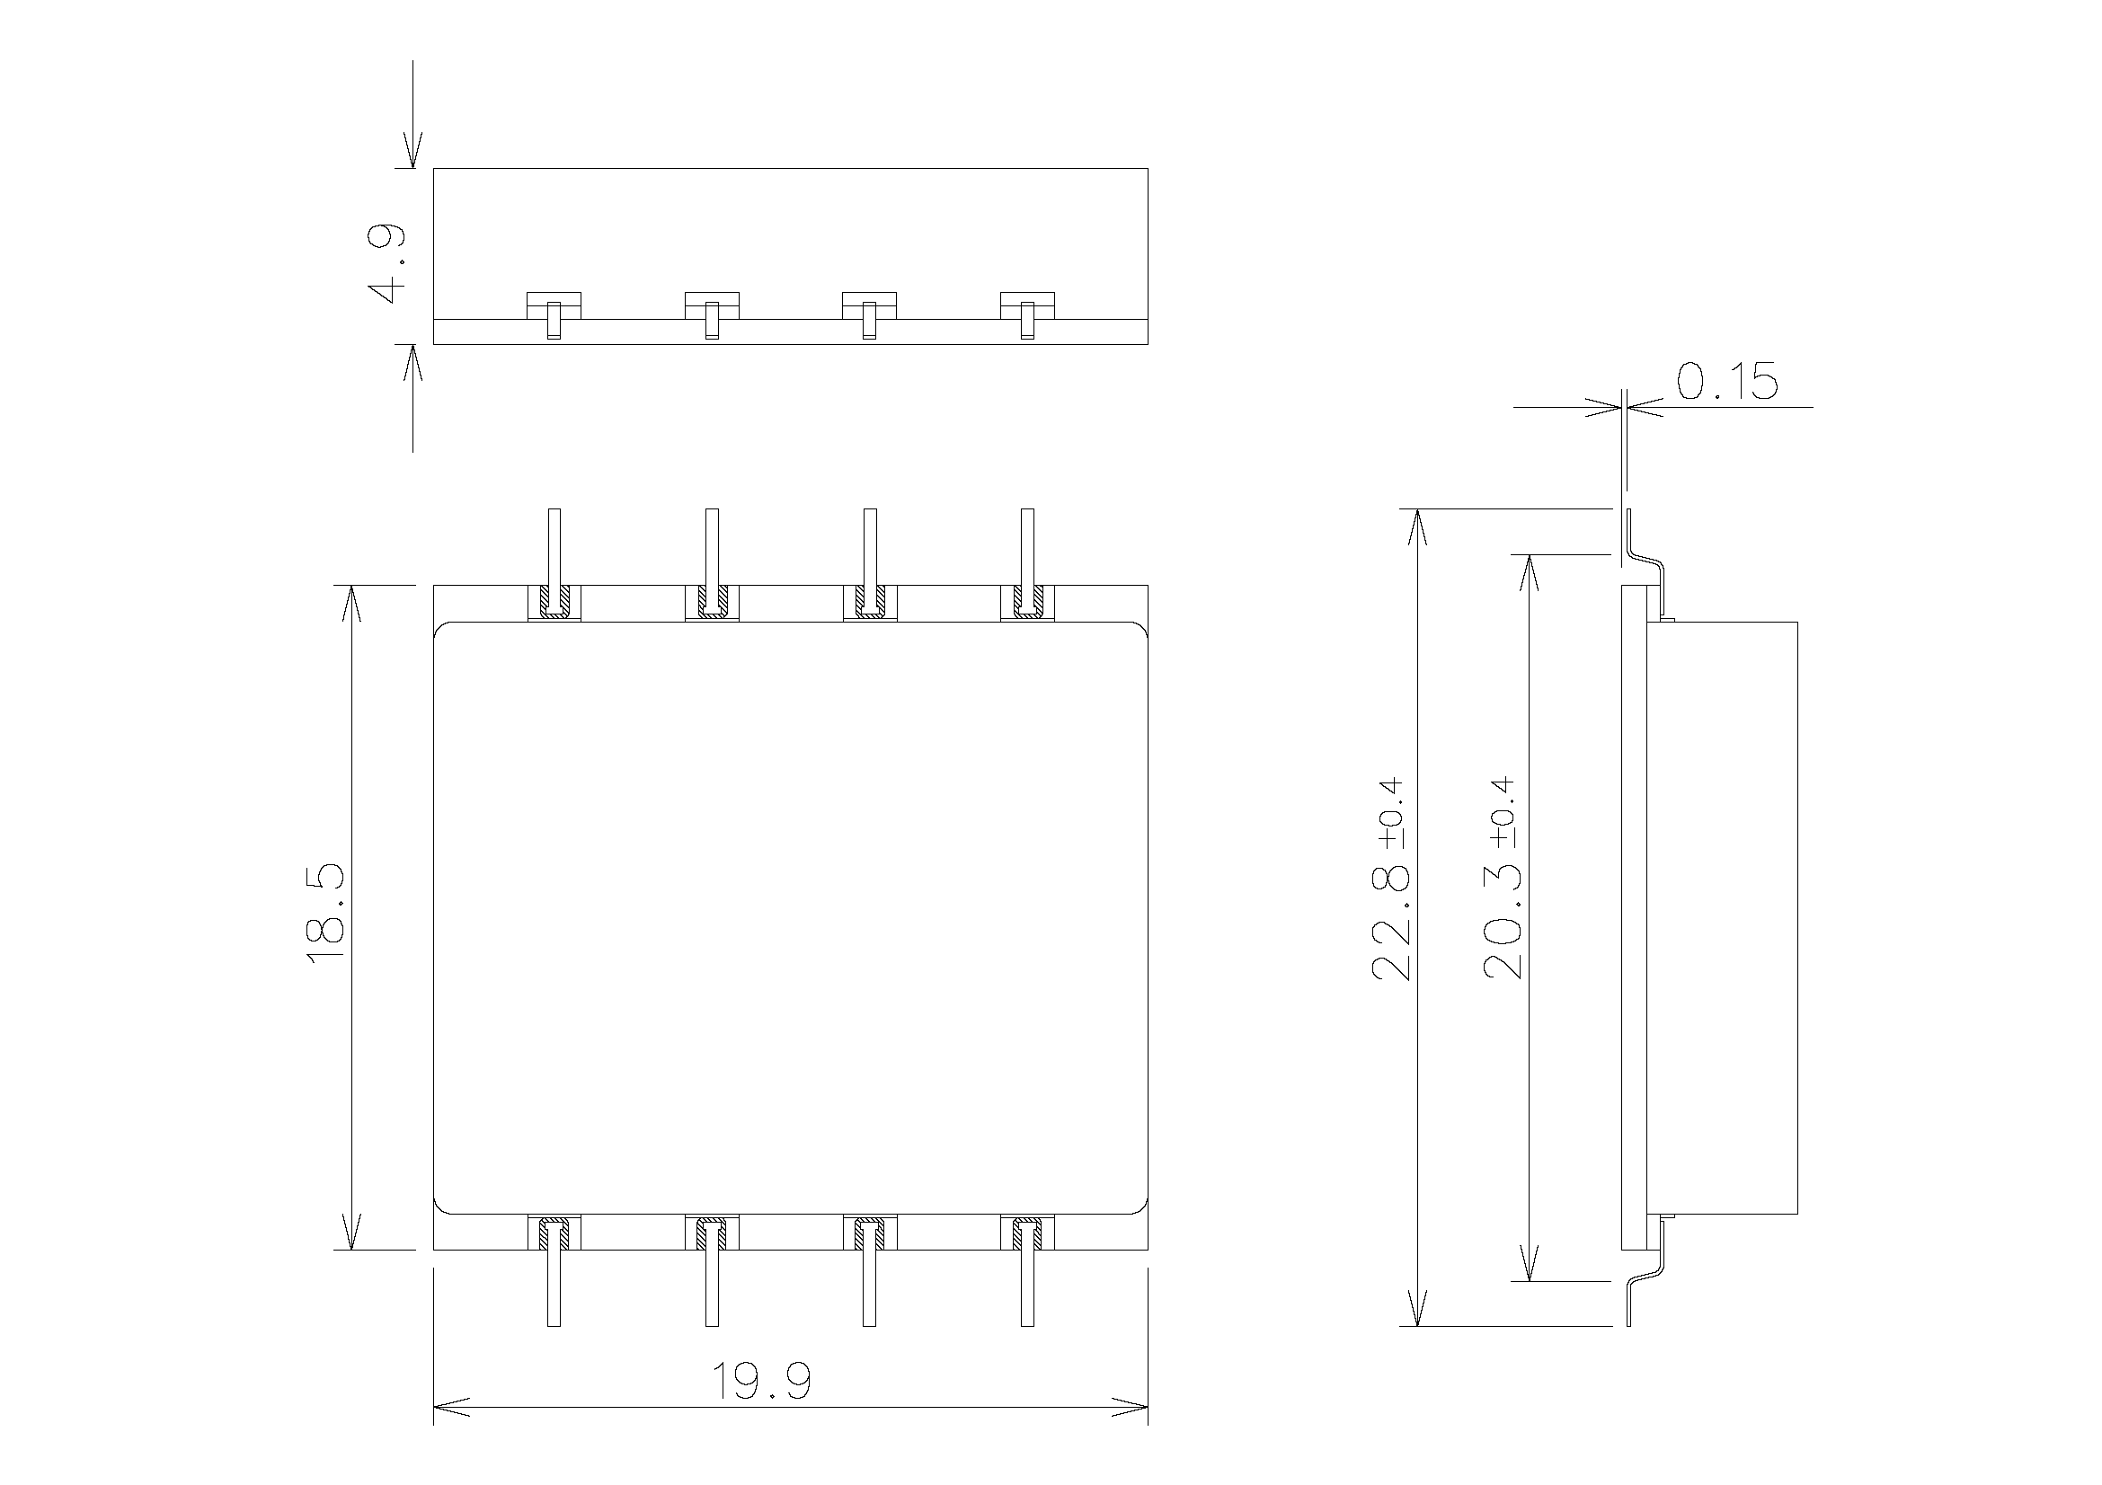

NOTES:
- All dimensions are in millimetres.
- Unless otherwise specified dimensions have a tolerance of ±0.15mm.
- Terminal identification is not applicable (the numbering and assignment of the terminals is
dependent on the specific SAW Filter design.)

Type G-1 - 16 Pre-formed Stripline Terminals
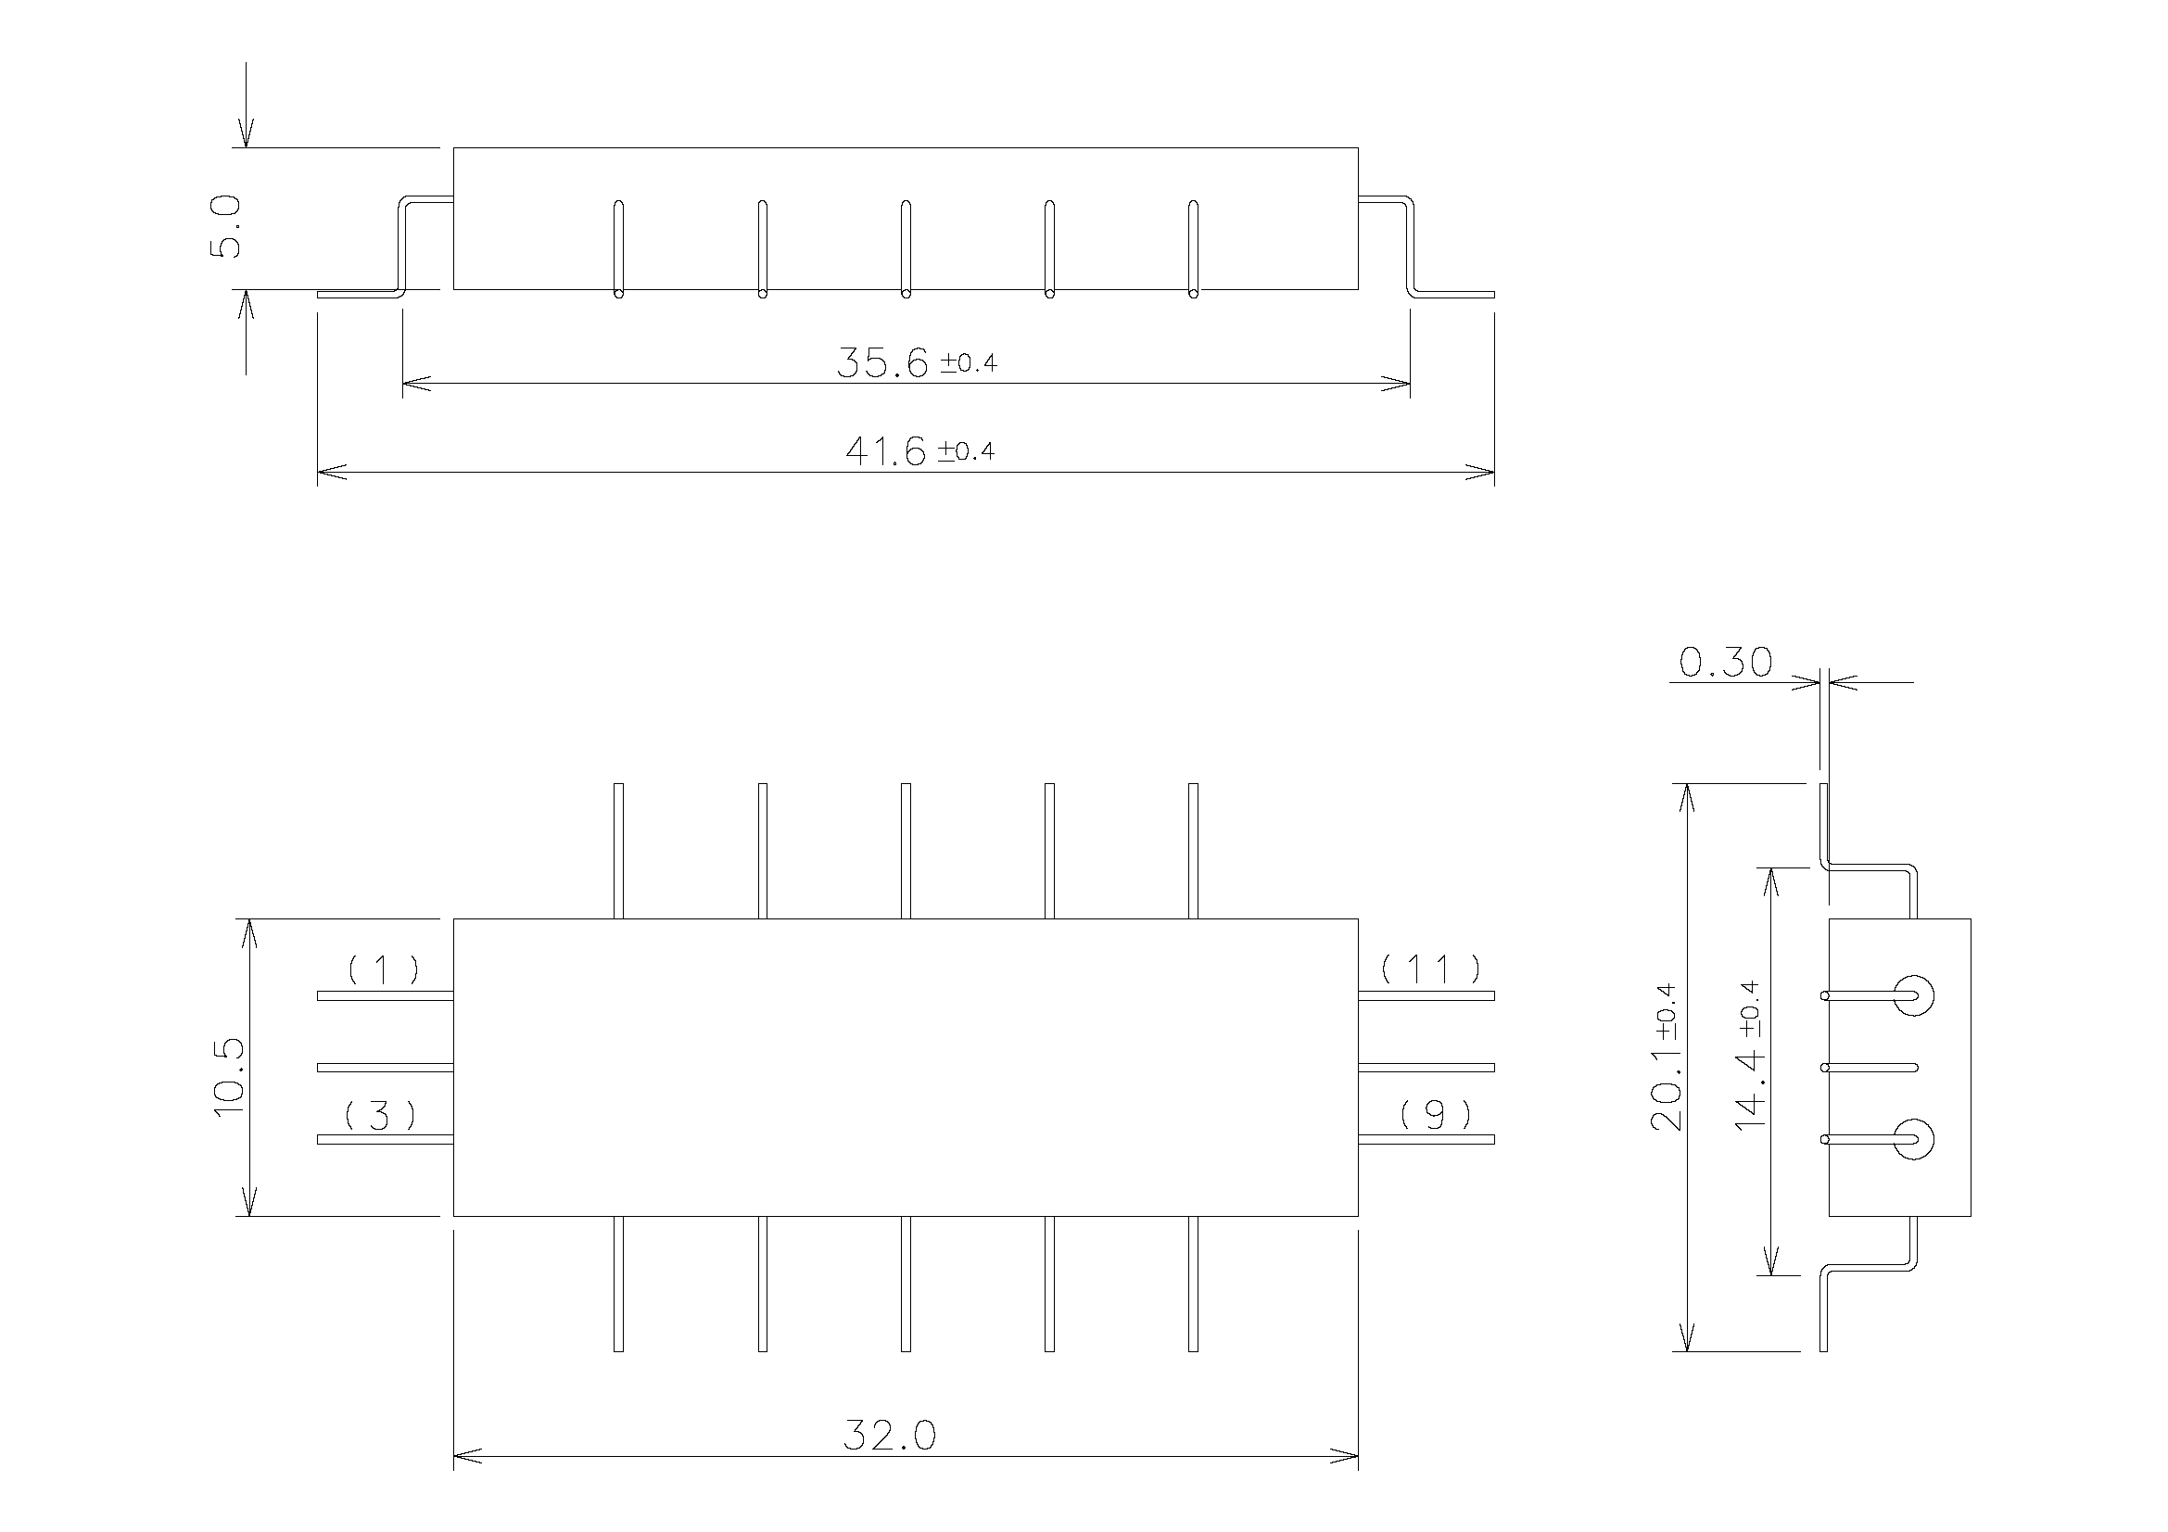

NOTES:
- All dimensions are in millimetres.
- Unless otherwise specified, terminal dimensions/positions have a tolerance of ±0.2mm and package dimensions have a tolerance of ±0.13mm.
- Terminal identification:
1 - Input
2, 4, 5, 6, 7, 8, 10, 12, 13, 14, 15, 16 - GND
3 - Input Return
9 - Output Return
11 - Output
Terminal No. 1 may be identified by means of a coloured glass feed-through in addition to the top marking.
- All 16 terminals shall be pre-formed prior to their assembly into the package body. The terminals on all four sides of the package shall be pre-formed in the same manner.

Type G-2 - 16 Formed Stripline Terminals
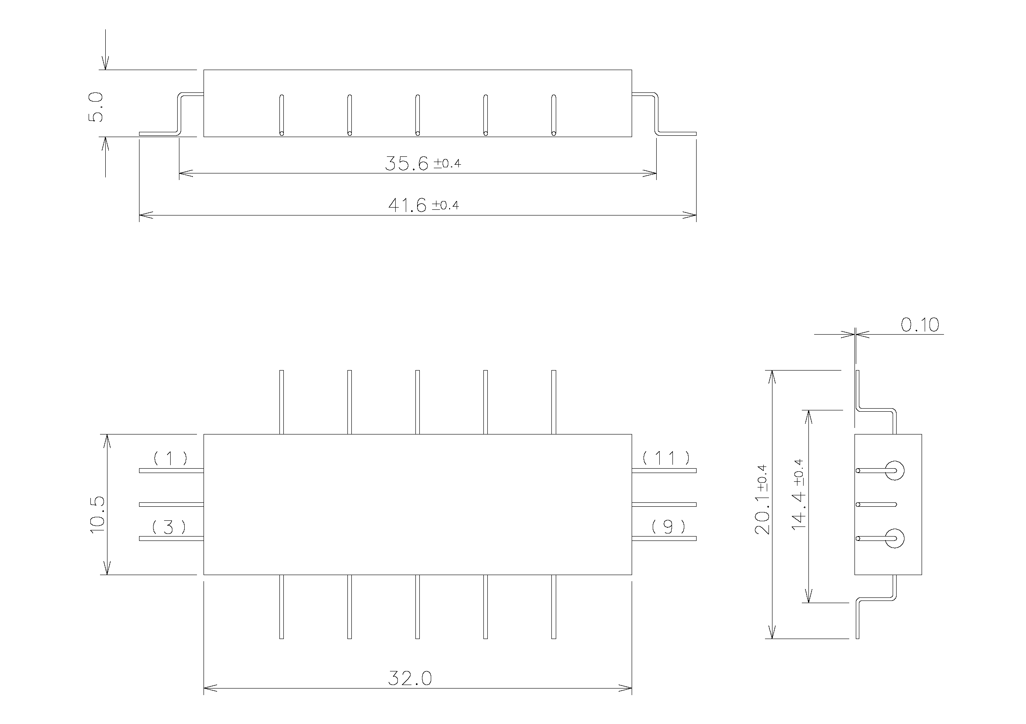

NOTES:
- All dimensions are in millimetres.
- Unless otherwise specified, terminal dimensions/positions have a tolerance of ±0.2mm and package dimensions have a tolerance of ±0.13mm.
- Terminal identification:
1 - Input
2, 4, 5, 6, 7, 8, 10, 12, 13, 14, 15, 16 - GND
3 - Input Return
9 - Output Return
11 - Output
Terminal No. 1 may be identified by means of a coloured glass feed-through in addition to the top marking.

Type H - 26 Formed Stripline Terminals
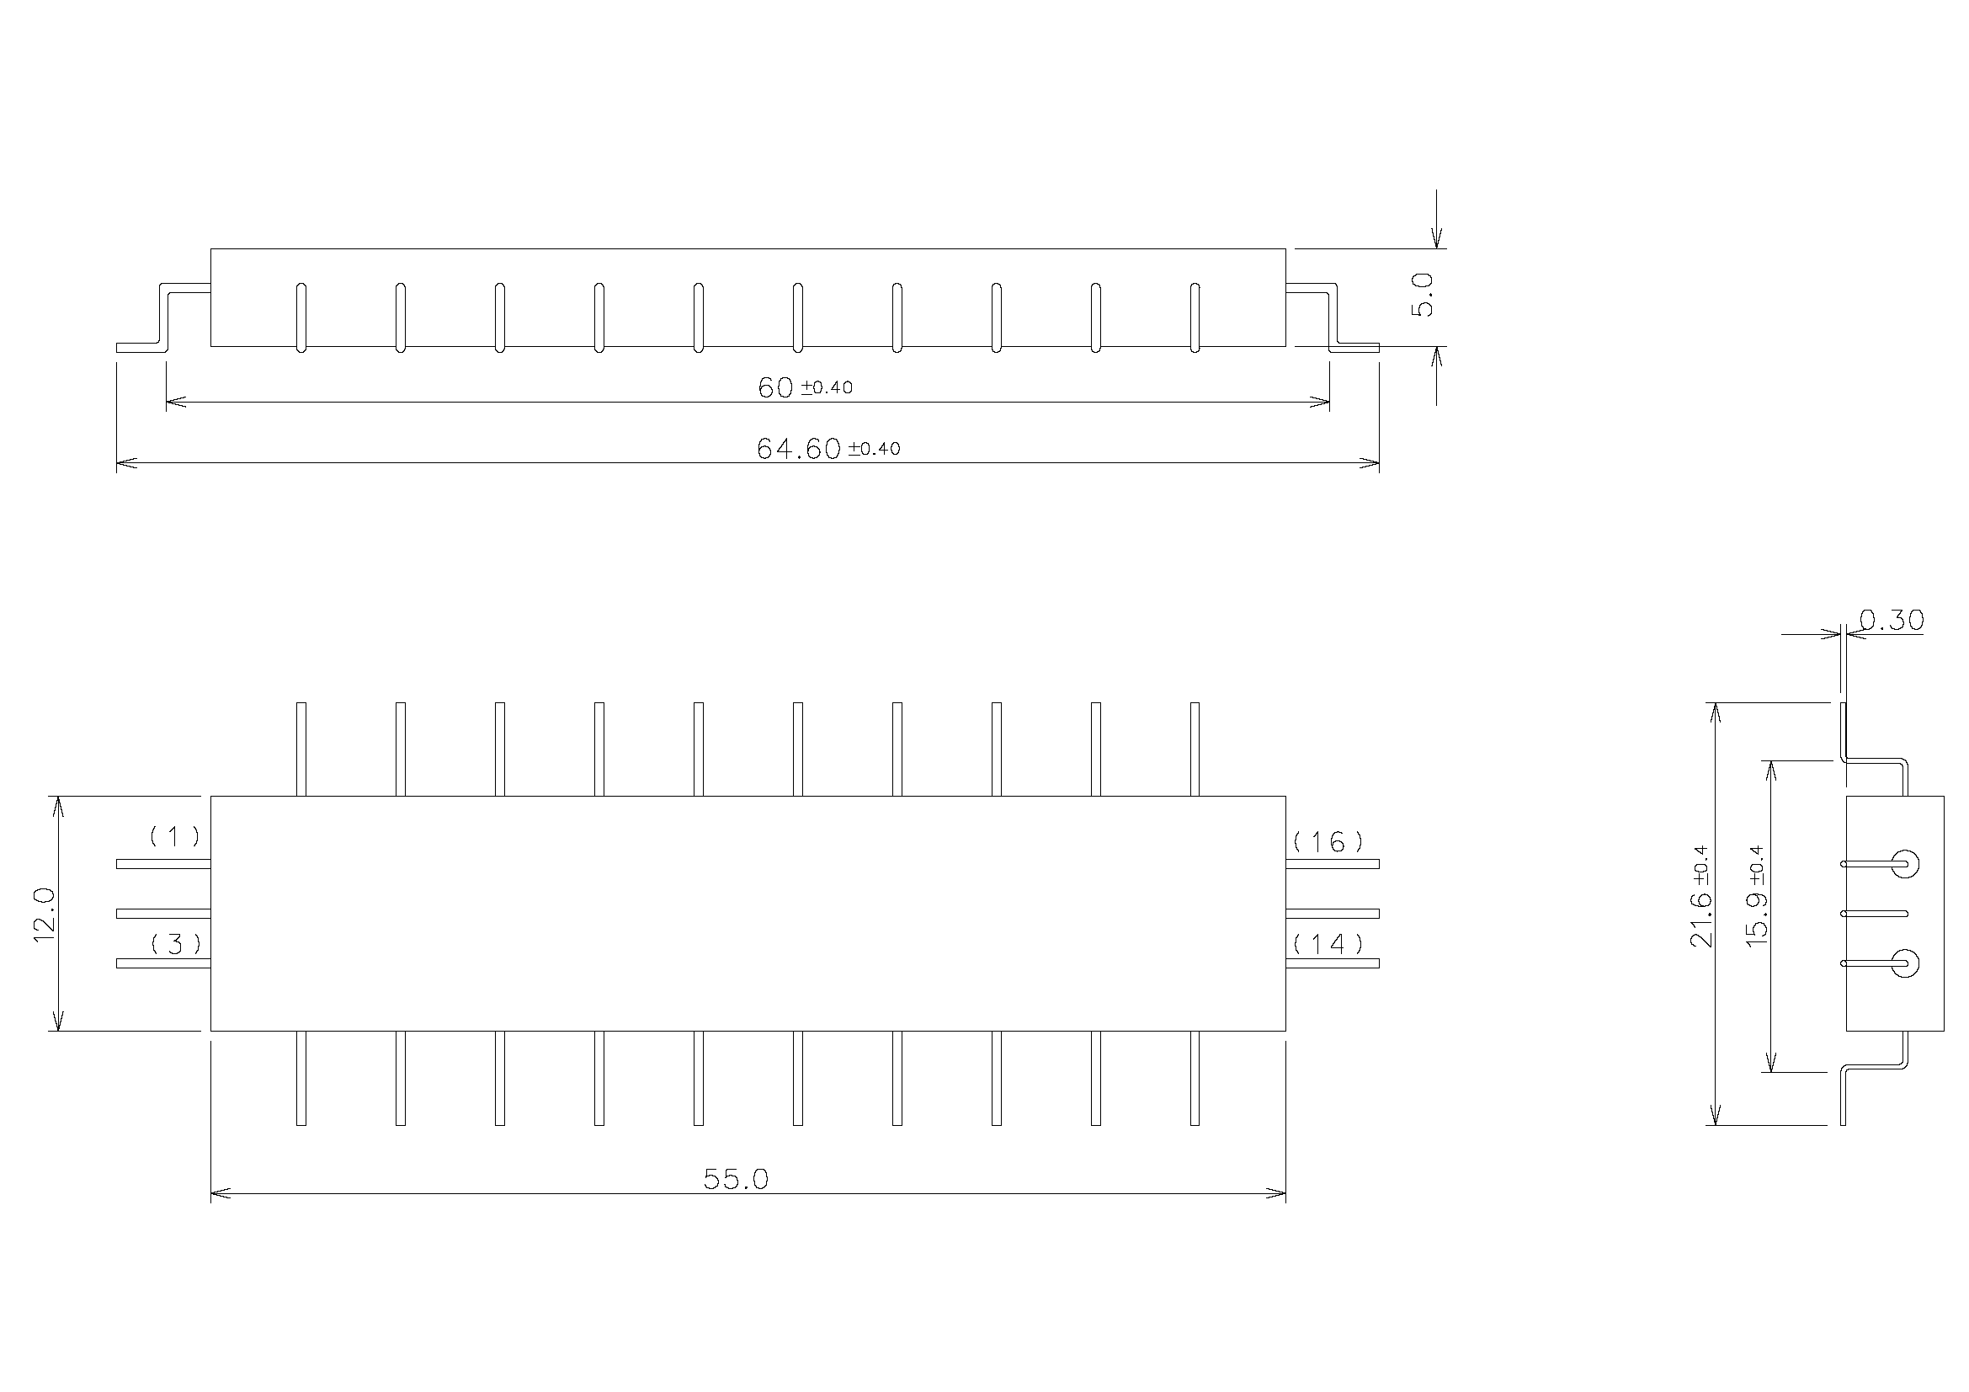

NOTES:
- All dimensions are in millimetres.
- Unless otherwise specified, terminal dimensions/positions have a tolerance of ±0.2mm and package dimensions have a tolerance of ±0.13mm.
- Terminal identification:
1 - Input
2, 4, 5, 6, 7, 8, 10, 12, 13, 15, 17, 18, 19, 20, 21, 22, 23, 24, 25, 26 - GND
3 - Input Return
14 - Output Return
16 - Output
Terminal No. 1 may be identified by means of a coloured glass feed-through in addition to the top marking.

Type I - 6 Stripline Terminals
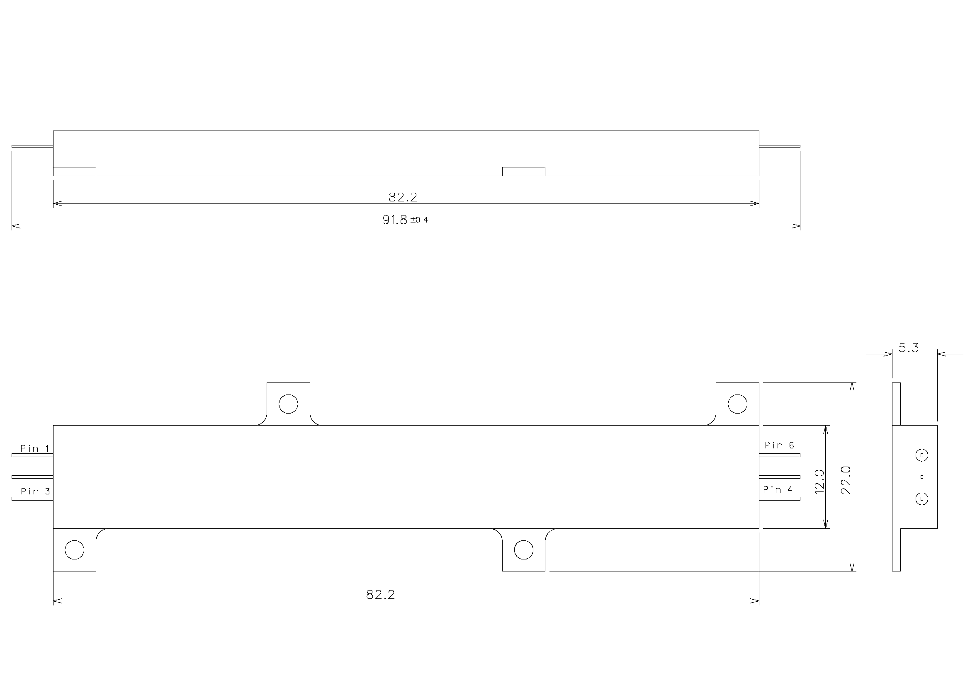

NOTES:
- All dimensions are in millimetres.
- Unless otherwise specified dimensions have a tolerance of ±0.13mm.
- Terminal identification: 1 - Input
2, 3, 4, 5 - GND
6 - Output
Terminal No. 1 may be identified by means of a coloured glass feed-through in addition to the top marking.

Type J-1 - 6 Formed Stripline Terminals
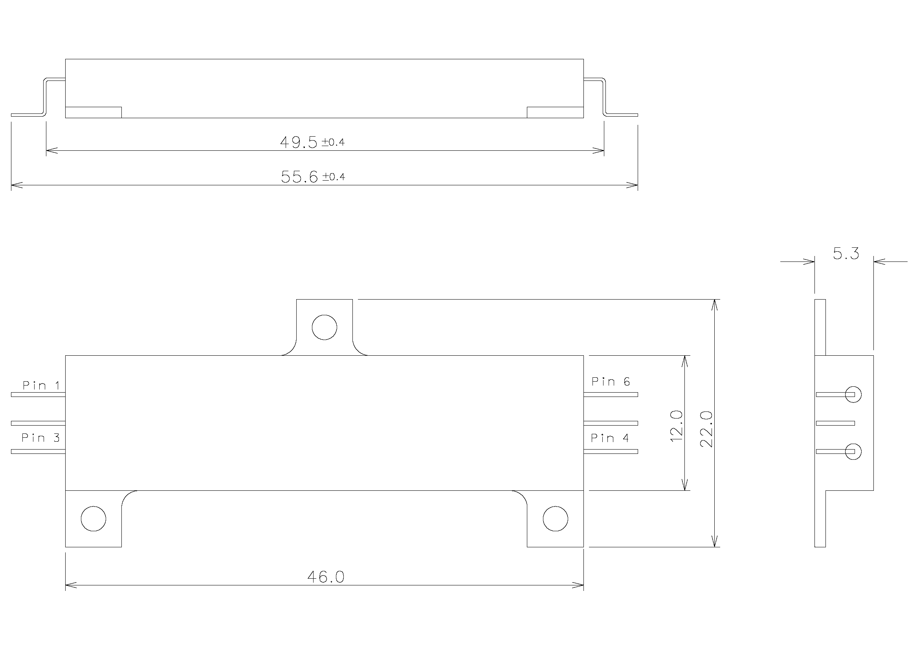

NOTES:
- All dimensions are in millimetres.
- Unless otherwise specified dimensions have a tolerance of ±0.13mm.
- Terminal identification:
1 - Input
2, 5 - GND
  - - Input Return
  - - Output Return
6 - Output
Terminal No. 1 may be identified by means of a coloured glass feed-through in addition to the top marking.

Type J-2 - 6 Stripline Terminals
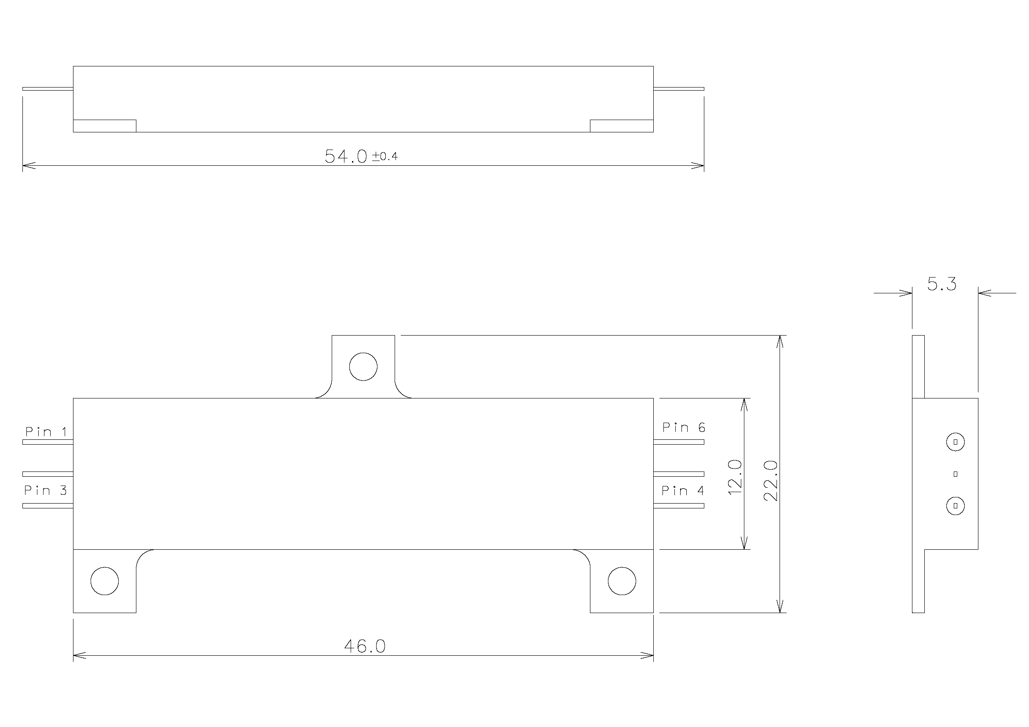

NOTES:
- All dimensions are in millimetres.
- Unless otherwise specified dimensions have a tolerance of ±0.13mm.
- Terminal identification:
1 - Input
2, 3, 4, 5 – GND
6 - Output
Terminal No. 1 may be identified by means of a coloured glass feed-through in addition to the top marking.

Type J-3 – 4 Stripline Terminals
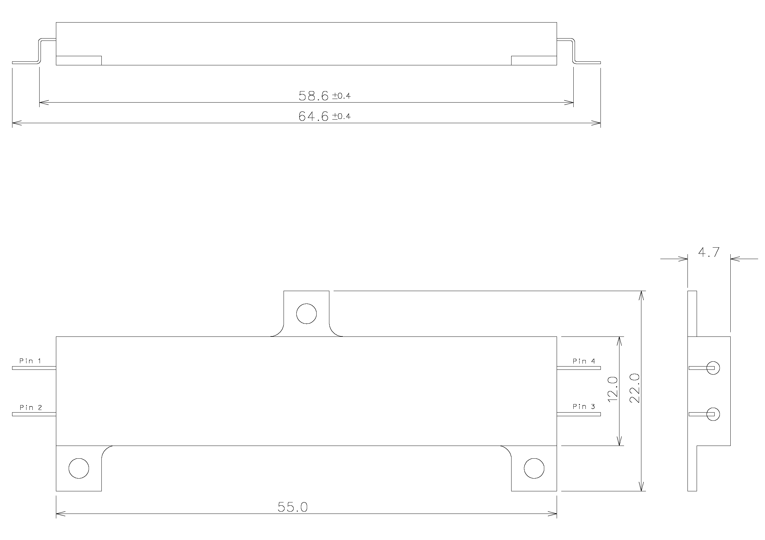

NOTES:
- All dimensions are in millimetres.
- Unless otherwise specified dimensions have a tolerance of ±0.13mm.
- Terminal identification:
1 - Input
2 – Input return
3 – Output return
4 - Output
Terminal No. 1 may be identified by means of a coloured glass feed-through in addition to the top marking.

FUNCTIONAL DIAGRAM
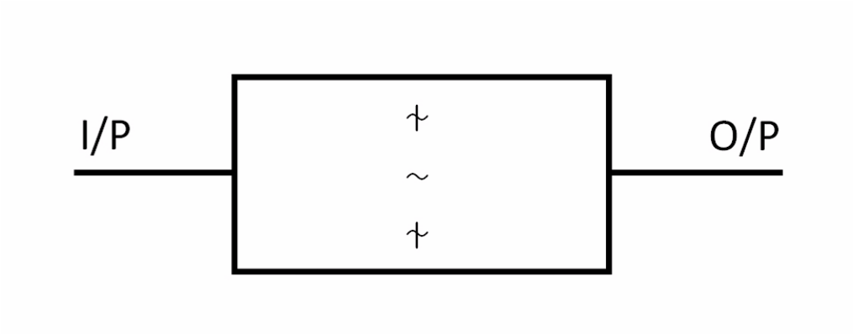

PIN ASSIGNMENT
The pin assignment shall be defined in each individual SAW Filter Data Sheet.

REQUIREMENTS

GENERAL
The complete requirements for procurement of the components specified herein are as stated in this specification and the ESCC Generic Specification. Permitted deviations from the Generic Specification, applicable to this specification only, are listed below.
Permitted deviations from the Generic Specification and this Detail Specification, formally agreed with specific Manufacturers on the basis that the alternative requirements are equivalent to the ESCC requirement and do not affect the component’s reliability, are listed in the appendices attached to this specification.

Deviations from the Generic Specification
None.

MARKING
The marking shall be in accordance with the requirements of ESCC Basic Specification No. 21700 and as follows.
The information to be marked on the component shall be:
- Lead Identification.
- The ESCC Qualified Component Symbol (for ESCC qualified components only).
- The ESCC Component Number.
- Traceability information.

ELECTRICAL MEASUREMENTS AT ROOM, HIGH AND LOW TEMPERATURES
Electrical measurements shall be performed at room, high and low temperatures. The characteristics to be measured vary depending on the particular SAW Filter. Therefore, typical characteristics are given below and the specific characteristics to be measured shall be defined in each individual SAW Filter Data Sheet.

Room Temperature Electrical Measurements
The measurements shall be performed at T_{amb} = +22 ± ^{3o}C.
Characteristics | Symbols | MIL-STD-883 Test Method | Test Conditions Note 1 | Limits |  | Units
 |  |  |  | Min | Max | Units
Centre Frequency | fC | - | See SAW Filter Data Sheet |  |  | MHz
In-band Ripple, f_{L} to f_{U} | - | - | See SAW Filter Data Sheet |  |  | dB (p-p)
Insertion Loss | IL | - | See SAW Filter Data Sheet |  |  | dB
Phase Linearity, f_{L} to f_{U} | - | - | See SAW Filter Data Sheet |  |  | º(p-p)
Out-of-band Rejection | - | - | See SAW Filter Data Sheet |  |  | dB

NOTES:
1. All measurements shall be made with the use of external matching networks.

High and Low Temperatures Electrical Measurements
The measurements shall be performed at the High and Low temperatures defined in each individual SAW Filter Data Sheet. Unless otherwise specified the characteristics, test methods, conditions and limits shall be the same as specified for Room Temperature Electrical Measurements.

PARAMETER DRIFT VALUES
Unless otherwise specified, the measurements shall be performed at T_{amb} = +22 ± ^{3o}C.
The test methods and test conditions shall be as per the corresponding test defined in Room
Temperature Electrical Measurements.
The drift values (Δ) shall not be exceeded for each characteristic specified. The corresponding absolute limit values for each characteristic shall not be exceeded.
Characteristics | Symbols | Limits |  |  | Units
Characteristics | Symbols | Drift  Value Δ | Absolute |  | Units
Characteristics | Symbols | Drift  Value Δ | Min | Max | Units
Centre Frequency (at -6dB) | f_{C}(-6dB) | See SAW Filter Data Sheet |  |  | MHz
Insertion Loss | IL | See SAW Filter Data Sheet |  |  | dB

INTERMEDIATE AND END-POINT ELECTRICAL MEASUREMENTS
Unless otherwise specified, the measurements shall be performed at T_{amb} = +22 ± ^{3o}C. Unless otherwise specified the characteristics, test methods, conditions and limits shall be the same as specified for Room Temperature Electrical Measurements.

BURN-IN CONDITIONS
As specified in Burn-in in the Generic Specification.

OPERATING LIFE CONDITIONS
As specified in Operating Life in the Generic Specification.

APPENDIX ‘A’
AGREED DEVIATIONS FOR KONGSBERG NORSPACE AS (NORWAY)
ITEMS AFFECTED | DESCRIPTION OF DEVIATIONS
Para. 2.1.1, Deviations from the Generic Specification | Chart F3 - Screening Tests: Radiographic Inspection shall not be performed.  Chart F3: Nondestructive bond pull test is performed 100 % on bond wires, according to MIL-STD-883, Test Method 2023.  Paragraph 5.1.1 – Rebonding: Wire re-bonding is allowed within the following limitations:  i) All re-bonds shall be placed on undisturbed metal  ii) The total number of pin to substrate or substrate-to-substrate wire re-bondings shall be limited to a maximum of 10 % of the total number of wires in the SAW device.  Paragraph 8.6 – Seal: MIL-STD-883, Test Method 1014, condition CH2 is employed

