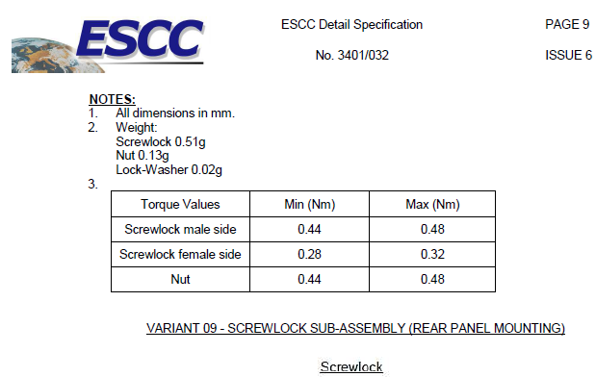
Self-locking Nut
Self-locking Nut 0.4g

