

Page 1 of 18
TRANSISTORS, POWER, MOSFET, N-CHANNEL, RAD-HARD
BASED ON TYPE STRH100N6
ESCC Detail Specification No. 5205/022

Issue 4 Draft A | July 2015



Document Custodian: European Space Agency – see https://escies.org

Legal Disclaimer and Copyright
European Space Agency, Copyright © 2015. All rights reserved.
The European Space Agency disclaims any liability or responsibility, to any person or entity, with respect to any loss or damage caused, or alleged to be caused, directly or indirectly by the use and application of this ESCC publication.
This publication, without the prior permission of the European Space Agency and provided that it is not used for a commercial purpose, may be:
- copied in whole, in any medium, without alteration or modification.
- copied in part, in any medium, provided that the ESCC document identification, comprising the ESCC symbol, document number and document issue, is removed.

DOCUMENTATION CHANGE NOTICE
(Refer to https://escies.org for ESCC DCR content)
DCR No. | CHANGE DESCRIPTION
tbd | Specification upissued to incorporate changes per DCR.

TABLE OF CONTENTS
1 General 5
1.1 Scope 5
1.2 Applicable Documents 5
1.3 Terms, Definitions, Abbreviations, Symbols and Units 5
1.4 The ESCC component number and component Type Variants 5
1.4.1 The ESCC Component Number 5
1.4.2 Component Type Variants 5
1.5 Maximum Ratings 6
1.6 HANDLING PRECAUTIONS 7
1.7 Physical Dimensions and Terminal Identification 8
1.8 Functional Diagram 9
1.9 Materials and Finishes 9
2 Requirements 10
2.1 GENERAL 10
2.1.1 Deviations from the Generic Specification 10
2.1.1.1 Deviations from Screening Tests - Chart F3 10
2.2 WAFER LOT ACCEPTANCE 10
2.3 MARKING 10
2.4 TERMINAL STRENGTH 10
2.5 Electrical Measurements at Room, High and Low Temperatures 10
2.5.1 Room Temperature Electrical Measurements 10
2.5.2 High and Low Temperatures Electrical Measurements 12
2.5.3 Notes to Room, High and Low Electrical Measurements 12
2.6 Parameter Drift Values 13
2.7 Intermediate and End-Point Electrical Measurements 14
2.8 High Temperature reverse bias burn-in conditions 14
2.9 high temperature forward bias Burn-in Conditions 14
2.10 Operating Life Conditions 15
2.11 TOTAL DOSE RADIATION TESTING 15
2.11.1 Bias Conditions and Total Dose Level for Total Dose Radiation Testing 15
2.11.2 Electrical Measurements for Total Dose Radiation Testing 15
APPENDIX ‘A’ 17

General

Scope
This specification details the ratings, physical and electrical characteristics and test and inspection data for the component type variants and/or the range of components specified below. It supplements the requirements of, and shall be read in conjunction with, the ESCC Generic Specification listed under Applicable Documents.

Applicable Documents
The following documents form part of this specification and shall be read in conjunction with it:
          - ESCC Generic Specification No. 5000
          - MIL-STD-750, Test Methods and Procedures for Semiconductor Devices

Terms, Definitions, Abbreviations, Symbols and Units
For the purpose of this specification, the terms, definitions, abbreviations, symbols and units specified in ESCC Basic Specification No. 21300 shall apply.

The ESCC component number and component Type Variants

The ESCC Component Number
The ESCC Component Number shall be constituted as follows:
Example: 520502201F
- Detail Specification Reference: 5205022
- Component Type Variant Number: 01 (as required)
- Total Dose Radiation Level Letter: F (as required)

Component Type Variants
The component type variants applicable to this specification are as follows:
Variant Number | Based on Type | Case | Lead Material and Finish | Weight  max g | Total Dose Radiation Level Letter
01 | STRH100N6 | TO-254AA | S14 | 10 | F [50kRAD(Si)]
02 | STRH100N6 | TO-254AA | S4 | 10 | F [50kRAD(Si)]
The lead material and finish shall be in accordance with the requirements of ESCC Basic Specification No. 23500.
Total dose radiation level letters are defined in ESCC Basic Specification No. 22900. If an alternative radiation test level is specified in the Purchase Order the letter shall be changed accordingly.

Maximum Ratings
The maximum ratings shall not be exceeded at any time during use or storage.
Maximum ratings shall only be exceeded during testing to the extent specified in this specification and when stipulated in Test Methods and Procedures of the ESCC Generic Specification.
Characteristics | Symbols | Maximum Ratings | Unit | Remarks
Drain-Source Voltage | V_{DS} | 60 | V | Over T_{op}  V_{GS}=0V  Note 2
Gate-Source Voltage | V_{GS} | ±20 | V | Over T_{op}
Drain Current | I_{DS} | 40 | A | Continuous  At T_{case} ≤ +25ºC  and at T_{case} >+100ºC  Note 1
Drain Current (Pulsed) | I_{DM} | 320 | A | Note 2
Power Dissipation | P_{tot} | 176 | W | At T_{case} ≤ +25ºC  Note 1
Avalanche Energy  (Single Pulse) | E_{AS} | 954  280 | mJ | V_{DS}=40V  I_{A}=40A  T_{j}=+25±3ºC  T_{j}=+110(+0 -5)ºC
Avalanche Energy  (Repetitive Pulse) | E_{AR} | 24  7.7 | mJ | V_{DS}=40V  I_{A}=40A  f=100kHz,  Duty Cycle = 10%  T_{j}=+25±3ºC  T_{j}=+110(+0 -5)ºC
Operating Temperature Range | T_{op} | -55 to +150 | ºC | Note 3
Junction Temperature | T_{j} | +150 | ºC
Storage Temperature Range | T_{stg} | -55 to +150 | ºC | Note 3
Soldering Temperature | T_{sol} | +260 | ºC | Note 4
Thermal Resistance, Junction-to-Heat Sink | R_{th(j-s)} | 0.71 | ºC/W | Note 5
Thermal Resistance, Junction-to-Ambient | R_{th(j-a)} | 48 | ºC/W | Note 2
NOTES:
            - I_{DS} and P_{tot} ratings are in accordance with R_{th(j-s)}. The maximum theoretical I_{D} limit at T_{case} > +25 ºC can be obtained by using the following formula (I_{D} is limited by the package and device construction):
Where (r_{DS(on)} at T_{j}(max)) = 30mΩ.
For T_{case} > +25 ºC, the Power Dissipation derates linearly to 0W at T_{case} = +150 ºC.
            - Safe Operating Area applies as follows:
Maximum Safe Operating Area
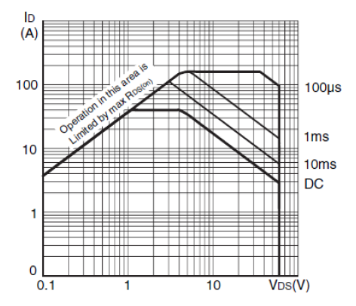
            - For Variants with hot solder dip lead finish all testing and any handling performed at T_{amb} > +125 ºC shall be carried out in a 100% inert atmosphere.
            - Duration 10 seconds maximum at a distance of not less than 1.5mm from the device body and the same lead shall not be resoldered until 3 minutes have elapsed.
            - Package is mounted on an infinite heatsink.

HANDLING PRECAUTIONS
These components are susceptible to damage by electrostatic discharge. Therefore, suitable precautions shall be employed for protection during all phases of manufacture, testing, shipment and any handling.

These components are categorised as Class 2 per ESCC Basic Specification No. 23800 with a Minimum Critical Path Failure Voltage of 2550 Volts.
The TO-254AA package contains Beryllium Oxide (BeO) and therefore it must not be ground, machined, sandblasted or subjected to any mechanical operation which will produce dust. The case must not be subjected to any chemical process (e.g. etching) which will produce fumes.

Physical Dimensions and Terminal Identification
Metal Flange Mount Package (TO-254AA) – 3 lead
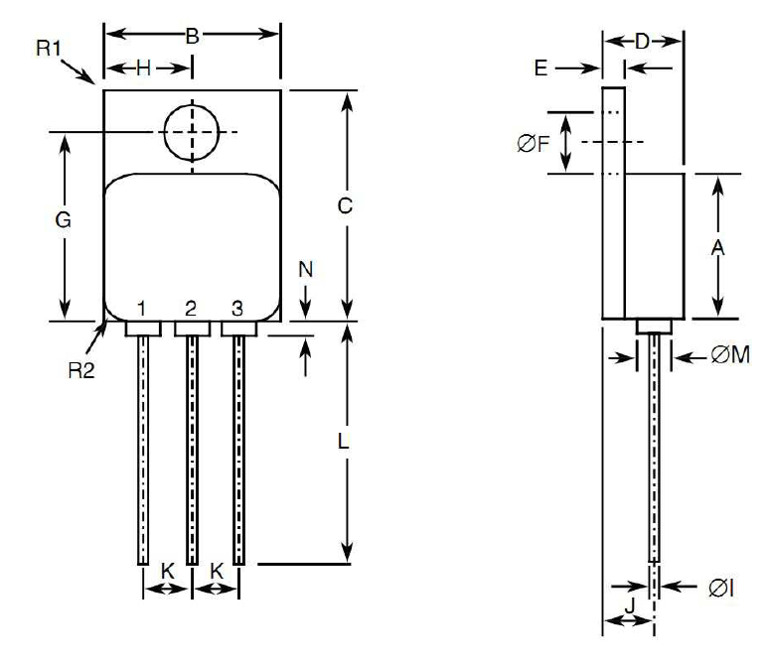
Symbols | Dimensions mm |  | Notes
Symbols | Min | Max | Notes
A | 13.59 | 13.84
B | 13.59 | 13.84
C | 20.07 | 20.32
D | 6.3 | 6.7
E | 1 | 1.35
ØF | 3.5 | 3.9
G | 16.89 | 17.4
H | 6.86 BSC
ØI | 0.89 | 1.14 | 2
J | 3.81 BSC
K | 3.81 BSC
L | 12.95 | 14.5
ØM | 3.05 Typical |  | 2
N | - | 0.71 | 2
R1 | - | 1 | 3
R2 | 1.65 Typical |  | 4
NOTES:
            - The terminal identification is specified by the components geometry. See Functional Diagram for the terminal connections.
            - 3 places.
            - Radius of heatsink flange corner, 4 places.
            - Radius of body corner, 4 places.

Functional Diagram
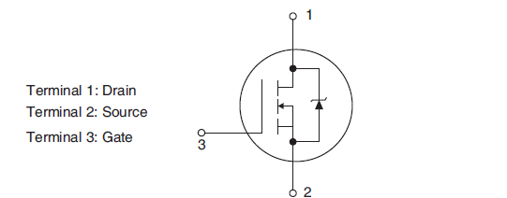
NOTES:
            - The case is not connected to any lead.

Materials and Finishes
Materials and finishes shall be as follows:
          - Case
The case shall be hermetically sealed and have a metal body. The leads pass through ceramic eyelets brazed into the frame and the lid shall be welded.
          - Leads
As specified in Component Type Variants.

Requirements

GENERAL
The complete requirements for procurement of the components specified herein are as stated in this specification and the ESCC Generic Specification. Permitted deviations from the Generic Specification, applicable to this specification only, are listed below.
Permitted deviations from the Generic Specification and this Detail Specification, formally agreed with specific Manufacturers on the basis that the alternative requirements are equivalent to the ESCC requirement and do not affect the component’s reliability, are listed in the appendices attached to this specification.

Deviations from the Generic Specification

Deviations from Screening Tests - Chart F3
- Verification of Safe Operating Area
The Safe Operating Area shall be verified by performing the ΔV_{SD} test specified in Room Temperature Electrical Measurements (Thermal Resistance, Junction-to-Heat Sink).
- A High Temperature Forward Bias test shall be performed instead of Power Burn-in.

WAFER LOT ACCEPTANCE
A SEM inspection shall be performed as specified in the ESCC Generic Specification.

MARKING
The marking shall be in accordance with the requirements of ESCC Basic Specification No. 21700 and as follows.
The information to be marked on the component shall be:
          - The ESCC Qualified Component symbol (for ESCC qualified components only).
          - The ESCC Component Number.
          - Traceability information.
          - Warning sign for Beryllium Oxide.

TERMINAL STRENGTH
The test conditions for terminal strength, tested as specified in the ESCC Generic Specification, shall be as follows:
Test Condition: A, tension, with an applied force of 10N for a duration of 10s.

Electrical Measurements at Room, High and Low Temperatures
Electrical measurements shall be performed at room, high and low temperatures. Consolidated notes are given after the tables.

Room Temperature Electrical Measurements
Unless otherwise specified, the measurements shall be performed at T_{amb} = +22 ±3 ºC.

Characteristics | Symbols | MIL-STD-750  Test Method | Test Conditions | Limits |  | Units
 |  |  |  | Min | Max
Drain-to-Source Breakdown Voltage | V_{(BR)DSS} | 3407 | V_{GS}=0V, I_{D}=1mA  Bias condition C | 60 | - | V
Gate-to-Source  Leakage Current 1 | I_{GSS1} | 3411 | V_{GS}=20V, V_{DS}=0V  Bias condition C | - | 100 | nA
Gate-to-Source  Leakage Current 2 | I_{GSS2} | 3411 | V_{GS}=-20V, V_{DS}=0V  Bias condition C | -100 | - | nA
Drain Current | I_{DSS} | 3413 | V_{DS}=48V, V_{GS}=0V  Bias condition C | - | 10 | µA
Gate-to-Source  Threshold Voltage | V_{GS(th)} | 3403 | V_{DS} ≥V_{GS}  I_{D}=1mA | 2 | 4.5 | V
Static Drain-to- Source On Resistance | r_{DS(on)} | 3421 | V_{GS}=12V, I_{D}=40A  Note 1 | - | 13.5 | mΩ
Source-to-Drain Diode Forward Voltage | V_{SD} | 4011 | V_{GS}=0V, I_{SD}=40A  Note 1 | - | 1.5 | V
Thermal Resistance, Junction-to-Heat Sink | R_{th(j-s)} | 3161 | Note 2 | - | 0.71 | ºC/W
Input Capacitance | C_{iss} | 3431 | V_{GS}=0V, V_{DS}=25V  f=1MHz | 3900 | 5900 | pF
Output  Capacitance | C_{oss} | 3453 |  | 860 | 1300 | pF
Reverse Transfer  Capacitance | C_{rss} | 3433 |  | 300 | 470 | pF
Total Gate Charge | Q_{g} | 3471 | V_{GS}=12V, V_{DS}=30V I_{D}=40A | 100 | 160 | nC
Gate-to-Source  Charge | Q_{gs} |  |  | 18 | 30 | nC
Gate-to-Drain  Charge | Q_{gd} |  |  | 29 | 51 | nC
Turn-on Delay  Time | t_{d(on)} | 3472 | V_{GS}=12V, V_{DS}=30V I_{D}=40A  R_{G}=4.7Ω | 16 | 40 | ns
Rise Time | t_{r} |  |  | 60 | 260 | ns
Turn-off Delay  Time | t_{d(off)} |  |  | 50 | 120 | ns
Fall Time | t_{f} |  |  | 60 | 160 | ns
Reverse Recovery  Time | t_{rr} | 3473 | V_{DS}=48V, I_{SD}=40A di/dt=100A/µs  T_{j}=+25±3ºC | 170 | 260 | ns

High and Low Temperatures Electrical Measurements
Characteristics | Symbols | MIL-STD-750  Test Method | Test Conditions  Note 3 | Limits |  | Units
 |  |  |  | Min | Max | Units
Gate-to-Source Leakage Current 1 | I_{GSS1} | 3411 | V_{GS}=20V, V_{DS}=0V  Bias condition C  T_{case}=+125(+0-5)ºC | - | 200 | nA
Gate-to-Source Leakage Current 2 | I_{GSS2} | 3411 | V_{GS}=-20V, V_{DS}=0V  Bias condition C  T_{case}=+125(+0-5)ºC | -200 | - | nA
Drain Current | I_{DSS} | 3413 | V_{DS}=48V, V_{GS}=0V  Bias condition C  T_{case}=+125(+0-5)ºC | - | 100 | μA
Gate-to-Source Threshold Voltage | V_{GS(th)} | 3403 | V_{DS}≥V_{GS}  I_{D}=1mA  T_{case}=+125(+0-5)ºC | 1.6 | 3.5 | V
 |  |  | V_{DS}≥V_{GS}  I_{D}=1mA  T_{case}=-55(+5-0)ºC | 2.2 | 5 | V
Static Drain-to-Source On Resistance | r_{DS(on)} | 3421 | V_{GS}=12V, I_{D}=40A  T_{case}=+125(+0-5)ºC  Note 1 | - | 24 | mΩ
Source-to-Drain Diode Forward Voltage | V_{SD} | 4011 | V_{GS}=0V, I_{SD}=40A  T_{case}=+125(+0-5)ºC  Note 1 | - | 1.275 | V

Notes to Room, High and Low Electrical Measurements
- Pulsed measurement: Pulse Width ≤ 680µs, Duty Cycle ≤ 2%.
- The R_{th(j-s)} limit is guaranteed by performing a ΔV_{SD} (go-no-go) test. The following test conditions and limits shall apply:
- V_{DS} = 5V
- I_{D} = 32A
- I_{cal} = 29mA
- t_{pulse} = 20ms
- t_{cal} = 50µs
V_{SD} = 60mV minimum, 200mV maximum.
            - Read and record measurements shall be performed on a sample of 5 components with 0 failures allowed. Alternatively a 100% inspection may be performed.

Parameter Drift Values
Unless otherwise specified, the measurements shall be performed at T_{amb} = +22 ±3 ºC.
The test methods and test conditions shall be as per the corresponding test defined in Room Temperature Electrical Measurements.
The drift values (Δ) shall not be exceeded for each characteristic specified. The corresponding absolute limit values for each characteristic shall not be exceeded.
Characteristics | Symbols | Limits |  |  | Units
Characteristics | Symbols | Drift  Value  Δ | Absolute |  | Units
Characteristics | Symbols | Drift  Value  Δ | Min | Max | Units
Gate-to-Source Leakage Current 1 | I_{GSS1} | ±50  or (1) ±100% | - | 100 | nA
Gate-to-Source Leakage Current 2 | I_{GSS2} | ±50  or (1) ±100% | -100 | - | nA
Drain Current | I_{DSS} | ±4  or (1)  ±100% | - | 10 | μA
Gate-to-Source Threshold Voltage | V_{GS(th)} | ±5% | 2 | 4.5 | V
Static Drain-to-Source On Resistance | r_{DS(on)} | ±10% | - | 13.5 | mΩ
NOTES:
- Whichever is the greater referred to the initial value.

Intermediate and End-Point Electrical Measurements
Unless otherwise specified, the measurements shall be performed at T_{amb} = +22 ±3 ºC.
The test methods and test conditions shall be as per the corresponding test defined in Room Temperature Electrical Measurements.
The limit values for each characteristic shall not be exceeded.
Characteristics | Symbols | Limits |  | Units
 |  | Min | Max | Units
Drain Current | I_{DSS} | - | 10 | μA
Gate-to-Source Threshold Voltage | V_{GS(th)} | 2 | 4.5 | V
Static Drain-to-Source On Resistance | r_{DS(on)} | - | 13.5 | mΩ

High Temperature reverse bias burn-in conditions
HTRB Burn-in shall be performed in accordance with MIL-STD-750, Test Method 1042, Test Condition A with the following conditions:
Characteristics | Symbols | Test Conditions | Units
Ambient Temperature | T_{amb} | +150 (+0 -5) | ºC
Drain-to-Source Voltage | V_{DS} | 48 | V
Gate-to-Source Voltage | V_{GS} | 0 | V
Duration | t | 240 minimum | Hours

high temperature forward bias Burn-in Conditions
HTFB Burn-in shall be performed in accordance with MIL-STD-750, Test Method 1042, Test Condition B with the following conditions:
Characteristics | Symbols | Test Conditions | Units
Ambient Temperature | T_{amb} | +150 (+0 -5) | ºC
Drain-to-Source Voltage | V_{DS} | 0 | V
Gate-to-Source Voltage | V_{GS} | 16 | V
Duration | t | 48 minimum | Hours

Operating Life Conditions
Operating Life shall consist of High Temperature Reverse Bias in accordance with MIL-STD-750, Test Method 1042, Test Condition A, followed by High Temperature Forward Bias in accordance with MIL-STD-750, Test Method 1042, Test Condition B. The test conditions are as follows:
High Temperature Reverse Bias Conditions
Characteristics | Symbols | Test Conditions | Units
Ambient Temperature | T_{amb} | +150 (+0 -5) | ºC
Drain-to-Source Voltage | V_{DS} | 48 | V
Gate-to-Source Voltage | V_{GS} | 0 | V
Duration | t | 1000 minimum | Hours
High Temperature Forward Bias Conditions
Characteristics | Symbols | Test Conditions | Units
Ambient Temperature | T_{amb} | +150 (+0 -5) | ºC
Drain-to-Source Voltage | V_{DS} | 0 | V
Gate-to-Source Voltage | V_{GS} | 16 | V
Duration | t | 1000 minimum | Hours

TOTAL DOSE RADIATION TESTING
All lots shall be irradiated in accordance with ESCC Basic Specification No. 22900, standard dose rate (window 1: 3.6kRAD to 36kRAD per hour).

Bias Conditions and Total Dose Level for Total Dose Radiation Testing
The following bias condition (worst-case) shall be used for Total Dose Radiation Testing at T_{amb} = 22 ±3 ºC:
With V_{GS} bias = +15V and V_{DS} = 0V during irradiation.
The total dose level applied shall be as specified in the component type variant information herein or in the Purchase Order.

Electrical Measurements for Total Dose Radiation Testing
Prior to irradiation testing the devices shall have successfully met Room Temperature Electrical Measurements specified herein.
Unless otherwise stated the measurements shall be performed at T_{amb} = 22 ±3 ºC.
Unless otherwise specified the test methods and test conditions shall be as per the corresponding test defined in Room Temperature Electrical Measurements.
The parameters to be measured during irradiation testing, on completion of irradiation testing, after 24 hours anneal at Room Temperature and after 168 hours anneal at +100 ±3 ºC are shown below.
Characteristics | Symbols | Limits |  |  | Units
 |  | Drift Values  (Δ) | Absolute
 |  | Drift Values  (Δ) | Min | Max
Drain-to-Source Voltage  Note 1 | V_{DSS} | -15%  Note 2 | N/A |  | V
Gate-to-Source Leakage Current 1 | I_{GSS1} | +1.5 | - | 100 | nA
Gate-to-Source Leakage Current 2 | I_{GSS2} | -1.5 | -100 | - | nA
Drain Current | I_{DSS} | +10 | - | 10 | μA
Gate-to-Source Threshold Voltage | V_{GS(th)} | -60% / +25% | 2 | 4.5 | V
Static Drain-to-Source On Resistance | r_{DS(on)} | ±15% | - | 13.5 | mΩ
Source-to-Drain Diode Forward Voltage | V_{SD} | ±5% | - | 1.5 | V
Total Gate Charge | Q_{g} | -5% / +50% | 100 | 160 | nC
Gate-to-Source Charge | Q_{gs} | ±35% | 18 | 30 | nC
Gate-to-Drain Charge | Q_{gd} | -5% / +110% | 29 | 51 | nC
NOTES:
- Drain-to-Source Voltage measurements shall be made in accordance with MIL-STD-750, Test Method 3405, with V_{GS} = 0V and I_{D} = 1mA.
- Referred to an initial Drain-to-Source Voltage measurement made prior to the commencement of Total Dose Radiation Testing.

APPENDIX ‘A’
AGREED DEVIATIONS FOR STMICROELECTRONICS (F)
ITEMS AFFECTED | DESCRIPTION OF DEVIATIONS
Deviations from Room Temperature Electrical Measurements | The AC characteristics C_{iss}, C_{oss}, C_{rss}, Q_{g}, Q_{gs}, Q_{gd}, t_{d(on)}, t_{r}, t_{d(off)}, t_{f} and t_{rr} may be considered guaranteed but not tested if successful pilot lot testing has been performed on the wafer lot in accordance with STMicroelectronics procedure 8212069, which includes AC (C_{iss}, C_{oss}, C_{rss}, Q_{g}, Q_{gs}, Q_{gd}, t_{d(on)}, t_{r}, t_{d(off)}, t_{f} and t_{rr}) characteristic measurements per the Detail Specification.  A summary of the pilot lot testing shall be provided if required by the  Purchase Order.
Deviations from Electrical Measurements for Total Dose Radiation Testing | The AC characteristics Q_{g}, Q_{gs} and Q_{gd} need not be measured because they are guaranteed by the results obtained by STMicroelectronics during the evaluation phase which proved these characteristics are directly correlated to the V_{GS(th)} shift.
Deviations from Screening  Tests - Chart F3 | Solderability is not applicable unless specifically stipulated in the  Purchase Order.
ADDITIONAL DATA – STMICROELECTRONICS (F)
          - Derating for Space Application
These components are susceptible to Single Event Gate Rupture when operated in a spece environment unless the following derating is applied during their use:
VDS | ≤ 100V | when | VGS = 0V,
VDS | ≤ 80V | when | VGS = -2V,
VDS | ≤ 25V | when | VGS = -15V.
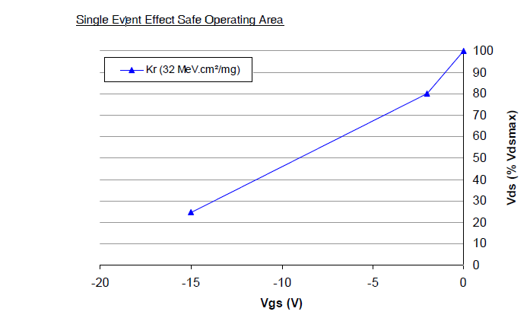
NOTES:
            - The derating for space application was originally obtained under the following Test conditions:

Ion used = Kr
LET = 32.1 (MeV/(mg/cm²))
Energy = 768 MeV
Range = 94 μm

