

Page 1 of 17
CAPACITORS, MICROWAVE, SILICON, MOS, NAKED DIE
BASED ON TYPEs 101m, 201m, 400m and 401m
ESCC Detail Specification No. 5711/002

Issue 3 Draft C | April 2015



Document Custodian: European Space Agency – see https://escies.org

Legal Disclaimer and Copyright
European Space Agency, Copyright © 2015. All rights reserved.
The European Space Agency disclaims any liability or responsibility, to any person or entity, with respect to any loss or damage caused, or alleged to be caused, directly or indirectly by the use and application of this ESCC publication.
This publication, without the prior permission of the European Space Agency and provided that it is not used for a commercial purpose, may be:
- copied in whole, in any medium, without alteration or modification.
- copied in part, in any medium, provided that the ESCC document identification, comprising the ESCC symbol, document number and document issue, is removed.

DOCUMENTATION CHANGE NOTICE
(Refer to https://escies.org for ESCC DCR content)
DCR No. | CHANGE DESCRIPTION
919 | Specification upissued to incorporate changes per DCR.

TABLE OF CONTENTS
1 General 5
1.1 SCOPE 5
1.2 APPLICABLE DOCUMENTS 5
1.3 TERMS, DEFINITIONS, ABBREVIATIONS, SYMBOLS AND UNITS 5
1.4 THE ESCC COMPONENT NUMBER AND COMPONENT TYPE VARIANTS 5
1.4.1 The ESCC Component Number 5
1.4.1.1 Characteristics and Ratings Codes 5
1.4.2 Component Type Variants and Range of Components 6
1.5 MAXIMUM RATINGS 7
1.6 handling precautions 8
1.7 PHYSICAL DIMENSIONS 8
1.7.1 Variants 01 to 10 8
1.7.2 Variants 11 to 23 8
1.7.3 Variants 24, 25, 26 9
1.7.4 Variants 27, 28 and 29 10
1.7.5 Variant 30 11
1.7.6 Variant 31 12
1.8 FUNCTIONAL DIAGRAM 12
1.9 MATERIALS AND FINISHES 12
2 REQUIREMENTS 13
2.1 GENERAL 13
2.1.1 Deviations from the Generic Specification 13
2.1.1.1 Deviations from Production Control (Chart F2) 13
2.1.1.2 Deviations from Screening Tests (Chart F3) 13
2.2 MARKING 13
2.3 die shear 13
2.4 ELECTRICAL MEASUREMENTS AT ROOM, HIGH AND LOW TEMPERATURES 14
2.4.1 Room Temperature Electrical Measurements 14
2.4.2 High and Low Temperatures Electrical Measurements 14
2.5 PARAMETER DRIFT VALUES 15
2.6 INTERMEDIATE AND END-POINT ELECTRICAL MEASUREMENTS 15
2.7 BURN-IN 2 CONDITIONS 16
2.8 OPERATING LIFE CONDITIONS 16
APPENDIX A 17

General

SCOPE
This specification details the ratings, physical and electrical characteristics and test and inspection data for the component type variants and/or the range of components specified below. It supplements the requirements of, and shall be read in conjunction with, the ESCC Generic Specification listed under Applicable Documents.

APPLICABLE DOCUMENTS
The following documents form part of this specification and shall be read in conjunction with it:
          - ESCC Generic Specification No. 5010
          - MIL-STD-750, Test Methods and Procedures for Semiconductor Devices

TERMS, DEFINITIONS, ABBREVIATIONS, SYMBOLS AND UNITS
For the purpose of this specification, the terms, definitions, abbreviations, symbols and units specified in ESCC Basic Specification No. 21300 shall apply.

THE ESCC COMPONENT NUMBER AND COMPONENT TYPE VARIANTS

The ESCC Component Number
The ESCC Component Number shall be constituted as follows:
Example: 5711002012C2KG
- Detail Specification Reference: 5711002
- Component Type Variant Number: 01 (as required)
- Characteristic code: Capacitance Value (2.2pF): 2C2 (as required)
- Characteristic code: Tolerance (±10%): K (as required)
- Rating code: Rated Voltage (200V): G (as required)

Characteristics and Ratings Codes
Characteristics and ratings to be codified as part of the ESCC Component Number shall be as follows:
          - Rated Capacitance Value C_{n} expressed by means of the following codes in accordance with ESCC Basic Specification No. 21700. The unit quantity shall be picofarads (pF):
Capacitance Value C_{n}  (pF) | Code
0.XX | CXX
X.X | XCX
XX | XX0
XX10¹ | XX1
          - Capacitance Tolerance expressed by the following codes in accordance with ESCC Basic Specification No. 21700:
Tolerance  (± %) | Code Letter
10 | K
20 | M
          - Rated Voltage expressed by the following codes:
Rated Voltage U_{R}  (V) | Code Letter
40 | B
100 | E
200 | G
400 | K

Component Type Variants and Range of Components
The component type variants and the associated range of components applicable to this specification are as follows:
Variant Number | Based on Type | Capacitance Values C_{n}  (pF) | Capacitance Tolerance  (± %) | Rated Voltage U_{R} (V)
01 | 201M106C | 2.2, 2.7, 3.3 | 10, 20 | 200
02 | 101M106C | 3.9, 4.7, 5.6, 6.8 | 10, 20 | 100
03 | 400M106C | 8.2, 10, 12, 15 | 10, 20 | 40
04 | 201M107C | 3.9, 4.7, 5.6, 6.8, 8.2 | 10, 20 | 200
05 | 101M107C | 10, 12, 15 | 10, 20 | 100
06 | 400M107C | 18, 22, 27, 33, 39 | 10, 20 | 40
07 | 201M108C | 10, 12, 15, 18 | 10, 20 | 200
08 | 101M108C | 22, 27, 33, 39 | 10, 20 | 100
09 | 400M108C | 47, 56, 68 | 10, 20 | 40
10 | 400M110C | 82, 100 | 10, 20 | 40
11 | 201M106A | 0.22, 0.27, 0.33, 0.39, 0.47, 0.56, 0.68, 0.82, 1, 1.2, 1.5, 1.8, 2.2, 2.7, 3.3 | 10, 20 | 200
12 | 101M106A | 3.9, 4.7, 5.6, 6.8 | 10, 20 | 100
13 | 400M106A | 8.2, 10, 12, 15 | 10, 20 | 40
14 | 201M104A | 3.9, 4.7, 5.6, 6.8 | 10, 20 | 200
15 | 101M104A | 10, 12 | 10, 20 | 100
16 | 400M104A | 18, 22, 27 | 10, 20 | 40
17 | 201M107A | 8.2 | 10, 20 | 200
18 | 101M107A | 15 | 10, 20 | 100
19 | 400M107A | 33, 39 | 10, 20 | 40
20 | 201M108A | 10, 12, 15, 18 | 10, 20 | 200
21 | 101M108A | 22, 27, 33, 39 | 10, 20 | 100
22 | 400M108A | 47, 56, 68 | 10, 20 | 40
23 | 400M110A | 82, 100 | 10, 20 | 40
24 | 401M111J | 0.125 (Note 1) | 10, 20 | 400
25 | 201M111J | 0.25 (Note 1) | 10, 20 | 200
26 | 101M111J | 0.5 (Note 1) | 10, 20 | 100
27 | 401M112J | 0.2 (Note 1) | 10, 20 | 400
28 | 201M112J | 0.4 (Note 1) | 10, 20 | 200
29 | 101M112J | 0.8 (Note 1) | 10, 20 | 100
30 | 400M113J | 10 (Note 1) | 10, 20 | 40
31 | 400M114J | 10 (Note 1) | 10, 20 | 40
Notes:
            - Capacitor arrays with several bond pads. The capacitance value refers to C_{n}, the smallest individual rated capacitance value available on the die. Multiples of C_{n} also available on the die shall be as specified in Physical Dimensions for the particular Variant.

MAXIMUM RATINGS
The maximum ratings shall not be exceeded at any time during use or storage.
Maximum ratings shall only be exceeded during testing to the extent specified in this specification and when stipulated in Test Methods and Procedures of the ESCC Generic Specification.
Characteristics | Symbols | Maximum Ratings | Unit | Remarks
Rated Voltage | U_{R} | See Component Type Variants and Range of Components | V
Breakdown Voltage | V_{BR} | 1.5U_{R} | V | Minimum
Operating Temperature Range | T_{op} | -55 to +150 | °C | T_{amb}
Storage Temperature Range | T_{stg} | -55 to +175 | °C
Die Attach Temperature | T_{die} | +320 | °C | Note 1
NOTES:
            - Duration 30 seconds maximum.

handling precautions
These devices are susceptible to damage by electrostatic discharge. Therefore suitable precautions shall be employed for protection during all phases of manufacture, test, packaging, shipping and handling.
These components are categorised as Class 1 per ESCC Basic Specification No. 23800 with a minimum Critical Path Failure Voltage of 1000V.

PHYSICAL DIMENSIONS

Variants 01 to 10
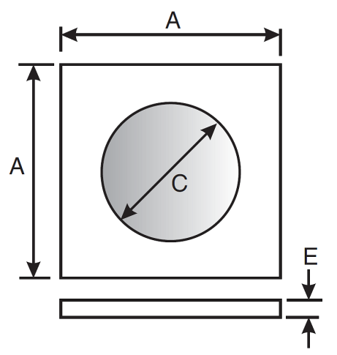 | Symbols | Dimensions mm |  | Variant Number
 | Symbols | Min | Max | Variant Number
 | A | 0.34 | 0.4 | 01, 02, 03
 | A | 0.54 | 0.6 | 04, 05, 06
 | A | 0.74 | 0.8 | 07, 08, 09
 | A | 0.94 | 1 | 10
 | ØC | 0.145 | 0.31 | 01, 02, 03
 | ØC | 0.31 | 0.49 | 04, 05, 06
 | ØC | 0.54 | 0.66 | 07, 08, 09
 | ØC | 0.72 | 0.78 | 10
 | E | 0.16 | 0.22 | All

Variants 11 to 23
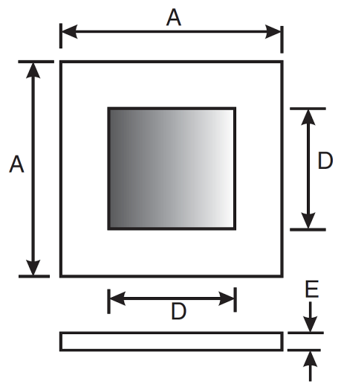 | Symbols | Dimensions mm |  | Variant Number
 | Symbols | Min | Max | Variant Number
 | A | 0.3 | 0.4 | 11, 12, 13
 | A | 0.44 | 0.54 | 14, 15, 16
 | A | 0.5 | 0.6 | 17, 18, 19
 | A | 0.7 | 0.8 | 20, 21, 22
 | A | 0.9 | 1 | 23
 | D | 0.22 | 0.28 | 11, 12, 13
 | D | 0.34 | 0.38 | 14, 15, 16
 | D | 0.4 | 0.44 | 17, 18, 19
 | D | 0.54 | 0.64 | 20, 21, 22
 | D | 0.68 | 0.78 | 23
 | E | 0.16 | 0.22 | All

Variants 24, 25, 26
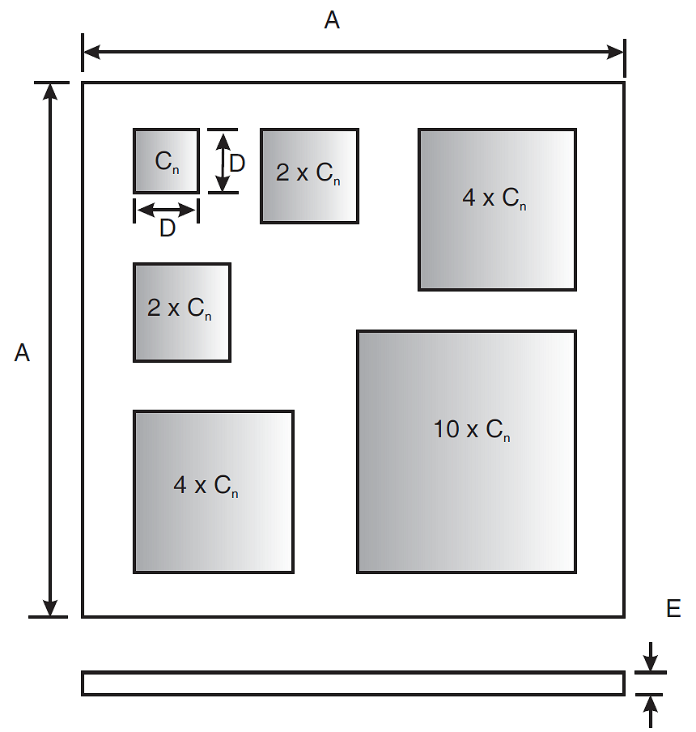
Symbols | Dimensions mm |  | Notes
Symbols | Min | Max | Notes
A | 0.4 | 0.5
D | 0.06 | 0.08 | 1
E | 0.16 | 0.22
notes:
            - Dimension of the smallest bond pad area, specified for bonding purposes.

Variants 27, 28 and 29
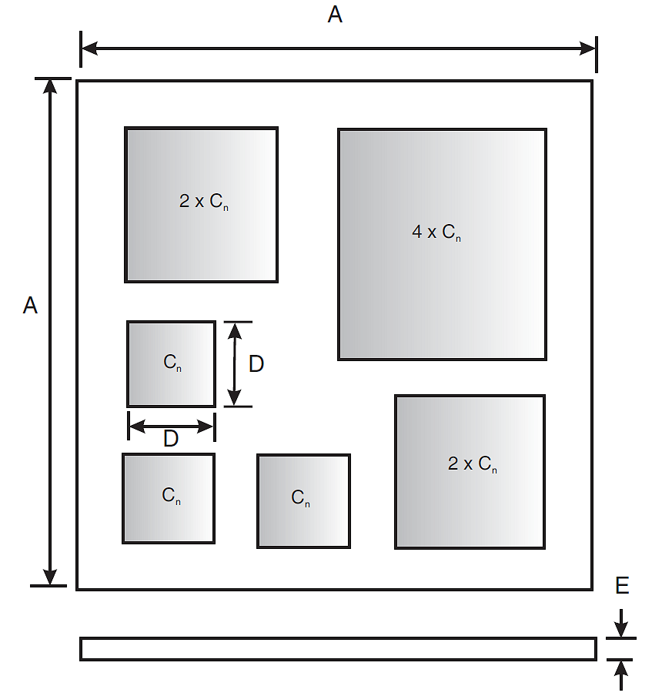
Symbols | Dimensions mm |  | Notes
Symbols | Min | Max | Notes
A | 0.4 | 0.5
D | 0.08 | 0.1 | 1
E | 0.16 | 0.22
notes:
            - Dimension of the smallest bond pad area, specified for bonding purposes.

Variant 30
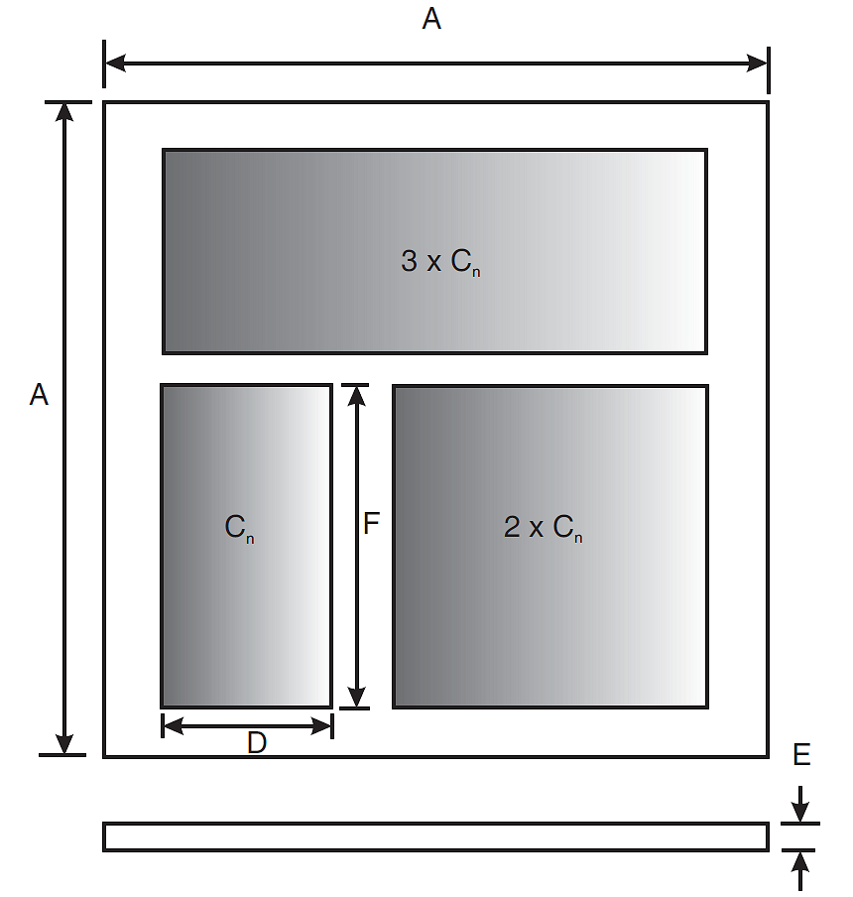
Symbols | Dimensions mm |  | Notes
Symbols | Min | Max | Notes
A | 0.4 | 0.5
D | 0.06 | 0.08 | 1
E | 0.16 | 0.22
F | 0.26 | 0.28 | 1
notes:
            - Dimension of the smallest bond pad area, specified for bonding purposes.

Variant 31
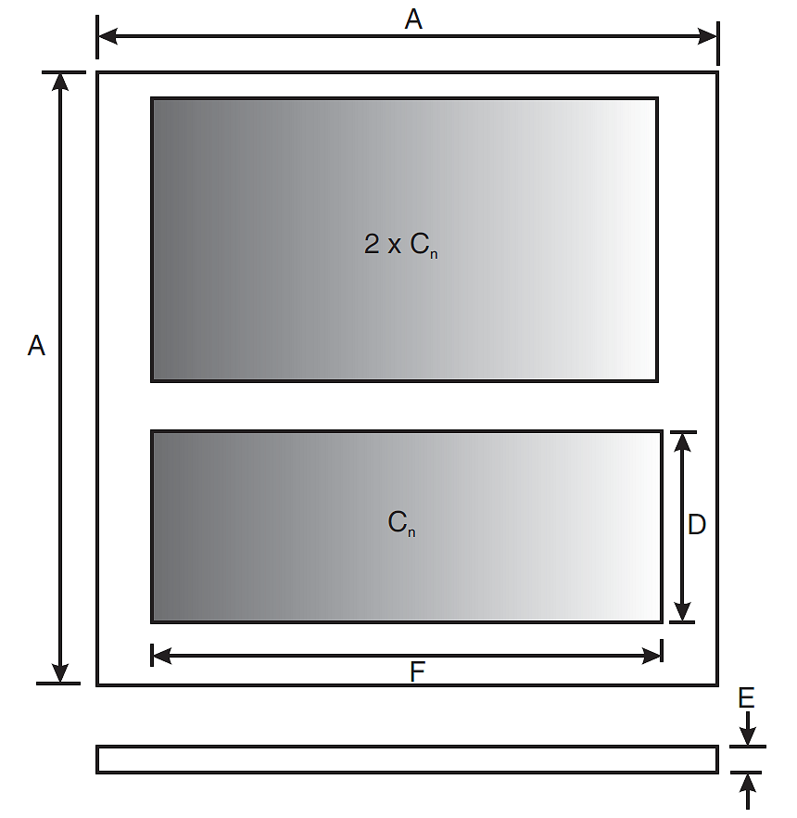
Symbols | Dimensions mm |  | Notes
Symbols | Min | Max | Notes
A | 0.4 | 0.5
D | 0.06 | 0.08 | 1
E | 0.16 | 0.22
F | 0.26 | 0.28 | 1
notes:
            - Dimension of the smallest bond pad area, specified for bonding purposes.

FUNCTIONAL DIAGRAM
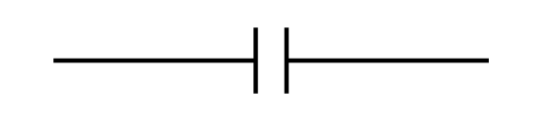

MATERIALS AND FINISHES
Materials and finishes shall be as follows:
          - Bond Pad
The bond pad metallisation shall be TiAu with a layer of vacuum-deposited gold, thickness ≥ 0.25µm and a final layer of electrolytic gold, thickness ≥ 2.7µm.
          - Die Backface
The die backface metallisation shall be TiAu with a layer of gold, thickness ≥ 0.5µm.

REQUIREMENTS

GENERAL
The complete requirements for procurement of the components specified herein are as stated in this specification and the ESCC Generic Specification. Permitted deviations from the Generic Specification, applicable to this specification only, are listed below.
Permitted deviations from the Generic Specification and this Detail Specification, formally agreed with specific Manufacturers on the basis that the alternative requirements are equivalent to the ESCC requirement and do not affect the component’s reliability, are listed in the appendices attached to this specification.

Deviations from the Generic Specification

Deviations from Production Control (Chart F2)
          - A Metallisation Adhesion test shall be performed on a randomly selected sample of 5 naked die from each wafer lot, after Die Visual Inspection during Wafer Lot Acceptance.
Samples shall be subjected to a high temperature bake of +320 (+5 -0)°C for a period of 5 minutes minimum. The samples shall then be visually inspected.
Any evidence of lifting or peeling metallisation shall be cause for wafer lot failure.
This test is considered as destructive and therefore components so tested shall not form part of the delivery lot.

Deviations from Screening Tests (Chart F3)
          - Burn-in 1: Not applicable.
          - Parameter Drift Values Δ1: Not applicable.
          - Check for Lot Failure for Burn-in 1: Not applicable.

MARKING
The marking shall be in accordance with the requirements of ESCC Basic Specification No. 21700.
The information to be marked and the order of precedence shall be as follows:
          - The ESCC qualified components symbol (for ESCC qualified components only).
          - The ESCC Component Number.
          - Traceability information.

die shear
In those cases where package clearances are such that a die shear test is not practicable, the die shall be pushed away with a suitable tool. The force required to remove the die need not be recorded. The die attachment area shall be inspected and the component shall be considered acceptable if more than 50% of the semiconductor material remains.

ELECTRICAL MEASUREMENTS AT ROOM, HIGH AND LOW TEMPERATURES

Room Temperature Electrical Measurements
The measurements shall be performed at T_{amb} = +22 ±3°C.
Characteristics | Symbols | MIL-STD-750  Test Method | Test Conditions | Tolerance  (± %) | Limits |  | Units
 |  |  |  |  | Min | Max | Units
Capacitance | C | 4001 | V_{T} = 0V, f = 1MHz | 10  20 | 0.9C_{n}  0.8C_{n} | 1.1C_{n}  1.2C_{n} | pF
Leakage Current | I_{L1} | 4016 | V_{T} = U_{R} | All | - | 50 | nA
Voltage Proof Leakage Current | I_{L2} | 4016 | V_{T} = 1.5U_{R} | All | - | 100 | nA

High and Low Temperatures Electrical Measurements
Characteristics | Symbols | MIL-STD-750  Test Method | Test Conditions  Note 1 | Limits |  | Units
 |  |  |  | Min | Max | Units
Leakage Current | I_{L1} | 4016 | T_{amb} = +150 (+0 -3)°C  V_{T} = U_{R} | - | 100 | nA
NOTES:
            - Measurements shall be performed on a sample basis as specified in the Generic Specification.

PARAMETER DRIFT VALUES
Unless otherwise specified, the measurements shall be performed at T_{amb} = +22 ±3°C.
The test methods and test conditions shall be as per the corresponding test defined in Room Temperature Electrical Measurements.
The drift values (Δ) shall not be exceeded for each characteristic specified. The corresponding absolute limit values for each characteristic shall not be exceeded.
Characteristics | Symbols | Limits |  |  | Units
Characteristics | Symbols | Drift  Value  Δ | Absolute |  | Units
Characteristics | Symbols | Drift  Value  Δ | Min | Max | Units
Capacitance | C | ±0.2  or (1) ±2% | Note 2 |  | pF
Leakage Current | I_{L1} | ±5  or (1) ±100% | - | 50 | nA
NOTES:
            - Whichever is the greater referred to the initial value.
            - As specified in Room Temperature Electrical Measurements.

INTERMEDIATE AND END-POINT ELECTRICAL MEASUREMENTS
Unless otherwise specified, the measurements shall be performed at T_{amb} = +22 ±3°C.
The test methods and test conditions shall be as per the corresponding test defined in Room Temperature Electrical Measurements.
The limit values for each characteristic shall not be exceeded.
Characteristics | Symbols | Limits |  | Units
Characteristics | Symbols | Min | Max | Units
Capacitance | C | Note 1 |  | pF
Leakage Current | I_{L1} | - | 50 | nA
Voltage Proof Leakage Current | I_{L2} | - | 100 | nA
NOTES:
            - As specified in Room Temperature Electrical Measurements.

BURN-IN 2 CONDITIONS
Characteristics | Symbols | Test Conditions | Units
Ambient Temperature | T_{amb} | +150 (+0 -3) | °C
Test Voltage | V_{T} | U_{R} | V

OPERATING LIFE CONDITIONS
The conditions shall be as specified for Burn-in 2.

APPENDIX A
AGREED DEVIATIONS FOR Cobham Microwave (F)
Items Affected | Description of Deviations
Deviations from Generic  Specification: Special In-Process Controls (Chart F2) | Assembly (Assembly of the Packaged Test Sublot for Naked Die Components):  A minimum of 5 dice per wafer and 20 dice per wafer lot shall be assembled to make up the Packaged Test Sublot.
 | Encapsulation: Encapsulation of the Packaged Test Sublot samples is optional at the Manufacturer’s discretion.
Deviations from Generic  Specification: Screening Tests (Chart F3) | Particle Impact Noise Detection (PIND): Not applicable.
 | Radiographic Inspection: Not applicable.
 | Seal (Fine and Gross Leak): Not applicable.
 | External Visual Inspection: Not applicable.

