

Page 1 of 47
REQUIREMENTS FOR THE
PROCESS CAPABILITY APPROVAL
FOR
MANUFACTURING LINES
OF
HERMETIC HYBRID MICROCIRCUITS
ESCC Basic Specification No. 2566000

Issue 2 | November 2014



Document Custodian: European Space Agency – see https://escies.org

Legal Disclaimer and Copyright
European Space Agency, Copyright © 2014, All rights reserved.
The European Space Agency disclaims any liability or responsibility, to any person or entity, with respect to any loss or damage caused, or alleged to be caused, directly or indirectly by the use and application of this ESCC publication.
This publication, without prior permission of the European Space Agency and provided it is not used for a commercial purpose, may be:
- copied in whole, in any medium, without alteration or modification.
- copied in part, in any medium, provided that the ESCC document identification, comprising the ESCC symbol, document number and document issue, is removed.

DOCUMENTATION CHANGE NOTICE
(Refer to https://escies.org for ESCC DCR content)
DCR No. | CHANGE DESCRIPTION

TABLE OF CONTENTS
1 PURPOSE AND SCOPE 6
2 APPLICABLE DOCUMENTS 6
2.1 ESCC SPECIFICATIONS 6
2.2 OTHER APPLICABLE DOCUMENTS 7
3 TERMS, DEFINITIONS, ABBREVIATIONS, SYMBOLS AND UNITS 7
3.1 TERMS FROM OTHER STANDARDS 7
3.2 TERMS SPECIFIC TO THE PRESENT STANDARD 7
3.3 Abbreviated terms 9
4 DEFINITION OF PROCESS CAPABILITY APPROVAL FOR HYBRID LINES 10
5 DEFINITION OF THE PROCESS CAPABILITY DOMAIN AND ITS BOUNDARIES 12
5.1 GENERAL 12
5.1.1 Materials and processes 12
5.1.2 Physical Design 12
5.1.3 Inspection and test 12
5.1.4 Traceability 13
5.2 THE PID OF AN HYBRID MANUFACTURER 13
5.2.1 General 13
5.2.2 Review and approval of the PID 13
5.2.3 Requirements for the preparation of the PID 14
6 MANUFACTURER EVALUATION 14
7 EVALUATION OF THE PROCESS CAPABILITY DOMAIN 14
7.1 GENERAL 14
7.2 EVALUATION TEST PROGRAMME 14
7.2.1 General 14
7.2.2 Description of Test Vehicles (TVE) 15
7.2.2.1 General 15
7.2.2.2 Definition of TVE1 test vehicle 15
7.2.2.3 Definition of TVE2 test vehicle 17
7.2.3 Examples of the two Evaluation Test Vehicles 17
7.3 MANUFACTURER’S AUDIT 21
7.4 EVALUATION TESTING 21
7.4.1 General 21
7.4.2 Control samples 22
7.4.3 Test plans 22
7.4.4 Test methods and conditions 25
7.4.5 Evaluation test report 28
8 PROCESS CAPABILITY APPROVAL (PCA) PHASE 28
8.1 GENERAL 28
8.2 PROCESS CAPABILITY APPROVAL TESTING 29
8.2.1 Definition and requirements for test vehicles for PCA testing 29
8.2.2 Hermetic Hybrids PCA test plans 29
8.2.2.1 General 29
8.2.2.2 Sample size 30
8.2.2.3 PCA test plan 31
8.2.3 Hermetic Hybrids PCA test methods and conditions 32
8.2.4 PCA test report 34
8.3 PROCEDURES SPECIFIC TO THE PCA OF HYBRID MANUFACTURING LINES 35
8.3.1 Manufacturing Line under TRB management 35
8.3.2 Extension or change of the Process Capability Approval Domain 35
8.3.3 Maintenance, suspension, withdrawal of the Process Capability Approval 37
8.3.3.1 Maintenance of process capability approval. 37
8.3.3.2 Suspension of process capability approval. 37
8.3.3.3 Withdrawal of process capability approval 38
8.3.3.4 Renewal after lapse of process capability approval 38
9 ANNEX 1 REQUIREMENTS GUIDELINES FOR THE MATERIALS AND PROCESSES DESCRIPTION 39
9.1 DEFINITION OF PROPOSED SUB-TECHNIQUES IN THE PCA DOMAIN 39
9.1.1 Definition of sub-techniques depending on the substrate technology 39
9.1.1.1 Screen Printed Thick film 39
9.1.1.2 Thin film deposition 40
9.1.1.3 HTCC (High Temperature Cofired Ceramic) 41
9.1.1.4 LTCC (Low Temperature Co-fired Ceramic) 41
9.1.1.5 Organic substrate(s) 42
9.1.1.6 DBC (Direct Bonded Copper) 42
9.1.2 Assembly of added-on components, substrates and carriers 43
9.1.2.1 Passive components assembly 43
9.1.2.2 Active components assembly 43
9.1.3 Encapsulation 45
9.1.3.1 Hermetic packaging 45
10 ANNEX 2 OVERVIEW OF THE PCA EXTENSION APPLICATION 47

PURPOSE AND SCOPE
The purpose of this specification is to define the requirements for the Process Capability Approval (PCA) of a manufacturing line of Hermetic Hybrid Microcircuits intended for space application.
This specification:
- provides the specific requirements which a manufacturer has to fulfill in order to be successfully evaluated and capability approved for a set of materials and processes used on a manufacturing line to construct hermetic Hybrid Microcircuits and for this capability to be described and published in the ESCC REP007 (ESCC List of PCA certificates).
- is applicable to substrate and interconnect technologies (see paragraph 3.2)
- shall be read in conjunction with ESCC Basic Specification 25600 which provides the general requirements for Process Capability Approval.

NOTES
- This specification does not provide requirements for the PCA of a manufacturing line of any devices which are not designed to be hermetic.

APPLICABLE DOCUMENTS
The following specifications form part and shall be read in conjunction with, this specification. The relevant issues shall be those in effect at the date of commencement of a particular task, as applicable and as required for each stage of the sequence of activities which may lead to the PCA certification of the manufacturing line.

ESCC SPECIFICATIONS
ESCC 25600 Requirements for the Process Capability Approval
ESCC 21300 Terms, Definitions, Abbreviations, Symbols and Units
ESCC 21500 Calibration System Requirements
ESCC 24600 Minimum Quality Management System Requirements

ESCC 22800 ESCC Non-Conformance Control System
ESCC 24900 Minimum requirements for controlling environmental contamination of components
ESCC 24800 Resistance to solvents of marking, materials and finishes
ESCC 2026000 Checklist for Hybrids Manufacturers and Line survey
ESCC 2276000 Guidelines for the PID of Hybrid manufacturers

OTHER APPLICABLE DOCUMENTS
The following documents are applicable to the extent specified herein. The relevant issues shall be those in effect at the date of commencement of a particular task, as applicable and as required for each stage of the sequence of activities which may lead to the PCA certification of the manufacturing line.
ECSS-Q-ST-60-05 Generic Procurement Requirements for Hybrids
ECSS-S-ST-00-01 Glossary of Terms
MIL-STD-883 Test Method Standard Microcircuits
MIL-STD-750 Test Method Standard Test Methods for Semiconductor Devices
MIL-STD-202 Test Method Standard Electronic and Electrical component parts
ISO 14644-1 Cleanrooms and Associated Controlled Environments - Part 1: Classification of Air Cleanliness
IPC-9191 General Guidelines for Implementation of Statistical Process Control
IPC-9199 Statistical Process Control (SPC) Quality Rating

TERMS, DEFINITIONS, ABBREVIATIONS, SYMBOLS AND UNITS

TERMS FROM OTHER STANDARDS
For the purpose of this Standard, the terms, definitions, abbreviations, symbols and units defined in ESCC Basic Specification No. 21300 and ECSS-S-ST-00-01 apply, plus specific terms as in 3.2..

TERMS SPECIFIC TO THE PRESENT STANDARD
Hybrid microcircuit
Hybrid circuits
Combination of elements (interconnection substrate, added active or passive chips) sealed inside a package, in order to perform an electronic function
NOTES
            - Interconnection substrate (e.g. thick film, thin film, co-fired, DBC) can be with or without integrated passive components (e.g. resistors, inductors, capacitors).
            - Active parts can be monolithic or discrete, chips or packaged components.

            - Electronic functions that are performed by hybrids include digital or analog, low frequency or radiofrequency, low power or high power functions. These functions may be mixed according to the application.
            - The terms “hybrid circuits” and “hybrids” are synonymous for “Hybrids microcircuits”.

Production lot
Number of units of a single device type manufactured on the same production line using the same production techniques, in one uninterrupted period, according to the same component or part design and having the same chip lots and the same materials (as defined in ECSS-Q-60-05)

STATISTICAL PROCESS CONTROL (SPC)
Statistical Process Control is the use of statistical techniques and tools for monitoring a process through the use of control charts, to warn when the process is moving away from predetermined limits always before non conformance occurrence, in accordance with IPC-9191 and IPC-9199.
Design of Experiments (DoE)
Design of Experiments is a structured, organized method for determining, with a reduced number of experiments, the effect of process parameters on a process result (for determination of influent parameters) and the correlation between parameters (for process optimization).
Semi-finished Product
A Semi-finished product is a product performing a specific function procured from an external supplier entering the fabrication flow of an hybrid (for example: package, interconnection substrate etc) not produced by the hybrid manufacturer itself.
External Sub-contractor
A company different from the hybrid manufacturer that performs a particular process step used in the hybrid fabrication flow mentioned in the PID

Rework
Action to correct a defect of a product that does not lead to a configuration item change
            - Unlike repair, rework does not affect or modify parts of the defective product.
            - No NCR needs to be raised.

Repair
Action to correct a defect of a product that leads to a configuration item change
            - Unlike rework, repair affects or modifies parts of the defective product.
            - An NCR needs to be raised for the configuration item change.

Abbreviated terms
The following abbreviations are used within this document:
Abbreviation Meaning
CTA Circuit Type Approval
DBC Direct Bond Copper
DoE Design of Experiments
DPA Destructive Physical Analysis
ECSS European Cooperation for Space Standardisation
ESCC European Space Components Cooperation
ESD Electrostatic discharge
ETP Evaluation Test Programme
HTCC High Temperature Co-fired Ceramic
HTIF Hybrid Technology Identification Form
I/O Input / Output
ISP Integrated Substrate Package
LAT Lot Acceptance Testing
LF Low Frequency
LTCC Low Temperature Co-fired Ceramic
NCR Non Conformance Report
PCA Process Capability Approval
PID Process Identification Document
PIND Particle Impact Noise Detection
QA Quality Assurance
QS Quality System
RF Radio Frequency
RGA Residual Gas Analysis
SEC Standard Evaluation Circuit
SEM Scanning Electron Microscope
SPC Statistical Process Control
TCR Temperature Coefficient of Resistance
TRB Technology Review Board
TVCA Test Vehicle for Capability Approval
TVE Test Vehicle for Evaluation

DEFINITION OF PROCESS CAPABILITY APPROVAL FOR HYBRID LINES
The ESCC Process Capability Approval (PCA) of Hermetic Hybrid Manufacturing Lines shall include the 4 stages specified in ESCC Basic Specification 25600, namely
- Manufacturer Evaluation,
- Definition of the Capability Domain,
- Evaluation Phase and
- PCA Phase testing.
The successful completion of these stages requires, therefore, the definition of the PCA and its boundaries, the preparation, review and approval of the relevant PID and the actual completion of test sequences specified for Evaluation testing and PCA testing.
The flow to reach the PCA of an Hybrid Line is described in Flow Chart 1.
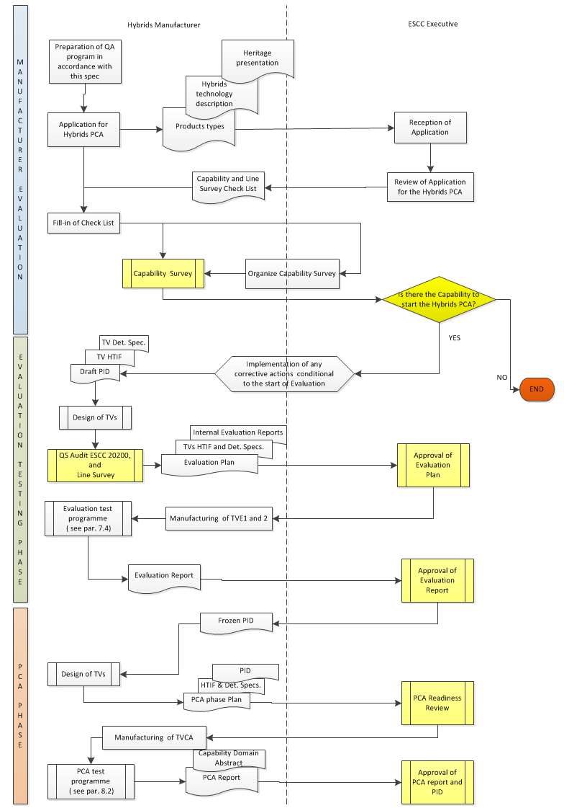
Flow Chart 1

DEFINITION OF THE PROCESS CAPABILITY DOMAIN AND ITS BOUNDARIES
In addition to the requirements of ESCC 25600, the following is specific and applicable to the Definition of the capability domain, and the preparation of the Capability Abstract, of Hybrid Manufacturers for the purpose of PCA.

GENERAL
The Manufacturer shall define the process capability domain for which process capability approval is sought as required in ESCC 25600. This definition shall result in the Capability Abstract and the PID.
The Capability Abstract and the PID have to demonstrate that the Process capability domain represents a structured, properly controlled and monitored manufacturing process for hybrid microcircuits.
The definition of the process capability domain shall address the areas listed in the rest of this paragraph at least to the extent detailed therein. Additional information shall be supplied whenever necessitated by the particular capability domain under approval.
Within the definition of the PCA for Hybrid manufacturing lines, the following areas are of particular concern and are therefore the object of specific requirements in the rest of this paragraph:
- Materials, Processes and add-on parts
- Physical design
- Inspection and test
- Traceability

The manufacturer shall describe the type of functions / products which are planned to be developed and manufactured, in term of power dissipation (Low/ High Power), maximum current / voltage, signal frequency (Low / Radio Frequency), digital / analog functions, mixed functions, etc.
When existing, heritage in hybrids design, qualification and manufaturig activities shall be presented in order to define the capability abstract. Existing PID shall be considered.

Materials and processes
Annex 1 gives requirements guidelines for the materials and processes description anticipated to be included in the PCA application

Physical Design
The manufacturer shall specify physical design rules that define the construction and composition of all items foreseen for the production of hybrid microcircuits within the process capability domain. Methodologies and procedures used by the manufacturer to validate their design shall also be addressed.
The design rules shall at least cover the following:
- Substrate and carrier physical constraints
- Conductor, termination and wire bonding physical constraints
- Thick film, thin film circuit physical constraints
- Electrical design constraints, including Multipaction and Corona effects
- Package Assembly and encapsulation

Inspection and test
The Manufacturer shall describe the methods applicable for inspections and test, including references to the documents specifying those methods.
At least the following areas shall be covered:
- Materials, piece parts and EEE add-on parts Incoming Inspection
- In-process inspections
- Internal and external visual inspection

Traceability
The Manufacturer shall describe his methods for assuring traceability of materials, piece parts, EEE add-on parts, test and manufactured items. At least the following points shall be covered:
- The use of purchase orders and specifications
- The use of route sheets and travellers
- The traceability of materials, piee parts and EEE add-on parts
- The traceability of test structures
- The traceability of manufactured items

THE PID OF AN HYBRID MANUFACTURER

General
A PID for the process capability domain to be approved shall be prepared per ESCC 2276000

Review and approval of the PID
The PID will contain the complete definition of the Capability Domain and will be updated into a stable state at the end of the Evaluation phase so that its review and approval by the ESCC Executive becomes a mandatory pre-requisite for the commencement of the PCA testing phase.
The complete PID, comprising all called-up specifications, shall be kept by the manufacturer at the production plant. It shall be made available to the ESCC Executive or its designated representative for review.
Any deviation from PID shall be subjected to the ESCC Executive for approval.
A condensed PID, comprising all basic information, e.g. flow-charts, lists of specifications, materials, processes, organization/responsibility, equipments and layouts but complemented by copies of only the agreed specifications, shall be kept by the ESCC Executive and treated as proprietary information.

MANUFACTURER EVALUATION
In addition to the requirements of ESCC Basic Specfiication 25600, the following is specific and applicable to the Evaluation of Hybrid Manufacturers for the purpose of PCA.
The following activities shall be carried out during the manufacturer evaluation phase:
- Capability survey. This survey is made to assess a manufacturer's general capability for the production of reliable Hybrid Microcircuits.
- Line survey. This survey consists of an assessment of a manufacturer’s technology and production line based on applied processes and controls and a detailed review of existing test data.

In general, to enable the survey team of the ESCC Executive to carry out the capability survey, the line survey and the manufacturer audit, the manufacturer shall grant free access to the facilities concerned. He shall also enable the team to witness any development, engineering, production and quality assurance operations involved in the processes for which approval is sought.
To facilitate the evaluation procedure for capability survey, line survey and manufacturer audit, the checklist based on ESCC Basic Specification 2026000 shall be used.

EVALUATION OF THE PROCESS CAPABILITY DOMAIN

GENERAL
The evaluation phase of the process capability domain of Hybrid Manufacturing Lines shall be as specified in ESCC Basic Specification 25600 with additional requirements set in the rest of this paragraph.

EVALUATION TEST PROGRAMME

General
The Evaluation testing to be performed on test structures representative of the hybrid process under approval shall be in accordance with an Evaluation Test Programme (ETP) which shall, as a minimum, conform to the requirements of this paragraph.
The test structures used for Evaluation testing are called Test vehicles (TVE). The quantity and type of samples to be used for the ETP shall be agreed by the ESCC Executive and the manufacturer. The samples shall also be the most suitable for highlighting those characteristics and parameters that are pertinent to an investigation on failure modes and weaknesses.
Upon completion of evaluation testing, the final definition of the process capability domain and its boundaries shall be agreed between the Manufacturer and the ESCC Executive, and the Process Capability Abstract shall be issued.

Description of Test Vehicles (TVE)

General
On the basis of materials, processes and sub-techniques proposed by the manufacturer for approval, the manufacturer shall define the test vehicles implementing the different sub-techniques and their related limits.
To cover all the different sub-techniques, a minimum of two types of test vehicles shall be used:
- One type addressing the substrate technology (TVE1)
- One type addressing the assembly of added-on parts and the actual packaging technique (TVE2)

TVE1 test vehicle shall consist of the main substrate mounted and connected with a selected packaging technology that is representative of the packaging technique used for the hybrid process. The number of I/O pins shall be enough to perform the electrical measurements.
TVE2 test vehicle shall be encapsulated with the actual packaging technique . The package used for TVE2 may be different from the actual package planned for the hybrid but shall in any case cover the technology domain under approval
In order to cover the full Process Capability Domain it might be necessary to define several Test Vehicles of the type TVE1 and/or TVE2 above.
If proposed by the manufacturer, and in accordance with the ESCC Executive, some Evaluation test vehicles may be intentionally repaired (and/or reworked) and the traceability of the various repair/rework operations established accordingly. These repaired/reworked devices shall be clearly identified and submitted to the same test campaign as the non-repaired/reworked hybrid components.
The manufacturer shall write a specification in accordance with ECSS-Q-ST-60-05, Annex B, for each test vehicle to be evaluated and submit it to the ESCC Executive for approval.

Definition of TVE1 test vehicle
This test vehicle shall be representative in term of:
- Maximum X Y dimensions, minimum thickness package and bulk substrates
- Maximum number of conductive layers and associated dielectric layers
- Typical thicknesses of conductive and dielectric layers
- Minimum and typical line width/space
- Minimum and typical via/holes dimensions and typical density
- Minimum and maximum dimensions of resistors in all paste decades for both trimmed and no- trimmed resistors
- Protective coverglaze on conductive and/or resistive layer (if any): material, deposition process, thickness,
Note: In case of matrix production, the vendor shall assess the worst position on the tile and include in the test vehicles configuration
This type of test vehicle shall be designed with specific patterns to assess the performance of :
- The conductor/dielectric network (multilayer structure) :
- Conductor resistance
- On each conductor layer through Greek pattern (about one substrate perimeter long) with a minimum of two different line widths (see example TVE1, pattern A1, A2)
- On a chain of a minimum of 200 vias between two adjacent conductive layers (one chain on the substrate and one chain on the top of the multilayer network) with a minimum of two different line widths (see example TVE1, pattern B)
- On a chain of a minimum of N* vias interconnecting all the conductive layers with a minimum of two different line widths (* N = 100 x number of conductive layers) (see example TVE1, pattern D)
- Insulation resistance
- Between two coplanar adjacent lines through Greek pattern (about one substrate perimeter long) with different space widths (see example TVE1, pattern A1, A2)
- Between one couple of interlaced lines (about one substrate perimeter long) with different space widths (one couple on the substrate and one couple on the top of the multilayer network) (see example TVE1, pattern B)
- Between two ground planes (about 10 % of the total substrate area) located on each conductor layer (see example TVE1, pattern E)
- Capacitance
- Between coplanar adjacent lines in Greek pattern (about one substrate perimeter long) with two different line widths (see example TVE1, pattern A1, A2)
- Between each Greek line and a ground plane separated by one dielectric level (see example TVE1, pattern A1, A2)
- Between two ground planes (about 10 % of the total substrate area) separated by one dielectric level (see example TVE1, pattern E)
- Dielectric strength
- Between all ground planes (about 10 % of the total substrate area) separated by one dielectric level

- The conductor network (monolayer structure) for high power and/or high current applications
- Conductor resistance on the conductor layer with different line width
- Current density on the conductor layer with different line width for long term current density evaluation and for destructive test on specific patterns.

- The resistor network (deposited directly on substrate or on dielectric/ trimmed or not/encapsulated or not):
- Resistor value
- Temperature coefficient of resistance (TCR)
- Maximum power dissipation
For minimum/medium/maximum resistivity, the minimum number of resistors shall be: 4 resistors of minimum length and 4 resistors of maximum length.
Note: Each combination of resistor / conductor termination shall be evaluated.

Definition of TVE2 test vehicle
This test vehicle shall be representative in terms of:
- Maximum X Y, Minimum Z dimensions.
- Representative substrate in terms of :
- Total number of dielectric layers for multilayer structures
- Total thickness (Z)
- External conductor layers
- Configurations of wire interconnections at different conductor layer level (if applicable)
- Metallized holes in contact with attachment medium (grounding connections, if applicable)
- Added-on parts (active and passive components/carrier/substrate)
- Types and manufacturers
- Termination finish
- Minimum and maximum dimensions (two components per size)
- Added-on parts assembly
- Attachment medium
- Interconnection technologies
- Each part shall be connected to the substrate/package
- In addition, a “daisy” chain consisting of a minimum of 100 loops per process/material/diameter wire (or ribbon) shall be implemented in the case of Chip & Wire technology (according to the manufacturer technology the number of loops may be reduced in case of heavy wires)
- Encapsulation
- Hermetic

This test vehicle shall be designed to evaluate :
- The main electrical parameters related to the added-on passive and discrete active components (and integrated circuits, if possible)
- The mechanical (and electrical, when applicable) performance of attachment medium (adhesive bonded or soldered joints)
- The mechanical and electrical performance of bonding wires or ribbons
- The behavior of the encapsulation with respect to the environmental stresses (thermo-mechanical, humidity, contamination)

Examples of the two Evaluation Test Vehicles
The following drawings are provided for general guidance. The manufacturer shall propose, for its evaluation, layouts that cover the full domain of technologies and added-on parts that he wishes to evaluate.
TVE1 test vehicle (thick film multilayer, 3 conductive levels)
Overview
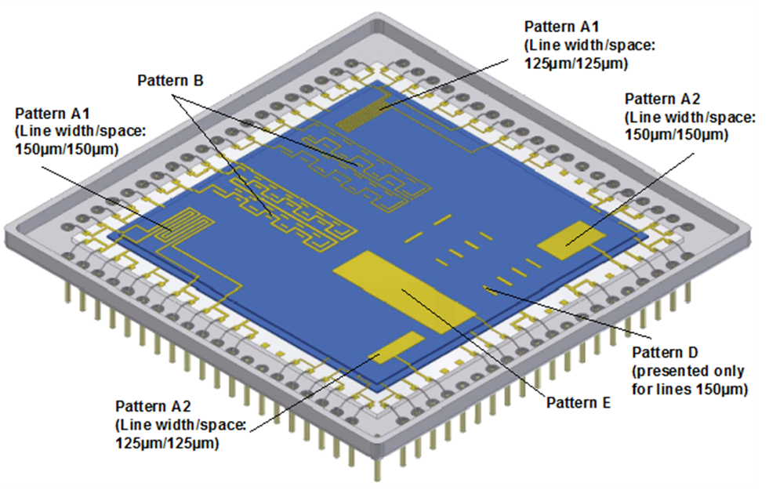
Detail TVE1 | Description
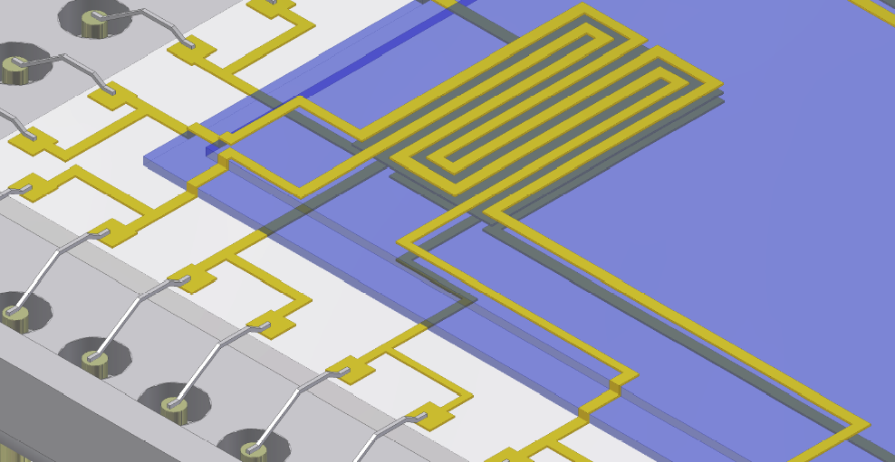  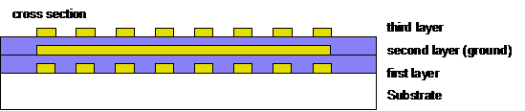 | Pattern A1  Measurement of :  - Conductor resistance at first layer (conductor on substrate) and third layer (conductor on top dielectric layer)  - Insulation resistance between the adjacent coplanar lines  - Capacitance between the adjacent coplanar lines  - Capacitance between each line and the ground plane (second layer)
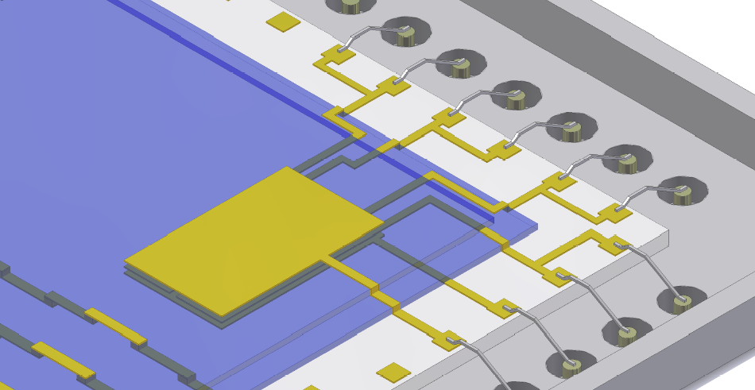  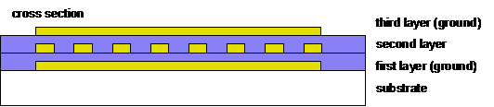 | Pattern A2  Measurement of :  - Conductor resistance at the Greek pattern on second layer (same as in pattern A1)  - Insulation resistance between the coplanar adjacent lines  - Capacitance between the coplanar adjacent lines  - Capacitance between each line and the ground planes (first and third layer)

Detail TVE1 | Description
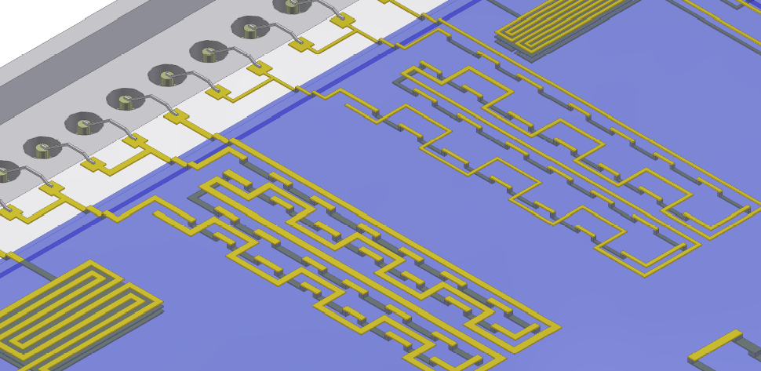 | Pattern B  Measurement of :  - Resistance of a chain of vias between second and third conductive layer (on top of the multilayer network)  - Insulation resistance between different interlaced lines on coplanar adjacent and superposed adjacent layers  (on top of the multilayer network)
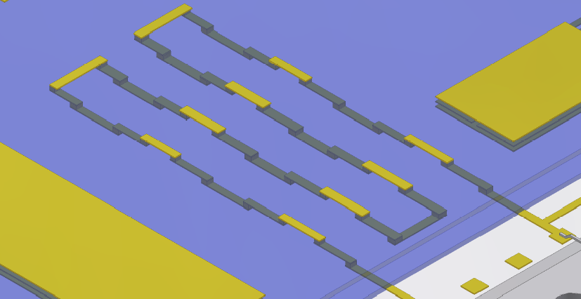 | Pattern D  Measurement of the conductor resistance of a chain (lines and vias), interconnecting all of the three conductive layers .
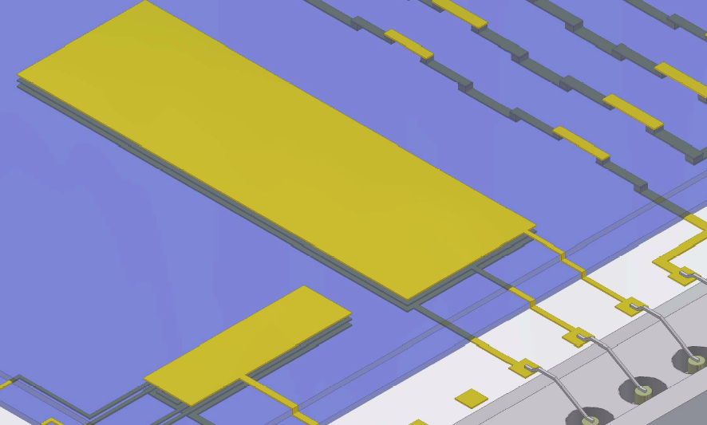 | Pattern E  Measurement of :  - Insulation resistance between the ground planes on the different conductive layers (first-second, second-third)  - Capacitance between the superposed adjacent ground planes

TVE2 test vehicle (thick film multilayer, 3 conductive levels)

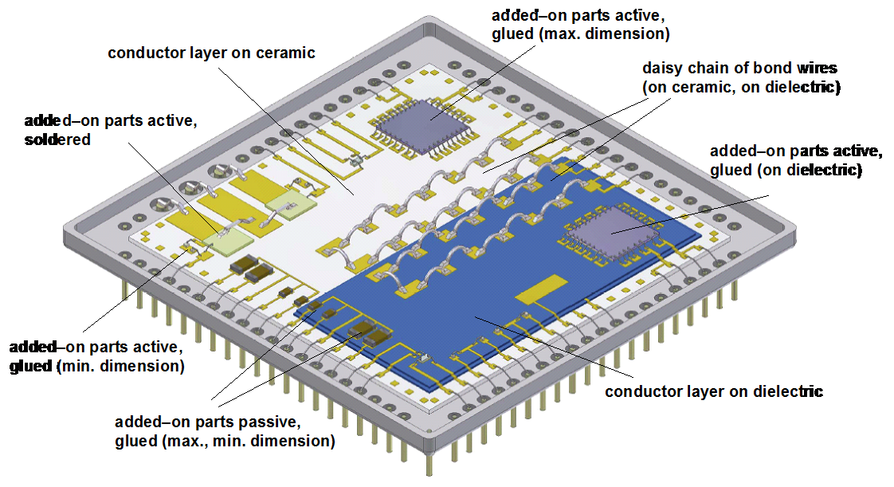

MANUFACTURER’S AUDIT
The Manufacturer Quality Management System Audit shall take place as part of the PCA Evaluation stage. This audit shall assess the manufacturer's quality management system and his ability to successfully execute a contract for the supply of high reliability Hybrid Microcircuits. The manufacturer shall have in place a Quality System according to ESCC 24600. The Line Survey, shall take place in parallel to the QMS Audit, and shall be performed against the Check List ESCC 2026000.

EVALUATION TESTING

General
Evaluation testing of test structures shall generally consist of the tests and subgroups given in Chart 2.1 of this specification. Samples to be submitted to Chart 2.2 shall be test structures as defined in Para. 7.2.2 of this specification and the PID. Test structures shall be randomly divided into the various test subgroups. Unless otherwise agreed with the ESCC Executive, when different types of test structure are being tested, each type shall be represented in each subgroup.
All test structures shall be serialized prior to testing. For each measurement or inspection performed, the results shall be recorded and summarized in terms of serials number and quantity tested, quantity passed and quantity rejected failed. If test structures are rejected failed, the reason shall be clearly identified through an adequate failure analysis.
All failed test structures shall be subjected to failure analysis. The depth of the analysis shall depend on the circumstances in which failure occurred and upon whether useful information can be gained. As a minimum, the failure mode shall be determined in each case. Test structures not failing catastrophically, i.e. those displaying out of tolerance electrical rejects, shall not be removed from the test sequence but may be used, with the agreement of the ESCC, as additional test samples for evaluation testing as defined in chart 1 in order to monitored to and observe the degradation trends. In no case these parts shall substitute for good parts.
For TVEs representative of large or complex hybrids, the sample size may be reduced, provided that the design of TVE includes statistically meaningful number of each subtechniques. A proposal of sample size shall be introduced in the test plan to be submitted to ESCC Executive approval

Initial DPA and Reference devices
A reference device of each type of test structure shall be kept for comparison purposes. Whenever electrical measurements are performed on any test structure during evaluation testing the reference deviceof the same type shall also be measured.
A supplementary test vehicle shall be used for initial DPA without burn-in simulation (TVE1) or with burn-in simulation (TVE2) for internal water-vapor content test

Test plans
Testing, analysis of test results and definition of the evaluation test programme shall be in accordance with the test plan and tables specified herein for each test vehicle.
The test plans and the definition of test vehicles proposed by the manufacturer shall be submitted to the ESCC Executive for approval prior to commencing the tests.
The following test plans shall be applicable to the test vehicles TVE1 and TVE2.
The numbers in brackets for each test correspond to the test number of the table “test methods and conditions” (paragraph 7.4.4).

Chart 2.1. Evaluation Test Plan for test structures TVE1 (Note 0).

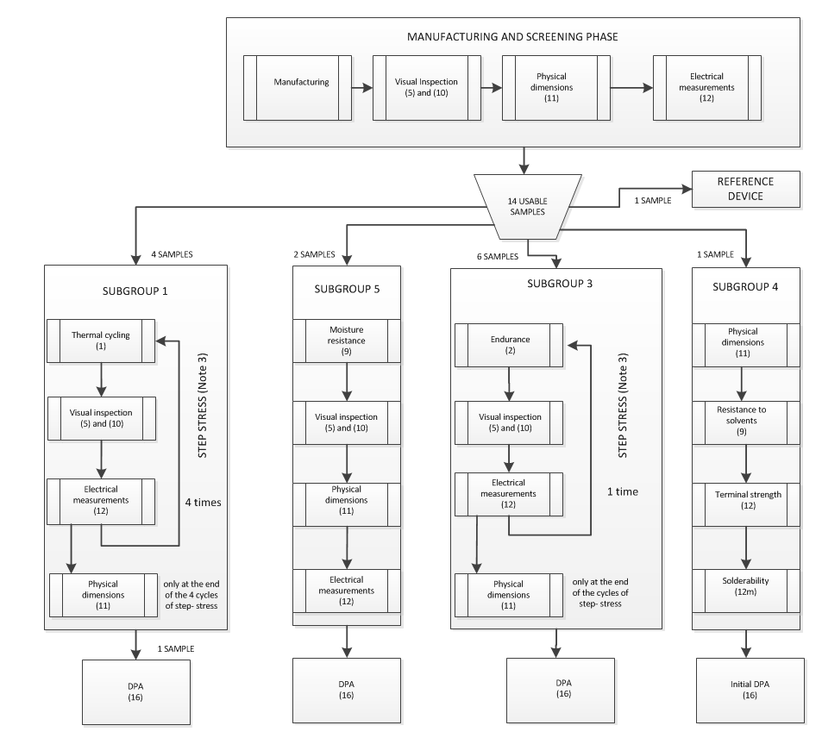

Chart 2.2. Evaluation Test Plan for test structures TVE2.
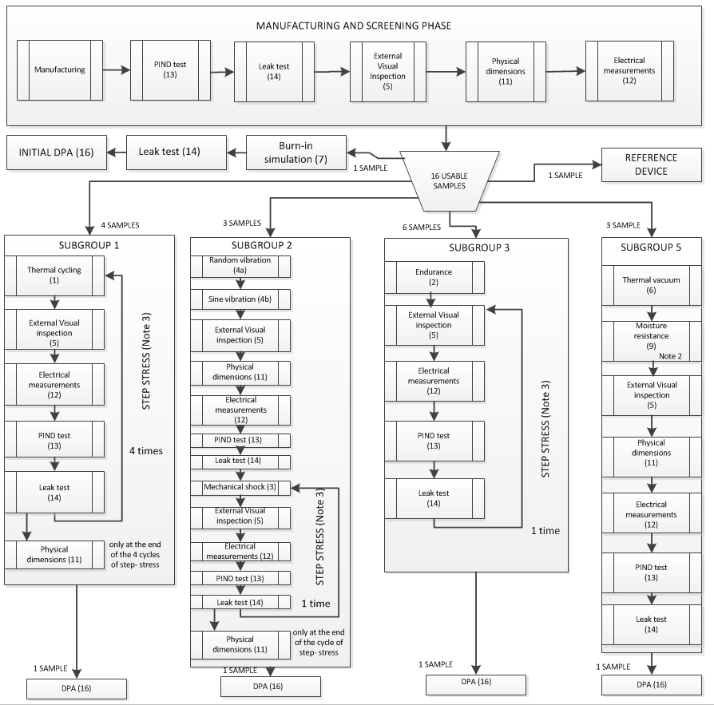

Note 0: The TVE1 technology/configuration drives the specific Evaluation Plan. The tailoring has to analyze the applicability (e.g. seal test is NA for just a substrate), and eventual replacement of a test (e.g. if solderability is NA then it has to be replaced by other test e.g. bondability).
Note 1 : The hybrid manufacturer shall fabricate additional TVE1/TVE2 vehicles or define and fabricate specific test vehicles for evaluation of specific application (on/off or power cycling, high voltage, high current,…) and perform related specific tests including DPA.
Note 2: Step stressing requires the performance of each test (test No 5, 10 and 12) in the loop for each step.
Note 3: RGA is also used to verify hybrid hermeticity after ageing tests (O, Ar, He levels). For DPA in SG3 test 16e Internal Water Vapor content requirement (max 5000ppm moisture) is not applicable. The hybrids manufacturer can use the RGA measurements together with other observations (e.g. a current drift) to define its own requirements (e.g. hydrogen<300ppm) for later specifications (including TVCA in Chart 3).
Note 4: Step stressing requires the performance of each test (test No 5, 11, 12,13 and,14) in the loop for each step

Test methods and conditions
The test methods and conditions pertinent to TVE1 and TVE2 test plans are listed in following Table 2 together with the reference of the applicable specifications and each detail specification. The number of each test corresponds to that shown in brackets for each test in the evaluation test plans.
Table 2
N° | Test | MIL-STD | Method | Test conditions and remarks
1 | Thermal cycling | 883 | 1010 | Condition B, 100 cycles per step up to  500 or failure
2a | Endurance | 883 | 1005 | Duration 1000h + 1000h. Ambient T will be defined to achieve 125C<Tj<150C (or maximum ratings). If the Tj of the most stressed part is lower than 125C, time shall be increased according to MIL-STD-883 Method 1005.
2b | High Temperature Storage | 883 | 1008 | Condition B: +125°C; 2000 hours
3 | Mechanical shock | 883 | 2002 | Step1 : Condition B (1500g) for packages up to 1” x 2” and 1000 g 0,5 ms for packages above.  Step 2 : Condition C (3000g) for packages up to 1” x 2” and Condition B (1500g) for packages above.  Shocks performed on Y1, Y2, X, Z axis
4a | Random vibration | 883 | 2026 | Condition I K, Random Vibration 44.8 g RMS, 3 axis
4b | Sinus vibration | 883 | 2007 | Condition B, 50 g
5 | External Visual Inspection | 883 | 2009
6 | Thermal vacuum |  |  | 20 cycles -30 + 70 °C at 10-5 Pa, dwell time : 2 hours, slope 2°C/mn
7 | Burn-in simulation |  |  | Bake during 240 h at 125 °C, no voltage
8 | Solvent Resistance | 883 | 2015 | Or ESCC 24800
9 | Moisture resistance | 883 | 1004 | 10 V DC between all terminals connected together and package (+ on terminals)
10 | Internal Visual inspection | 883 | 2017 | Class K requirements
11 | Physical dimensions | 883 | 2016 | According to test vehicle detail specification.  e.g. for TVE1 : line width, space, vias diameter, substrate camber,…  e.g. for TVE2 : external dimensions, lid and package deformation,…
12 | Electrical measurements  ient of resistance |  |  | As per TVE2 specification
13 | PIND test | 883 | 2020 | Condition A. Only applicable to cavity type devices
14 | Leak test | 883 | 1014 | Fine leak : condition A  Gross leak : condition C  Only applicable to hermetically sealed, cavity type, devices
15 | - None-
16 | DPA (initial or final) |  |  | Note 1, Note 2
16a | External Visual inspection | 883 | 2009
16bc | Radiography | 883 | 2012 | When soldered items or gold wires are present
16c | SAM inspection | 883 | 2030 | May be used in substitution of radiography
16d | Residual gas analysis | 883 | 1018
16e | Delidding | 883 | 5009 | Micromilling is allowed
16f | Internal visual inspection | 883  883  750  750  750  883 | 2017  2010  2072  2073  2074  2032 | Class K  Condition A. Or ESCC equivalent for monolithic devices
16g | Dielectric strength | 202 | 301 | 100 V DC between conductive layers in a multilayer system, between conductors on same layer in a monolayer system
16h | SEM Inspection | 883 | 2018 | Provide photos of typical assemblies, non  conformances and anomalies
16i | Bond pull test | 883 | 2011 | On TVE2 only. Pull all wires and ribbons
16j | Die shear test | 883 | 2019 | On TVE2 only. Shear all chips and small substrates
16l | Substrate attach strength | 883 | 2027 | When shear test cannot be performed in case of substrates or large chips
16m | Adhesion test | - |  | Peeling test on metallization according to the hybrid manufacturer specification and agreed by ESCC executive
16n | Micro-sections | - |  | Micro-sectioning shall be performed to evaluate : multilayer substrates (conductors, dielectric, vias), assembly of added-on parts, cross-overs, local encapsulations, hermetic sealing (seal joint and feed-through).
17 | Solderability | 202 | 208 | Three terminals per test item
18 | Soldering heat | 883 | 2036 | Visual inspection (x 30 minimum) to verify  that terminals, glass seals, connections or  substrate are not damaged. Conditions as per test method to be defined according to application.
19 | Terminal strength | 883 | 2004 | Flexible leads :  condition A, F (N) = 30 x S (mm²)  (F : strength, S : lead section)  Rigid feed-throughs in packages :  - Diameter ≤ 1mm as above  - Diameter > 1mm, condition C1,  torque :1,5 N.cm

Note1: the DPA (test number 16 in the table above) shall be performed by a laboratory mutually approved by the hybrid manufacturer and by the ESCC Executive.
Note 2: Initial DPA shall contain also Soldering Heat (test nr 18), before RGA (test Nr 16e).

Evaluation test report
On completion of the evaluation testing, the manufacturer shall prepare an evaluation report. This report shall include:
- Description of the process capability domain technology tested: processes, materials and sub-techniques and how these were implemented in the devices tested.
- The Detail Specification for each Test Vehicle or circuit
- Production data for the test structures including details of any failures during production
- The evaluation test programme (ETP) giving details of all test methods and conditions and the number of test structures tested
- ETP detailed test results including: all electrical measurements and statistical analysis of the results, DPA reports, Failure Analysis reports (as applicable)
- Reference to the Manufacturer’s alternative test data accepted as satisfying part or all of the ETP (as applicable)
- ETP summary and conclusions

The Evaluation report shall be sent to the ESCC Executive for review and acceptance.

PROCESS CAPABILITY APPROVAL (PCA) PHASE

GENERAL
The PCA phase of Hybrid Manufacturing Lines shall be as specified in ESCC Basic Specification 25600 with additional requirements set in the rest of this paragraph.
The objective of the Process Capability Approval Phase is to demonstrate, on the operational manufacturing line, the ability of the manufacturer to produce high reliability hybrids for space applications.
To this end the following prerequisites shall be satisfied:
- The Evaluation Phase has been completed successfully and the Capability Domain with its boundaries has been agreed between the Manufacturer and the ESCC Executive.
- The materials and processes and related specifications have been frozen in a PID agreed by the ESCC Executive
- The facilities and equipment and tools are operational and under control
- The training and certification of personnel is completed and surveyed
- All corrective actions derived from the manufacturer audit and line survey shall have been correctly and completely implemented
- An ESD control plan, meeting the minimum requirements of ESCC 24900, is frozen. Such control plan shall include provisions for the handling of Class 0 devices as per MIL-STD-883, Method 3015.

The ESCC Executive shall verify the completion of the prerequisites listed above at the time of the PCA readiness review.

PROCESS CAPABILITY APPROVAL TESTING
Process capability approval testing to be performed on test vehicles in accordance with the PID shall conform to ESCC 25600 and the rest this paragraph.
This phase shall consist in the fabrication and testing of either test structures or actual circuit types covering the full technology domain defined in the PID.
The test vehicles used for PCA testing are called Test vehicles (TVCA) in the rest of this document.

Definition and requirements for test vehicles for PCA testing
The capability approval test vehicles (TVCA) shall be one or several functional products and additional test structures, if necessary, able to cover the capability domain boundaries defined in the PID.
For each TVCA:
- The Hybrid Technology Identification Form (HTIF) shall be established according to the format defined in Annex A of ECSS-Q-ST-60-05. The HTIF shall be checked against the Technology Domain boundaries defined in the PID.
- The Detail Specification has been written according to Annex B of ECSS-Q-ST-60-05 and agreed by the ESCC Executive.
- The capability approval test vehicles shall be manufactured in accordance with the PID and screened to Level 1 of ECSS-Q-ST-60-05.

In order to validate rework and repair procedures and limits, some of the TVCAs shall be intentionally reworked and repaired according to the methods described in the PID. At least one device per pCA test subgroup shall be reworked and/or repaired for that purpose.
The ESCC Executive shall be notified 3 weeks in advance of the following key points: Pre-cap Inspection and End of screening (for a review of screening results).

Hermetic Hybrids PCA test plans

General
The PCA programme of tests shall be reviewed and approved by the ESCC Executive prior to the start of the PCA testing.
The PCA test programme shall generally consist of the tests and subgroups given in Chart 3 of this specification. Samples to be submitted to Chart 3 shall be test structures as defined in Para. 8.2.1 of this specification and the PID. These test structures shall be randomly divided into the various test subgroups. Unless otherwise agreed with the ESCC Executive, when different types of test structure are being tested, each type shall be represented in each subgroup. In Chart 3, the numbers in brackets for each test correspond to the test number of the table “test procedures and conditions”.
All TVCAs shall be serialized prior to testing. For each measurements or inspection performed, the results shall be recorded and summarized in terms of serials numbers and quantity tested, quantity passes and quantity rejected.
A reference device of each type of TVCA shall be kept for comparison purposes. Whenever electrical measurements are performed on any TVCA during PCA testing the reference device of the same type shall also be measured.
The manufacturer shall prepare and submit to the ESCC Executive a test plan specifying:
- The tests sub-groups (sequences, conditions, limits)
- The electrical measurement steps as per Detail Specification
- The inspection steps with related accept / reject criteria
- The sample size and the accept and reject criteria per sub-group
- The distribution of repaired hybrids per sub-group

Sample size
The following table defines the sample size and the accept/reject criteria per Subgroup (to be read together with Chart 3 under Para 8.2.2.3):
Table 3
Nr of TVCA  type | “N” TVCA’s required per subgroup (Note 1) |  |  |  |  |  | Additional Samples | Total per type | T  O  T  A  L  Nr | Accept/ reject criteria
 | SG I | SG II | SG III | SG IV | SG V | SG VI
 | Mecha-nical tests | Thermal  cycling | Workman-ship | QA/  DPA | Life  Test | HTS  if req. | Reference device
1 | 6 | 6 | 2 | 1 | 10 | 6 | 1 | 32 | 32 | a=0, r≥1
2 | 3 | 3 | 1 | 1 | 5 | 3 | 1 | 17 | 34 | a=0, r≥1
3 | 2 | 2 | 1 | 1 | 3 | 2 | 1 | 12 | 36 | a=0, r≥1

Note 1: For or complex hybrids sample size may be reduced provided that the design of TVCA include in them a statistically meaningful number of each subtechniques. A proposal of sample size shall be introduced in the PCA test plan to be submitted to ESCC Executive approval.

PCA test plan
Chart 3. Process Capability Approval testing of TVCA test vehicles
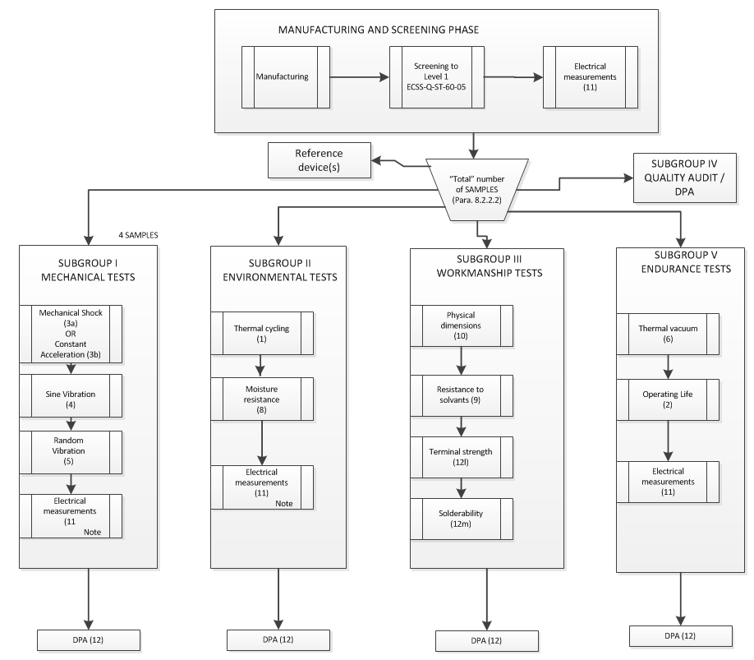
Note: ONLY in the case of RF multi-cavity hybrids, the electrical measurements to be performed at the end of SUBGROUPS I and II shall be made in Thermal Vacuum (6)

Hermetic Hybrids PCA test methods and conditions
The test methods and conditions applicable to Chart 3 are listed in the following Table 4 together with the reference of the applicable specifications and each detail specification. The number of each test corresponds to that shown in brackets for each test in the Chart 3.
The manufacturer’s test procedures derived from the following table shall be submitted to the ESCC Executive for approval.
Table 4
N° | Test | MIL-STD | Method | Test conditions and remarks
1 | Thermal cycling | 883 | 1010 | Condition B minimum, 100 cycles
2a | Operating life test | 883 | 1005 | Duration 1000h + 1000h. Ambient T will be defined to achieve 125C<T<150C (or maximum ratings). If the Tj of the most stressed part is lower than 125C, time shall be increased according to MIL-STD-883 Method 1005.
2b | High Temperature Storage | 883 | 1008 | Condition B: +125°C; 2000 hours
3a | Mechanical shock | 883 | 2002 | Condition B for packages up to 1” x 2”  1000 g 0,5 ms for packages above.  Shocks on Y1, plus shocks on Y2, X, Z axis if required by the configuration.
3b | Constant acceleration | 883 | 2001 | Condition B for packages up to 1” x 1”. Y1 axis  Condition A for packages above. Y1 axis, Y2 axis as needed  Note : Constant acceleration is not applicable for packages > 1”x 2”
4 | Vibration Sinus | 883 | 2007 | Condition A, 20g
5 | Vibration Random | 883 | 2026 | Condition I F, Random Vibration 20 g RMS, 3 axis
6 | Thermal vacuum |  |  | 10 cycles -30 + 70 °C at 10-5 Pa, dwell time : 2 hours, slope 2°C/mn  The performance of this test under actual vacuum conditions may be waived by the ESCC Executive in cases where the approval domain includes only small hybrids.
7 | Not used
8 | Moisture resistance | 883 | 1004 | Bias conditions shall be as agreed with the ESCC Executive ir order to saveguard the integrity of the device.
9 | Resistance to solvents | 883  ESCC | 2015  24800
10 | Physical dimensions |  |  | According to hybrid detail specification.
11 | Electrical measurements |  |  | According to the hybrid detail specification.  Note : Initial electrical measurements can be the final measurements performed after screening
12 | DPA (initial or final) |  |  | DPA on 1 sample per SG  Note 1
12a | External visual inspection | 883 | 2009
12b | Radiography | 883 | 2012 | If soldered items or gold wires are present
12c | SAM inspection | 883 | 2030 | May be used in substitution of radiography
12d | Seal test | 883 | 1014 | Fine leak : condition A  Gross leak : condition C
12e | PIND test | 883 | 2020 | Condition A
12f | IResidual Gas Analysis | 883 | 1018 | The internal water vapour content requirement (maximum limit) is only for information after the Subgroup V “Endurance test” and Subgroup VI (HTS); in this case the RGA test is used as a verification of the hermeticity.
12g | Internal visual | 883  883  750  750  750  883 | 2017  2010  2072  2073  2074  2032 | Class K  Condition A. Or ESCC equivalent for monolithic devices
12h | SEM Inspection | 883 | 2018 | Provide photos of typical assemblies, non  conformances and anomalies
12i | Bond pull test | 883 | 2011 | Pull all wires and ribbons
12j | Die shear test | 883 | 2019 | Shear all chips and small substrates
12k | Substrate attach strength | 883 | 2027 | When shear test cannot be achieved for  substrates or large chips
12l | Terminal strength | 883 | 2004 | Only for Subgroup III “Workmanship tests”  Flexible leads : condition A, F (N) = 30 x S (mm²)  (F : strength, S : lead section)  Rigid feed-throughs in packages :  - Diameter ≤ 1mm as above  - Diameter > 1mm, condition C1, torque :1,5 N.cm
12m | Solderability | 202 | 208 | Only for Subgroup III “Workmanship tests”  Three terminals per test item.

Note 1: the DPA (test number 12 in the table above) shall be performed by a laboratory mutually approved by the hybrid manufacturer and by the ESCC Executive

PCA test report
On completion of the PCA testing, the manufacturer shall collect all test data and documentation in the form of a report. This report shall be sent to the ESCC Executive for review and acceptance.
The report shall contain the following information:
- Description of the process capability domain tested:, including processes (including the associated equipment), materials and subtechniques and how these were implemented in the devices tested.
- The Specification for each test structure. The Detail Specification for each Test Vehicle or hybrid circuit type written according to Annex B of ECSS-Q-ST--60-05
- A description of the test vehicle(s) or actual hybrid type(s) used for approval testing in the form of the HTIF(s) according to Annex A of ECSS-Q-ST-60-05
- Production data for the test structures including details of any failures during production
- The PCA test programme giving details of all test methods and conditions and the number of test structures tested
- The Test Plans carried out for Capability Approval Testing with indication of the allowable number of failed devices per test file. The Test Methods and conditions used
- Detailed test results including: all electrical measurements and statistical analysis of the results, DPA reports, non-conformance reports if any
- Reference to the Manufacturer’s alternative test data accepted as satisfying part or all of the PCA test programme (as applicable)
- PCA testing summary and conclusions

PROCEDURES SPECIFIC TO THE PCA OF HYBRID MANUFACTURING LINES
The following provisions, see Annex 2 for an overview, are specific to PCA of Hybrid Lines and supplement related requirements in ESCC 25600.

Manufacturing Line under TRB management
A manufacturing hybrid line can be under TRB management and SPC (Category 1 Option 2 of ECSS-Q-ST-60-05) only after having first achieved the PCA per this specification.
The migration to Category 1 Option 2 status shall be approved by the ESCC executive after that a proper system is in place based on IPC-9191 and verified by ESCC executive or his expert delegate against IPC-9199.

Extension or change of the Process Capability Approval Domain
By change of the Capability Approval Domain it is intended the addition or change of materials and/or processes and/or boundaries that were included in the previous PID.
The Extension of Capability Domain is a particular case of change.
Changes of the Capability Approval domain are categorized into two classifications:
- Major change (new materials, new processes, new production equipment, move of line location, new or modified inspection criteria, change of process parameters beyond PID limits)
- Minor change (addition of already-existing production equipment to the line, addition of a second supplier for an already-used material)

Upon application for change of the Capability Approval Domain by the manufacturer concerned, the ESCC Executive will decide whether the change is major or minor.
Changes shall be validated by tests programmes according to tests plan reviewed and approved by the ESCC Executive.
As a minimum, major changes in the PID, as listed in Table 5, will be the object of Evaluation of test as in the table. A reduced testing may be used in case of minor changes. Inspection tests after environmental tests shall be adapted in accordance to the changes.

Table 5. Testing requirements for major changes
Major changes | Environmental tests  Chart 2.1 and/or 2.2 and Table 2
1. Change of substrate material | SG1 | SG2 | SG3
2. Change of  - conductor  - resistor  - dielectric material deposite don substrate and/or change of deposit method | SG1  SG1  SG1 |  | SG3  SG3  SG3
3. Changes to substrate mask design that reduce nominal design dimensions, spacing or isolation  or changes to electrical parameters of the deposited elements beyond the design limits | SG1 |  | SG3
4. Change of trimming method | SG1 |  | SG3
5. Increase in substrate fabrication multi-layer conductor levels, more than one level | SG1 | SG2 | SG3
6. Change of attach material  or of attachment method | SG1 | SG2 | SG3
7. Increase in element attach area | SG1 | SG2
8. Change of wire bond method and or material | SG1 | SG2 | SG3
9. Increase in substrate attach perimeter | SG1 | SG2 |  |  | SG5
10. Change of package base material | SG1 | SG2 | SG3 |  | SG5
11. Change of seal method, seal material, lid base material | SG1 | SG2 |  |  | SG5
12. Increase in package seal perimeter | SG1 | SG2 |  |  | SG5
13. Increase in lead count per package type | SG1 | SG2 |  |  | SG5
14. Change of element backside or topside finish material | SG1 |  | SG3
15. Change in package/lead finish | SG1 | SG2 |  | SG4 | SG5

NOTE 1: The test content and specification for each subgroup (SG) in the Table 5 shall be consistent with Charts 2.1 and 2.2 as applicable:
SG1 = Thermal cycling
SG2 = Vibration / mechanical shock
SG3 = Life test
SG4 = Workmanship
SG5 = Thermal vacuum / moisture resistance
NOTE 2: SG3 test to eb performed in the case of changes in package base material (Major change No. 10 in Table 5) when thermal performance differences may be expected fur to changes in the thermal reisstance of the materials.

Maintenance, suspension, withdrawal of the Process Capability Approval

Maintenance of process capability approval.
The maintenance of PCA can be achieved in two ways.
On one hand, the certification of PCA of hybrid manufacturing lines may be maintained by the successful repetition of the PCA test programme after a lapse period of 2 years.
On the other hand, Process Capability Approval may also be maintained by:
- the continuous production of devices according to the capability domain defined in the PID.
At least two months prior to the expiry date of line approval, the manufacturer shall send a letter to the ESCC executive with the details of lots processed to ECSS-Q-ST-60-05
The letter will identify: lot numbers, delivered hybrids and numbers and a synthesis of failures during burn-in, environmental and life testing (LAT) .
If considered necessary, the ESCC executive may require further details or a repetition of some tests on suitable test vehicles.
- Ior, if Hybrids have been manufactured and tested within the capability domain (including SEC, LAT, CTA, User LAT), and having a complexity covering the domain boundaries or part of them, these tests may suffice for the maintenance of PCA.

Modifications, additions or changes to the PID (domain), shall be submitted at the time of maintenance. Inclusion in the PID will be justified and supported by relevant Delta Qualifications.
The minimum requirement for capability approval is that, during the last 12- month lapse period, one lot of hybrids has been manufactured, screened and tested for lot acceptance in accordance with ECSS-Q-60-05..
The ESCC Executive shall be provided with documented evidence of the lot in question having passed successfully the specified tests and inspections. The ESCC Executive shall be provided with DPA test reports on three hybrids successfully screened as part of the lot proposed to sustain the maintenance of PCA. Such DPA exercise shall be consistent with requirements for DPA found at the end of PCA test as defined in this document.
Renewal of capability approval shall be valid either from the date on which:
            - The previous approval expired or,
            - The date on which lot acceptance testing was completed successfully if this date occurred more than 6 months prior to 1.

Suspension of process capability approval.
The ESCC executive reserves its right to suspend the approval status of a production line, or any part thereof, for the following reasons:
            - failure(s) which cannot be remedied within a 6 months period of time
            - failures of more than two consecutive lots.
            - a complete stop in production at the space hybrid line for a period longer than 6 months

Note: failures due to causes external to the PCA domain are not considered (e.g. Hybrid containing an ASIC failing due to its design).
In the event of 1. and / or 2 or 3. , the manufacturer shall initiate any corrective action considered appropriate and, in order to achieve reinstatement of approval status, supply the ESCC Executive with evidence that the cause of failure has been eliminated.
During the suspension period, the line shall not be considered as approved and not be used for the production of high reliability circuits unless they serve for approval purposes.

Withdrawal of process capability approval
Process Capability Approval status shall be withdrawn by the ESCC Executive:
            - at the request of the manufacturer
            - in case of persistent non-conformances to the PID requirements

Renewal after lapse of process capability approval
Following the lapse of capability approval, a renewal of approval can be started within a period of 6 months. Provided the Manufacturer can demonstrate that the original evaluation of the capability domain is still valid, this renewal procedure shall comprise a destructive physical analysis of sample hybrids, a Manufacturer audit and a survey of test records generated in the lapse period. If this survey shows that the Manufacturer's data, equivalent to either PCA testing or Lot Acceptnace Testing are available and acceptable, the ESCC Executive may take such data into consideration for renewal of the process capability approval. Where such data is not available or not acceptable, the testing of a number of components to the requirements of ECSS-Q-ST-60-05will be required for the renewal.
Failure to satisfy the requirements regarding the validity of the original evaluation of a capability domain will necessitate a completely new process capability approval.

ANNEX 1 REQUIREMENTS GUIDELINES FOR THE MATERIALS AND PROCESSES DESCRIPTION
The manufacturer shall describe the type of functions / products which are planned to be developed and manufactured within the perimeter of the process capability domain under approval. Such description shall include basic electrical characteristics as pertinent. For the purpose of fabricating these types of products, the manufacturer shall define the extent of his capability domain for which approval is sought in terms of construction technologies also called sub-techniques (type of substrates, components mounting and interconnection techniques, encapsulation,…) and their associated boundaries.
The manufacturer shall describe the procedures for selection, procurement and control of materials used for production of structures within the process capability domain.
The manufacturer shall describe the processes within the process capability domain. He shall also give reference to the documents specifying the processes. At least the following areas shall be covered including a statement on the equipment used:
- Substrate and carrier preparation
- Conductor, termination and wire bonding process
- Thick film, thin film circuit processes
- Package assembly and encapsulation processes
- Rework procedures

DEFINITION OF PROPOSED SUB-TECHNIQUES IN THE PCA DOMAIN
The different sub-techniques are defined by:
- The materials (composition, designation, manufacturer)
- The processes (process owner- if subcontracted)
- The associated limits in terms of Dimensions and density of integration

The definition of the sub-techniques within a process capability domain depends of the substrate technology involved (e.g. thick film) and the related needs for assembly and encapsulation. It is specified in the following paragraphs.

Definition of sub-techniques depending on the substrate technology
This paragraph lists some substrate technologies and the applicable requirements, in each case, for the appropriate definition of the related necessary sub-techniques.

Screen Printed Thick film
Substrate(s)
- Composition, designation, manufacturer
- Surface characteristics (as fired…)
- Minimum/maximum size, thicknesses, shape…
- Cutting method
- Holes drilling method, dimensions and number per square unit
Conductive ink(s)
- Composition, designation, manufacturer, application (conductive layer, via filling, holes/edges metallization, …)
- Minimum track width/space for different layers (if applicable), thickness
- Resistivity, current density
- Maximum number of layers
- Minimum vias/holes dimensions
Dielectric ink(s)
- Composition, designation, manufacturer, application (multi layer, cross over, overglaze, capacitor dielectric, …)
- Thickness
- Maximum number of layers
- Number of printings per layer
- Withstanding voltage, insulation resistance
Resistive ink(s)
- Composition, designation, manufacturer, application (printed on dielectric or directly on the bare substrate, …)
- Associated specific conductive ink used as resistor terminations (if applicable)
- Resistivity range (ohm/square), TCR, long term stability, power rating
- Blending of resistor inks (if applicable)
- Minimum dimensions
- Minimum/maximum number of squares
- Trimming methods

Thin film deposition
Substrates
- Composition, designation, manufacturer
- Surface characteristics (as fired, lapped and polished…)
- Minimum/maximum size, thicknesses, shape…
- Cutting method
- Holes drilling method, dimensions and number per square unit
Metallization(s): resistive, barrier, conductive layer
- Deposition and etching method
- Composition, target designation and manufacturer
- Minimum track width/space, thicknesses
- Resistivity, current density for conductive layer
- Resistivity range (ohm/square), TCR, long term stability, power rating for resistive layer
- Conductive layer over-plating (if any)
- Resistor trimming methods
- Holes metallization method (if any)
Dielectric layer
- Composition, designation, manufacturer, application (multi layer, cross over, overglaze, capacitor dielectric, …)
- Deposition and etching method
- Thickness
- Maximum number of layers
- Withstanding voltage, insulation resistance

HTCC (High Temperature Cofired Ceramic)
- Manufacturer
- Ceramic type (Al2O3, AlN), composition
- Minimum/maximum size and thickness, shape, …
- Minimum dimensions of punched via holes
- Maximum number of layers
- Maximum numbers of green tapes per layer
- Typical shrinkage (after firing)
- Minimum dielectric thickness as fired
- Withstanding voltage, insulation resistance
- Conductor (internal and external)
- Composition
- Minimum track width/space, thickness
- Resistivity, current density
- External conductor plating
- Plating method
- Composition
- Different layers and thicknesses
- Brazed elements (carrier, frame, leadframe,…)
- Element function (thermal dissipation, hermetic cavity, interconnection, mechanical carrier, …)
- Element composition (raw material and plating)
- Maximum dimensions, thickness
- Attachment medium composition

LTCC (Low Temperature Co-fired Ceramic)
- Tape material, designation, manufacturer
- Minimum/maximum size, thicknesses after firing
- Minimum dimensions of punched via holes
- Maximum number of layers
- Typical shrinkage (after firing)
- Minimum dielectric thickness as fired
- Withstanding voltage, insulation resistance
- Conductive ink(s) (internal and external)
- Composition, designation, manufacturer, application (conductive layer, via filling, holes/edges metallization, …)
- Minimum track width/space, thickness
- Resistivity, current density
- Resistive ink(s)
- Composition, designation, manufacturer
- Resistivity range (ohm/square), TCR, long term stability, power rating
- Blending of resistor inks (if applicable)
- Minimum dimensions
- Minimum/maximum number of squares
- Trimming methods
- Substrate cutting method
- Holes drilling method, dimensions and number per square unit
- Brazed elements (carrier, frame, leadframe,…)
- Element function (thermal dissipation, hermetic cavity, interconnection, mechanical carrier, …)
- Element composition (raw material and plating)
- Maximum dimensions, thickness
- Attachment medium composition

Organic substrate(s)
- Substrate manufacturer
- Raw material: designation, manufacturer
- External maximum dimensions, total thickness
- Maximum number of layers
- Conductors (internal and external)
- Composition
- Minimum track width/space and thickness for internal and external layers
- Minimum dimensions of via holes
- Resistivity, current density
- External conductor plating
- Types
- Thicknesses
- Embedded passives

DBC (Direct Bonded Copper)
- Manufacturer
- Ceramic type (Al2O3, AlN), composition
- Minimum/maximum size and thickness, shape, …
- Minimum/maximum dimensions of via holes
- Minimum/maximum dimensions of plaggged holes
- Minimum track width/space, thickness
- Minimum width and maximum length of flying leads
- Withstanding voltage, insulation resistance
- Conductor plating
- Plating method
- Composition
- Different layers and thicknesses
- Brazed elements (carrier, frame, leadframe,…)
- Element function (thermal dissipation, hermetic cavity, interconnection, mechanical carrier, …)
- Element composition (raw material and plating)
- Maximum dimensions, thickness
- Attachment medium composition

Assembly of added-on components, substrates and carriers

Passive components assembly
- Type (resistor, capacitor, inductance, …)
- Packaging (chip, package type, …)
- Materials
  - Substrate (silicon, ceramic,…)
  - passive part material (NiCr, Ta2N, …)
  - Interconnecting metallization ( Ni/Au, Ag/Pd, …)
- Minimum/maximum dimensions
- Attachment medium
- Mechanical
  - Material
- Type (non conductive adhesive, solder, …)
- Thickness
  - Process (dispensing, preform reflow,…)
- Electrical
  - Material
- Type (conductive adhesive, solder, wires, ribbons, …)
- Dimensions (diameter, thickness, width)
  - Process (dispensing, preform reflow, wire bonding, …)

- Attachment substrate
- Composition (thick film main substrate or carrier, package base, …)
- Material
  - Raw material ( alumina, Kovar, …)
  - Metallization (thick film gold pad, Ni/Au, …)

Active components assembly
- Type of active components
- Type (diode, transistor, integrated circuit, …)
- Packaging (bare chip, beam lead, flip chip, package type, …)
  - Materials
  - Silicon, Gallium Arsenide,…
  - Interconnecting metallization (Al, Au…)
  - Minimum/maximum dimensions
- Attachment medium
  - Mechanical
  - Material
  - Type (non conductive adhesive, solder, …)
  - Thickness
  - Process (dispensing, preform reflow,…)
  - Electrical
  - Material
  - Type (conductive adhesive, solder, wires, ribbons, …)
  - Dimensions (diameter, thickness, width)
  - Process (dispensing, preform reflow, wire bonding, …)
- Attachment substrate
  - Composition (Thick film main substrate or carrier, package base, …)
  - Material
  - Raw material ( alumina, Kovar, Cu/W, …)
  - Metallization (thick film gold pad, Ni/Au, …)

- Wire/ribbon bonding
  - Material
  - Composition
  - Dimensions
  - Process (Thermocompression, thermosonic, ultrasonic, parallel gap,…)

9.1.2.3 Substrate and carrier assembly
- Substrate assembly
- Material (adhesive, solder, …)
- Process (preform curing, reflow,…)
- Details of package base to which the substrate is attached
  - Composition
  - Metallization
- Interconnection substrate/package
  - Material
  - Process

- Carrier assembly
- Material (adhesive, solder,…)
- Process (preform curing, reflow,…)
- Details of main substrate or package base
  - Composition
  - Metallization
- Interconnection carrier/main substrate or carrier/package base
  - Material
  - Process

Encapsulation

Hermetic packaging
- Package technology (metallic with glass or ceramic feed-throughs, HTCC or LTCC without or with interconnection in the package base (ISP), …)
- Application (low power, high power, LF, RF, …)
- Package manufacturer
- Body
- Base
  - Material
  - Minimum/maximum dimensions
  - Plating (composition, thicknesses,…)
- Wall/frame
  - Material
  - Minimum/maximum dimensions
  - Plating (composition, thicknesses, …)
- Base/frame attachment
  - Attachment medium
  - Process
- Feedthroughs
  - Material
  - Dielectric (glass, ceramic, …)
  - Conductor (metal, ink, …)
  - Dimensions
  - Sealing technology (matched seal, …)
- Leads
  - Material
  - Dimensions
  - Plating (composition, process, thicknesses, …)
  - Number and pitch
  - Leads to package attachment
  - Attachment medium (Au/Sn, Ag/Cu,…)
  - Process
- Lid
- Material
- Lid manufacturer
- Minimum/maximum dimensions
- Thickness and design
- Plating (composition, process, thicknesses,…)

- Sealing
- Process (parallel seam welding, laser,…)
- Sealing atmosphere
- Getter/absorber

ANNEX 2 OVERVIEW OF THE PCA EXTENSION APPLICATION

