

Pages 1 to 19

REQUIREMENTS FOR QUALIFICATION OF STANDARD ELECTRONIC COMPONENTS FOR SPACE APPLICATION

ESCC Basic Specification No. 20100

Relevant changes only in 3.2 + 6.5 + 7.1 + 7.2 + 7.3 + 7.4 + 7.4.1 + 7.4.2 + 10.3

The scrambled charts starting from para. 11 are an unintentional artifact created as a result of file conversion !!!
This is also true for other formatting flaws such as unintentional indentations and inappropriate spacing between paragraphs.

ESCC format compliant editing will be performed after PSWG approval of content change.

Draft 3 of Issue 4 / RdM / 28.10.2013 / includes explanatory comments for all non-editorial corrections

Issue 3 October 2011



Document Custodian: European Space Agency - see https://escies.org

LEGAL DISCLAIMER AND COPYRIGHT

European Space Agency, Copyright © 2011. All rights reserved.

The European Space Agency disclaims any liability or responsibility, to any person or entity, with respect to any loss or damage caused, or alleged to be caused, directly or indirectly by the use and application of this ESCC publication.

This publication, without the prior permission of the European Space Agency and provided that it is not used for a commercial purpose, may be:

– copied in whole, in any medium, without alteration or modification.
– copied in part, in any medium, provided that the ESCC document identification, comprising the
ESCC symbol, document number and document issue, is removed.

DOCUMENTATION CHANGE NOTICE

(Refer to https://escies.org for ESCC DCR content)

DCR No. | CHANGE DESCRIPTION
585 | Policy and Editorial Changes per DCR

TABLE OF CONTENTS

1. PURPOSE 6

2. APPLICABLE DOCUMENTS 6

3. TERMS AND DEFINITIONS 6

3.1 Definitions 6
3.2 abbreviations 6

4. INTRODUCTION 7

5. REQUIREMENTS FOR THE QUALIFICATION OF A COMPONENT 7

5.1 Application for Qualification 7
5.2 Review of Application 7
5.3 The Detailed Evaluation 8
5.3.1 The Evaluation of a Manufacturer 8
5.3.2 The Evaluation of a Component 8
5.3.3 Evaluation Certification 8
5.4 The Qualification Testing Phase 8

6. QUALIFICATION TESTING 9

6.1 Documentation Requirements 9
6.1.1 Process Identification Document (PID) 9
6.1.2 Production and Test Schedule 9
6.2 Production of Components for Qualification Testing 9
6.3 Qualification Testing (Chart 3) 9
6.4 Qualification Test Report 10
6.5 Qualification Approval and Certification 10
6.6 DIsposition of The Qualification Test Lot 10

7. MAINTENANCE OF QUALIFICATION 10

7.1 Qualification Validity Period 10
7.2 Conditions for Maintenance of Qualification 10
7.3 Extension of Qualification Validity (Chart 4) 10
7.4 Lapse of Qualification 11
7.4.1 Renewal after Lapse of Qualification (Chart 5) 11
7.4.2 Notification of Lapse of Qualification 11
7.5 Loss of Qualification 12

8. QUALIFICATION BY SIMILARITY 12

9. QUALIFICATION OF A SERIES OF COMPONENTS 12

10. QUALITY CONFORMANCE REQUIREMENTS 12

10.1 Certificate of Conformity 12
10.2 Records 12
10.3 Alert Procedure 13
10.4 ESCC Non-Conformance Control System 13

11. CHART 1 ESCC QUALIFICATION PROCEDURE 14

12. CHART 2 ESCC QUALIFICATION METHODOLOGY 15

13. CHART 3 INITIAL ESCC QUALIFICATION 16

14. CHART 4 EXTENSION OF ESCC QUALIFICATION 17

15. CHART 5 RENEWAL OF ESCC QUALIFICATION AFTER LAPSE 18

APPENDIX A CERTIFICATE OF CONFORMITY 19

1. PURPOSE
This specification describes all aspects of the ESCC qualification procedure for standard electronic components. It defines the requirements for:

– an application for qualification by a Component Manufacturer.
– the Detailed Evaluation Phase consisting of both Manufacturer evaluation and component evaluation.
– the Qualification Testing Phase leading to qualification approval by ESA.
– Maintenance of Qualification.

2. APPLICABLE DOCUMENTS
The following ESCC specifications form part of, and shall be read in conjunction with, this specification. The relevant issues shall be those in effect on the date of commencement of the qualification of the component.

ESCC 20200 Component Manufacturer Evaluation.

ESCC 22600 Requirements for the Evaluation of Standard Electronic Components for Space
Application

ESCC 22700 Requirements and Guidelines for the Process Identification Document (PID) ESCC 22800 ESCC Non-Conformance Control System
ESCC Generic and Detail Specification(s) relevant to the component(s) to be qualified.

3. TERMS AND DEFINITIONS

3.1 DEFINITIONS

Standard Electronic
Component
A standard electronic component is one which:
– is fabricated from well understood and stable technologies according to an effective quality assurance system.
– has a history of continuous or frequent production runs.
– has well established and available data for its performance, reliability and application.

3.2 ABBREVIATIONS

EA Evaluating Authority (see para. 5.3)

ESA European Space Agency

ESCC European Space Components Coordination

ESCIES European Space Components Information Exchange System

ETP Evaluation Test Programme

MOQ Maintenance of Qualification

PID Process Identification Document

QPL Qualified Parts List (ESCC Report 005)
QML Qualified Manufacturers List (ESCC Report 006)

4. INTRODUCTION
ESCC qualification approval is a status given to electronic components which are manufactured, under controlled conditions, by an European Manufacturer and which have been shown to meet all the requirements of this specification and the relevant ESCC Generic and Detail specifications.
The formal qualification procedure consists essentially of three phases: (a) The selection of the component.
(b) The Detailed Evaluation comprising an evaluation of the Manufacturer and an evaluation of the
component.
(c) The Qualification Testing of the component.

The procedure is performed in the above order and supervised throughout by the ESCC Executive. The completion of any phase carries no guarantee that a subsequent phase, or procurement, will be initiated.

The evaluation of a Manufacturer is detailed in ESCC Basic Specification No. 20200. The evaluation of a component is detailed in ESCC Basic Specification No. 22600.
This specification deals with the overall aspects of the ESCC qualification methodology, the Qualification
Testing Phase and subsequent quality conformance requirements.

The ESCC qualification procedure is shown diagrammatically in Chart 1; the overall qualification methodology in Chart 2 and the individual aspects of initial qualification, maintenance and renewal after a lapse in Charts 3, 4 and 5.

5. REQUIREMENTS FOR THE QUALIFICATION OF A COMPONENT

5.1 APPLICATION FOR QUALIFICATION
To obtain qualification approval for a component, a Manufacturer shall first submit a formal application to the ESCC Executive. This shall be based on the form “Application for ESCC Qualification” provided in the ESCC Section of ESCIES (https://escies.org). This application requires brief details of the component, the production and quality procedures to be applied and of the Manufacturer’s organisation. Samples of the component, together with complete details of its electrical and mechanical characteristics and all pertinent test data shall also be forwarded. Where it is available, the Manufacturer shall also forward all pertinent information concerning his manufacturing organisation, the plan for quality assurance and a production flow chart.

The Manufacturer shall commit to the following undertakings with respect to the application:

(a) He will perform any actions arising from the subsequent evaluation and qualification phases, which are considered necessary by the ESCC Executive for the proper qualification of the component, subject to the ESCC Executive providing the Manufacturer with a full justification.
(b) He will maintain production capability for a qualified component for a minimum of 5 years after the initial qualification certification, or as agreed with the ESCC Executive.
(c) He will provide the ESCC Executive and all his customers with a minimum of 6 months prior notice of the last order acceptance date, in the event of a planned discontinuation of a qualified component.

5.2 REVIEW OF APPLICATION
The ESCC Executive will review the application for qualification, perform a constructional analysis of a sample of the components and appraise the initial documentation. If considered necessary, the Manufacturer may be requested to provide further samples and documents. When the submitted items are deemed to be satisfactory and the ESCC Executive agrees to support the application, the Detailed Evaluation Phase will be initiated.

5.3 THE DETAILED EVALUATION
The Detailed Evaluation Phase comprises an evaluation of the Manufacturer and an evaluation of the component. Supervison of an evaluation is by the Evaluating Authority (EA). For an ESCC Qualification the EA is the ESCC Executive. For project purposes the ESCC evaluation methodology is recommended and the EA is the user. A successful user evaluation in accordance with ESCC requirements may provide data that can be proposed by the Manufacturer and accepted and used towards a subsequent ESCC qualification.

5.3.1 The Evaluation of a Manufacturer
The purpose of the evaluation of a Manufacturer is to assess his capability, to ensure the adequacy of his organisation, plant and facilities, and to ascertain his fitness to supply components to the appropriate specifications for space application. This evaluation phase shall include, but not necessarily be limited to, an audit of:

(a) The overall manufacturing facility and its organisation and management. (b) The Manufacturer’s system for inspection and manufacturing control.
(c) The production line used for the component to be qualified.

The evaluation of a Manufacturer shall be performed by the EA in accordance with the requirements of
ESCC Basic Specification No. 20200.

NOTES:
The Manufacturer is required to verify compliance with the ESCC requirements prior to an audit. ESCC Basic Specification No. 20200 provides details of the requirements and a checklist to support the Manufacturer in this process.

5.3.2 The Evaluation of a Component
The purpose of the evaluation of a component is to decide in the most cost-effective manner, if there is sufficient justification to proceed to qualification testing of the component for space application, with a high level of confidence in the result. This evaluation shall include, but not necessarily be limited to:

(a) The establishment of an evaluation test programme for the component. (b) Evaluation testing of the component.
(c) Definition of any corrective actions that may be required and their implementation.
(d) A documentation review and the finalisation of information to be contained in a Process Identification
Document (PID) for the component.

The evaluation of a component shall be performed by the EA in accordance with ESCC Basic
Specification No. 22600.

5.3.3 Evaluation Certification
Following a successful Detailed Evaluation the EA will issue a letter of recognition to the Manufacturer. For an ESCC evaluation the ESCC Executive will additionally agree with the Manufacturer the intention to complete the Qualification Testing Phase within a planned period not to exceed 18 months. Upon such agreement the ESCC Executive will prepare and publish an entry in the ESCC QPL to record the

successful Detailed Evaluation result.

Upon the successful completion of the Qualification Testing Phase and its acceptance by ESA, the QPL
entry will be transferred from the Evaluation Listing section to the Qualification section.

Failure by the Manufacturer to successfully complete the Qualification Testing Phase within the planned period may result in the removal of the QPL evaluation entry. The entry will in any case be removed after
18 months.

5.4 THE QUALIFICATION TESTING PHASE
During this phase, all documentation essential for the production and testing of the component to be qualified is reviewed by the ESCC Executive and a specified quantity of the component is subjected to a qualification test programme. The applicable requirements are specified in Section 6 of this document and the relevant ESCC Generic and Detail specifications.

The latest issues and revisions of all applicable specifications shall be used together with any pertinent
Document Change Requests that are approved and valid at the commencement of this phase.

6. QUALIFICATION TESTING

6.1 DOCUMENTATION REQUIREMENTS

6.1.1 Process Identification Document (PID)
A PID for the component to be qualified shall be prepared by the Manufacturer to the satisfaction of the ESCC Executive. In terms of content, layout and configuration control the PID shall be in accordance with the requirements of ESCC Basic Specification No. 22700

6.1.2 Production and Test Schedule
Prior to commencing production of the qualification test lot, the Manufacturer shall compile, based on the production flow chart or equivalent information in the PID, a production and test schedule to the satisfaction of the ESCC Executive. This schedule shall show by date and duration when important production and test activities are to take place, including all major processing operations and key points in production and testing, such as:

(a) Start of manufacture.
(b) Critical process and inspection activities.
(c) Final encapsulation or sealing, or similar activity.
(d) Start and finish of all test groups specified in the relevant ESCC Generic and Detail Specifications.

NOTES:
A "critical process" is a manufacturing stage which is identified during the component evaluation phase as being of particular importance for the quality of the finished product.

6.2 PRODUCTION OF COMPONENTS FOR QUALIFICATION TESTING
The components required for qualification testing shall be produced strictly in accordance with the PID. The ESCC Executive shall have the right to witness the manufacture of these components. The quantity of components required for qualification testing shall be as prescribed in the relevant ESCC Generic Specification.

6.3 QUALIFICATION TESTING (CHART 3)
Qualification testing of the component shall be in accordance with the requirements of the relevant ESCC Generic Specification. Where a Generic Specification provides for testing to Level B or Level C then Testing to Level B shall be performed. If the Manufacturer is able to produce relevant and recent valid test data, the ESCC Executive may accept these as replacing part, or all, of the qualification testing requirements of the relevant Generic Specification.

Changes to component specifications, that are approved during the course of the qualification programme, shall be brought to the attention of the Manufacturer by the ESCC Executive and agreement reached on any further work to be performed. The Manufacturer shall propose, and the ESCC Executive shall decide upon, those additional tests and/or data required to comply with these approved changes.

Provided that prior and express authorisation has been given by the ESCC Executive, and the Manufacturer notified accordingly, the correctness of test data and documentation may be certified by a registered ESCC Inspector. The certification by an ESCC Inspector will signify the conformance of items to the specified requirements, but shall not be interpreted as acceptance of the results.

The qualification testing may be performed at a Manufacturer’s premises or any mutually agreed facility approved by the ESCC Executive. The latter may require to witness some or all of the qualification tests.

6.4 QUALIFICATION TEST REPORT
On completion of the qualification testing, the ESCC Executive will call for all relevant test data and documentation in the form of a qualification test report.

6.5 QUALIFICATION APPROVAL AND CERTIFICATION
The ESCC Executive will review the qualification test report and any other reports or results compiled during the manufacture and testing of the qualification test lot. If these are satisfactory, the ESCC Executive will formally request the approval of ESA for the qualification.

Where ESA approves the request for qualification the Manufacturer will be provided with a certificate of qualification and an appropriate entry will be added to the ESCC QPL dated with the month and year of initial qualification.

The certificate of qualification will bear a numeric serial number for identification purposes. This will be referenced in the QPL entry.

6.6 DISPOSITION OF THE QUALIFICATION TEST LOT
The qualification test lot shall be adequately identified and its disposition shall be as directed by the
ESCC Executive.

7. MAINTENANCE OF QUALIFICATION
The maintenance of the validity of a qualification is the responsibility of the Manufacturer. He shall notify the ESCC Executive immediately of any matter liable to affect the validity of the qualification or result in its lapse or loss.

7.1 QUALIFICATION VALIDITY PERIOD
A qualification, once established in accordance with the foregoing procedures, shall be valid for two years from the date of formal certification of approval, or such lesser period as may be determined by ESA as advised by the ESCC Executive. In the case where a qualification may lapse during production and testing for an order or due to other relevant circumstances, once informed by the Manufacturer but not later than a minimum of 1 month prior to the expiration date of the certificate, the ESCC Executive will determine the

procedure to be followed and advise the Manufacturer accordingly.

If justified the ESCC Executive may extend the validity period of a qualification certificate by a maximum of 6 months. The manufacturer will be informed about the Executive decision in writing. If a short term extension is granted prior to the completion of the qualification maintenance programme then the product(s) remain(s) listed on the QPL or QML for this period of time. A new certificate will not be issued for short term extensions. Such extensions will only be advertised in the QPL and QML.

For applicable Generic specifications which require periodic testing on an annual basis, failure to successfully complete the tests by the required date shall result in:

– the Manufacturer raising an ESCC non-conformance in accordance with ESCC Basic Specification
No. 22800.
– unless determined otherwise by the ESCC NRB, immediate loss of qualification.

If qualification status is lost in this manner then the requirements pertaining to “Renewal after Lapse of
Qualification” will apply to reestablishing the qualification.

7.2 CONDITIONS FOR MAINTENANCE OF QUALIFICATION
The conditions for maintenance of a valid qualification are as follows:

(a) The manufacture of components to ESCC requirements shall be strictly in accordance with the production and control documentation approved by the ESCC Executive’s acceptance of the PID. In the event of specification changes occurring during the validity period of a qualification, the ESCC Executive and the Manufacturer shall jointly agree any additional work necessary to maintain compliance with these amended specifications.
(b) Detailed records of each production lot of the qualified component shall be readily available to the
ESCC Executive.
(c) Any non-conformance detected to an ESCC requirement is dealt with in accordance with the requirements of ESCC Basic Specification No. 22800.

7.3 EXTENSION OF QUALIFICATION VALIDITY (CHART 4)
A qualification may be extended if fully compliant ESCC components have been produced during the qualification validity period and test data equivalent to either Lot Acceptance Level 1 testing or the required Periodic Testing as per the applicable Generic Specification is available.

The Manufacturer shall ensure that records and test data are made available to the ESCC Executive in due time to avoid a lapse of qualification.

The ESCC Executive will review the reports and test data, including non-conformance reports and failure analysis records, collected and presented in support of Qualification extension and determine whether the data package presented complies with the ESCC specifications, including approved changes thereto, current at the date of submission of the request for approval extension. If the results of the review are satisfactory, the ESCC Executive will formally request the approval of ESA for the extension of qualification.

Where ESA approves the request, the qualification validity will be extended for a further period of up to two years and the Manufacturer will be provided with a new certificate of qualification and the corresponding entry will be updated in the ESCC QPL or QML.

The new certificate of qualification will bear the serial number of the original certificate supplemented with a letter suffix commencing with A for the first renewal, B for the second etc. (Letters I, O and X will not be used.)

7.4 LAPSE OF QUALIFICATION
A qualification shall be considered to be lapsed from the day following the expiraton date of the existing qualification certificate unless the ESCC Executive has notified the manufacturer about the extended approval.

When a qualification has lapsed, all components manufactured in the period from the lapse date until the granting of a qualification extension or requalification shall be considered as unqualified and shall not bear the ESCC Qualified Components Symbol or be described as qualified in the delivery data package.

The corresponding entry in the QPL or QML will be removed without prejudice in the issue following the lapse of qualification

7.4.1 Renewal after Lapse of Qualification (Chart 5)
Following the lapse of a qualification, a renewal of qualification can be effected within a reasonable time period. Provided the Manufacturer can demonstrate that the original evaluation of the component is still valid, this renewal procedure shall comprise a destructive physical analysis of sample components, a Manufacturer audit and a review of test records generated in the lapse period. If this review shows that Manufacturer’s data, equivalent to either, Lot Acceptance Level 1 or, the required Periodic Testing per the applicable Generic Specification is available and acceptable, the ESCC Executive may take such data into consideration for the renewal of the qualification. Where such data is not available or not acceptable, the testing (Lot Acceptance Level 1 or Periodic as applicable) of a number of the components to the requirements of the Generic Specification will be required for the renewal.

Failure to satisfy the requirements regarding the validity of the original evaluation of a component will necessitate a completely new qualification.

7.5 LOSS OF QUALIFICATION
Loss of qualification occurs and formal qualification approval will be withdrawn when a Manufacturer is no longer able to meet the original requirements pertaining to qualification. The corresponding QPL or QML entry will be removed with the next following document update, which is monthly for the QPL and ‘on change’ for the QML.

8. QUALIFICATION BY SIMILARITY
If a component is similar to another, for which a qualification is valid, it may be qualified by similarity. The Manufacturer shall supply complete data concerning the similarity of the component for consideration by the ESCC Executive. The latter will determine the extent of similarity and decide on the qualification requirements for that component.

9. QUALIFICATION OF A SERIES OF COMPONENTS
A series of components consists of a number of components which perform different or discrete circuit functions, but are derived from the same design rules, technology and assembly procedures, e.g. a logic series of integrated circuits, a series of Zener diodes, etc. Such a series of components may be qualified in accordance with this specification by the evaluation of the component series and qualification testing of a sample of components representative of the series. This sample shall embrace all of the technologies and procedures involved and adequately cover the range of functions available. For this type of qualification, the sample distribution and sample quantities will be indicated in the relevant ESCC Generic and Detail specifications.

10. QUALITY CONFORMANCE REQUIREMENTS

10.1 CERTIFICATE OF CONFORMITY
A certificate of conformity shall be provided with each delivery or partial delivery of components.

The certificate may be the standard company certificate but must contain, as a minimum, the information given in Appendix A of this specification.

At the discretion of the Manufacturer, for qualified components, the certificate may also contain the ESCC Qualified Components Symbol and/or the Valid Qualification Certificate number and date of expiry.

10.2 RECORDS
The Manufacturer shall maintain detailed records of each production lot of a qualified component and these shall be readily available to the ESCC Executive. A record of all components found to be defective during testing by the Manufacturer shall be maintained.

When requested by the ESCC Executive, the Manufacturer shall perform failure analysis to the depth necessary to identify such defects as are due to design, poor process control, workmanship or mishandling, misuse, etc.

When requested by a customer, the Manufacturer shall undertake similar failure analyses of components failing while in use.

Any repetitive defect occurring during manufacture shall be brought immediately to the attention of the
ESCC Executive by the Manufacturer. Failure to do so may lead to loss of qualification approval.

10.3 ALERT PROCEDURE
The purpose of the ESA Alert procedure (https://alerts.esa.int) is to expediently provide pertinent information and suggested corrective actions about any problem concerning a test, material, piece part and process which could result in unsafe conditions or adversely affect a component’s reliability to its users. The need to apply this procedure may arise in the course of resolving a non-conformance and when any such problem is brought to the attention of a Manufacturer by another party. The Manufacturer shall, as a matter of urgency, carry out the necessary action(s) and investigation(s) in support of the ESCC Executive and the ESA Alert system.

10.4 ESCC NON-CONFORMANCE CONTROL SYSTEM
In the case of non-conformance, the Manufacturer’s ESCC Chief Inspector shall initiate the Non- Conformance Control System in accordance with ESCC Basic Specification No. 22800.

11. CHART 1 ESCC QUALIFICATION PROCEDURE

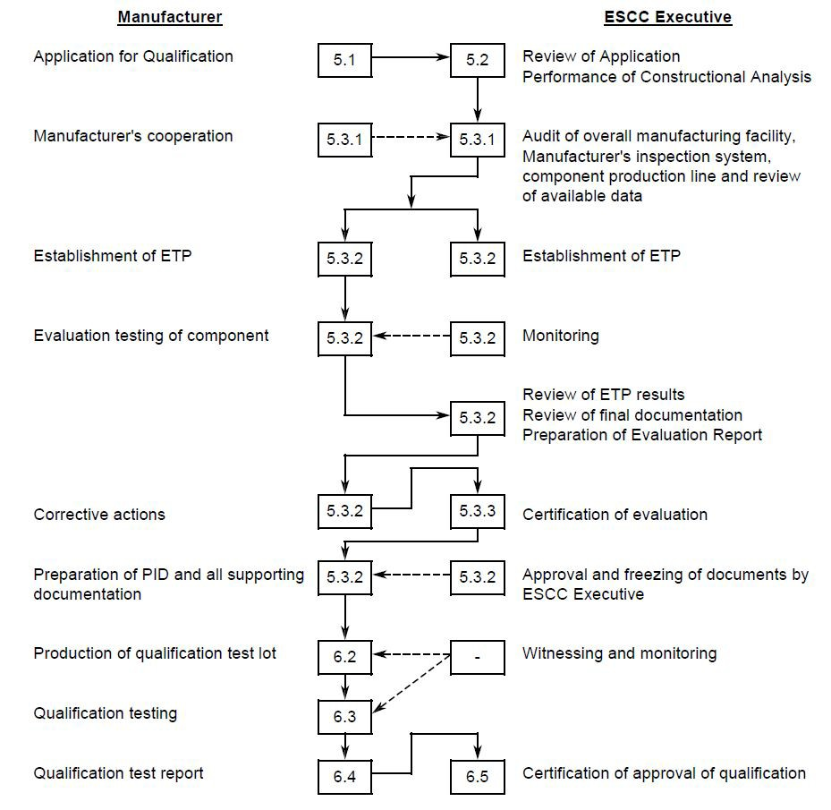

12.
CHART 2 ESCC QUALIFICATION METHODOLOGY

EXTENSION OF QUALIFICATION

Evaluation of Manufacturers
QUALIFICATION
RENEWAL OF QUALIFICATION AFTER LAPSE

production and testing record since last quailfication certification
r--E_v_a_lu_a_tio_n_o_LftM_a_n_u_fa_c_tu_re_r-----,c O"g'nal """'""'on valid?

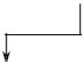Evaluation of adequacy of NO YES Manufacturers testing records
and data

I Acceptable I
t
t t
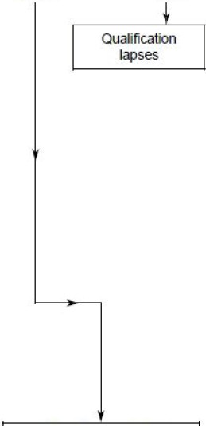YES NO

Evaluation test programme required?

t
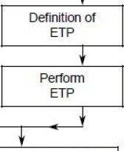NO YES

Production of Qualification Lot

Screening Tests or Final Production Tests and Bum-in and Electlical Measurements to Level B per the applicable Generic Spedfication

Qualification Testing

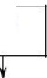DPA and Manufacturer audit

Review of Manufacturers testing record

Satisfactory Unsatisfactory
!
Perform Lot Acceptance
Level 1 or Pertodic Testing

satisfactory

Qualification granted for up to two years

See Chart4

YES

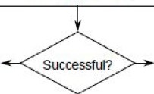NO

See Chart 3
Failure
Analysis

See Chart 5



13. CHART 3 INITIAL ESCC QUALIFICATION

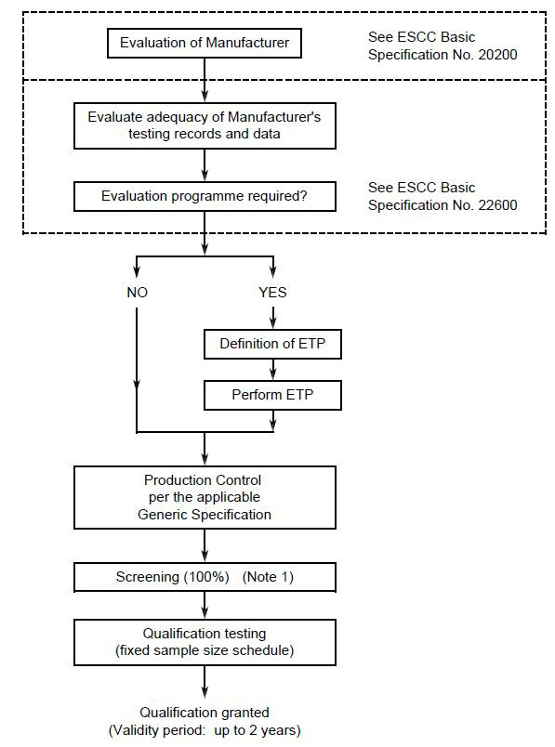

NOTES:
1. Either Screening Tests or Final Production Tests and Burn-in and Electrical Measurements to Level
B per the applicable Generic Specification.

14. CHART 4 EXTENSION OF ESCC QUALIFICATION

Qualification validity period about to expire

Components procured to Lot Acceptance Level 1 or Periodic Testing completed during Qualification validity period per applicable Generic Specification?
t

YES NO
I

Is recent data equivalent to Lot Acceptance Level 1 or the Periodic Testing available and acceptable?

YEs NO

1
Qualification lapses
(see Chart 5)

Extension of Qualification by up to further 2-year period

15. CHART 5 RENEWAL OF ESCC QUALIFICATION AFTER LAPSE

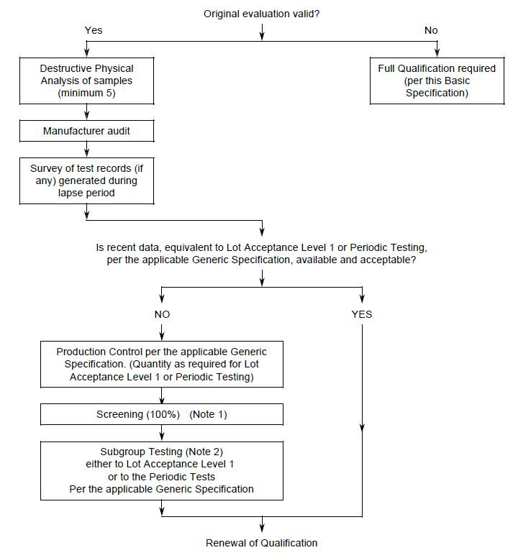

NOTES:
1. Either Screening Tests or Final Production Tests and Burn-in and Electrical Measurements to Level
B per the applicable Generic Specification.
2. On a sample for which the allowable number of failures is specified.

APPENDIX A CERTIFICATE OF CONFORMITY

The following minimum information shall appear on an ESCC Certificate of Conformity:

– “ESCC Certificate of Conformity”

– Name of Company

– Address

– Component type

– Component number

– Lot identification

– Quantity

– Order number

– “This is to certify that the above mentioned components fulfil the requirements of the following Generic and Detail specifications of the ESCC System:” Generic and Detail Specification numbers and issues as applicable

– “The components subject to this Certificate of Conformity were manufactured at our plant located at:” Plant location

– “Certified by:” Name and Title, the latter to be either the “ESCC Chief Inspector” or “Deputy ESCC Chief Inspector”

– Date

NOTES:
The text above in quotations is intended for literal use on the ESCC Certificate of Conformity.

